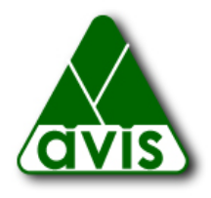

Capital Campaign

As of September 1, 2016 AVIS has raised more than 50% of its $400,000 goal from foundations and AVIS leadership donors. We ask the community to support this effort to protect the riverfront and the Bay Circuit Trail in Andover.

Please check one:
Conservationist $10,000
Environmentalist $5,000
Forester $2,500
Naturalist $1,000
Hiker $500
Other Amount $________

Note: AVIS is a 501(c)(3) organization. All contributions are tax deductible to the extent permitted by federal regulations.

Name (please print)

Address

Town / State / Zip

Phone e-mail

Please make check out to A.V.I.S. and mail to:
AVIS
P.O. Box 5097
Andover, MA 01810

Thank you!

