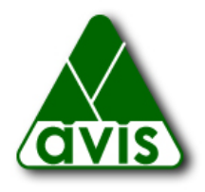

Membership

Please check one:
Sustaining $100
Family $50
Individual $30
Seniors and Students $15

Donation

Additional Unrestricted Contribution $
To be used as the Trustees deem in AVIS’s best interest.

Additional Contribution for Land Acquisition Fund $
Used to purchase land to expand existing or create new reservations.

Additional Contribution for Land Stewardship Endowment Fund $
The income from this fund is used for stewardship of the many AVIS reservations in Andover, including land management projects, such as boardwalks, and other maintenance and preservation activities.

Note: AVIS is a 501(c)(3) organization. All contributions and dues are tax deductible to the extent permitted by federal regulations.

Name (please print)

Address

Town / State / Zip

Phone e-mail

Please make check out to A.V.I.S. and mail to:
AVIS
P.O. Box 5097
Andover, MA 01810

Thank you!

