Practical No. 3
Aim: Write a program to do a square using a while loop, doing steps with a for loop, to change directions based on condition, controlling motor speed using switch case.
- Square using While loop
Source Code: Square
importch.aplu.robotsim.*;

class Square
{
Square()
{
TurtleRobot robot = new TurtleRobot();

inti = 0;
while (i< 4)
{
robot.forward(50);
robot.right(90);
i++;
}
robot.exit();
}

public static void main(String[] args)
{
new Square();
}
}

Output:
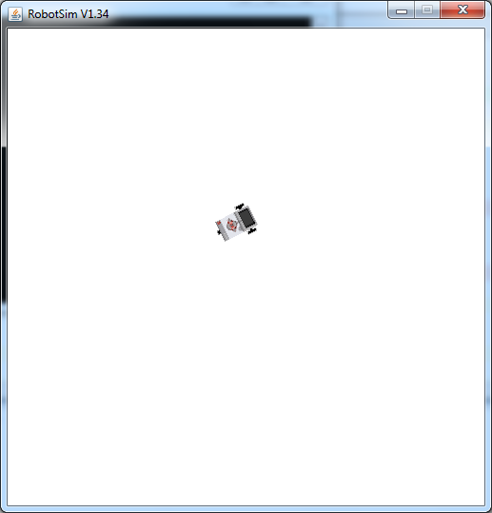

- Doing steps with a for loop
Source Code: Steps
import ch.aplu.robotsim.*;
class Steps
{
Steps()
{
TurtleRobot robot = new TurtleRobot();
for (int i = 0; i < 4; i++)
{
robot.forward(20);
robot.right(90);
robot.forward(20);
robot.left(90);
}
robot.exit();
}
public static void main(String[] args)
{
new Steps();
}
}

Output:

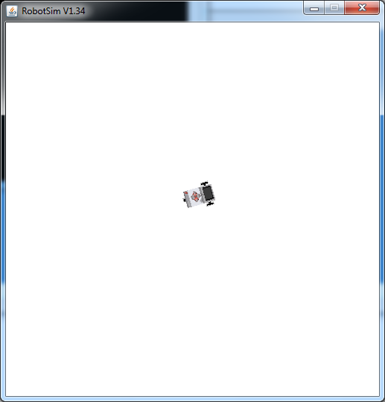

- Change directions based on condition

Source Code:RandomMove
import ch.aplu.robotsim.*;
class RandomMove
{
RandomMove()
{
TurtleRobot robot = new TurtleRobot();
for (int i = 0; i < 7; i++)
{
double a = Math.random();
if (a < 0.5)
robot.right(90);
else
robot.left(90);
robot.forward(100);
}
robot.exit();
}
public static void main(String[] args)
{
new RandomMove();
}
}

Output:

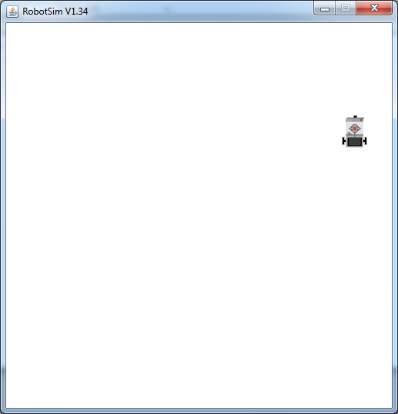

- Controlling motor speed using switch case.
Source Code:SpeedSwitch

import ch.aplu.robotsim.*;
class SpeedSwitch
{
SpeedSwitch()
{
TurtleRobot robot = new TurtleRobot();
for (int k = 1; k < 6; k++ )
{
int speed;
switch(k)
{
case 1:
speed = 20;
break;
case 2:
speed = 40;
break;
case 3:
speed = 60;
break;
case 4:
speed = 80;
break;
default:
speed = 50;
}
robot.setTurtleSpeed(speed);
robot.forward(200);
robot.right(90);
}
robot.exit();
}
public static void main(String[] args)
{
new SpeedSwitch(); }
}

Output:



