The Real Challenge Wasn’t Counting Steps, It Was Trusting The Data
I have recently built a step-tracking app. Not because the world needs another one, but because I wanted to experience the full journey from raw sensor data to meaningful insights.
What I didn't expect was that the hardest problem wouldn't be counting steps.
It would be deciding which data to trust.
At first, the problem sounded simple: track activity, estimate distance, and maintain workout history.
Wrong.
A fitness tracker looks simple on the surface, but underneath, it's a real-time data system built on noisy sensors, imperfect measurements, and algorithmic decisions.
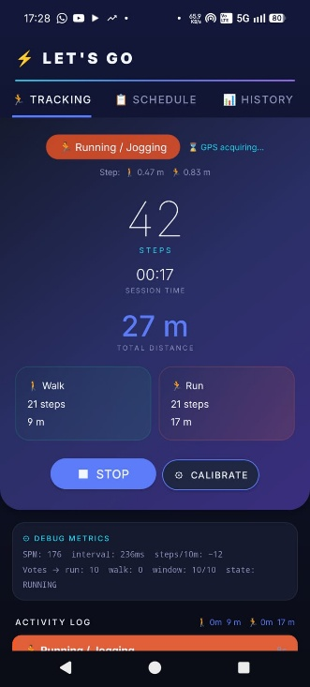
The best example was activity detection: counting steps is relatively easy, but determining whether someone is walking or running is much harder.
The app had to answer questions like:
- Is this fast walking or slow jogging?
- Did the user really start running?
- Did they slow back down to walking?
- Or is this just a temporary fluctuation?
My first instinct was to use a simple threshold:
"If cadence is above X, classify as running."
That worked surprisingly badly.
Real-world movement is noisy. Cadence fluctuates. GPS drifts. Sensors produce imperfect signals.
The result was an app that sometimes switched between walking and running too aggressively and sometimes got stuck in the wrong state.
The solution was introducing hysteresis: different thresholds for entering and exiting a running state, combined with a voting window to smooth short-term noise.
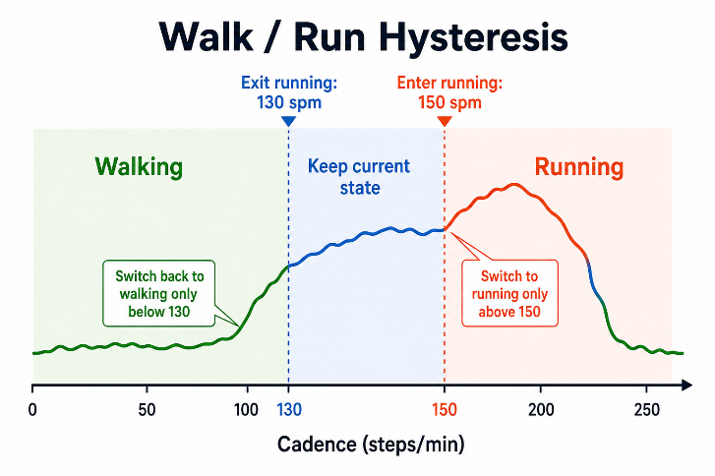
Simple idea. Complex reality…
On paper, the logic looked reasonable.
In reality, transitions from running back to walking almost never happened, while transitions into running occurred unpredictably.
The algorithm wasn't failing because the idea was wrong. It was failing because reality was messier than the assumptions behind it.
What looked like an algorithm problem quickly became a data problem.
The thresholds were wrong.
Some signals were less reliable than expected.
The classifier behaved differently on real users than on test data.
The lesson was valuable:
A good algorithm can still fail when the data doesn't behave the way you assumed.
And that pattern appears far beyond fitness applications. In recommendation systems, forecasting models, fraud detection, and AI products, we often focus on algorithms and models.
In practice, much of the engineering effort goes into understanding noisy signals, defining reliable metrics, and deciding what should be treated as truth.

The interesting part is that classification errors don't stay local.
If the app incorrectly labels a walk as a run, that decision affects:
- Distance statistics
- Workout summaries
- Historical trends
- Future recommendations
A small classification error becomes historical truth.
And that leads to an important observation about AI.
It's tempting to add features that answer questions like:
- Am I improving?
- How often do I run?
- What should I do next week?
But AI doesn't fix weak data.
If the underlying measurements are inaccurate, the AI will simply generate confident answers from unreliable foundations.

Building this app reinforced a lesson I've seen repeatedly in data engineering. Whether you're building fitness apps, recommendation systems, forecasting models, or AI products, the hardest problems are often not algorithmic.
They're data problems.
Before a system can generate valuable insights, it must first earn the right to trust its own data.
Building a step tracker reminded me that this challenge has very little to do with fitness apps, and everything to do with data engineering.

Appendix – system architecture
