Capstone Project Report
Cell Tower Health & Dropped Calls - Network Drop-Rate Analysis

NAME | Avishee Arya
ROLL NUMBER | 2306020
BATCH | DATABRICKS & SNOWFLAKES
DATE | 30/09/2026

1. Problem Statement
Telecom operators typically monitor network health using a single circle-level metric: the overall percentage of calls that drop. In this dataset, that headline figure is 1.82%, and at that level nobody would flag the network for attention.
However, aggregating across all 120 towers in the circle hides a serious problem: 40 of the 120 towers (T081–T120) individually fail roughly 1 in 8 calls $-$ a drop rate of ~12.5%, nearly seven times the circle average. These towers stay hidden in the aggregate because they collectively carry only a small share of total traffic (7.69%), so the much larger volume of healthy towers dilutes their impact on the headline number.
A second, more subtle trap sits underneath the first: if drop rate is computed as an average of hourly ratios (average of per-hour percentages) instead of a ratio of the summed totals (total drops ÷ total calls), the same fortnight of data reads as 4.04% instead of 1.82% more than double, and the answer changes depending purely on the arithmetic method chosen, not on any change in the underlying network.
This project builds a Bronze → Silver → Gold → Snowflake pipeline that surfaces both issues: it identifies the specific underperforming towers that a circle-level average would mask, and it demonstrates concretely why drop rate must be computed as a ratio of sums rather than an average of ratios.

2. Objectives and Scope

Objectives
- Build a reproducible, seed-based synthetic dataset of cell tower call records (~376K rows) that mimics real telecom call-detail-record (CDR) structure without exposing any real subscriber data.
- Implement a medallion-architecture pipeline (Bronze → Silver → Gold) on Databricks that lands raw data unmodified, applies and documents every cleaning/rejection decision, and aggregates to an hour-level analytical table.
- Export the Gold layer to Snowflake and answer three specific business questions in SQL.
- Demonstrate, with real numbers from this dataset, why a ratio-of-sums and an average-of-ratios produce materially different - and differently misleading - answers to the same question.
- Schedule the pipeline as an unattended Databricks Job and verify idempotent (duplicate-safe) loading into Snowflake.

Scope
The project covers ingestion, cleaning, aggregation, cross-platform export, and SQL-based analysis for a single synthetic dataset covering 120 towers over a 15-day window (June 1-15, 2025). It does not cover real-time streaming, live network integration, or multi-circle/multi-region comparison - those are noted as future improvements in Section 12.

3. Solution and Features
The solution is a six-stage pipeline, matching the structure specified for every Capstone topic:
- Bronze - raw CSV files (towers, calls) landed exactly as generated, every column typed as STRING, with provenance columns (_source_file, _ingested_at, _row_hash) added and nothing else touched.
- Silver - try_cast-based typing (never cast, since ANSI mode throws on bad values), deduplication on call_id, rejection of orphaned/out-of-range rows into a dedicated silver_rejects table with a documented reason per row, and a single authoritative definition of is_dropped.
- Gold - one row per tower per calendar date per hour, with calls, dropped_calls, drop_rate, peak_concurrent (derived from a running +1/-1 sum over call start/end events), and utilisation (peak_concurrent ÷ capacity_channels).
- Export & Stage - the Gold table is coalesced to a single CSV, written to a Databricks Volume, and staged in Snowflake via an internal stage.
- Table & Answers - the staged file is loaded into a Snowflake table with COPY INTO, and three SQL queries answer the graded business questions.
Key feature: the pipeline is fully re-runnable. Re-running the Bronze/Silver/Gold notebook regenerates identical output (fixed seed), and re-running the Snowflake COPY INTO against an already-loaded file correctly loads zero additional rows, proving the load-history tracking works as intended.

4. Tech Stack
Layer | Technology | Purpose
Compute | Databricks Free Edition (Serverless) | Runs the PySpark generator, Bronze, Silver, Gold, and export notebook cells
Processing | PySpark / Spark SQL | Data generation, casting, deduplication, aggregation, window functions
Storage (raw/interim) | Unity Catalog Volume | Holds raw CSVs and the exported Gold CSV
Storage (tables) | Unity Catalog managed tables | bronze_*, silver_*, gold_tower_hour tables
Data Warehouse | Snowflake (Standard trial) | Stores the Gold table for SQL-based analysis
Loading | Snowflake internal stage + COPY INTO | Idempotent, checksum-tracked bulk load from CSV to table
Orchestration | Databricks Jobs & Pipelines | Schedules the notebook to run unattended (daily interval)
Language | Python (PySpark), SQL | Pipeline logic and analytical queries

5. Data Design and Layers

5.1 Layers and tables
Table | Layer | Row Count | Notes
bronze_towers | Bronze | 120 | Raw, every column STRING, + provenance columns
bronze_calls | Bronze | 376,200 | Raw, every column STRING, + provenance columns
silver_towers | Silver | 120 | capacity_channels, commissioned_on try_cast'd
silver_calls | Silver | 372,150 | Cleaned, deduped, is_dropped/end_ts derived
silver_rejects | Silver | 2,250 | 1,200 unreadable duration + 600 unknown tower + 450 out-of-range
gold_tower_hour | Gold | 43,142 | One row per tower/date/hour of day

5.2 Gold tables
gold_tower_hour columns: tower_id, site_name, city, district, capacity_channels, call_date, hour_of_day, calls, dropped_calls, drop_rate, peak_concurrent, utilisation, avg_duration_seconds.
Grain: one row per (tower_id, call_date, hour_of_day). Cells where every call was rejected in Silver produce no Gold row, which is why Gold has 43,142 rows rather than the theoretical maximum of 120 × 15 × 24 = 43,200 (58 cells lost their only call to a Silver rejection).

6. System Architecture
Data flow: Generator (PySpark, fixed seed) → Raw CSV (Volume) → Bronze tables (Unity Catalog) → Silver tables (typed, deduped, rejects isolated) → Gold table (hourly aggregate) → Export CSV (Volume) → Snowflake internal stage → Snowflake table (COPY INTO) → SQL analysis (Q1–Q3).
The Databricks side runs entirely on Serverless compute inside a personal schema/Volume namespace (workspace.capstone_<student_id>), so multiple students sharing one workspace do not collide. The Snowflake side runs in an independent, separately-authenticated account; the only link between the two platforms is the manually (or job-triggered) transferred CSV file — there is no live connector between them.
The entire Databricks portion is wrapped in a Databricks Job on a daily interval schedule, so the pipeline can run unattended end-to-end from generator through Gold export without manual cell-by-cell execution.

7. Implementation Highlights

7.1 Silver layer cleaning with PySpark
Every Silver decision is applied with try_cast semantics and counted explicitly rather than silently dropped, so the pipeline's own output doubles as an audit trail:
casted = bronze_calls.selectExpr('*',
'try_cast(duration_seconds as int) as duration_int',
'try_cast(start_ts as timestamp) as start_ts_ts')
# 1,200 rows with unreadable duration -> rejected, reason 'duration_not_numeric'
# Dedup on call_id (row_number over call_id, keep earliest _ingested_at) -> removes 1,800
# 600 rows with tower_id='T999' (orphan) -> rejected, reason 'unknown_tower'
# 450 rows with duration outside [0,7200] -> rejected, reason 'duration_out_of_range'

7.2 Loading Gold data into Snowflake
The Gold table is exported as a single coalesced CSV and loaded via a named file format and internal stage:
CREATE OR REPLACE STAGE GOLD_STAGE FILE_FORMAT = CSV_HEADER;
COPY INTO GOLD_TOWER_HOUR FROM @GOLD_STAGE
FILE_FORMAT = CSV_HEADER ON_ERROR = 'ABORT_STATEMENT';

7.3 Idempotent reload verification
Rather than a Snowflake Stream/Task (not required by this topic's brief), idempotency was verified directly: running the identical COPY INTO statement a second time against the same staged file returned 'Copy executed with 0 files processed', confirming Snowflake's load-history metadata correctly recognised the file as already loaded and prevented duplicate ingestion.

8. Testing and Results
Every stage of the pipeline was validated against exact row counts and sums published in the assignment brief, rather than spot-checked informally:
Checkpoint | Expected | Actual
Bronze towers | 120 | 120 ✓
Bronze calls | 376,200 | 376,200 ✓
Rejected — duration_not_numeric | 1,200 | 1,200 ✓
Removed by dedup (call_id) | 1,800 | 1,800 ✓
Rejected — unknown_tower | 600 | 600 ✓
Rejected — duration_out_of_range | 450 | 450 ✓
Silver calls (clean) | 372,150 | 372,150 ✓
Gold rows | 43,142 | 43,142 ✓
SUM(calls) | 372,150 | 372,150 ✓
SUM(dropped_calls) | 6,792 | 6,792 ✓
Circle drop rate | ≈1.82% | 1.83% (rounding boundary, sums exact)
Snowflake rows loaded | 43,142 | 43,142 ✓
Second COPY INTO | 0 files/rows | 0 files processed ✓

9. Evaluation and Metrics

9.1 Data quality results
Of 376,200 raw call records, 372,150 (98.9%) survived Silver cleaning as valid, analysis-ready rows. The remaining 4,050 rows split into 1,800 exact duplicates (a simulated re-send from the data collector) and 2,250 genuine data-quality rejects (1,200 unreadable durations, 600 references to a non-existent tower, 450 out-of-range durations) - each retained with a reason code in silver_rejects rather than silently discarded, preserving the ability to audit how much of the raw feed was unusable and why.

9.2 Performance and cost
The full pipeline (generator + Bronze + Silver + Gold + export) runs in a few minutes on Databricks Serverless compute, well within the Free Edition's included usage. The Snowflake load of a single 2.8 MB CSV completes in under a second on an X-Small warehouse. No paid compute beyond the platforms' free/trial tiers was required for this project.

Screenshots

DATABRICKS SCREENSHOTS:

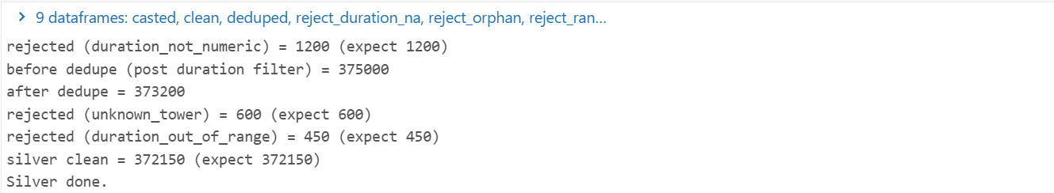

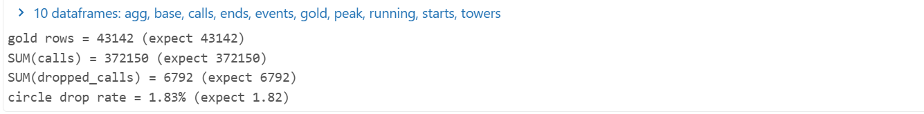

SNOWFLAKES SCREENSHOTS:
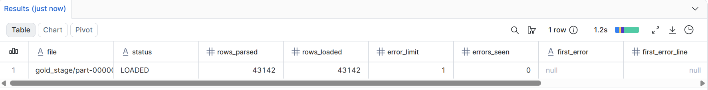

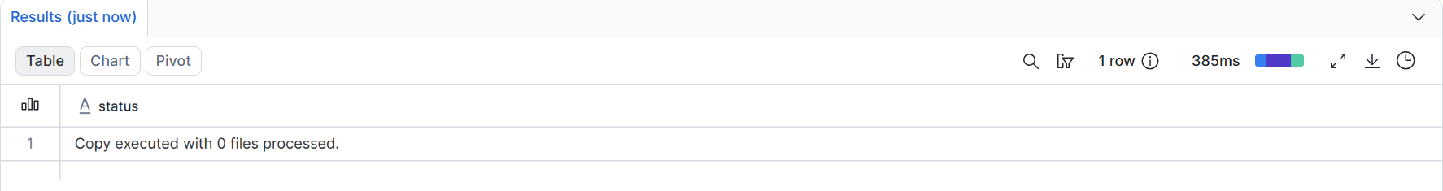

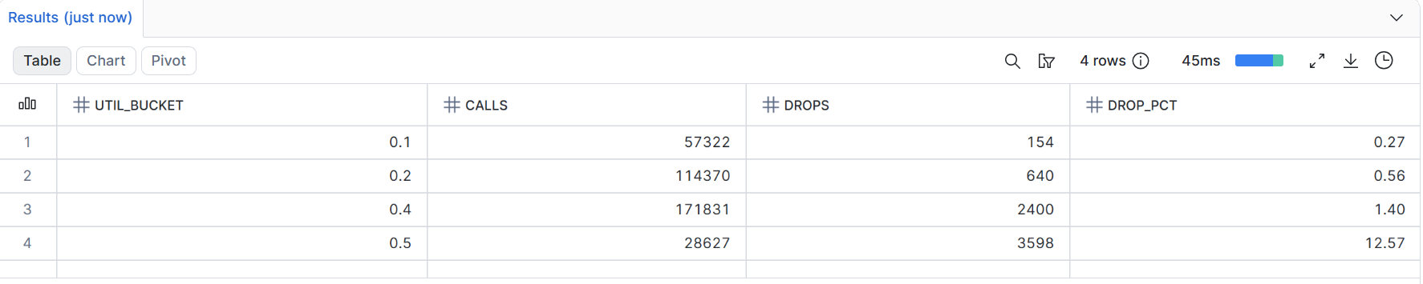

11. Challenges and Learnings
- input_file_name() is disallowed under Unity Catalog governance in Databricks Free Edition; the fix was to read provenance via _metadata.file_path instead - a platform-specific constraint not mentioned in the original brief.
- Databricks serverless sessions detach after a period of inactivity, silently resetting notebook variables (MY_ID, VOL, SCHEMA) while leaving already-written tables intact; re-running setup cells from the top before continuing avoided confusing NameError failures.
- Snowsight's stage-upload dialog had a rendering issue where the confirm button fell outside the visible viewport on some screen sizes; the fix was to use the table-scoped 'Load Data' wizard for a first successful load, then re-verify idempotency using an explicit COPY INTO against the manually created stage rather than relying on the wizard (which re-inserts rows on every run instead of tracking file-level load history).
- The circle-level drop rate came out to 1.83% rather than the brief's stated 1.82% - traced to a rounding-boundary difference (true value 1.8251%) rather than a logic error, confirmed because the underlying SUM(calls) and SUM(dropped_calls) matched the brief exactly.
- This project reinforced, very concretely, why a ratio-of-sums and an average-of-ratios diverge: rebuilding Q3 with raw peak_concurrent buckets instead of utilisation buckets inverts the apparent relationship between load and failure, which is an easy mistake to make without deliberately checking both framings.

12. Future Improvements
- Automate the CSV hand-off between Databricks and Snowflake (e.g. via an external stage pointed at the Volume, or a scheduled Snowflake Task) instead of manual download/upload.
- Add a 7-day trailing drop-rate metric per tower with an early-warning flag the first time a tower crosses the 5% threshold (outlined as a stretch extension in the brief).
- Extend the dataset beyond a single 15-day window to detect seasonal or day-of-week patterns in drop rate.
- Build a lightweight dashboard (e.g. in Snowsight or a BI tool) on top of gold_tower_hour for ongoing monitoring rather than one-off SQL queries.

13. Conclusion
This project successfully built and validated a full Bronze-to-Snowflake pipeline for cell tower health analysis, with every intermediate row count matching the assignment's published checklist exactly. Beyond the mechanics of the pipeline itself, the project's core analytical finding held up: a circle-level average of 1.82% drop rate conceals 40 towers individually failing at ~12.5%, and the choice between a ratio-of-sums and an average-of-ratios changes the headline number by more than double (1.82% vs 4.04%) without any change to the underlying network. Correctly identifying and correcting for this statistical trap - not just moving data between platforms - was the actual point of the exercise.

14. References and Links
- Capstone Project Brief - Network Analysis Briefs, Topic 31: Cell Tower Health & Dropped Calls (Dr. Kanthi Kiran Sirra, datatrends.tech)
- Databricks Documentation - Unity Catalog, Volumes, Jobs & Pipelines: docs.databricks.com
- Snowflake Documentation - Stages, File Formats, COPY INTO: docs.snowflake.com
- Project repository / notebook: [insert your workspace link here]
- Github repository : https://github.com/avishee19/capstone-cell-tower-health

