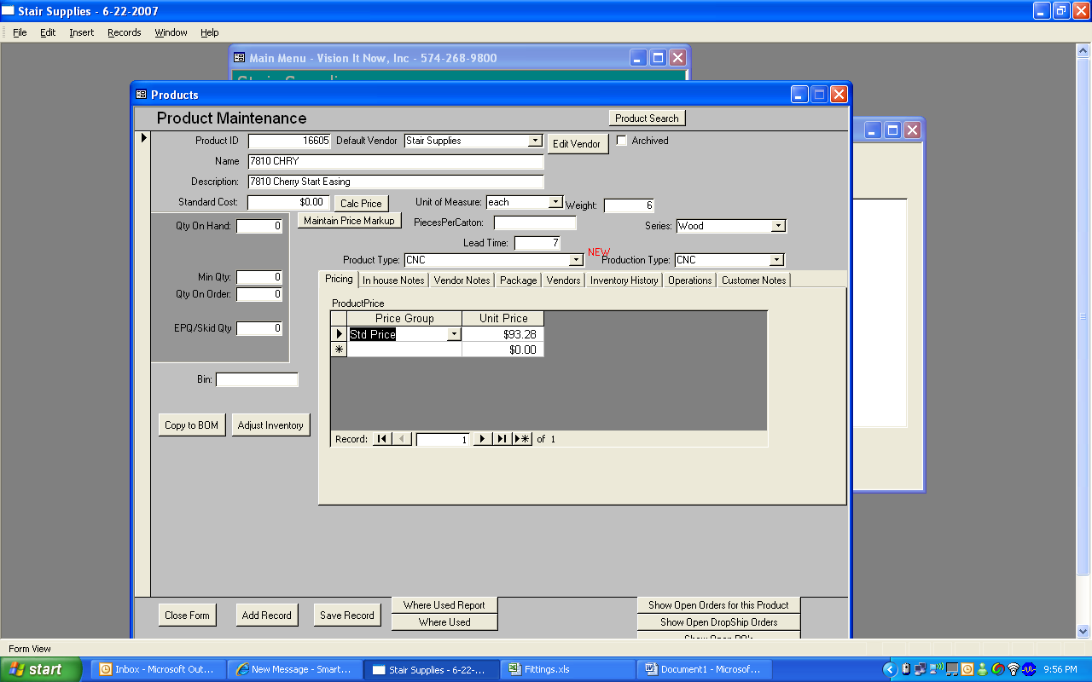

I need a form to add/edit items in the Products table.

- Please place this under the Products Menu
- The access should be limited to those who have access to the Products menu.
- Provide the ability to search for products and edit them.
- When a new product is created do a search for products that are similar. Show the user the similar and prompt them if they want to continue. We have problems with records being duplicates so let's try to keep it from happening.
- When a product is created a price needs to be entered into the table ProductPrice. The user should be able to insert a Price called “Standard Price” which corresponds to a 3 in the ProductPrice.CustomerPriceId.
- There should be a button which allows the user to copy the items to TblBom. When the button is pressed it copies the information from the current record in Products to a new record in TblBom. Once the button has been pressed and the record is copied it shouldn't be able to be copied again. Set all of the existing records so that they cannot be copied to TblBom.
- The following are field descriptions. *are required fields
    - *ProductName-- ”Product Name”
    - *ProductDescription “Description”
    - *VendorID -- ”Default Vendor” Provide a Dropdown of all Active Vendors
    - *ProductionCat_ID -- “Production Category” Provide a drop down from TblProductionCat
    - There is a field called ProductType_ID it is similar to the ProductionCat_ID, can you find a way to make ProductType_ID the same as the ProductionCat_ID
    - PurchasePrice-- “Cost”
    - *Unit of Measure-- Drop down with the values TblUnitofMeasure
    - Bin- “bin”
    - *Pcs_per_box-- “Pieces per box”
    - *Unit Weight--”Unit Weight”
    - Archived “Yes or No”
    - Species—“Species”drop down from tbl_lumber_species
    - BoardFootage-- “Board Footage”

