Contents

AEM ASSETS 2

SMART TAGS 2

MANAGING SMART TAGS 2

METADATA SCHEMAS 3

RENDITIONS 3

SEARCH ASSETS AND CONTENT 4

VISUAL SEARCH 4

COLLECTION 6

REPORTING 6

EXAMPLE – MODIFICATION REPORT 6

# AEM ASSETS

* AEM Assets extracts and stores the metadata for every asset uploaded to the system.
* Metadata is simply information that helps categorize and organize assets. Most importantly, metadata enables us to locate assets quickly and efficiently. Examples of metadata include manually curated data like
  + **Title**
  + **Description**
  + **Owner**
  + **Tags**.
* Other types of metadata, like **size**, **resolution**, **bitrate**, **timestamps**, and **location** data are automatically extracted by AEM.

## SMART TAGS

* AEM Assets is natively integrated with Adobe Sensei, Adobe's artificial intelligence and machine learning engine.
* AEM Assets leverages Sensei's s*mart* features to intelligently tag both image and video assets with keywords, making these assets more discoverable.
* Experience Manager Assets leverages Adobe Sensei to intelligently tag assets with keywords that describe key elements of the images or videos, allowing them to be easily discovered using keyword search by AEM users.

|  |  |  |
| --- | --- | --- |
|  |  | * The smart tag feature – enhances the search capability of AEM assets by automatically adding metadata tags to image assets which are uploaded in AEM dam * In AEM as Cloud service – the smart tag feature by default enabled. * When the image are uploaded to AEM – The image are processed by AEM asset compute service. * Among the processing step – the images are analyzed by Adobe Sensie – which generates the relevant tag – which then added as a metadata of the image asset. * These smart tag helps in “keyword” search. |

### MANAGING SMART TAGS

* Smart tags can be managed from the parent folder level.
* Smart Tags can be added/removed from image asset form manage tag option.
* The right /left arrow – help us to navigate to different assets in the folder.

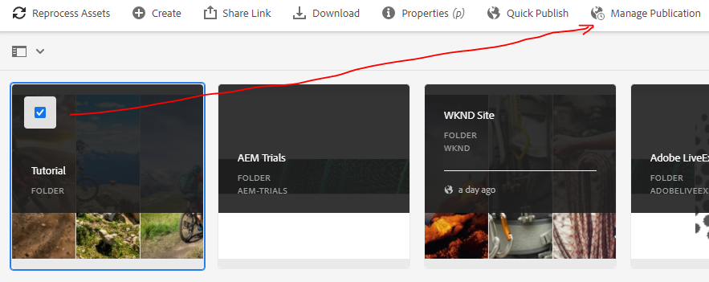

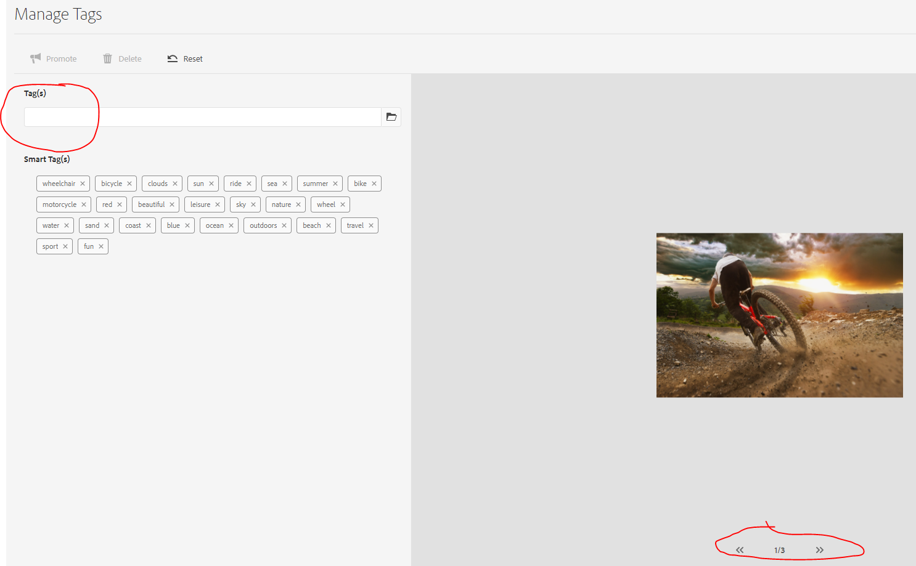

## METADATA SCHEMAS

* Metadata schemas are sets of metadata defining how users interact with assets in AEM, empowering you with additional tools to help organize and manage assets at scale. You can adjust schemas as needed to define, apply, and adjust different sets of metadata as needed.

## RENDITIONS

* Renditions are representations of an asset's original file.
* When we upload a file to AEM Assets, renditions are automatically generated. Typical examples of renditions are different sizes and variations optimized for web and mobile channels.  Other examples of renditions include watermarks and auto-cropped images.
* Renditions are important as they are usually used downstream or in the final channel rather than the larger source image.

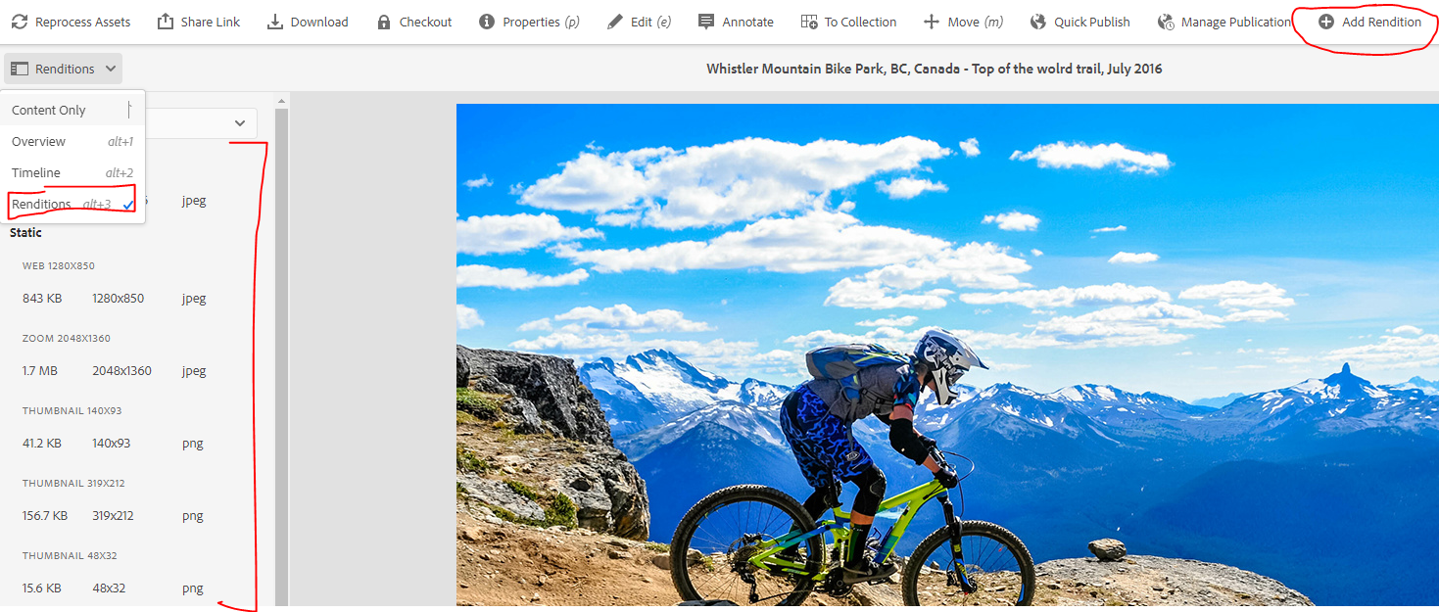

* Rendition can be added or deleted to an image assets

## SEARCH ASSETS AND CONTENT

* AEM makes it easy to quickly search and find assets. The AEM search tool, Omni-search, searches and shows results of the entire collection of asset metadata, regardless of folder location, and it allows us to quickly perform key-word searches, no matter where we are in the AEM interface.
* Search facets and metadata filters allow us to quickly narrow results to find the perfect asset.
* Omni Search in AEM Assets is intuitive and returns search results based on asset’s content, taxonomy, meta data and tagging.

|  |  |
| --- | --- |
|  | * AEM Search supports full text search * This will search for occurrence of ski or surf in assert metadata |
|  | * Search for Portland excluding “hood” from it |
|  | * Wrap the text in quotes for the Exact Search * This will do an exact text search in PDF assets and Smart Tag search in image assets. |

### VISUAL SEARCH

* As Adobe Sensei processes the upload of an asset, it not only detects Smart Tag keywords, but it also generates a mathematical representation of the asset for visual similarity.

#### Understand Experience Manager Assets search results interface.

* **A.**Save search as a smart collection.   
  **B.**Filters or predicates to narrow the search results.   
  **C.**Display files, folders, or both.   
  **D.**Click Filters to open or close the left rail.   
  **E.**Search location is DAM.   
  **F.**Omni search field with user-provided search keyword.   
  **G.**Select the loaded search results.   
  **H.**Number of displayed search results out of the total search results.   
  **I.**Close search   
  **J.**Switch between card view and list view.

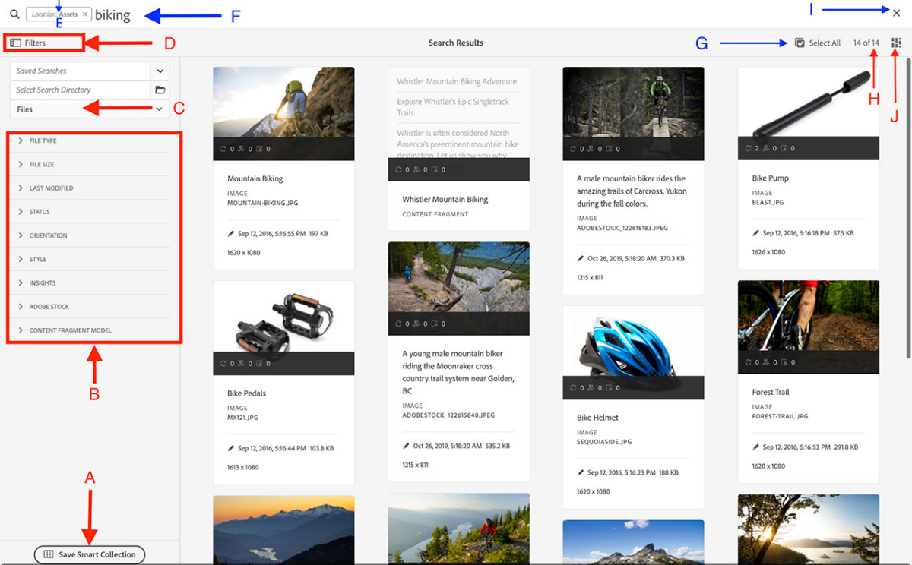

|  |  |
| --- | --- |
|  | * From your search results for the term **Tutorial**, roll over your desired image, select the **ellipsis**, and choose **Find Similar**. |

* We will notice the small thumbnail of the image we selected appeared on the top search bar. The returned search results will include the most visually similar assets.

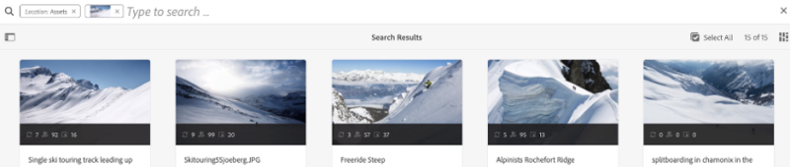

Visual search is an advanced capability powered by Adobe Sensei, Adobe's artificial intelligence engine. Visual search allows us to search based on an image to find images with similar composition.

### COLLECTION

* Grouping content at the folder level by similar asset properties, Collections provide another lens and more flexibility to the already robust set of content organization and discovery options AEM offers.

#### VARIATIONS OF COLLECTION

* LIGHTBOX COLLECTION
* NAMED COLLECTION
* SEARCH COLLECTION

## REPORTING

* Asset reporting lets you assess the utility of your AEM Assets deployment.
* We can generate various reports that provide useful information about the system’s usage, such as how users interact with assets, including which assets have been downloaded and/or shared.
* With these reports, users can derive key insights. For example, reports on asset usage help users measure the adoption of AEM Assets throughout the enterprise.
* All the DAM reports are located at following location: From the Navigation page, select the hammer icon on the left of the screen. **Select Assets > Reports**.
* Once in the Report Console Wizard, you’ll have access to a variety of report templates:
  + Upload
  + Expiration
  + Modification
  + Publish
  + Brand Portal Publish
  + Disk Usage
  + Files
  + Link Share
  + Smart Tags Training

### EXAMPLE – MODIFICATION REPORT

* Lets consider an example – to create the report of asset which are modified in specific date range

#### STEP -1: BASIC FIELD

|  |  |
| --- | --- |
| **TITLE** | Tile of the Modification Report |
| **FOLDER PATH** | The rooty path of the folder – for which reports has to be created |
| **SCHEDULE REPORT** | Timeline of report creation |

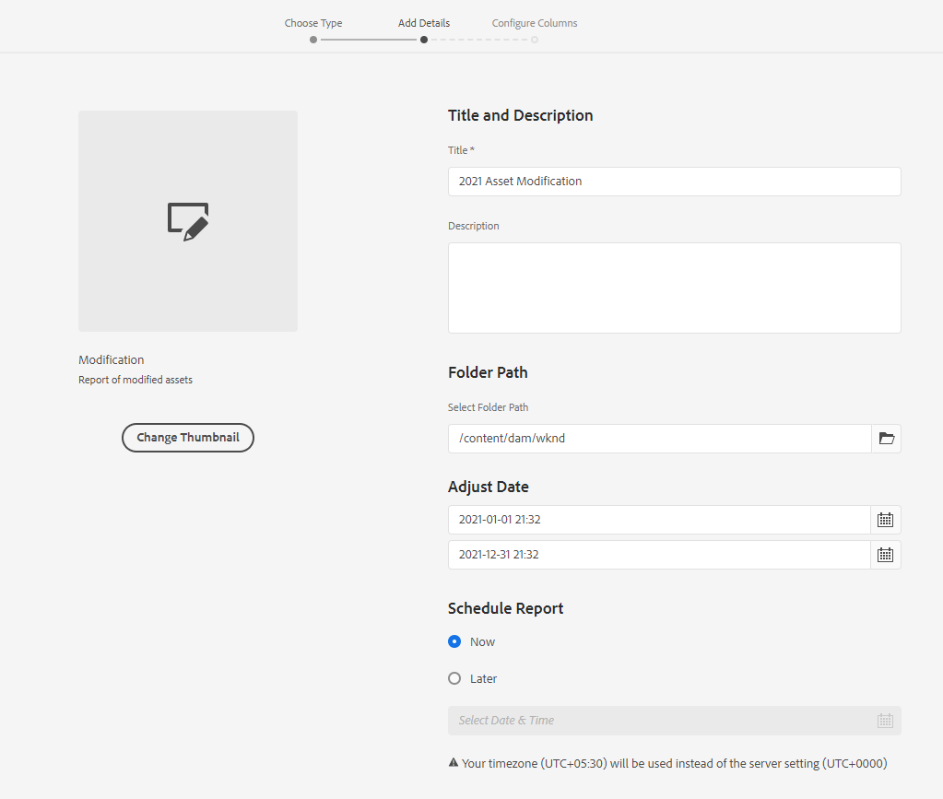

#### STEP -2 :ADDING CUSTOM COLUMN IN THE REPORT

* Apart from Default column – we can include other columns in the report using custom columns multifiled

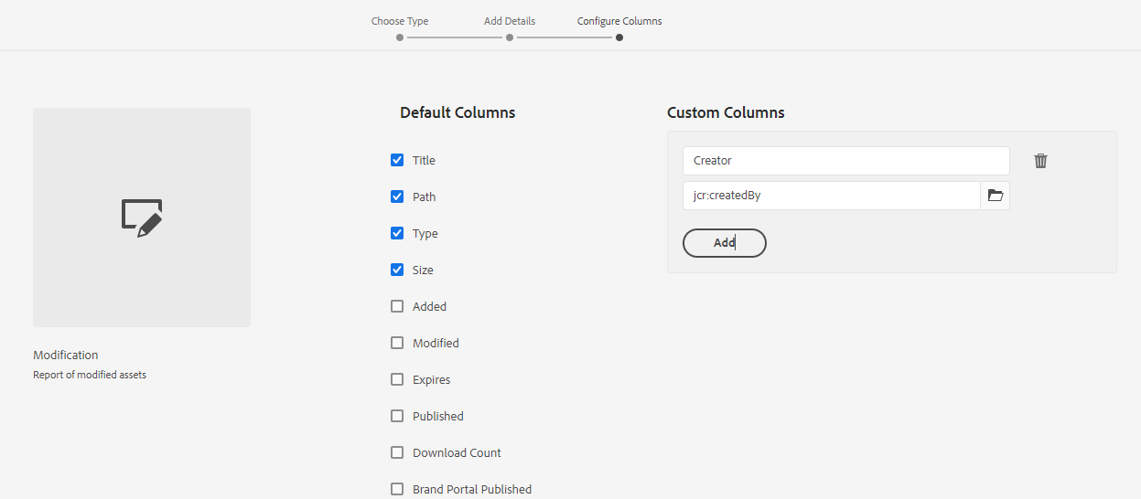

#### STEP -3 :REPORT GENERATED

* Report



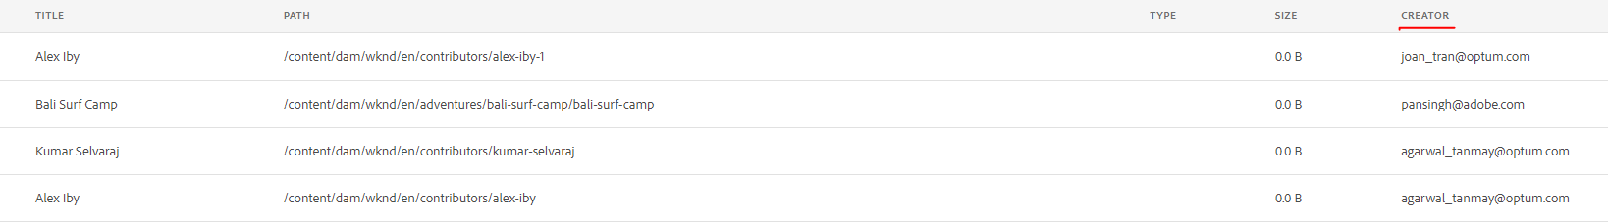

* *The created reported can be downloaded as CSV format.*