Contents

CONTENT FRAGMENT DELIVERY VIA GRAPHQL INTERGRATION 2

WHAT IS GRAPHQL? 2

BENEFITS OF GRAPHQL? 2

CONTENT FRAGMENT AND GRAPH QL 3

DATA MODELING USING CONTENT FRAGMENTS 3

ADVANCED DATA MODELING 4

GRAPHQL 5

EXECUTING THE GRAPHQL 6

GRAPH QL ENDPOINT 10

CREATING GRAPHQL ENDPOINT 10

SETTINGS FOR CREATED GRAPHQL ENDPOINT 11

AUTHOR AND PUBLISH ARCHITECTURE IN HEADLESS 12

GRAPH-QL PERSISTED QUERY 13

CREATING THE PERSISTED QUERIES (PUT REQUEST) 13

EXECUTING THE PERSISTED QUERIES (GET REQUEST) 15

UPDATING THE PERSISTED QUERIES 15

DELETING THE PERSISTED QUERIES 16

EXECUTING THE PERSISTED QUERY USING CURL 17

# CONTENT FRAGMENT DELIVERY VIA GRAPHQL INTERGRATION

The GraphQL API is primarily designed to deliver content fragment data to downstream application

## WHAT IS GRAPHQL?

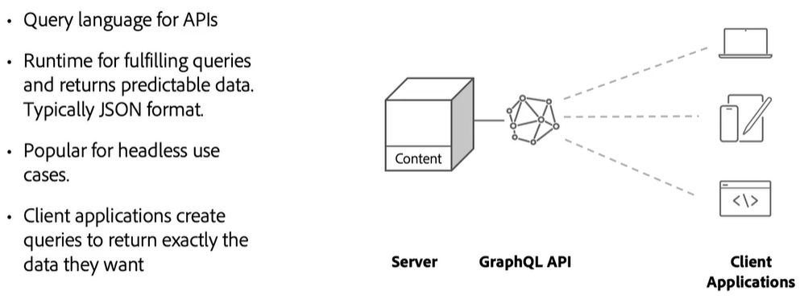

* The client applications like desktop, mobile or IOT devices can create Graph QL Queries.
* The Graph QL return the data exactly same data – what client is looking for.
* Unlike REST API – graph QL has single end point – which return the data we need.

|  |  |
| --- | --- |
|  |  |

## THE GRAPH DATA STRUCTURE

* Graph QL are based on graph data structure.
* When we want to navigate to any node from application – we have a flexibility to land on different points and the further in the graph we can traverse to any related data.
* For example – lets say if we have a query as

|  |  |
| --- | --- |
| {  book(id: 1) {  title  genre  author {  name  age  books {  name  }  }  }  }} | * If we start the traversing from book (id=1). This is the entry point of the graph traversal.. We can grab the tile and genre from the node. * Next we traverse connected node of author and grab the name and age * In the next step – for the books we can traverse to next connected node of books . i.e book name - Book(2) and Book(3) |

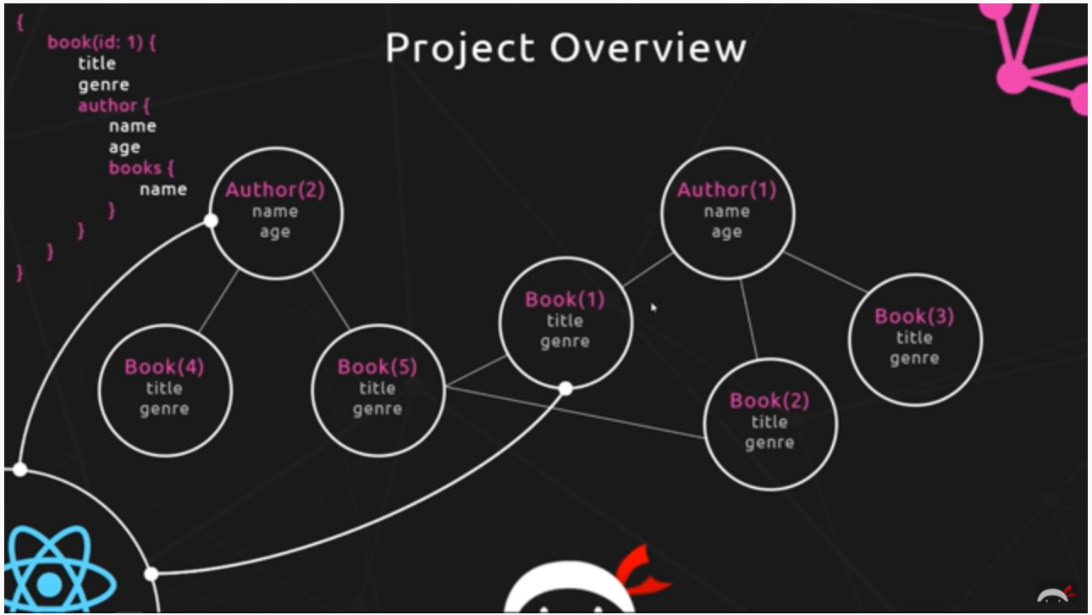

## BENEFITS OF GRAPHQL?

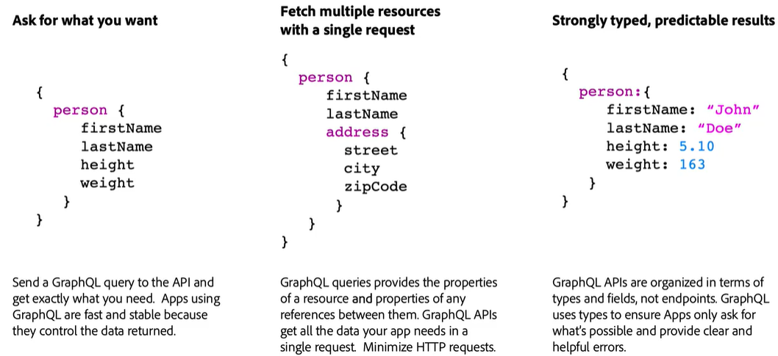

## CONTENT FRAGMENT AND GRAPH QL

AEM has implemented a set of GraphQL API to expose data about content fragment.

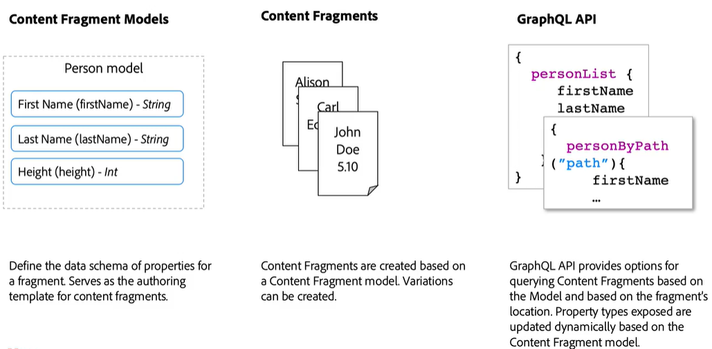

### DATA MODELING USING CONTENT FRAGMENTS

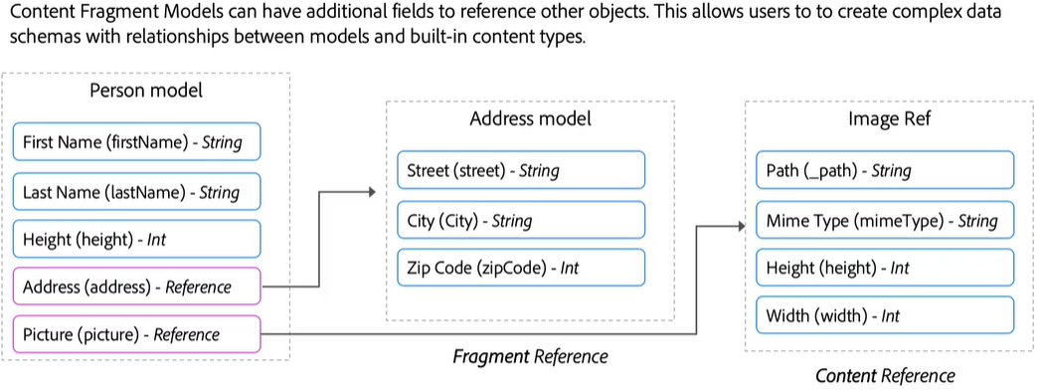

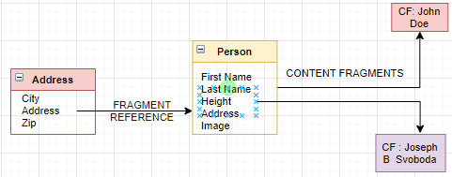

### ADVANCED DATA MODELING

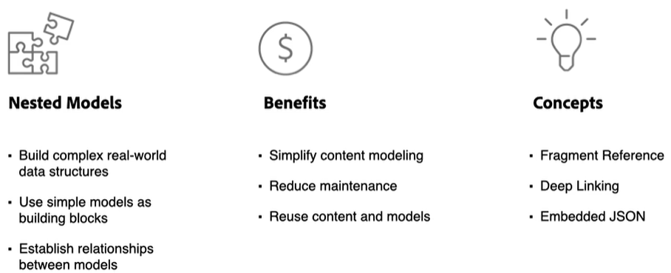

#### FRAGMENT REFERENCE

Fragment Reference field is to refer the other content fragments. Hence it helps in nesting the CFs

#### DEEP LINKING

* We can create a deep link to a CF in a Rich text editor.

CF MODEL

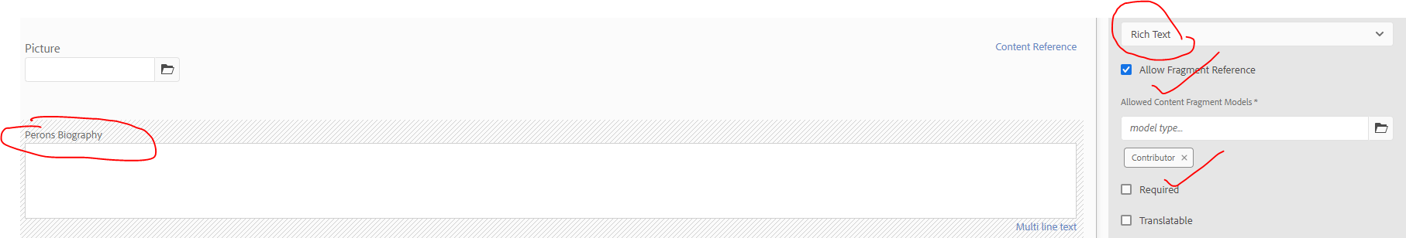

CF

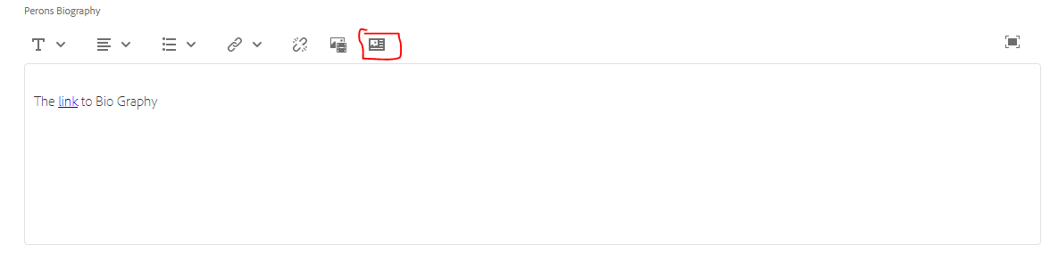

#### EMBEDDED JSON

CF MODEL



CF

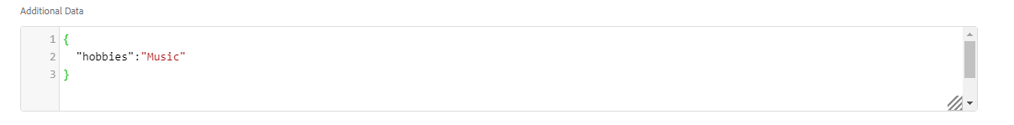

#### CONTENT REFERENCE

Content Reference field is to refer the complex content types like images.  
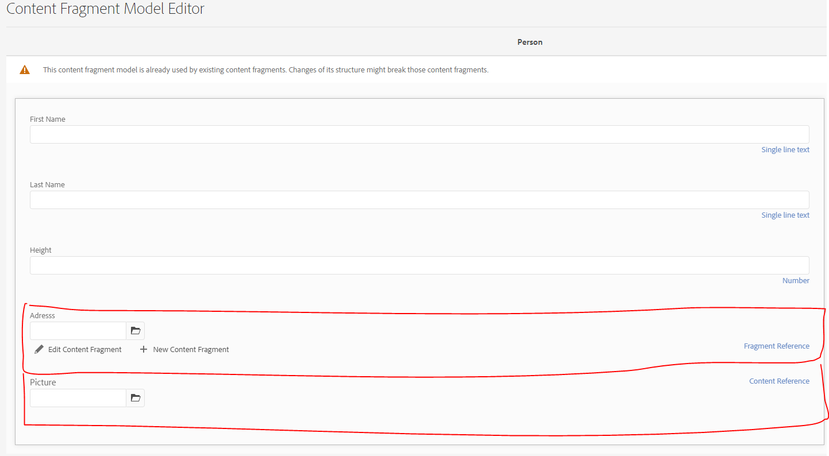

### GRAPHQL

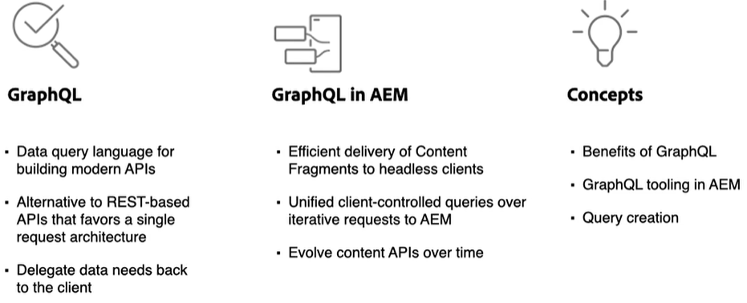

* AEM supports 2 query types by convention. The format of the Query type is ***modelName[ByPath|list]***

### EXECUTING THE GRAPHQL

* The GraphQL API of AEM provides a powerful query language to expose data of Content Fragments to downstream applications.
* Content Fragment Models define the data schema used by Content Fragments. Whenever a Content Fragment Model is created or updated, the schema is translated and added to the graph that makes up the GraphQL API.
* GRAPHIQL : <http://localhost:4502/content/graphiql.html>

#### QUERYING THE CONTENT FRAGMENT COLLECTION

|  |  |
| --- | --- |
| {  personList {  items {  _path  _variation  firstName  lastName  height  picture {  ... on ImageRef {  _path  type  }  }  address {  street  city  zip  }  }  }  } | {  "data": {  "personList": {  "items": [  {  "_path": "/content/dam/wknd/en/person/john-doe",  "_variation": "master",  "firstName": "John",  "lastName": "Doe",  "height": 53,  "picture": {  "_path": "/content/dam/wknd/en/contributors/ian_provo.jpg",  "type": "image"  },  "address": {  "street": "2743 Lonely Oak Drive",  "city": "CALHOUN",  "zip": 42327  }  },  {  "_path": "/content/dam/wknd/en/person/joseph-b-svoboda",  "_variation": "master",  "firstName": "Joseph B ",  "lastName": "Svoboda",  "height": 43,  "picture": {  "_path": "/content/dam/wknd/en/contributors/justin_barr.jpg",  "type": "image"  },  "address": {  "street": "337 Black Oak Hollow Road",  "city": "Santa Clara",  "zip": 34  }  }  ]  }  }  } |

#### FILTERING

|  |  |
| --- | --- |
| {  personList(filter: {firstName: {_expressions: {value: "John"}}}) {  items {  _path  _variation  firstName  lastName  height  picture {  ... on ImageRef {  _path  type  }  }  address {  street  city  zip  }  }  }  } | {  "data": {  "personList": {  "items": [  {  "_path": "/content/dam/wknd/en/person/john-doe",  "_variation": "master",  "firstName": "John",  "lastName": "Doe",  "height": 53,  "picture": {  "_path": "/content/dam/wknd/en/contributors/ian_provo.jpg",  "type": "image"  },  "address": {  "street": "2743 Lonely Oak Drive",  "city": "CALHOUN",  "zip": 42327  }  }  ]  }  }  } |

#### QUERY A SINGLE FRAGMENT

* It is also possible to directly query a single Content Fragment.
* Content in AEM is stored in a hierarchical manner and the unique identifier for a fragment is based on the fragment’s path.
* If the goal is to return data about a single fragment, it is preferred to use the path and query the model directly.
* Using this syntax means that the query complexity will be very low and will generate a faster result.

|  |  |
| --- | --- |
| {  personByPath(_path: "/content/dam/wknd/en/person/john-doe") {  item {  _path  _variation  firstName  lastName  height  picture {  ... on ImageRef {  _path  type  }  }  address {  street  city  zip  }  }  }  } | {  "data": {  "personByPath": {  "item": {  "_path": "/content/dam/wknd/en/person/john-doe",  "_variation": "master",  "firstName": "John",  "lastName": "Doe",  "height": 53,  "picture": {  "_path": "/content/dam/wknd/en/contributors/ian_provo.jpg",  "type": "image"  },  "address": {  "street": "2743 Lonely Oak Drive",  "city": "CALHOUN",  "zip": 42327  }  }  }  }  } |

#### ADDING PARAMETERS TO GRAPH QL QUERIES

|  |  |
| --- | --- |
| query findPersonByPath($path: String!){  personByPath(_path: $path) {  item {  _path  _variation  firstName  lastName  height  picture {  ... on ImageRef {  _path  type  }  }  address {  street  city  zip  }  }  }  } | * “!” sign in the parameter indicate that is a required parameter * The variables are prefixed by “$” symbol   **CALLING THE FUNCTION**  {  "path": "/content/dam/wknd/en/person/john-doe"  } |

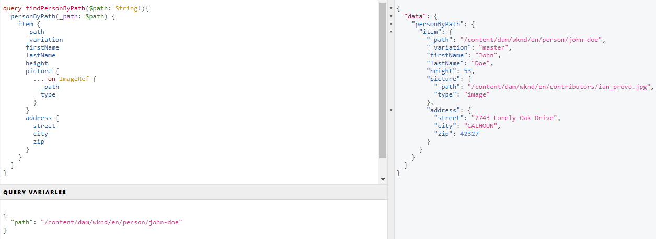

#### EXECUTING MULTIPLE GRAPH QL QUERIES IN SINGLE REQUEST

|  |  |
| --- | --- |
| {  adventureList {  items {  _path  adventureTitle  adventurePrice  adventureTripLength  adventurePrimaryImage {  ... on ImageRef {  _path  mimeType  width  height  }  }  }  }  personList {  items {  _path  _variation  firstName  lastName  height  }  }  } | * GraphQL offers the ability to specify multiple queries within a single request and therefore help reduce the round-trip times. * Here ***adventureList*** and ***personList*** are two different queries. |

#### QUERYING THE VARIATIONS

* If we query for a variation for a CF – Just in case the variation is not available, it will fall back to the master variation.

|  |  |  |
| --- | --- | --- |
| FETCHING ALL VARIATIONS:  The content fragment variations can be fetched in graplQL using variations  {  personList {  items {  _path  _variations  }  }  } | {  "data": {  "personList": {  "items": [  {  "_path": "/content/dam/wknd/en/person/john-doe",  "_variations": [  "john_doe_spanish"  ]  },  {  "_path": "/content/dam/wknd/en/person/joseph-b-svoboda",  "_variations": []  }  ]  }  }  } | |
| * Since we have the variations information available – we can be able to fetch the values of a specific variation. * If variation is not available, it will fall back to the master variation. | | |
| USING PATH  {  personByPath(  _path: "/content/dam/wknd/en/person/john-doe"  **variation: "john_doe_spanish"**  ) {  item {  _path  firstName  lastName  height  picture {  ... on ImageRef {  _path  type  }  }  address {  street  city  zip  }  }  }  } | | {  "data": {  "personByPath": {  "item": {  "_path": "/content/dam/wknd/en/person/john-doe",  "firstName": "John Spanish",  "lastName": "Doe Spanish",  "height": 53,  "picture": {  "_path": "/content/dam/wknd/en/contributors/ian_provo.jpg",  "type": "image"  },  "address": {  "street": "2743 Lonely Oak Drive",  "city": "CALHOUN",  "zip": 42327  }  }  }  }  } |
| USING LIST  {  personList(variation: "john_doe_spanish") {  items {  _path  firstName  lastName  height  picture {  ... on ImageRef {  _path  type  }  }  address {  street  city  zip  }  }  }  } | | {  "data": {  "personList": {  "items": [  {  "_path": "/content/dam/wknd/en/person/john-doe",  "firstName": "John Spanish",  "lastName": "Doe Spanish",  "height": 53,  "picture": {  "_path": "/content/dam/wknd/en/contributors/ian_provo.jpg",  "type": "image"  },  "address": {  "street": "2743 Lonely Oak Drive",  "city": "CALHOUN",  "zip": 42327  }  },  {  "_path": "/content/dam/wknd/en/person/joseph-b-svoboda",  "firstName": "Joseph B ",  "lastName": "Svoboda",  "height": 43,  "picture": {  "_path": "/content/dam/wknd/en/contributors/justin_barr.jpg",  "type": "image"  },  "address": {  "street": "337 Black Oak Hollow Road",  "city": "Santa Clara",  "zip": 34  }  }  ]  }  }  } |

##### FILTERING THE VARIATIONS

|  |  |
| --- | --- |
| {  personList(  variation: "**social**"  filter: {  _variations: {  _expressions: {  value: " **social** ",  _operator: EQUALS  }  }  }  ) {  items {  _path  firstName  lastName  height  picture {  ... on ImageRef {  _path  type  }  }  address {  street  city  zip  }  }  }  } | * This will filter the exact variation of a content fragment which are names as “***social***” |

## GRAPH QL ENDPOINT

### CREATING GRAPHQL ENDPOINT

* To view all the GraphQL endpoint, navigate to Graph QL manager: Tools 🡪Assets 🡪Graph QL.
* Below is the global endpoint of Graph QL – which is will allow as to query across all the projects (system wide)



|  |  |
| --- | --- |
|  | * We can also create project specific endpoint as well. * For example: <http://localhost:4502/content/cq:graphql/wknd/endpoint.json> * The project/schema specific endpoint can only query with the project. * The global graph QL endpoint can query across all the projects. * All the graphql endpoints, CF and CFM needs to be published. |

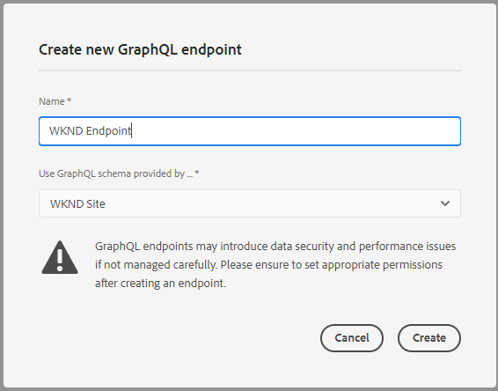



### SETTINGS FOR CREATED GRAPHQL ENDPOINT

To Allow the project specific endpoint we need to update the following

#### DISPATCHER CONFIGURATION

Update the dispatcher configuration to allow the endpoint.

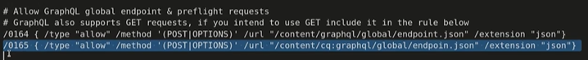

#### SECURITY /PERMISSION CONFIGURATIONS

* *Navigate to : Tools 🡪 Security 🡪 Permission*

# AUTHOR AND PUBLISH ARCHITECTURE IN HEADLESS

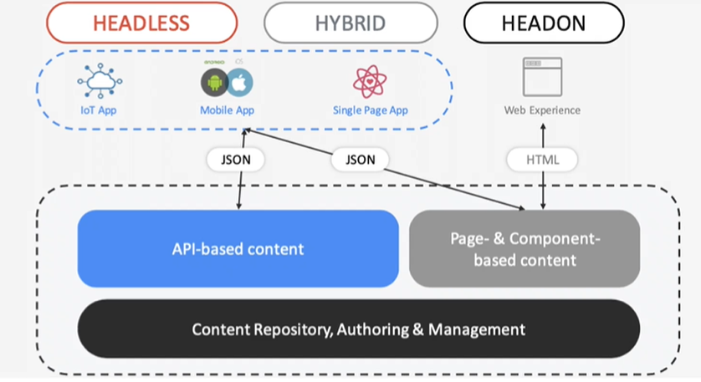

By default, AEM does not allow cross origin request from another domain. To allow the SPA application or third-party web-app to use AEM as headless service – we need to make following OSGi configurations

1. AEM CROSS ORIGIN RESOURCE SHARING POLICY (FACTORY CONFIGURATION)– This will allow the cross origin domain.

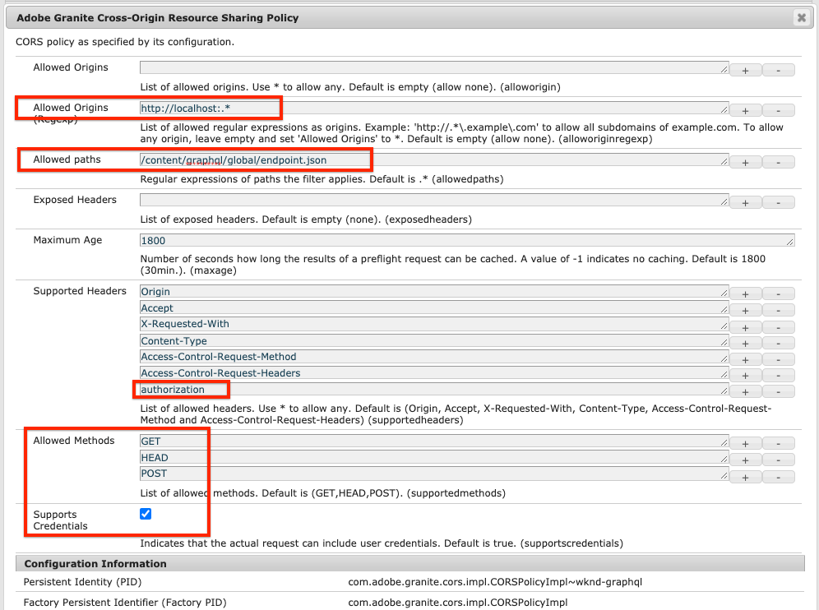

|  |  |  |
| --- | --- | --- |
| **CONFIGURATION** | **VALUE** | **DESCRIPTION** |
| **ALLOWED ORIGINS** | (Regex): http://localhost:.* | Allows all local host connections. |
| **ALLOWED PATHS** | /content/graphql/global/endpoint.json | This is the only GraphQL endpoint currently configured. As a best practice, CORs configurations should be as restrictive as possible. |
| **ALLOWED METHODS** | GET, HEAD, POST | Only POST is required for GraphQL however the other methods can be useful when interacting with AEM in headless manner. |
| **SUPPORTED HEADERS** | Authorization | authorization has been added to pass in basic authentication on the author environment. |
| **SUPPORTS CREDENTIALS** | Yes | This is required as our React app will communicate with the protected GraphQL end points on the AEM Author service. |

1. APACHE SLIING REFERER FILTER: This will allow the empty to allow empty referrer headers

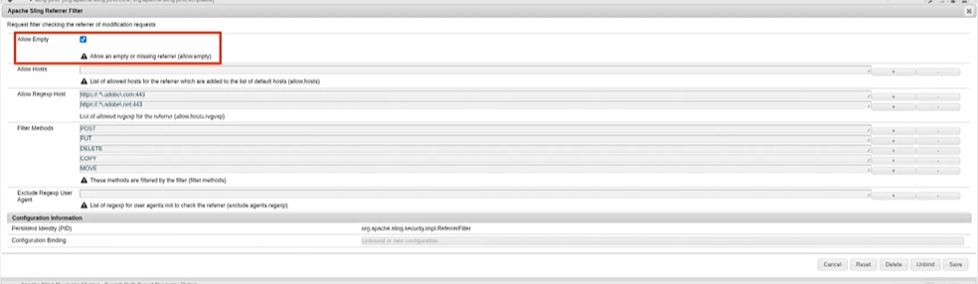

# GRAPH-QL PERSISTED QUERY

* To enable the graph query, navigate to Tool🡪 Configuration Browser
* Select the configuration folder of your project (we are using wknd site) 🡪 Properties
* Enable the “Graph QL Persistence Queries”

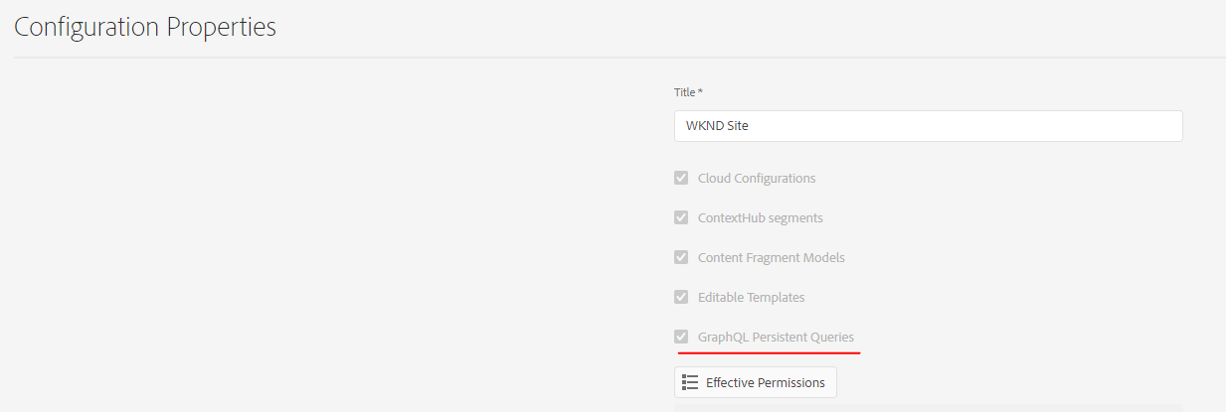

## CREATING THE PERSISTED QUERIES (PUT REQUEST)

* To create a persisted query in AEM – we have to send a post request to below end point.
* The request will create a node in AEM at /conf/<Site Name>/<Short Path>

|  |  |
| --- | --- |
| ENDPOINT- PUT REQUEST | EXAMPLE |
| http://localhost:4502/graphql/persist.json/<Site Name>/<Query Name> | <http://localhost:4502/graphql/persist.json/wknd/person-list> |

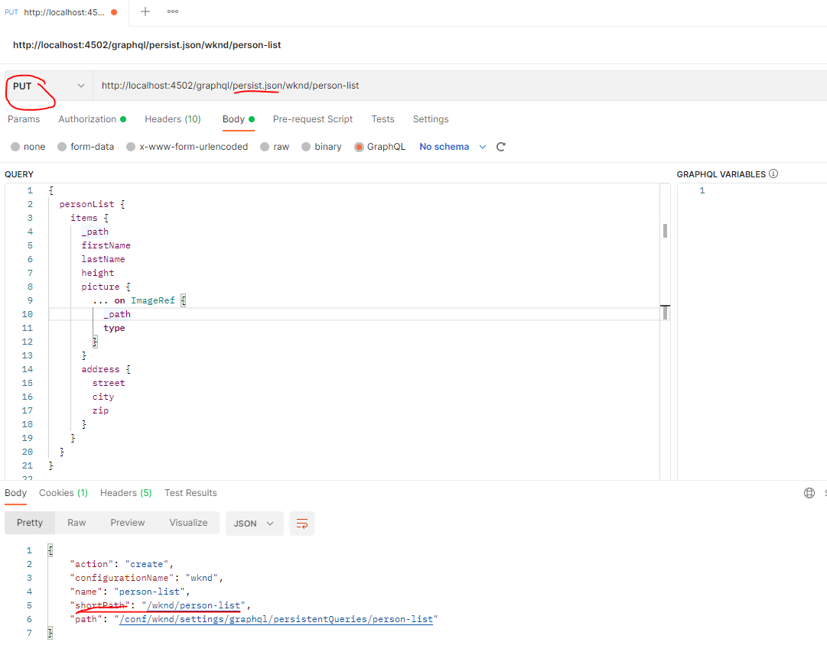

|  |  |
| --- | --- |
|  | * person-list is the *short path* used in the PUT request while creating the persisted query. * After the persisted query is saved in AEM(server side), We can do a get request to fetch the data – without sending anything in the request body. |

## EXECUTING THE PERSISTED QUERIES (GET REQUEST)

* As its Get request – we can be able to cache the response on dispatcher level.
* Note – We don’t have to send the anything in the request body.

|  |  |
| --- | --- |
| ENDPOINT- GET REQUEST | EXAMPLE |
| http://localhost:4502/graphql/execute.json/<Site Name>/<Query Name> | <http://localhost:4502/graphql/execute.json/wknd/person-list> |

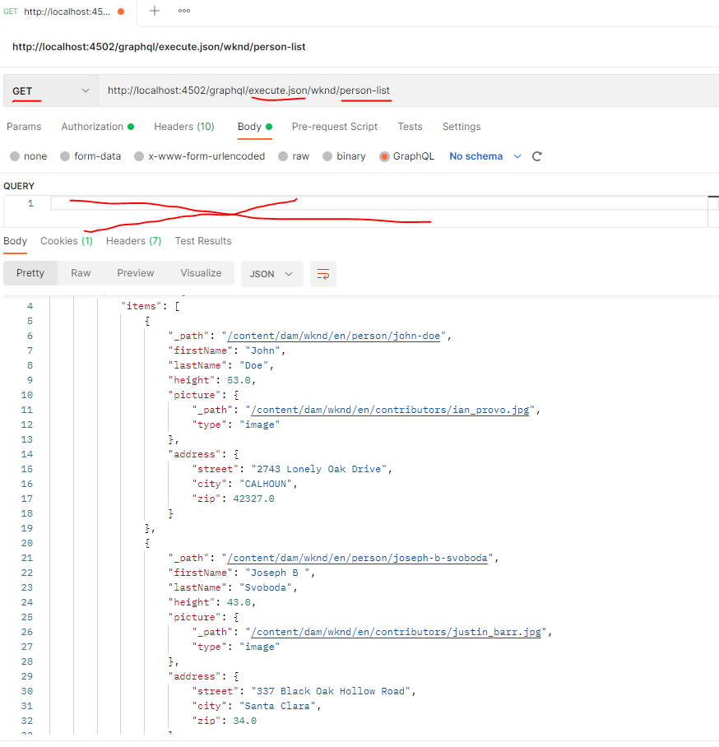

## UPDATING THE PERSISTED QUERIES

* If we want to update the persisted query, we can be able to update it using POST request.

|  |  |
| --- | --- |
| ENDPOINT- POST REQUEST | EXAMPLE |
| http://localhost:4502/graphql/persist.json/<Site Name>/<Query Name> | <http://localhost:4502/graphql/persist.json/wknd/person-list> |

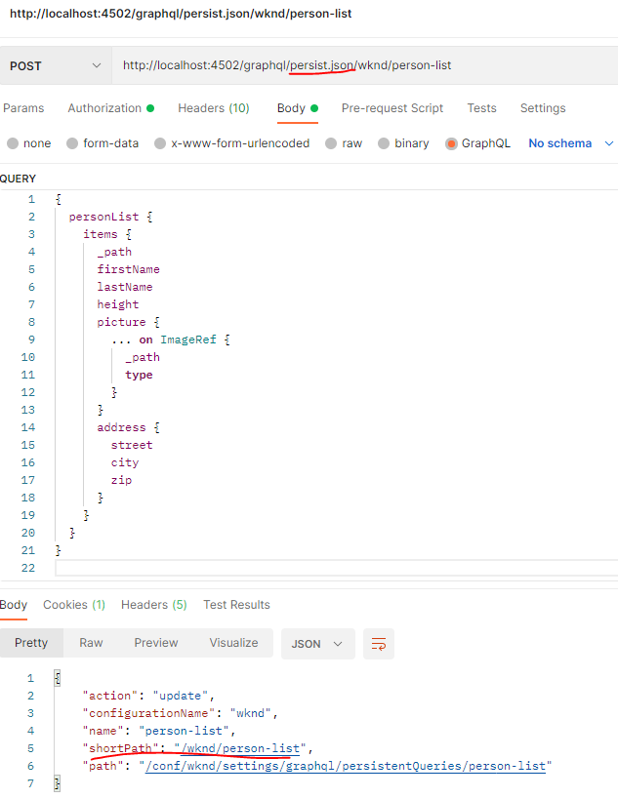

## DELETING THE PERSISTED QUERIES

* To delete the persisted query – we need to trigger a ***DELETE*** request to the same endpoint.

|  |  |
| --- | --- |
| ENDPOINT- DELETE REQUEST | EXAMPLE |
| http://localhost:4502/graphql/persist.json/<Site Name>/<Query Name> | <http://localhost:4502/graphql/persist.json/wknd/person-list> |

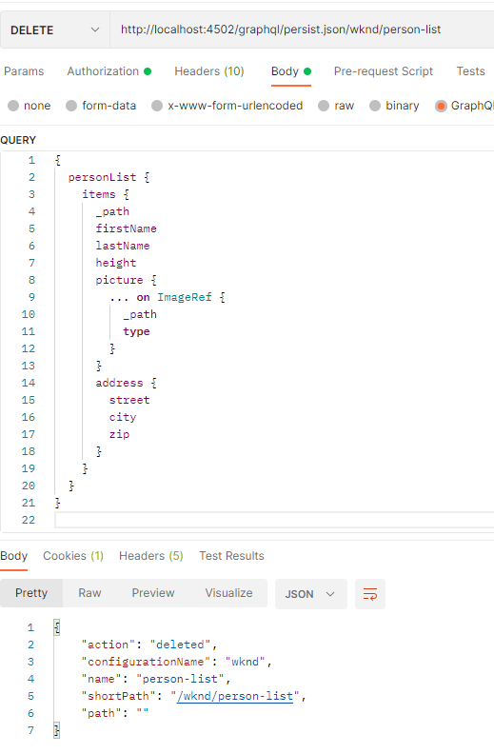

# EXECUTING THE PERSISTED QUERY USING CURL

