**AZ-900 sample questions**

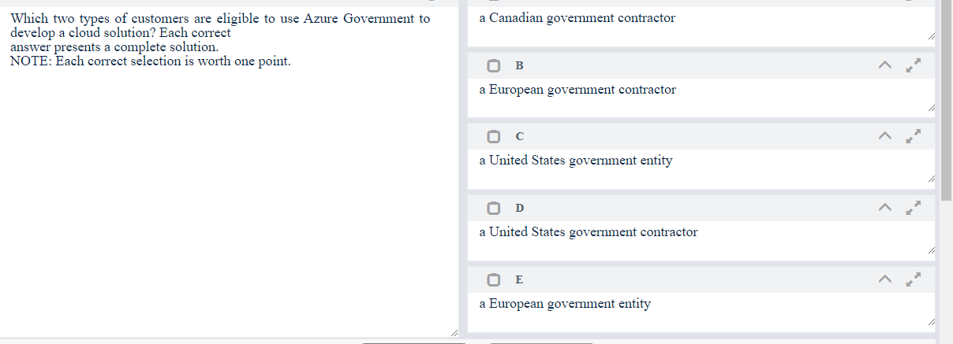

Solution – C,D

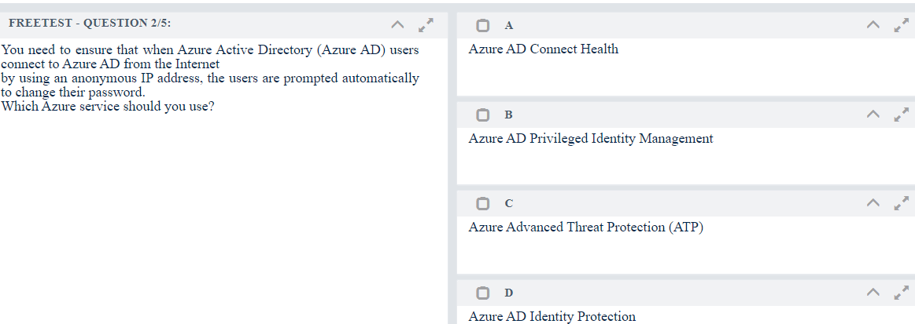

Solution - D

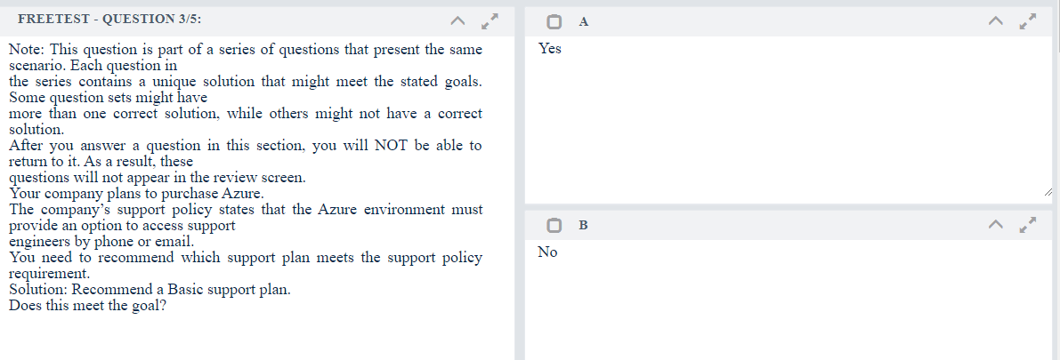

Solution - B

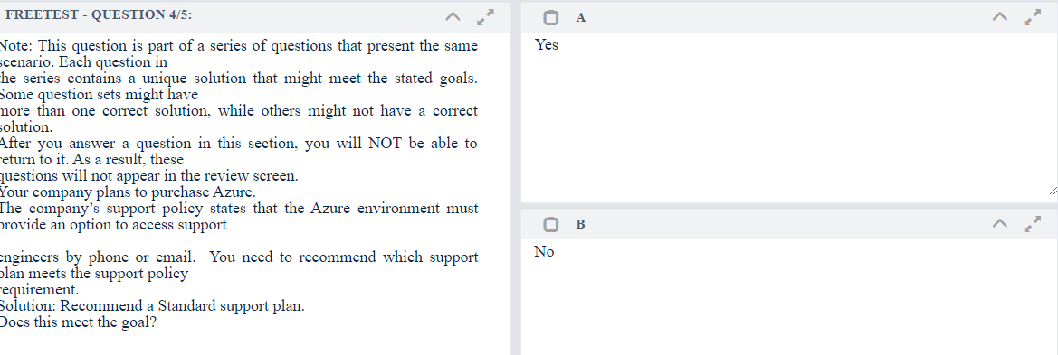

Solution - A

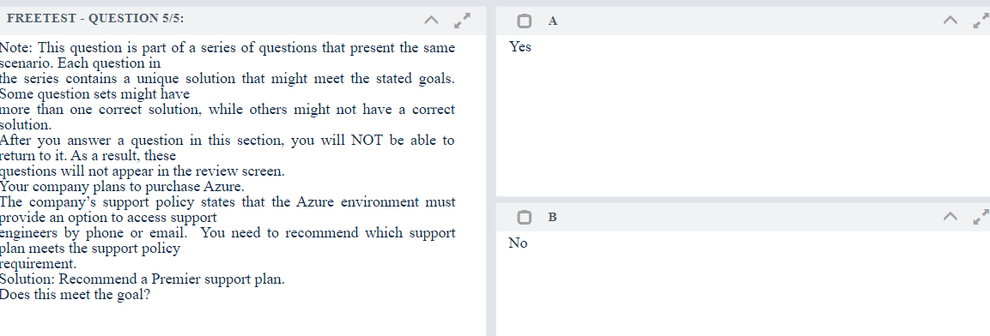

Solution - A

## Question

This question requires that you evaluate the underlined text to determine if it is correct.

When you are implementing a software as a service (SaaS) solution, you are responsible for configuring high

availability.

Instructions: Review the underlined text. If it makes the statement correct, select "No change is needed”. If the

statement is incorrect, select the answer choice that makes the statement correct.

**Options:**

1. No change is needed.
2. defining scalability rules
3. installing the SaaS solution
4. configuring the SaaS solution

**Answer: D**

Question 4

You have an on-premises network that contains several servers. You plan to migrate all the servers to Azure.

You need to recommend a solution to ensure that some of the servers are available if a single Azure data center goes offline for an extended period.

What should you include in the recommendation?

**Options:**

1. fault tolerance
2. elasticity
3. scalability
4. low latency

**Answer: A**

Question 5

This question requires that you evaluate the underlined text to determine if it is correct.

An organization that hosts its infrastructure in a private cloud can decommission its data center. Instructions: Review the underlined text. If it makes the statement correct, select "No change is needed”. If the

statement is incorrect, select the answer choice that makes the statement correct.

**Options:**

1. No change is needed.
2. in a hybrid cloud
3. in the public cloud
4. on a Hyper-V host

**Answer: C**

Question 6

What are two characteristics of the public cloud? Each correct answer presents a complete solution. NOTE: Each correct selection is worth one point.

**Options:**

1. dedicated hardware
2. unsecured connections
3. limited storage
4. metered pricing
5. self-service management

**Answer: D, E**

Question 7

This question requires that you evaluate the underlined text to determine if it is correct.

When planning to migrate a public website to Azure, you must plan to pay monthly usage costs. Instructions: Review the underlined text. If it makes the statement correct, select "No change is needed”. If the

statement is incorrect, select the answer choice that makes the statement correct.

**Options:**

1. No change is needed
2. Deploy a VPN
3. pay to transfer all the website data to Azure
4. reduce the number of connections to the website

**Answer: A**

Question 8

Note: This question is part of a series of questions that present the same scenario. Each question in the series contains a unique solution that might meet the stated goals. Some question sets might have more than one correct solution, while others might not have a correct solution.

After you answer a question in this section, you will NOT be able to return to it. As a result, these questions will not appear in the review screen.

An Azure administrator plans to run a PowerShell script that creates Azure resources. You need to recommend which computer configuration to use to run the script.

Solution: Run the script from a computer that runs Linux and has the Azure CLI tools installed. Does this meet the goal?

1. Yes
2. No

**Answer: B**

Question 9

Note: This question is part of a series of questions that present the same scenario. Each question in the series contains a unique solution that might meet the stated goals. Some question sets might have more than one correct solution, while others might not have a correct solution.

After you answer a question in this section, you will NOT be able to return to it. As a result, these questions will not appear in the review screen.

An Azure administrator plans to run a PowerShell script that creates Azure resources. You need to recommend which computer configuration to use to run the script.

Solution: Run the script from a computer that runs Chrome OS and uses Azure Cloud Shell. Does this meet the goal?

**Options:**

1. Yes
2. No

**Answer: B**

Question 10

Note: This question is part of a series of questions that present the same scenario. Each question in the series contains a unique solution that might meet the stated goals. Some question sets might have more than one correct solution, while others might not have a correct solution.

After you answer a question in this section, you will NOT be able to return to it. As a result, these questions will not appear in the review screen.

An Azure administrator plans to run a PowerShell script that creates Azure resources. You need to recommend which computer configuration to use to run the script.

Solution: Run the script from a computer that runs macOS and has PowerShell Core 6.0 installed. Does this meet the goal?

**Options:**

1. Yes
2. No

**Answer: A**

## Question 1

HOTSPOT

For each of the following statements, select Yes if the statement is true. Otherwise, select No. NOTE: Each correct selection is worth one point.

Hot Area:

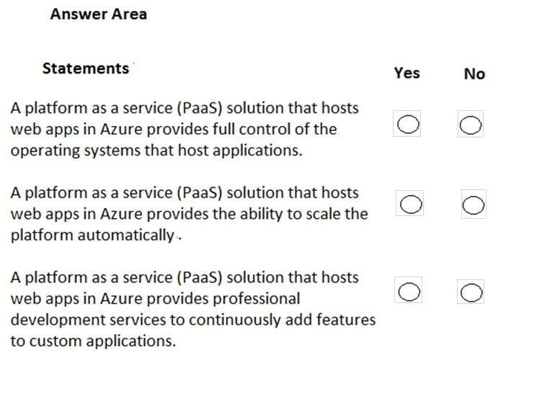

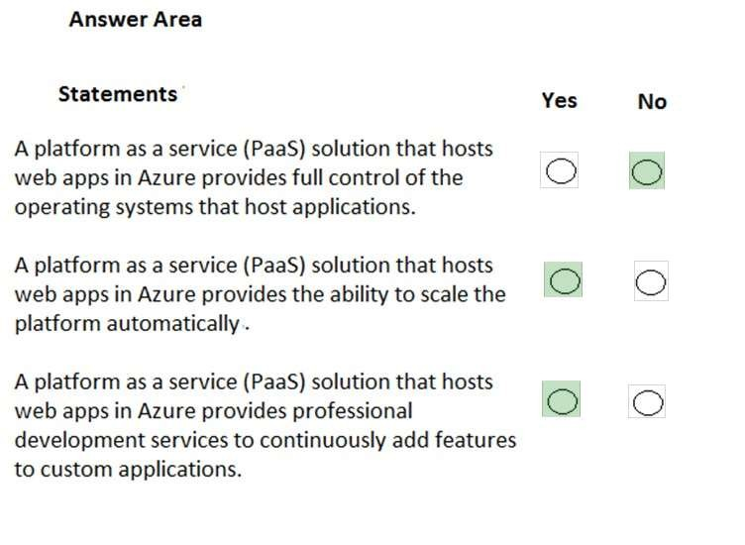

## Question 2

HOTSPOT

For each of the following statements, select Yes if the statement is true. Otherwise, select No. NOTE: Each correct selection is worth one point.

Hot Area:

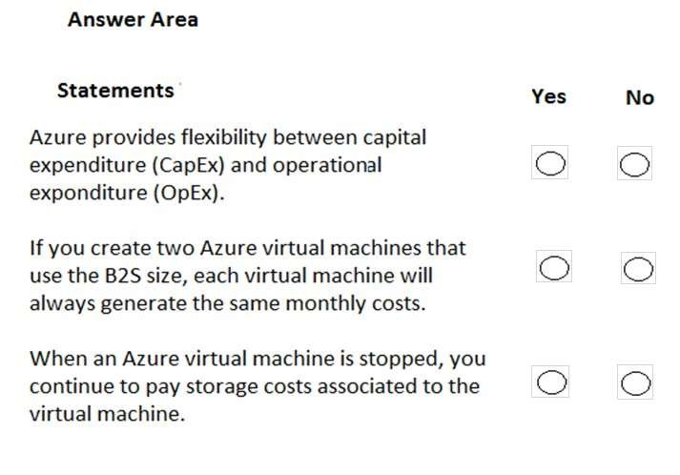

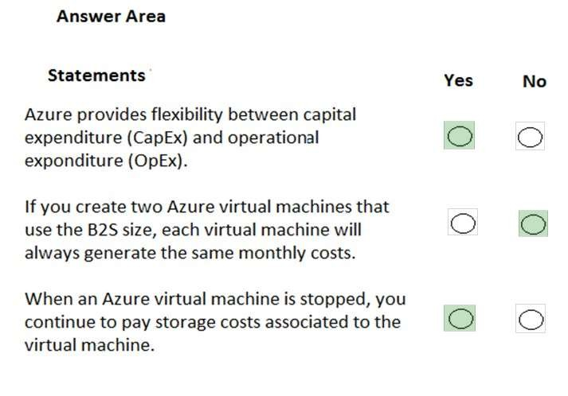

Exam A

QUESTION 1

This question requires that you evaluate the underlined text to determine if it is correct.

When planning to migrate a public website to Azure, you must plan to pay monthly usage costs.

Instructions: Review the underlined text. If it makes the statement correct, select “No change is needed”. If the statement is incorrect, select the answer choice that makes the statement correct.

* 1. No change is needed
  2. Deploy a VPN
  3. pay to transfer all the website data to Azure
  4. reduce the number of connections to the website

Correct Answer: A

Section: Understand Cloud Concepts Explanation

Explanation/Reference:

QUESTION 2

Note: This question is part of a series of questions that present the same scenario. Each question in the series contains a unique solution that might meet the stated goals. Some question sets might have more than one correct solution, while others might not have a correct solution.

After you answer a question in this section, you will NOT be able to return to it. As a result, these questions will not appear in the review screen.

Your company plans to migrate all its data and resources to Azure.

The company’s migration plan states that only platform as a service (PaaS) solutions must be used in Azure. You need to deploy an Azure environment that supports the planned migration.

Solution: You create an Azure App Service and Azure SQL databases.

Does this meet the goal?

1. Yes
2. No

Correct Answer: A

Section: Understand Cloud Concepts Explanation

Explanation/Reference:

QUESTION 3

Note: This question is part of a series of questions that present the same scenario. Each question in the series contains a unique solution that might meet the stated goals. Some question sets might have more than one correct solution, while others might not have a correct solution.

After you answer a question in this section, you will NOT be able to return to it. As a result, these questions will not appear in the review screen.

Your company plans to migrate all its data and resources to Azure.

The company’s migration plan states that only platform as a service (PaaS) solutions must be used in Azure. You need to deploy an Azure environment that supports the planned migration.

Solution: You create an Azure App Service and Azure virtual machines that have Microsoft SQL Server installed. Does this meet the goal?

1. Yes
2. No

Correct Answer: B

Section: Understand Cloud Concepts Explanation

Explanation/Reference:

QUESTION 4

Your company hosts an accounting named App1 that is used by all the customers of the company.

App1 has low usage during the first three weeks of each month and very high usage during the last week of each month. Which benefit of Azure Cloud Services supports cost management for this type of usage pattern?

1. high availability
2. high latency
3. elasticity
4. load balancing

Correct Answer: C

Section: Understand Cloud Concepts Explanation

Explanation/Reference:

QUESTION 5

You plan to migrate a web application to Azure. The web application is accessed by external users.

You need to recommend a cloud deployment solution to minimize the amount of administrative effort used to manage the web application. What should you include in the recommendation?

1. software as a service (SaaS)
2. platform as a service (PaaS)
3. infrastructure as a service (IaaS)
4. database as a service (DaaS)

Correct Answer: B

Section: Understand Cloud Concepts Explanation

Explanation/Reference:

QUESTION 6

You have an on-premises network that contains 100 servers.

You need to recommend a solution that provides additional resources to your users. The solution must minimize capital and operational expenditure costs. What should you include in the recommendation?

1. a complete migration to the public cloud
2. an additional data center
3. a private cloud
4. a hybrid cloud

Correct Answer: C

Section: Understand Cloud Concepts Explanation

Explanation/Reference:

QUESTION 7

Note: This question is part of a series of questions that present the same scenario. Each question in the series contains a unique solution that might meet the stated goals. Some question sets might have more than one correct solution, while others might not have a correct solution.

After you answer a question in this section, you will NOT be able to return to it. As a result, these questions will not appear in the review screen.

An Azure administrator plans to run a PowerShell script that creates Azure resources. You need to recommend which computer configuration to use to run the script.

Solution: Run the script from a computer that runs Linux and has the Azure CLI tools installed. Does this meet the goal?

1. Yes
2. No

Correct Answer: B

Section: Understand Core Azure Services

Explanation Explanation/Reference:

QUESTION 8

Note: This question is part of a series of questions that present the same scenario. Each question in the series contains a unique solution that might meet the stated goals. Some question sets might have more than one correct solution, while others might not have a correct solution.

After you answer a question in this section, you will NOT be able to return to it. As a result, these questions will not appear in the review screen.

An Azure administrator plans to run a PowerShell script that creates Azure resources. You need to recommend which computer configuration to use to run the script.

Solution: Run the script from a computer that runs Chrome OS and uses Azure Cloud Shell. Does this meet the goal?

1. Yes
2. No

Correct Answer: B

Section: Understand Core Azure Services Explanation

Explanation/Reference:

QUESTION 9

Note: This question is part of a series of questions that present the same scenario. Each question in the series contains a unique solution that might meet the stated goals. Some question sets might have more than one correct solution, while others might not have a correct solution.

After you answer a question in this section, you will NOT be able to return to it. As a result, these questions will not appear in the review screen.

An Azure administrator plans to run a PowerShell script that creates Azure resources. You need to recommend which computer configuration to use to run the script.

Solution: Run the script from a computer that runs macOS and has PowerShell Core 6.0 installed.

Does this meet the goal?

1. Yes
2. No

Correct Answer: A

Section: Understand Core Azure Services Explanation

Explanation/Reference:

QUESTION 10

You have an Azure environment that contains 10 virtual networks and 100 virtual machines. You need to limit the amount of inbound traffic to all the Azure virtual networks.

What should you create?

1. one network security group (NSG)
2. 10 virtual network gateways
3. 10 Azure ExpressRoute circuits
4. one Azure firewall

Correct Answer: D

Section: Understand Core Azure Services Explanation

Explanation/Reference:

QUESTION 11

DRAG DROP

Match the Azure service to the correct definition.

Instructions: To answer, drag the appropriate Azure service from the column on the left to its description on the right. Each service may be used once, more than once, or not at all.

NOTE: Each correct match is worth one point.

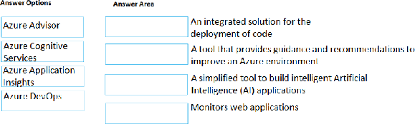Select and Place:

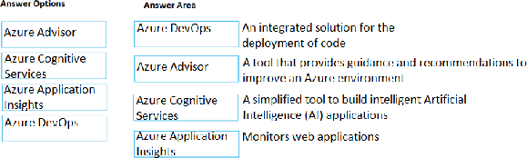Correct Answer:

Section: Understand Core Azure Services Explanation

Explanation/Reference:

QUESTION 12

You plan to map a network drive from several computers that run Windows 10 to Azure Storage. You need to create a storage solution in Azure for the planned mapped drive.

What should you create?

1. an Azure SQL database
2. a virtual machine data disk
3. a Files service in a storage account
4. a Blobs service in a storage account

Correct Answer: C

Section: Understand Core Azure Services Explanation

Explanation/Reference:

QUESTION 13

Your company plans to deploy an Artificial Intelligence (AI) solution in Azure.

What should the company use to build, test, and deploy predictive analytics solutions?

1. Azure Logic Apps
2. Azure Machine Learning Studio
3. Azure Batch
4. Azure Cosmos DB

Correct Answer: B

Section: Understand Core Azure Services Explanation

Explanation/Reference:

QUESTION 14

This question requires that you evaluate the underlined text to determine if it is correct.

Azure policies provide a common platform for deploying objects to a cloud infrastructure and for implementing consistency across the Azure environment.

Instructions: Review the underlined text. If it makes the statement correct, select “No change is needed”. If the statement is incorrect, select the answer choice that makes the statement correct.

1. No change is needed
2. Resource groups provide
3. Azure Resource Manager provides
4. Management groups provide

Correct Answer: C

Section: Understand Core Azure Services Explanation

Explanation/Reference:

QUESTION 15

Your company has several business units.

Each business unit requires 20 different Azure resources for daily operation. All the business units require the same type of Azure resources. You need to recommend a solution to automate the creation of the Azure resources.

What should you include in the recommendations?

1. Azure Resource Manager templates
2. virtual machine scale sets
3. the Azure API Management service
4. management groups

Correct Answer: A

Section: Understand Core Azure Services Explanation

Explanation/Reference:

QUESTION 16

HOTSPOT

You plan to deploy a critical line-of-business application to Azure. The application will run on an Azure virtual machine.

You need to recommend a deployment solution for the application. The solution must provide a guaranteed availability of 99.99 percent.

What is the minimum number of virtual machines and the minimum number of availability zones you should recommend for the deployment? To answer, select the appropriate options in the answer area.

NOTE: Each correct selection is worth one point.

Hot Area:

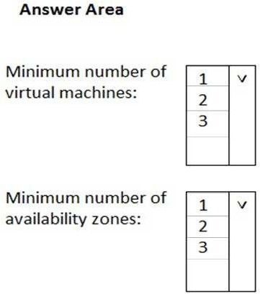

Correct Answer:

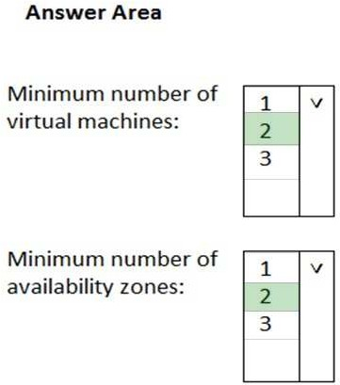

Section: Understand Core Azure Services Explanation

Explanation/Reference:

References:

https://docs.microsoft.com/en-us/azure/availability-zones/az-overview

QUESTION 17

Which Azure service should you use to correlate events from multiple resources into a centralized repository?

1. Azure Event Hubs
2. Azure Analysis Services
3. Azure Monitor
4. Azure Log Analytics

Correct Answer: D

Section: Understand Core Azure Services Explanation

Explanation/Reference:

QUESTION 18

Note: This question is part of a series of questions that present the same scenario. Each question in the series contains a unique solution that might meet the stated goals. Some question sets might have more than one correct solution, while others might not have a correct solution.

After you answer a question in this section, you will NOT be able to return to it. As a result, these questions will not appear in the review screen.

You have an Azure environment. You need to create a new Azure virtual machine from an Android laptop. Solution: You use PowerShell in Azure Cloud Shell.

Does this meet the goal?

1. Yes
2. No

Correct Answer: A

Section: Understand Core Azure Services Explanation

Explanation/Reference: QUESTION 19

Note: This question is part of a series of questions that present the same scenario. Each question in the series contains a unique solution that might meet the stated goals. Some question sets might have more than one correct solution, while others might not have a correct solution.

After you answer a question in this section, you will NOT be able to return to it. As a result, these questions will not appear in the review screen.

You have an Azure environment. You need to create a new Azure virtual machine from an Android laptop. Solution: You use the PowerApps portal.

Does this meet the goal?

1. Yes
2. No

Correct Answer: B

Section: Understand Core Azure Services Explanation

Explanation/Reference:

QUESTION 20

This question requires that you evaluate the underlined text to determine if it is correct.

An Azure region contains one or more data centers that are connected by using a low-latency network.

Instructions: Review the underlined text. If it makes the statement correct, select “No change is needed”. If the statement is incorrect, select the answer choice that makes the statement correct.

1. No change is needed
2. Is found in each country where Microsoft has a subsidiary office
3. Can be found in every country in Europe and the Americas only
4. Contains one or more data centers that are connect by using a high-latency network

Correct Answer: A

Section: Understand Core Azure Services Explanation

Explanation/Reference:

QUESTION 21

This question requires that you evaluate the underlined text to determine if it is correct.

You plan to deploy 20 virtual machines to an Azure environment. To ensure that a virtual machine named VM1 cannot connect to the other virtual machines, VM1 must be deployed to a separate virtual network.

Instructions: Review the underlined text. If it makes the statement correct, select “No change is needed”. If the statement is incorrect, select the answer choice that makes the statement correct.

1. No change is needed
2. run a different operating system than the other virtual machines
3. be deployed to a separate resource group
4. have two network interfaces

Correct Answer: A

Section: Understand Core Azure Services Explanation

Explanation/Reference:

QUESTION 22

This question requires that you evaluate the underlined text to determine if it is correct.

When you need to delegate permissions to several Azure virtual machines simultaneously, you must deploy the Azure virtual machines to the same Azure region.

Instructions: Review the underlined text. If it makes the statement correct, select “No change is needed”. If the statement is incorrect, select the answer choice that makes the statement correct.

1. No change is needed
2. by using the same Azure Resource Manager template
3. to the same resource group
4. to the same availability zone

Correct Answer: C

Section: Understand Core Azure Services Explanation

Explanation/Reference:

QUESTION 23

This question requires that you evaluate the underlined text to determine if it is correct.

One of the benefits of Azure SQL Data Warehouse is that high availability is built into the platform.

Instructions: Review the underlined text. If it makes the statement correct, select “No change is needed”. If the statement is incorrect, select the answer choice that makes the statement correct.

1. No change is needed
2. automatic scaling
3. data compression
4. versioning

Correct Answer: A

Section: Understand Core Azure Services Explanation

Explanation/Reference:

QUESTION 24

A support engineer plans to perform several Azure management tasks by using the Azure CLI. You install the CLI on a computer.

You need to tell the support engineer which tools to use to run the CLI.

Which two tools should you instruct the support engineer to use? Each correct answer presents a complete solution.

NOTE: Each correct selection is worth one point.

1. Command Prompt
2. Azure Resource Explorer
3. Windows PowerShell
4. Windows Defender Firewall
5. Network and Sharing Center

Correct Answer: AC

QUESTION 25

You plan to store 20 TB of data in Azure. The data will be accessed infrequently and visualized by using Microsoft Power BI. You need to recommend a storage solution for the data.

Which two solutions should you recommend? Each correct answer presents a complete solution.

NOTE: Each correct selection is worth one point.

1. Azure Data Lake
2. Azure Cosmos DB
3. Azure SQL Data Warehouse
4. Azure SQL Database
5. Azure Database for PostgreSQL

Correct Answer: AC

Section: Understand Core Azure Services Explanation

Explanation/Reference:

QUESTION 26

You need to identify the type of failure for which an Azure availability zone can be used to protect access to Azure services. What should you identify?

1. a physical server failure
2. an Azure region failure
3. a storage failure
4. an Azure data center failure

Correct Answer: D

QUESTION 27

Note: This question is part of a series of questions that present the same scenario. Each question in the series contains a unique solution that might meet the stated goals. Some question sets might have more than one correct solution, while others might not have a correct solution.

After you answer a question in this section, you will NOT be able to return to it. As a result, these questions will not appear in the review screen.

Your Azure environment contains multiple Azure virtual machines.

You need to ensure that a virtual machine named VM1 is accessible from the Internet over HTTP. Solution: You modify a DDoS protection plan.

Does this meet the goal?

1. Yes
2. No

Correct Answer: B

Section: Understand Security, Privacy, Compliance and Trust Explanation

Explanation/Reference:

QUESTION 28

Note: This question is part of a series of questions that present the same scenario. Each question in the series contains a unique solution that might meet the stated goals. Some question sets might have more than one correct solution, while others might not have a correct solution.

After you answer a question in this section, you will NOT be able to return to it. As a result, these questions will not appear in the review screen.

Your Azure environment contains multiple Azure virtual machines.

You need to ensure that a virtual machine named VM1 is accessible from the Internet over HTTP. Solution: You modify an Azure Traffic Manager profile.

Does this meet the goal?

1. Yes
2. No

Correct Answer: B

Section: Understand Security, Privacy, Compliance and Trust Explanation

Explanation/Reference:

QUESTION 29

Which two types of customers are eligible to use Azure Government to develop a cloud solution? Each correct answer presents a complete solution.

NOTE: Each correct selection is worth one point.

1. a Canadian government contractor
2. a European government contractor
3. a United States government entity
4. a United States government contractor
5. a European government entity

Correct Answer: CD

Section: Understand Security, Privacy, Compliance and Trust Explanation

Explanation/Reference:

References:

https://docs.microsoft.com/en-us/learn/modules/intro-to-azure-government/2-what-is-azure-government

QUESTION 30

Your company plans to deploy several web servers and several database servers to Azure.

You need to recommend an Azure solution to limit the types of connections from the web servers to the database servers. What should you include in the recommendation?

1. network security groups (NSGs)
2. Azure Service Bus
3. a local network gateway
4. a route filter

Correct Answer: A

Section: Understand Security, Privacy, Compliance and Trust Explanation

Explanation/Reference:

QUESTION 31

To what should an application connect to retrieve security tokens?

1. an Azure Storage account
2. Azure Active Directory (Azure AD)
3. a certificate store
4. an Azure key vault

Correct Answer: B

Section: Understand Security, Privacy, Compliance and Trust Explanation

Explanation/Reference:

QUESTION 32

This question requires that you evaluate the underlined text to determine if it is correct.

Resource groups provide organizations with the ability to manage the compliance of Azure resources across multiple subscriptions.

Instructions: Review the underlined text. If it makes the statement correct, select “No change is needed”. If the statement is incorrect, select the answer choice that makes the statement correct.

1. No change is needed
2. Management groups
3. Azure policies
4. Azure App Service plans

Correct Answer: C

Section: Understand Security, Privacy, Compliance and Trust Explanation

Explanation/Reference:

QUESTION 33

Your company has an Azure environment that contains resources in several regions.

A company policy states that administrators must only be allowed to create additional Azure resources in a region in the country where their office is located. You need to create the Azure resource that must be used to meet the policy requirement.

What should you create?

1. a read-only lock
2. an Azure policy
3. a management group
4. a reservation

Correct Answer: B

Section: Understand Security, Privacy, Compliance and Trust Explanation

Explanation/Reference:

QUESTION 34

This question requires that you evaluate the underlined text to determine if it is correct.

Authorization is the process of verifying a user’s credentials.

Instructions: Review the underlined text. If it makes the statement correct, select “No change is needed”. If the statement is incorrect, select the answer choice that makes the statement correct.

1. No change is needed
2. Authentication
3. Federation
4. Ticketing

Correct Answer: B

Section: Understand Security, Privacy, Compliance and Trust Explanation

Explanation/Reference:

QUESTION 35

Your company plans to migrate all on-premises data to Azure. You need to identify whether Azure complies with the company’s regional requirements. What should you use?

1. the Knowledge Center
2. Azure Marketplace
3. the Azure portal
4. the Trust Center

Correct Answer: D

Section: Understand Security, Privacy, Compliance and Trust Explanation

Explanation/Reference:

QUESTION 36

Your company plans to automate the deployment of servers to Azure.

Your manager is concerned that you may expose administrative credentials during the deployment.

You need to recommend an Azure solution that encrypts the administrative credentials during the deployment. What should you include in the recommendation?

1. Azure Key Vault
2. Azure Information Protection
3. Azure Security Center
4. Azure Multi-Factor Authentication (MFA)

Correct Answer: A

Section: Understand Security, Privacy, Compliance and Trust Explanation

Explanation/Reference:

QUESTION 37

This question requires that you evaluate the underlined text to determine if it is correct.

Azure Germany can be used by legal residents of Germany only.

Instructions: Review the underlined text. If it makes the statement correct, select “No change is needed”. If the statement is incorrect, select the answer choice that makes the statement correct.

1. no change is needed
2. only enterprises that are registered in Germany
3. only enterprises that purchase their azure licenses from a partner based in Germany
4. any user or enterprise that requires its data to reside in Germany

Correct Answer: D

Section: Understand Security, Privacy, Compliance and Trust Explanation

Explanation/Reference:

References:

https://docs.microsoft.com/en-us/azure/germany/germany-welcome?toc=%2fazure%2fgermany%2ftoc.json

QUESTION 38

Note: This question is part of a series of questions that present the same scenario. Each question in the series contains a unique solution that might meet the stated goals. Some question sets might have more than one correct solution, while others might not have a correct solution.

After you answer a question in this section, you will NOT be able to return to it. As a result, these questions will not appear in the review screen.

Your company plans to purchase Azure.

The company’s support policy states that the Azure environment must provide an option to access support engineers by phone or email. You need to recommend which support plan meets the support policy requirement.

Solution: Recommend a Basic support plan.

Does this meet the goal?

1. Yes
2. No

Correct Answer: B

Section: Understand Azure Pricing and Support Explanation

Explanation/Reference:

References:

https://azure.microsoft.com/en-gb/support/plans/

QUESTION 39

Note: This question is part of a series of questions that present the same scenario. Each question in the series contains a unique solution that might meet the stated goals. Some question sets might have more than one correct solution, while others might not have a correct solution.

After you answer a question in this section, you will NOT be able to return to it. As a result, these questions will not appear in the review screen.

Your company plans to purchase Azure.

The company’s support policy states that the Azure environment must provide an option to access support engineers by phone or email. You need to recommend which support plan meets the support policy requirement.

Solution: Recommend a Premier support plan. Does this meet the goal?

1. Yes
2. No

Correct Answer: A

Section: Understand Azure Pricing and Support Explanation

Explanation/Reference:

References:

https://azure.microsoft.com/en-gb/support/plans/

QUESTION 40

What is required to use Azure Cost Management?

1. a Dev/Test subscription
2. Software Assurance
3. an Enterprise Agreement (EA)
4. a pay-as-you-go subscription

Correct Answer: C

Section: Understand Azure Pricing and Support Explanation

Explanation/Reference:

References:

https://docs.microsoft.com/en-gb/azure/cost-management/overview-cost-mgt

**QUESTION 1**

**This question requires that you evaluate the underlined text to determine if it is correct.**

**An organization that hosts its infrastructure in a private cloud can decommission its data center.**

**Instructions: Review the underlined text. If it makes the statement correct, select “No change is needed”. If the statement is incorrect, select the answer choice that makes the statement correct.**

* 1. **No change is needed.**
  2. **in a hybrid cloud**
  3. **in the public cloud**
  4. **on a Hyper-V host**

**Correct Answer: C**

**Section: Understand Cloud Concepts Explanation**

**Explanation/Reference:**

**QUESTION 2**

**This question requires that you evaluate the underlined text to determine if it is correct.**

**When planning to migrate a public website to Azure, you must plan to pay monthly usage costs.**

**Instructions: Review the underlined text. If it makes the statement correct, select “No change is needed”. If the statement is incorrect, select the answer choice that makes the statement correct.**

1. **No change is needed**
2. **Deploy a VPN**
3. **pay to transfer all the website data to Azure**
4. **reduce the number of connections to the website**

**Correct Answer: A**

**Section: Understand Cloud Concepts Explanation**

**Explanation/Reference:**

**QUESTION 3**

**Note: This question is part of a series of questions that pres**[**ent the same scenario. Each qu**](https://vceplus.com/)**estion in the series contains a unique solution that might meet the stated goals. Some question sets might have more** [**than one correct solution, while**](https://vceplus.com/) **others might not have a correct solution.**

**After you answer a question in this section, you will NOT be able to return to it. As a result, these questions will not appear in the review screen.**

**An Azure administrator plans to run a PowerShell script that creates Azure resources. You need to recommend which computer configuration to use to run the script.**

**Solution: Run the script from a computer that runs Linux and has the Azure CLI tools installed. Does this meet the goal?**

1. **Yes**
2. **No**

**Correct Answer: B**

**Section: Understand Core Azure Services Explanation**

**Explanation/Reference:**

**QUESTION 4**

**Note: This question is part of a series of questions that present the same scenario. Each question in the series contains a unique solution that might meet the stated goals. Some question sets might have more than one correct solution, while others might not have a correct solution.**

**After you answer a question in this section, you will NOT be able to return to it. As a result, these questions will not appear in the review screen.**

**An Azure administrator plans to run a PowerShell script that creates Azure resources. You need to recommend which computer configuration to use to run the script.**

**Solution: Run the script from a computer that runs Chrome OS and uses Azure Cloud Shell. Does this meet the goal?**

1. **Yes**
2. **No**

**Correct Answer: B**

**Section: Understand Core Azure Services Explanation**

**Explanation/Reference:**

**QUESTION 5**

**Note: This question is part of a series of questions that present the same scenario. Each question in the series contains a unique solution that might meet the stated goals. Some question sets might have more than one correct solution, while others might not have a correct solution.**

**After you answer a question in this section, you will NOT be able to return to it. As a result, these questions will not appear in the review screen.**

**An Azure administrator plans to run a PowerShell script that creates Azure resources. You need to recommend which computer configuration to use to run the script.**

**Solution: Run the script from a computer that runs macOS and has PowerShell Core 6.0 installed. Does this meet the goal?**

1. **Yes**
2. **No**

**Correct Answer: A**

**Section: Understand Core Azure Services Explanation**

**Explanation/Reference:**

**QUESTION 6**

**You have an Azure environment that contains 10 virtual networks and 100 virtual machines. You need to limit the amount of inbound traffic to all the Azure virtual networks.**

**What should you create?**

1. **one network security group (NSG)**
2. **10 virtual network gateways**
3. **10 Azure ExpressRoute circuits**
4. **one Azure firewall**

**Correct Answer: D**

**Section: Understand Core Azure Services Explanation**

**Explanation/Reference:**

**QUESTION 7**

**You plan to map a network drive from several computers that run Windows 10 to Azure Storage. You need to create a storage solution in Azure for the planned mapped drive.**

**What should you create?**

1. **an Azure SQL database**
2. **a virtual machine data disk**
3. **a Files service in a storage account**
4. **a Blobs service in a storage account**

**Correct Answer: C**

**Section: Understand Core Azure Services Explanation**

**Explanation/Reference:**

**QUESTION 8**

**Your company plans to deploy an Artificial Intelligence (AI) solution in Azure.**

**What should the company use to build, test, and deploy predictive analytics solutions?**

1. **Azure Logic Apps**
2. **Azure Machine Learning Studio**
3. **Azure Batch**
4. **Azure Cosmos DB**

**Correct Answer: B**

**Section: Understand Core Azure Services Explanation**

**Explanation/Reference:**

**QUESTION 9**

**This question requires that you evaluate the underlined text**

**Azure policies provide a common platform for deploying objects to a cloud infrastructure and for implementing consistency across the Azure environment.**

**Instructions: Review the underlined text. If it makes the statement correct, select “No change is needed”. If the statement is incorrect, select the answer choice that makes the statement correct.**

1. **No change is needed**
2. **Resource groups provide**
3. **Azure Resource Manager provides**
4. **Management groups provide**

**Correct Answer: C**

**Section: Understand Core Azure Services Explanation**

**Explanation/Reference:**

**QUESTION 10**

**Your company has several business units.**

**Each business unit requires 20 different Azure resources for daily operation. All the business units require the same type of Azure resources. You need to recommend a solution to automate the creation of the Azure resources.**

**What should you include in the recommendations?**

1. **Azure Resource Manager templates**
2. **virtual machine scale sets**
3. **the Azure API Management service**
4. **management groups**

**Correct Answer: A**

**Section: Understand Core Azure Services Explanation**

**Explanation/Reference:**

**QUESTION 11**

**Which Azure service should you use to correlate events from multiple resources into a centralized repository?**

1. **Azure Event Hubs**
2. **Azure Analysis Services**
3. **Azure Monitor**
4. **Azure Log Analytics**

**Correct Answer: D**

**Section: Understand Core Azure Services Explanation**

**Explanation/Reference:**

**QUESTION 12**

**Note: This question is part of a series of questions that present the same scenario. Each question in the series contains a unique solution that might meet the stated goals. Some question sets might have more than one correct solution, while others might not have a correct solution.**

**After you answer a question in this section, you will NOT be able to return to it. As a result, these questions will not appear in the review screen.**

**Your Azure environment contains multiple Azure virtual machines.**

**You need to ensure that a virtual machine named VM1 is accessible from the Internet over HTTP. Solution: You modify an Azure firewall.**

**Does this meet the goal?**

1. **Yes**
2. **No**

**Correct Answer: A**

**Section: Understand Security, Privacy, Compliance and Trust Explanation**

**Explanation/Reference:**

**QUESTION 13**

**Note: This question is part of a series of questions that present the same scenario. Each question in the series contains a unique solution that might meet the stated goals. Some question sets might have more than one correct solution, while others might not have a correct solution.**

**After you answer a question in this section, you will NOT be able to return to it. As a result, these questions will not appear in the review screen.**

**Your Azure environment contains multiple Azure virtual machines.**

**You need to ensure that a virtual machine named VM1 is accessible from the Internet over HTTP.**

**Solution: You modify an Azure Traffic Manager profile. Does this meet the goal?**

1. **Yes**
2. **No**

**Correct Answer: B**

**Section: Understand Security, Privacy, Compliance and Trust Explanation**

**Explanation/Reference:**

**QUESTION 14**

**You need to ensure that when Azure Active Directory (Azure AD) users connect to Azure AD from the Internet by using an anonymous IP address, the users are prompted automatically to change their password.**

**Which Azure service should you use?**

1. **Azure AD Connect Health**
2. **Azure AD Privileged Identity Management**
3. **Azure Advanced Threat Protection (ATP)**
4. **Azure AD Identity Protection**

**Correct Answer: D**

**Section: Understand Security, Privacy, Compliance and Trust Explanation**

**Explanation/Reference:**

**References:**

**https://docs.microsoft.com/en-us/azure/active-directory/identity-protection/howto-sign-in-risk-policy**

**QUESTION 15**

**Your company plans to deploy several web servers and several database servers to Azure.**

**You need to recommend an Azure solution to limit the types of connections from the web servers to the database servers. What should you include in the recommendation?**

1. **network security groups (NSGs)**
2. **Azure Service Bus**
3. **a local network gateway**
4. **a route filter**

**Correct Answer: A**

**Section: Understand Security, Privacy, Compliance and Trust Explanation**

**Explanation/Reference:**

**QUESTION 16**

**This question requires that you evaluate the underlined text to determine if it is correct.**

**Resource groups provide organizations with the ability to manage the compliance of Azure resources across multiple subscriptions.**

**Instructions: Review the underlined text. If it makes the statement correct, select “No change is needed”. If the statement is incorrect, select the answer choice that makes the statement correct.**

1. **No change is needed**
2. **Management groups**
3. **Azure policies**
4. **Azure App Service plans**

**Correct Answer: C**

**Section: Understand Security, Privacy, Compliance and Trust Explanation**

**Explanation/Reference:**

**QUESTION 17**

**Your network contains an Active Directory forest. The forest contains 5,000 user accounts.**

**Your company plans to migrate all network resources to Azure and to decommission the on-premises data center. You need to recommend a solution to minimize the impact on users after the planned migration.**

**What should you recommend?**

1. **Implement Azure Multi-Factor Authentication (MFA)**
2. **Sync all the Active Directory user accounts to Azure Active Directory (Azure AD)**
3. **Instruct all users to change their password**
4. **Create a guest user account in Azure Active Directory (Azure AD) for each user**

**Correct Answer: B**

**Section: Understand Security, Privacy, Compliance and Trust Explanation**

**Explanation/Reference:**

**QUESTION 18**

**Note: This question is part of a series of questions that present the same scenario. Each question in the series contains a unique solution that might meet the stated goals. Some question sets might have more than one correct solution, while others might not have a correct solution.**

**After you answer a question in this section, you will NOT be able to return to it. As a result, these questions will not appear in the review screen.**

**Your company plans to purchase Azure.**

**The company’s support policy states that the Azure environment** [**must provide an option to access**](https://vceplus.com/) **support engineers by phone or email. You need to recommend which support plan meets the support policy require**[**ment.**](https://vceplus.com/)

**Solution: Recommend a Standard support plan. Does this meet the goal?**

1. **Yes**
2. **No**

**Correct Answer: A**

**Section: Understand Azure Pricing and Support Explanation**

**Explanation/Reference:**

**References: https://azure.microsoft.com/en- gb/support/plans/**

**QUESTION 19**

**Your company plans to request an architectural review of an Azure environment from Microsoft.**

**The company currently has a Basic support plan.**

**You need to recommend a new support plan for the company. The solution must minimize costs. Which support plan should you recommend?**

1. **Premier**
2. **Developer**
3. **Professional Direct**
4. **Standard**

**Correct Answer: A**

**Section: Understand Azure Pricing and Support Explanation**

**Explanation/Reference:**

**References: https://azure.microsoft.com/en- gb/support/plans/**