Azure Assignment

(AZ – 104)

Avishekh Sinha

# Module 1 - Basics

## Assignment 1

1. Connect to azure cloud shell.

Ans: Step1: Opened the azure portal and clicked on the cloudshell button.

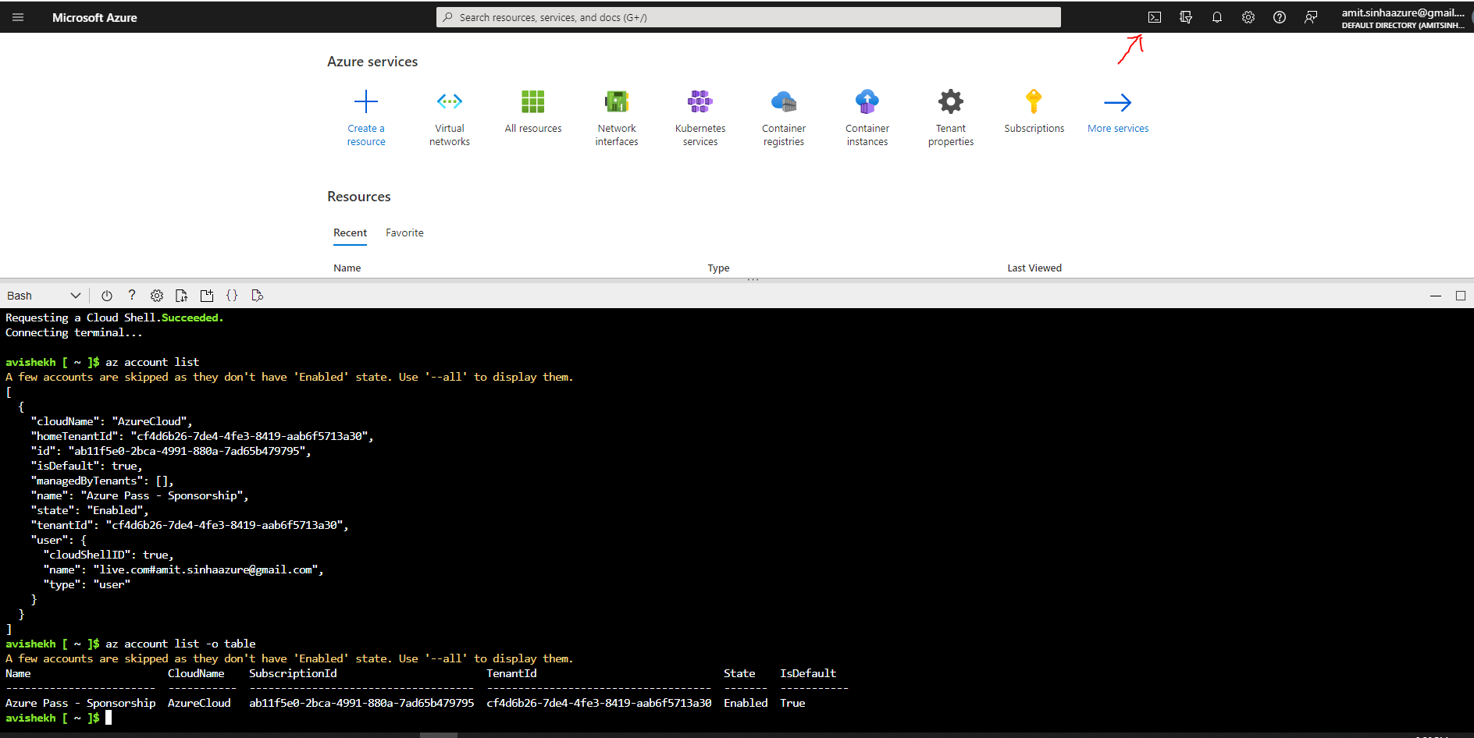

1. Create a resource group “new-rg” in South Central US region

Command: **az group create -l southcentralus -n new-rg**

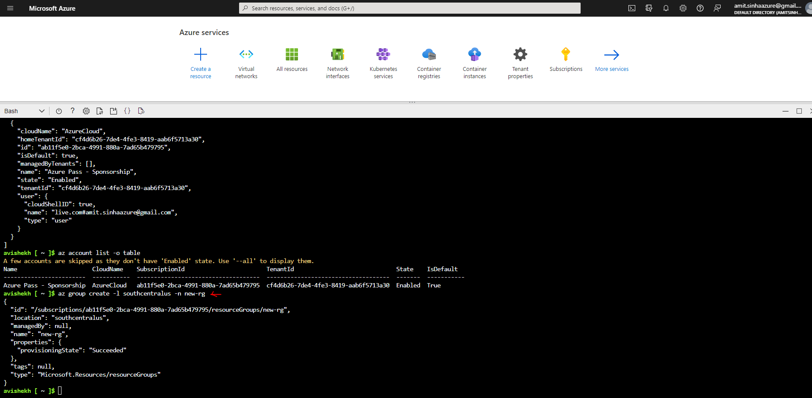

List the Resource Group

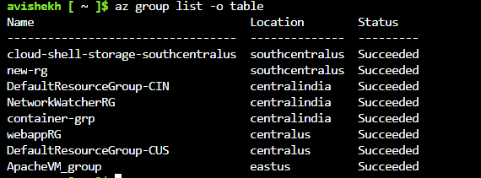

## Assignment 2

1. Connect Azure powershell to your azure account

2. Create a new resource group in South Central US with the name “rg-powershell”

Ans -

Command - **New-AzResourceGroup -Name rg-powershell -Location "South Central US"**

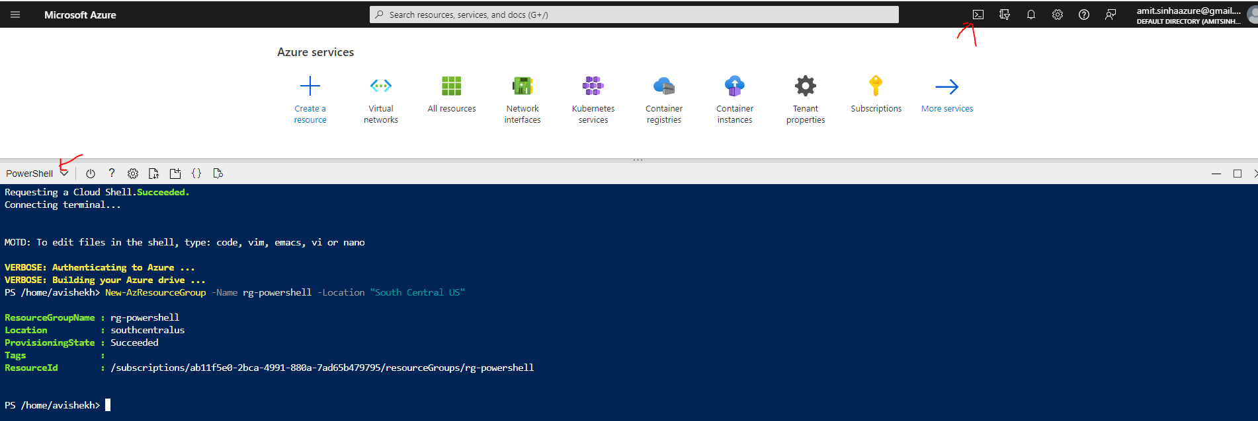

## Assignment 3

**USING POWERSHELL**

Create three more Resource groups in a specific region let’s say “West US”

Ans -

Command - **New-AzResourceGroup -n p-new-rg1 -l westus && New-AzResourceGroup -n p-new-rg2 -l westus && New-AzResourceGroup -n p-new-rg3 -l westus**

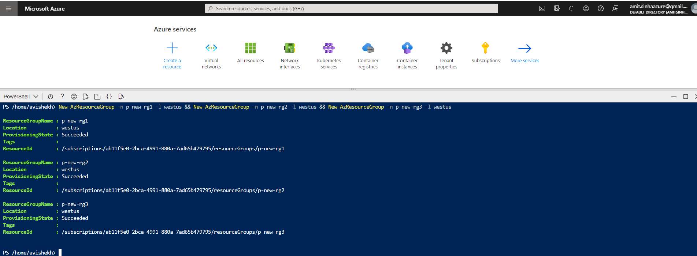

2. List all resource groups in West US

Command- **Get-AzResourceGroup -Location westus | FT**

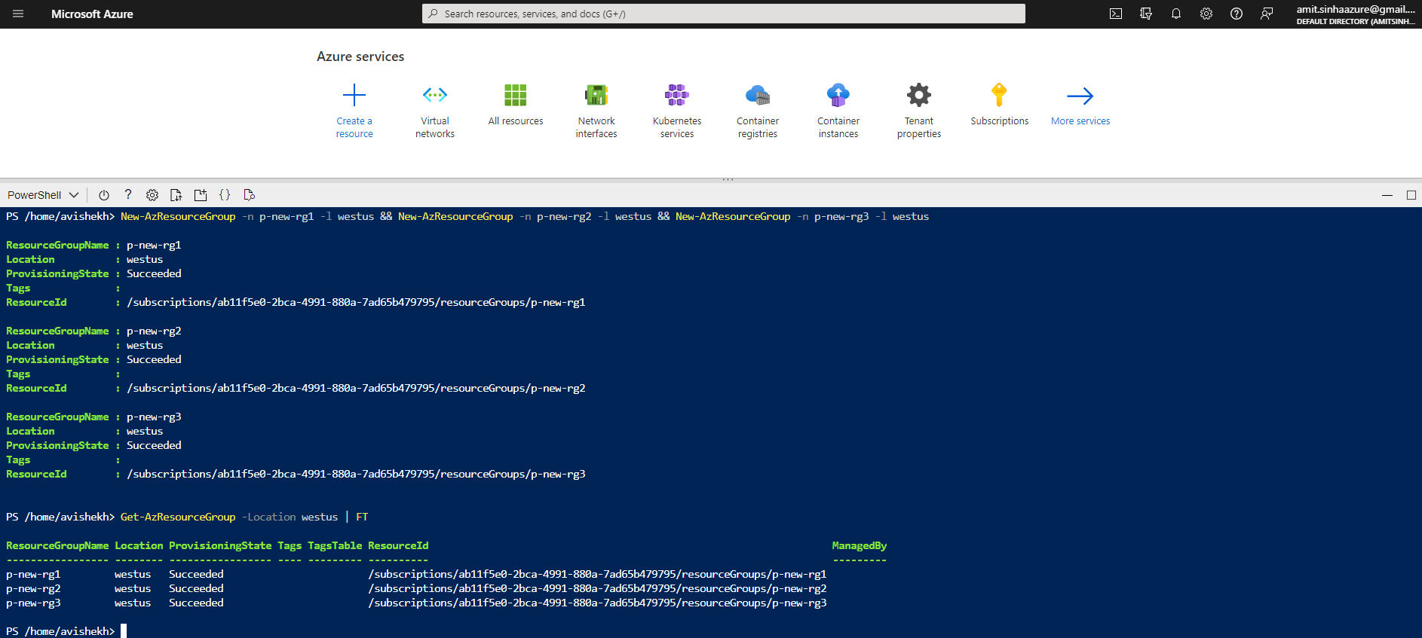

**USING AZURE CLI**

Create three more Resource groups in a specific region let’s say “West US”

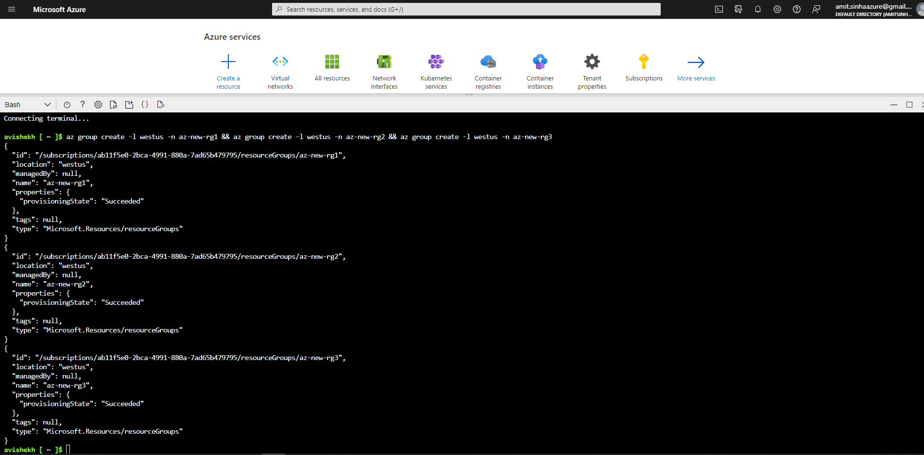

2. List all resource groups in West US

**Command - az group list --query "[?location=='westus']" -o table**

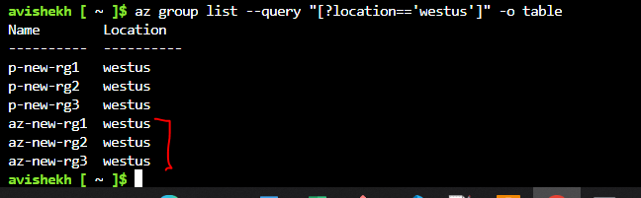

## Assignment 4

Delete all the resource groups in West US region using one command

Ans

**USING AZURE CLI**

Command - **az group list --query "[?location=='westus']".name -o tsv | xargs -otl az group delete -n**

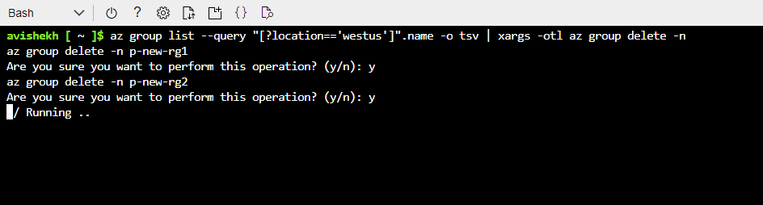

**USING POWERSHELL**

**Command - Get-AzResourceGroup -l 'westus'| Remove-AzResourceGroup**

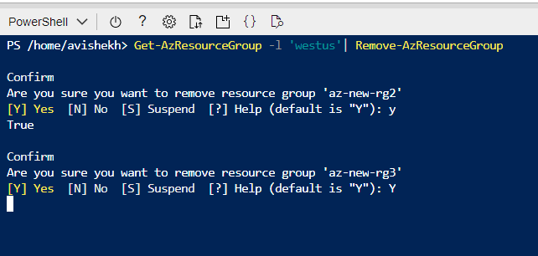

# Module 2

## Assignment 1

Create 2 resource groups rg-1 and rg-2

|  |  |
| --- | --- |
|  |  |

2.Add storage account to rg-1

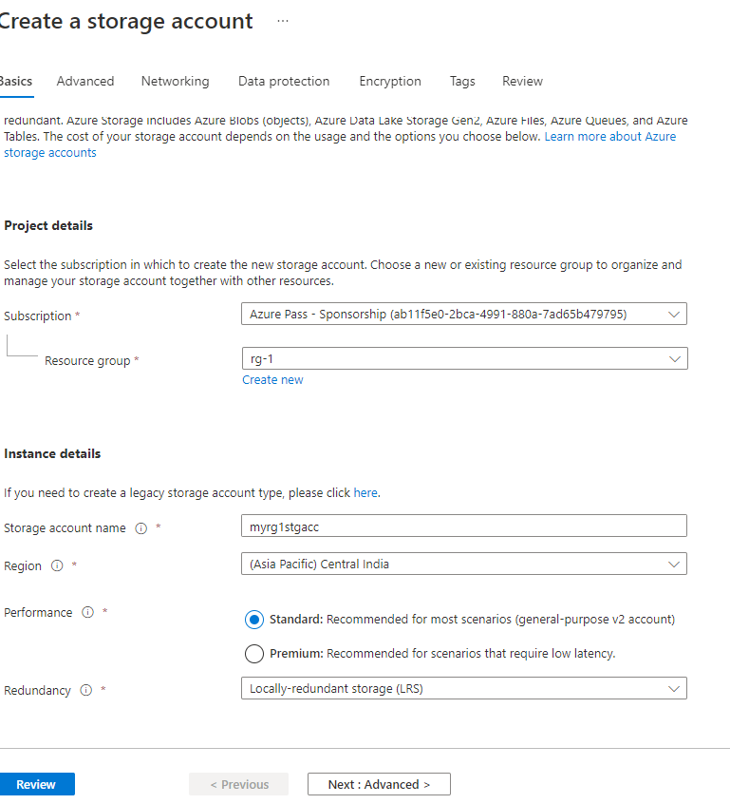

3. Move storage account from rg-1 to rg-2

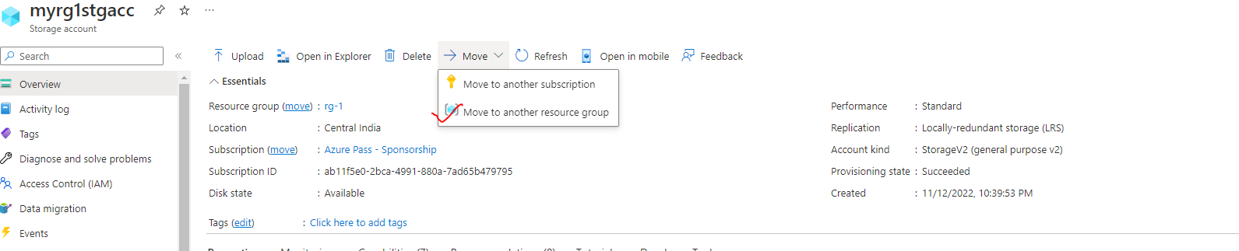

## Assignment 2

1. Create 3 storage accounts with “Team” tags: team1, team2 and team3 respectively

|  |  |
| --- | --- |
|  |  |
|  |  |

2. Create one more storage account for team2

3. List all resources for team2 using tags

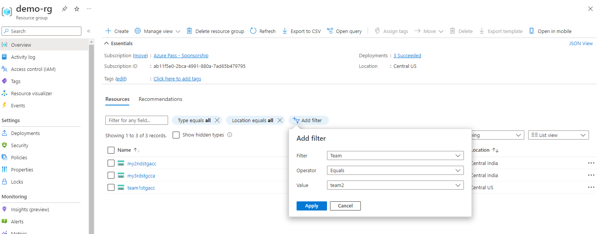

## Assignment 3

1. Create a File share in Azure Storage

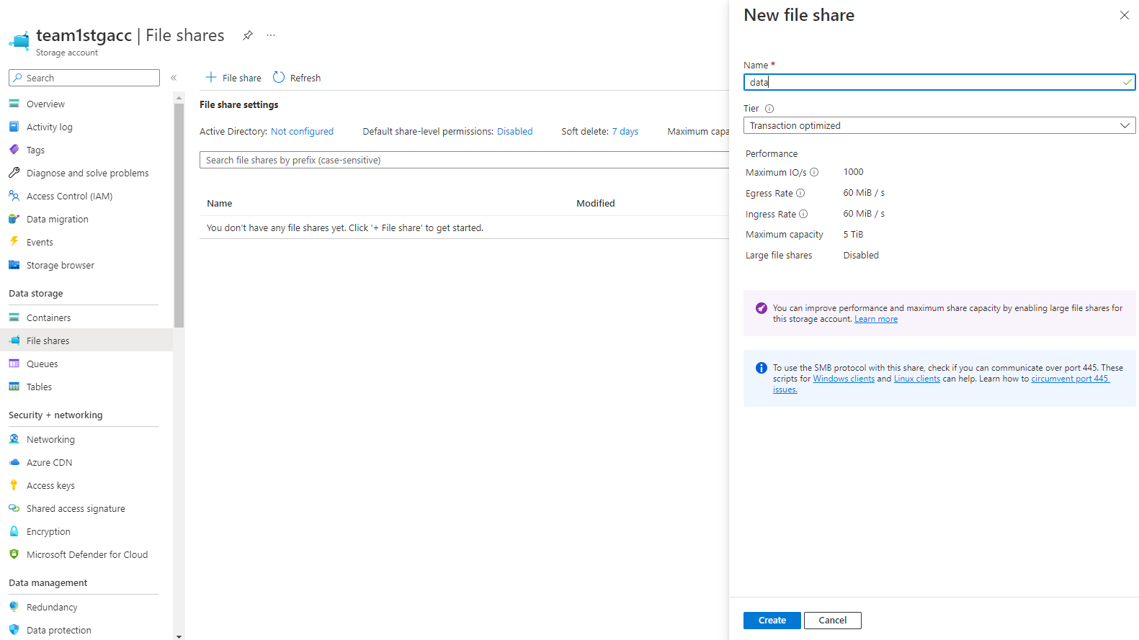

1. Mount this file share on windows and linux

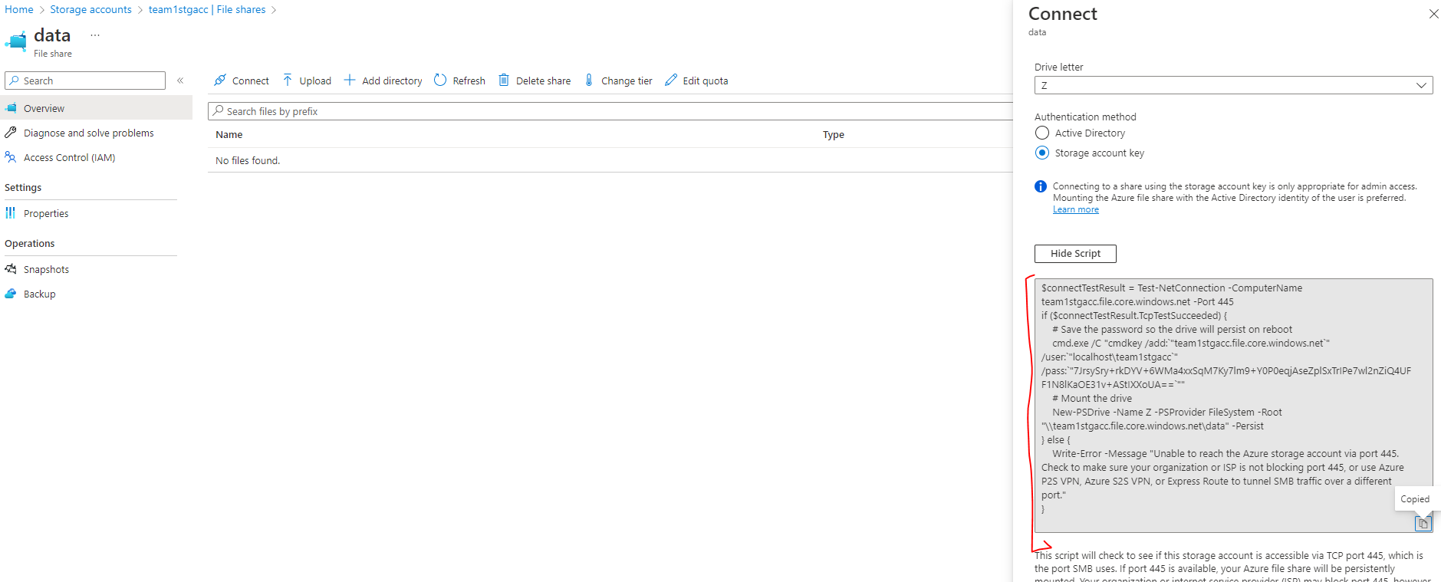

## Assignment 4

1. Create a Storage account, and upload some files in Blob storage

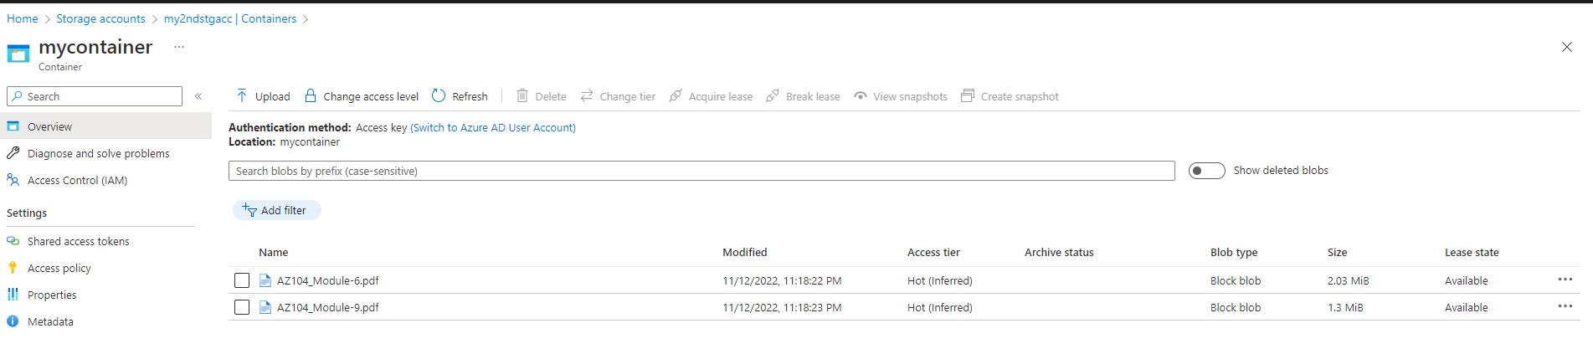

1. Create a CDN profile

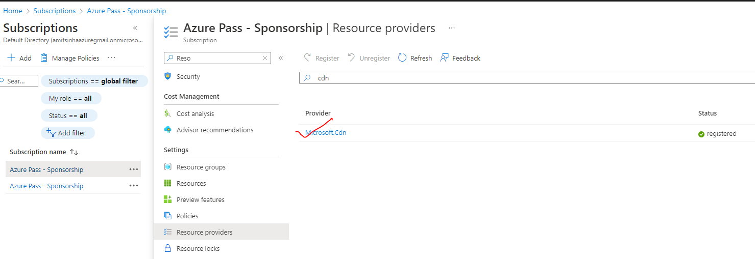

3. Create an endpoint and connect to the Azure blob to access the files uploaded

## Assignment 5

1. Create a storage account

2. Use the blob service and upload some files in it

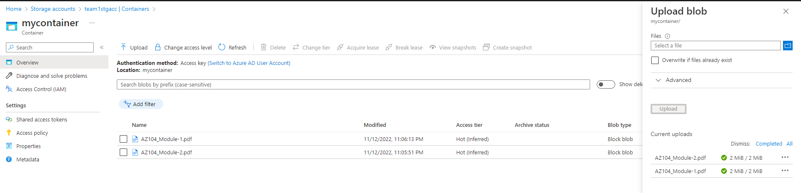

1. Change the access tier to archive

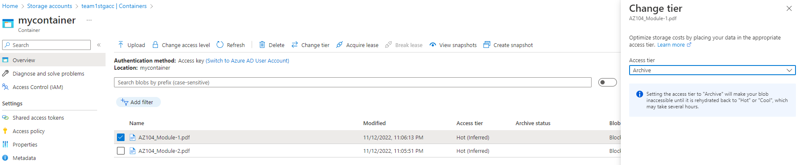

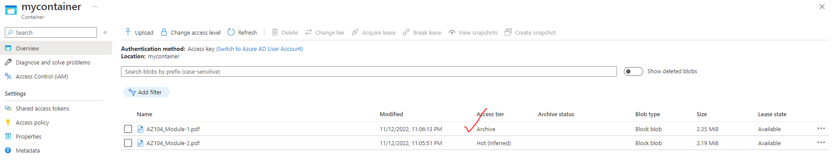

# Module 3 - Storage Account

## Assignment 1

1. Create a storage account

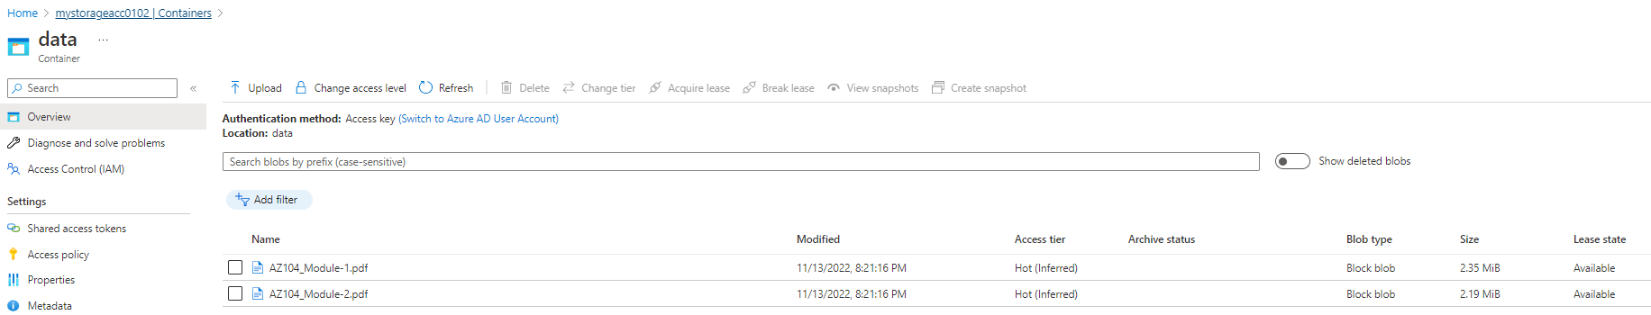

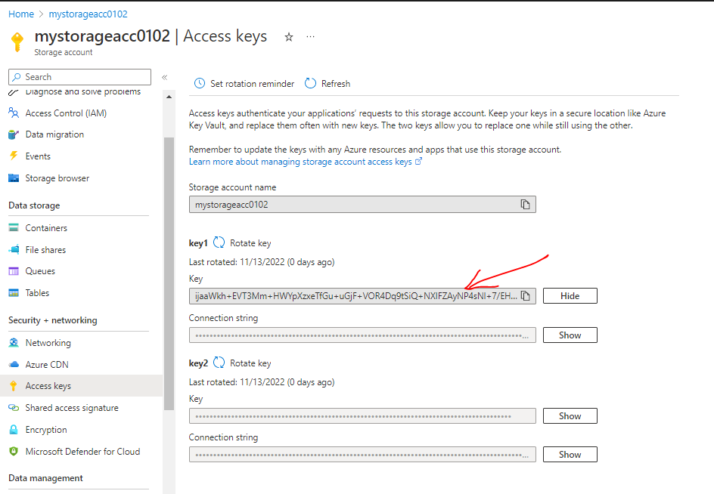

1. Connect storage explorer to this storage account

**USING CONNECTION STRING**

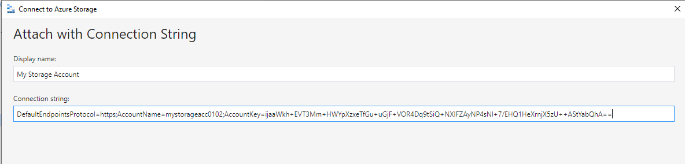

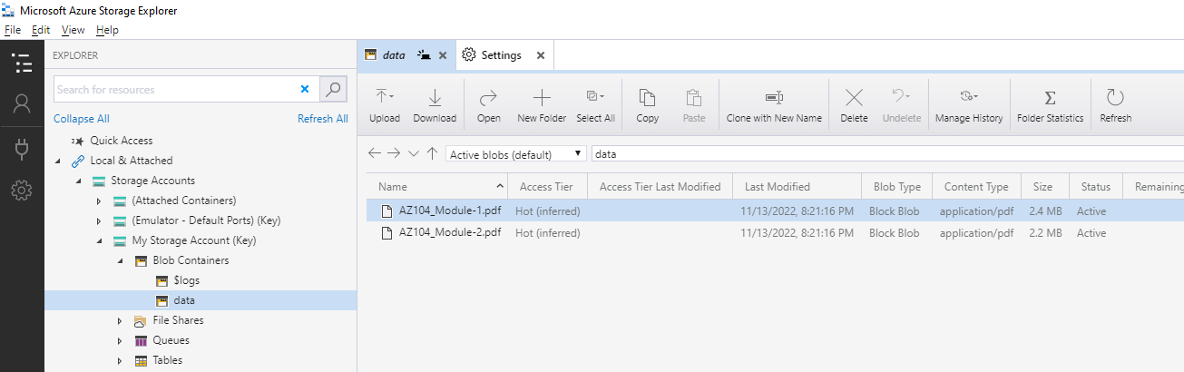

## Assignment 2

1. Create a Fileshare using the Storage explorer

|  |  |
| --- | --- |
|  |  |

1. Upload files to the blob service

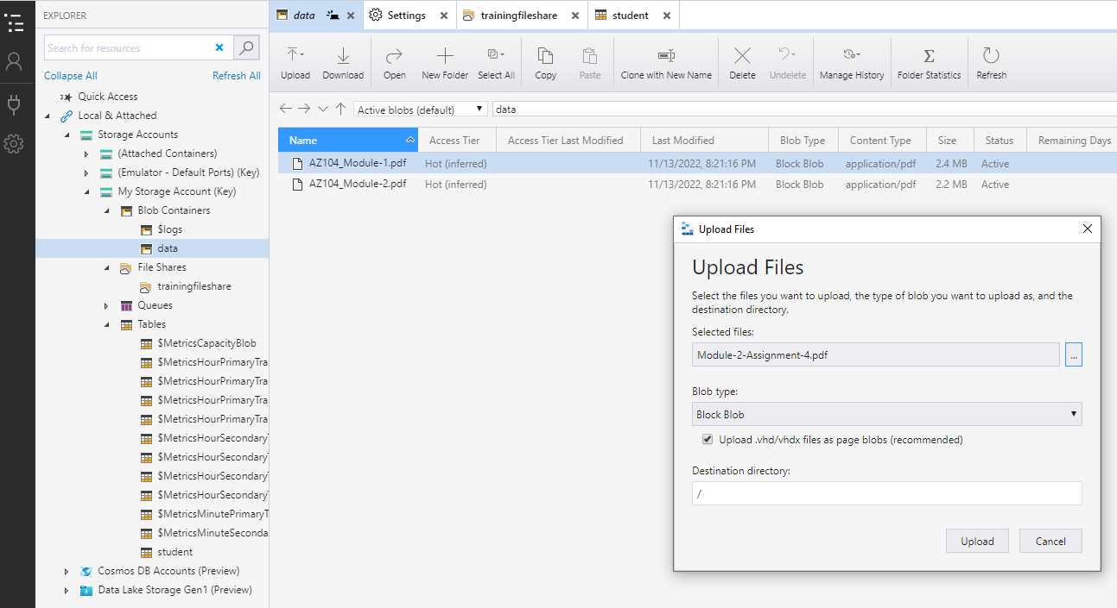

1. Create an Azure Table and insert a record

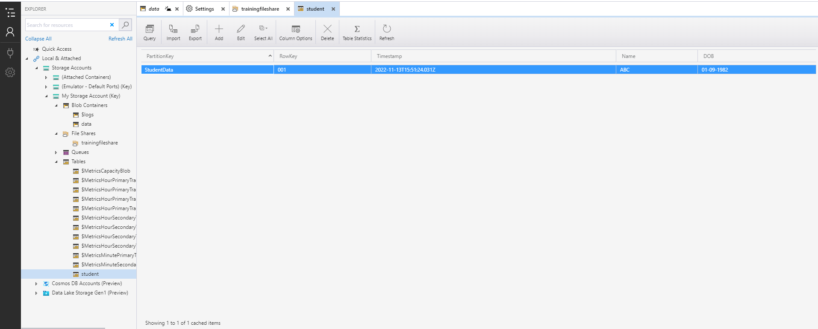

# Module 4 - VMs

## Assignment 1

1. Create a VM in the West US region
2. Select the Ubuntu image for creating the VM
3. Open the SSH port
4. Connect to the linux VM using the terminal

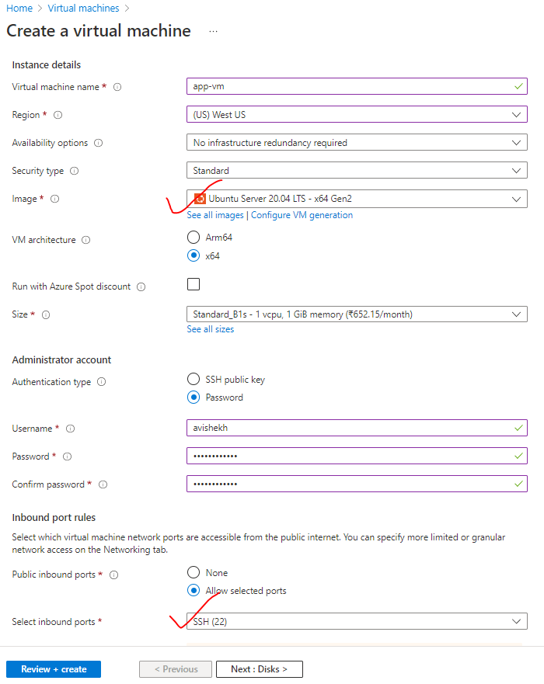

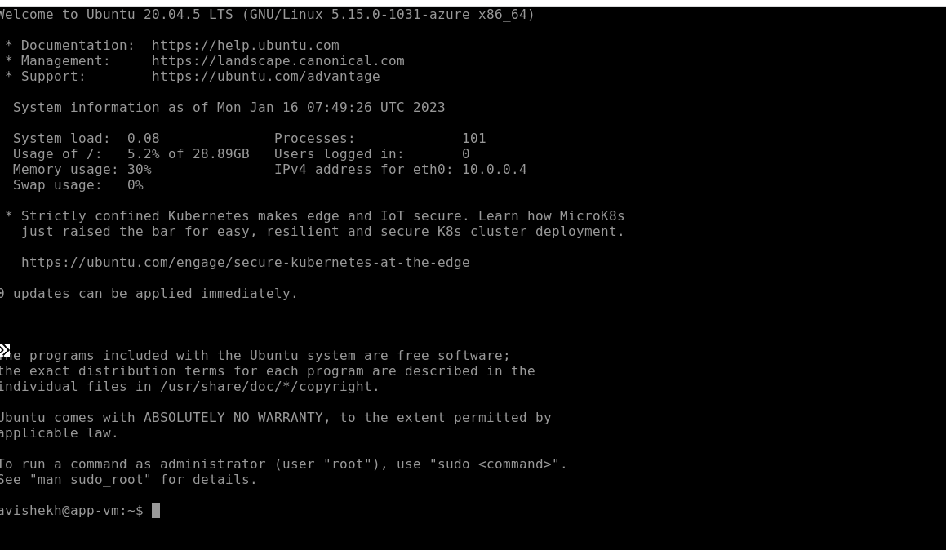

## Assignment 2

1. Create a Windows VM in West US region
2. Open the RDP port
3. Connect to it using Windows Remote Desktop

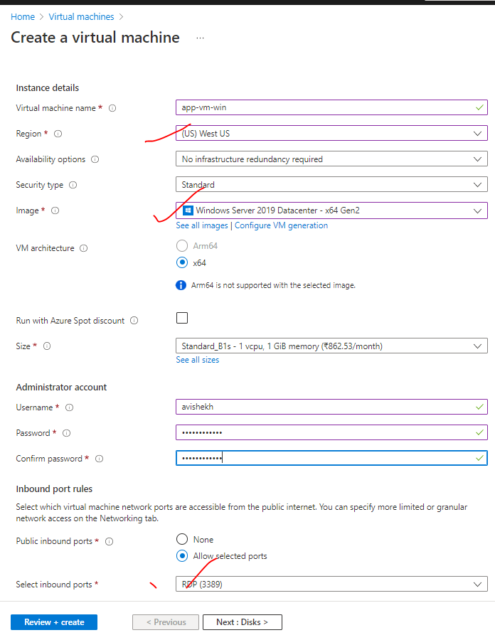

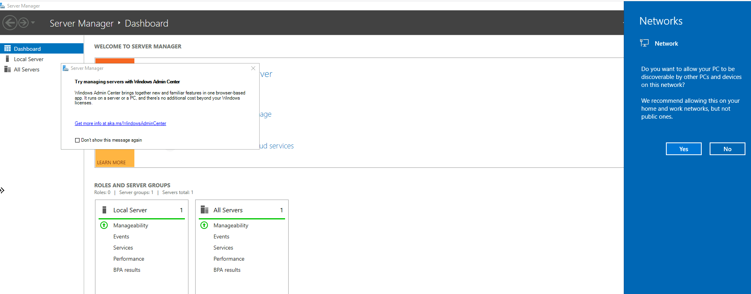

## Assignment 3

1. Create a VM scaleset with Ubuntu as OS
2. Give min VM’s as 1, and maximum as 5
3. For Scale-out CPU % is 75, and increase by 1 VM
4. For Scale-in CPU % is 25, decrease by 1 VM

|  |  |
| --- | --- |
| STEP 1 | STEP 2 |
|  | |

## Assignment 4

1. Create a Linux VM with ubuntu OS
2. Install apache2 software
3. Create image out of VM

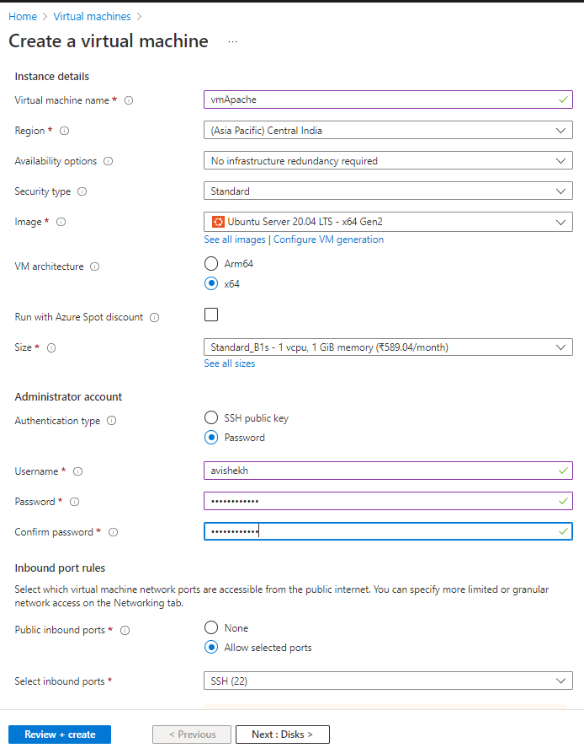

To Install Apache – We need to execute following command from the VM’s terminal

1. *sudo apt-get update*
2. *sudo apt-get install apache2*

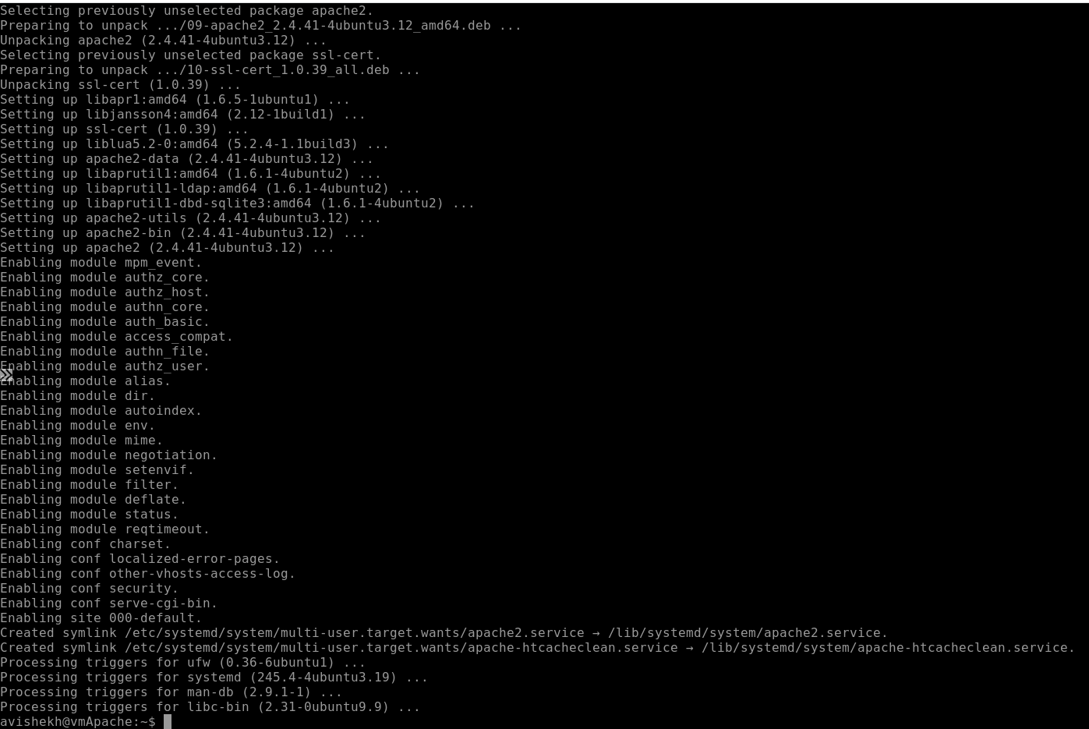

CREATING IMAGE

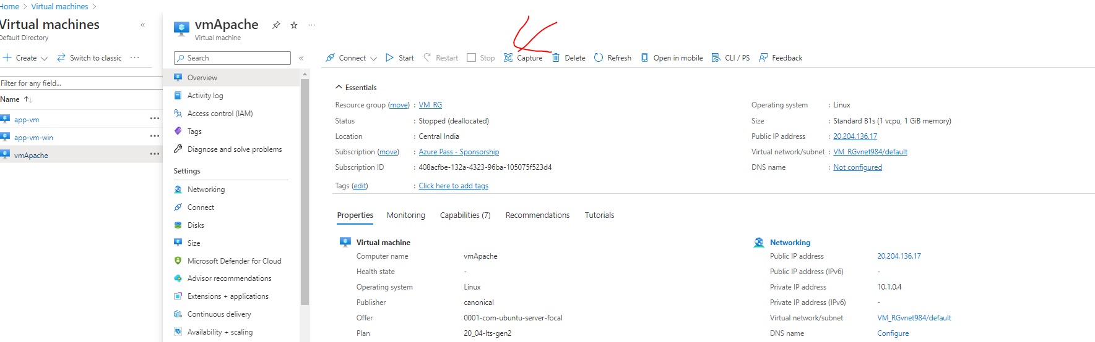

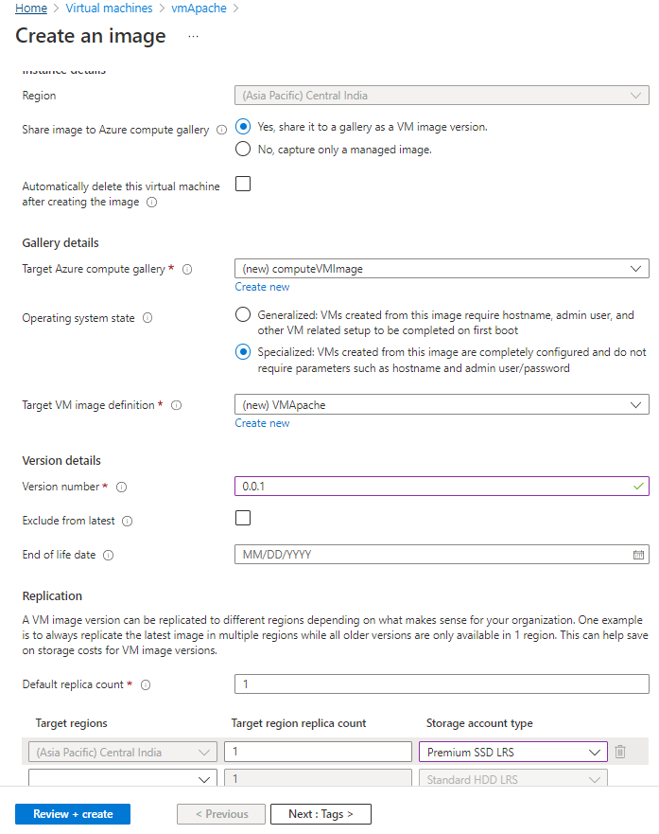

## Assignment 5

1. Deploy a VM from the previously created image
2. Open Port 80 in NSG
3. Start the apache2 service in the VM
4. Verify if you are able to access the website

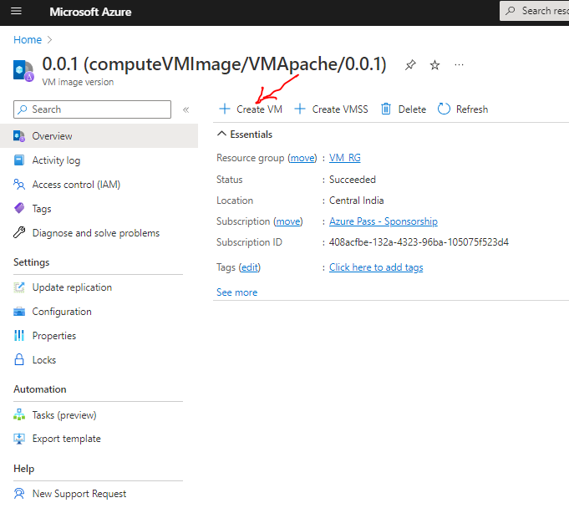

CREATING VM FROM IMAGE

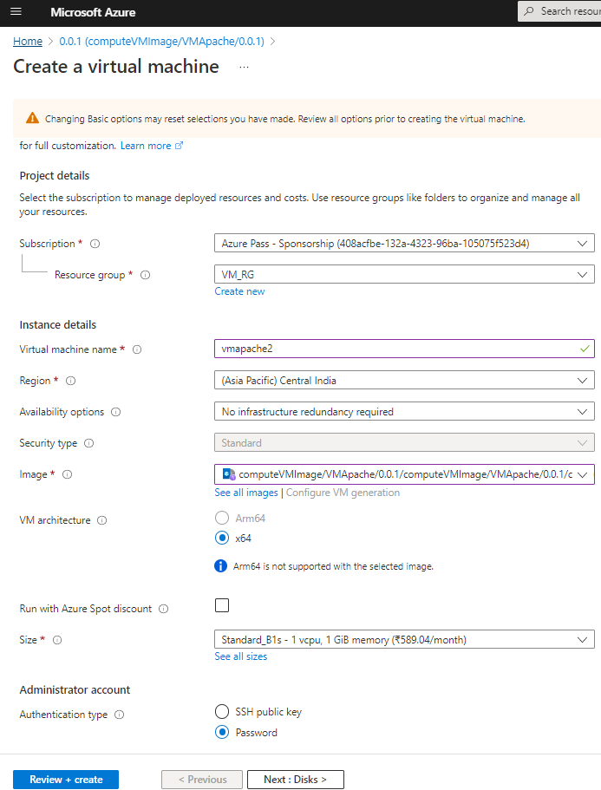

ADDING PORT TO NSG

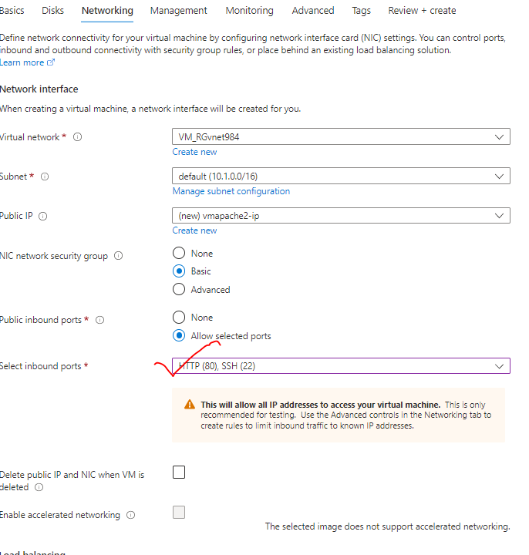

**ACCESSING APACHE HOME PAGE**

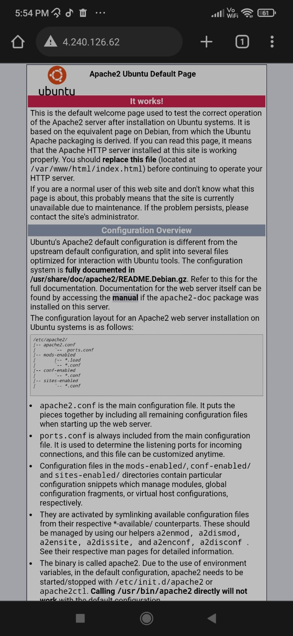

After attaching all the screenshots of all the question from a particular assignment save this file and attach it as attachment to the mail and send it to **support@intellipaat.com**