Contents

KUBERNETES 2

CONTAINERS 2

WHY WE NEED CONTAINERS 2

SOLUTION 3

WHAT IS CONTAINER? 3

HOW DOCKER WORKS? 3

CONTAINER VERSUS VM 4

CONTAINER VERSUS IMAGE 4

CONTAINER ADVANTAGE 4

CONTAINER ORCHESTRATION 5

ORCHESTRATION TECHNOLOGIES 5

ADVANTAGE OF KUBERNETES 5

KUBERNETES ARCHITECTURE 6

NODES 6

CLUSTER 6

MASTER 6

COMPONENTS OF KUBERNETES 7

MASTER VERSUS WORKER NODES 7

SETTING UP KUBERNETES - MINIKUBE 8

MINIKUBE 8

KUBERNETES PODS 10

MULTICONTAINER POD 11

PODS IN PRACTICE 12

YAML 12

PODS WITH YAML 13

# KUBERNETES

* Developed by Google also known as k8.
* It’s a container orchestration tool

## CONTAINERS

### WHY WE NEED CONTAINERS

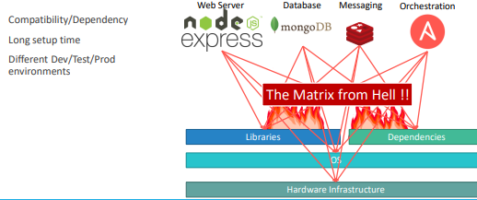

To understand the concept of container. Let’s take an example

* Let say we have a requirement to setup an end-to-end stack including various technologies like a Web Server using NodeJS and a database such as MongoDB/CouchDB, messaging system like Redis and an orchestration tool like Ansible.
* We will have lot of issues developing this application with all these different components. First, their compatibility with the underlying OS. We must ensure that all these different services were compatible with the version of the OS we were planning to use.
* There is a possibility when certain version of these services was not compatible with the OS, and we have to go back and look for another OS that will be compatible with all of these different services. Secondly, we must check the compatibility between these services and the libraries and dependencies on the OS.
* The possibility can be where one service requires one version of a dependent library whereas another service required another version.
* Going forward if architecture of the application changed over time, when have an upgrade to newer versions of these components or change the database etc. and every time something changed, we have to go through the same process of checking compatibility between these various components and the underlying infrastructure. **This compatibility matrix issue is usually referred to as the matrix from hell**.
* Apart from that – every time to on board a new developer, it will be difficult to setup a new environment. The new developers must follow a large set of instructions and run 100s of commands to finally setup their environments. They must make sure they were using the right Operating System, the right versions of each of these components and each developer had to set all that up by himself each time.
* We also had different development test and production environments. One developer may be comfortable using one OS, and the others may be using another one and so we couldn’t guarantee the application that we were building would run the same way in different environments. And so, all of this made our life in developing, building and shipping the application really difficult.

### SOLUTION

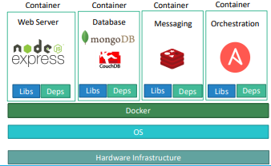

* To solve the compatibility issue we need some tool that will allow us to modify or change these components without affecting the other components and even modify the underlying operating systems as required. The solution to the problem is Docker.
* With Docker we can be able to run each component in a separate container – with its own libraries and its own dependencies. All on the same VM and the OS, but within separate environments or containers.
* We just had to build the docker configuration once, and all our developers could now get started with a simple “docker run” command. Irrespective of what underlying OS they run, all they needed to do was to make sure they had Docker installed on their systems

### WHAT IS CONTAINER?

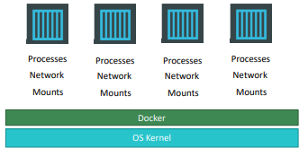

* Containers are completely isolated environments, as in they can have their own processes or services, their own network interfaces, their own mounts, just like Virtual machines, **except that they all share the same OS kernel**.
* But it’s also important to note that containers are not new with Docker. Containers have existed for about 10 years now and some of the different types of containers are LXC, LXD, LXCFS etc. Docker utilizes LXC containers.
* Setting up these container environments is hard as they are very low level and that is where Docker offers a high-level tool with several powerful functionalities making it easy for end users like us.

### HOW DOCKER WORKS?

### CONTAINER VERSUS VM

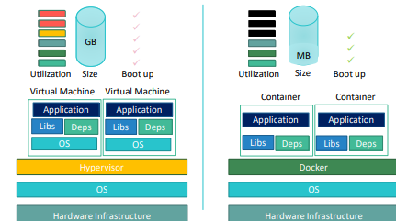

### CONTAINER VERSUS IMAGE

|  |  |
| --- | --- |
|  | * An image is a package or a template, just like a VM template. It is used to create one or more containers. * Containers are running instances off images that are isolated and have their own environments and set of processes. |

### CONTAINER ADVANTAGE

* For a traditionally developed application, developer hand it over to Ops team to deploy and manage it in production environments. They do that by providing a set of instructions such as information about how the hosts must be setup, what pre-requisites are to be installed on the host and how the dependencies are to be configured etc. Since the Ops team did not develop the application on their own, they struggle with setting it up. When they hit an issue, they work with the developers to resolve it.
* With Docker, a major portion of work involved in setting up the infrastructure is now in the hands of the developers in the form of a Docker file. The guide that the developers built previously to setup the infrastructure can now easily put together into a ***Dockerfile*** to create an image for their applications. This image can now run on any container platform and is guaranteed to run the same way everywhere.
* So the Ops team now can simply use the image to deploy the application. Since the image was already working when the developer built it and operations are not modifying it, it continues to work the same when deployed in production.

## CONTAINER ORCHESTRATION

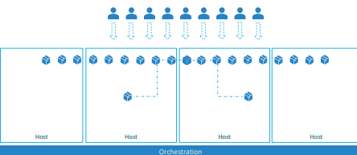

* After the application packaged into a docker container. Now the question is
  + How do we run it in production?
  + What if the application relies on other containers such as database or messaging services or other backend services?
  + What if the number of users increase and we need to scale the application? And to scale down when the load decreases.
* ***To enable these functionalities, we need an underlying platform with a set of resources. The platform needs to orchestrate the connectivity between the containers and automatically scale up or down based on the load. This whole process of automatically deploying and managing containers is known as Container Orchestration.***

### ORCHESTRATION TECHNOLOGIES

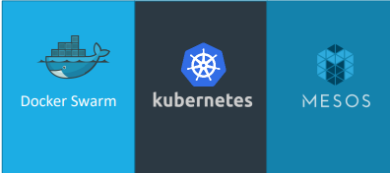

* Kubernetes is thus a container orchestration technology. There are multiple such technologies available today

1. DOCKER SWARM.

Docker Swarm is really easy to setup and get started, it lacks some of the advanced autoscaling features required for complex applications.

1. KUBERNETES from Google
   * + Kubernetes - arguably the most popular of it all – is a bit difficult to setup and get started but provides a lot of options to customize deployments and supports deployment of complex architectures.
     + Kubernetes is now supported on all public cloud service providers like GCP, Azure and AWS and the kubernetes project is one of the top ranked projects in Github.
2. MESOS from Apache. While Mesos on the other hand is quite difficult to setup and get started but supports many advanced features.

## ADVANTAGE OF KUBERNETES

There are various advantages of container orchestration.

* Application will be highly available as hardware failures do not bring the application down because we have multiple instances of the application running on different nodes.
* The user traffic is load balanced across the various containers. When demand increases, deploy more instances of the application seamlessly and within a matter of second and we can do that at a service level.
* When we run out of hardware resources, scale the number of nodes up/down without having to take down the application. And do all these easily with a set of declarative object configuration files.
* **Kubernetes - It is a container Orchestration technology used to orchestrate the deployment and management of 100s and 1000s of containers in a clustered environment.**

## KUBERNETES ARCHITECTURE

### NODES

|  |  |
| --- | --- |
|  | * A node is a machine – physical or virtual – on which Kubernetes is installed. * A node is a worker machine, and this is where containers will be launched by Kubernetes) It was also known as Minions in the past). * But what if the node on which our application is running fails? Well, obviously our application goes down. So, you need to have more than one node. Then comes the concept of Cluster |

### CLUSTER

|  |  |
| --- | --- |
|  | * A cluster is a set of nodes grouped together. * This way even if one node fails the application still accessible from the other nodes. * Having multiple nodes helps in sharing load as well. |

### MASTER

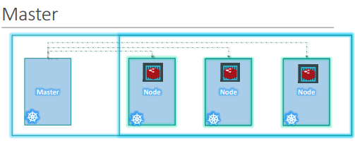

Master node is Kubernetes are

* Is responsible for managing the cluster
* Master has the information about the members of the cluster stored
* Monitoring the Nodes – For example - when a node fails it moves the workload of the failed node to another worker node

**The master is another node with Kubernetes installed in it and is configured as a Master. The master watches over the nodes in the cluster and is responsible for the actual orchestration of containers on the worker nodes.**

### COMPONENTS OF KUBERNETES

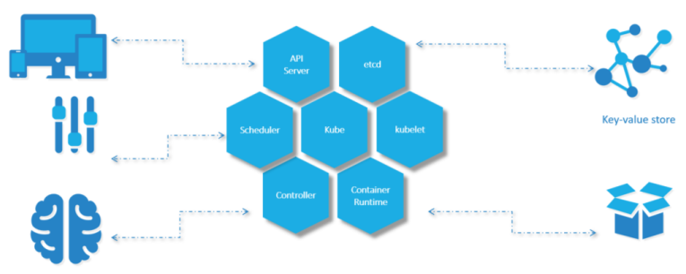

When we install Kubernetes on a System, following components get installed

1. AN API SERVER.

The API server acts as the front-end for Kubernetes. **The users, management devices, Command line interfaces all talk to the API server to interact with the Kubernetes cluster.**

1. AN ETCD SERVICE.

* ETCD key store is a distributed reliable key-value store used by Kubernetes to store all data used to manage the cluster. For example - when we have multiple nodes and multiple masters in our cluster, etcd stores all that information on all the nodes in the cluster in a distributed manner.
* ETCD is responsible for implementing locks within the cluster to ensure there are no conflicts between the Masters.

1. A KUBELET SERVICE.

Kubelet is the agent that runs on each node in the cluster. The agent is responsible for making sure that the containers are running on the nodes as expected.

1. A CONTAINER RUNTIME

The container runtime is the underlying software that is used to run containers. For example - Docker

1. CONTROLLERS

The controllers are the brain behind orchestration. They are responsible for noticing and responding when nodes, containers or endpoints goes down. The controllers make decisions to bring up new containers in such cases.

1. SCHEDULERS.

The scheduler is responsible for distributing work or containers across multiple nodes. It looks for newly created containers and assigns them to Nodes.

### MASTER VERSUS WORKER NODES

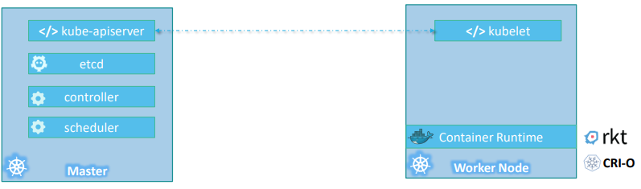

**So far we have seen two types of servers – Master and Worker** and a set of components that make up Kubernetes.

Question - **But how are these components distributed across different types of servers. In other words, how does one server become a master and the other slave?**

**WORKER**

* The containers are hosted by the worker node. Hence the worker node should have a container runtime e.g. Docker.
* There are other container runtime alternatives available such as Rocket or CRIO.

**MASTE**

* ***The master server has the kube-apiserver and that is what makes it a master***. Similarly, the worker nodes have the ***kubelet agent*** that is responsible for interacting with the master to provide health information of the worker node and carry out actions requested by the master on the worker nodes.
* All the information gathered are stored in a key-value store on the Master. The key value store on ***etcd framework***.
* The master also has the controller manager and the scheduler.

## SETTING UP KUBERNETES - MINIKUBE

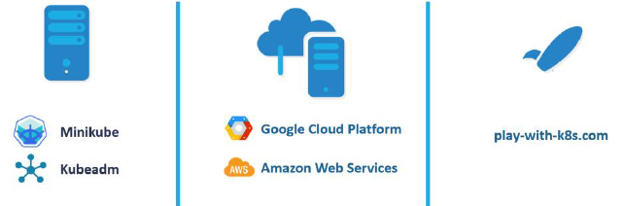

* There are lots of ways to setup Kubernetes. We can setup it up ourselves locally on our laptops or virtual machines using solutions like z
  + **MINIKUBE** – Minikube is an open source tool used to setup a single instance of Kubernetes in an All-in-one setup
  + **KUBEADMIN** – Kubeadmin is a tool used to configure Kubernetes in a multi-node setup.
  + **HOSTED SOLUTIONS** available for setting up Kubernetes in a cloud environment such as **GCP and AWS**.
  + **ONLINE** - <https://labs.play-with-k8s.com/>

### MINIKUBE

* <https://minikube.sigs.k8s.io/docs/start/>

|  |  |
| --- | --- |
|  | For Kubernetes installation (Production Cluster Set up)   * The master node consists of - *apiserver, etcd - key value store, controllers, and scheduler* * Worker Node has – *kubelets and container runtime* * It would take a lot of time and effort to setup and install all these various components on different systems individually by ourselves. |

We need 3 things to get Kubernetes working on a local machine,

* + **HYPERVISOR** – Minikube installation needs virtualization. ***For windows we could use Virtualbox or Hyper-V and for Linux use Virtualbox or KVM*** *as a Hypervisor software.*
  + **KUBECTL -** Kubernetes command line tool
  + **MINIKUBE** executable
* Minikube provides an executable command line utility that will AUTOMATICALLY download the ISO and deploy it in a virtualization platform such as **Oracle Virtualbox or Vmwarefusion**.
* ***kubectl Kubernetes command line tool*** will be used to interact with the Kubernetes cluster.
* **Minikube bundles all these different components into a single image providing us a pre-configured single node Kubernetes cluster so we can get started in a matter of minutes. The whole bundle is packaged into an ISO image and is available online for download.**

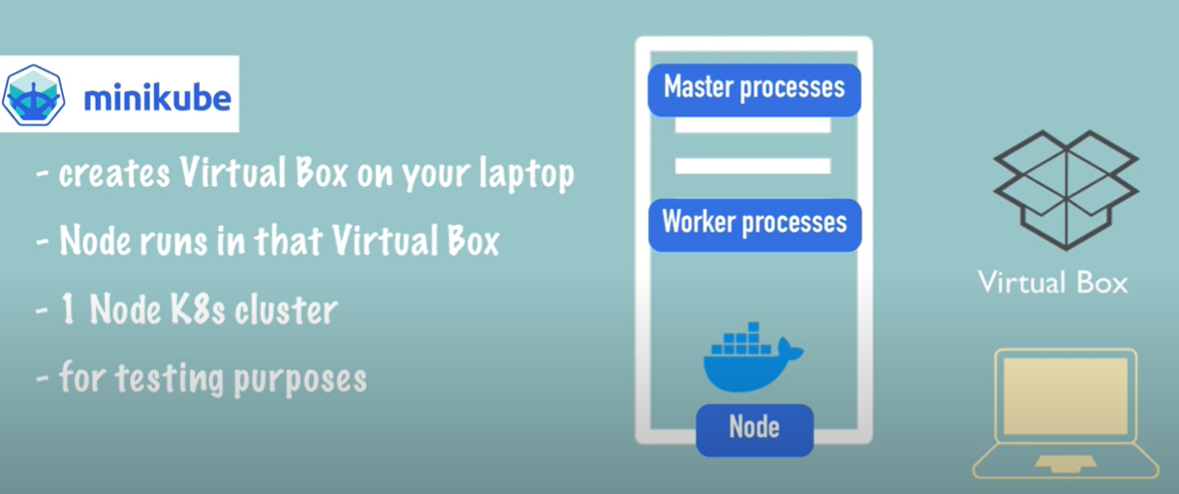

* Minicube is one node cluster – where the master process and worker process run on one machine
* The node has docker container runtime preinstalled – which provides the runtime environment for the containers
* The way – it runs on local machine is –
  + Minikube creates a Virtualized environment using Virtual Box (Virtual box is a Type 2 hypervisor software)
  + The Single Cluster node runs on the Virtual Box (Virtualized Environment)

#### KUBECTL

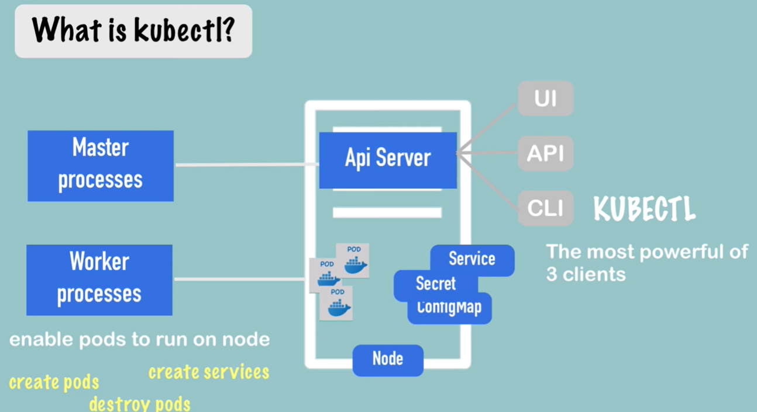

* Once we have a virtual node on our local machine – we need a way to interact with Pod and create other Kubernetes components like Services, Secrets and ConfigMap Etc. The way to do it is kubectl(Command line tool for k8 clusters)

##### HOW KUBECTL INTERACT WITH MINIKUBE CLUSTER?

* Since Minikube run both master and worker process. One of the master processes called “API Server” is the main entry point into the Kubernetes cluster. Hence if we want to any create component or configuration we need to talk to API Server
* The way to interact with API server is using some sort of client. kubectl is one such client
* Once the kubectl submits a request to create / delete pods or service – the Worker process does the actual job.

#### MINIKUBE COMMAND

* To get the list of minikube command just type “minikube” in your command line

**BASIC COMMANDS**

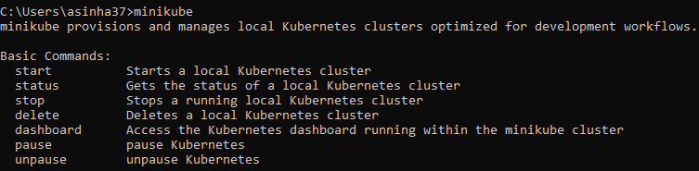

|  |  |  |
| --- | --- | --- |
| COMMAND | | DESCRIPTION |
| **minikube start –vm-driver<*driverName*>**  Ex- minikube start –vm-driver=hyperkit | | * This will start minikube single node cluster for given hypervisor (hyperkit, Virtual box or Docker) * List of supported Minikube Drivers - <https://minikube.sigs.k8s.io/docs/drivers/> |
| START A CLUSTER USING THE DOCKER DRIVER: minikube start --driver=docker  TO MAKE DOCKER THE DEFAULT DRIVER: minikube config set driver docker | | |
| minikube status |  | |

KUBECTL COMMANDS (TO INTERACT WITH NODE & PODS)

* To validate the installation of minikube – we can run couple of kubectl commands from the reference document - <https://kubernetes.io/docs/tutorials/hello-minikube/>

|  |  |
| --- | --- |
| **NODE INFORMATION**  ***kubectl get nodes***  This gives the information of single node minikube cluster | **NAME**- Name of the Node (minikube) which is in ready state.  **VERSION** – Kubernetes version  **AGE** – Since when the Node has been spun up |
| **CREATE DEPLOYMENTS** | kubectl create deployment hello-node --image=registry.k8s.io/echoserver:1.4 |

## KUBERNETES PODS

Before going to the POD- we assume that

* At this point, we assume that the application is already developed and built into Docker Images, and it is available on a Docker repository like Docker hub, so that Kubernetes can pull it down.
* We also assume that the Kubernetes cluster has already been setup and is working. This could be a single-node setup or a multi-node setup, doesn’t matter. All the services need to be in a running state.

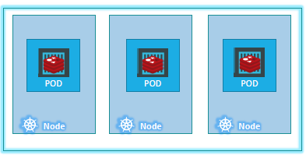

* With Kubernetes our aim is to deploy our application in the form of containers on a set of machines that are configured as worker nodes in a cluster.
* However, Kubernetes does not deploy containers directly on the worker nodes. The containers are encapsulated into a Kubernetes object known as PODs.
* **A POD is a single instance of an application. A POD is the smallest object, that you can create in Kubernetes.**

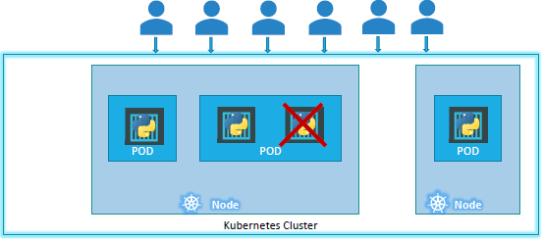

* Here we see the simplest of simplest cases where we can have a single node Kubernetes cluster with a single instance of the application running in a single docker container encapsulated in a POD.
* **If the number of users accessing the application increases and we need to scale our application. Then we create a new POD altogether with a new instance of the same application**,
* *Note – if load increases - we don’t add additional instances of the web application to share the load or a new container instance within the same POD*
* If the user base FURTHER increases and the current node has no sufficient capacity - THEN we can always deploy additional PODs on a new node in the cluster. You will have a new node added to the cluster to expand the cluster’s physical capacity.
* SO, PODs usually have a one-to-one relationship with containers running the application. To scale UP we create new PODs and to scale down we delete PODs. We do not add additional containers to an existing POD to scale your application.
* Reference - <https://kubernetes.io/docs/concepts/workloads/pods/>

### MULTICONTAINER POD

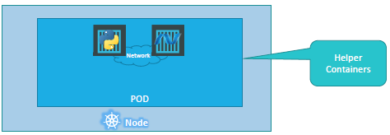

* PODs usually have a one-to-one relationship with the containers.
* But - we are not restricted to having a single container in a single POD.A single POD CAN have multiple containers, except for the fact that they are usually not multiple containers of the same kind.
* if our intention was to scale our application, then we would need to create additional PODs. But sometimes you might have a scenario where we have a helper container, that might be doing supporting task for our web application such as processing a user entered data, processing a file uploaded by the user etc. and we want these helper containers to live alongside our application container. In that case, we can have both of these containers part of the same POD, so that when a new application container is created, the helper is also created and when it dies the helper also dies since they are part of the same POD.
* The two containers can also communicate with each other directly by referring to each other as ‘localhost’ since they share the same network namespace. Plus they can easily share the same storage space as well.

### PODS IN PRACTICE

|  |  |
| --- | --- |
| CREATING A POD WITH A GIVEN DOCKER IMAGE  Note   1. The POD name can be anything, but the image name has to be the name of the Docker Image in the DockerHUB 2. What if image is hosted in another registry apart from docker?? | **kubectl run <POD_NAME> --image=<IMAGE_NAME>**  **Example-**  **kubectl run nginx –image=nginx**  **Note – Using above command we can create a POD directly using Docker image. The another way to create image using Manifest file (Yaml configuration file)** |
| GET THE RUNNING PODS   * NAME – Name of the POD * READY (1/1) – Number of containers in the POD which are in ready state | **kubectl get pods** |
| DETAIL INFORMTAION OF A GIVEN POD(nginx) | **kubectl describe pod nginx** |
| 1. NAME - Name of the POD 2. IP – Internal IP Address of the POD 3. READY (1/2) – Number of containers in the POD Running / Total number of container in a POD 4. NODE – The Node(worker node) in which the POD is deployed | |

## YAML

* YAML is a way to represent data like JSON and XML

QUICK COMPARISION

|  |  |  |
| --- | --- | --- |
| XML | JSON | YAML |
| <Servers>  <Server>  <name>Server1</name>  <owner>ABC</owner>  <created>21-01-22</created>  <status>Active</status>  </Server>  <Server>  <name>Server2</name>  <owner>ZYZ</owner>  <created>22-01-22</created>  <status>Inactive</status>  </Server>  </Servers> | {  "Servers": {  "Server": [  {  "name": "Server1",  "owner": "ABC",  "created": "21-01-22",  "status": "Active"  },  {  "name": "Server2",  "owner": "ZYZ",  "created": "22-01-22",  "status": "Inactive"  }  ]  }  } | Servers:  Server:  **-** name: Server1  owner: ABC  created: 21-01-22  status: Active  **-** name: Server2  owner: ZYZ  created: 22-01-22  status: Inactive |

|  |  |
| --- | --- |
| **KEY VALUE PAIR**   * The simplest data in YAML is key-value pair * There is always a “space” between “:” and the value | Fruit: Apple  Vegetables: Carrot  Liquid: Water |
| **ARRAY**  Array of Fruits. “-” indicates an element of an array | Fruits:  - Apple  - Banana  - Grapes |
| **DICTIONARY / MAP**  We should equal space for a property of each map item, so that they aligned together | Apple:  Calories: 105  Fat: 0.4 g  Carbs: 16 g  Banana:  Calories: 120  Fat: 0.5 g  Carbs: 18 g |
| **ALL COMBINED** | Fruits:  - Apple:  Calories: 105  Fat: 0.4 g  Carbs: 16 g  - Banana:  Calories: 120  Fat: 0.5 g  Carbs: 18 g |

## PODS WITH YAML

* Kubernetes uses YAML files as input for the creation of objects such as PODs, Replicas, Deployments, Services etc. The YAML file for k8 is Manifest file.

|  |  |
| --- | --- |
| A Kubernetes definition file always contains 4 top level fields.   * + **THE APIVERSION, KIND, METADATA AND SPEC.**   + These are top level or root level properties.   + These are all REQUIRED fields | SAMPLE MANIFEST FILE (pod-defination.yaml)  l apiVersion: v1  kind: Pod  metadata:    name: my-first-pod    labels:      app: my-first-app      type: front-end  spec:    containers:      - name: nginx-container        image: nginx |
|  | |

|  |  |  |
| --- | --- | --- |
| apiVersion | * This is the version of the Kubernetes API we’re using to create the object. * Depending on what we are trying to create we must use the RIGHT apiVersion(refer below table). For POD - set the apiVersionas as “v1” * Few other possible values for this field are apps/v1beta1, extensions/v1beta1 etc. | |
| kind | * The kind refers to the type of object we are trying to create, For POD - we will set it as Pod. * Other possible values here could be ReplicaSet or Deployment or Service. | |  |  | | --- | --- | | KIND | VERSION | | POD | v1 | | Service | v1 | | ReplicaSet | apps/v1 | | Deployment | apps/v1 | |
| metadata | * The metadata is data about the object like its name, labels etc. * Represented in form of dictionary/ Map * Labels (usability)- Say for example there are 100s of PODs running a front-end application, and 100’s of them running a backend application or a database, it will be DIFFICULT for you to group these PODs once they are deployed. If you label them now as front-end, back-end or database, you will be able to filter the PODs based on this label at a later point in time. * We can only specify name or labels or anything else that Kubernetes expects to be under metadata. We CANNOT add any other property under this. However, under labels we CAN have any kind of key or value pairs. | |
| spec | * Depending on the object we are going to create, this is where we provide additional information to Kubernetes pertaining to that object. This is going to be different for different objects, * Spec is a dictionary so add a property under it called containers, which is a list or an array. The reason this property is a list is because the PODs can have multiple containers within | |
| * Once the file is created, run the below command to creates a POD out of it   **kubectl create -f pod-definition.yml** | | |

## REPLICATION CONTROLLER AND REPLICASET

## DEPLOYMENTS

## NETWORKING