Contents

MARKDOWNS 3

WHY WE USE MARKDOWN 3

IDEs 3

ONLINE EDITORS 3

OFFLINE EDITORS 3

HOW MARKDOWN WORKS? 3

PARAGRAPH AND LINE BREAK 4

HEADERS 4

HORIZONTAL LINE 4

BOLD & EMPHASIS 4

STRIKETHROUGH 5

BLOCKQUOTES 5

LIST -ORDERED AND UNORDERED LIST 7

IMAGES 7

INLINE IMAGES 7

REFERENCED IMAGES 7

LINKS 8

CODE STYLES AND BLOCKS 8

INLINE CODE 8

CODE BLOCKS /FENCED CODE 8

INLINE HTML 9

TABLES 9

MKDOCS 10

MKDOCS INSTALLATION 10

CREATING A NEW MKDOCS PROKJECT 10

BUILDING THE SITE 10

RUNNING THE SITE 11

DEPLOYING THE SITE 11

DEFAULT WELCOME PAGE 11

WRITING THE DOCS 11

ADDING PAGES & NAVIGATIONS 11

MARKDOWN EXTENSIONS 12

CONFIGURATIONS 12

MKDOCS.YML 13

PROJECT INFORMATION CONFIGURATION 13

DOCUMENT LAYOUT CONFIGURATION 13

BUILD DIRECTORIES CONFIGURATION 13

PREVIEW CONTROL CONFIGURATION 14

FORMATING OPTIONS CONFIGURATION 14

THEMES 14

INSTALLING AND ADDING THEMES 14

# MARKDOWNS

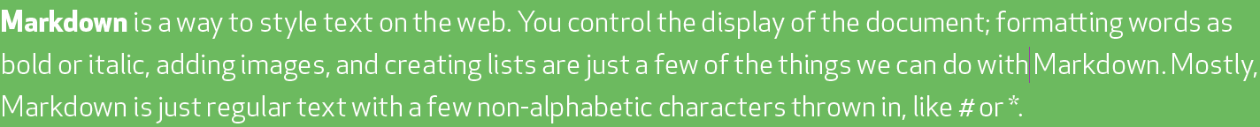

* Lightweight markup language with plain text formatting syntax
* Can be converted into HTML/ XTHML and other formats
* It main purpose is readability and ease of use.

## WHY WE USE MARKDOWN

* Readme Files (Github , etc..)
* Forum & Blog post
* Used in many static site generators.

## IDEs

### ONLINE EDITORS

* + <https://stackedit.io/>
  + <https://dillinger.io/>
* Create a new File to write markdown from a “New File” option.

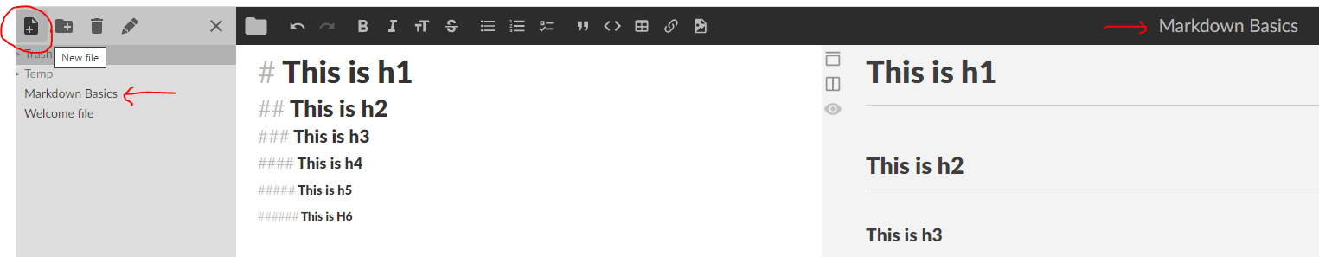

### OFFLINE EDITORS

* **TEXT EDITOR EXTENSION (IN VS CODE OR ATOM).**
* **MARKPAD**
* **HAROOPAD**
* **MARKDOWNPAD2**
* **TYPORA**

## HOW MARKDOWN WORKS?

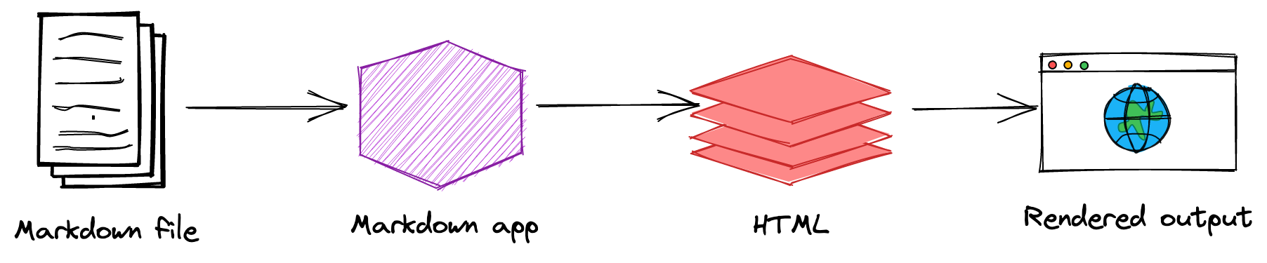

## PARAGRAPH AND LINE BREAK

## HEADERS

|  |  |
| --- | --- |
|  | * Header can be written using “#”. * Markdown supports header till “h6”. As show below |

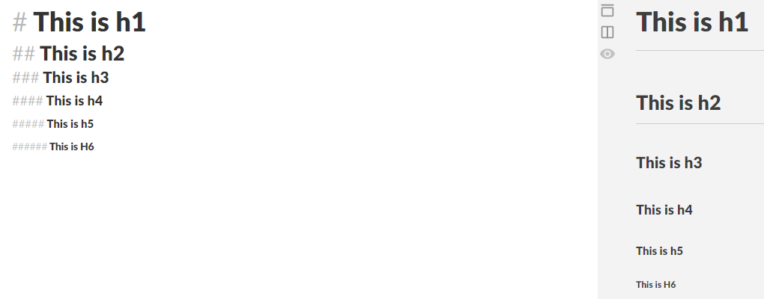

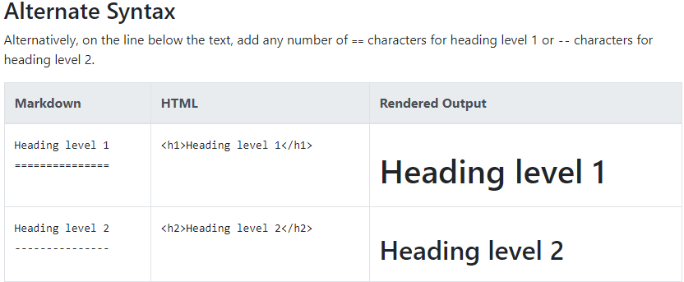

## HORIZONTAL LINE

* To generate horizontal lines in markdown
  + Use 3 consecutive “___” [underscores]
  + Use 3 consecutive “---” [dash]

## BOLD & EMPHASIS

|  |  |
| --- | --- |
|  | * Emphasis text uses “ *” of “_” interchangeably * “**” or “__”🡪 To **bold** the text |

**To emphasize text with bold and italics at the same time, add three asterisks or underscores before and after a word or phrase. To bold and italicize the middle of a word for emphasis, add three asterisks without spaces around the letters.**

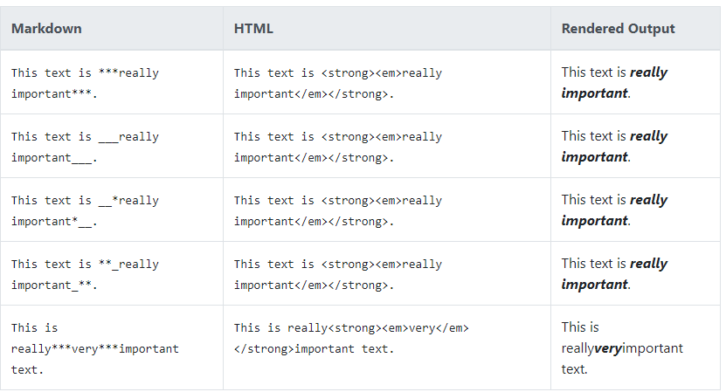

## STRIKETHROUGH

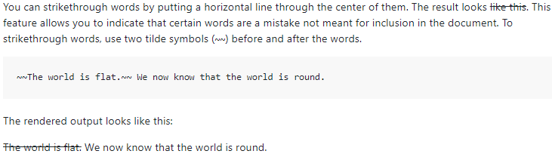

## BLOCKQUOTES

* Markdown uses “**>”** to create blockquotes

|  |  |
| --- | --- |
|  |  |

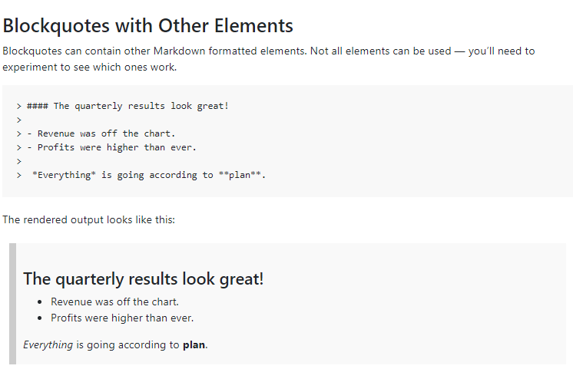

## LIST -ORDERED AND UNORDERED LIST

|  |  |
| --- | --- |
|  |  |
| OUTPUT | OUTPUT |

## IMAGES

### INLINE IMAGES

|  |  |
| --- | --- |
| ![Mars Image](<https://images.unsplash.com/photo-1451188502541-13943edb6acb>) |  |

### REFERENCED IMAGES

|  |  |
| --- | --- |
| Step 1: Create a reference Image  [DemoImage]: https://via.placeholder.com/150/771796 "Placeholder image"  Step 2: Refer the image anywhere in the markdown any number of times using the reference  This is a Place holder Image  ![DemoImage]  ![DemoImage] |  |

## LINKS

|  |  |
| --- | --- |
|  | EXAMPLES  Markdown:  Best Search Engine is [Google](<https://www.google.com/>)  Output |
|  | |

## CODE STYLES AND BLOCKS

* To embed the code in the markdown we use tilde(`)

### INLINE CODE

|  |  |
| --- | --- |
| **MARKDOWN**  To install the node dependencies use `npm install` in the project root | OUTPUT |

### CODE BLOCKS /FENCED CODE

* To write the code block we use 3 consecutive tilde to start and 3 consecutive tilde to end the code block
* **Alternatively we can use the language as well to write the code blocks for syntax highlighting.As Below.**

|  |  |
| --- | --- |
| ```javascript  let i = 10  ```  ```html  <p>This is HTML text</p>  # It ignores the reserved keyword  ``` |  |

## INLINE HTML

* Markdown supports most of formatting, except few(e.g <) . In those cases we can use inline HTML to get the desired formatting.

## TABLES

|  |  |  |  |  |
| --- | --- | --- | --- | --- |
| **SIMPLE TABLE** | **OUTPUT** | **CENTER ALIGNED** | **RIGHT ALIGNED** | **LEFT ALIGNED** |

# MKDOCS

* MkDocs is a **fast**, **simple** and **downright gorgeous** static site generator that's geared towards building project documentation. Documentation source files are written in Markdown, and configured with a single YAML configuration file.
* MkDocs uses the Python-Markdown library to render Markdown documents to HTML.



## MKDOCS INSTALLATION

* MkDocs requires a recent version of [Python](https://www.python.org/) and the Python package manager, [pip](https://pip.readthedocs.io/en/stable/installing/), to be installed on your system.
* Reference : <https://squidfunk.github.io/mkdocs-material/>

|  |  |
| --- | --- |
| **INSTALLING PIP (Python Package Manager) :**  If you're using a recent version of Python, the Python package manager, [pip](https://pip.readthedocs.io/en/stable/installing/), is most likely installed by default. However, you may need to upgrade pip to the lasted version: | **pip install --upgrade pip** |
| **INSTALLING MKDOCS (Static Site Generator)** | **pip install mkdocs** |
| **CHECKINNG MKDOCS VERSION** | **mkdocs --version** |

## CREATING A NEW MKDOCS PROKJECT

|  |  |
| --- | --- |
| **CREATING A NEW PROJECT** | mkdocs new my-project  cd my-project |
| **INITIAL PROJECT STRUCTURE** | The initial MkDocs layout |
| **BUILDING THE SITE** | mkdocs build |

## BUILDING THE SITE

* This will create a new directory, named site

|  |  |
| --- | --- |
|  |  |

## RUNNING THE SITE

* There's a single configuration file named mkdocs.yml, and a folder named docs that will contain the documentation source files in the above example – **In the initial project set-up the docs folder just contains a single documentation page, named index.md.**
* MkDocs comes with a built-in dev-server that lets you preview your documentation as you work on it. Make sure you're in the same directory as the mkdocs.yml configuration file, and then start the server by running the mkdocs serve command:

|  |  |
| --- | --- |
| **TO START THE DEV SERVER ON DEFAULT PORT (8000)** | mkdocs serve |
| **TO START THE DEV SERVER IN DIFFERENT PORT** | mkdocs serve --dev-addr 127.0.0.1:9000 |
| * Open up <http://127.0.0.1:8000/>  in your browser, and you'll see the default home page being displayed. * The dev-server also supports auto-reloading, and will rebuild your documentation whenever anything in the configuration file, documentation directory, or theme directory changes. | |

## DEPLOYING THE SITE

* The documentation site that is built only uses static files so we can able to host it from pretty much anywhere.
* Simply upload the contents of the entire site directory to wherever you're hosting your website from and you're done.

## DEFAULT WELCOME PAGE

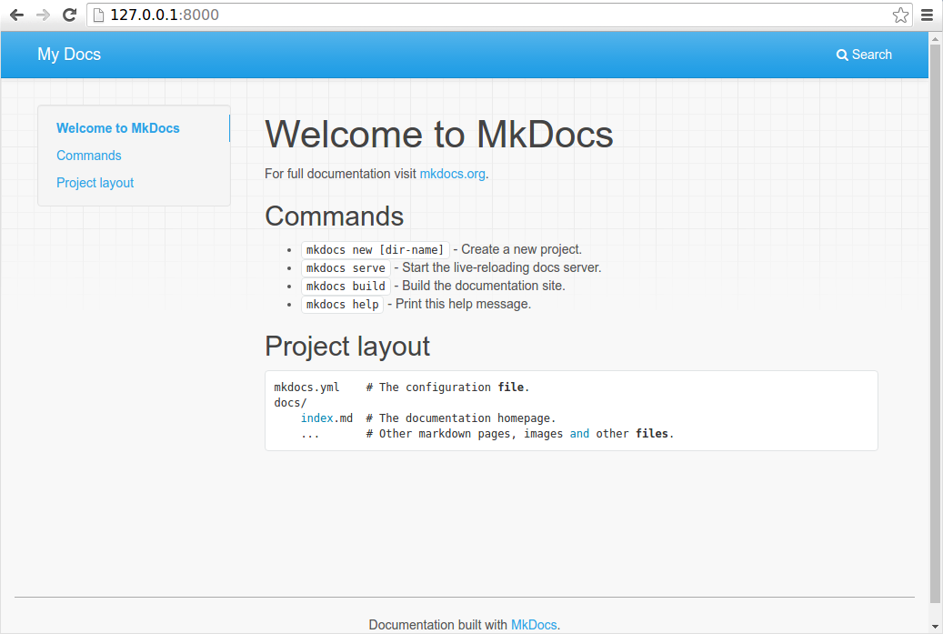

## WRITING THE DOCS

* Documentation source should be written as regular Markdown files and placed in the docs directory.
* Possible Extensions of Markdown Files : ***markdown, mdown, mkdn, mkd, md***
* By default, this directory will be named docs and will exist at the top level of the project, alongside the **mkdocs.yml** configuration file.

### ADDING PAGES & NAVIGATIONS

#### INDEX PAGES

* When a directory is requested, by default, most web servers will return an index file (usually named index.html) contained within that directory if one exists. For that reason, the homepage in all of the examples above has been named index.md, which MkDocs will render to index.html when building the site.
* Many repository hosting sites provide special treatment for README files by displaying the contents of the README file when browsing the contents of a directory. Therefore, MkDocs will allow you to name your index pages as README.md instead of index.md. In that way, when users are browsing your source code, the repository host can display the index page of that directory as it is a README file. However, when MkDocs renders your site, the file will be renamed to index.html so that the server will serve it as a proper index file.
* If both an index.md file and a README.md file are found in the same directory, then the index.md file is used and the README.md file is ignored.

#### NAVIGATION

* The [nav](https://www.mkdocs.org/user-guide/configuration/#nav) configuration setting in the mkdocs.yml file defines which pages are included in the global site navigation menu as well as the structure of that menu. If not provided, the navigation will be automatically created by discovering all the Markdown files in the docs folder.
* An automatically created navigation configuration will always be sorted alphanumerically by file name (except that index files will always be listed first within a sub-section). You will need to manually define your navigation configuration if you would like your navigation menu sorted differently.

A minimal navigation configuration could look like this:

nav:

- 'index.md'

- 'about.md'

* All paths in the navigation configuration must be relative to the docs_dir configuration option. If that option is set to the default value, docs, the source files for the above configuration would be located at docs/index.md and docs/about.md.
* The above example will result in two navigation items being created at the top level and with their titles inferred from the contents of the Markdown file or, if no title is defined within the file, of the file name. To override the title in the nav setting add a title right before the filename.

nav:

- Home: 'index.md'

- About: 'about.md'

*Note: that if a title is defined for a page in the navigation, that title will be used throughout the site for that page and will override any title defined within the page itself.*

* Navigation sub-sections can be created by listing related pages together under a section title. For example:

nav:

- Home: 'index.md'

- 'User Guide':

- 'Writing your docs': 'writing-your-docs.md'

- 'Styling your docs': 'styling-your-docs.md'

- About:

- 'License': 'license.md'

- 'Release Notes': 'release-notes.md'

* With the above configuration we have three top level items: "Home", "User Guide" and "About." "Home" is a link to the homepage for the site. Under the "User Guide" section two pages are listed: "Writing your docs" and "Styling your docs." Under the "About" section two more pages are listed: "License" and "Release Notes."

### MARKDOWN EXTENSIONS

|  |  |
| --- | --- |
| In addition to the base Markdown syntax which is common across all Markdown implementations, MkDocs includes support for extending the Markdown syntax with Python-Markdown extensions. | **EXAMPLE** :  markdown_extensions:  - toc:  permalink: "#" |

#### DEFAULT MARKDOWN EXTENSIONS

* The default markdown extensions are : **meta, toc, tables, and fenced_code**

##### TOC

## CONFIGURATIONS

### MKDOCS.YML

* Project settings are always configured by using a YAML configuration file in the project directory named mkdocs.yml.
* **As a minimum, this configuration file must contain the site_name and site_url settings**. All other settings are optional

### PROJECT INFORMATION CONFIGURATION

* As a minimum, this configuration file must contain the site_name and site_url settings. All other settings are optional.

|  |  |
| --- | --- |
| **site_name** | Example : **site_name: Marshmallow Generator**  **This is a required setting and should be a string that is used as the main title for the project documentation.** |
| **site_url** |  |
| **repo_url** |  |
| **repo_name** |  |
| **edit_uri** |  |
| **site_description** | Adds a meta description in the Landing page of the site  **<meta name="description" content="This is site description">** |
| **site_author** | Adds author’s information in the page of the site  **<meta name="author" content="Avishekh">** |
| **copyright** | Adds global Copyright text in the global footer of the site. |
| **remote_branch** |  |
| **remote_name** |  |

### DOCUMENT LAYOUT CONFIGURATION

#### NAVIGATION

### BUILD DIRECTORIES CONFIGURATION

#### CUSTOM SCRIPT AND CSS

|  |  |  |  |
| --- | --- | --- | --- |
| **CONFIGURATION NAME** | **CONFIGURATION** | **OUTPUT** | |
| **extra_css** | extra_css:      - css/custom.css |  | * Custom script and css can also be added in to MkDocs site. * These configurations are added in mkdocs.yml file. |
| **extra_javascript** | extra_javascript:      - js/custom.js |  |

### PREVIEW CONTROL CONFIGURATION

#### use_directory_urls

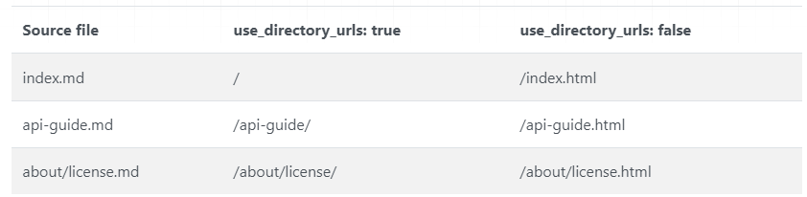

### FORMATING OPTIONS CONFIGURATION

## THEMES

* MkDocs includes two built-in themes **mkdocs** and **readthedocs.**
* Third party themes and its configuration values can be referred from : <https://github.com/mkdocs/mkdocs/wiki/MkDocs-Themes>

### INSTALLING AND ADDING THEMES

* In-built themes can be used directly in the mkdocs.yml file.
* For third party themes we need to install the theme before using it. Example below.
* Every theme has they own configuration option . For default themes configuration option refer: <https://www.mkdocs.org/user-guide/choosing-your-theme/>
* For material theme refer : <https://squidfunk.github.io/mkdocs-material/>

|  |  |
| --- | --- |
| **IN-BUILT THEME (e.g** readthedocs**)**  theme:  name: readthedocs | The theme configuration are configured in mkdocs.yml file. |
| **THIRD PART THEME: EXAMPLE( IVORY THEME)**  **(**[**https://github.com/daizutabi/mkdocs-ivory**](https://github.com/daizutabi/mkdocs-ivory) **)** | **INSTALL THE THEME**: pip install mkdocs-ivory  **USE THE THEME**  theme:  name: ivory |