Contents

NODE 3

NODE ARCHITECTURE 3

HOW NODE WORKS? 3

SYNCHRONOUS AND ASYCHRONOUS NATURE OF NODE 4

CREATING A NODE PROJECT 4

EVENT LOOP – NODE JS 4

NODE GLOBAL OBJECT 4

NODE MODULES 5

CORE MODULES IN NODE 5

EVENT MODULE 5

HTTP MODULE 6

FILE SYSTEM MODULE 7

STREAMS AND BUFFERS 7

NODE PACKAGE MANAGER (NPM) 8

PACKAGE.JSON 8

INSTALLING A THIRD PARTY NODE PACKAGES 9

USING THE NODE PACKAGE 9

INSTALLING DEV DEPENDENCIES 9

NPM PACKAGES AND SOURCE / VERSION CONTROL 9

UN-INSTALLING PACKAGES 10

PUBLISHING NPM PACKAGE TO NPM REPO 10

ASYNCRONOUS PROGRAMMING IN NODE 10

CALLBACK HELL 10

SOLVING CALLBACK HELL 11

EXPRESS JS 12

RESTFUL API USING EXPRESS JS 12

NODEMON 12

CONFIGURING LISTENING PORT 12

MIDDLEWARE / MIDDLEWARE FUNCTIONS 12

app.use() 13

OUTSOURCING THE ROUTES 14

FILTERING THE PATHS 15

ADDING VIEWS 15

BUILD IN MIDDLEWARE FUNCTION 15

CREATING CUSTOM MIDDLEWARE FUNCTION 17

LOCALS 18

THIRD PARTY MIDDLEWARE FUNCTION 19

ROUTING PARAMETER & HANDLING HTTP REQUESTS 19

POST REQUEST 19

INPUT VALIDATION (USING JOI) 20

PUT REQUEST 20

DELETE REQUEST 20

RESPONSE 20

SERVER-SIDE RENDERING USING TEMPLATING ENGINE 21

APP SETTING TABLE 21

HOW EXPRESS USES THE TEMPLATING ENGINE 21

USING TEMPLATING ENGINE - EJS 21

EXPRESS GENERATOR 23

DEBUG – EXPRESS 24

EXAMPLE 24

ENABLING DEBUG 24

DEBUGGING CODE – USING CHROME DEVELOPER TOOL 25

STEPS TO DEBUG 25

REQUEST/RESPONSE OBJECT IN EXPRESS 25

EXAMPLE - APPLICATION FLOW DIAGRAM 25

DYNAMIC ROUTE PARAMS 26

ROUTERS 26

TESTING NODE AND EXPRESS USING JEST 26

INSTALL MODULES 26

UPDATE PACKAGE.JSON 27

WRITING TEST 27

WRITING TEST FOR ASYNCHRONOUS CODE 27

TESTING ASYNCHRONOUS CODE USING PROMISES 27

TESTING ASYNCHRONOUS CODE USING ASYNC AND AWAIT 27

TESTING THE EXPRESS API 28

# NODE

* Usually to execute a JavaScript code we need a browser as a runtime environment. Node is an open source and cross platform runtime environment for executing JavaScript code outside browser
* Node is majorly use to create highly scalable, data intensive and real-time backend APIs
* Node is not a programming language- It’s a runtime environment
* ***Node is ideal for IO intensive operations.Node should not be used for CPU intensive applications***

## NODE ARCHITECTURE

|  |  |
| --- | --- |
| **JS ENGINE FOR DIFFERENT BROWSERS** | * Every browser has a JS engine which converts the JS code to machine understandable code * Because of different type of JS engine, the JS code behaves differently in different browsers |
| * To give a flexibility to run the JS outside the browser for consistent experience. * **Ryan Dhal (founder of Node), took the Chrome’s V8 JS engine- which is the fastest JS engine, and wrapped it in C++ wrapper program- That we call Node JS** |  |

## HOW NODE WORKS?

* Node is highly scalable because of it non-blocking or asynchronous behavior.

|  |  |
| --- | --- |
|  | **PROBLEM WITH SYNCHRONOUS ARCHITECTURE**   * In the synchronous architecture, whenever a request comes – it creates a thread to serve the request * If the request is for IO intensive operation the thread will be busy till it finishes the task – so if any new request comes in between, a new thread will be created for it. * So, when we have large number of such requests the - at some point of time – the request has to wait the thread to free thread to serve the request. |
|  | HOW NODE SOLVES THIS PROBLEM   * Node has Single thread to serve all the requests. * Whenever an IO intensive task comes in - the Node thread will serve the request, and by the time the operation is going on (like Database fetch operation)- the thread will be ready to serve other requests. * Once the previous database operation done - it is placed in an Event Queue. The Node thread always keeps on monitoring the event queue. If its finds something in the event queue it executes it. |

### SYNCHRONOUS AND ASYCHRONOUS NATURE OF NODE

* Node has single threaded architecture. So, to avoid the blocking, entire node has been designed using “***callbacks***”

### CREATING A NODE PROJECT

|  |  |
| --- | --- |
| **CREATE A FOLDER** | mkdir first-app |
| **NAVIGATE TO THE FOLDER** | cd first-app |
| **OPEN VS CODE FROM THE FOLDER** | code . |
| **CREATE A SIMLPLE JS FILE (APP.JS) AND WRITE SOME JS CODE** | var sayHello = function(message) {  console.log("Hello " + message);  };  sayHello("John"); |
| **EXECUTE THE FILE** | node app.js |

**IMPORTANT POINT:** Node doesn’t have global objects like “window” or “document”.

### EVENT LOOP – NODE JS

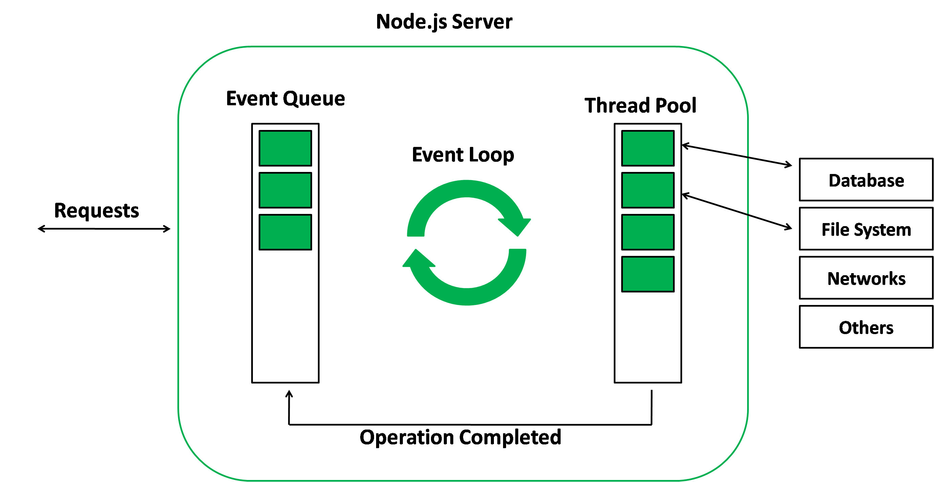

### NODE GLOBAL OBJECT

* “global” is the name of the global object in node similar to “window” object in browser runtime environment.

|  |  |  |
| --- | --- | --- |
| IN Browser window object | In Node global object    O/P | * In Node the variables we declare are not part of global object * **The scope of the variable is limited to that file itself or module itself. This because of Node’s modular system** |

### NODE MODULES

Every file in node is considered as module and the variables and function defined in that module is scoped to that module only

If we want to use the function or variable outside the module – we need to explicitly export it

Node JS modules follow ***Common JS Module System***.

1. **CREATE A MODULE**
2. **EXPORT THE MODULE**
3. **USE THE MODULE**

|  |  |  |
| --- | --- | --- |
| **CREATE A MODULE [LOGGER MODULE]** | **USE THE MODULE** | **FILE LOCATIONS** |
| CREATE a JS file **logger.js**  function logMessage(message) {  console.log(message);  }  **module.exports.logger = logMessage;** | USE IN **app.js**  const log = require("./logger");  log.logger("Hello"); |  |

**IMPORTANT POINTS**

1. **module.exports 🡪** This is used to export variables and function- which can be used by another modules.
2. **“require(<file_path/ module>)” 🡪** This is used to import the exported function /variables from the module

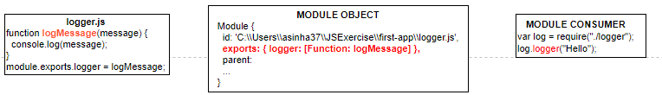

#### MODULE WRAPPER FUNCTION

|  |  |
| --- | --- |
| * module is an object which is local to the module – not a global object. * The code in the modules are internally wrapped around IIFE * As we can see exports , require,__filename,__dirname are local variables in an IIFE | (function (exports, require, module, __filename, __dirname)  var log = require("./logger");  log.logger("Hello");  )  **The IIFE is called MODULE WRAPPER FUNCTION** |

## CORE MODULES IN NODE

1. **PATH MODULE**
2. **OS MODULE**
3. **HTTP MODULE**
4. **EVENT MODULE**
5. **FILE SYSTEM MODULE**

### EVENT MODULE

* Event module has one important class “**EventEmitter**”

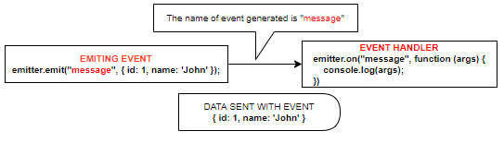

|  |  |
| --- | --- |
| const EventEmitter = require('events');  const emitter = new EventEmitter();  emitter.on("message", (args) => console.log(args));  emitter.emit("message", { id: 1, name: 'John' }); | * While writing the event listener – the order is very important. The event listerner must be written before the “emit” is raised * We can pass the “data” as well which will be recieved by the event listener callback function as argument. |

#### CUSTOM EVENT EMITTER

* Custom Event Emitter are used by inheriting EventEmitter class
* Note: While emiting and handling an event – it should use same EventEmitter object reference. As shown below

|  |  |
| --- | --- |
| **Logger.js** | **App.js** |
| const EventEmitter = require('events');  class Logger extends EventEmitter {  logMessage(message) {  this.emit("message", message);  }  }  module.exports = Logger; | const Logger = require('./logger');  const log = new Logger();  log.on("message", (args) => console.log(args));  log.logMessage({ id: 1, name: "John" }); |

### HTTP MODULE

* This module helps us to create a webserver which can listen to a HTTP request on a given PORT.
* In the below program we are using “http” module to create a webserver which can listen to HTTP request at PORT=3000
* “server” object is an EventEmitter which generates “connection” event using” server.listen()”.
* We pass the “callback” function to the createServer() function.

|  |  |
| --- | --- |
| const http = require('http');  const server = http.createServer((request, response) => {  response.write("Hello World");  response.end();  });  server.listen(3000);  console.log("Listening on port 3000"); |  |

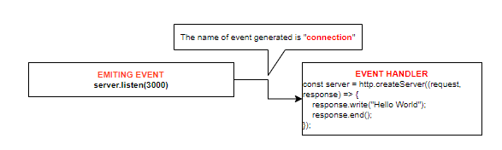

#### HANDLING MULTIPLE ROUTES

|  |  |
| --- | --- |
| const http = require('http');  const server = http.createServer((request, response) => {  if (request.url == "/") {  response.writeHead(200, { 'content-type': 'text/html});  response.write("<h1>Hello World</h1>");  }  if (request.url == "/api/courses") {  response.write(JSON.stringify(  {  courseId: 1,  courseName: 'C++'  }  ));  }  response.end();  });  server.listen(3000);  console.log("Listening on port 3000"); | The mime type play an important role for the browser to interprete the data in the response  response.writeHead(200, { 'content-type': 'text/html});    response.writeHead(200, { 'content-type': 'text/text}); |
| const url = require("url");  const {pathname, query} = url.parse(request.url,true);  const server = http.createServer((request,response) =>{  if(pathname =='/api'){  console.log({  pathname:pathname,  queryString:query['productid']  })  response.end();  }  });  server.listen(3001,()=>{  console.log('Listening on Port 3001...')  }); | **FETCHING THE QUERY STRING**   * To fetch the query string from the url we need to parse the url * Parsing the url can be done using the “**url**” module |

### FILE SYSTEM MODULE

#### READING AND WRITING FILE SYNCHRONOUSLY

|  |  |
| --- | --- |
| const fs = require('fs');  const txtIn = fs.readFileSync('./txt/input.txt','utf-8');  const txtOut = `Adding to new file\n ${txtIn}`  fs.writeFileSync('./txt/output.txt',txtOut);  console.log(txtIn); | * We are using File System module to access file system * We are using “readFileSync” and “writeFileSync” function to read and write synchronously. * The reading and writing synchronously – shows the blocking nature of node. |

#### READING AND WRITING FILE ASYNCHRONOUSLY

|  |  |
| --- | --- |
| const fs = require('fs');  const txtIn = fs.readFileSync('./txt/input.txt','utf-8');  const txtOut = `Adding to new file\n ${txtIn}`  fs.writeFileSync('./txt/output.txt',txtOut);  console.log(txtIn); | * We are using File System module to access file system * We are using “readFileSync” and “writeFileSync” function to read and write synchronously. * The reading and writing synchronously – shows the blocking nature of node. |

## STREAMS AND BUFFERS

**INCOMING REQUEST**

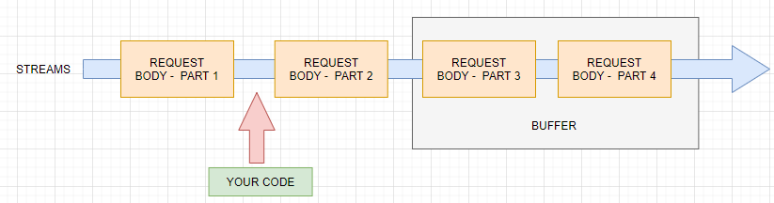

* **This concept is used parsing the data from the request.**
* Our stream here is basically an ongoing process, the request is simply read by node in chunks(multiple parts).
* Reading the incoming request as individual chunks without having to wait for the full request being read. Hence node don’t have to wait for entire request to finish before it start parsing it.

**USE CASE – HOW READING IN CHUNKS IS EFFICIENT?**

* Lets say – we are uploading a file by ready a stream of data – reading the data in chunks and writing it to disk is more efficient than reading the entire stream of data and the writing it.
* To read the incoming chunks of stream – we use something called “Buffer”. Buffers are chunks which can get hold of streams of data.

## NODE PACKAGE MANAGER (NPM)

|  |  |  |
| --- | --- | --- |
| NOTE : CREATE A NODE ACCOUNT in - <https://www.npmjs.com/> [avishekh/Sapient!123]  It’s a command line tool as well registry of third party module/libraries which we add to node project.  It has many build in modules which can be installed on out node application | |  |
| TO KNOW NODE VERSION | **npm –v** |
| TO INSTALL SPECIFIC VERSION OF NPM | **npm i -g npm@5.5.1** |
| TO CHECK LIST OF DEPENDENCIES AND VERSIONS | **npm list –depth=0** |
| INSTALLING DEV DEPENDENCIES | **npm install js-beautify --save-dev** |
| TO KNOW THE OUTDATED PACKAGES | **npm outdated** |
| UPDATE THE OUTDATED PACKAGE | **npm update <package_name>** |
| UNINSTALL A MODULE | **npm uninstall <package_name>** |

### PACKAGE.JSON

Package.json contains the basic information of the project like version ,author , git repo , dependecies etc.

It’s a metadata of the project

Before adding any node module to our project we need to have package.json file

|  |  |
| --- | --- |
| **CREATING PACKAGE.JSON FILE** | mkdir npm-demo  cd npm-demo  **npm init** |
| The npm init will prompt for some options to define the metadata of the project  This will create a package.json file based on the input provided | **PACKAGE.JSON**  {  "name": "npm-demo",  "version": "1.0.0",  "description": "",  "main": "index.js",  "scripts": {  "test": "echo \"Error: no test specified\" && exit 1"  },  "author": "",  "license": "ISC"  } |
| * We can even create package.json file with default values (without prompting any options) using below   COMMAND : **npm init --yes** |

#### NPM START SCRIPT

|  |  |
| --- | --- |
| {  …..  "scripts": {  "test": "echo \"Error: no test specified\" && exit 1"  “start”: ”node app.js”  “start-app”:”node app.js”  },  …..  } | The “start” script for package has special meaning in package .json file.   * Any script in the “start” can be executed as   **npm start**   * The script in the “start-app” must be executed as   **npm run start-app** |

### INSTALLING A THIRD PARTY NODE PACKAGES

|  |  |
| --- | --- |
| **INSTALLING A NODE PACKAGE**  We can find the package names at [**https://www.npmjs.com/**](https://www.npmjs.com/) | **npm i <package_name>**  **eg - npm i underscore** |
|  | Runnning this command will Add “underscore” node module and add the **dependencies** to package.json file.  When we install the node package- it will also install other package too on which underscore in depending on. |

### USING THE NODE PACKAGE

|  |  |
| --- | --- |
| * To can use the node package using “require” function * **contains** is a function from underscore library | const _ = require("**underscore**");  console.log(_.contains([1, 2, 3], 3)); |

### INSTALLING DEV DEPENDENCIES

|  |  |
| --- | --- |
| Sometime we need some dependecies which are needed during development only . This package will not be part of the application in PROD environment  COMMAND: **npm install js-beautify --save-dev** | {  "name": "npm-demo",  "version": "1.0.0",  "description": "",  "main": "index.js",  "scripts": {  "test": "echo \"Error: no test specified\" && exit 1"  },  "keywords": [],  "author": "",  "license": "ISC",  "dependencies": {  "underscore": "^1.9.2"  },  "devDependencies": {  "js-beautify": "^1.10.3"  }  } |

### NPM PACKAGES AND SOURCE / VERSION CONTROL

* When we commit out code in any version control system like GIT, we don’t actually commit the node_modules folder. We don’t need to do so because node can able re-download the dependencies by referring the package.json file by executing “**npm install”** command.
* So will committing the project we need to ignore the node_module folder.

|  |  |  |
| --- | --- | --- |
| **STEP 1 : GIT INIT** | Create an empty Git repository or reinitialize an existing one | |
| **STEP 2: GIT STATUS** | git status 🡨 The git status will show all the files along with node_modules folder which we need to ignore  index.js  **node_modules/**  package-lock.json  package.json | |
| STEP 3: CREATE .GITIGNORE FILE   * Create a .gitigore in the root folder of the project * Enter the folder name in the file as * node_module/ * Now- git status will ignore the folder this time | |  |
| **Step 4: git add .**  **Step 5: git commit –m “first commit”** | |  |

### UN-INSTALLING PACKAGES

* COMMAND – **npm un <package_name>** e.g **npm un jshint**

This will remove the entry from the package.json file and uninstall the node package too from node_module folder.

### PUBLISHING NPM PACKAGE TO NPM REPO

|  |  |
| --- | --- |
| 1. Create a folder e.g node-publish 2. Create a **package.json** file in it(npm **init**) 3. Create a **index.js** file and add the following function | **module.exports.add** = function(a, b) {  return a + b;  }; |
| Note :  **While creating the package.json file the name property should have same value as you node repo username** |  |
| TO PUSH TO TO NPM REPO  We should have npm account to push our custom package to node repo  STEPS TO PUSH  LOGIN TO NPM - npm login  PUSH THE PACKAGE – npm push |  |
| **USING THE PUBLISHED PACKAGE** |  |

## ASYNCRONOUS PROGRAMMING IN NODE

### CALLBACK HELL

In the below example

* We are using “superagent” module as an http client.
* In the below code
  + We are reading a dog breed name from a file using “fs” module
  + Making a API call to using the breed name and fetching the dog’s image
  + Finally, we are writing the image path in the file.
* Chaining multiple callbacks leads to a problem call callback hell – which is hard to manage and degug

|  |
| --- |
| const fs = require("fs");  const superagent = require('superagent');  fs.readFile(`${__dirname}/dog.txt`,'utf-8',(err,data) =>{  if(err) return console.log(err.message);  superagent.get(`https://dog.ceo/api/breed/${data}/images/random`).end((err,data)=>{  if(err) return console.log(err.message);  fs.writeFile(`${__dirname}/dogImage.txt`,data.body.message,(err)=>{  if(err) return console.log(err.message);  console.log("Data Dumbed in File");  });  })  }); |

### SOLVING CALLBACK HELL

The callback hell can be resolved using

1. Promises
2. Async /Await

#### PROMISES

# EXPRESS JS

* There are various frameworks available to build REST API on top of node HTTP Module. Express is one on them. Express is built on top of HTTP node module.
* With HTTP module of node – to handle routes- Node has to explicitly set the status code, mime type and end the response. Express takes care of all without writing anything explicitly.

## RESTFUL API USING EXPRESS JS

* UHG <https://hubconnect.uhg.com/docs/DOC-210865>

|  |  |
| --- | --- |
| CREATING A NODE PROJECT (creates a package.json) | **npm init --yes** |
| INSTALL EXPRESS | **npm i express** |
| SAMPLE EXPRESS PROGRAM(index.js)  const express = require('express') 🡨 *Returns a function*  const app = express() 🡨 Calling the function  app.get('/', function (req, res) { 🡨 It will handle get request  res.send('Hello World')  })  app.listen(3000,() => console.log(“Listening on port 3000…”)) | TO RUN THE PROGRAM: node index.js  Hit the browser : [**http://localhost:3000/**](http://localhost:3000/)  Note:  require('express') returns a function |

## NODEMON

* Nodemon is a tool that helps develop node.js based applications by automatically restarting the node application when file changes in the directory are detected.
* Nodemon act as a watcher for the changes we make in node application – so we don’t have to restart the server with every code change

|  |  |
| --- | --- |
| INSTALLING NODEMON | **npm i nodemon** |
|  | * **RUNNING THE PROGRAM: nodemon index.js** |

## CONFIGURING LISTENING PORT

|  |  |
| --- | --- |
| const port = process.env.PORT | 3000;  app.listen(port, () => {  console.log(`Listening on ${port}`);  }); | * The port on which the express server can be made configurable. The port on a particular environment is assigned dynamically. This captures the dynamically assigned port we use : ***process.env.PORT*** * If no port is assigned it will fall back to port = 3000 |
| **export PORT= 5000** | * The port can be assigned from command line too by setting the environment variable. |

## MIDDLEWARE / MIDDLEWARE FUNCTIONS

* Express is all about middleware.
* When a request arrives – It funneled through bunch of functions by express JS. All the function (which we are calling as middleware) – are pluggable in nature.
* To plug the middleware – express provide “**use**” function. [https://expressjs.com/en/4x/api.html#app.use ]

|  |  |
| --- | --- |
|  | **REQUEST PROCESSING PIPELINE**   * When we get request to the express server that request goes to a pipeline called “Request Processing Pipeline”. * In this pipeline – we can have one-or-more middleware functions to process the request * Each middleware function either pass the processed request to next middleware using **next()** or terminates the request/ response cycle by sending the response. * The middleware functions are called in sequence – in which they are defined |
| * In this code we are moving from middleware to middleware using next() function * The request-response will terminate only when the response is sent. | const express = require('express');  const  app  = express();  app.use((req,res,next)=>{      console.log("In the middleware 1")      next();  });  app.use((req,res,next)=>{      console.log("In the middleware 2");      res.send("<h1>Hello From Express!!</h1>");  });  app.listen(3000); |

### app.use()



* If no path is used in use function, then the root path (“/”) is the default.
* The path in app.use does the pattern matching for paths unlike app.get() or app.post() which does the exact match.

|  |  |
| --- | --- |
| EXAMPLE | |
| app.use(“/”,(req,res,next) =>{}) | This match all the urls |
| app.get(“/”,(req,res,next) =>{}) | This will match only the root path. |

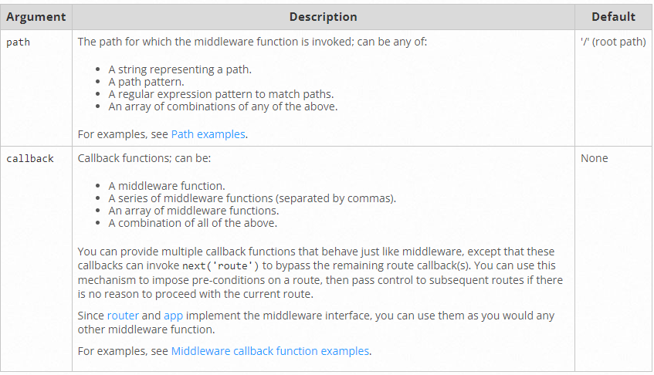

### OUTSOURCING THE ROUTES

|  |  |
| --- | --- |
|  | * The routes in the application can be outsourced in another file – rather than keeping all the routes in app.js * In the application – we are keeping the route in a routes folder. |

|  |
| --- |
| admin.js(Admin Route)  const express = require("express");  const router = express.Router();  router.use('/add-product',(req,res,next)=>{      res.send('<html><form action="/product" method="POST"><input type="text" name="title"><button type="submit">Submit</button></form></html>');  });  router.post('/product',(req,res,next)=>{     console.log(req.body);     res.redirect("/");  });  module.exports= router; |
| Shop Route  const express = require("express");  const router = express.Router();  router.get('/',(req,res,next)=>{      console.log("Welcome")     res.send('<h1>Hello From Express!</h1>');   });  module.exports=router; |
| App.js  const express = require('express');  const  app  = express();  const bodyParser = require("body-parser");  const adminRoutes = require('./routes/admin');  const shopRoutes = require('./routes/shop');  app.use(bodyParser.urlencoded({extended:false}));  app.use(adminRoutes);  app.use(shopRoutes);  app.use((req,res,next) =>{      res.status(404).send('<h1>Page Not Found'); 🡨 404 page implementation  })  app.listen(3000); |

### FILTERING THE PATHS

* If we have a common pre-fix in the route path it can be added to route as : app.use(“/admin”,adminRoutes);

Now the request that will be intercepted by admin Router will be : <http://localhost:3000/admin/add-product> or

### ADDING VIEWS

|  |  |
| --- | --- |
|  | * In the above example – we are sending the HTML directly in the response. We can send back the HTML page as well as a view in the response. |

### BUILD IN MIDDLEWARE FUNCTION

1. [express.static](https://expressjs.com/en/4x/api.html#express.static) serves static assets such as HTML files, images, and so on.
2. [express.json](https://expressjs.com/en/4x/api.html#express.json) parses incoming requests with JSON payloads. **NOTE: Available with Express 4.16.0+**
3. [express.urlencoded](https://expressjs.com/en/4x/api.html#express.urlencoded) parses incoming requests with URL-encoded payloads.

#### SERVING THE STATIC FILES

* This is a built-in middleware function in Express. It serves static files and is based on serve-static.
* The public folder can be used to serve static files like CSS or images.
* The express.static(“public”) indicates the folder/ path where the static files can reside
* The path to the “public” folder can be given as(using node’s path module) :

**app.use(express.static(path.join(__dirname, 'public')));**

* We can have multiple public folders, which can be configured using this middleware
* To access the static files in public folder : <http://localhost:4000/styles.css>

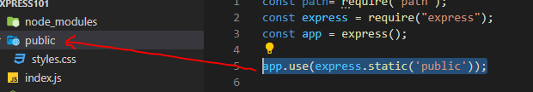

#### PARSING REQUEST BODY

express.json() : This parses the request body and if the request body is a JSON.It assign that value to request.body property

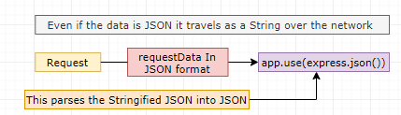

#### SERVING STATIC CONTENT [[express.static](https://expressjs.com/en/4x/api.html#express.static)]

|  |  |  |
| --- | --- | --- |
| CONFIGURING THE MIDDLEWARE FUNCTION:  app.use(express.static('public')); |  | The static file can be access from the root path  <http://localhost:7096/readme.txt>  <http://localhost:7096/courses.jpg> |

#### express.urlEncoded



* HOW TO CALL THE MIDLLEWARE : app.use(express.urlencoded({ extended: true }));
* Request Format : path?**key=data&key2=data2**

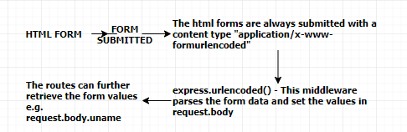EXAMPLE

* The below is a posting of JSON data. The content type of the request is as in the tab;le
* To cater this type of request we need express.urlencoded middleware

|  |  |  |
| --- | --- | --- |
| **REQUEST** | **EXPRESS** | |
| <script>  function fetchData(){  var request = $.ajax({  method:'POST',  url:'users',  dataType:"json",  type:'application/json',  data:{  userName:'Rob'  },  success: (data,status,xhr)=>console.log(data.message),  error:(jqXhr, textStatus, errorMessage)=> console.log("Error",errorMessage)  });  }  </script>  <button onclick="fetchData()">Fetch Data</button> | | const express = require("express");  const app = express();  app.use(express.static('public'));  app.use(express.json());  app.use(express.urlencoded({extended:true}));  **app.post('/users',(req , res)=>{**  **res.json(req.body.userName);**  **});**  app.listen(4000,()=>{  console.log("Listening on Port 4000...");  }) |
|  |

#### PUTTING IT TOGETHER

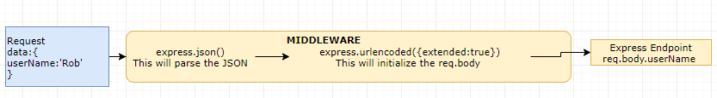

### CREATING CUSTOM MIDDLEWARE FUNCTION

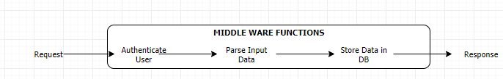

* For each the intermediate step we can have a dedicated middleware function to pre-process the request and response
* We can any number of middleware before we send back the response to the client.
* All the routes are also middleware.
* The Locals variable of response object is heavily used by middle ware to pass object to templates

**EXAMPLE**:

* validateUser is a custom middleware
  + The middleware has access to request, response and next
  + The next() function pass the control to the next middleware
* app.use(validateUser) 🡪 Call the middle ware for all HTTP request
* app.use(‘’/home”,validateUser) 🡪 Call the middle ware for for all HTTP request having “home” route
* app.get('/',validateUser,(req , res)=>{ }); 🡪 Calls the middleware for GET call with route path “/”
  + Note: (req , res)=>{ } is also a middleware function .
  + In above case the next middleware for validateUser is **(req , res)=>{ }**

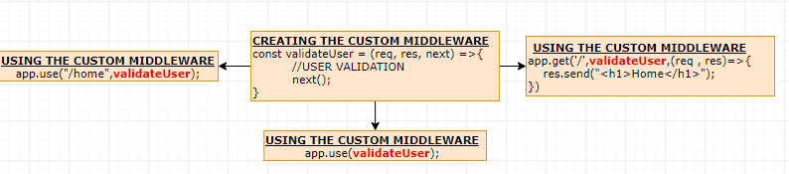

#### EXAMPLE – CUSTOM MIDDLEWARE

|  |  |
| --- | --- |
| const express = require('express');  const app = express();  const courses = [  { id: 1, name: 'Node' },  { id: 2, name: 'Java' },  { id: 3, name: 'C++' }  ];  app.use(express.json());  app.use((req, res) => {  console.log("Logging...")  req.next();  });  app.use((req, res) => {  console.log("Authencating...")  req.next();  }) | app.use(‘/admin’, (req, res) => {  console.log("Authencating...")  req.next();  })  app.get('/', (req, res) => {  res.send('Welcome to courses');  });  app.get('/api/courses', (req, res) => {  res.send(JSON.stringify(courses));  });  const port = process.env.PORT | 3000;  app.listen(port, () => {  console.log(`Listening on ${port}`);  }); |
| * Express usually has series of middleware functions. In the given example we have multiple middleware functions.(Highlighted in red) * The middleware functions are called in sequence – as they are declared * ***Each middleware either terminate the request -response cycle by sending the response or pass the control to next middleware function using next() function*** * App.get() [Route middleware function] is a middleware function which terminates the request -resposne cycle. * The middle ware functions can be included as a module too. * The middleware function can be also be executed for a specific routes as well (example in green) . This middleware will only execute for “/admin” route | |

### LOCALS

* All the middleware has an access to request , response and next() .
* The locals is and object encasulated in the response object . This locals object can be used to send data between the middlewares or to the template – which finally can be sent to the client.
* The property set in **locals** can be directly accessed in templates as shown below in the template(EJS)
* Locals property can also set in the routes (routes also are middleware)- as shown below

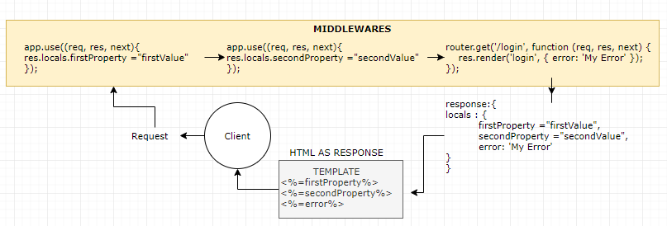

### THIRD PARTY MIDDLEWARE FUNCTION

* List of Third party middlewate : <https://expressjs.com/en/resources/middleware.html>

#### HELMET



|  |  |
| --- | --- |
| INSTALL HELMET | npm i helmet |
| INCLUDING THE HELMET MODULE | const express = require("express");  const helmet = require("helmet");  const app = express();  app.use(helmet()); |

## ROUTING PARAMETER & HANDLING HTTP REQUESTS

* Node has function to accept HTTP requests like GET, POST, DELETE,PUT
* REQUEST URL : <http://localhost:3000/api/courses?name=John>

|  |
| --- |
| const express = require('express')  const app = express();  app.use(express.json()); 🡨 THIS PARSE THE REQUEST BODY IN JSON FORMAT  const courses = [  { courseId: 1, courseName: 'Java' },  { courseId: 2, courseName: 'C++' }  ];  app.get('/api/courses', (req, res) => res.send(courses)); 🡨 GET REQUEST  app.get('/api/courses/:id', (req, res) => { 🡨 REST PARAMETERIZED & QS STRING - GET REQUEST  const filteredCourse = courses.find(course => course.courseId == req.params.id);  if (filteredCourse) {  res.send(`Hello ${req.query.name} - your courses id is ${filteredCourse.courseId} and name is ${filteredCourse.courseName}`);  } else {  res.status(404).send("No Courses Found");  }  });  app.listen(3000);  console.log(`Listening on port 3000 ...`); |

### POST REQUEST

|  |  |
| --- | --- |
| app.post('/api/courses', (req, res) => {  var course = {  courseId: courses.length + 1,  courseName: req.body.courseName  };  courses.push(course);  res.send(course);  }); | * Note : For req.body to work – We need to write app.use(express.json());. This will parse the request body in JSON format. |
| **POSTING DATA USING POSTMAN** | |
|  | |

### INPUT VALIDATION (USING JOI)

The most powerful schema description language and data validator for JavaScript.

|  |  |
| --- | --- |
| INSTALLING JOI | npm install joi |
| JOI API | <https://joi.dev/api/> |

### PUT REQUEST

Updating the resource(Example for updating the course)

|  |
| --- |
| app.put('/api/courses', (req, res) => {  const isCourseExist = courses.find(course => course.courseId == req.body.courseId);  if (!isCourseExist) {  res.status(404).send("No Courses Found");  return;  }  courses[isCourseExist.courseId - 1].courseName = req.body.courseName;  res.send(isCourseExist);  }); |

### DELETE REQUEST

Deleting the resource(Example for deleting the course)

|  |
| --- |
| app.delete('/api/courses/:id', (req, res) => {  const course = courses.find(course => course.courseId == parseInt(req.params.id));  if (!course) {  res.status(404).send("No Courses Found");  return;  }  res.send(courses.splice(courses.indexOf(course), 1));  }) |

### RESPONSE

* Whenever express sends back the response it does set the appropriate header to the response header
* The response header depends upon the method used (send(); json()) while sending back the response

|  |  |
| --- | --- |
| app.post('/users',(req , res)=>{  res.send("Data");  }); |  |
| **SENDING THE JSON RESPONSE**  app.post('/users',(req , res)=>{  res.json("Data");  }); |  |

## SERVER-SIDE RENDERING USING TEMPLATING ENGINE

* The template engine helps is Server Side rendering as the HTMLs (using template engine) in server side. The final HTML is sent back to client.

|  |  |
| --- | --- |
|  | * Templating Engines are used by express to send HTML markups to the client. * The HTMLs are created on the server side itself and send back to client as a HTML payload * We have multiple templating engines for express JS like   + **PUG(JADE)**   + **MUSTACHE**   + **HANDLEBARS**   + **EJS** |

### APP SETTING TABLE

* <https://expressjs.com/en/4x/api.html#app.set>

### HOW EXPRESS USES THE TEMPLATING ENGINE

1. Step 1: Install the templating engine node module
2. Step 2: Let express know about the view engine we want to use
3. Step 3: Let express know – the path, where views are located
4. Step 4: The client gets the final rendered HTML (already build in server side itself)

### USING TEMPLATING ENGINE - EJS

Reference - <https://ejs.co/>

|  |  |
| --- | --- |
| **INSTALLING EJS** | npm i ejs |
| **DECLARE THE VIEW ENGINE** |  |
| **SET THE VIEW ENGINE – This will load the pug module and set the view engine as EJS** | app.set('view engine', 'ejs'); |
| **SET THE PATH OF VIEW FILES – default is “view” folder under root folder** | app.set('views','./views'); |
| **SETTING THE PATH USING PATH MODULE** | const path = require('path');  app.set('views', path.join(__dirname, 'views')); |

#### EXAMPLE

|  |  |
| --- | --- |
| EJS | DATA PASSING FROM ROUTE |
| <h1> <%=heading%> </h1>  <p> <%=content%> </p> | app.get('/', function (req, res) {  res.render('index', { heading: 'Headline', content: 'Some Content' });  }); |

#### USING TEMPLATING ENGINE - HANDLEBARS

* Handlebars is not part express installation – Hence we need to add the import explicitly

|  |  |
| --- | --- |
| INSTALLING HANDLEBARS | npm i express-handlebars |
| ADDING THE IMPORT | app.engine(hbs,expressHbs()); |
| SET THE VIEW ENGINE – This will load the pug module and set the view engine as EJS | app.set('view engine', 'hbs'); |
| SET THE PATH OF VIEW FILES – default is “view” folder under root folder | app.set('views','./views'); |
| SETTING THE PATH USING PATH MODULE | const path = require('path');  app.set('views', path.join(__dirname, 'views')); |

#### USING TEMPLATING ENGINE - PUG

|  |  |
| --- | --- |
| INSTALLING PUG | npm i pug |
| SET THE VIEW ENGINE – This will load the pug module and set the view engine as Pug | app.set('view engine', 'pug'); |
| SET THE PATH OF VIEW FILES – default is “view” folder under root folder | app.set('views','./views'); |

##### SAMPLE PUG SYNTAX

|  |  |
| --- | --- |
|  | * The dynamic values are filled by an JS object e.g.   **app.get('/', (req, res) => {**  **res.render('index', { title: 'The Title', message: 'The Message' });**  **});**   * **“index” is name of the view (index.pug)** * The JS object has dynamic value for the template (title & message) |
|  |

#### STRUCTURING THE EXPRESS APPLICATION

To structure the express application – we might have to divide the file in follworing ways

|  |  |  |
| --- | --- | --- |
| View | This will have all the template code/file (.pug) |  |
| Routes | This will all the routes similar type |
| middleware | Contains the middleware Functions |
| Public | Contains the static contnet like css, Js, txt and images |
| **index.js**  const express = require('express');  const app = express();  const loggingMiddleWare = require('./middleware/logging-middleware');  const auth = require('./middleware/authentication');  const courses = require('./routes/courses');  const home = require('./routes/home');  app.set('view engine', 'pug');  app.set('views', './views');  app.use(express.json());  app.use(express.static('public')); 🡨 The middleware function configure the location of static content (public folder)  app.use(loggingMiddleWare);  app.use(auth);  app.use('/api/courses', courses);  app.use('/', home);  const port = process.env.PORT | 3000;  app.listen(port, () => {  console.log(`Listening on ${port}`);  }); | |

|  |  |
| --- | --- |
| **MIDDLEWARE FUNCTIONS** | |
| **Auth** | **logging** |
| const auth = (req, res) => {  console.log("Authencating...")  req.next();  }  module.exports = auth; | const loggingMiddleWare = (req, res) => {  console.log("Logging...");  req.next();  };  module.exports = loggingMiddleWare; |
| **ROUTES** | |
| **COURSES ROUTE** | **HOME ROUTE** |
| const express = require('express');  const router = express.Router();  const courses = [  { id: 1, name: 'Node' },  { id: 2, name: 'Java' },  { id: 3, name: 'C++' }  ];  router.get('/', (req, res) => {  res.send(JSON.stringify(courses));  });  router.get('/:id', (req, res) => {  const course = courses.filter(course => course.id == req.params.id);  if (course.length == 0) {  res.status(404);  res.send("Course Not Found");  }  console.log(course);  res.send(JSON.stringify(course));  });  router.post('/', (req, res) => {  course = {  id: courses.length + 1,  name: req.body.name  }  courses.push(course);  res.send(course);  });  module.exports = router; | const express = require('express');  const router = express.Router();  router.get('/', (req, res) => {  res.render('index', { title: 'The Title', message: 'The Message' });  });  module.exports = router; |
| * While setting up the courses route in index.js file – we configure the root path “**/api/courses**”. Then we can remove the root route from couses routings * In the router file we are don’t have to use the “app” object to configure different routes as we did in previous example instead we use   const router = express.Router();  to configure route   * All the middleware function as exposed as module – which in turn added in index.js in a desired in sequence.(because the middleware order matters) |

## EXPRESS GENERATOR

* Express Application Generator creates the express application skeleton (like maven)
* Reference : <https://expressjs.com/en/starter/generator.html>

|  |  |  |
| --- | --- | --- |
| **INSTALL EXPRESS GENERATOR GLOABALLY** | npm install -g express-generator | GENERATED STRUCTURE |
| **CREATING EXPRESS APP(myapp) WITH PUG AS TEMPLATING ENGINE** | express --view=pug myapp |  |
| **INSTALL DEPENDENCIES** | npm install |
| **RUNNING THE APP**  **Note: VS code uses “PowerShell”** | On Windows Command Prompt, use this command:  **set DEBUG=myapp:* & npm start**  On Windows PowerShell, use this command: : **$env:DEBUG='myapp:*'; npm start** |
| **ACCESS THE APP ON BROWSER** | <http://localhost:3000/> |

## DEBUG – EXPRESS

* Debugging is basic step in the development.
* The debug module in express help us enabling and disabling the “debug logs” based on the environment variables.

|  |  |
| --- | --- |
| **INSTALLING DEBUG MODULE** | npm i debug |
| **IMPORTING DEBUG MODULE** : - The debuggers are enabled based on the namespace. We can logically we divide the debugger into different namespaces. Here ‘app:start’ is a namespace | const debug = require("debug")('app:start'); |
| **USING THE DEBUG MODULE** | debug("Appllication Running!"); |

### EXAMPLE

|  |  |
| --- | --- |
| Module 1 | Module 2 (Routing ) |
| const express = require('express');  const debug = require("debug")('app:start');  const app = express();  const port = process.env.PORT | 3000;  app.listen(port, () => {  console.log(`Listening on ${port}`);  debug("Application Running!");  });  Here debuggers are created in 2 different namespaces. They can be enabled and disabled based on the environemnt variables (during the app start-up also) | const express = require('express');  const router = express.Router();  const routingDebug = require("debug")('app:router');  const courses = [  { id: 1, name: 'Node' },  { id: 2, name: 'Java' },  { id: 3, name: 'C++' }  ];  router.get('/:id', (req, res) => {  const course = courses.filter(course => course.id == req.params.id);  if (course.length == 0) {  res.status(404);  res.send("Course Not Found");  }  routingDebug(course);  res.send(JSON.stringify(course));  });  module.exports = router; |

### ENABLING DEBUG

|  |  |  |
| --- | --- | --- |
| **COMMAND** | **COMMAND LINE** | **POWERSHELL (VS CODE)** |
| Enable the debugging of app:start namespace | set DEBUG=app:start & nodemon .\index.js | $env:DEBUG='app:start' ; nodemon .\index.js |
| Enable the debugging of both “app:start” and “app:router”namespace | set DEBUG=app:start,app:router & nodemon .\index.js | $env:DEBUG='app:start','app:router' ; nodemon .\index.js |
| Enable the debugging of all namespace | set DEBUG=app:* & nodemon .\index.js | $env:DEBUG='app:*' ; nodemon .\index.js |
| The debug module code code the debug statement which are in different namespace. | |  |

## DEBUGGING CODE – USING CHROME DEVELOPER TOOL

To debug the Node Js code in chrome developer tool (We can able to do so because both node and chrome build upon same JS engine – V8)

### STEPS TO DEBUG

|  |  |
| --- | --- |
| 1. Add a “debugger” statement in the code around the code to debug 2. Run command : npm inspect <file.js> **: npm inpect app.js** |  |
| 1. Open Chrome and hit : **chrome://inspect** 2. **It will show a remote target** |  |
| 1. Click on inspect . It will open the Chrome developer tool. 2. In the chrome developer tool. Browse to the folder – where the code has been placed. 3. Click the “Play” button to resume the debugging . 4. Hit Ctrl+ C in the terminal to stop the debugging. |  |

## REQUEST/RESPONSE OBJECT IN EXPRESS

|  |  |
| --- | --- |
| FETCH DATA FROM QS | If QS is “msg”. Fetching : req.query.msg |
| SET DATA IN COOKIE | res.cookie("username", username); |
| FETCH DATA FROM COOKIES | req.cookies.username |
| REDIRECTING TO A ROUTE (LANDING) | res.redirect('/landing'); |
| DELETE COOKIE | res.clearCookie("username"); |

### EXAMPLE - APPLICATION FLOW DIAGRAM

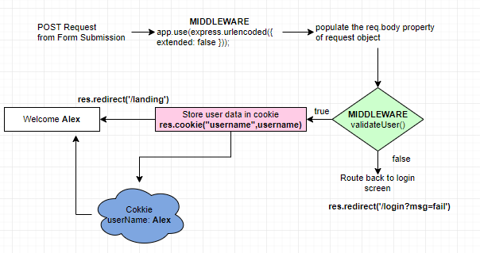

## DYNAMIC ROUTE PARAMS

|  |  |
| --- | --- |
| app.get('/story/:storyId',(req,res,next)=>{  const storyId = req.params.storyId;  res.send(`<h1>Story ${storyId}</h1>`)  }); | * StoryId is a route param which take dynamic params |

### ROUTERS

* In the above examples we were dumping all the routes in a single file. It always preferable to divide/organize the routes logically into separate files.
* If we create a middleware in a route file. That middleware will execute only for the route in that route file

|  |  |
| --- | --- |
|  |  |

* The below route file will intercept urls like : <http://localhost:4000/story/1> or <http://localhost:4000/story/2>
* Note : “:storyId” indicate that it’s a dynamic route param

|  |  |
| --- | --- |
| app.js | Route file(story.router.js) |
| let storyRouter = require('./routes/story.router');  app.use("/story",storyRouter); | const express = require("express");  let router = express.Router();  router.get('/:storyId',(req,res,next)=>{  const storyId = req.params.storyId;  res.send(`<h1>Story ${storyId}</h1>`)  });  module.exports = router; |

## TESTING NODE AND EXPRESS USING JEST

To write unit test using JEST for node and express code . We need couple of dev dependencies

### INSTALL MODULES

|  |  |  |
| --- | --- | --- |
| JEST | Jest is the framework which enable the unit test for Unit test for node and express code | **npm install jest** |
| SUPERTEST | Helps in the testing HTTP calls. | **npm install supertest** |

### UPDATE PACKAGE.JSON

|  |  |  |
| --- | --- | --- |
| * Add the test script . Here “Jest” will get started in watch mode. * To start Test suite : **npm test** * **Note :** The test file should have “.test” in the file name . e.g demo.test.js |  |  |

### WRITING TEST

|  |  |
| --- | --- |
| INDEX.JS [FUNCTION TO BE TESTED] | TEST |
| const calculateTotalBill = (billAmount, tipPercent)=> billAmount + billAmount * tipPercent  const fahrenheitToCelsius = (tempInFahrenheit) => (tempInFahrenheit-32)* (5/9);  const celsiousTofahrenheit= (tempInCelsius) => (tempInCelsius*9/5)+ 32;  module.exports= {  calculateTotalBill,  fahrenheitToCelsius,  celsiousTofahrenheit  } | const {calculateTotalBill,fahrenheitToCelsius,celsiousTofahrenheit} = require('../index');  test('Calculate Bill',()=>{  expect(calculateTotalBill(10,.3)).toBe(13);  });  test('Calculate Fahrenheit Tempreature',()=>{  expect(fahrenheitToCelsius(32)).toBe(0);  });  test('Calculate Fahrenheit Tempreature',()=>{  **expect**(celsiousTofahrenheit(32)).**toBe**(89.6);  }) |
| **OUTPUT** |  |

### WRITING TEST FOR ASYNCHRONOUS CODE

Jest has multiple ways to test asynchronous code.

1. **USING CALLBACKS**
2. **USING PROMISES**
3. **USING ASYNC AND AWAIT**

### TESTING ASYNCHRONOUS CODE USING PROMISES

* Testing Asynchronous code is a special case. JEST never wait for the asynchronous code to complete. Due this behavior it shows the test to pass even if the assertion is failed.
* done() has to be called after the Promise is resolved and returned.

|  |  |
| --- | --- |
| **CODE TO TEST** | **TEST CASE** |
| const add = (operand1, operand2)=>{  return new Promise((resolve, reject) =>{  setTimeout(()=>{  resolve(operand1+operand2);  }, 500);  });  } | test(Promise Add Test',(done)=>{  add(2,3).then(result =>{  expect(result).toBe(5);  done();  })  }); |

### TESTING ASYNCHRONOUS CODE USING ASYNC AND AWAIT

* For async and await – We need to mark the test case as async

|  |  |
| --- | --- |
| **CODE TO TEST** | **TEST CASE** |
| const add = (operand1, operand2)=>{  return new Promise((resolve, reject) =>{  setTimeout(()=>{  resolve(operand1+operand2);  }, 500);  });  } | test('Async Await Add Test',async()=>{  const sum = await add(4,5);  expect(sum).toBe(9);  }); |

### TESTING THE EXPRESS API