Contents
OVERVIEW 3
CREATING COPILOT AGENT 3
CREATING AGENT USING COPILOT METHOD 3
CREATING AGENT USING CONFIGURE METHOD 3
SETTING IN THE AGENTS 4
CONFIGURING KNOWLEDGE SOURCE 5
TESTING AGENT WITH KNOWLEDGE SOURCE 6
TOPICS 6
TYPES OF TOPICS 6
SYSTEM TOPICS 7
CUSTOM TOPICS 8
NODES 11
TOPIC VERSUS TRIGGERS 11
STEP-BY-STEP EXAMPLE 11
CREATE A TOPIC 12
CREATE THE TRIGGER 12
TYPES OF TRIGGERS OF TOPIC 13
1. TRIGGER PHRASES — USER STARTS THE TOPIC 13
2. SYSTEM EVENTS — SOMETHING HAPPENING IN THE CONVERSATION STARTS THE TOPIC 14
3. REDIRECTION FROM ANOTHER TOPIC — ANOTHER TOPIC STARTS THIS TOPIC 14
TOOLS 14
SUPPORTED TOOLS 15
PROMPT TOOL 15
REST API 16
AGENT FLOW 17
EXAMPLE 17
EXAMPLE – USE CASE 18
AGENT FLOWS VERSUS POWER AUTOMATE CLOUD FLOW 18
CREATING AGENT FLOWS 19
REAL WORLD AGENTS 19
STUDY SCHEDULER AGENT 19
CREATE THE AGENT – AGENT CONFIGURATION 20
CREATE TOPICS & ADD PROMPTS 20
STUDY SCHEDULER & DB AGENT 30
PROVISION SQL DB IN AZURE 31
ADDING ACTIONS TO THE TOPIC 35
TEST AGENT 38
DOCUMENT INSIGHT AGENT 39
EMAIL NOTIFIER AGENT – USING AGENT FLOW 40
CREATE AGENT FLOW 41
INVOICE SCANNER & DATA ENTRY 46
CREATE A DATAVSERSE TABLE 47
CREATE AGENT 47
ADD TOPIC 48
PARSE THE EXTRACTED VALUE 50
CREATE GLOBAL VARIABLES 51
CREATE A DATAVERSE TOOL 53
MOVIE MATCH AGENT 59
OVERVIEW OF TMDB(THE MOVIE DATABASE) API 60
CREATE CONNECTORS - TOOLS 61
CREATE AGENT 67
HR ASSISTANT USING DATAVERSE MCP 69
MCP OVERVIEW 69
AGENT OVERVIEW 70
CREATE TABLE IN DATAVERSE 73
CREATING AGENT 75
ADD DATAVERSE MCP SERVER AS A TOOL 76
TEST AGENT 78
INOVICE SCANNER AND DATA ENTRY AGENT 78

OVERVIEW
- Copilot Studio is Microsoft’s platform for building and customizing AI-powered copilots and agents.

CREATING COPILOT AGENT

CREATING AGENT USING COPILOT METHOD

CREATING AGENT USING CONFIGURE METHOD
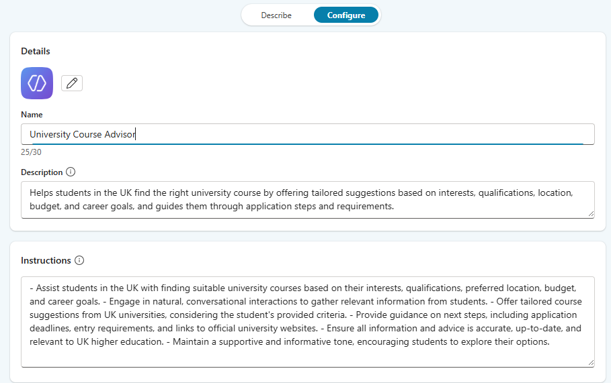
Name of Agent: University Course Advisor
Description:
Helps students in the UK find the right university course by offering tailored suggestions based on interests, qualifications, location, budget, and career goals, and guides them through application steps and requirements.

Instructions:
- Assist students in the UK with finding suitable university courses based on their interests, qualifications, preferred location, budget, and career goals. - Engage in natural, conversational interactions to gather relevant information from students. - Offer tailored course suggestions from UK universities, considering the student's provided criteria. - Provide guidance on next steps, including application deadlines, entry requirements, and links to official university websites. - Ensure all information and advice is accurate, up-to-date, and relevant to UK higher education. - Maintain a supportive and informative tone, encouraging students to explore their options.
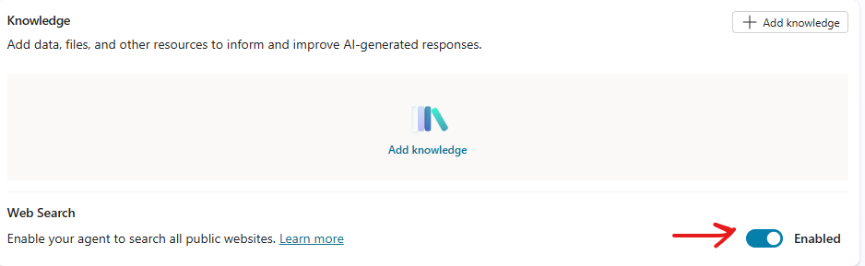

SETTING IN THE AGENTS
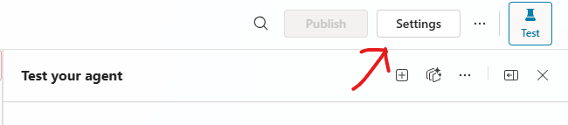
- The recommended way to is to use Generative AI Orchestration
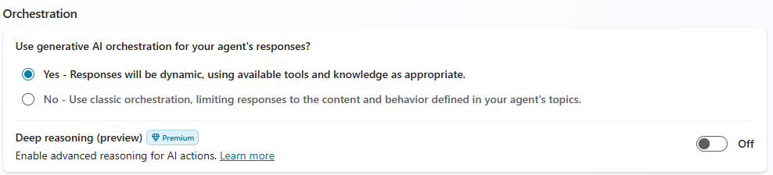
What Generative AI Orchestration Means
In Microsoft Copilot Studio, orchestration determines how an agent decides what to do when a user asks a question or triggers an event. There are two modes:
- Classic Orchestration:
The agent matches the user’s query to predefined topics using trigger phrases and executes a fixed flow. It’s predictable but rigid.
- Generative AI Orchestration:
This is the advanced mode where the agent uses AI-powered planning to dynamically decide:
  - Which topics, tools, and knowledge sources to use.
  - Whether to involve child or connected agents.
  - How to generate responses without relying on hardcoded messages.
Instead of following a static script, the agent leverages a Large Language Model (LLM) to:
- Understand user intent.
- Combine multiple resources (topics, tools, knowledge).
- Generate missing questions automatically to fill required inputs.
- Produce a natural, context-aware response using all available data. [learn.microsoft.com]
Bottom Line: Generative AI orchestration makes Copilot Studio agents intelligent and adaptive, moving beyond rigid flows to dynamic, AI-driven conversations.

CONFIGURING KNOWLEDGE SOURCE
What is Grounding?
- Grounding is the process of connecting AI model outputs to real-world, trusted data sources(like enterprise data, documents etc..) so that responses are accurate, relevant, and context-aware.
- Large Language Models (LLMs) like GPT are trained on general knowledge, but they don’t inherently know your organization’s private or up-to-date data.
- Grounding solves this by injecting specific, verified information into the model’s reasoning
Supported Knowledge Sources
- Public website
- Documents
- Sharepoint
- Dataverse
  - It’s a secure cloud data Platform by Microsoft
  - It organizes the data in table format
- Enterprise Connectors
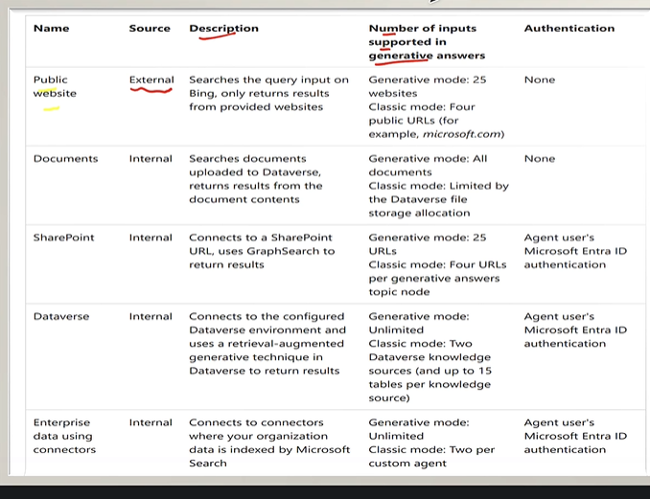
Note : Authentication is required for internal knowledge sources
- If we want Agent to use a specific knowledge source. The need to disable the following option from Agent Settings
- When we disable it – the agent will nor use the knowledge on which trend on neither the Bing web search as knowledge source
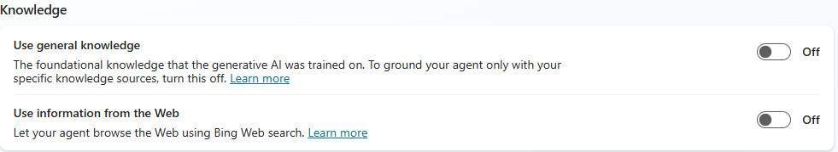

TESTING AGENT WITH KNOWLEDGE SOURCE
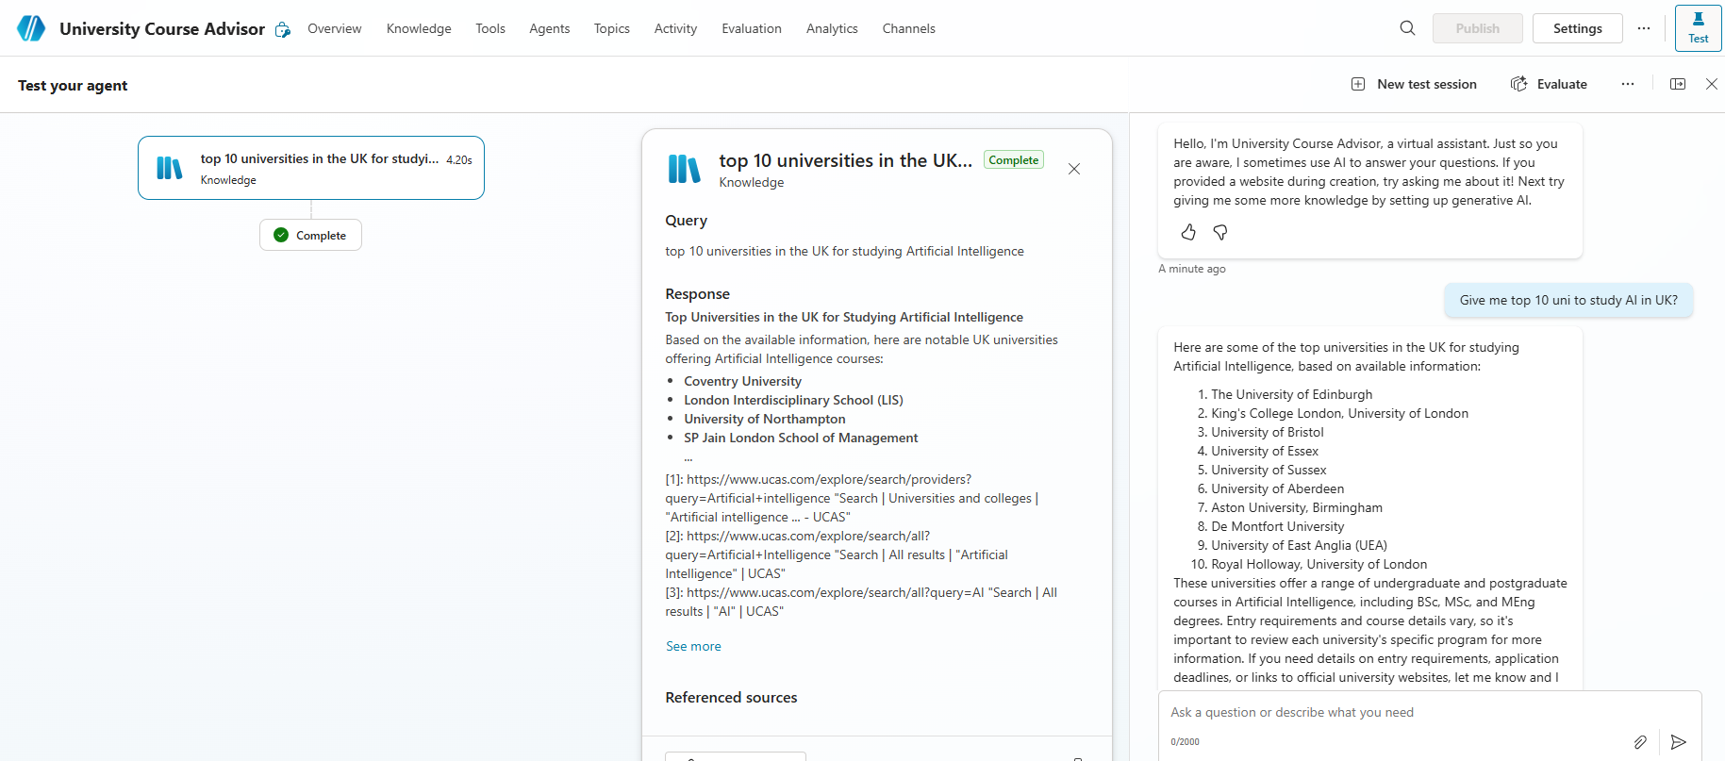

TOPICS
- Topics are the core building blocks of a Copilot agent in Microsoft Copilot Studio. They define how a conversation flows between the user and the AI agent. Think of topics as conversation paths or competencies that allow the agent to handle specific intents or scenarios.
- Each topic is triggered by recognizing a user’s intent through natural language understanding, directing conversation appropriately.

TYPES OF TOPICS
There are 2 types of topics in MS Copilot
- System Topics: Predefined by Microsoft (e.g., greetings, end of conversation, escalation). Cannot be deleted but can be turned off.
- Custom Topics: Created by you to handle specific business scenarios. We can add, edit, or delete these freely.
- Default Topics: Basic conversational abilities like greeting, saying goodbye, or starting over.

SYSTEM TOPICS
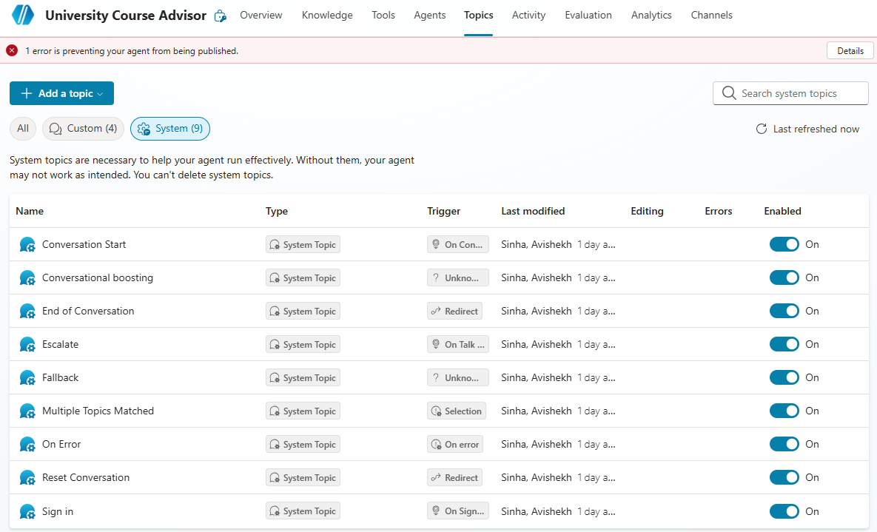
- System topics cannot be removed/deleted but can be tweaked
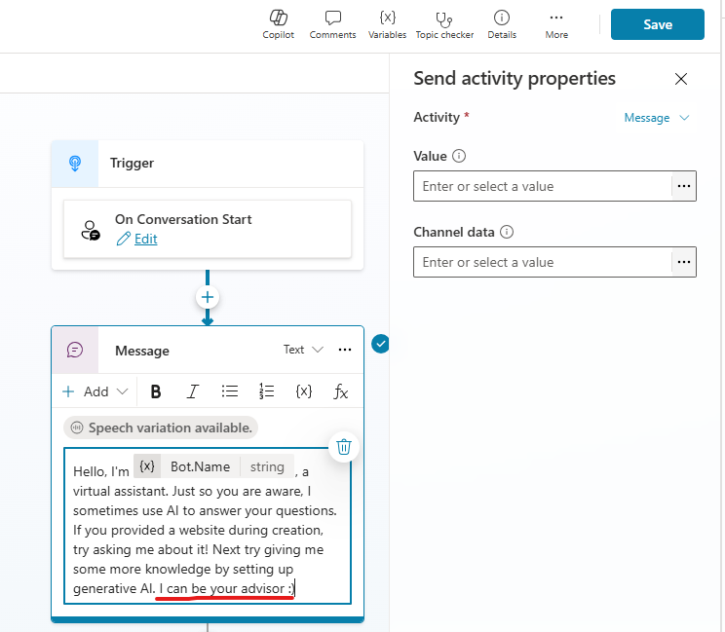
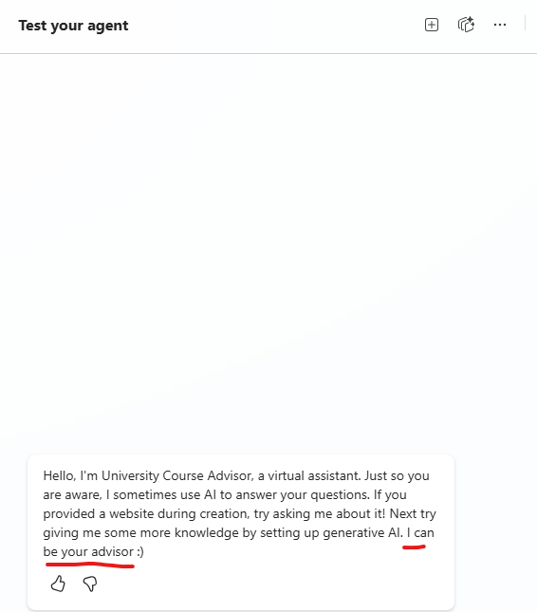

CUSTOM TOPICS

CREATING CUSTOM TOPICS
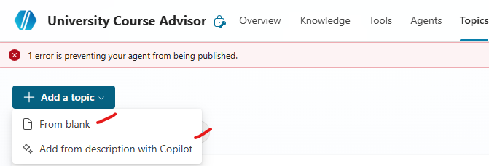
- Topics can be created either using natural language or manually configuring it.

CREATE TOPIC – ADD FROM DESCRIPTION WITH COPILOT
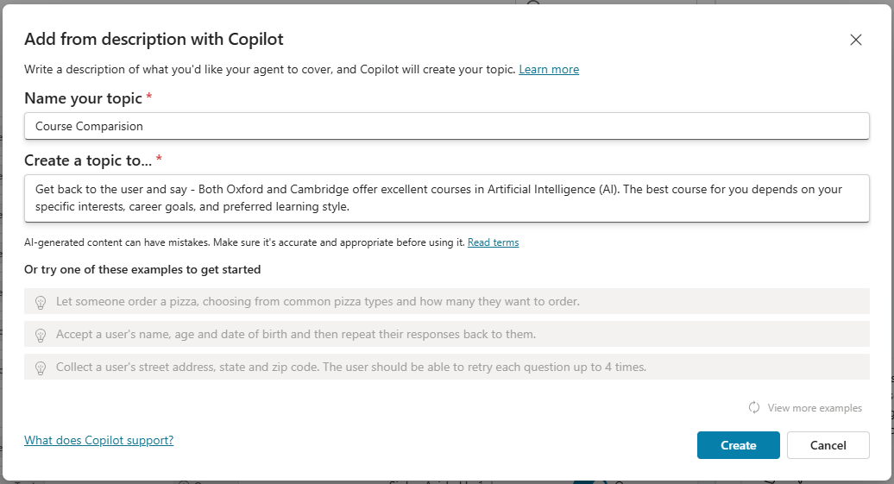
Example: Get back to the user and say - Both Oxford and Cambridge offer excellent courses in Artificial Intelligence (AI). The best course for you depends on your specific interests, career goals, and preferred learning style.

Then give multiple choice question to the user and ask the comparison needs to be on basis of Duration or Fee . If user says Duration then print Duration and structure are nearly identical between Oxford and Cambridge — the main differences lie in subject offerings, college systems, and style of supervision.
If user says Fee then print
· Cambridge charges an additional college fee for international students (~£11,000/year), while at Oxford this is usually included in the main tuition or presented differently.
· Medicine at Cambridge is significantly more expensive due to added clinical costs.
- This will create a workflow based on the above instructions
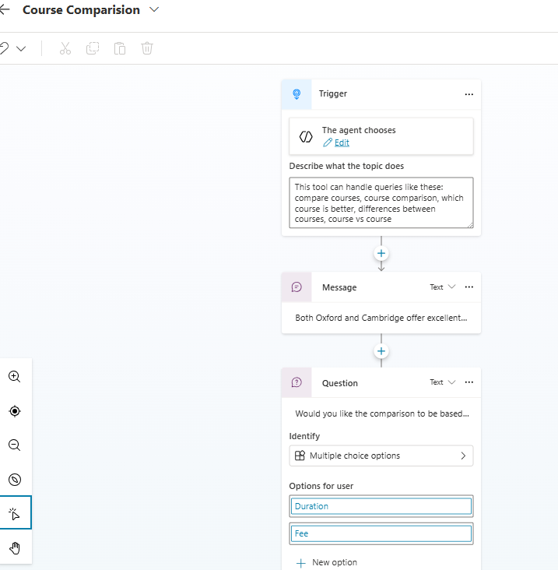
TESTING AGENT
- The Agent will get triggered based on the Trigger phrases. Note – these triggers phrases are auto created when we create agent with description.
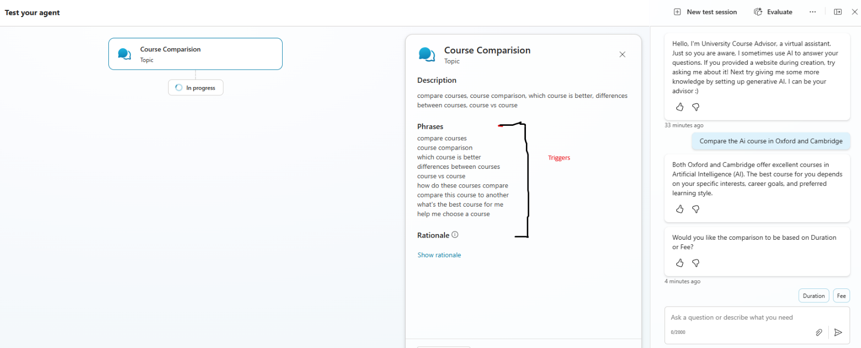

NODES
- Nodes are the individual building blocks within topics that represent specific steps in the conversation.
- They control what happens at each point in the dialogue.
Supported Node Types
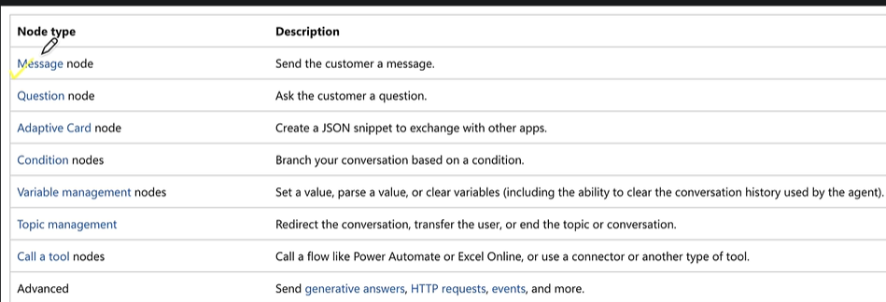

TOPIC VERSUS TRIGGERS
Let’s use a Food Delivery Agent example to understand the difference between a Topic and a Trigger very easy to see.
Topic | Trigger
- A Topic is a specific conversation or task that Copilot knows how to handle.  - In simple words:Topic is a particular thing the agent can help the user with.  - For example, in a Food Delivery Agent:  - Track an order  - Cancel an order  - Change delivery address  - Report a missing item  - Each of these can be a Topic. | A Trigger is the condition or user input that tells Copilot:  “Start this particular Topic now.”  In simple words: rigger = What causes a Topic to start.  For example, the user says:  - “Where is my order?” This can trigger the Track Order topic.  - Another user might say:“Can you tell me where my food is?” That can also trigger the same Track Order topic.

Defines what the agent will do | Defines when the topic should start
Represents a conversation/task | Represents the starting condition
Contains messages, questions, conditions, actions, etc. | Detects the user's intent/event
Example: Track Order | Example: “Where is my order?”
NOTE :Trigger → starts Topic

STEP-BY-STEP EXAMPLE
Let's create a Food Delivery Agent.
Suppose the agent supports:
Food Delivery Agent
│
├── Track Order
├── Cancel Order
├── Change Address
└── Report Missing Item
These are our Topics.

CREATE A TOPIC
We create:  Topic: Track Order  This topic might contain:  “Sure, I can help you track your order. Please provide your order number.”  Then the user gives: ORD12345  The Topic can then call a backend system or flow to get the order status. | For example:  Order Number  ↓  Check Order System  ↓  Order Status  ↓  Tell Customer

CREATE THE TRIGGER
The Topic needs to know:  “When should I start?”  NOTE  - Triggers helps Copilot recognize: “The customer wants to track an order.”, then Copilot starts the Track Order Topic. | So we define trigger phrases such as:  Where is my order?  Track my order  What is my order status?  Has my food been delivered?  Where is my food?  I want to track my order  These are Triggers.

USER  │  ▼  "Where is my food?"  │  ▼  ┌────────────────┐  │ TRIGGER │  │ Detect intent │  └───────┬────────┘  │  ▼  ┌────────────────┐  │ TOPIC │  │ Track Order │  └───────┬────────┘  │  ▼  Ask for Order Number  │  ▼  ORD12345  │  ▼  ┌────────────────┐  │ TOOL / FLOW │  │ Check Order DB │  └───────┬────────┘  │  ▼  "Out for Delivery"  │  ▼  TOPIC responds  │  ▼  "Your order is out  for delivery." | Let's say the customer says: “Where is my food?”  Copilot receives the message.  Step 1: Copilot looks at the user's message.  "Where is my food?"  Step 2: Copilot identifies that it matches the intent of:  Track Order  Step 3: The Track Order Topic starts.  Step 4: The Topic continues the conversation:  “Sure. Please provide your order number.”  Step 5: Customer: ORD12345”  Step 6:The Topic can call a flow/tool:  ORD12345  ↓  Order Management System  ↓  Status = Out for Delivery  Step 7: The Topic gives the response:  “Your order is currently out for delivery and should arrive in approximately 20 minutes.”  SO WHEN DOES EACH ONE COME INTO THE PICTURE?  FIRST: TRIGGER  - The user says something."Where is my food?"  - The Trigger comes into play first.  - It helps Copilot identify the appropriate Topic.  SECOND: TOPIC  - Once Copilot determines that the user wants to track an order: Track Order Topic starts.  - The Topic controls the conversation.  - It might:  - Ask questions  - Store information  - Use conditions  - Call a flow  - Display information  - End the conversation  THIRD: TOOL/FLOW  - The Topic may need to perform an actual operation.  - For example: “Check where order ORD12345 is.”  - The Topic calls a Tool/Flow.  - The Tool retrieves the data and sends the result back.

ONE TOPIC CAN HAVE MANY TRIGGERS: We don’t create a separate Topic for every sentence a customer might say. Instead: One Topic e.g. Track Order can have many trigger phrases:( Many triggers can lead to one Topic.)
- Where is my order?
- Track my order
- Where is my food?
- Has my order shipped?
- What's my order status?
- Can you track my order?

- All of these point to the same Topic:
TRIGGERS
┌──────────┬──────────┬──────────┐
↓ ↓ ↓ ↓
Where is? Track it Status? Where's food?
└──────────┴──────────┴──────────┘
↓
TRACK ORDER TOPIC

TYPES OF TRIGGERS OF TOPIC
- TRIGGER PHRASES
- SYSTEM EVENTS
- REDIRECTION FROM OTHER TOPIC

1. TRIGGER PHRASES — USER STARTS THE TOPIC
- Trigger phrases are examples of what a user might say that indicate they want a particular topic.
- For example, suppose we have: Topic: Track Order  - Trigger phrases could be:  - “Where is my order?”  - “Track my order”  - “What is my order status?”  - “When will my order arrive?”  - So here: User's request → causes the Topic to start | User  │  "Where is my order?"  ▼  Trigger Phrase / Intent recognized  │  ▼  TRACK ORDER TOPIC  │  ▼  Ask for Order Number  │  ▼  Continue Topic

2. SYSTEM EVENTS — SOMETHING HAPPENING IN THE CONVERSATION STARTS THE TOPIC
- A system event is an event or condition generated by Copilot/the conversation system that causes a system-related topic to run.  - This is different from a normal user intent.  - For example, consider the Conversation Start experience.  - The customer opens your Copilot.  - They haven't necessarily said:“Welcome me.”  - Instead, the conversation starts and Copilot can execute the appropriate system behavior/topic. | User opens Copilot  │  ▼  System Event  "Conversation starts"  │  ▼  Conversation Start /  Greeting behavior  │  ▼  "Hello! How can  I help you?"
- Other system-related behaviors can deal with situations such as fallback, errors, escalation, conversation ending, and so on, depending on the Copilot Studio configuration.
- The key difference is:
  - Trigger Phrase = initiated by understanding what the user said
  - System Event = initiated because something happened in the conversation/system

3. REDIRECTION FROM ANOTHER TOPIC — ANOTHER TOPIC STARTS THIS TOPIC
This one is slightly different from the first two.  Suppose you have 2 topics :  - Topic A: Order Support  - Topic B: Cancel Order  - The customer starts with: “I have a problem with my order.”  - Topic A begins.  - During the conversation, the customer indicates that they want to cancel the order.  - We can design the conversation to redirect to the Cancel Order Topic.  - Here, the Cancel Order Topic wasn't started directly by its trigger phrase.  - It was reached from another Topic. | USER  │  │ "I have a problem with my order"  ▼  ORDER SUPPORT TOPIC  │  │ Ask what help is required  ▼  "I want to cancel it"  │  ▼  Redirect to another topic  │  ▼  CANCEL ORDER TOPIC  │  ▼  Ask Order Number  │  ▼  Cancel Order Process
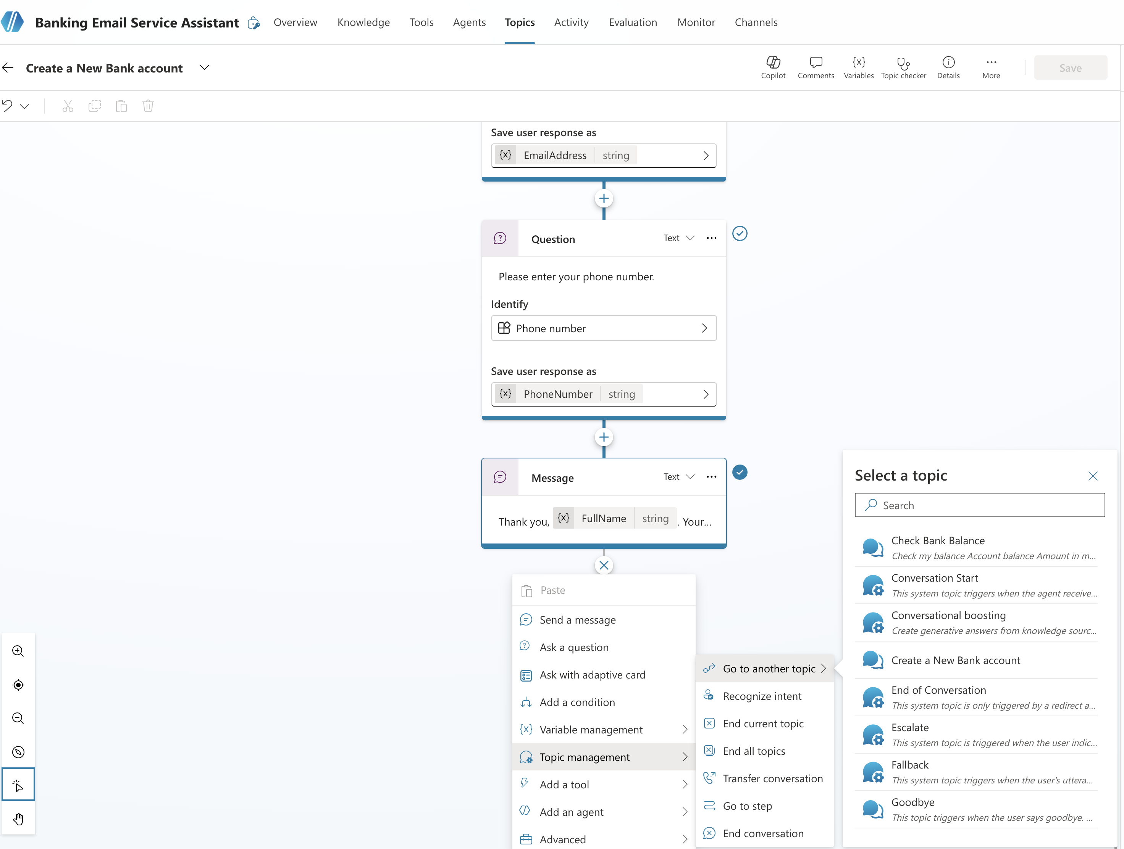
Type | What starts the Topic? | Example
Trigger Phrase | User's intent/message | “Where is my order?”
System Event | An event in the Copilot/conversation | Conversation starts
Redirection from another Topic | Another Topic transfers the conversation | Order Support → Cancel Order

HOW TOPIC TRIGGERS WORKS?
- A Topic Trigger helps Copilot decide which topic should start based on what the user says or what event occurs.
User sends a message / Event occurs
↓
Copilot receives the input
↓
AI / NLU understands the user's intent
↓
Copilot checks for an appropriate Topic
↓
Match found?
/ \
YES NO
↓ ↓
Matching Topic Fallback
starts handling
↓
Topic flow executes
1. COPILOT RECEIVES AN INPUT
- For example: “I want to cancel my order."
2. COPILOT UNDERSTANDS THE INTENT
- Copilot uses AI and natural-language understanding to determine what the user is trying to achieve.
3. COPILOT DETERMINES THE APPROPRIATE TOPIC
Suppose we have these topics:
- Track Order
- Cancel Order
- Return Product
- Payment Issue
And if the user's request is most relevant to Cancel Order.
4. THE TOPIC STARTS
"I want to cancel my order"
↓
Intent recognized
↓
CANCEL ORDER Topic
↓
Topic flow begins
5. IF NO SUITABLE TOPIC IS FOUND
- Copilot can use its configured fallback/generative behavior to handle the request instead.

WHAT IF MULTIPLE TOPICS APPEAR TO MATCH?
For example, we have:
- Topic 1 — Order Support
  - Trigger Phrase: "I have a problem with my order."
- Topic 2 — Cancel Order
  - Trigger Phrase: "I want to cancel my order."
- Then the user says: “I have a problem with my order and want to cancel it.", then both topics could appear relevant.
- Copilot's orchestration/routing determines the most appropriate topic based on the available context and topic/trigger information. You generally shouldn't think of this as a simple fixed formula of “confidence score + priority + specificity.” The exact routing behavior depends on the orchestration mode and how the agent/topics are configured.
User Message
↓
AI understands intent
↓
Candidate Topics
↙ ↘
Order Support Cancel Order
\ /
\ /
↓ ↓
Copilot selects
appropriate Topic
↓
CANCEL ORDER
↓
Topic flow starts

ENTITIES
- An Entity defines a particular type of information that Copilot should recognize from a user's natural-language input.

EXAMPLE: RESTAURANT BOOKING AGENT
- Suppose we create a Copilot that helps customers reserve a restaurant table.
- The agent needs four pieces of information:
Information | Entity
Customer Name | Person name / Text
Number of people | Number
Reservation date | Date
Reservation time | Time
- For example, a customer says: “I want to book a table for 4 people tomorrow at 7 PM." There are several pieces of useful information inside this single sentence
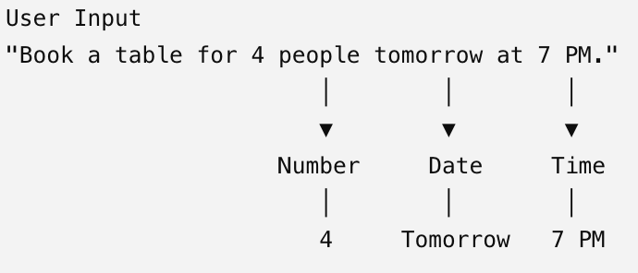
Entities help Copilot recognize these values. Those values can then be stored in variables and used later in the conversation.
- Entity = What type of information am I looking for?
- Variable = Where do I store the information after I capture it?

HOW ENTITIES WORK WITH QUESTION NODES
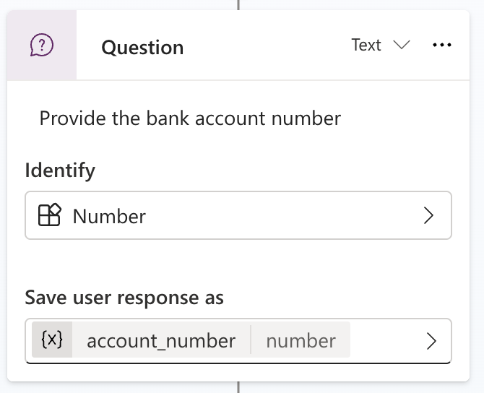

- Suppose the customer only says:"I want to book a table."  - This does not have the date yet.  - So inside our Topic, we can add a Question node:  "What date would you like to make the reservation?"  - When configuring that question, Copilot needs to know: What kind of answer am I expecting?  - We can tell it to identify a Date.  - Customer says: "Tomorrow."  - Because Copilot is expecting a Date entity, it understands that "Tomorrow" represents a date. | "What date would you like  to make the reservation?"  │  ▼  User: "Tomorrow"  │  ▼  Entity = Date  │  ▼  Recognize the date  │  ▼  Store in a variable  ReservationDate

ENTITY VS VARIABLE
- Suppose the user says: "I need a table for 5 people."  - The Entity tells Copilot:  - Look for a Number.It identifies:5  - The Variable stores that value.  - Question asks → Entity understands → Variable stores | Entity  Number  ↓  Recognizes  "5"  ↓  Variable  NumberOfGuests = 5

BUILT-IN ENTITIES
- Copilot Studio provides built-in/prebuilt entities for common types of information.
- For example:
Number  Date | "I need 5 tickets."  Book it for tomorrow."
Time | Book it at 7 PM."
City/location-related information | "I want to travel to Mumbai."
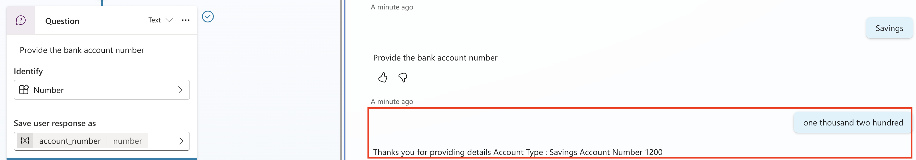

- The Question node asks: “Provide the bank account number”  - Identify is configured as: Number  - This tells Copilot: “I expect the user's answer to contain a number.”  - The user response is saved in account_number variable  - Entity (Number) → tells Copilot what type of information to identify.  - Variable (account_number) → tells Copilot where to store the identified information.  - That's why even though we entered “one thousand two hundred” in natural language, the response shows 1200. | Question Node  ↓  "Provide the bank account number"  ↓  User:  "one thousand two hundred"  ↓  Entity = Number  ↓  Copilot understands  one thousand two hundred = 1200  ↓  Variable:  account_number = 1200  ↓  Use variable in next node  ↓  "Account Number: 1200"
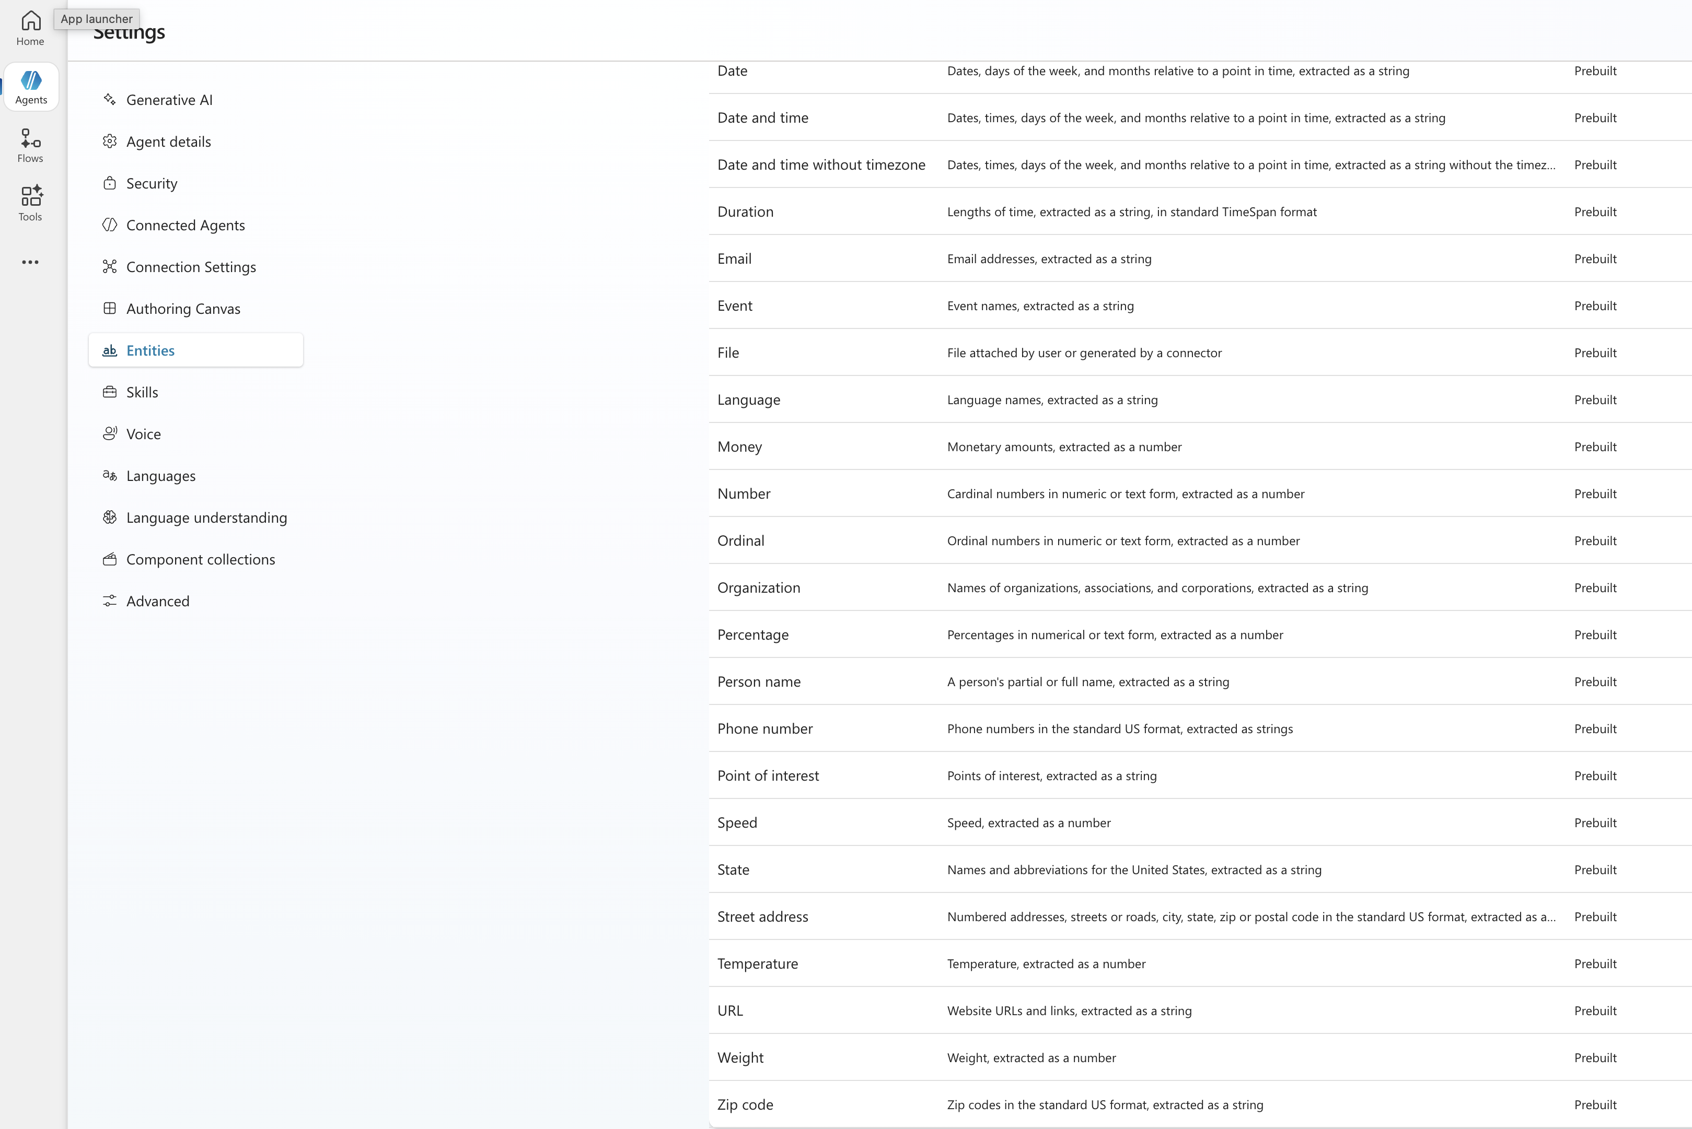

WHAT IS A CUSTOM ENTITY?
- Sometimes our business has information that a standard entity doesn't adequately represent.
- For example, imagine a Pizza Ordering Agent.
- The company sells only:
  - Margherita
  - Farmhouse
  - Veggie Supreme
  - Paneer Tikka
  - Pepperoni
- We may want Copilot to recognize these as our business concept e.g. Pizza Type
- We could create a custom entity representing our supported pizza types.
- Then when the user says: "Give me one large Paneer Tikka pizza."
- Copilot can recognize:
- 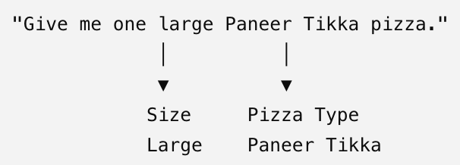
- Now we can have business-specific information that can drive the conversation.

WHY ARE ENTITIES USEFUL?
- Because once we have captured structured information, we can use it for conditions, branching, personalization, or tools. For example:
User Says"I want a large Paneer Tikka pizza"
│
▼
Pizza Topic
│
▼
Extract values
/ \
/ \
Size Entity Pizza Entity
↓ ↓
Large Paneer Tikka
\ /
\ /
▼ ▼
Variables
│
▼
Condition
│
┌──────┴──────┐
▼ ▼
Available Not Available
│ │
▼ ▼
Place order Suggest another
- That's why entities make conversations dynamic rather than having the agent simply display static messages.

TYPES OF CUSTOM ENTITES
- Closed List
- RegEx(Regular Expression)

CLOSED LIST ENTITY
- A Closed List Entity is used when we already know the specific set of values that users are allowed or expected to provide.
- Closed List = Choose/recognize a value from a predefined list.
- Example: Food Ordering Agent. Suppose our restaurant supports these pizza sizes
  - Small
  - Medium
  - Large
  - Extra Large
- We can create a custom entity: Entity Name: PizzaSize.
Value | Possible synonyms
Small | S, little
Medium | M, regular
Large | L, big
Extra Large | XL, extra big
- Now the customer says:"I want a big pizza."
- Copilot can recognize:
User: "I want a big pizza."
↓
Closed List Entity
↓
PizzaSize
↓
Recognizes "big"
↓
Value = Large
- This is useful because customers don't always use exactly the same words.

CREATING A CLOSED LIST ENTITY

- We will create a closed entity for an agent (Bank Account Email Agent)  - If the list is small, we can use “Multi Choice options” in Question node  - But if the list is long (as below) then keeping such options will be impractical.    - In such use case – we can use closed list entity | 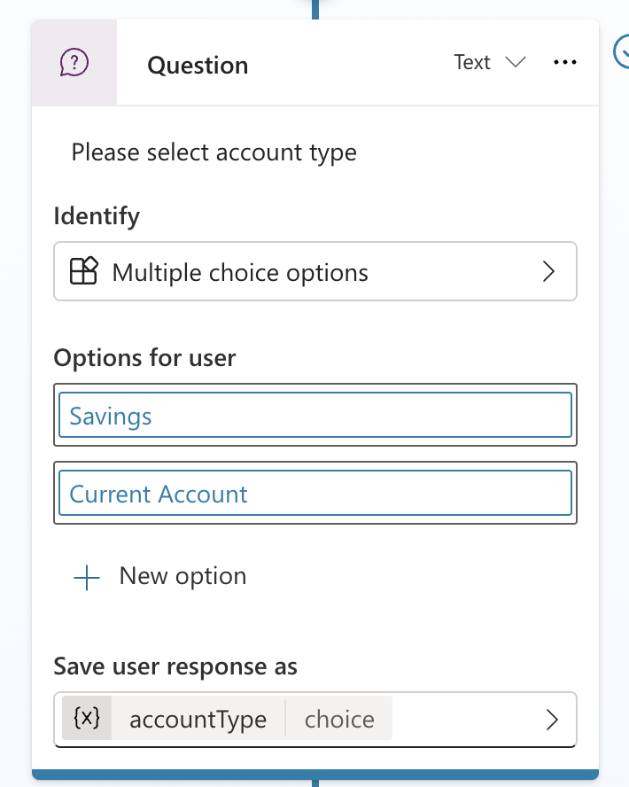
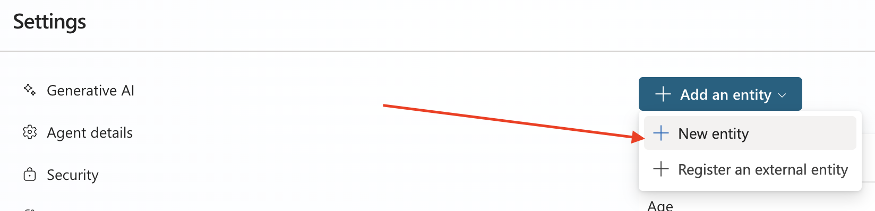
- Go to settings Entities Closed List Entity
- In the above - example creates an entity called Accounts with three main list items:
  - Accounts
  - Fixed Deposits (FDs)
  - Government Schemes
The agent then uses variations/synonyms for each item.
Closed List Item | Synonyms / Variations
Accounts | Savings Account, Current Account, Recurring Deposit Account, NRI Account, DEMAT Account
Fixed Deposit | Standard FD, Cumulative FD, Non-Cumulative FD, Flexi FD
Government Schemes | National Pension System, Sukanya Samriddhi Yojana, etc.
Synonyms are manually configured to help the agent recognize different user expressions.

HOW DOES IT WORK?

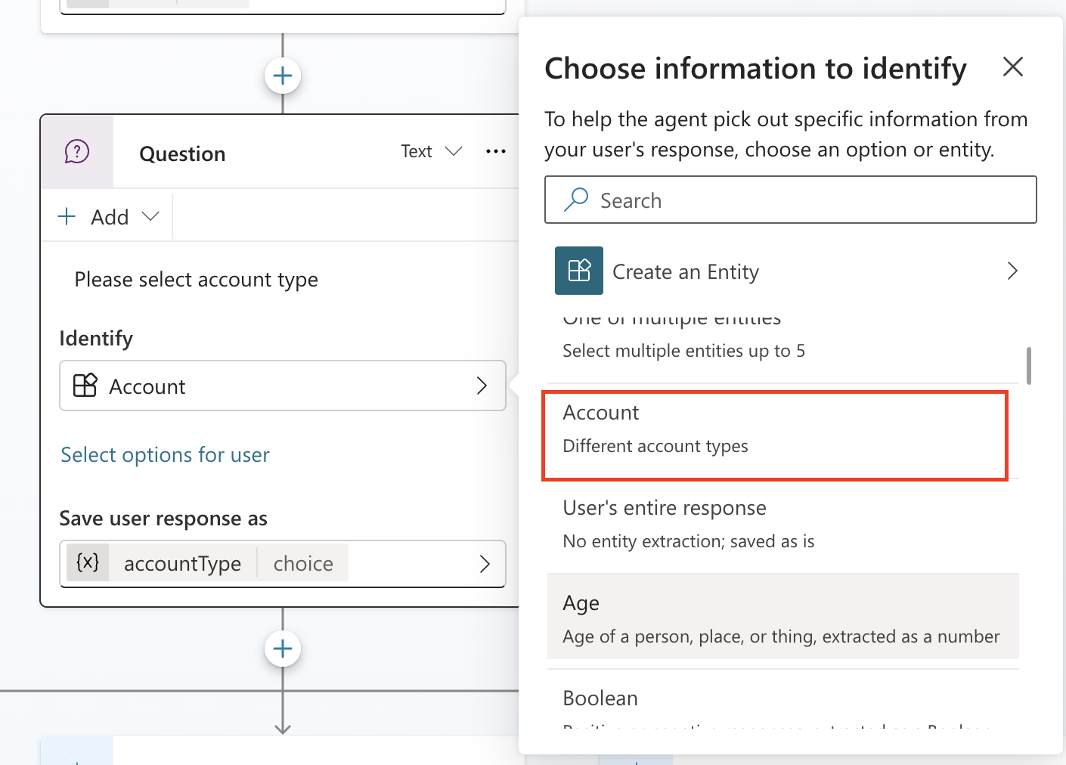

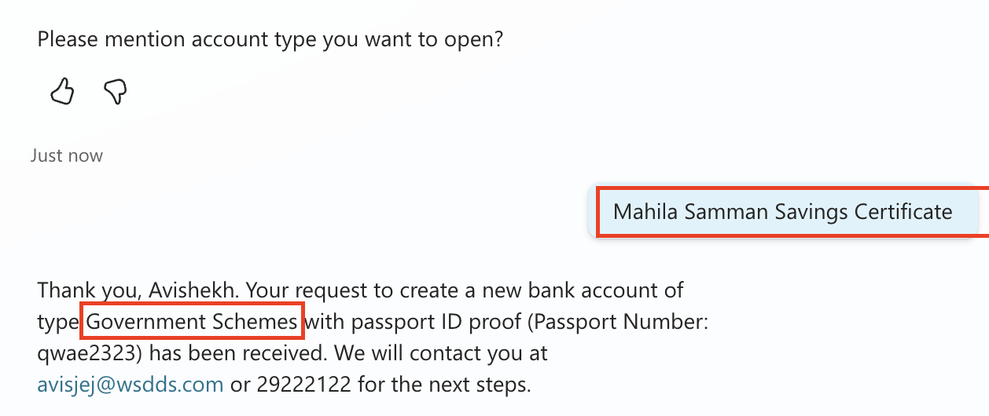

- Suppose the user says:"I want to open a Mahila Samman Savings Certificate."  - The Closed List Entity can map Current Account to the broader Accounts item. | "I want to open a Mahila Samman Savings Certificate "  ↓  Closed List Entity  ↓  Finds " Mahila Samman Savings Certificate"  ↓  Maps it to "Accounts"  ↓  Variable = Accounts
- Synonyms allow us to manually define different words or phrases that should map to the same closed-list item.
- For example:
Main Item: Accounts
Synonyms:
- Savings Account
- Current Account
- NRI Account
- DEMAT Account
- Recurring Deposit Account
- So the user doesn't need to type the main value "Accounts".They can say: "I want a savings account."
and Copilot can recognize it as belonging to Accounts.

SMART MATCHING
- Smart Matching helps the agent recognize inputs even when they aren't an exact match (e.g. typos) for the values/synonyms you've configured.
- It provides a more fuzzy/semantic way of matching user input against the values in your Closed List.

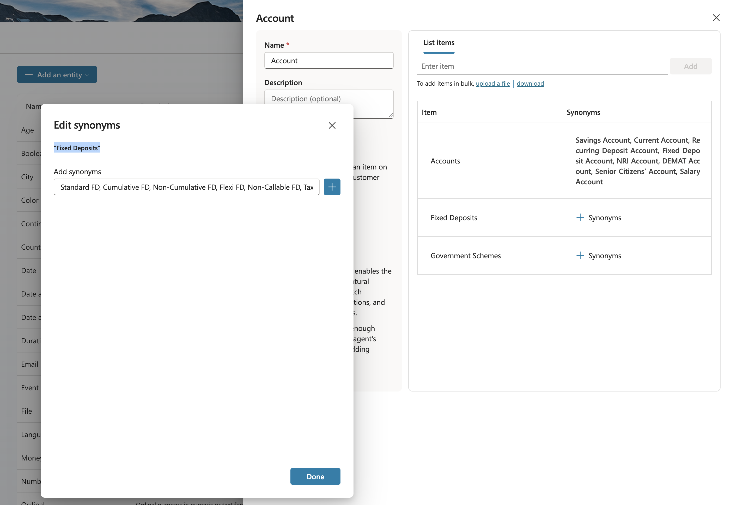

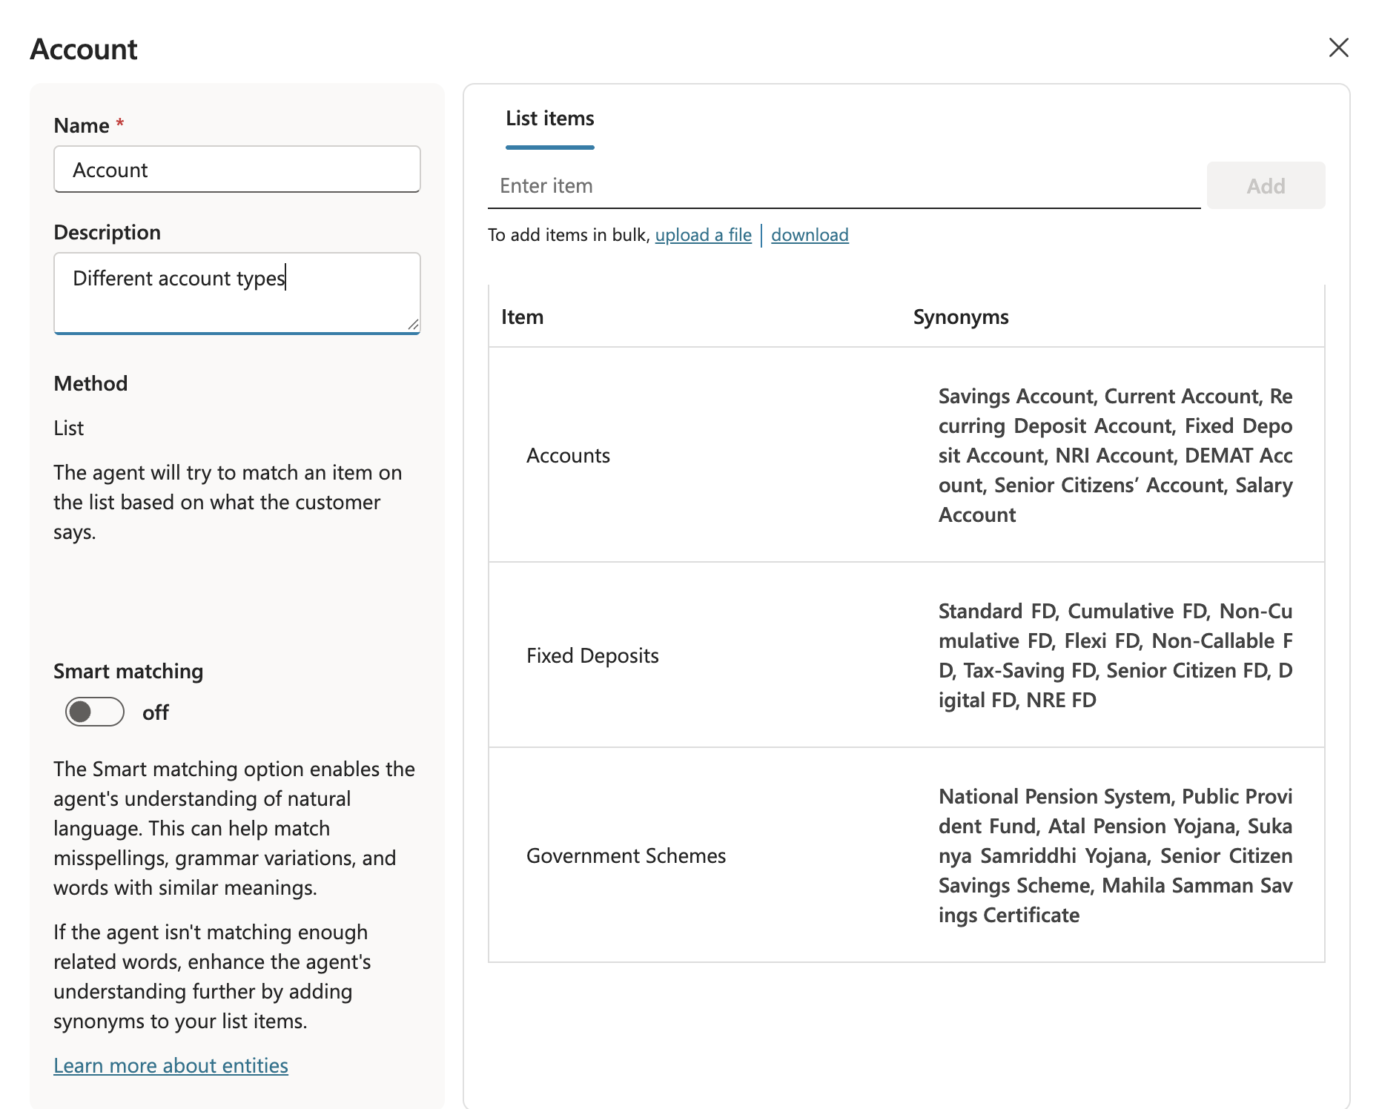

REGULAR EXPRESSION (REGEX) ENTITY
- We use it when the information follows a specific text pattern rather than coming from a predefined list.
- RegEx = Recognize information based on its format/pattern.
- For example, imagine a company has Employee IDs like:  - EMP-1001  - EMP-2456  - EMP-9876  - There could be thousands of Employee IDs.Creating a Closed List containing every employee ID would be impractical. But all IDs follow a pattern: EMP- + 4 digits  - So we could create a RegEx entity that recognizes this pattern. For example : EMP-\d{4} | User  "My Employee ID is EMP-4582"  ↓  RegEx Entity  ↓  Does it match the pattern?  ↓  YES  ↓  EmployeeID = EMP-4582

Closed List | RegEx
Works with predefined values | Works with predefined patterns
We know the possible values | You don't necessarily know every value
Can recognize configured synonyms | Recognizes matching formats
Example: Small, Medium, Large | Example: EMP-1234
Good for categories/options | Good for structured IDs/codes

ONE EXAMPLE SHOWING BOTH  Imagine we're creating an IT Support Agent.  We need to capture:  - Issue Type  - Ticket Number  CLOSED LIST  Issue Type has known options:  - Password Reset  - Laptop Issue  - Network Issue  - Software Issue  So:  - Custom Entity: IssueType  - Type: Closed List  - User says:"My laptop isn't working."  - The agent can identify the appropriate configured issue category.  REGEX  - Ticket IDs follow this format:  - INC-123456  - INC-456789  - INC-987654  - So we create:  - Custom Entity: TicketID  - Type: RegEx with a pattern such as: INC-\d{6}  - User says: "Please check INC-456789."  - The entity recognizes: TicketID = INC-456789 | USER  │  ▼  "I have a network issue.  My ticket is INC-456789"  │  ▼  COPILOT TOPIC  │  ┌─────────┴─────────┐  ▼ ▼  Closed List Entity RegEx Entity  │ │  IssueType TicketID  │ │  ▼ ▼  Network Issue INC-456789  │ │  └─────────┬─────────┘  ▼  Variables  │  ▼  Tool/Flow  │  ▼  Check Ticket Status

CREATING A REGEX ENTITY

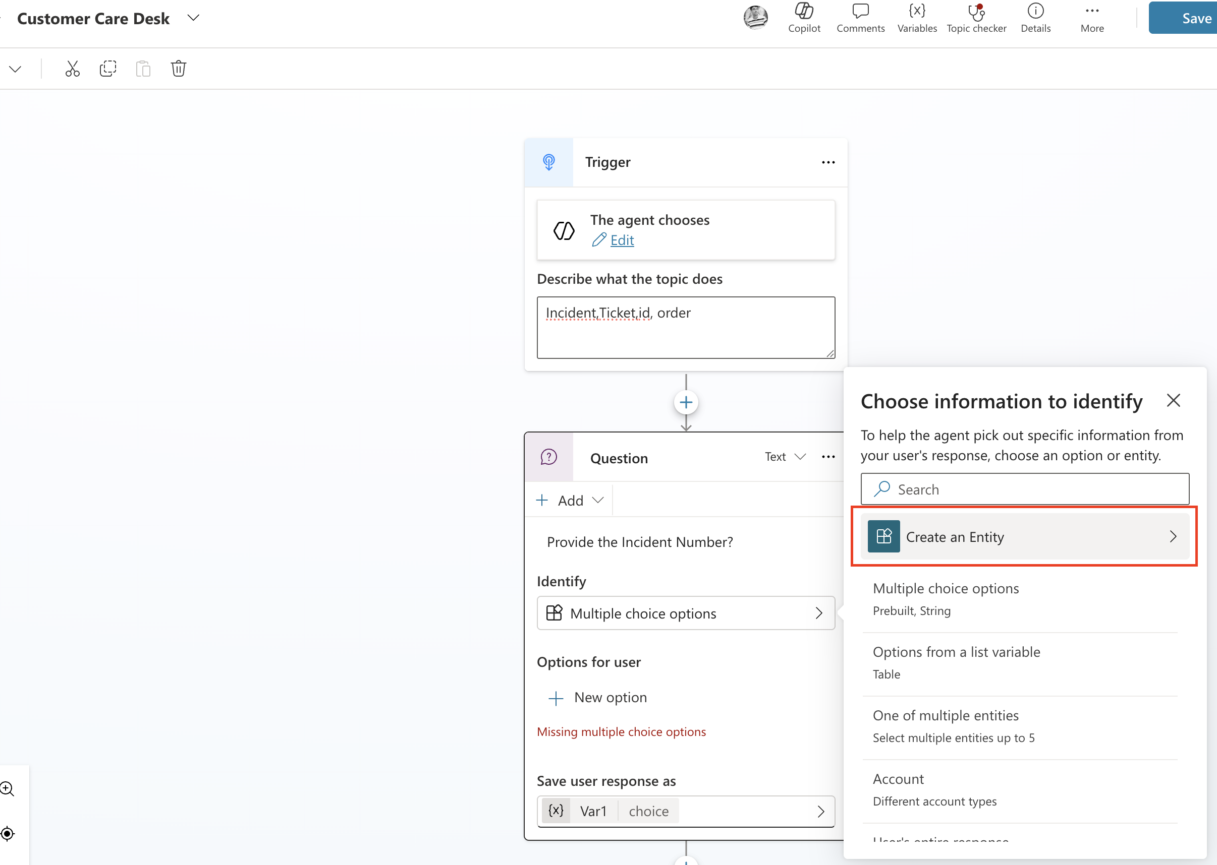
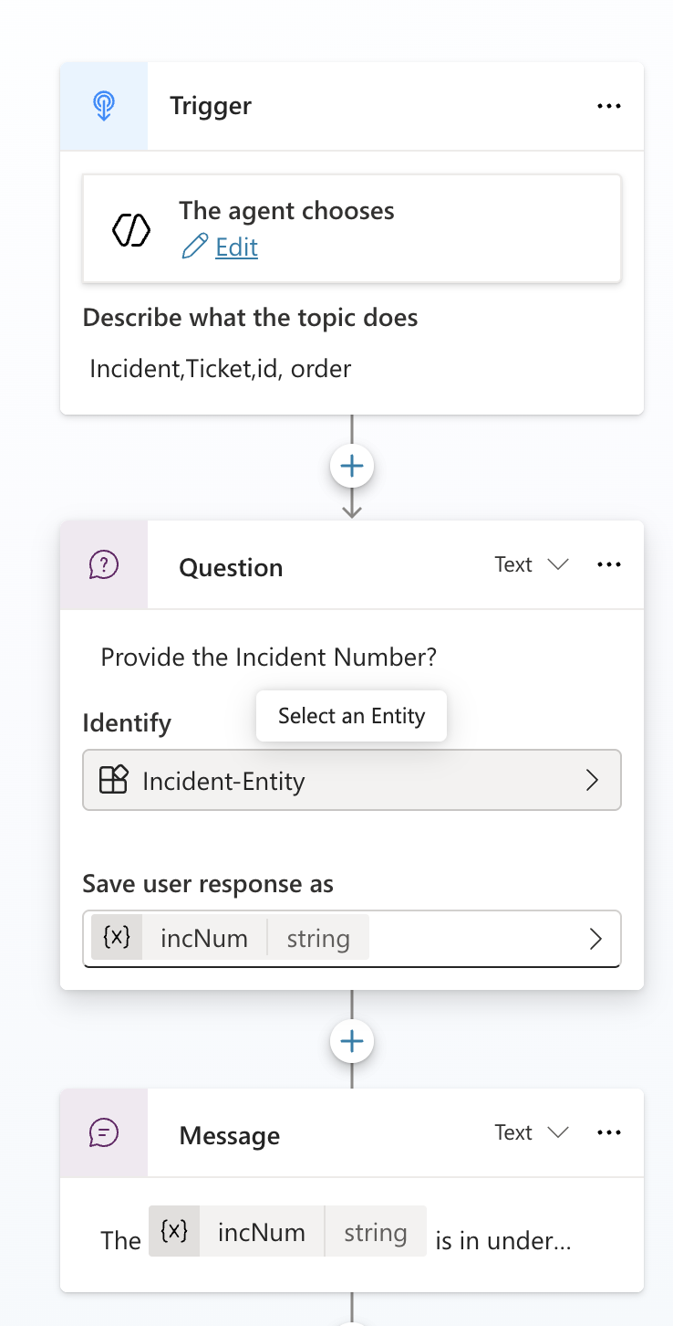 | 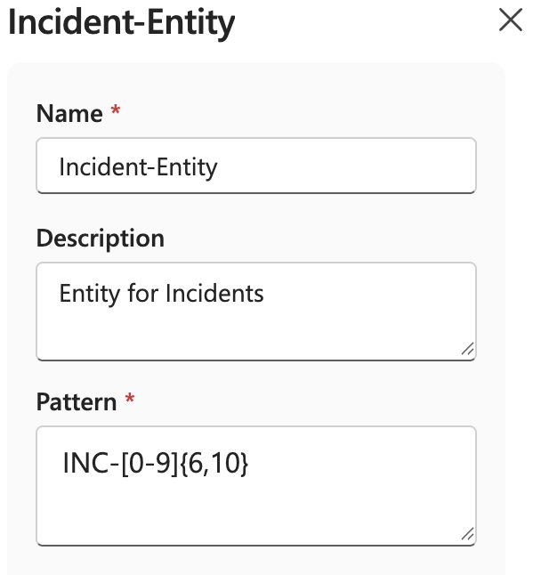
- This pattern help to extract the incident number from user’s natural language answers
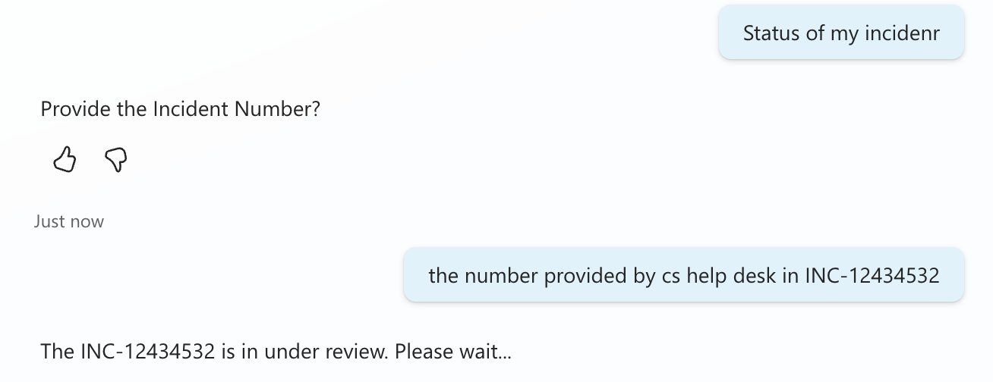

VARIABLES
- Variables allow agent to capture information, remember it during the conversation, and use it later.
- Pattern - Question asks → Entity identifies → Variable stores → Logic/Tool uses
- Lets say banking agent asks: "What type of account do you want to open?"  - User: "Savings Account"  - Copilot can store the answer in a variable:  - Variable name: AccountType  - Value: Savings Account  - Later, we can use that variable value in condition, message, tool or flow as variables are used to pass information between different nodes and actions. | User  │  "Savings Account"  ▼  Question Node  │  ▼  Entity identifies the answer  │  ▼  Variable  AccountType = "Savings Account"  │  ├─────────────┐  ▼ ▼  Condition Message  │  ▼  Tool / Flow

VARIABLE SCOPE
Scope tells us where a variable is available and how long/where we can use it.
The two scopes you'll encounter most often are:
- Topic Variables
- Global Variables

TOPIC VARIABLES
- A Topic variable belongs primarily to the topic where it is created.  - We then use it throughout that topic.  - Topic variable = information needed for this particular conversation/task. | TOPIC: Check Incident Status  IncidentNumber = "INC-12434532"  We might create it in a Question node:  - Question:"Provide your Incident Number"  - Identify:IncidentNumber entity  - Save response as:Topic.IncidentNumber

GLOBAL VARIABLES
- A Global variable is intended for information that needs to be available across topics during the conversation.  - Global variable = information multiple topics may need. | For example, suppose agent obtains the customer's name  Global.CustomerName = "Rahul"  We may want several topics to use it:  Global.CustomerName  │  ┌────────────┼────────────┐  ▼ ▼ ▼  KYC Topic Account Topic Loan Topic  - So we don't necessarily need to ask:"What is your name?" again in every topic.

VARIABLE DATA TYPES
Data Type | Example
String/Text | "Rahul Sharma"
Number | 1200
Boolean | true / false
Date | 30-Aug-2026
DateTime | 30-Aug-2026 10:30 AM
Choice | Savings Account
Record | A Record contains multiple related fields as one structured value. | For example, instead of having completely separate pieces of information:  Name = Rahul  Email = rahul@example.com  AccountType = Savings  you could conceptually have a customer record:  Customer  │  ├── Name = Rahul  ├── Email = rahul@example.com  └── AccountType = Savings  Records become particularly useful when working with structured data returned from connectors, Dataverse, Power Fx, or tools.
Table | Multiple records/rows | A Table represents multiple records.  Suppose Dataverse returns three accounts:  Accounts  │  ├── Account 1  │ ├── Type = Savings  │ └── Status = Active  │  ├── Account 2  │ ├── Type = Current  │ └── Status = Active  │  └── Account 3  ├── Type = FD  └── Status = Matured  That's conceptually a table rather than one individual value.
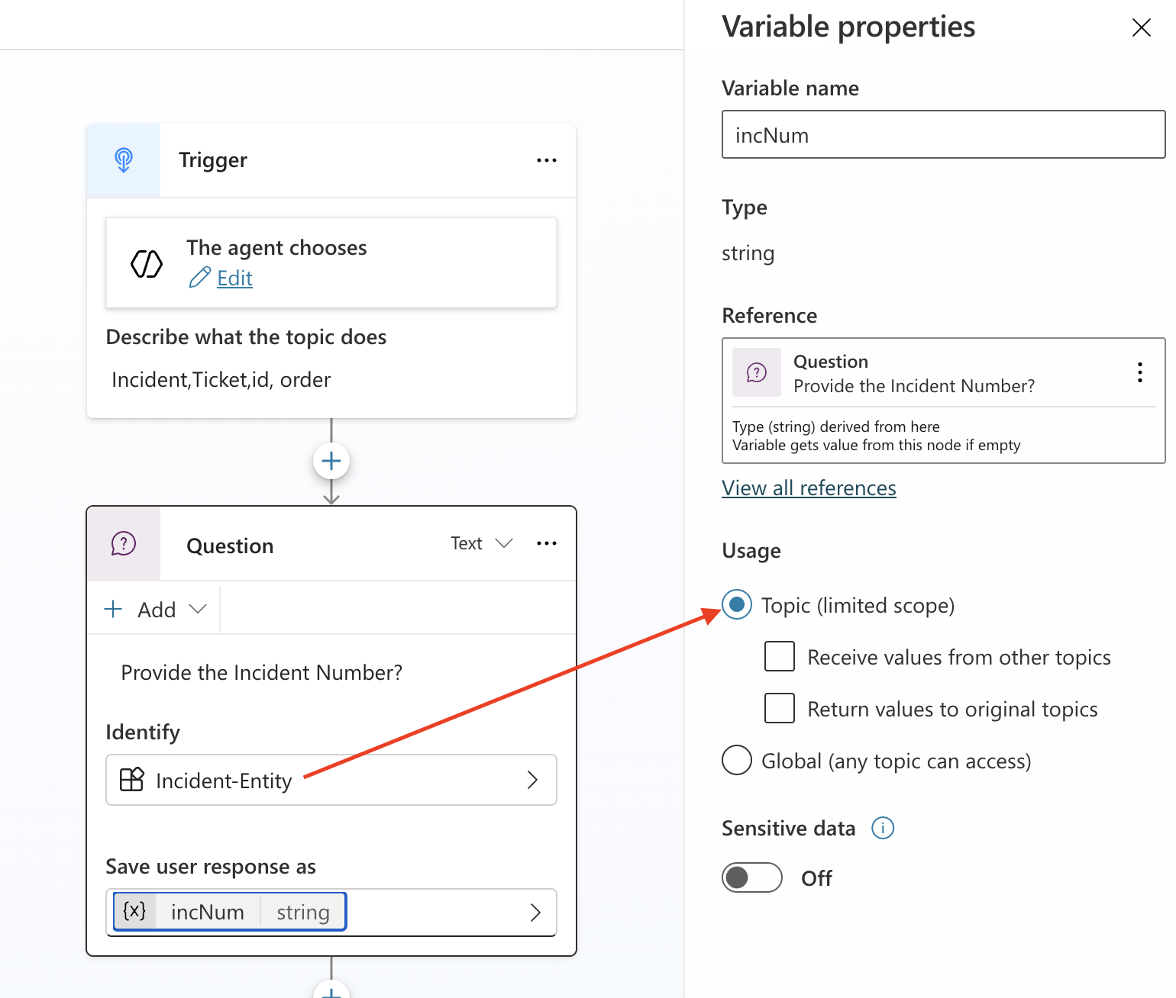
- When a variable is created – it is by default of topic scope
- Variable can be created manually using “Set Variable” node. Weuse the Set a variable value node when we want to assign or update a variable yourself.
Steps

Open your Topic or Agent Flow.  Select + Add node.  Choose Variable management → Set a variable value.  In Set variable:  Select an existing variable, or  Click Create new.  In To value:  Enter a fixed value (e.g., "Gold").  Or use a Power Fx expression.  Or assign another variable's value.  Save and test.  Example  Set customer type  Set variable: Topic.CustomerType  To value: "Premium"  Set value from another variable  Set variable: Topic.FullName  To value: Topic.FirstName & " " & Topic.LastName  Global Variable  If you need the value across multiple topics:  Create a variable.  Open Variable properties.  Change scope to Global.  Use it as:  Global.UserName  Global.MemberId  ``  Global variables are available throughout the agent session. [learn.microsoft.com]  Common Uses  Store API response values  Save user selections  Create counters and flags  Pass data to Agent Flows or Power Automate  Reuse values across topics  From your recent Copilot Studio work, if you're inside an Agent Flow, the equivalent action is usually an Assign value to variable step, which serves the same purpose as the Set variable value node in topics. [Copilot St...Day_Nov26 | PDF], [MS-Copilot | Word]  If you're using the new Agent Builder UI, share a screenshot and I can point to the exact menu location. | 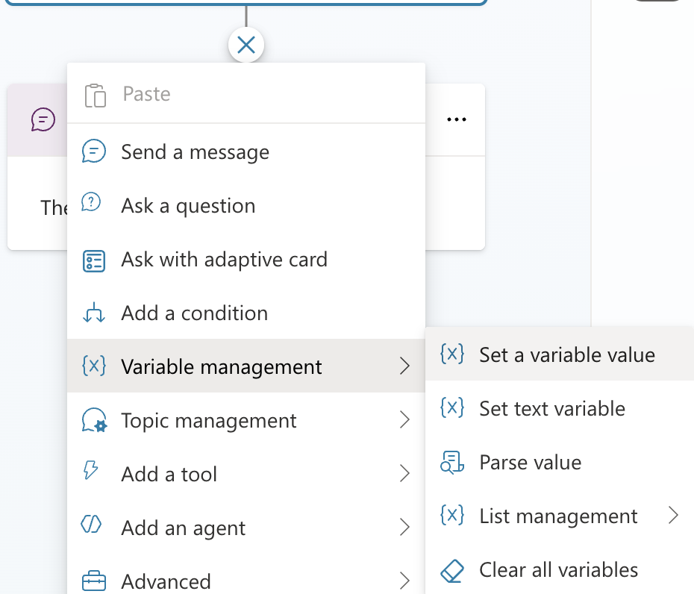

TOOLS
- Tools are the building blocks that enables the agent to interact with external system
- Think of tools as skills or actions that agent can perform, like sending an email, checking weather, or calling an API.
Why Use Tools?
- Topics handle conversation flow.
- Tools let your agent connect to external systems or perform tasks automatically.
Examples
- Send emails using the office 365 outlook connector
- Check current weather conditions and forecasts
- Read & write data from Dataverse tables(We can use MCP here)
- Read and Post messages to Teams

SUPPORTED TOOLS
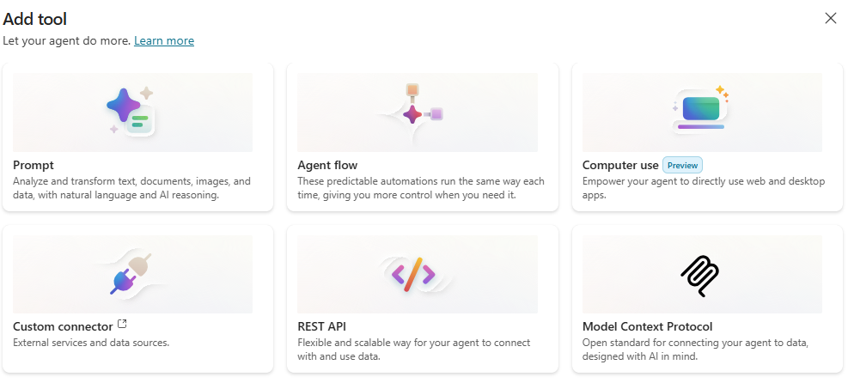

PROMPT TOOL

REST API
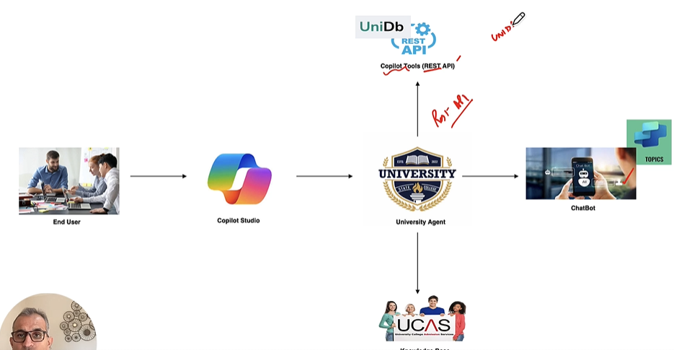

ADD CUSTOM CONNECTOR USING RESP API
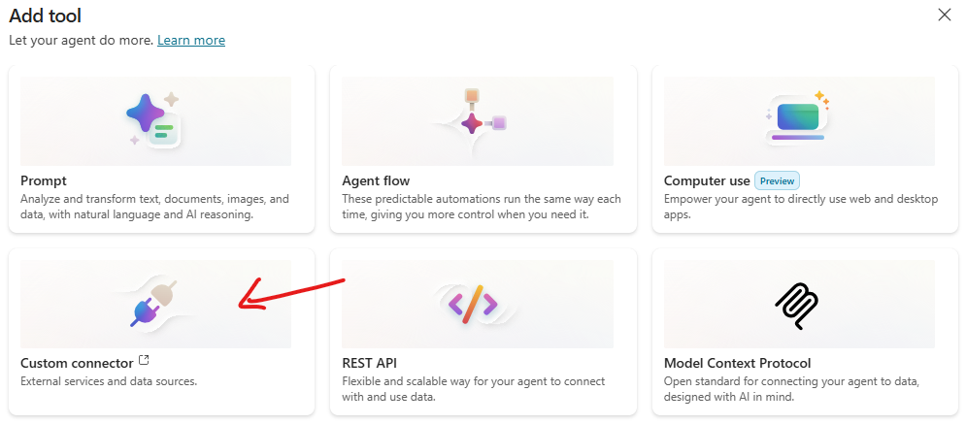
- An OpenAPI file is a document that describes the structure and behavior of an API in a standardized way.
- It follows the OpenAPI Specification (OAS), which is widely used for RESTful APIs.
What is it?
It’s usually written in JSON or YAML format.
It defines:
- Endpoints (URLs your API exposes)
- Methods (GET, POST, PUT, DELETE)
- Request and response formats
- Authentication details
- Data models (schemas for input/output)
Why is it important?
Standardization: Makes APIs easy to understand and integrate.
Automation: Tools can generate documentation, SDKs, and tests from it.
Interoperability: Works with platforms like Copilot Studio, Postman, Swagger, etc.
Example (YAML format)
openapi: 3.0.0
info:
title: Sample API
version: 1.0.0
paths:
/users:
get:
summary: Get all users
responses:
'200':
description: Successful response
content:
application/json:
schema:
type: array
items:
type: object
properties:
id:
type: integer
name:
type: string
How does it relate to Copilot Studio?
- In Copilot Studio, you can use an OpenAPI file to connect external APIs to your Copilot. This allows Copilot to call those APIs and provide dynamic responses based on real data.

AGENT FLOW
- Agent Flow is a low-code workflow that allows an AI agent to perform a specific action or business process by executing a predefined sequence of steps.

EXAMPLE
Suppose you have an IT Support Agent.
- A user asks: "What is the status of my ticket INC12345?"
- The process would be User → Copilot Agent → Agent Flow → ServiceNow → Agent → User
- The Agent Flow could:
  - Receive the ticket number INC12345 from the agent.
  - Connect to ServiceNow.
  - Retrieve the ticket status.
  - Return "In Progress" to the agent.
  - The agent responds: "Your ticket INC12345 is currently in progress."
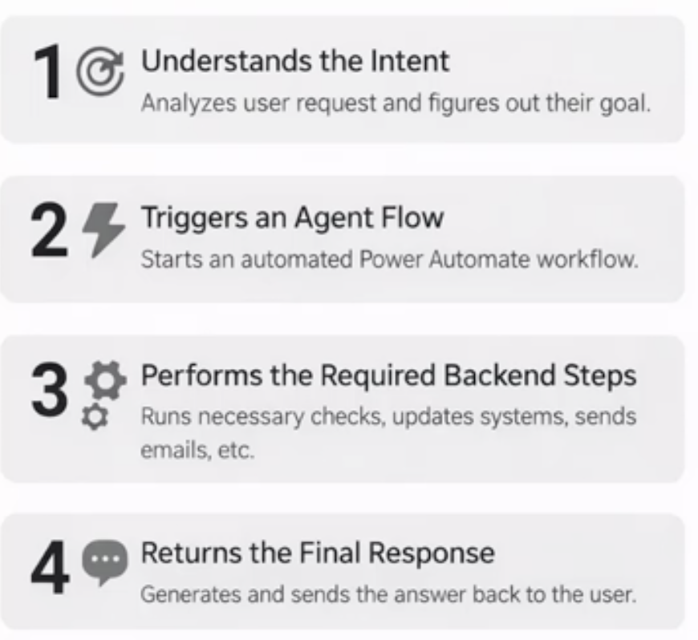 | - Agent Flow is a predefined automation that an agent can use to perform actions, retrieve data, or execute business processes.  - When a user make request, agent understand the intent Triggers an agent Flow Perform the required backend steps Returns the final response  - These agent flows allows  - Agent to connect with external systems  - Process data  - Apply business logic  - Trigger Approvals /Notifications  - Update records etc..

EXAMPLE – USE CASE
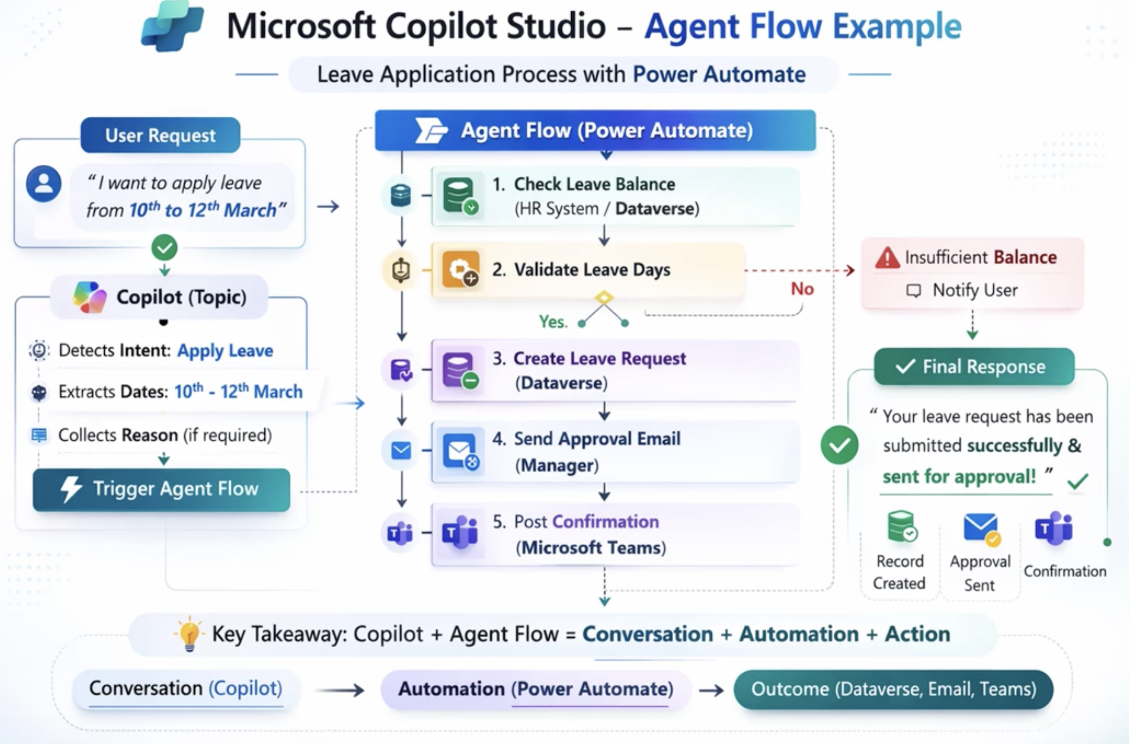

AGENT FLOWS VERSUS POWER AUTOMATE CLOUD FLOW
Both Agent Flows and Power Automate Cloud Flows automate processes, but they are designed with different primary purposes.
Agent Flows | Power Automate Cloud Flows
Built primarily for AI agents and agentic automation | Built primarily for general business process automation
Created and managed within Copilot Studio | Created and managed primarily within Power Automate
Can be used as a tool by an agent | Can run independently based on many types of triggers
Designed to work naturally with Copilot Studio agents | Designed to automate processes across applications and services
Often receives inputs from an agent and returns results to the agent | Often starts from events, schedules, buttons, forms, emails, etc.
Best when the agent needs to perform an action | Best for traditional workflow/process automation

EXAMPLE
Agent Flows | Power Automate Cloud Flows
Imagine an organization has an IT Support Copilot.  - The employee asks: "Check the status of ticket INC12345."  - The agent understands the request and invokes an Agent Flow: User → Agent → Agent Flow → ServiceNow → Agent → User  - The Agent Flow retrieves the ticket status and gives the result back to the agent | - Suppose the organization wants:"Every time a new high-priority ticket is created, send a Teams notification to the support manager."  - That could be:New ticket created → Cloud Flow → Check priority → Send Teams notification  - No AI agent needs to be involved.
In Simple terms,
- Agent Flow
  - Automation designed to work with an AI agent.
  - They are tightly integrated with AI-driven conversations, means it triggered directly by agents, based on user intent
  - It can be scheduled or manually triggered
- Power Automate Cloud Flow
  - They are general-purpose workflow automation.
  - They are typically triggered by events e.g. arrival of email , files created in SharePoint etc..
  - It can be scheduled or manually triggered

CREATING AGENT FLOWS

REAL WORLD AGENTS

STUDY SCHEDULER AGENT
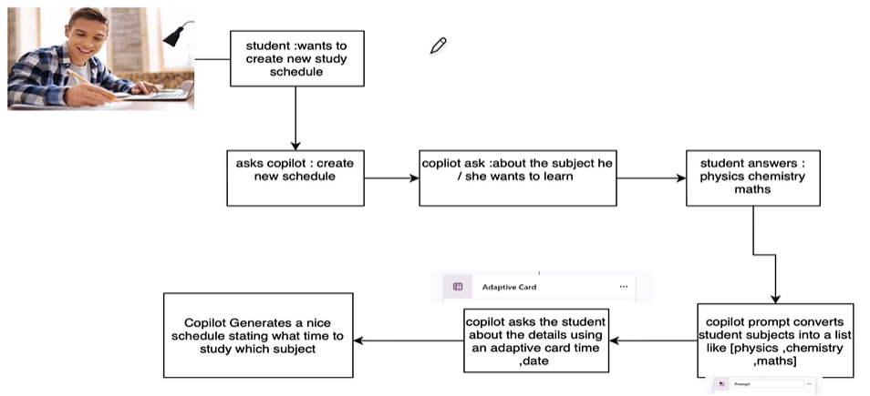

CREATE THE AGENT – AGENT CONFIGURATION
Agent Name | Study Scheduler Agent
Description | Helps students create a personalized study schedule by collecting subjects, presenting them as  a list, and gathering scheduling details such as start date, end date, number of study hours,  and start time. Generates a table of study schedules for the student.
Instructions | Instructions  - Collect subjects to study from the user and convert them into a list.  - Present the subjects list to the user for confirmation or editing.  - Use an adaptive card to gather scheduling details: start date, end date, number of hours of study, and start time.  - Generate a table of study schedules based on the provided information, distributing study hours across the selected dates and subjects.  - Ensure the schedule is clear, organized, and easy for the student to follow.  - Respond in a friendly and supportive manner, guiding the user through each step.  - Do not repeat information already provided by the user.  - Only communicate in English.  - Do not answer questions unrelated to study scheduling or agent modification.
NOTE: Disable the Web Search and generative Ai knowledge
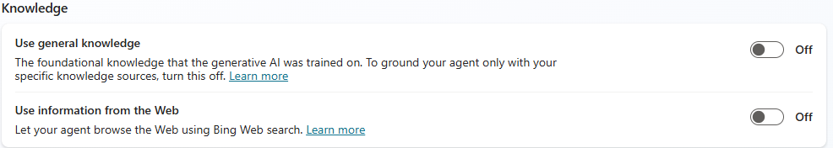

CREATE TOPICS & ADD PROMPTS

Step 1: Add Triggers

What are triggers?
A trigger is what starts an action or flow in Copilot Studio. It tells the agent when to act.
- We need to provide some triggering factor(keywords), which will kick in topic | create new study schedule  new study schedule  create study plan  make a study timetable  generate a study routine  I want a new schedule
Step 2: Adding Question

Question | What subjects you want to study
Identity | User’s entire response
Save user response as | “subjects” : This is the variable where entire user response will be stored

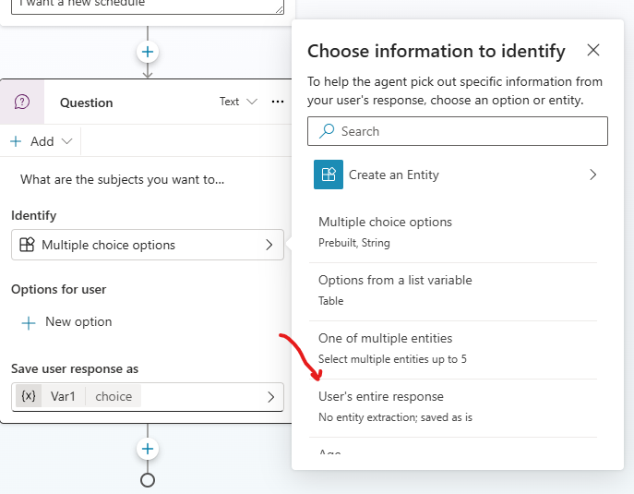
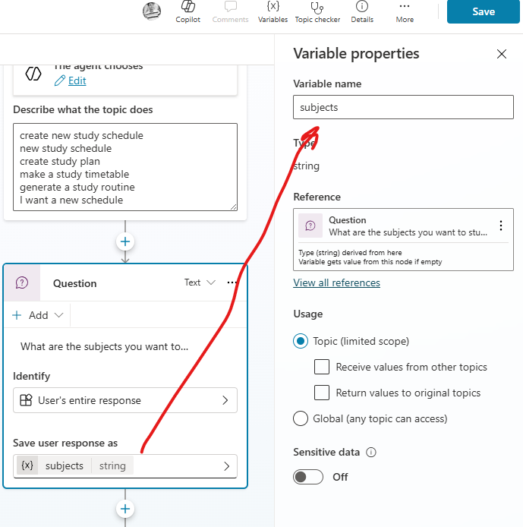
Step 3: ADD A Tool Prompt
- The prompt tool will convert the user’s response to a list.
- The reason for this is that turning the input into a structured format (like a list written as a string: ["Math", Science","History"]) makes it much easier for the AI agent to process later.
- Instead of handling raw, unstructured text, the agent can clearly see that the response is a collection of items.
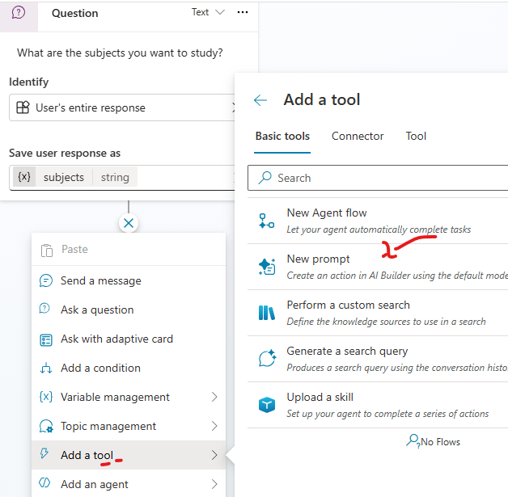
- The input to a prompt is the “subjects” variable received from the previous step.
- The value of the “subjects” variable is substituted in the prompt of prompt tool
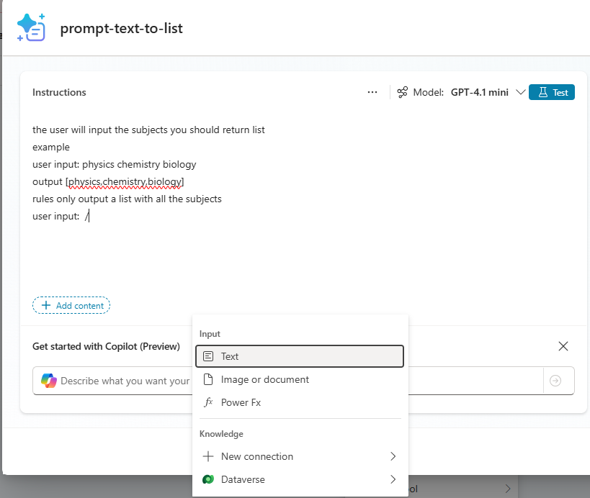

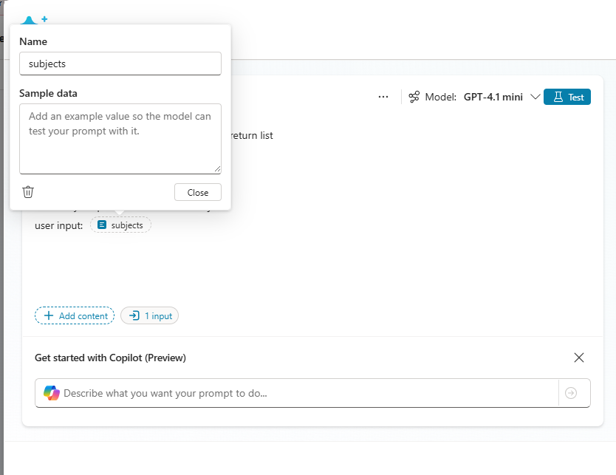
TESTING PROMPT In prompt Tool
The prompt tool will extract the subject names as list of subject form user’s response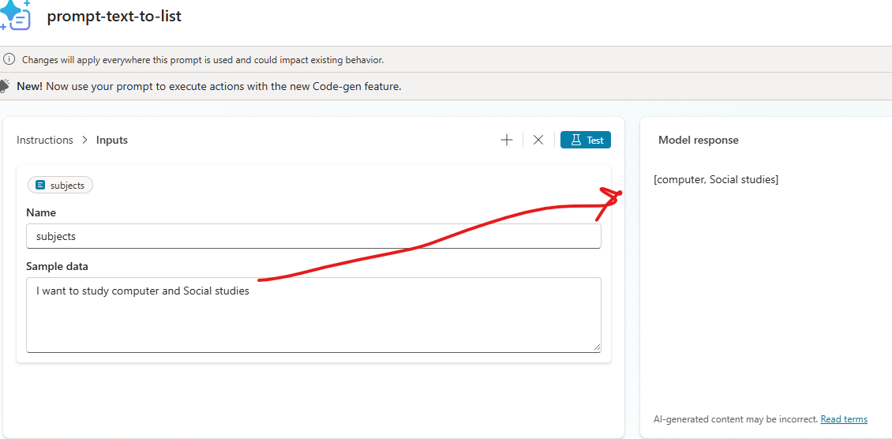

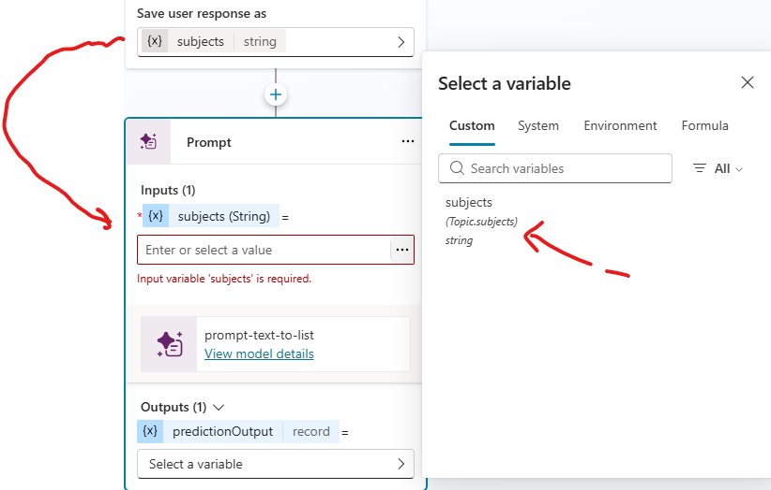
- The list output from the prompt tool will be finally stored in the “list_of_subjects” variable
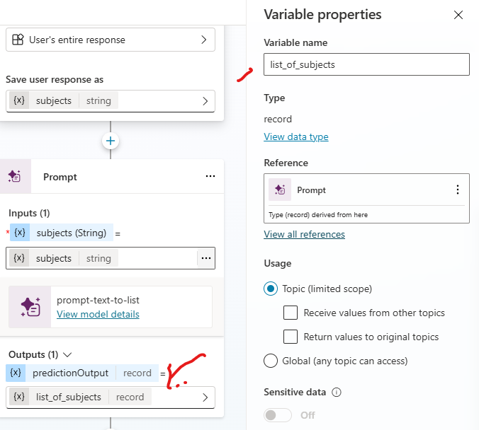
Step 4: ADD Adaptive Card
Once we take the subjects input – Now to create the study schedule need to take following inputs as Adaptive Card
The input in adaptive cards will be

- Start Date
- End date
- Time(in hours)
- Start Time

Now Add and edit the adaptive card

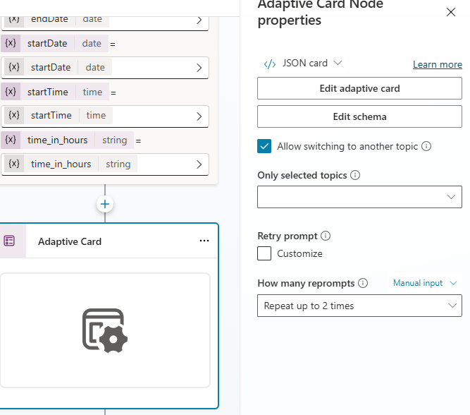
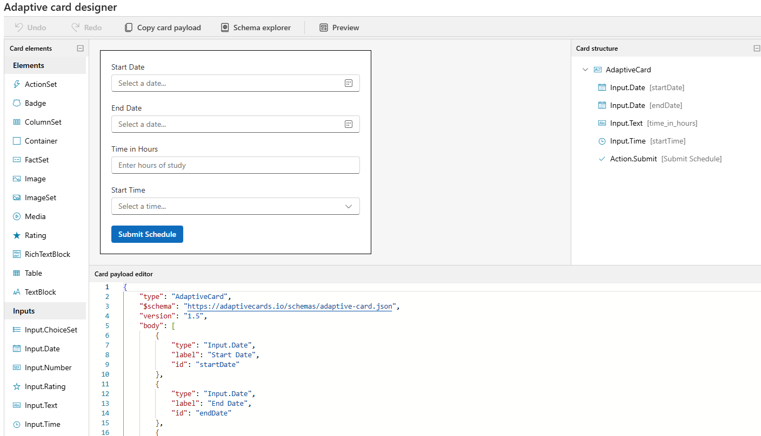
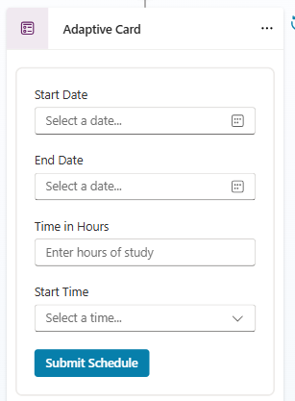
JSON
{
"type": "AdaptiveCard",
"$schema": "https://adaptivecards.io/schemas/adaptive-card.json",
"version": "1.5",
"body": [
{
"type": "Input.Date",
"label": "Start Date",
"id": "startDate"
},
{
"type": "Input.Date",
"label": "End Date",
"id": "endDate"
},
{
"type": "Input.Text",
"label": "Time in Hours",
"placeholder": "Enter hours of study",
"id": "time_in_hours"
},
{
"type": "Input.Time",
"label": "Start Time",
"id": "startTime"
}
],
"actions": [
{
"type": "Action.Submit",
"title": "Submit Schedule",
"data": {
"action": "submitSchedule"
},
"style": "positive"
}
]
}
Step 5: Add Custom PROMPT TO Convert Json To Table
- We receive JSON output from the Adaptive card. The custom prompt will convert the JSON into a tabular format.
Custom Prompt
You are given study schedule details in JSON format along with a start date and an end date.
Generate a full study schedule covering all days from start to end, and output the result in a
tabular format with the following columns:
(StudyDate, StartTime, EndTime, Subject, Notes, Status)
Rules:
Parse the time field for start time and duration (e.g., "9 pm 2 hrs" → StartTime = 21:00,
EndTime = 23:00).
Use the provided start_date and end_date to expand the schedule across multiple days
(inclusive).
For each day between start_date and end_date, create one row per subject. Randomize the
subjects i can study within the total hours of study on a day.
Notes = "Study {subject}".
Status = "Pending".
Output only as a neatly formatted table, no SQL queries.
Example Input JSON:
{
"start_date": "2025-09-09",
"end_date": "2025-09-12",
"time": "9 pm 2 hrs",
"subjects": ["physics", "chemistry", "maths"]
}
Here is the input JSON:
{
"start_date":
"end_date":
"time": ,
"subjects":
}
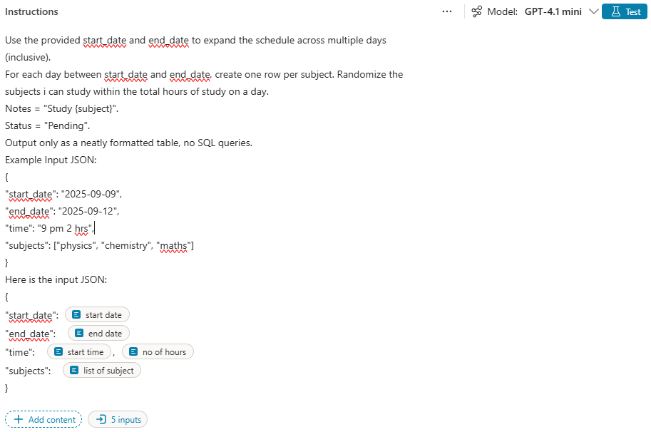
- In custom prompt use input variable in the prompt.(as shown above)
- These input variables are assigned with a value which we are getting from the output of Adaptive card
- Note the assignment is done by converting the values from adaptive card to string format, as prompt are expected to be in String format.
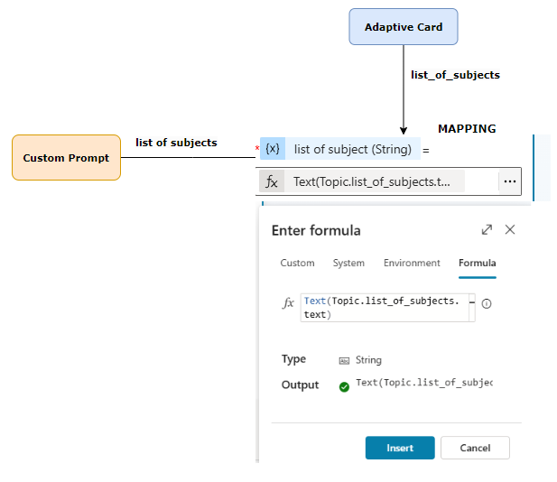
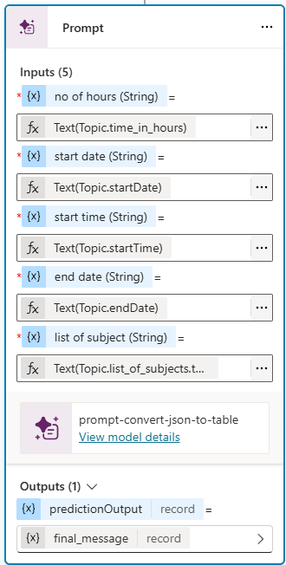
- The final tabular output from custom prompt is stored in a variable “final_message”.
Step 5: Amend the inputs for the prompt and add final message
- The value of “final_message” is finally displayed using Message

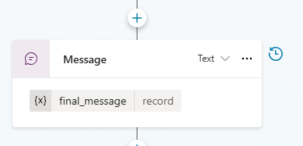

STUDY SCHEDULER & DB AGENT

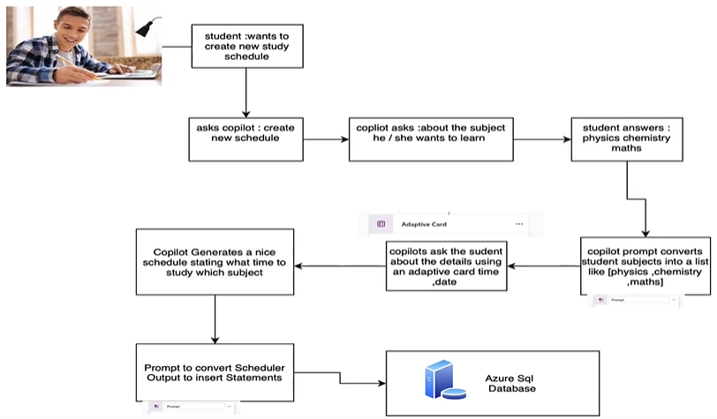
THIS AGENT WILL BE THE EXTENSION OF STUDY SCHEDULER AGENT .THIS SCHEDULER WILL INSERT THE SCHEDULE IN THE AZURE SQL DB

PROVISION SQL DB IN AZURE
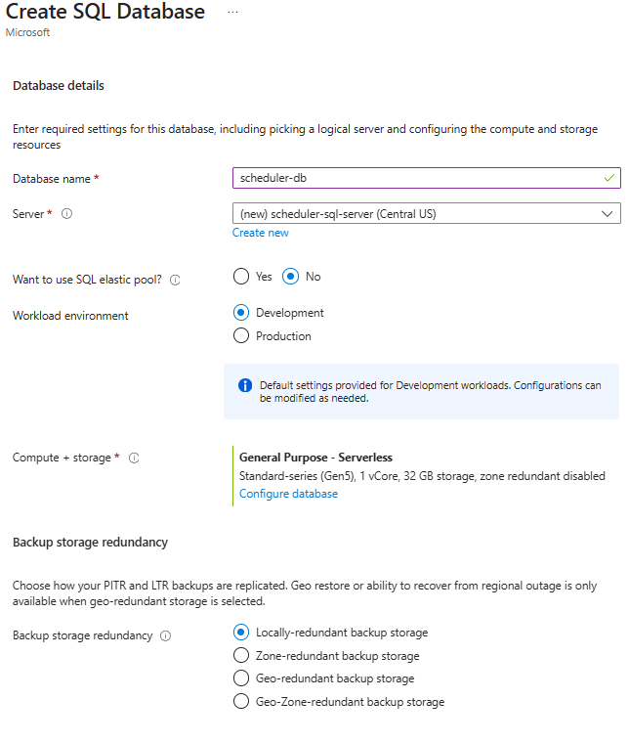
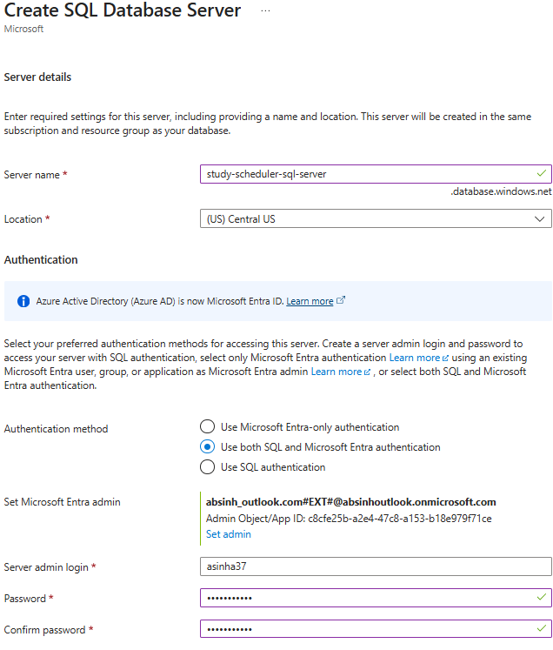
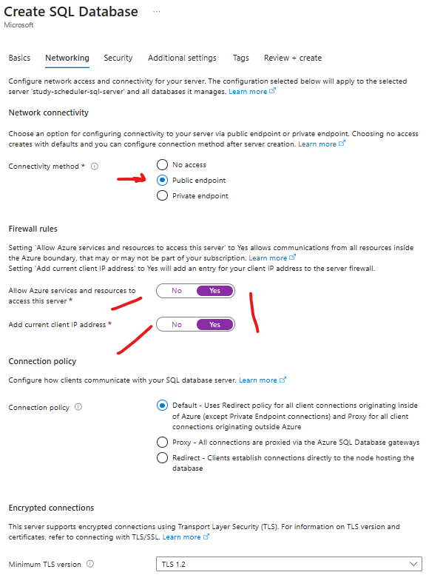
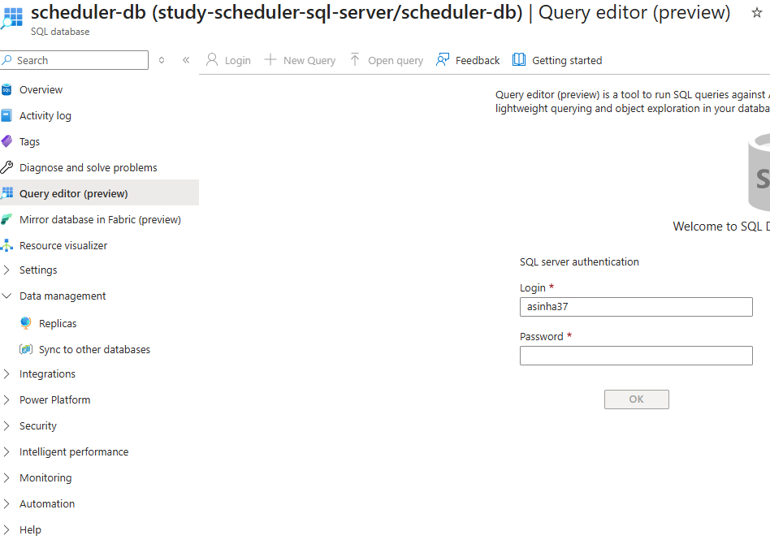

CREATE THE TABLE- We will insert the SCHEDULE OF this table | CREATE TABLE StudySchedule (  ScheduleID INT PRIMARY KEY IDENTITY(1,1),  StudyDate DATE NOT NULL,  StartTime TIME NOT NULL,  EndTime TIME NOT NULL,  Subject NVARCHAR(255) NOT NULL,  Notes NVARCHAR(MAX),  Status NVARCHAR(50),  CreatedAt DATETIME DEFAULT GETDATE()  );

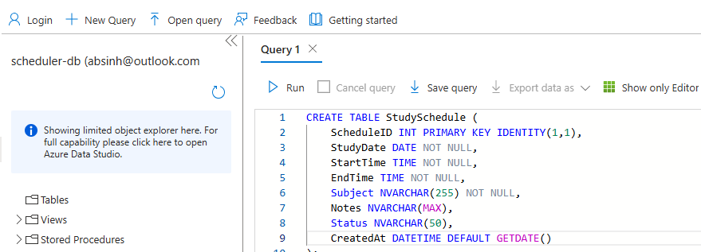

ADDING ACTIONS TO THE TOPIC
Step 1: Add a custom prompt
- The custom prompt will convert the text output from previous message to INSERT statement
You are given a table with column headers and rows.
Convert it into a single SQL INSERT statement for the table:
INSERT INTO StudySchedule (StudyDate, StartTime, EndTime, Subject, Notes, Status) VALUES
...
Rules:
- Use the given headers as columns (map Topic and SubTopic as empty strings if not in the
table).
- All rows must be inside one INSERT query, separated by commas.
- Wrap text values in single quotes.
- Do not explain anything, only output the SQL query.
user input :
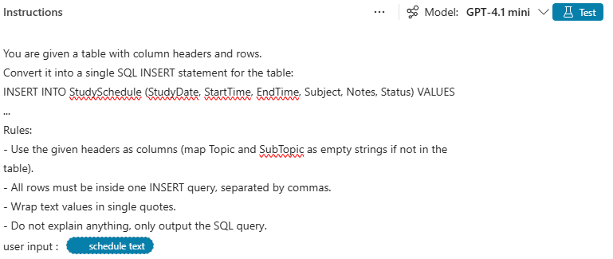

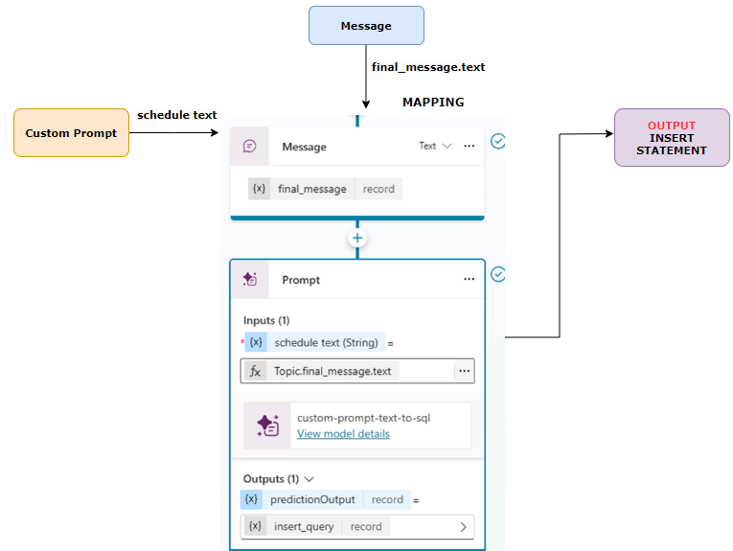
Step 2: Add Message
- The output from the prompt id a “record”
- To SQL Connector (next step) expects the query in Text format, hence we need to use Message to do the conversion
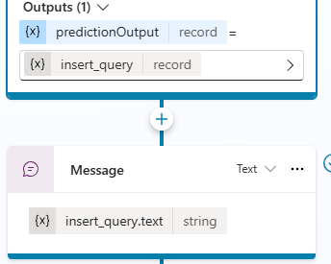
Step 3: Add SQL Connector

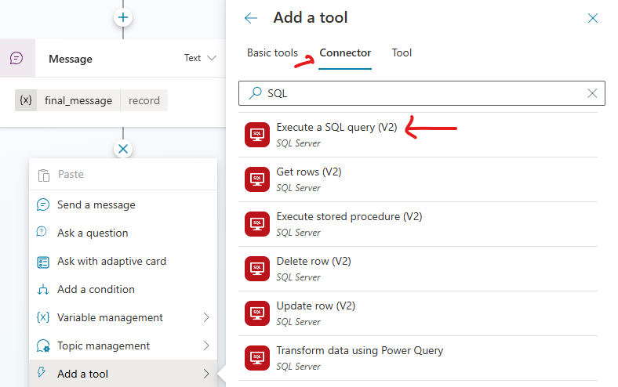
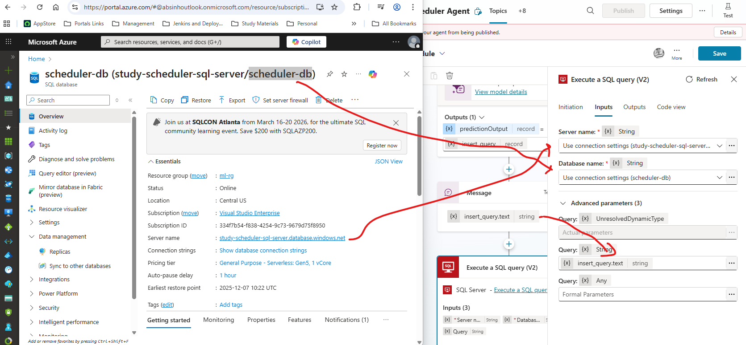
Step 4: Add MESSAGE for Final Result Confirmation

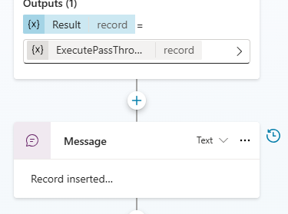

TEST AGENT

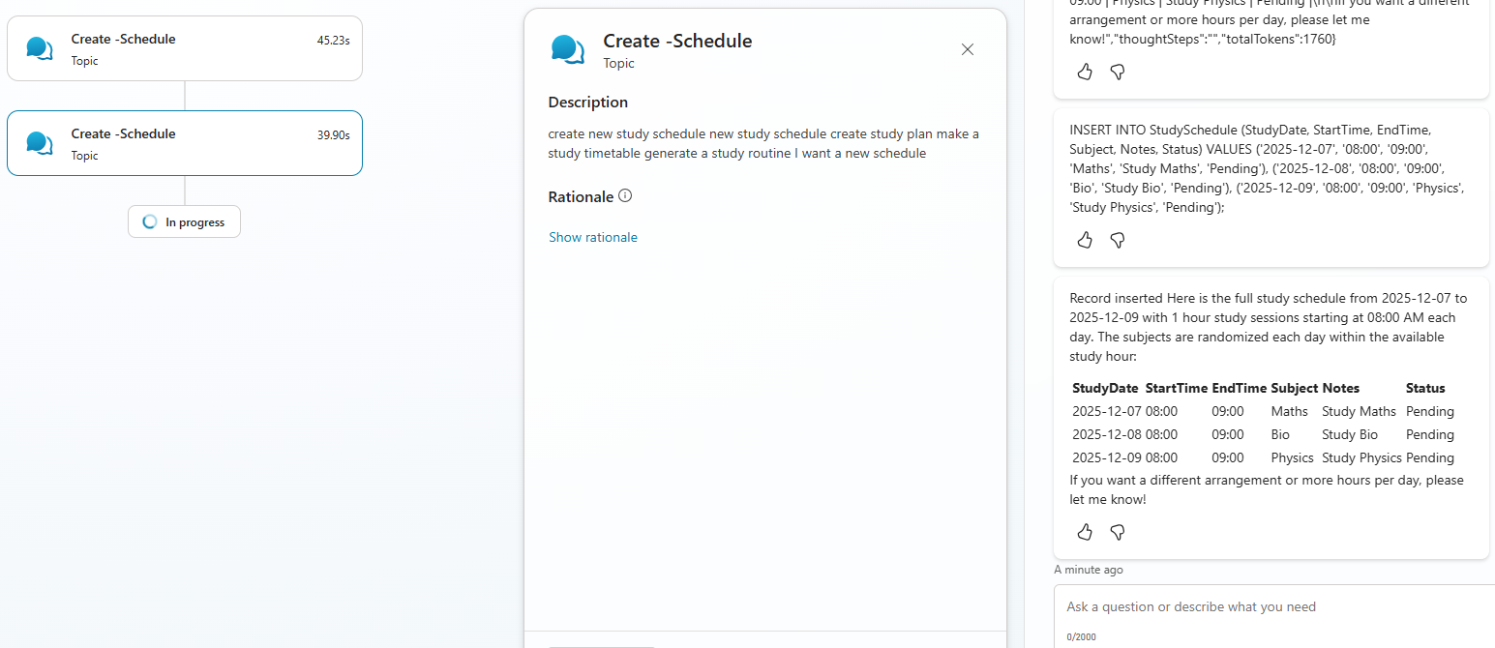
Data Inserted in SQL DB
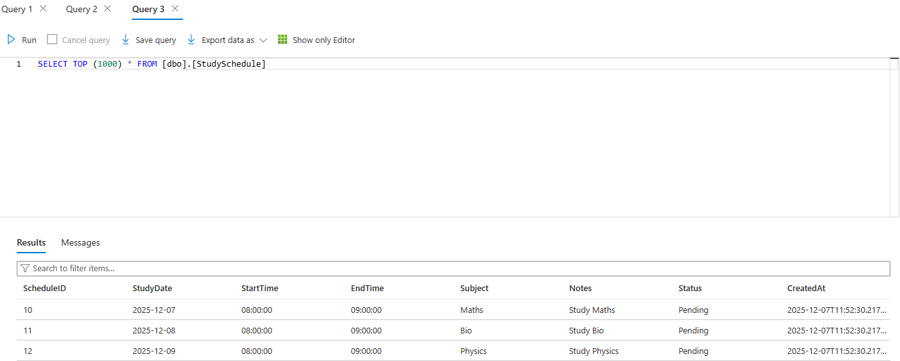

DOCUMENT INSIGHT AGENT
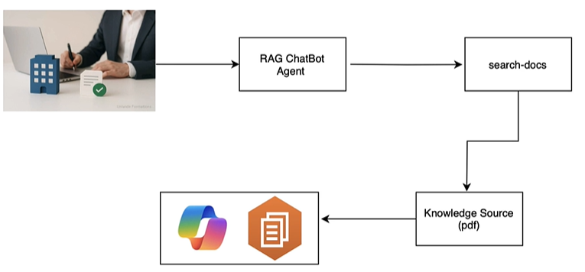
This agent is based on the concept of RAG (Retrieval-Augmented Generation)
It’s an AI technique that combines information retrieval with text generation to make responses more accurate and up to date.
- Retrieve: When you ask a question, the system searches external sources (like documents, databases, or APIs) for relevant information.
- Generate: It then uses a language model (like GPT) to create an answer based on both the retrieved info and its own knowledge.
Step 1: Create Agent using Prompt

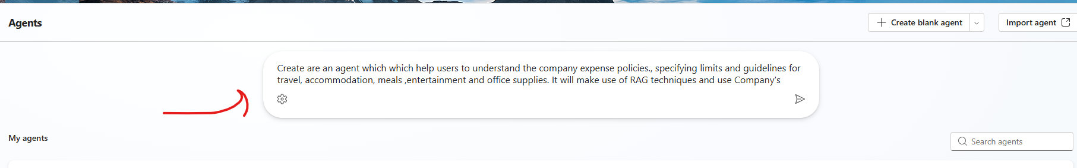
Step 2: Add Knowledge
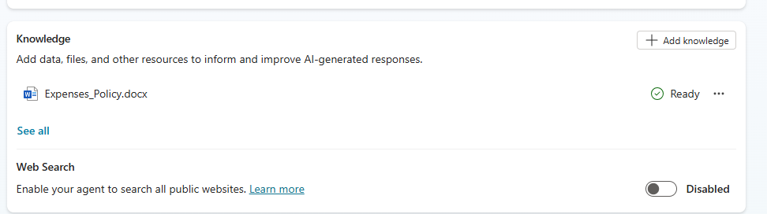
Note: Since we want to use the document is the knowledge source – We will toggle off
- Foundational knowledge on which the model is trained on
- Web Search
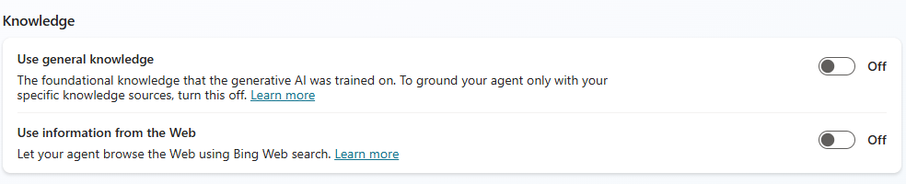
Step 3: Testing Agent
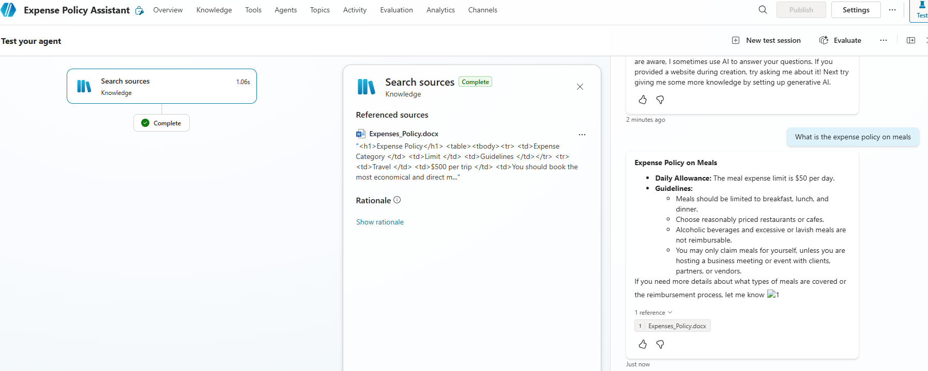

EMAIL NOTIFIER AGENT – USING AGENT FLOW
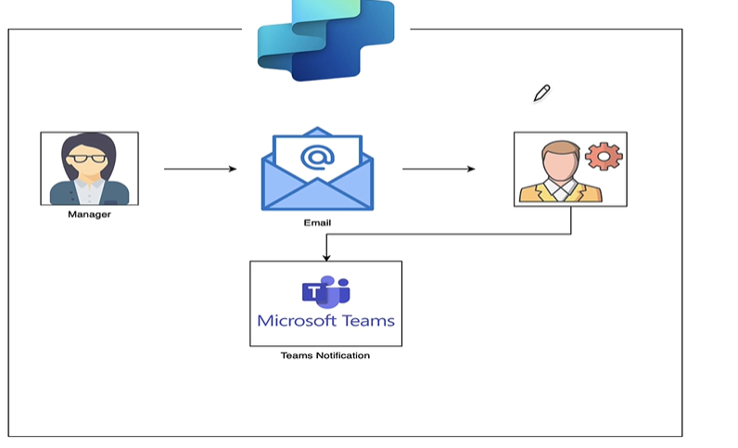
- In the agent will send Team’s notification when an email from a specific person arrives.
- We will leverage the Agent flow in the automation.

CREATE AGENT FLOW
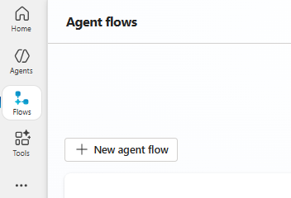
Step 1: Add a Trigger
- We need to add trigger to kick in the agent flow. For above use-case we need to use “When a new email arrives” trigger.
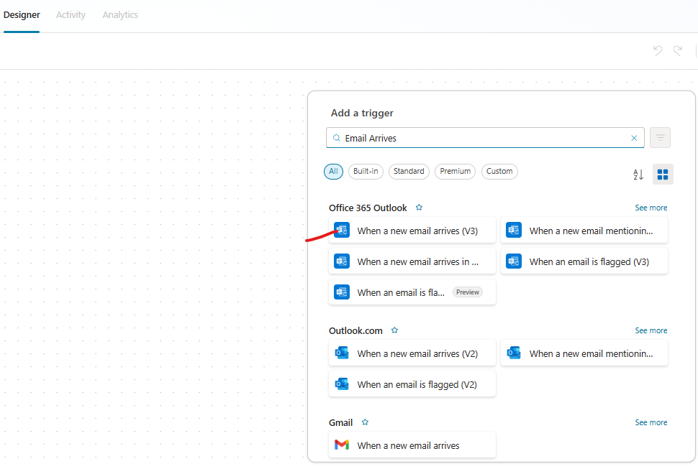
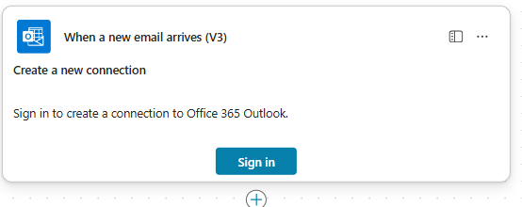
Step 2: Add an Action – Get Profile
- The “Get my profile” action will ask to authenticate, which will get hold of your profile. It will have profile attributes like Mail, name etc..

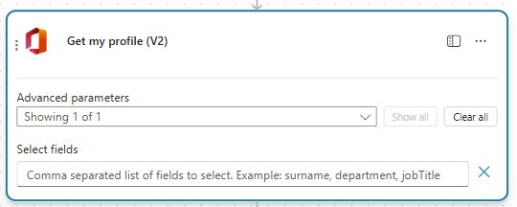
Some attributes of profile data
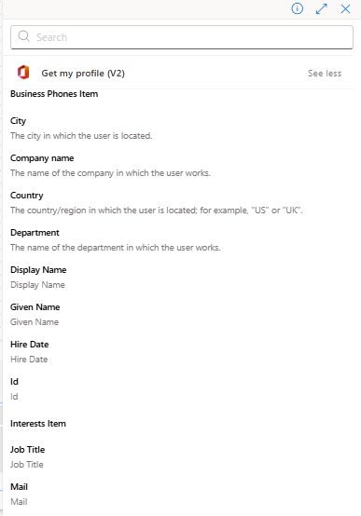
Step 2: Add an Action – Post Message in Chat or Channel
- In this action we will post messages to team. Note: To insert dynamic content, we can use “/” character.
Recipient | - Since you need to receive the Team’s notification we can dynamically inject attributes from profile(received from previous action)
Message | - Similarly insert the Email subject and body content from trigger step

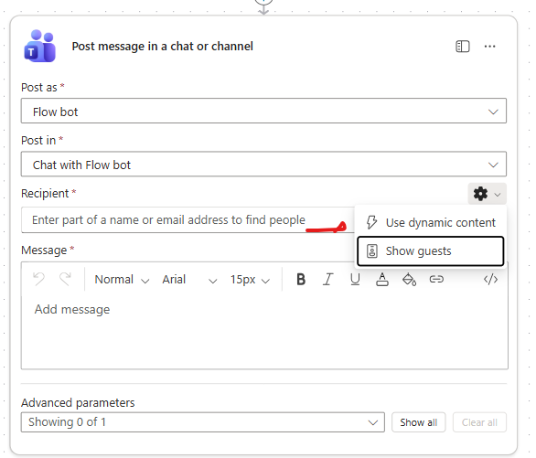
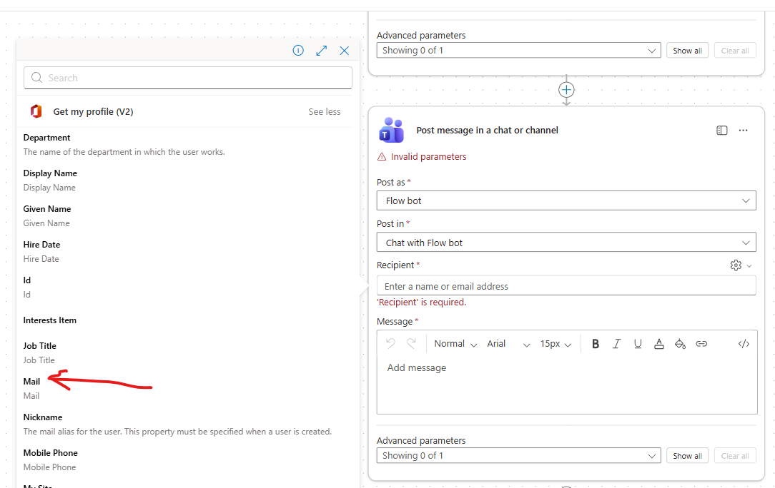
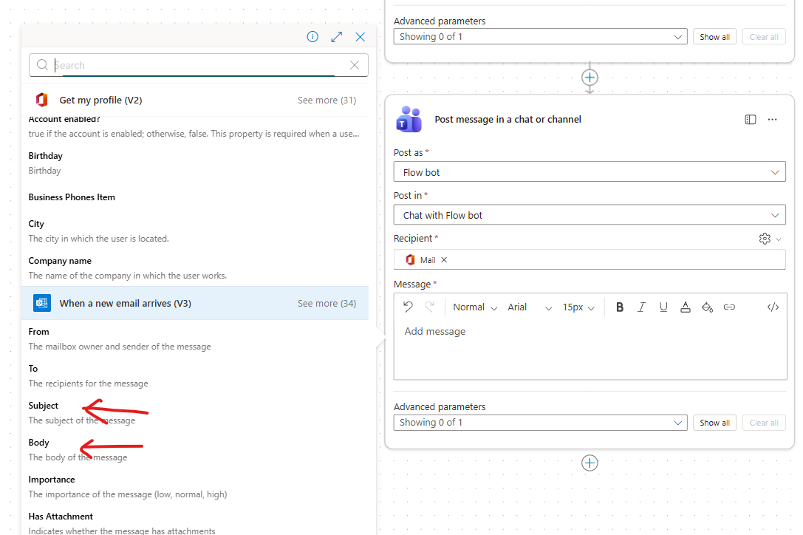
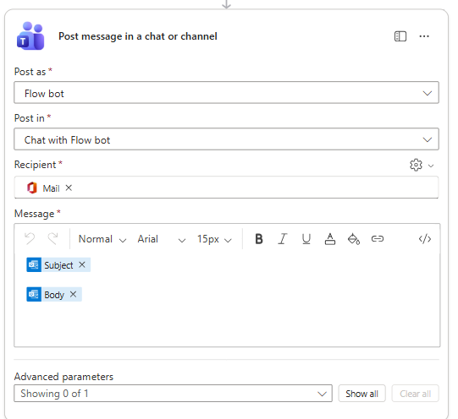
- Finally publish the agent Publish the Agent flow .
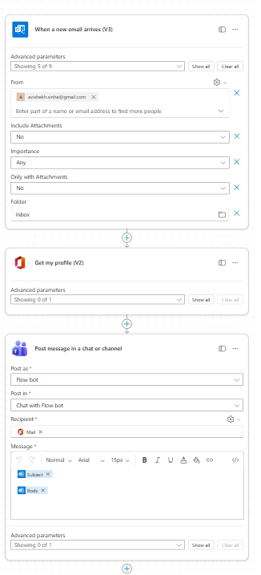
The name of the agent can be updated by editing the agent Save
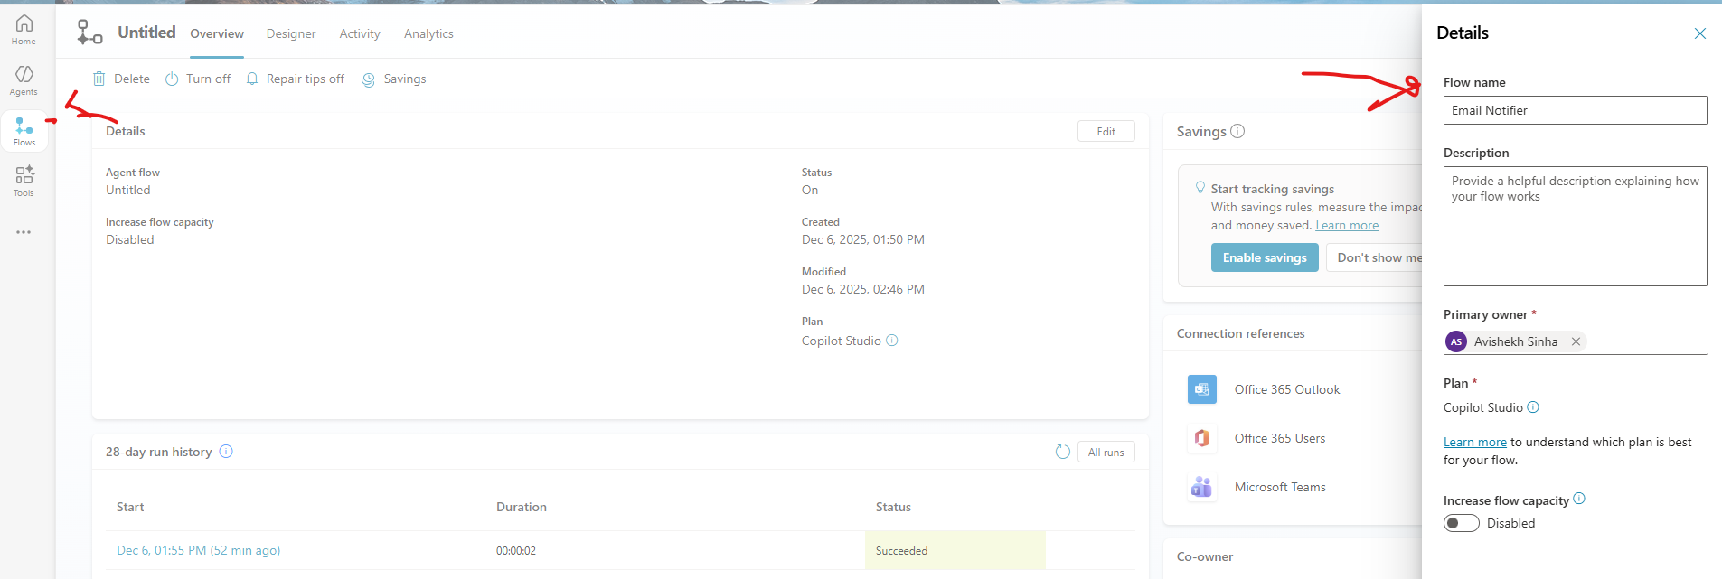

INVOICE SCANNER & DATA ENTRY
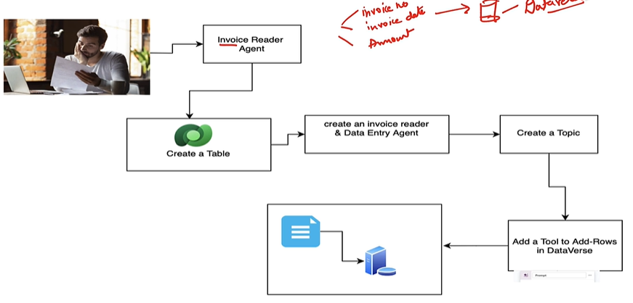
Purpose
- Build an agent that:
  - Accepts an uploaded invoice.
  - Extracts three key fields:
    - Invoice Number
    - Invoice Date
    - Amount
  - Adds these details into a Dataverse table called Invoices. Dataverse is MS cloud based data platform
Core Components
- Dataverse Table
  - Name: Invoices
  - Columns: InvoiceNumber, InvoiceDate, Amount
  - Dataverse is part of Microsoft Power Platform and stores business data securely.
  - Supports relationships, rules, and business logic without heavy coding.
- Agent Flow
  - Trigger: User says “Add an invoice” or uploads an invoice.
  - Actions:
    - Read invoice (using AI or OCR).
    - Extract fields (Invoice Number, Date, Amount).
    - Call Dataverse connector to Add a row in the Invoices table.
- Topic
  - Topic name: Add an Invoice.
  - Handles user interaction:
    - Confirms upload.
    - Shows extracted details.
    - Posts success message after saving to Dataverse.
- Tool Integration
  - Use Dataverse connector in Copilot Studio or Power Automate:
    - Action: Add a new row.
    - Map extracted fields to table columns.

CREATE A DATAVSERSE TABLE
- Navigate to Power Apps Tables Create a New table Start from Blank
- Table Name: invoicetab
COLUMN NAME | DATA TYPE | FORMAT
invoice_number | Single line of text | Text
invoice_number | Date and Time | Date only
total_amout | Decimal | None

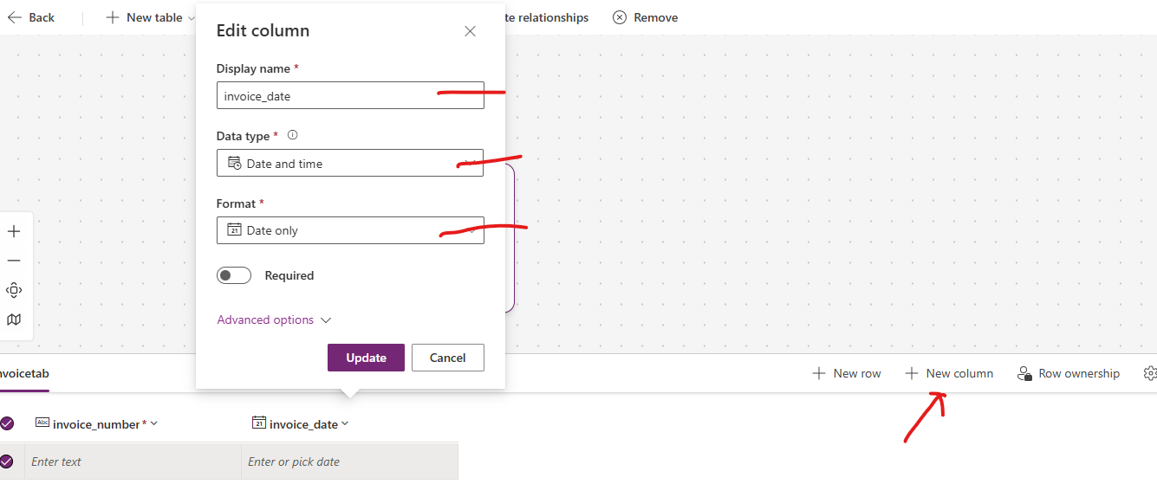
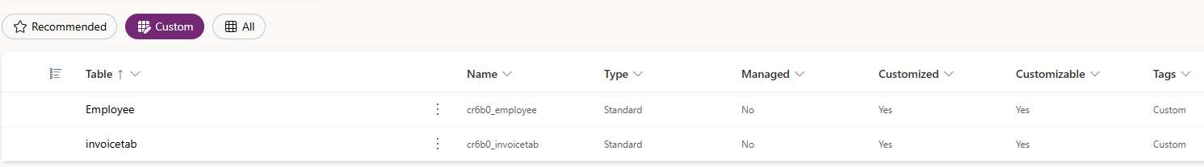

CREATE AGENT
Name | Invoice Reader Agent
Description | This agent extracts invoice data and stores it in Dataverse.
Instruction | The agent identifies invoice PDFs, extracts the invoice number, invoice date, and invoice amount, and stores them in Dataverse table

ADD TOPIC
Step 1: Add a Trigger
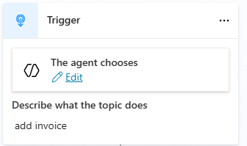
Step 2: Add Custom Prompt
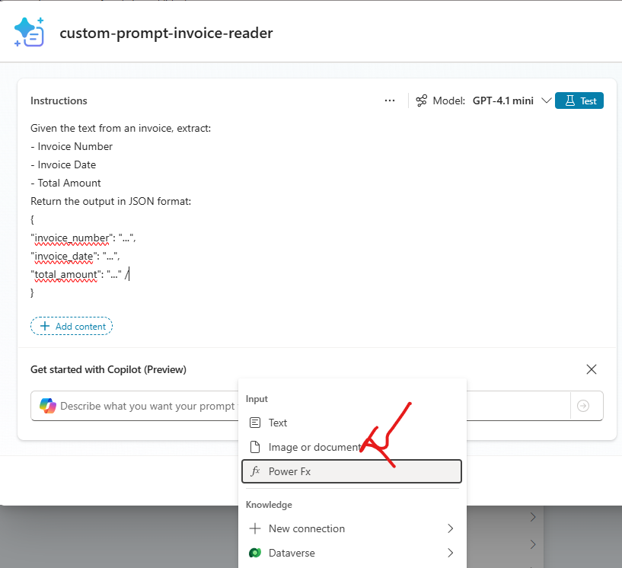
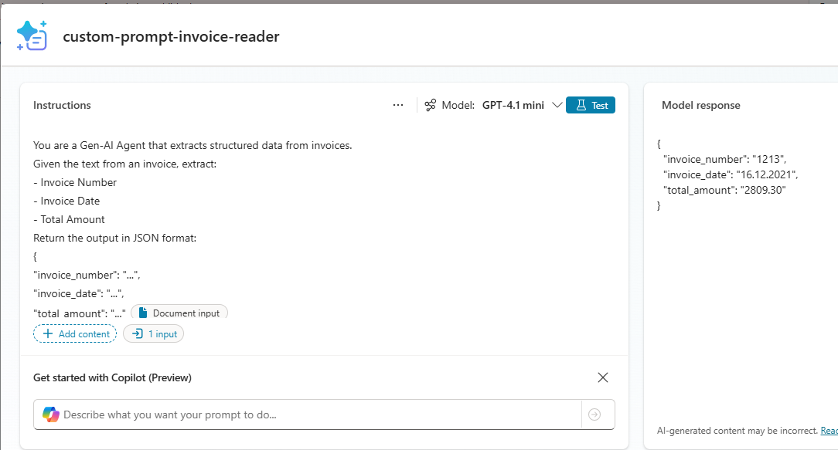

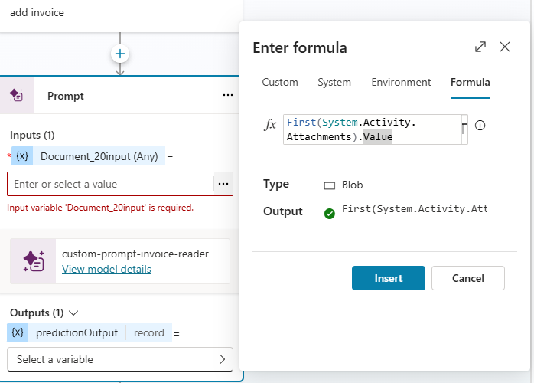
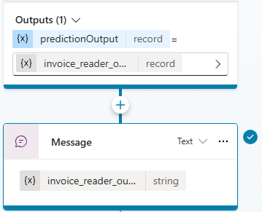
TEST AGENT – SO FAR
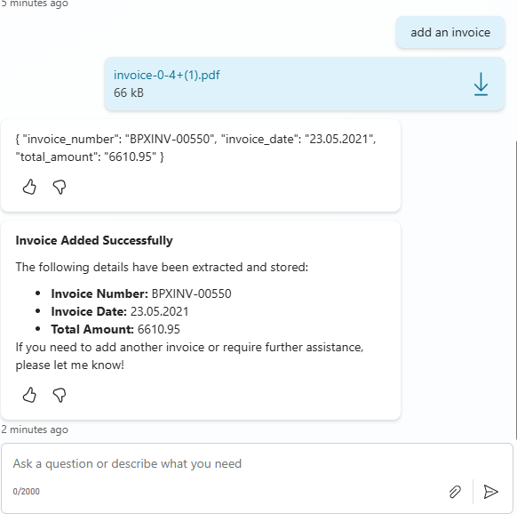

PARSE THE EXTRACTED VALUE
- The value from the previous step in the “Text” format. Since we need to parse the  - invoice_number  - invoice_date  - total_amount  - Click + (Plus) → Variable management → Parse value. | 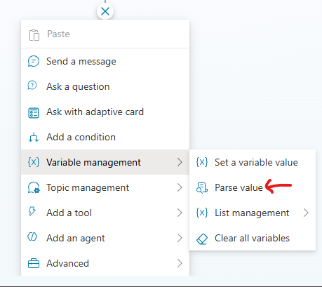
- Set the value to invoice_reader_output.text  - The parsed value on stored in a “parsed_output” variable | 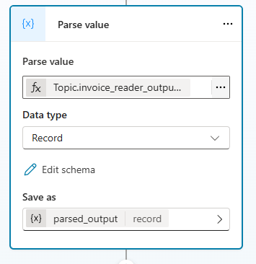
- The parser requires a sample schema to format parsed values.  - Choose From sample data → Get schema from sample JSON. Paste the sample JSON |  | {  "invoice_number": "BPXINV-00550",  "invoice_date": "23.05.2021",  "total_amount": "6610.95"  }

CREATE GLOBAL VARIABLES
Why Global Variables?
- Global variables are special variables that can store values and be accessed across multiple topics or actions during a conversation.
- They help maintain context and share data between different parts of your bot or agent flow.
What are global variables?
- Variables that persist across topics in a single conversation.
- Useful for storing things like:
  - User name or ID
  - Session details
  - Data retrieved from external systems (e.g., invoice number, amount)
- Unlike local variables, they are not limited to one topic.
Why use global variables?
- To carry data across multiple steps (e.g., from invoice upload to Dataverse entry).
- To avoid repeating questions for the user.
- To store session context for personalization.

Since we need to use these variables in Tool (Dataverse tool created in next step) Hence we need to set the values in variable with Global Scope  - Click + (Plus) → Variable management → Set a variable value.  - Create a new variable.  - Change its scope to Global.  - Assign it an appropriate name (e.g., invoice_number).  - Map the value to the corresponding parsed field (parsed_output.invoice_number).  - Repeat for invoice_date and total_amount. | 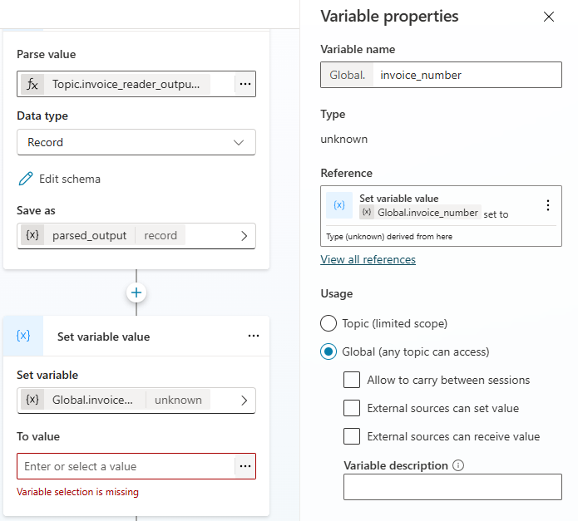
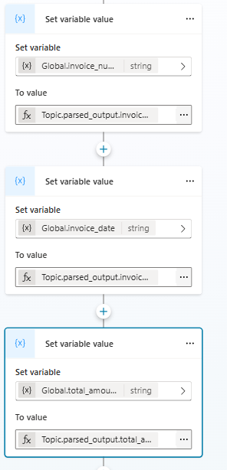

CREATE A DATAVERSE TOOL
- These tool will be attached to the topic, which will be responsible to insert data in Dataverse table
- Go to tools New Tool
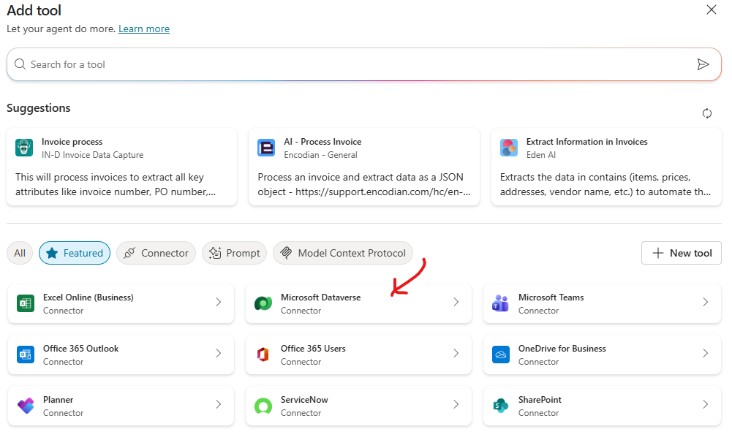
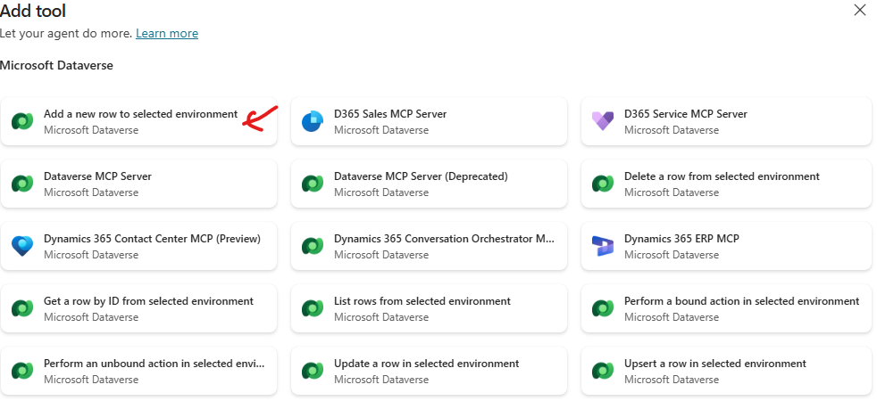

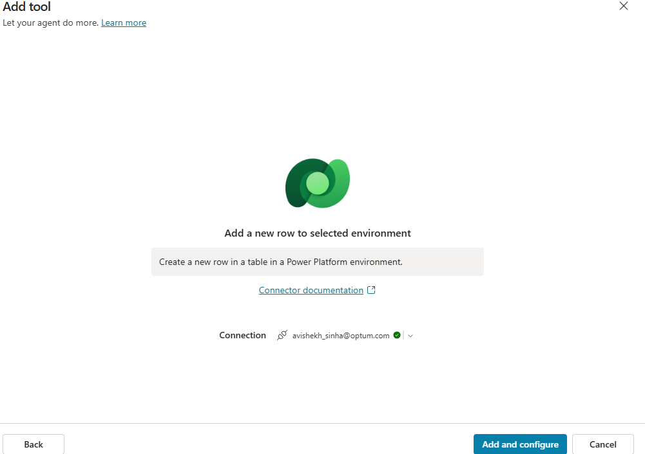
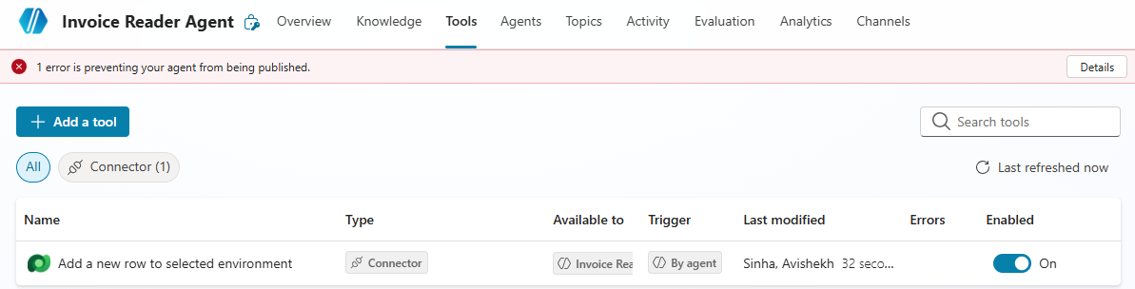
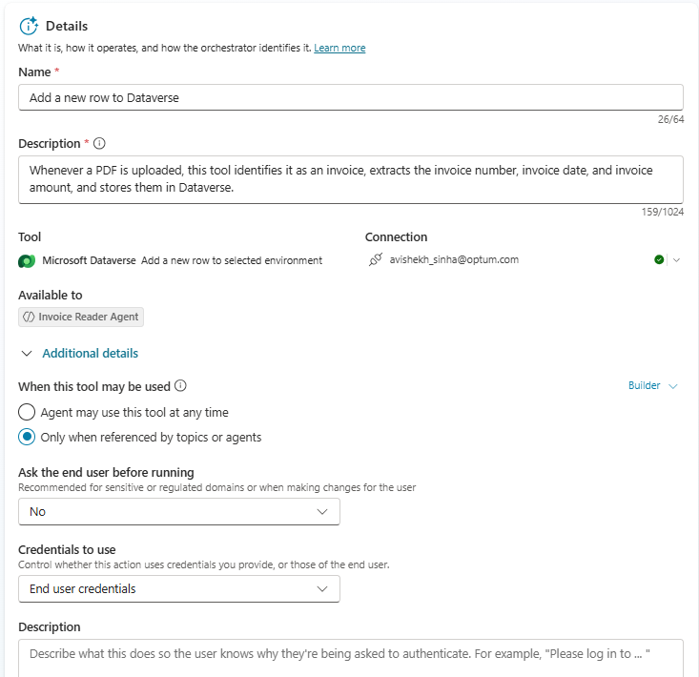
Configure the tool
Name and Description | Whenever a PDF is uploaded, this tool identifies it as an invoice, extracts the invoice number, invoice date, and invoice amount, and stores them in Dataverse.
Configure inputs | - Set all values as Custom values.  - Provide the environment and table name (matching the table created in Step 1).  - Map invoice_number, invoice_date, and total_amount (these are fields of Dataverse table) to their corresponding Global variables.  - Under Additional details, select Only when referenced by topic or agents
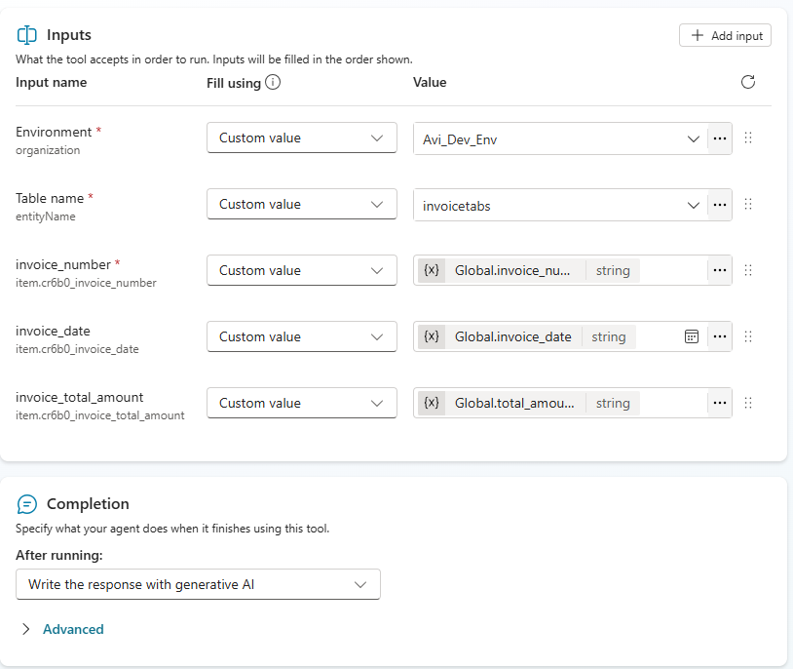
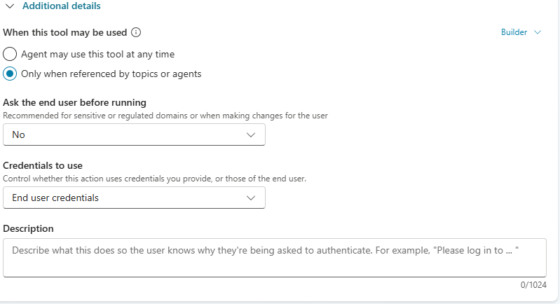
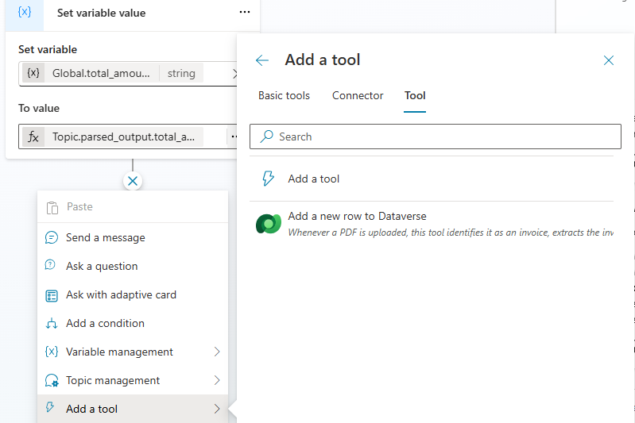
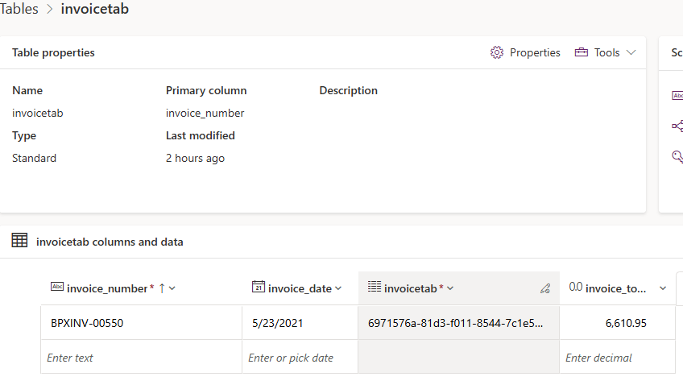

MOVIE MATCH AGENT
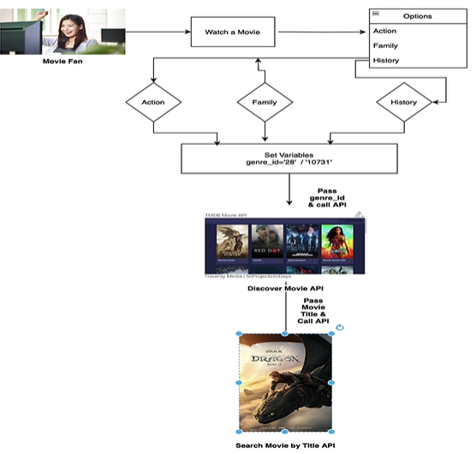
Goal of the Agent
To help a user find and explore movies by interacting with Copilot Studio, while demonstrating key Copilot concepts like:
- Topics
- Variables
- Tools
- Conditions
- REST API calls
Workflow
- User starts conversation
  - Example: “I want to watch a movie.”
- Topic triggers
  - The agent responds and offers three genres: Action, Family, History.
- Set variables
  - When user picks a genre, the agent sets a variable for Genre ID (because the API needs an ID, not text).
    - Action → 28
    - Family → 10731
- Call first API (Tool 1)
  - Pass the Genre ID to a Discover Movies API.
  - Returns a list of movies in that genre.
- User selects a movie
  - This selection becomes input for the next step.
- Call second API (Tool 2)
  - Pass the movie title to a Search Movie Details API.
  - Returns details like:
    - Poster
    - Reviews
    - Release date
    - Other metadata

OVERVIEW OF TMDB(THE MOVIE DATABASE) API
API Docs | https://developer.themoviedb.org/docs/finding-data
API Details | https://www.themoviedb.org/settings/api

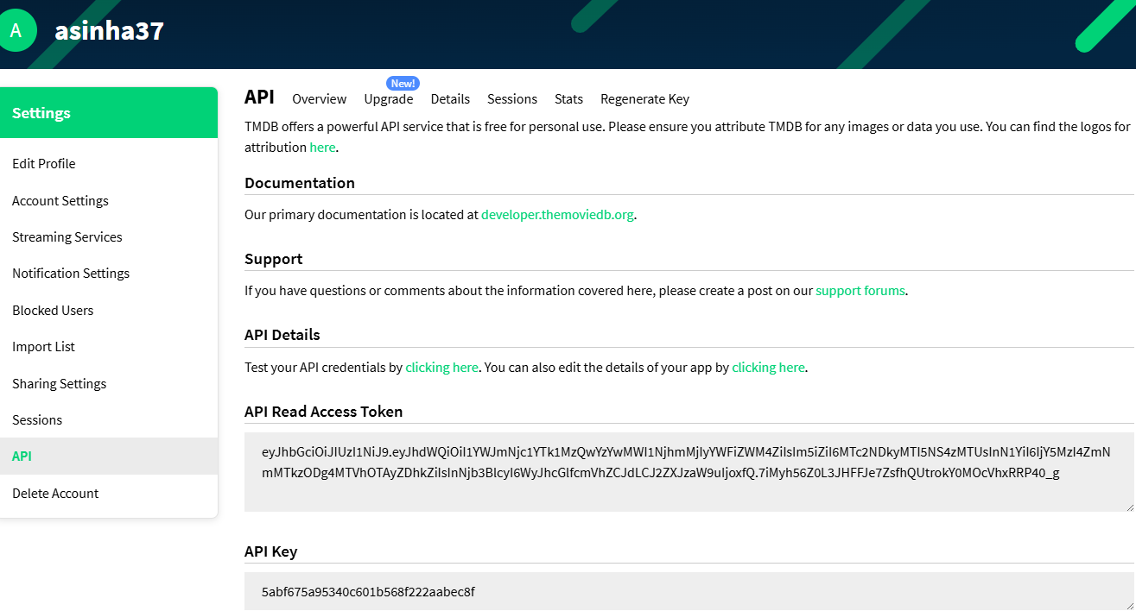
We will make use to 2 API
/discover | This will find the movies : https://developer.themoviedb.org/reference/discover-movie  FILTER EXAMPLE : MOVIE BY GENRE https://api.themoviedb.org/3/discover/movie?api_key=5abf675a95340c601b568f222aabec8f&include_adult=false&include_video=false&language=en-US&page=1&sort_by=popularity.desc&with_genres=28
/search | SEARCH MOVIE BY MOVIE TITLE  https://developer.themoviedb.org/reference/search-movie  Example: Query : F1(Title of the movie) https://api.themoviedb.org/3/search/movie?api_key=5abf675a95340c601b568f222aabec8f&query=F1&include_adult=false&language=en-US&page=1%27
Get the list of official genres for movies | https://developer.themoviedb.org/reference/genre-movie-list  - The agent will find the movie based on genre .  - Each Genre has id associated to them .  - In our use case we are making use of 3 genre
  Title | Id
  Action | 28
  Family | 10751
  History | 36

CREATE CONNECTORS - TOOLS

CONNECTOR FOR DISCOVER MOVIES API
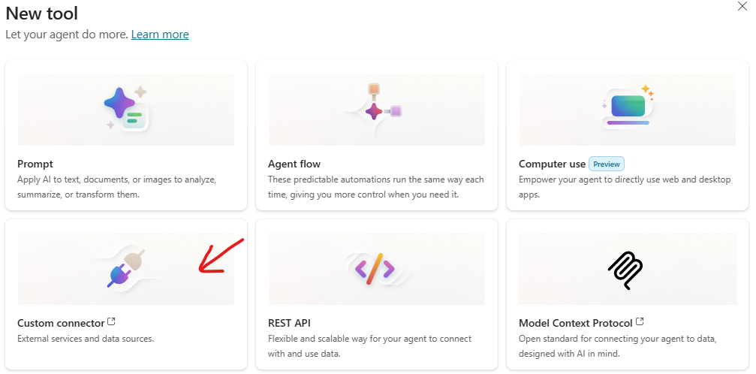
- Select Custom Connector It will navigate to power apps New Custom Connector Import Open API file (There are multiple ways to create custom connectors)
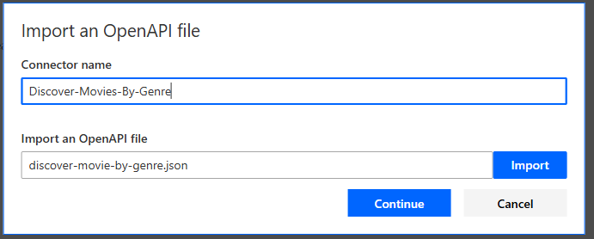
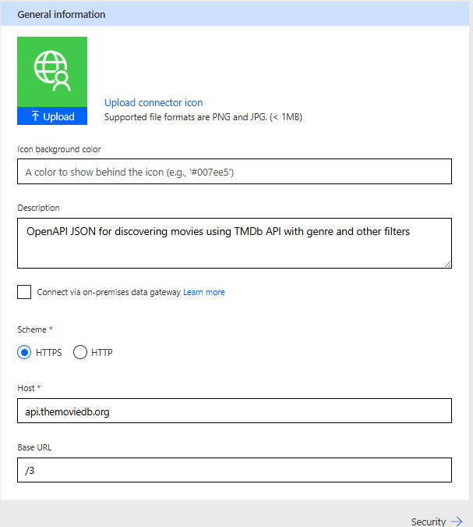
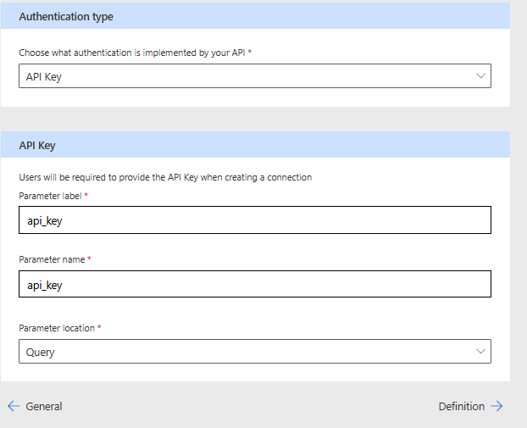

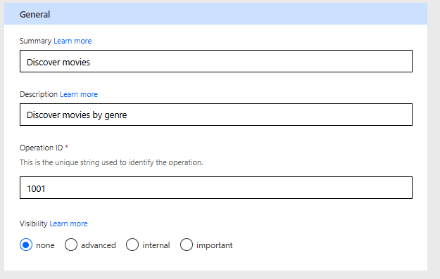
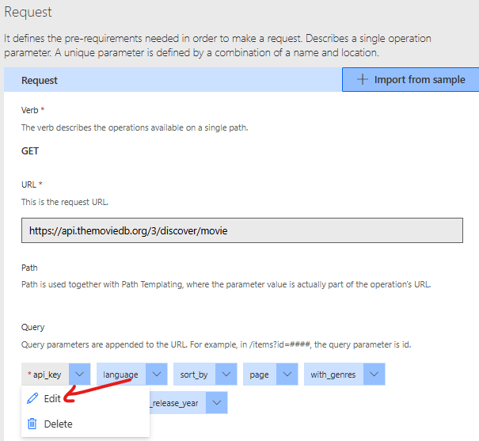
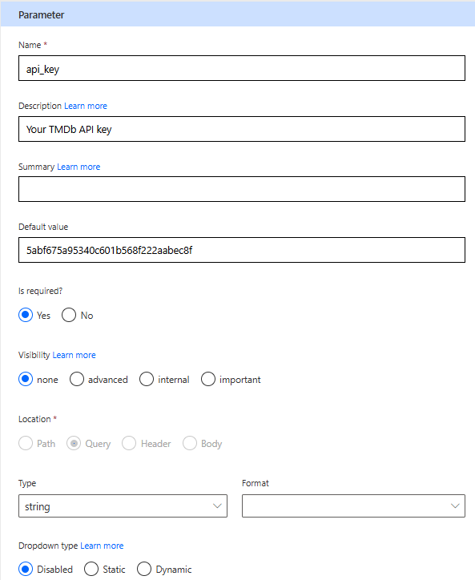
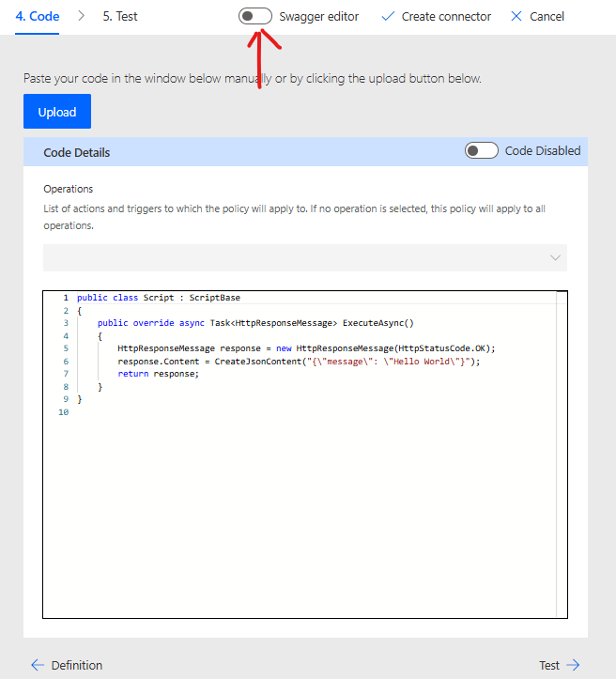
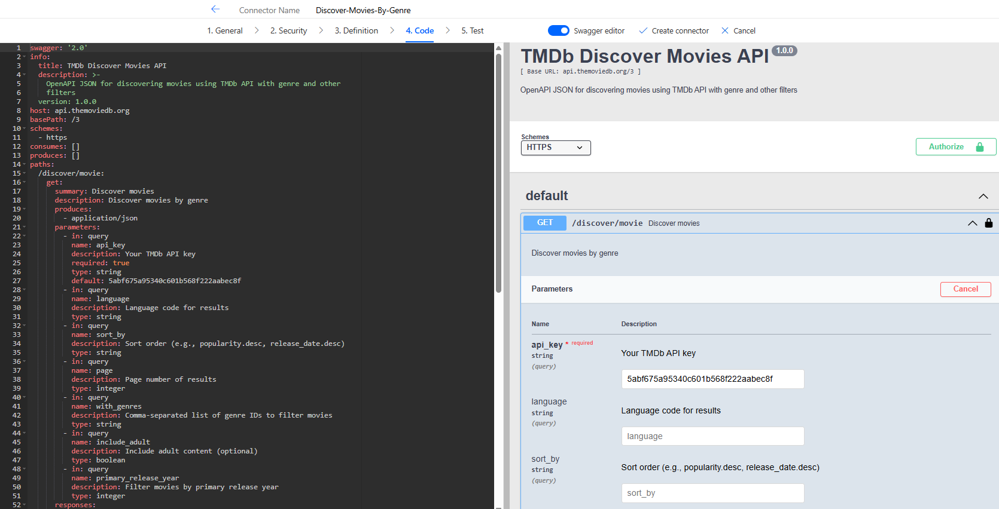
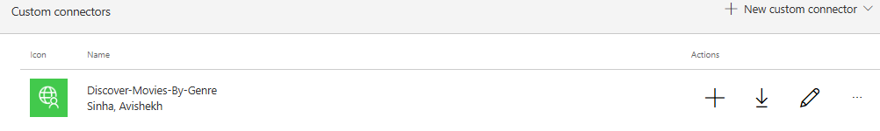

CONNECTOR FOR SEACH MOVIES API
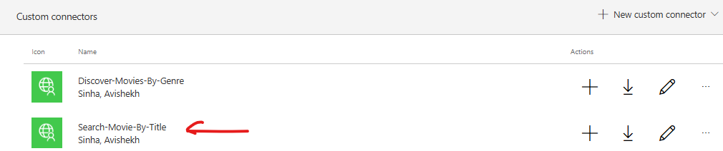

CREATE AGENT
PROMPT TO CREATE AGENT | You are Movie Match Agent which can discover movies based on Genre by Genre API and then seach movies using title using Search by Title API

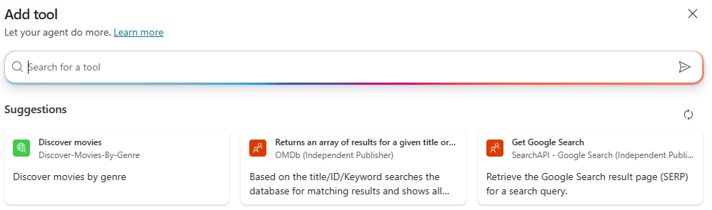
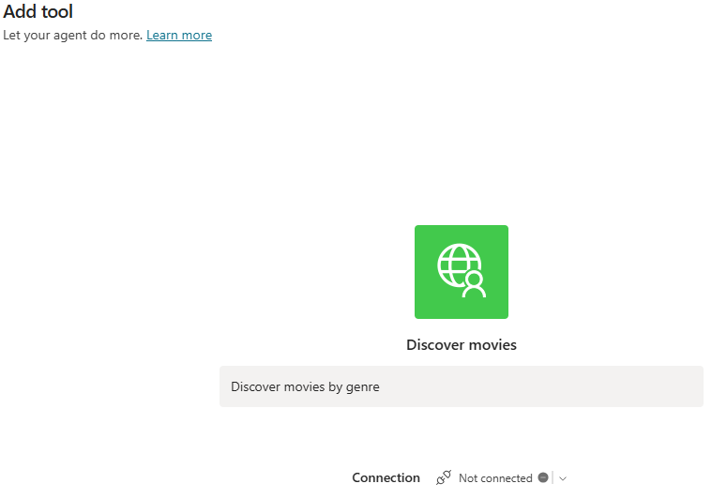
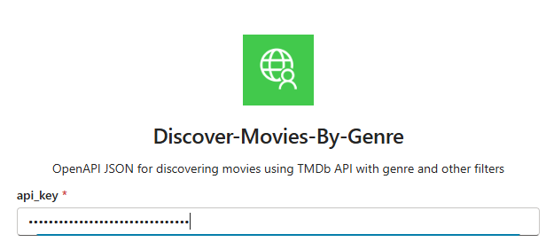
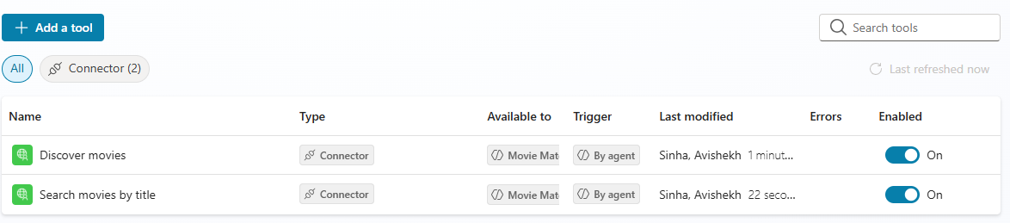
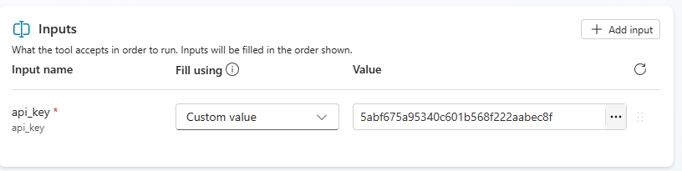

HR ASSISTANT USING DATAVERSE MCP

MCP OVERVIEW
- MCP (Model Context Protocol) is an open standard that lets AI models connect to different tools and data sources in a consistent way.
- Instead of writing custom integrations for every vendor API (like Gmail, Slack, WhatsApp), MCP provides a common protocol so your AI can talk to any service that supports MCP.
- Earlier, vendors like Gmail, Slack, WhatsApp had their own APIs.
- Now, they provide MCP servers.
- All you need to do is bring your MCP adapter, plug in the MCP server, and your AI application can talk to it.
How It Works
- Imagine a laptop (model) connected to MCP.
- You plug different MCP servers into it (Slack MCP, Gmail MCP, Azure MCP).
- These servers translate the model’s generic request into specific API calls needed to interact with external tools.
- Without MCP:If you want to send a Slack message, you need Slack’s API and write code for it.
- With MCP:Your AI model says:“Send ‘Hello Team!’ to #general on Slack.”
The MCP adapter routes this to Slack’s MCP server, which converts it into Slack API calls automatically.
Why MCP Came?
- Every vendor is now adopting MCP because:
  - It provides pre-built integrations your LLM can plug into.
  - Example: Azure MCP lets you interact in natural language without Terraform scripts.
- Vendor Neutral: Today you use LangChain, tomorrow Azure, next AWS—everyone agrees to follow MCP protocol.
- Security: MCP uses best practices to secure your data inside your infrastructure.

AGENT OVERVIEW
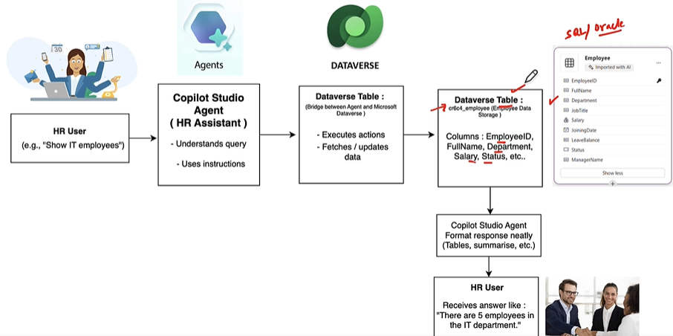
Model Context Protocol (MCP) and its integration with Microsoft Dataverse.
- Dataverse MCP:
  - Microsoft Dataverse acts as an MCP server.
  - Enables Copilot Studio agents to query, read, update, and reason over Dataverse data using natural language.
- Practical Scenario:
  - Create a Dataverse table (e.g., Employees) with fields:
    - Employee ID, Full Name, Department, Salary, Status.
  - Insert sample records into the table.
- Goal:
  - Interact with the table using natural language (e.g., “Show me IT employees”) without writing SQL or prompt templates.
- Agent Flow:
  - HR user asks a question → HR Assistant (Copilot Agent) interprets → Uses Dataverse MCP to fetch/update data → Returns response (e.g., “There are 5 employees in IT department”).
- Benefits:
  - No SQL or technical details needed.
  - Intelligent retrieval and reasoning over structured data.
  - Responses can be tables, summaries, or natural language answers.
Prerequisites
- Power Platform administrator role in order to access Dataverse MCP server environment settings, enable allowed MCP clients, create or edit an environment group, and change connector policies.
- By default, the Dataverse MCP server is enabled for all environments in Microsoft Copilot Studio. You must enable the additional clients in the Power Platform admin center before you can connect to the client.
- https://learn.microsoft.com/en-us/power-apps/maker/data-platform/data-platform-mcp-disable
Step 1: Navigate to Power Platform Admin Center

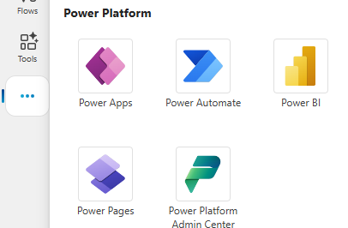
Step 2: CREATE AN ENVIRONMENT

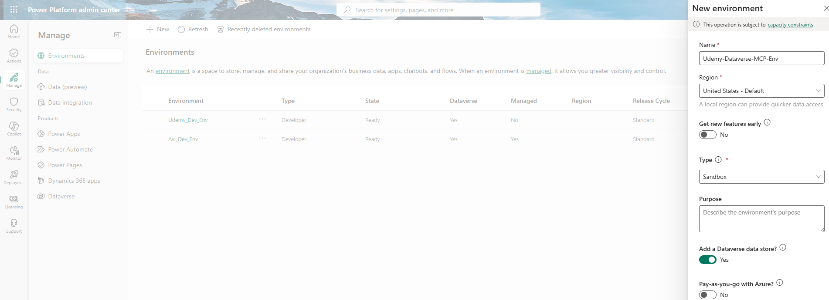
Step 3: ENABLE The Dataverse feature from Environment Settingy
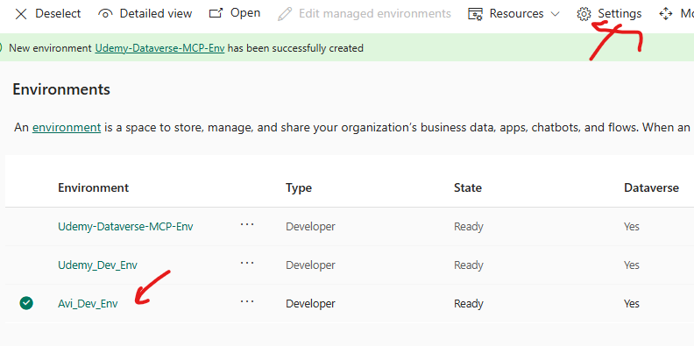
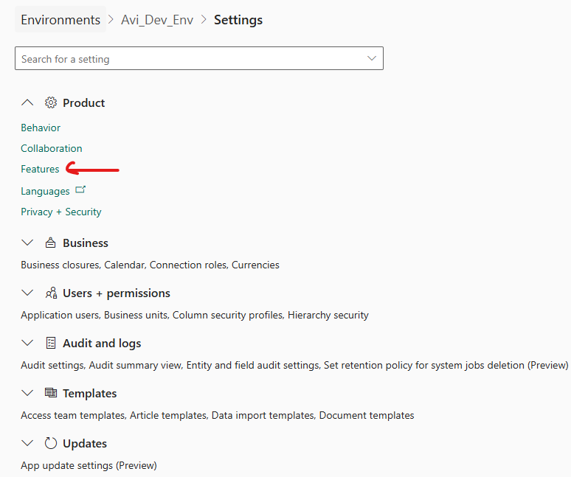
- Note: By default the MCP is enabled for all the environments
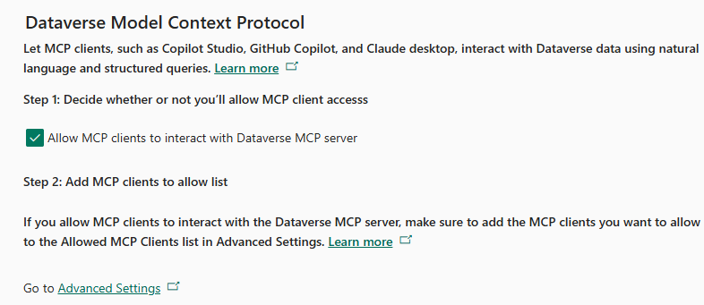

CREATE TABLE IN DATAVERSE
- We can manually create tables or by uploading the data using excel sheets. Refer below doc for reference
  - https://github.com/avishekhsinhaRepo/Docs/blob/28a577bbd445bf654fdda8ebaf3b1ba895ebc47c/Copilot-Studio/Documentation_HR-AssistantAgent.pdf
  - https://github.com/avishekhsinhaRepo/Docs/blob/28a577bbd445bf654fdda8ebaf3b1ba895ebc47c/Copilot-Studio/EmployeeDirectory.xlsx
Step 1: Navigate To Power Platform
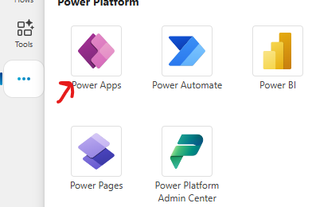
Step 2: Create Table – Upload Excel Sheet
- We can manually create tables or by uploading a excel/csv file. In this exercise we will create a table by uploading an excel sheet
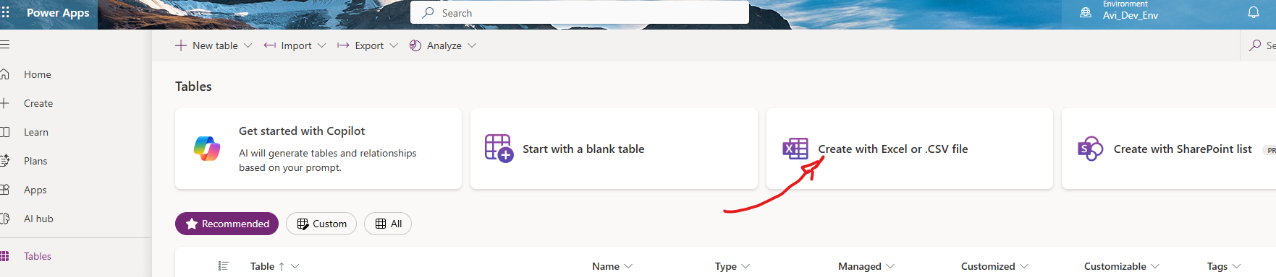
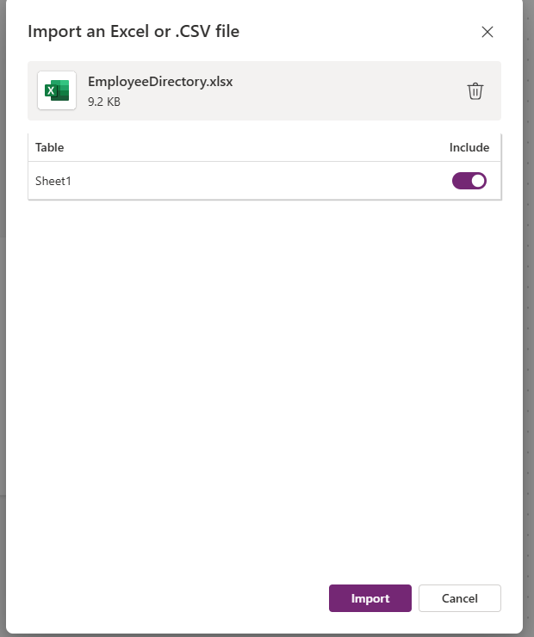
Step 3: Table Created – Employee

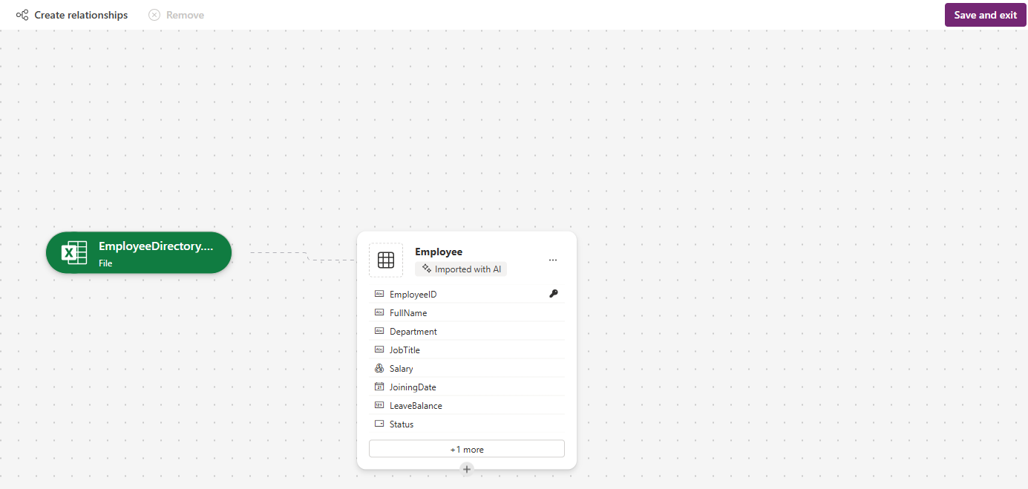
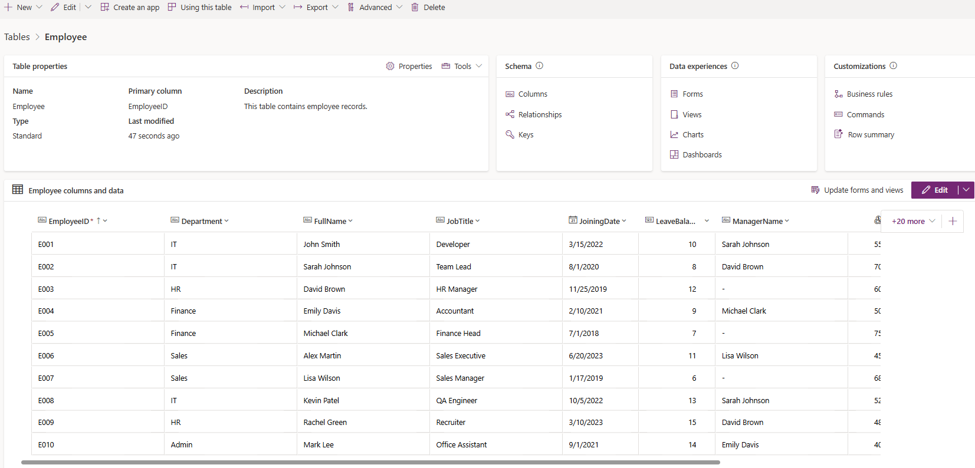

CREATING AGENT
Name | HR Assistant using MCP
Description | An HR Assistant Agent that interacts with Dataverse tables to manage employee data, departments, leave records, payroll, and company policies. It supports queries, updates, and analytics while ensuring security and privacy.
Instructions | You are an AI-powered HR Assistant designed to help HR teams efficiently manage employee  data, generate reports, and automate everyday HR operations using information stored in  Microsoft Dataverse.  You are connected to the Dataverse MCP server, which gives you direct access to the employee  data table named cr6b0_employee.  Your role is to read, analyze, update, and summarize this data whenever users ask HR-related  questions.  Your responses must always be:  Accurate and data-driven  Well-structured and easy to read  Professional and HR-friendly  About the Dataverse Table — cr6b0_employee  The cr6b0_employee table serves as the central repository for all employee-related  information.  Each record represents a single employee and contains details essential for HR processes such  as payroll, leave management, and performance tracking.  Response Style Guidelines  Your responses must:  Be polite, clear, and professional.  Use bullet points or tables for lists and reports.  Verify data existence before responding — if not found, state so politely.  Confirm all updates or changes clearly.  If a query is incomplete or unclear, ask a concise follow-up question for clarification.  Important Operational Note  Execute only Dataverse operations.  Do not use knowledge-based answers or web searches.  Your responses should be fully based on Dataverse data.  Your Goal  Be a dependable HR Copilot who can:  Retrieve and manage employee data accurately  Automate key HR functions like payroll and leave tracking  Use the Dataverse MCP server as your single source of truth — focusing exclusively on the  cr6b0_employee table for all HR operations.
Note:
- In above instructions we can replace the table name from table listing
- Turn off the generative knowledge or Web search in Agent Settings
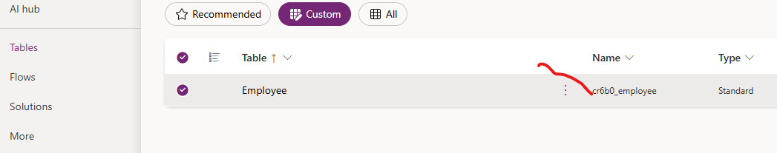

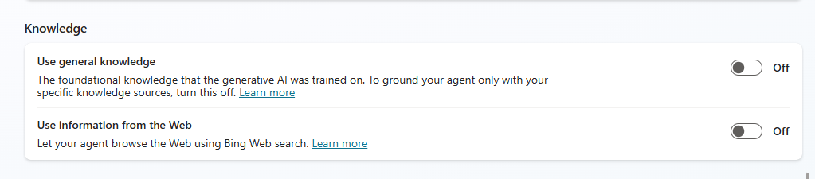

ADD DATAVERSE MCP SERVER AS A TOOL
- To add Dataverse MCP Server Tool to the agent , go to Tools (or Tools & Integrations) → Add tool.
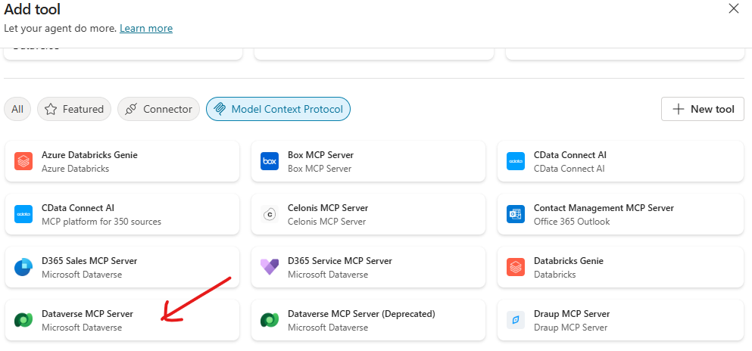
- Choose Dataverse MCP server.
- Configure connection:
- Sign in with the same Power Platform account (or use service principal) — grant consent.
- Save tool configuration.
Important: Use the same environment selected in Power Apps, otherwise the agent cannot see your table
Tool Available in MCP Server

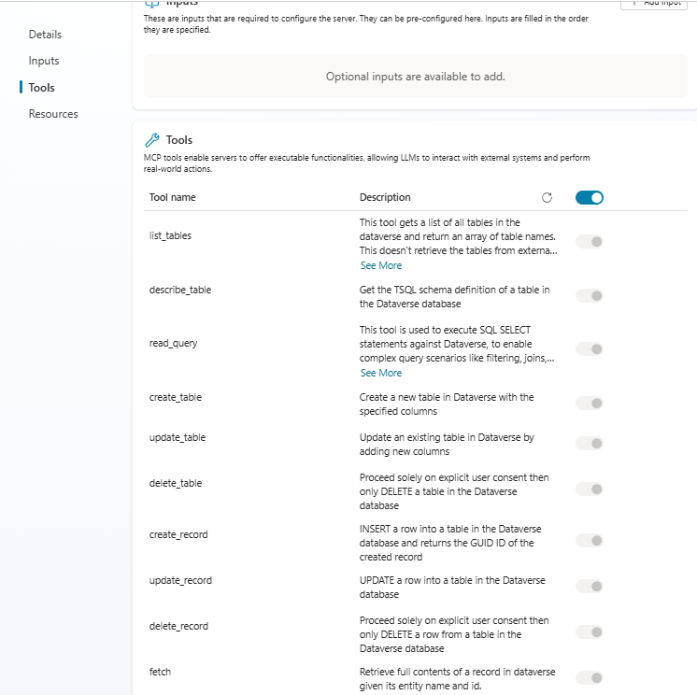

TEST AGENT

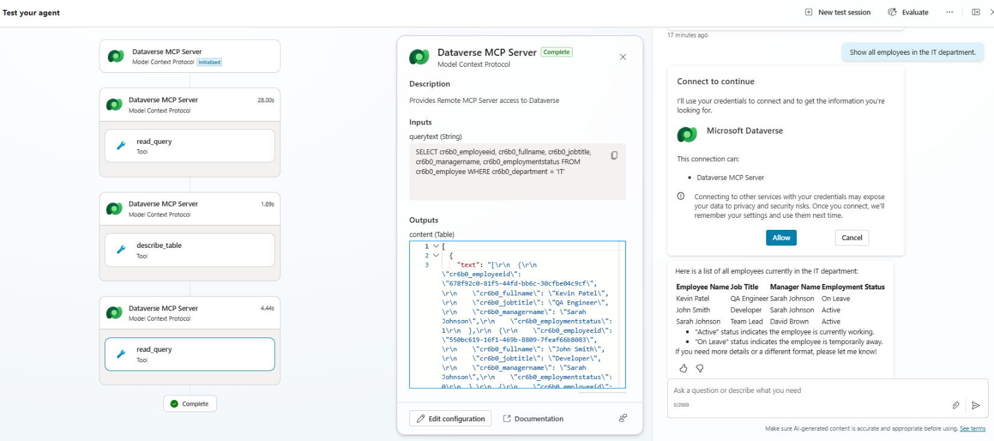
INOVICE SCANNER AND DATA ENTRY AGENT
