Table of Contents
BMAD 2
CORE CONCEPT 2
GETTING STARTED 2
BMAD – PLANING TRACKS 2
ASK FOR HELP 3
BMAD WORKFLOW 3
LIST OF WORKFLOW STEPS AND ACTIVATION COMMAND 3
FILES CREATED IN BMAD PHASES 4
STEP 1: ANALYSIS PHASE( OPTIONAL BUT USEFUL) 4
STEP 2: PLANNING PHASE 5
STEP 3: SOLUTIONING PHASE 6
STEP 4: IMPLEMENTATION PHASE 7
SETTING UP SAMPLE PROJECT 8

BMAD
- BMad = a structured way to build software with AI agents.
- Instead of jumping straight into coding, it walks us through phases
  - Optional analysis
  - Required planning
  - Solutioning/architecture for bigger projects
  - Implementation story by story.
- It is designed to work with AI coding tools like Claude Code, Cursor, or Codex CLI.
What BMad is doing for you?
BMMA gives:
- Specialized agents,
- Named workflows you run as skills,
- A sequence to follow so the ai does not lose direction.

CORE CONCEPT
- BMAD breaks development into phases instead of doing everything in one prompt
The docs describe 4 phases:
ANALYSIS | - Brainstorming  - Research  - Product Brief | OPTIONAL
PLANNING | - PRD/Spec | REQUIRED
SOLUTIONING | - Architecture And Implementation Readiness, | REQUIRED for BMad Method/Enterprise
IMPLEMENTATION | - Sprint Planning  - Create Stories  - Build  - Review  - Retrospective.

GETTING STARTED
INSTALL BMAD | npx bmad-method install
INSTALL PRE RELEASE VERSION | npx bmad-method@next install
BMAD HELP (bmad-help is the built-in guide. It checks your project state, tells you the first required step, and recommends what to do next) | bmad-help
After install, your folder should contain:  - _bmad/  - _bmad-output/  Then open your AI IDE in that same folder and run: bmad-help  • _bmad/ for agents, workflows, tasks, config  • _bmad-output/ for generated artifacts/documents | 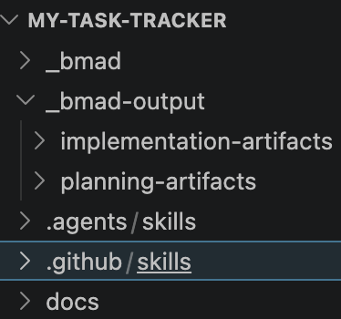

BMAD – PLANING TRACKS
BMad has 3 planning tracks:
QUICK FLOW | - Quick Flow if we want to move fast on a small app or feature  - Used for bug fixes, simple features, small scope
BMAD METHOD | - Normal product/app work
ENTERPRISE | - Bigger systems with more planning needs

ASK FOR HELP
Your first prompt should be:  bmad-help I want to build a simple task tracker app and learn BMad step by step. What should I do first? | WHY THIS MATTERS:  - We do not have to memorize workflows, BMad-Help recommends the next step based on your installed modules and project state.

BMAD WORKFLOW
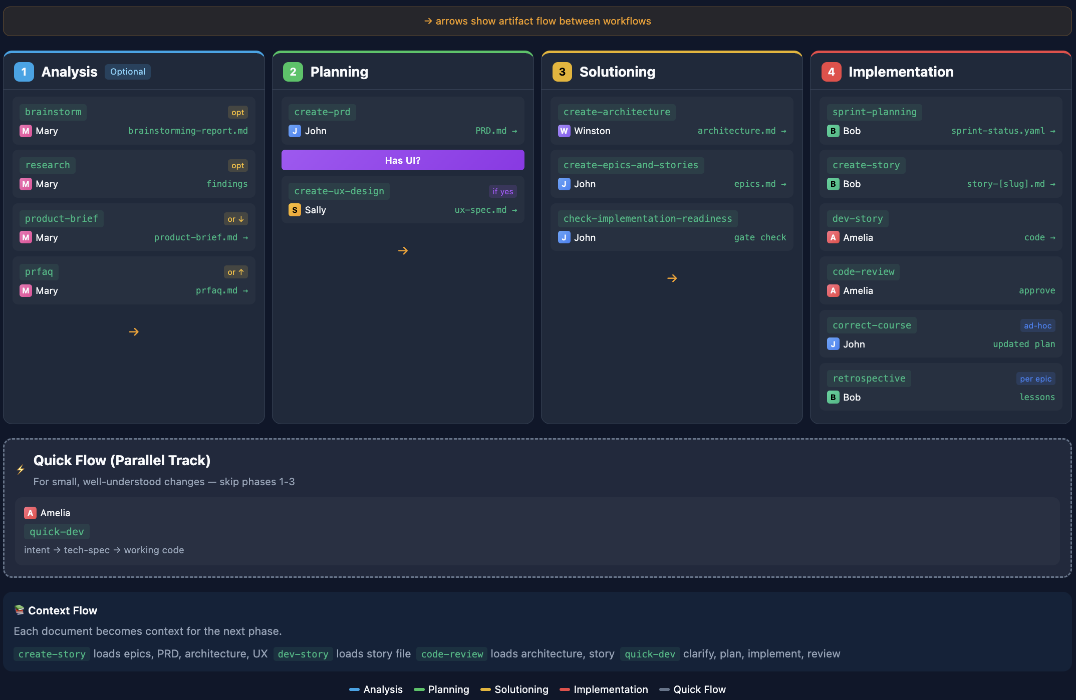

- In BMad, different workflow steps are designed to be executed by specialized agents.
- While workflows can sometimes run without explicitly activating an agent, it is recommended to activate the appropriate agent using its activation command to ensure correct role-based thinking, consistency, and higher-quality outputs.

LIST OF WORKFLOW STEPS AND ACTIVATION COMMAND
Note . For the :
- Core workflows → Always activate agent (Highlighted Below)
  - https://docs.bmad-method.org/reference/core-tools/
- Exploratory workflows → Usually auto-handled

Workflow Step | Agent Responsible | Activation Command | Activation Needed?
bmad-help | BMad Master | — (auto) | ❌ No
bmad-brainstorming | Analyst (implicit) | — (auto) | ❌ No
bmad-market-research | Analyst | — (auto) | ❌ No
bmad-domain-research | Analyst | — (auto) | ❌ No
bmad-technical-research | Analyst / Architect | — (auto) | ❌ No
bmad-product-brief | PM | bmad-agent-pm | ✅ Recommended
bmad-create-prd | PM | bmad-agent-pm | ✅ Recommended
bmad-create-ux-design | UX Designer | bmad-agent-ux-designer | ✅ Recommended
bmad-create-architecture | Architect | bmad-agent-architect | ✅ Recommended
bmad-create-epics-and-stories | PM | bmad-agent-pm | ✅ Recommended
bmad-check-implementation-readiness | Architect | bmad-agent-architect | ✅ Recommended
bmad-sprint-planning | Dev | bmad-agent-dev | ✅ Recommended
bmad-create-story | PM / Dev | bmad-agent-pm (or Dev) | ⚠️ Optional
bmad-dev-story | Dev | bmad-agent-dev | ✅ Recommended
bmad-code-review | Dev / QA | bmad-agent-dev | ✅ Recommended
bmad-retrospective | Multi-agent / Team | (optional bmad-party-mode) | ⚠️ Optional
bmad-party-mode | BMad Master + multiple agents | — (auto) | ❌ No

FILES CREATED IN BMAD PHASES
PHASE 1: ANALYSIS (OPTIONAL)
Workflow Step | Agent | File(s) Created | Purpose
bmad-brainstorming | Analyst (implicit) | — | Explore & refine idea
bmad-market-research | Analyst | optional notes | Understand market
bmad-domain-research | Analyst | optional notes | Learn domain
bmad-technical-research | Analyst / Architect | optional notes | Feasibility check
bmad-product-brief | PM | product-brief.md | Define product clearly
PHASE 2: PLANNING (REQUIRED)
Workflow Step | Agent | File(s) Created | Purpose
bmad-create-prd | PM | PRD.md | Full requirements
bmad-create-ux-design (optional) | UX Designer | ux-design.md | UI/UX structure
PHASE 3: SOLUTIONING
Workflow Step | Agent | File(s) Created | Purpose
Define project context (manual) | You / Architect | project-context.md | Tech preferences
bmad-create-architecture | Architect | architecture.md | Technical design
bmad-create-epics-and-stories | PM | epics.md | Work breakdown
bmad-check-implementation-readiness | Architect | validation notes | Ensure readiness
PHASE 4: IMPLEMENTATION
Workflow Step | Agent | File(s) Created | Purpose
bmad-sprint-planning | Dev | sprint-status.yaml | Plan execution
bmad-create-story | PM / Dev | story output | Define work unit
bmad-dev-story | Dev | source code | Implement feature
bmad-code-review | Dev / QA | review notes | Improve code
bmad-retrospective | Team (multi-agent) | retrospective notes | Learn & improve

STEP 1: ANALYSIS PHASE( OPTIONAL BUT USEFUL)
- The Analysis phase helps us think clearly about product before commit to building it.
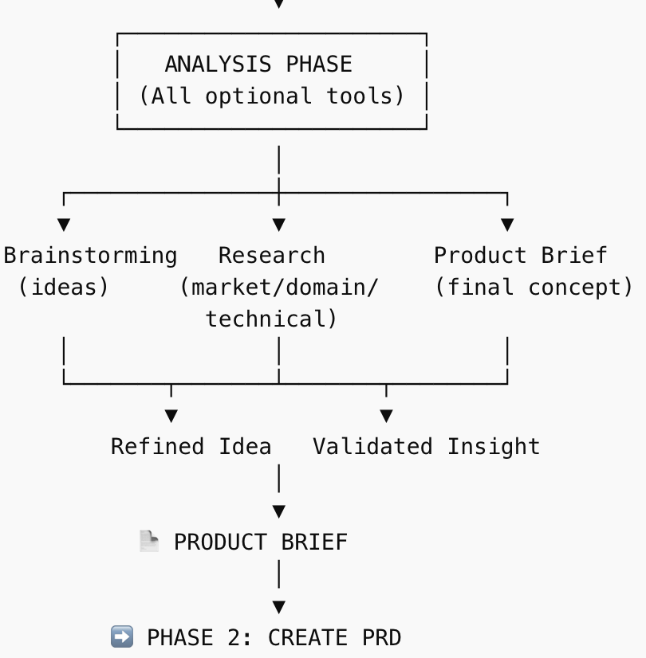

BRAINSTROMING
- Brainstorming in BMad is a guided thinking session where the AI helps us explore and expand our idea by asking questions and suggesting different angles.
- Purpose: It clarify our idea, understand the problem better, and generate multiple possible solutions before deciding what to build.
- Objective: turn a vague idea into a clear, well-defined direction that can later be converted into a product brief and PRD.

RESEARCH (MARKET, DOMAIN, TECHNICAL)
- Research in BMad means gathering knowledge about the market, domain, and technical feasibility to better understand what you’re building and why.
- Purpose: to validate your idea by checking real-world demand, understanding the problem space, and ensuring the solution is practical to build.
- Objective: reduce risks and assumptions so your product brief and PRD are based on informed decisions, not guesses.

PROJECT BRIEF
- Product Brief in BMad is a short, structured document that clearly defines what you are building, who it is for, and what problem it solves.
- Purpose: to convert ideas and research into a clear, focused product direction before writing the PRD.
- Objective: create a solid foundation (user, problem, MVP scope, constraints) that guides all later steps like PRD, architecture, and development.
- The results from Analysis are used in the next step (Planning).
- The PRD (Product Requirement document)takes inputs like product brief, research, and brainstorming, and turns them into clear requirements.
- The better we analysis, the clearer and stronger our PRD will be.

STEP 2: PLANNING PHASE
WHAT IS THE DIFFRENCE BETWEEN ANALYSIS AND PLANING PHASE
- Analysis = understand the problem
- Planning = define the solution clearly
EXAMPLE- Food Delivery App
Analysis (understand the problem)
People feel hungry but don’t want to cook Finding nearby restaurants is inconvenient Ordering food should be quick and easy
Here are identifying the problem
Planning (define the solution)
App will:
show nearby restaurantsallow users to select food place an order Keep checkout simpleNo advanced features for MVP
Here are defining what exactly to build
Super simple contrast
Analysis: “People want an easy way to order food”
Planning: “We will build an app to browse restaurants and order food online”

What is the Planning Phase in BMad?
- Planning Phase = We turning our idea into clear, structured requirements
You are answering: WHAT exactly are we building?
- The planning phase creates a PRD (Product Requirements Document) named : PRD.md
- This file becomes the source of truth for the whole project. It includes:
  - Product overview
  - Target users
  - User stories
  - Functional requirements
  - Non-functional requirements
  - Scope (what’s included / excluded)
Workflow Step | Agent Responsible | Activation Command
bmad-create-prd | PM | bmad-agent-pm
bmad-create-ux-design | UX Designer | bmad-agent-ux-designer
- Note= creating PRD is so important because everything later depends on it:
PRD → Architecture → Epics → Code

STEP 3: SOLUTIONING PHASE
SOLUTIONING = DECIDING HOW TO BUILD WHAT WAS DEFINED IN PLANNING
BMAD PHASE | WHAT IT ANSWERS | ANALOGY- Building a house
Analysis | WHAT problem
Planning | WHAT to build | Blueprint (rooms, layout)
Solutioning | HOW to build it | - Engineering design  - Materials  - Wiring  - Plumbing

GOAL OF SOLUTIONING
- Convert requirements (PRD) into a technical design
- In this step we decide :
  - Architecture
  - Tech stack
  - Components
  - Data flow
- It creates a clear implementation plan for developers

FILES CREAED
Workflow Step | Agent | File(s) Created | Purpose
Define project context (manual) | Architect | project-context.md | - Technical preferences  - Constraints
bmad-create-architecture | Architect | architecture.md | - System design  - Components  - Data model  - Tech stack
bmad-create-epics-and-stories | PM | epics.md | - Breaks work into:  - Epics (big chunks)  - Stories (small tasks)
bmad-check-implementation-readiness | Architect | validation notes | - Ensure readiness – I,e everything is consistent and nothing is missing
FLOW

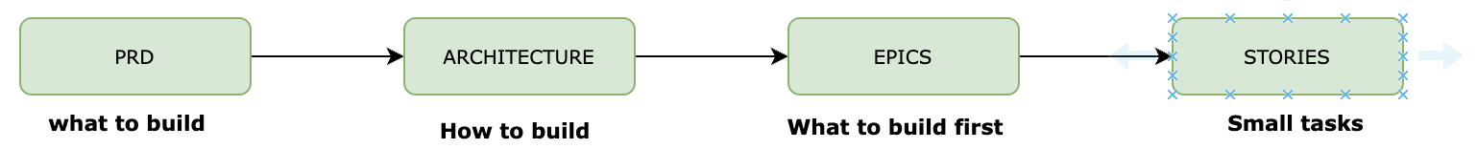

STEP 4: IMPLEMENTATION PHASE
IMPLEMENTATION = ACTUALLY BUILDING THE PRODUCT, STEP BY STEP
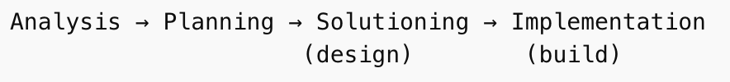
- Implementation phase is where we actually build the product using code. i.e. it convert: architecture + epics + stories into working code
- The goal is to convert planned features and architecture into a working application.
- Work is done in small steps called stories, not all at once.
- Each story represents one small, clear task (e.g., add task input, show list).
- We do not build the whole app at once instead the process follows a loop:
create story → build → review → repeat.
- Sprint planning decides which stories to build first and in what order.
- The developer agent (bmad-agent-dev) is mainly used in this phase.
- Code is written step by step, using PRD and architecture as guidance.
- Code review ensures the implementation is correct, clean, and consistent.
- This phase is iterative, meaning you keep improving the product story by story.
- By the end of this phase, you get a fully working application built in a structured way.

WORKFLOW

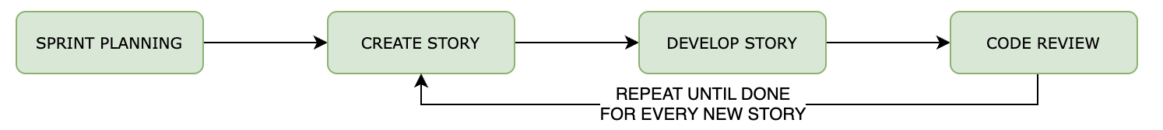
STEP | ACTIVATION COMMAND | AGENT | FILE CREATED | WHAT IT DOES
SPRINT PLANNING | bmad-agent-dev | bmad-sprint-planning | sprint-status.yaml | Decides what to build first
CREATE STORY | bmad-agent-dev(OPTIONAL) | bmad-create-story | NA | Defines ONE small task
DEVELOP STORY | bmad-agent-dev | bmad-dev-story | NA | Writes actual code  Uses:  - Prd  - Architecture  - Current story
CODE REVIEW | bmad-agent-dev | bmad-code-review | NA | Checks:  - Correctness  - Simplicity  - Consistency

DEPENDENCY TREE
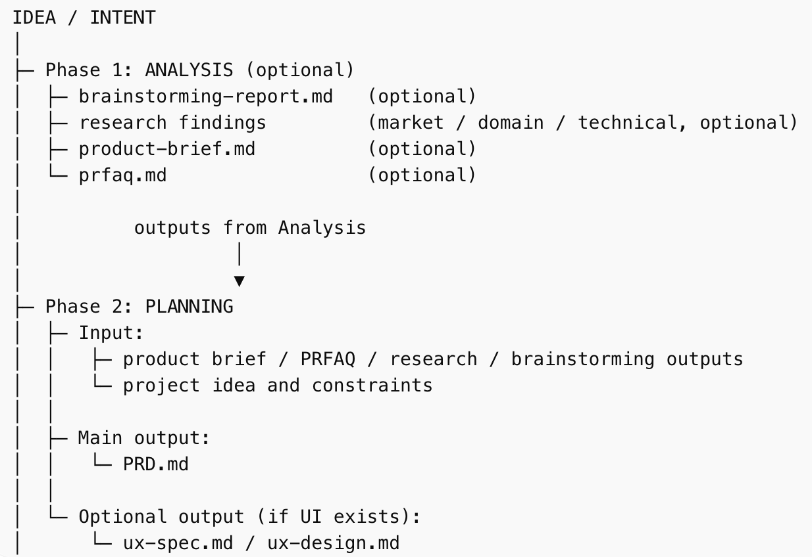
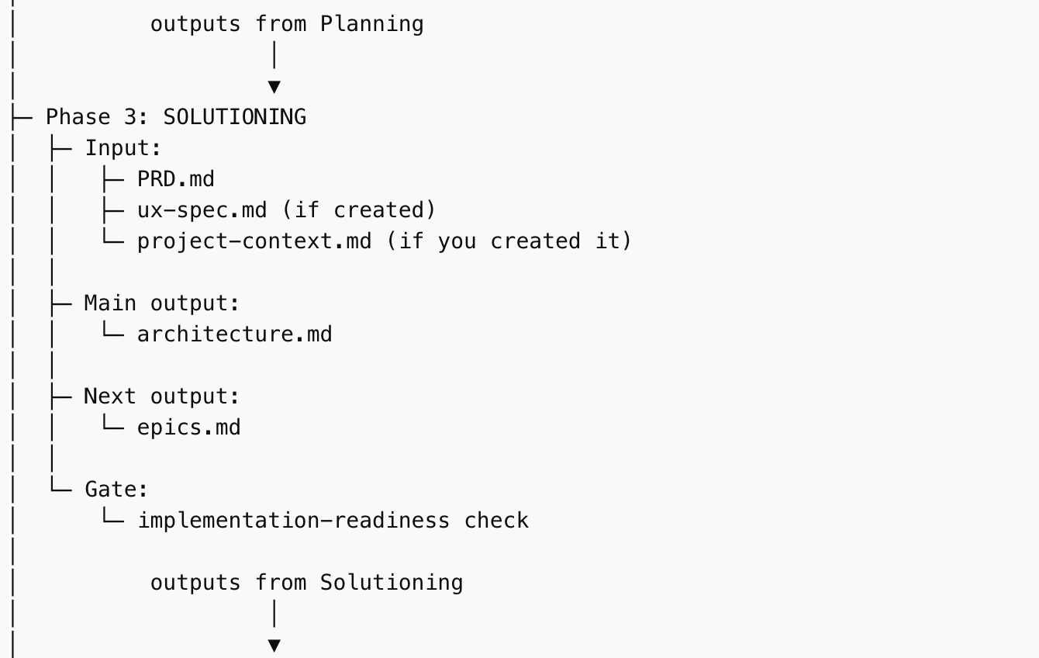
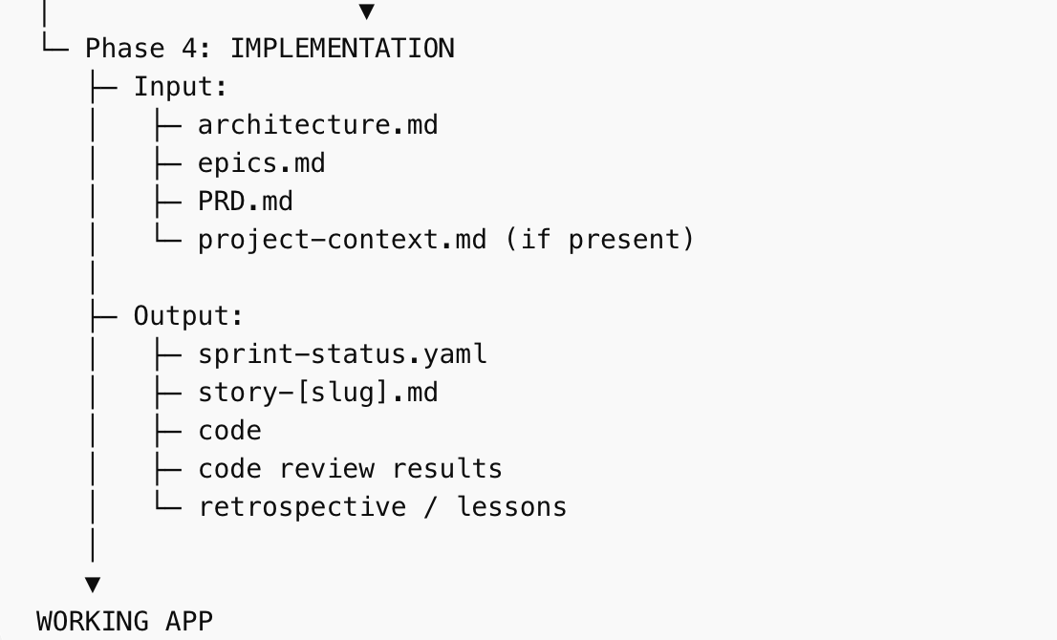
- Analysis gives you understanding.
- Planning turns that understanding into requirements (PRD.md).
- Solutioning turns requirements into a technical approach (architecture.md) and a work breakdown (epics.md).
- Implementation uses those artifacts to build the app story by story.

SETTING UP SAMPLE PROJECT
TASK TRACKER APP | In the Task tracker app we able to  - Add tasks  - Mark complete  - Filter by status

