

ST. XAVIER’S COLLEGE सेन्ट जेभियसस कलेज
MAITIGHAR, KATHMANDU, NEPAL माईतीघर, काठमाडौं, नेपाल
Contact: 4221365, 4244636 सम्पकक: 4221365, 4244636
Email: ktm@sxc.edu.np इमेल: ktm@sxc.edu.np

4th February, 2026
To
The Principal,
By the approval of club moderator,
Sodalitas de’ Mathematica,
St. Xavier's College, Maitighar
Subject: Request for approval of official club T-shirt
Respected sir,
We hope this letter finds you in good health. With due respect, we would like to take your approval on introducing an official club T-shirt with the objective of maintaining uniformity, promoting institutional identity, and encouraging active participation among club members.
Request : We request permission to print the t-shirts as per the requirement and collect a sum of Rs 800/- per T-shirt from each interested member for buying t-shirts.

We hereby seek your kind approval for the same. The proposed T-shirt will be modest, appropriate, and in accordance with the rules, discipline, and values of the institution. It shall bear the club name and logo only and will be worn exclusively during official club activities, academic programs, exhibitions, and related events.
We assure you that the design, color, and usage of the T-shirt will strictly comply with institutional guidelines. The T-shirt will not be misused for any non-academic or unauthorized purpose.
Therefore, we humbly request you to kindly grant approval for the proposed club T-shirt. We shall be highly obliged for your favorable consideration.
Thanking you in anticipation.

Sincerely,
The executives
Sodalitas de’ Mathematica

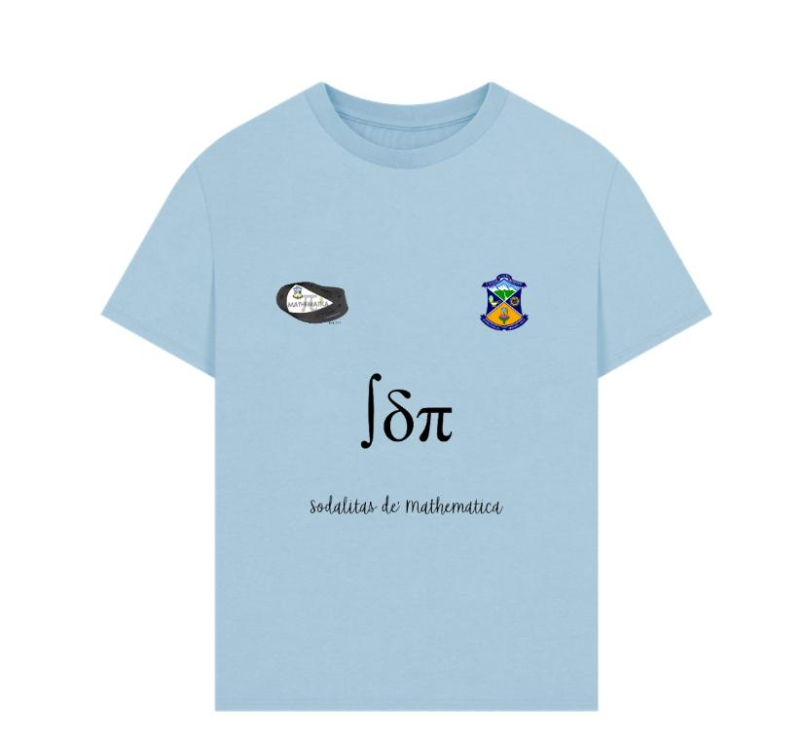

-
………………….… ……………….. ..……………………
Mr. Parash Mani Karn Mr. Gopal Jha Mr. Gehendra Chand
Club Moderator ECA Coordinator Vice Principal

