1. Title of the invention
Method and System for Energy-Optimal, Risk-Bounded Autonomous Actuation in Ambient-Intelligence IoT Using a Conformal Sensing Cascade with Optimised Risk-Budget Allocation (AmI-CC)
2. Field / Area of invention
Ambient Intelligence (AmI) for AI-native Internet of Things; context-aware multimodal sensing; energy-efficient edge AI; trustworthy (statistically guaranteed) autonomous actuation in smart homes, buildings, assisted living and Industry 5.0. (Responds to the IEEE IoT Journal special-issue CFP on "Ambient Intelligence for AI-Native IoT: Invisible, Context-Aware, and Autonomous Experiences": topics – AmI architectures, context-aware sensing, edge AI, explainable/trustworthy AmI, energy-efficient AI-native IoT.)
3. Prior patents and publications from literature
# | Reference (verify before filing) | What it teaches | Gap vs. present invention
1 | US 9,159,208, “Energy efficient cascade of sensors for automatic presence detection” (USPTO) | Cascade of sensors, cheaper sensors gate costlier ones to save power. | Gate is heuristic/threshold based; no distribution-free bound on wrong-actuation; no budget split; no deferral semantics.
2 | Angelopoulos, Bates, Fisch, Lei, Schuster, “Conformal Risk Control”, ICLR 2024 (arXiv:2208.02814) | Calibrating a single threshold to bound expected monotone loss. | Single model/stage; not a multi-sensor, energy-costed cascade; no allocation of a global budget across stages.
3 | “Fast yet Safe: Early-Exiting with Risk Control”, arXiv:2405.20915 | Risk-controlled early exit in neural networks. | Exits inside one network (compute saving); does not power physical sensor tiers, no energy-optimal per-tier budget split, no actuate/escalate/defer policy.
4 | “Efficient Conformal Prediction via Cascaded Inference with Expanded Admission”, arXiv:2007.03114 | Cascaded models to cheapen conformal sets. | Model cascade for set size; no sensing-hardware wake-up, no actuation risk.
5 | Gibbs & Candès, “Adaptive Conformal Inference Under Distribution Shift”, NeurIPS 2021 | Online adaptation of miscoverage level under shift. | Generic; not applied to per-tier budgets of a sensing cascade.
6 | Jitkrittum et al., “When Does Confidence-Based Cascade Deferral Suffice?”, NeurIPS 2023 (arXiv:2307.02764) | Analysis of confidence-threshold deferral in model cascades. | Heuristic confidence rules, no finite-sample guarantee (our baseline behaves this way).
7 | “Sensor-Aware Classifiers for Energy-Efficient Time Series Applications on IoT Devices”, arXiv:2407.08715 | Early-exit classifiers exploiting sensor structure for energy. | No statistical guarantee on wrong decisions; no joint budget allocation.
8 | “Early Time Classification with Accumulated Accuracy Gap Control”, arXiv:2402.00857 | Stopping-time classification with accuracy-gap control. | Time-series stopping, not multi-tier hardware sensing, no energy-optimal allocation.

Note: a professional patent-database search (Espacenet/Google Patents/InPASS, CPC G06N 20/00, G16Y, H04W 52/02, G05B 13) must confirm this table before filing. References 1–8 were identified by web search on 30-Sep-2026; only titles/abstract-level content was reviewed.
4. Summary and background of the invention (gap / novelty)
Background. Ambient IoT must act invisibly (no user prompts), yet a wrong autonomous action (unlocking a door, switching a heater, dismissing a fall alert) is costly, while always-on rich sensors (camera, mmWave radar) drain batteries and raise privacy exposure. Existing systems either (a) run all sensors and a single classifier (high energy, and softmax confidence is uncalibrated), or (b) use heuristic confidence-threshold sensor cascades that give no assurance on how often they act wrongly, especially for unseen occupants.
Gap. No known system couples a physical sensing-tier wake-up cascade with a finite-sample, distribution-free bound on wrong autonomous actuation while choosing how that bound is spent across tiers to minimise energy.
Invention. At each tier a split-conformal prediction set over candidate intents is computed. A singleton set triggers actuation and stops (higher-energy sensors stay asleep); a non-singleton set wakes the next tier; ambiguity at the last tier defers to the user (or a safe default). A wrong actuation implies the true intent was outside the stopping tier's set, so the wrong-actuation probability is bounded by the sum of per-tier miscoverage levels (union bound) – the risk budget α. The novel budget-allocation step searches the split of α over tiers that minimises expected energy + λ·deferral-rate on one data split, and calibrates the thresholds on a disjoint split, so the guarantee stays valid. On-site recalibration with few labelled samples restores the bound under occupant shift.
5. Objective(s) of the invention
(i) Bound the rate of erroneous autonomous actuation by a user/operator-set budget α without distributional assumptions; (ii) minimise sensing energy by waking high-power / privacy-intrusive modalities only when cheaper ones are ambiguous; (iii) provide a principled abstain (“ask user”) behaviour instead of forced decisions; (iv) make the guarantee portable to new occupants/homes through lightweight recalibration; (v) run on edge hardware (logistic/linear heads suffice; cost of allocation is a small grid search).
6. Working principle (in brief)
Tier-t score s=1−p_{t}(y|x); threshold q_{t} = ceil((n+1)(1−α_{t}))-th smallest calibration score; set C_{t}(x)={k: 1−p_{t,k}(x) ≤ q_{t}}. Rule: |C_{t}|=1 → actuate & stop; else escalate; last tier non-singleton → defer. P(wrong actuation) ≤ Σα_{t} ≤ α. Allocation: (α_{1..T})* = argmin E[energy]+λP(defer) s.t. Σα_{t}≤α (grid search on allocation split), thresholds from a disjoint calibration split.
7. Description of the invention in detail
7.1 Architecture. (a) Sensing tiers T1 passive low-power (PIR, door contact, ambient light, time-of-day; 1 energy unit), T2 medium (plug power, audio level, BLE RSSI; 6 units), T3 high (camera / mmWave embedding; 40 units); (b) per-tier classifiers over cumulative features (edge MCU / gateway); (c) conformal calibrator storing per-tier score quantiles; (d) budget allocator; (e) actuation controller with escalate / actuate / defer outputs; (f) optional on-site recalibration module fed by user overrides.
7.2 Procedure. Offline: 1) train tier classifiers on training occupants; 2) on allocation split run the cascade for each candidate split (α₁,…,α_{T}) with Σ=α and keep the split minimising J=E[cumulative energy]+λ·P(defer); 3) on a disjoint calibration split compute q_{t}. Online: power tier 1, compute set; if singleton → actuate; else power tier 2 … ; at the last tier defer if not singleton.
7.3 Why the bound holds. If the cascade actuates wrongly at tier t then C_{t}={ŷ} with ŷ≠y, hence y∉C_{t}; split-conformal gives P(y∉C_{t})≤α_{t} under exchangeability; union over tiers gives ≤Σα_{t}. Because the allocation uses data disjoint from the calibration data, the q_{t} remain valid.
7.4 Implementation. Reference implementation in Python (repository: amicg/: simulator.py, cascade.py; experiments/run_experiments.py; tests/test_cascade.py, unit tests pass). Drawing (block diagram):
Sensors T1 (1u) | → | Classifier₁ + conformal set C₁ | → | |C₁|=1 ? yes → ACTUATE (stop)
 |  | no ↓ wake T2 (6u)
Sensors T2 (+6u) | → | Classifier₂ + set C₂ | → | |C₂|=1 ? yes → ACTUATE
 |  | no ↓ wake T3 (40u)
Sensors T3 (+40u) | → | Classifier₃ + set C₃ | → | |C₃|=1 ? yes → ACTUATE ; no → DEFER to user

Fig. 1 – Conformal sensing cascade. Budget allocator chooses α₁+α₂+α₃ ≤ α; wrong actuation ≤ α.
8. Experimental validation results
Setup (simulation; no real-deployment data yet). Synthetic multi-tier smart-home benchmark with 8 intents (idle, enter home, cooking, TV, sleep, leave, exercise, fall-risk), 3 cumulative sensing tiers (6/14/26 features, energy 1/6/40 units), per-occupant offsets (inter-occupant covariate shift) and deliberately confusable intent pairs at low tiers. Per seed: 24 training occupants, 10 allocation, 14 calibration, 24 unseen test occupants × 150 samples; 30 random seeds; mean values shown. Tier accuracies (single seed): T1 67%, T2 80%, T3 99.6%. Baselines: always-all-sensors argmax; tier-1 only; single-stage conformal with always-full sensing; confidence-threshold cascade (single threshold tuned on the same calibration split to hit α, forced decision at last tier); ablation: equal budget split.
α | Method | False-actuation rate | Energy / decision | Deferral rate | Seeds with FA>α
0.01 | AmI-CC (proposed) | 0.0067 | 32.3 | 0.009 | 7%
0.01 | AmI-CC, equal split | 0.0043 | 33.6 | 0.003 | 0%
0.01 | Conformal, full sensing | 0.0011 | 47.0 | 0.009 | 0%
0.01 | Conf.-threshold cascade | 0.0109 | 31.7 | 0.000 | 57%
0.01 | All sensors, argmax | 0.0032 | 47.0 | 0.000 | 0%
0.02 | AmI-CC (proposed) | 0.0141 | 29.8 | 0.009 | 7%
0.02 | AmI-CC, equal split | 0.0073 | 31.9 | 0.005 | 0%
0.02 | Conformal, full sensing | 0.0005 | 47.0 | 0.020 | 0%
0.02 | Conf.-threshold cascade | 0.0196 | 29.2 | 0.000 | 50%
0.02 | All sensors, argmax | 0.0032 | 47.0 | 0.000 | 0%
0.05 | AmI-CC (proposed) | 0.0417 | 24.1 | 0.002 | 10%
0.05 | AmI-CC, equal split | 0.0164 | 28.9 | 0.014 | 0%
0.05 | Conformal, full sensing | 0.0002 | 47.0 | 0.051 | 0%
0.05 | Conf.-threshold cascade | 0.0481 | 23.6 | 0.000 | 47%
0.05 | All sensors, argmax | 0.0032 | 47.0 | 0.000 | 0%
0.1 | AmI-CC (proposed) | 0.0900 | 17.6 | 0.002 | 17%
0.1 | AmI-CC, equal split | 0.0359 | 25.0 | 0.023 | 0%
0.1 | Conformal, full sensing | 0.0001 | 47.0 | 0.102 | 0%
0.1 | Conf.-threshold cascade | 0.0967 | 17.0 | 0.000 | 40%
0.1 | All sensors, argmax | 0.0032 | 47.0 | 0.000 | 0%

Table 1 – mean over 30 seeds (std. in results/results.json). Tier-1-only: FA=0.330, energy 1.
Findings. (1) The mean false-actuation rate of AmI-CC is below the budget for every α (e.g. 0.042 at α=0.05; 0.090 at α=0.10), as the bound predicts (per-seed violations, 7–17%, are finite-sample fluctuation of a bound that holds in expectation). (2) At α=0.05 AmI-CC uses 24.1 energy units vs 47.0 for always-full sensing: 49% saving (63% at α=0.10: 17.6 vs 47.0) with FA 0.042 vs 0.0032 for the full-sensing argmax at its fixed operating point – i.e. the operator trades risk for energy in a controlled, tunable way. (3) Budget optimisation reduces energy by 17% vs equal split at α=0.05 (24.1 vs 28.9) and allocates almost all the budget to tier 2 (mean split α₁/α₂/α₃ = [0.001, 0.046, 0.003]). (4) The tuned confidence-threshold cascade reaches similar mean energy (23.6) but has no guarantee: it exceeds α in 47% of seeds at α=0.05 (40–57% across α) versus 10% for AmI-CC, and cannot defer. Honest limitation: energy is on par with that heuristic baseline, the benefit is the guarantee and the defer option.
Robustness to occupant shift (α=0.05). The exchangeability assumption fails when test occupants are more heterogeneous than calibration occupants: the bound is exceeded (Table 2). On-site recalibration with 800 labelled samples from the new environment restores it, paying with more deferrals/energy (the system safely asks more).
Occupant-shift severity | FA, calibrated pre-deployment | FA, + on-site recalibration (800 labelled) | Deferral after recalibration
×1.0 | 0.042 | 0.044 | 0.00
×1.5 | 0.062 | 0.041 | 0.02
×2.0 | 0.092 | 0.035 | 0.07
×3.0 | 0.178 | 0.027 | 0.32

Table 2.
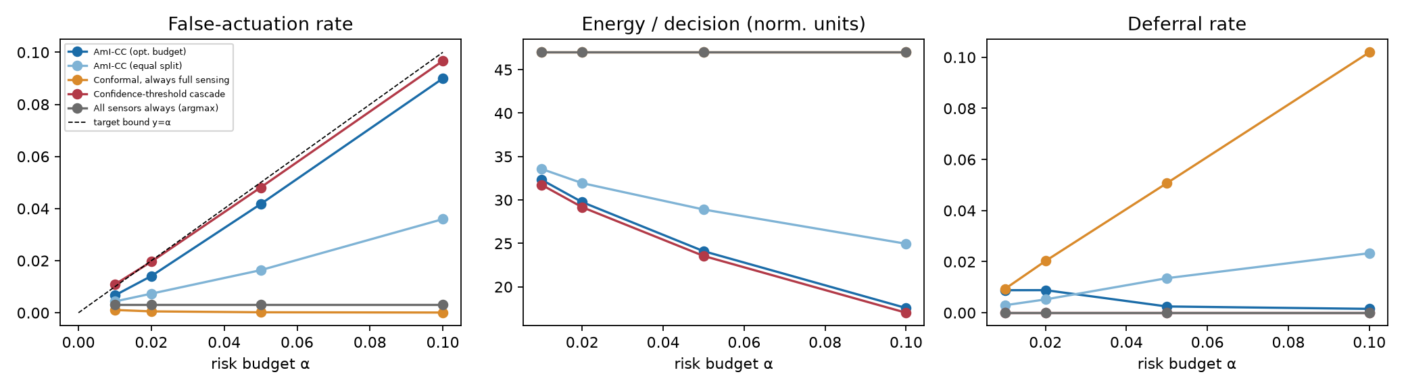
Fig. 2 – Risk-budget sweep: false-actuation, energy, deferral (30 seeds).
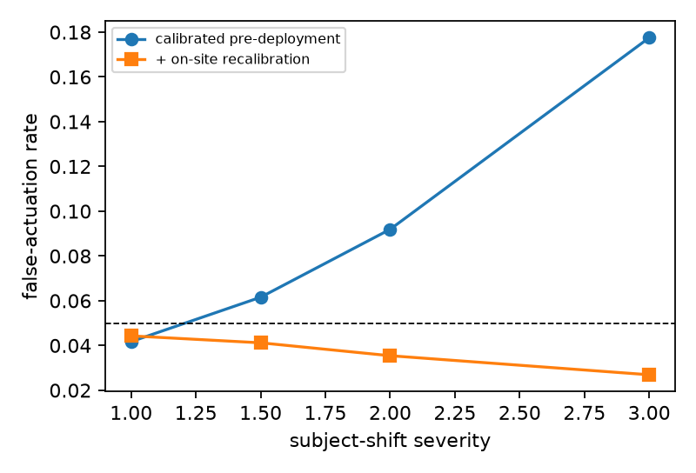
Fig. 3 – Effect of occupant shift with/without recalibration.
Reproduce: python experiments/run_experiments.py; python experiments/make_figures.py; python tests/test_cascade.py. Status: results are from a simulator, not field data; a pilot on a public smart-home dataset / campus testbed is planned before TRL≥4 claims and is recommended before the IoTJ submission.
9. What aspect(s) need protection?
Independent claim 1 (method): controlling actuation in an ambient IoT system comprising: powering a first sensing tier; computing with a first classifier a conformal prediction set of candidate intents whose threshold is calibrated to a first miscoverage level α₁; actuating if the set is a singleton and otherwise powering a higher-energy tier and repeating; deferring if the last-tier set is not a singleton; wherein the miscoverage levels satisfy Σα_{t} ≤ α, a predetermined actuation-risk budget, and are selected by minimising an objective comprising expected sensing energy on a data split disjoint from the split used to calibrate the thresholds.
Dependent aspects: (2) objective includes deferral (user-interruption) cost λ; (3) grid/convex search of the allocation; (4) per-tier classifiers on cumulative features; (5) on-site recalibration from user overrides when a drift detector fires, raising deferral to preserve the bound; (6) tiers including PIR/door/light → plug-power/audio/BLE → camera/mmWave, so privacy-intrusive sensors are powered only on ambiguity; (7) class-conditional (per-action criticality) budgets [not yet validated]; (8) system, and (9) non-transitory medium claims. Technical effect emphasised for eligibility (e.g. Indian Patents Act s.3(k) / 35 USC §101): reduced power consumption of sensor hardware and a bounded rate of erroneous physical actuation.
10. Technology readiness level
TRL 1 | TRL 2 | TRL 3 | TRL 4 | TRL 5 | TRL 6 | TRL 7 | TRL 8 | TRL 9
Basic principles observed | Concept formulated | [X] Experimental proof of concept (simulation, this work) | Validated in lab (planned: testbed) | Relevant environment | Demonstrated in relevant env. | Prototype in operational env. | System complete & qualified | Proven in operational env.

Ticked: TRL 3 (experimental proof of concept). Target: TRL 4 after a lab testbed run.
Declaration of Technical Integrity and IP Origin
We, the undersigned, declare that to the best of our knowledge the following is true:
1. The experimental results in Section 8 were obtained by running the accompanying reference implementation on a synthetic (simulated) smart-home benchmark. No laboratory, prototype or field measurements are reported, and no simulated result is presented as empirical data.
2. The Technology Readiness Level claimed is TRL 3 (experimental proof of concept). No higher TRL is claimed.
3. A generative AI assistant was used in ideation, software implementation, experiment design and drafting of this disclosure. The inventors have reviewed the content, re-run the code and results, and take responsibility for their accuracy. Use of AI tools is disclosed in line with institutional policy.
4. The prior-art list in Section 3 was compiled by web search and has not yet been confirmed by a professional patent search.
5. Prior publication / disclosure: ______________________________________________ (inventors to state whether any part of this work has been published, submitted or disclosed elsewhere).
6. Inventor contributions to conception: ______________________________________________ (inventors to complete).
Inventor name | Signature | Date

---------------------- END OF THE DOCUMENT -----------------------------

