KHARAGPUR COLLEGE
KHARAGPUR - 721305

Department of Computer Science & Engineering, IIT Kharagpur has been assigned for the development of online admission system for Kharagpur college. Professor Sujoy Ghose, a senior faculty of the department is the Principal Investigator for this project. They have been supplied with necessary information from the college like admission form, criteria and formula for calculating merit point for various honors subjects and general subjects, intake capacity for each of the honors subject and seat reservation.

IIT Kharagpur has developed the system partially which has been demonstrated to us and some suggestions have been given for modifications. Hard copy of a few screenshots of the demonstration has been provided to us.

(Prof. Sujit Mandal)
Teacher-in-Charge
Kharagpur College

Login Page for applicants
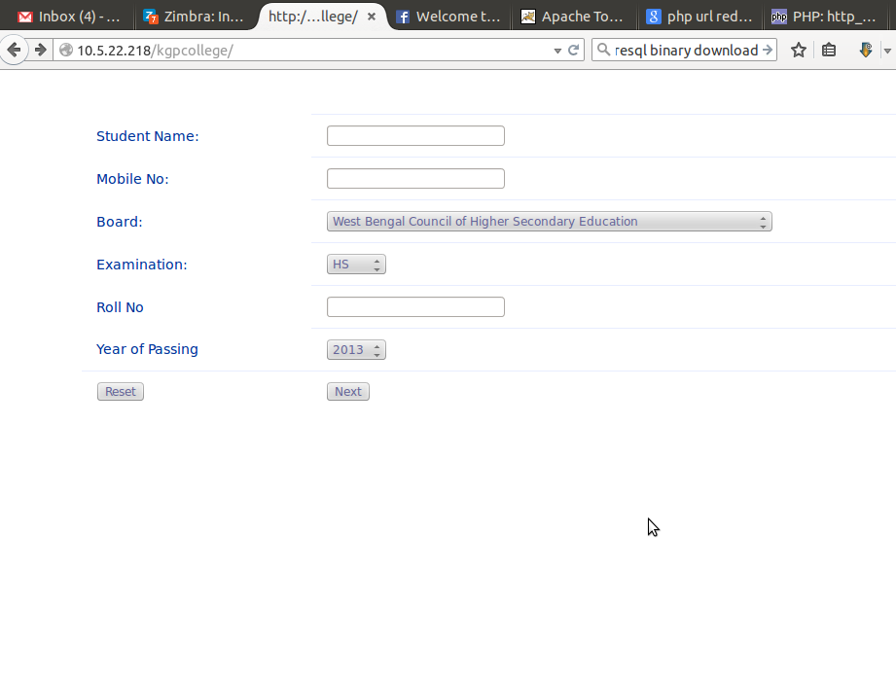
Board Selection for applicants:
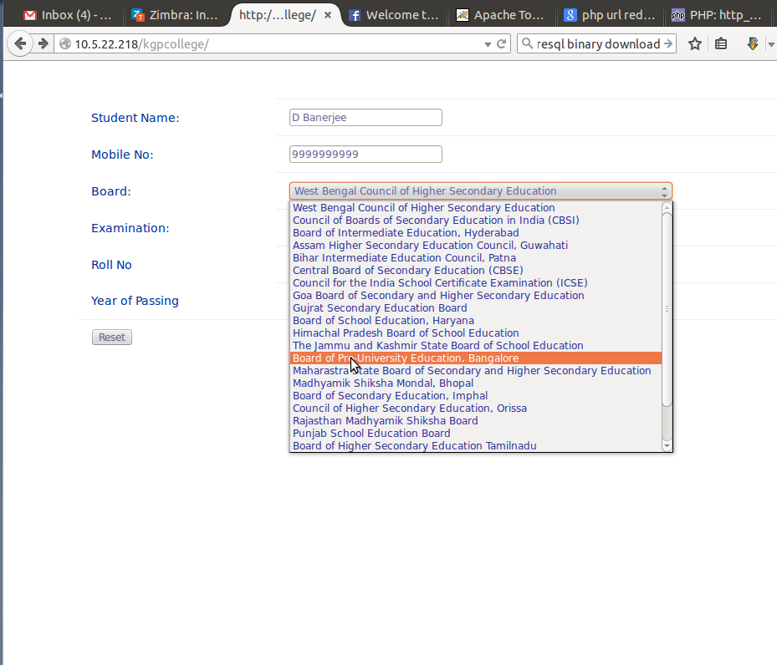
Main Form for applicants:
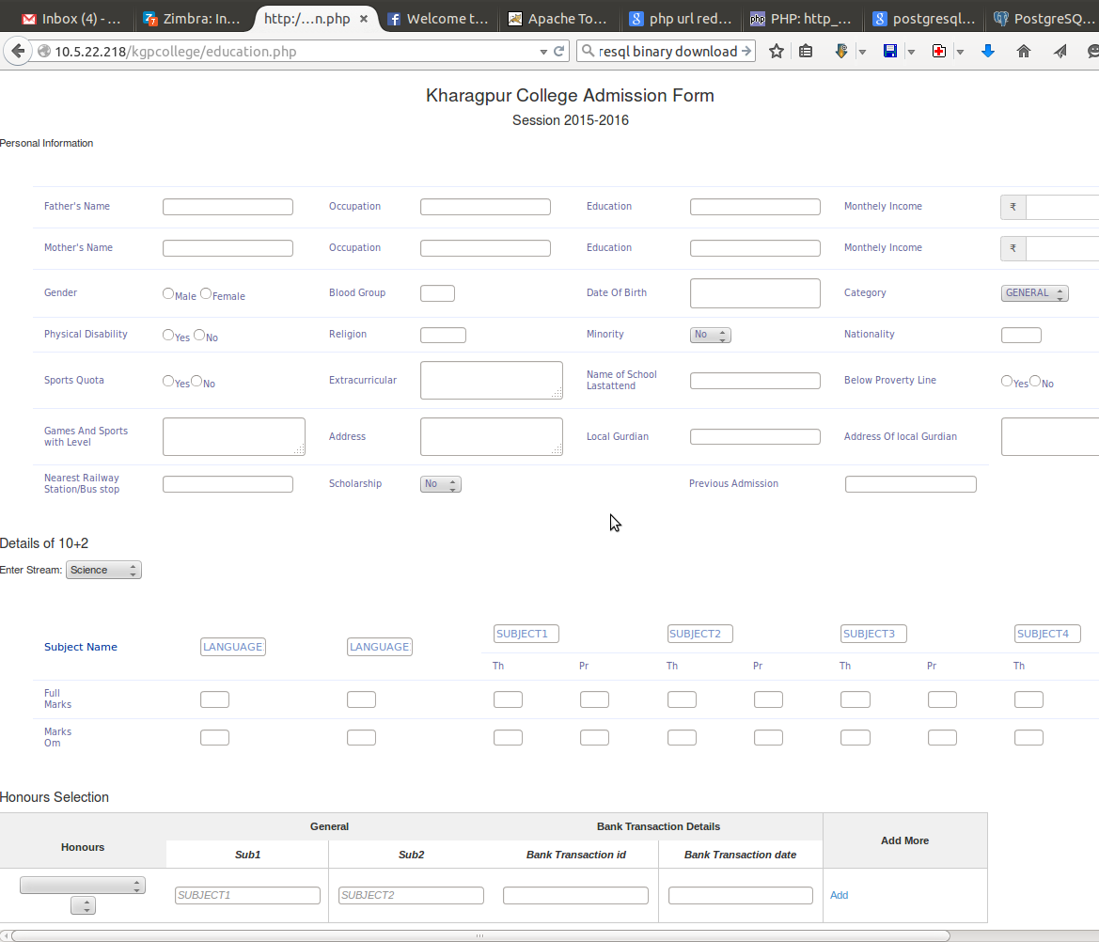
Honors Subject Selection for applicants:
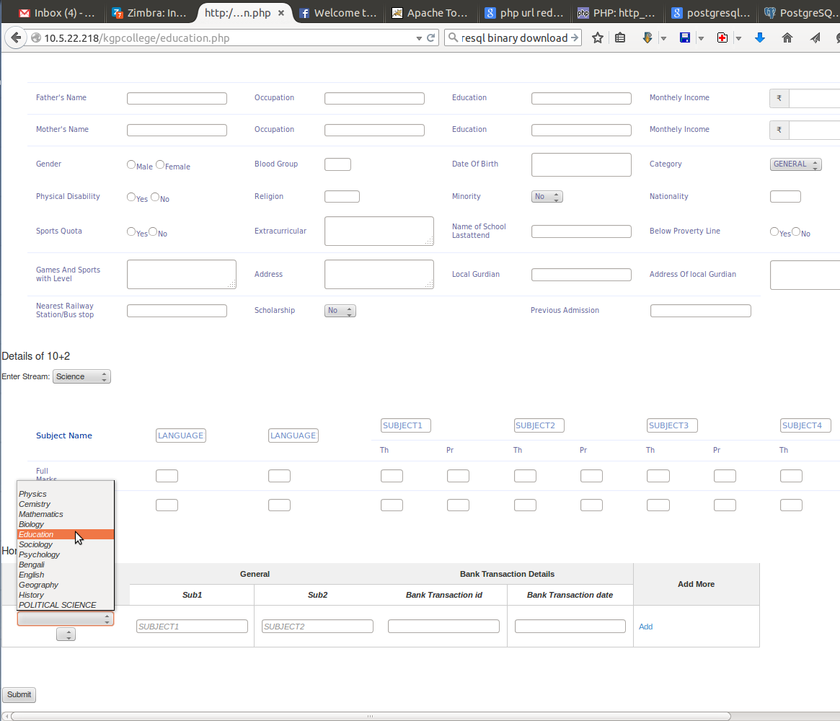
List of Students Applied for Physics honors General Category:
