**Vanguard Protection**

**Total Safety**

**Ensuring your Total Safety with Trust…**

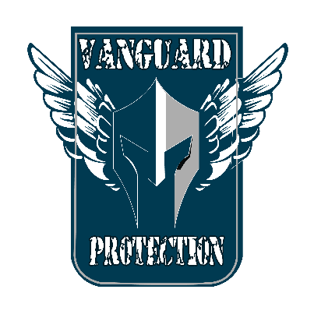  
 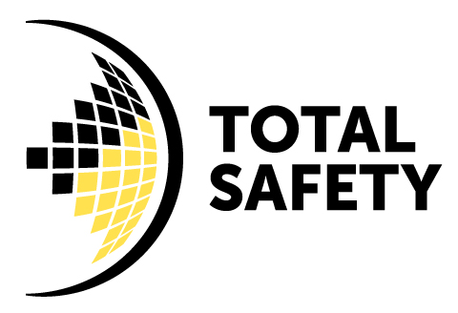

Unforeseen risks to lives and properties from various hazards at your home and business premises are commonplace in day to day life. In few seconds everything you built over the years up will be reduced to ashes or end up in a devastating catastrophe and shattered your dreams in no time. Unsafe conditions and behaviors of people inadvertently create high risk working environments that eventually lead to irreversible disasters. Fire hazards are common and most destructive among rest of hazards apart from industry specific hazards.

Safety of you, your employees and property meant lot and your prime responsibility is to ensure a safe working atmosphere although it is everyone’s responsibility too… Identifying hazards, through proper risk assessment and controlling all the risks to **As Low As Reasonable Practicable Level (ALARP)** level is a must for effectively mitigating risks in your environment to avert avoidable disasters.

What we do offers in your safety is….

It is total safety management solutions.

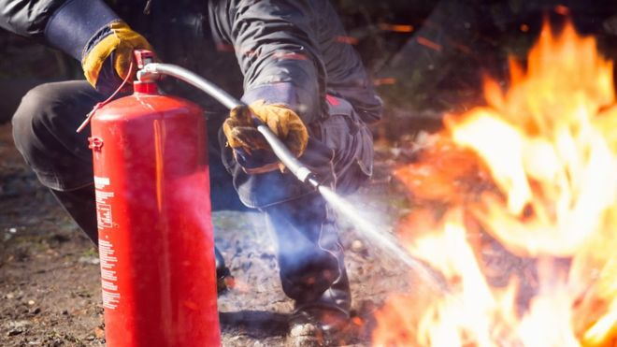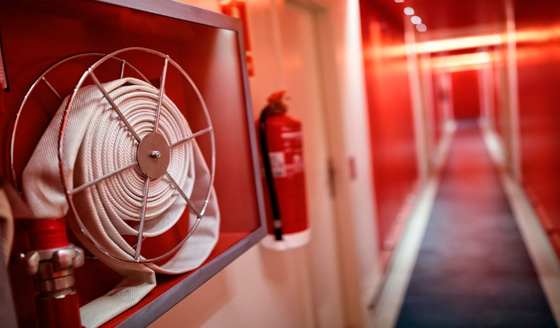

1. Life and Fire Safety

* Fire safety audit
* Emergency/Fire contingency plan preparation
* Installation of fire & gas detection and alarms systems
* Water spray and Sprinkler systems
* Carbon Dioxide(CO2)flooding systems
* All types of portable and transportable Fire extinguishers
* Safety and rescue Equipments
* Manual Alarm systems
* Fire training
* Periodical maintenance after installation

1. Other safety services, consultancy and Training

Special hazard environment monitoring

Electrical Safety

Chemical Safety

Construction Safety

Biological/Radiological Safety

Working at Height safety

Working at confined spaces safety

1. Personal Protection Equipments(PPEs)

We do provide PPEs to meet your requirements with training and aftersales services

1. Defensive driving Training
2. Training and evaluating Company Emergency Management Teams(CERT)
3. Training and workshops on Emergency Management/Crisis Management/ Business continuity Management and Resilience
4. Training and consultancy on OHSHAs 18001, ISO 45001.ISO 14001-2015 management systems.

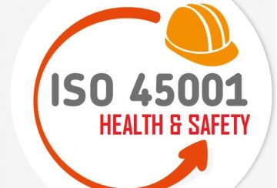 

1. Designing and locating safety signs appropriate to your work place/factory environments after careful evaluation/risk assessment.

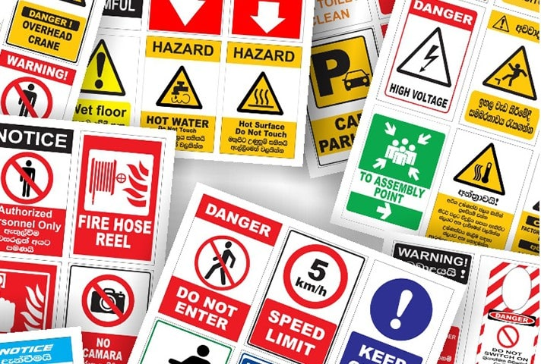

Your Safety is our utmost concern…..

Contact us…..

Hotline- 0777190287

Web- [WWW.vanguardprotection.lk](http://WWW.vanguardprotection.lk)

Email- [vanguadprotectioninfo@gmail.com](mailto:vanguadprotectioninfo@gmail.com)

info@vanguardtotalsafety.lk

Whatsapp/Viber/facebook/twitter/instergram/linkdin /Youtube