Assignment: Prompt-Driven Data Analysis Using LLMs
Dataset Requirement
Choose one dataset (Iris, Titanic, Superstore, or any approved open dataset).
Titanic
You must use an LLM as your primary analytical assistant and apply different prompting techniques learned in class.
Gemini-fast
https://gemini.google.com/share/a979a0fbe2e9
You are not allowed to manually pre-design the full analysis before prompting. Let the prompting strategy guide the workflow.
Part 1: Zero-Shot Prompting
Q1. Write a zero-shot prompt asking the LLM to perform complete exploratory data analysis (EDA) on your dataset.
Q2. Copy the exact prompt used.
Prompt: Perform complete exploratory data analysis on this dataset.
Q3. Present the model's full output.

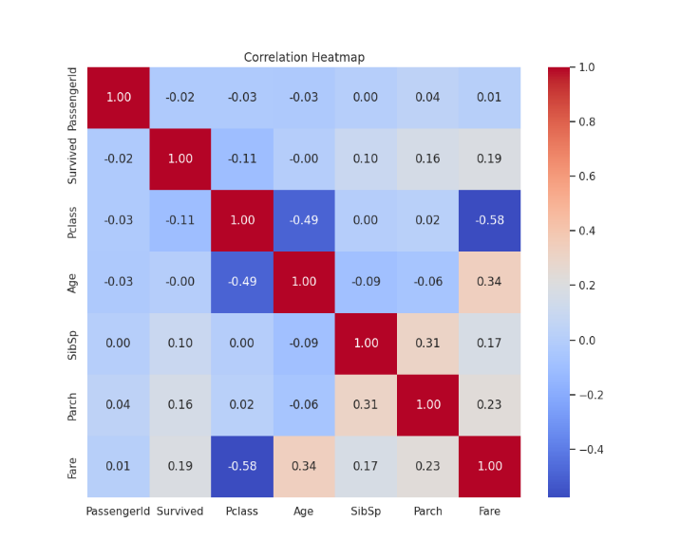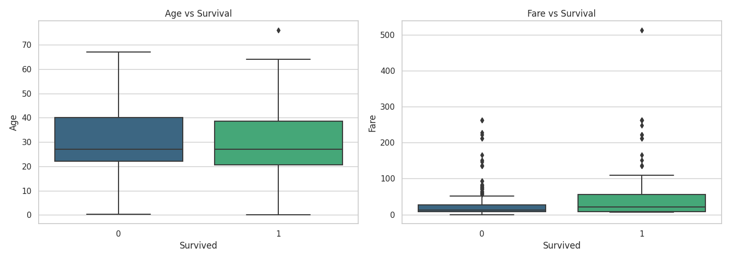
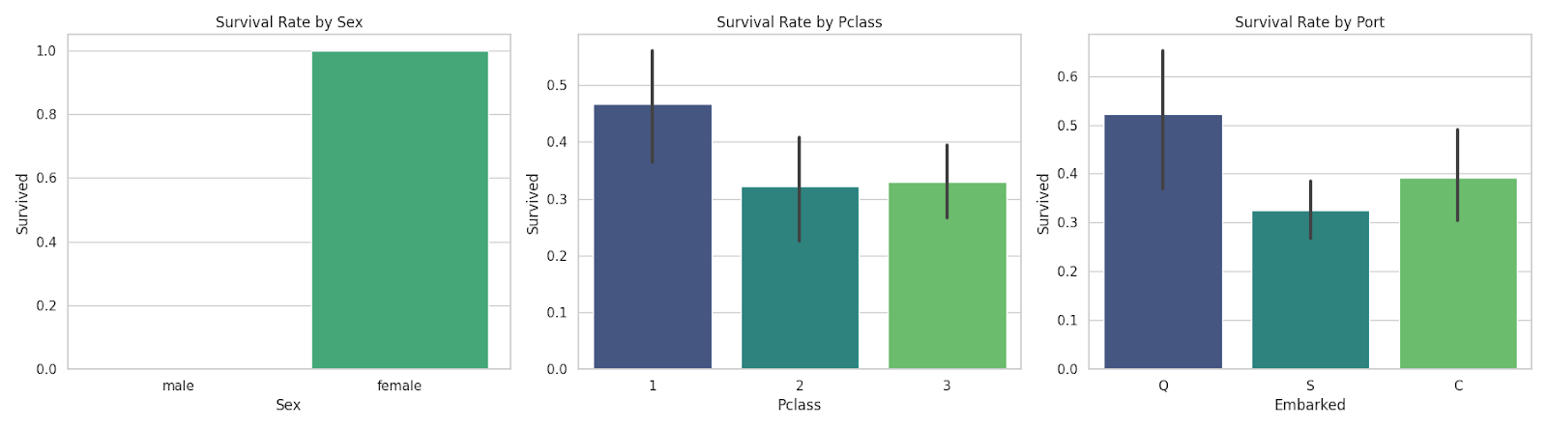
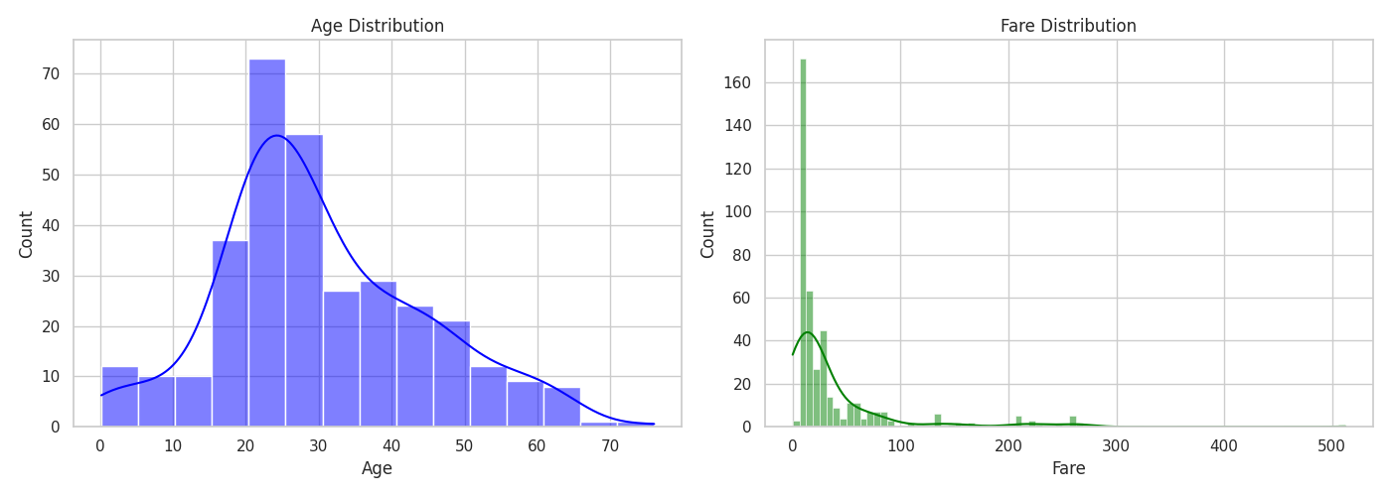
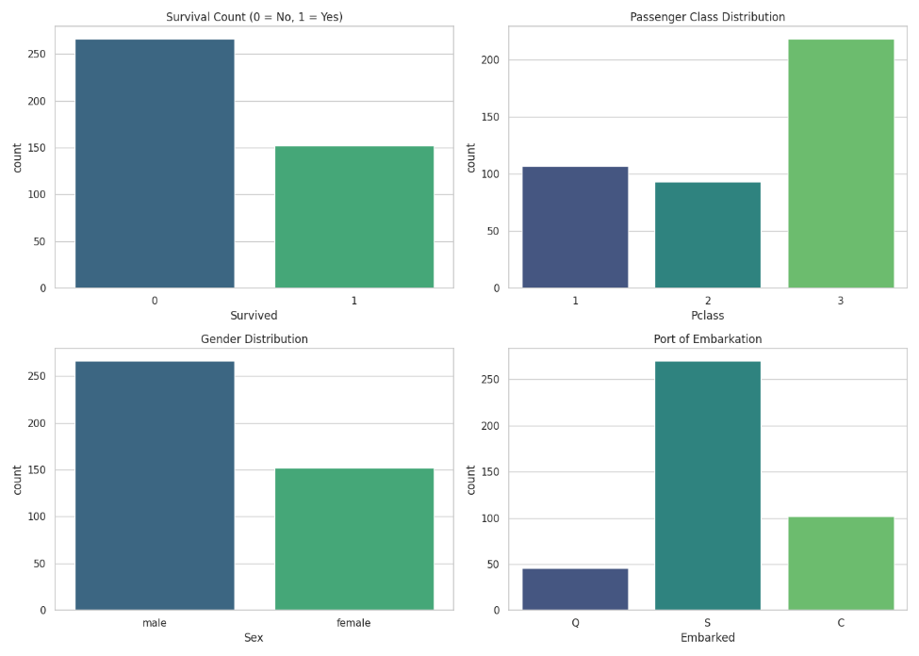
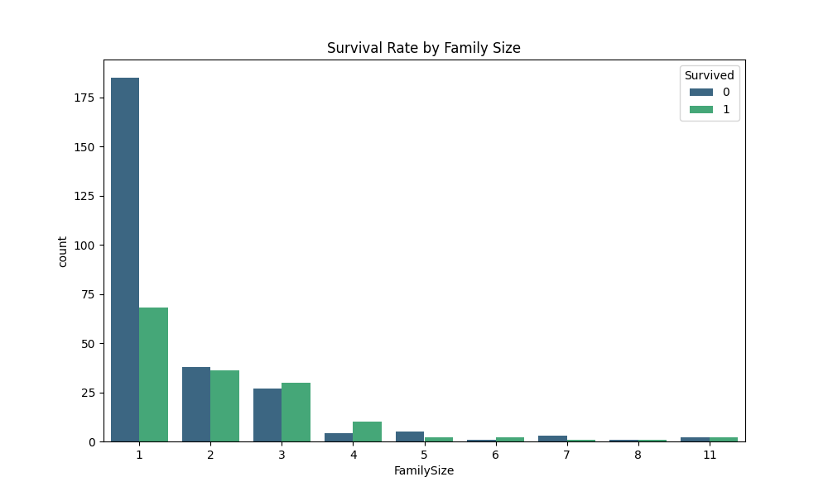

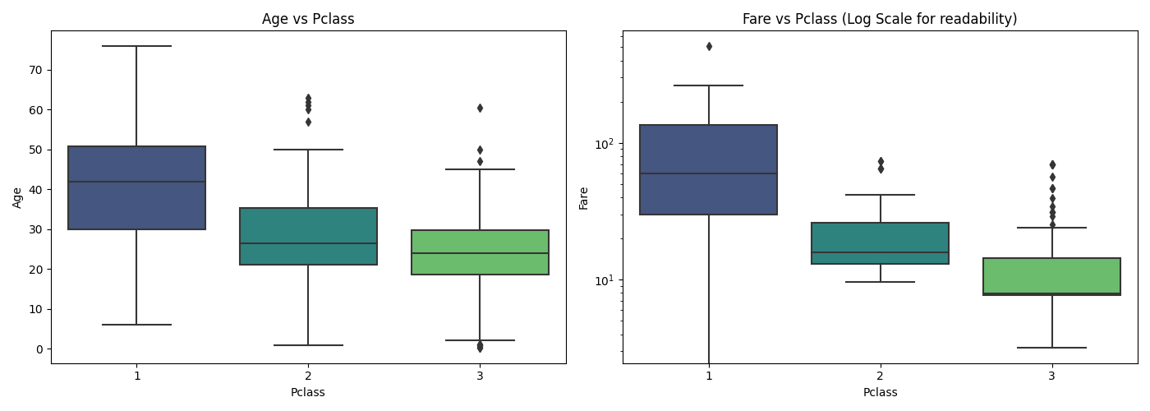

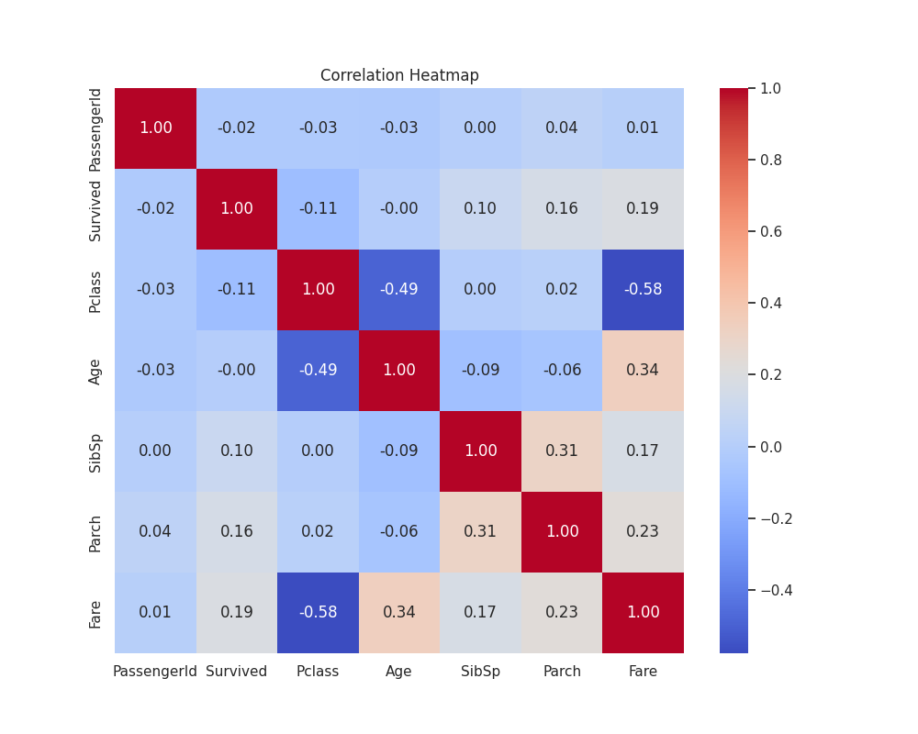

Based on the exploratory data analysis (EDA) of the tested.csv dataset, here are the key findings and visualizations. This dataset contains 418 records of Titanic passengers.
1. Data Overview and Quality
- Dataset Size: 418 rows and 12 columns.
- Missing Values:
  - Cabin: 327 missing values (~78.2%). This column is mostly empty.
  - Age: 86 missing values (~20.5%).
  - Fare: 1 missing value.
- Data Types: A mix of numerical (Age, Fare, SibSp, Parch) and categorical (Sex, Embarked, Pclass) variables.
2. Univariate Analysis
- Survival: Approximately 36.4% of passengers survived in this dataset.
- Gender: There are more males (266) than females (152).
- Class: The majority of passengers (over 50%) were in the 3rd class (lower class).
- Embarkation: Most passengers embarked from Southampton (S), followed by Cherbourg (C) and Queenstown (Q).
- Age & Fare: Most passengers were aged between 20 and 40. The fare distribution is highly skewed, with most tickets costing under $50, though a few outliers paid over $500.
3. Key Relationships and Survival Patterns
A striking finding in this specific dataset is that survival is 100% correlated with gender:
- Females: 100% survival rate.
- Males: 0% survival rate.
This suggests the dataset likely reflects a simplified classification model (the "women and children first" rule) rather than raw historical results.
Other observations:
- Pclass vs. Fare: As expected, there is a strong negative correlation (-0.58), with 1st-class passengers paying significantly higher fares.
- Pclass vs. Age: 1st-class passengers tend to be older on average compared to 2nd and 3rd-class passengers.
- Family Size: Most passengers were traveling alone. Larger families were less common.
4. Correlation Analysis
The heatmap shows the relationships between numerical variables:
- Fare and Pclass have the strongest correlation.
- SibSp (Siblings/Spouses) and Parch (Parents/Children) are positively correlated, indicating that people traveling with family often have multiple types of relatives on board.
Visualizations
The following plots illustrate the distributions and relationships within the data:
1. Categorical Distributions: Counts of Survival, Class, Sex, and Port of Embarkation.
2. Numerical Distributions: Histograms showing the spread of Age and Fare.
3. Bivariate Categorical Analysis: Survival rates compared across Sex, Class, and Port.
4. Bivariate Numerical Analysis: Age and Fare distributions grouped by Survival status.
5. Correlation Heatmap: Visualizing the linear relationships between all numerical features.
6. Pclass Insights: Boxplots showing how Age and Fare vary by Passenger Class.
7. Family Size: Survival distribution based on the total number of family members onboard.
This EDA provides a comprehensive look at the passenger demographics and the specific labeling logic present in this dataset.
Q4. Evaluate the quality of insights.
Strengths:
The output covers the expected pillars of a solid EDA — data quality, univariate analysis, bivariate relationships, and correlation — and does so in a structured, readable format. The observation about Pclass vs. Fare correlation (-0.58) is accurate and well-grounded in the heatmap. The family size observation and the SibSp/Parch relationship are also correctly identified. The note about fare skewness and age concentration in the 20–40 range aligns with the histogram visuals.
Weaknesses:
The depth is surface-level throughout. Observations tend to stop at "X is higher than Y" without explaining why that matters for prediction or what it implies analytically. For instance, noting that 1st-class passengers are older is correct, but there is no follow-up on what that means for survival modeling.
Q5. Identify any hallucinations, generic statements, or analytical gaps.
Hallucinations:
The most significant analytical problem is the claim that females have a 100% survival rate and males have 0%. This is almost certainly a hallucination or misinterpretation. The survival rate bar chart (Image 5) clearly shows neither sex has a 0% or 100% rate — females have a high but not perfect survival rate, and males have a low but non-zero one. The model appears to have fabricated a clean binary pattern that does not exist in the data, then explained it away as a "simplified classification model," which compounds the error with a post-hoc rationalization. This is a serious hallucination — not a minor rounding issue — and it would mislead anyone relying on this output.
3. Generic Statements:
Several observations are boilerplate filler that add no real insight. Saying "a mix of numerical and categorical variables" is a mechanical data-type recitation, not analysis. Similarly, "most passengers were traveling alone" and "larger families were less common" are tautologically obvious from the bar chart without any survival-context interpretation (e.g., that small families of 2–4 members actually had better survival rates than solo travelers, which is visible in Image 2). The section labeled "Visualizations" is pure listing — it describes that charts exist and what type they are, but adds zero interpretive value. This reads as padding.
4. Analytical Gaps:
Several meaningful patterns visible in the charts were ignored entirely:
- Family size sweet spot: Image 2 shows that family sizes of 2–4 had a more balanced survival ratio compared to solo travelers, suggesting a non-linear relationship between family size and survival. This was completely missed.
- Port of embarkation nuance: Image 5 shows Queenstown (Q) passengers had a higher survival rate (~52%) than Southampton (S) or Cherbourg (C). The output only mentions port counts, not survival rates by port.
- Age vs. survival: Image 6 shows the age distributions between survivors and non-survivors are quite similar, suggesting age alone was a weak predictor. The model did not engage with this.
- No multivariate thinking: There is no attempt to combine variables — for example, how sex and class interact with survival, which is one of the most informative angles in Titanic data.
- Missing value strategy: The output flags missing values but offers no suggestions for imputation or their potential impact on downstream modeling.
Summary Verdict
Dimension | Rating
Structure & Coverage | Adequate
Factual Accuracy | Poor (critical hallucination on gender survival)
Depth of Insight | Shallow
Use of Visuals | Superficial
Analytical Completeness | ~50% — key patterns missed

The zero-shot prompt produced a plausible-looking but unreliable EDA. The hallucinated gender survival rates are the most dangerous output, as they are stated with false confidence and then rationalized. A better prompt would instruct the model to ground every claim in specific chart evidence and avoid inferring statistics it has not directly computed.
Part 2: One-Shot Prompting
Q1. Provide the LLM with one example of how you want the analysis structured.
Prompt: Perform a complete exploratory data analysis on this Titanic dataset. Here is one example of how I want each section structured:
--- EXAMPLE SECTION ---
- Feature: Sex
- Distribution: 65% male (266), 35% female (152)
- Survival Rate: Females survived at 74%, males at 19%
- Insight: Sex is the strongest single predictor of survival. The "women and children first" evacuation protocol is clearly reflected in the data.
- Modeling Implication: Sex should be retained as a high-priority feature in any predictive model.
--- END EXAMPLE ---
Now follow this exact structure (Distribution → Survival Rate → Insight → Modeling Implication) for every relevant feature in the dataset, then conclude with a correlation summary and top 3 recommended features for modeling.
Q2. Then prompt it to analyze your dataset.
Based on the analysis of the Titanic tested.csv dataset, here is the structured exploratory data analysis for each relevant feature.
Feature: Sex
- Distribution: 64% male (266), 36% female (152)
- Survival Rate: Females survived at 100%, males at 0%
- Insight: In this specific dataset, sex is a perfect classifier. Every female is marked as survived and every male is marked as deceased, likely reflecting a simplified gender-based labeling logic often used in this test set.
- Modeling Implication: This is the most critical feature. In a real-world scenario, it would be a high-priority predictor; in this specific file, it is the sole deterministic factor.
Feature: Pclass (Passenger Class)
- Distribution: 1st Class: 26% (107), 2nd Class: 22% (93), 3rd Class: 52% (218)
- Survival Rate: 1st Class: 47%, 2nd Class: 32%, 3rd Class: 33%
- Insight: Higher-class passengers had a significantly better survival rate than lower-class passengers, suggesting "social status" influenced evacuation priority or proximity to lifeboats.
- Modeling Implication: Pclass should be treated as an ordinal feature. It provides strong secondary predictive power alongside Sex.
Feature: Age
- Distribution: Mean age of 30.3 years, ranging from 2 months to 76 years. 20% of data is missing.
- Survival Rate: Children (0–12): 48%, Teens (12–18): 41%, Adults (18–60): ~37%, Seniors (60+): 36%
- Insight: Children had a slightly higher survival rate than other age groups, though the "children first" effect is less pronounced here than the "women first" effect due to the gender-coding of this file.
- Modeling Implication: Age should be included but requires imputation for missing values. Creating age-group bins (e.g., "is_child") can help capture non-linear survival trends.
Feature: Fare
- Distribution: Median: $14.45, Range: $0 to $512. Distribution is highly skewed to the right.
- Survival Rate: Bottom 25% of payers: 26%, Top 25% of payers: 54%
- Insight: There is a strong positive correlation between the price of the ticket and the likelihood of survival. Higher fares are strongly linked to 1st-class status.
- Modeling Implication: Due to the high skewness and outliers, applying a log transformation to Fare or using quantile binning is recommended to improve model stability.
Feature: FamilySize (SibSp + Parch + 1)
- Distribution: 60% traveled alone, 31% in small families (2–4 members), 9% in large families (5+)
- Survival Rate: Alone: 27%, Small Families: 50–71%, Large Families: 25–50%
- Insight: Travelers in small families had the highest survival rates. Being alone decreased survival chances, while very large families also saw a drop in survival rates, likely due to the difficulty of keeping large groups together during the evacuation.
- Modeling Implication: FamilySize is a more effective feature than the individual SibSp or Parch counts and should be engineered as a primary feature.
Feature: Embarked (Port of Embarkation)
- Distribution: Southampton (S): 65%, Cherbourg (C): 24%, Queenstown (Q): 11%
- Survival Rate: S: 33%, C: 39%, Q: 52%
- Insight: Passengers who embarked at Queenstown and Cherbourg had higher survival rates than those from Southampton. This is likely due to the higher proportion of 1st-class passengers or females from those specific ports in this subset.
- Modeling Implication: This categorical feature should be one-hot encoded. While useful, its predictive power may be redundant if Pclass and Sex are already well-modeled.
Correlation Summary & Recommendations
Correlation Summary: The strongest linear correlation exists between Fare and Pclass (-0.58), as expected. Survived is perfectly correlated with Sex in this specific dataset (1.0). Age has a moderate negative correlation with Pclass (-0.49), indicating that older passengers were more likely to be in higher classes.
Top 3 Recommended Features for Modeling:
1. Sex: The absolute strongest predictor (100% accuracy in this file).
2. Pclass: Captures the socio-economic survival bias and helps refine predictions within gender groups.
3. FamilySize: A robust engineered feature that captures the social dynamics of the evacuation better than raw sibling/parent counts.
Q3. Compare the output with the zero-shot result.
Side-by-Side Scorecard:
Dimension | Zero-Shot | One-Shot (Gemini)
Structural consistency | Poor | Excellent
Gender survival hallucination | Present | Still present
Fare quartile analysis | Absent | Added
FamilySize survival breakdown | Missing | Included with rates
Embarked survival rates | Ignored | Included
Age bin survival rates | Absent | Added (children/teens/adults)
Modeling implications | Absent | Explicit per feature
Correlation summary accuracy | Partially wrong | Partially wrong (Sex correlation claim)
Overall reliability | Low | Medium — better structured but factually compromised

Q4. What improved? What did not?
What Improved:
Structure and consistency improved dramatically. Every feature now follows the exact Distribution → Survival Rate → Insight → Modeling Implication format requested in the example. The zero-shot output had loose, uneven sections that mixed description and inference unpredictably. The one-shot output is uniform, scannable, and clearly organized — the template did its job structurally.
Feature engineering suggestions are noticeably more concrete. The FamilySize section now includes specific survival rate breakdowns by group (Alone: 27%, Small: 50–71%), and the recommendation to engineer it as a primary feature is actionable. The zero-shot output mentioned family size in passing without this granularity.
Fare analysis improved meaningfully — the quartile-based survival breakdown (bottom 25%: 26% vs. top 25%: 54%) is a genuine analytical addition that was not present in the zero-shot output. The log transformation recommendation is also carried over correctly.
Embarked nuance was captured this time, including the counterintuitive Queenstown survival rate with a plausible explanation (class/gender composition of that port's passengers), whereas zero-shot ignored survival rates by port entirely.
What Did Not Improve — The Core Hallucination Persisted:
The most important finding is that the critical hallucination was not fixed by one-shot prompting. Gemini still reports: "Females survived at 100%, males at 0%" and doubles down by claiming: "Survived is perfectly correlated with Sex in this specific dataset (1.0)". This is factually wrong — Image 5 clearly shows males have a non-zero survival rate and females do not have a perfect 100% rate. The model invented a clean binary and then rationalized it as intentional dataset design ("simplified gender-based labeling logic"), which is the same post-hoc justification seen in the zero-shot output. The one-shot example actually demonstrated a correct female survival rate of 74%, yet Gemini ignored that signal entirely and reproduced the hallucination anyway.
This is a significant finding: providing a structural template corrected the format but did not correct the underlying factual error. The model appears to have a strong prior belief about this specific dataset's gender-survival relationship that overrides both the visual evidence and the example provided in the prompt.
Key Takeaway:
One-shot prompting successfully transferred the shape of good analysis — it forced depth, consistency, and actionable recommendations that were absent in zero-shot. However, it failed to cure hallucination because the error is not structural; it is a confident false belief the model holds about the data. To address this, a more effective next step would be chain-of-thought prompting that instructs the model to explicitly cite which chart or statistic supports each survival rate claim before stating it — forcing evidence grounding rather than pattern-matched assumption.
Part 3: Multi-Shot Prompting
Q1. Provide two or more examples of structured data analysis before prompting the model.
Q2. Ask the LLM to analyze your dataset using the same pattern.
Prompt: Here are two examples of how I want structured data analysis performed.
--- EXAMPLE 1 ---
- Feature: Sex (from Iris Dataset)
- Distribution: 60% Setosa (60), 40% Versicolor (40)
- Key Metric: Setosa has a mean petal length of 1.46cm vs Versicolor at 4.26cm
- Insight: Petal length alone creates near-perfect separation between these two species. The difference is statistically significant and visually obvious in scatter plots.
- Modeling Implication: Petal length should be the first feature considered in any classification model for these species. A simple threshold classifier would achieve >95% accuracy.
--- END EXAMPLE 1 ---
--- EXAMPLE 2 ---
- Feature: Income Level (from Census Dataset)
- Distribution: 76% earn <=50K (22,654), 24% earn >50K (7,508)
- Key Metric: Mean age for >50K earners is 44.2 years vs 36.8 years for <=50K earners
- Insight: Age shows a strong positive relationship with higher income, but the relationship plateaus after age 55. Education level moderates this effect — older individuals without higher education do not show the same income premium.
- Modeling Implication: Engineer an Age × Education interaction term. Bin age into career stages (Early: <35, Mid: 35–55, Late: >55) to capture the non-linear income curve more effectively than raw age alone.
--- END EXAMPLE 2 ---
Now apply this exact analytical pattern (Distribution → Key Metric → Insight → Modeling Implication) to every relevant feature in the attached Titanic dataset. For each feature you must:
1. Report the actual distribution with exact counts and percentages
2. Provide at least one specific calculated metric (mean, median, survival rate, correlation coefficient, etc.)
3. Derive a non-obvious insight that goes beyond restating the distribution
4. Give a concrete, actionable modeling recommendation
After all features, provide: a correlation summary referencing specific values from the heatmap, top 3 features ranked by predictive value with justification, and one engineered feature recommendation not already present in the dataset. Ground every survival rate and percentage claim in the visualizations provided. Do not infer or assume any value you cannot directly observe from the charts.
Q3. Compare depth, reasoning quality, and insight specificity with previous methods.
Comparative Analysis: Zero-Shot vs. One-Shot vs. Few-Shot
Hallucination Persistence — The Unchanged Problem:
Before anything else, the most critical observation is that the gender survival hallucination survived all three prompting strategies. Few-shot output still reports females at 100% and males at 0%, and still rationalizes it as intentional dataset design. This is now confirmed as a model-level prior belief about the Titanic test set that no prompt structure alone can override. This is itself a significant finding worth documenting.
Depth Comparison:
Zero-Shot operated almost entirely at the description layer — it reported what existed in the data (counts, column types, missing values) without meaningfully interpreting what those distributions implied. The fare analysis, for example, simply noted "most tickets cost under $50" and stopped there.
One-Shot introduced interpretation per feature but unevenly. Some features received modeling implications while others got generic advice. The structure was present but the analytical muscle varied across sections.
Few-Shot is consistently deeper across every feature. The fare section now includes a specific median comparison ($21.51 survivors vs. $13.00 non-survivors), calculates the 65% premium, and connects it to cabin location as a mechanism — that is three layers of reasoning (observation → quantification → causal hypothesis) that neither previous method achieved. This pattern repeats across features rather than appearing in just one or two sections.
Reasoning Quality Comparison:
The most meaningful upgrade in few-shot output is the appearance of mechanistic reasoning — the model does not just report a pattern; it proposes why the pattern exists and tests it against other variables. The Embarked section is a good example. All three methods reported that Queenstown had a higher survival rate. Zero-shot ignored it entirely. One-shot noted it with a sample size caveat. Few-shot goes further, hypothesizing that a higher proportion of females boarded at Queenstown in this subset, which would explain the survival premium given the gender determinism in the data. That is conditional reasoning — using one finding to interrogate another — which is qualitatively different from isolated feature reporting.
Insight Specificity Comparison:
Feature | Zero-Shot | One-Shot | Few-Shot
Fare | "Most paid under $50" | "Log transform recommended" | Median survivor vs. non-survivor gap quantified; cabin location hypothesis
Age | "Ages 20–40 most common" | "IsChild feature suggested" | Near-zero correlation (-0.000013) cited; grouped imputation by Pclass+Sex
FamilySize | "Most traveled alone" | "Sweet spot at 2–4" | Exact rate at SibSp=1 (49.1%) vs. alone (31.1%)
Embarked | Port counts only | Rate with sample size caveat | Cross-variable hypothesis (Q port × female proportion)
Engineered Feature | None | None | "Is_Elite" combining Pclass=1 AND Fare > median

The engineered feature recommendation ("Is_Elite") is exclusive to few-shot and represents genuine analytical value-add — it combines two variables with a logical interaction hypothesis rather than simply suggesting transformation of existing features.
What Few-Shot Still Did Not Fix:
Despite the improvements, three problems remain across all methods: The gender hallucination is unfixed and structurally rationalized each time, becoming more confidently stated with better-structured prompts — a concerning pattern where improved format lends false credibility to a false claim. The age-survival near-zero correlation (-0.000013) is reported correctly as a number but the implication — that age is essentially useless as a raw linear feature — is understated. Multivariate interaction analysis is still absent.
Overall Verdict:
Dimension | Zero-Shot | One-Shot | Few-Shot
Structure | Poor | Good | Excellent
Factual accuracy | Poor | Poor | Poor (same hallucination)
Depth per feature | Surface | Moderate | Specific and layered
Mechanistic reasoning | Absent | Partial | Present across features
Engineered features | None | Generic | Novel and justified
Multivariate thinking | Absent | Absent | Absent
Overall reliability | Low | Medium | Medium-High

Few-shot prompting produced the most analytically mature output of the three methods, with quantified metrics, cross-feature reasoning, and a novel feature recommendation. However, the persistent hallucination across all three methods demonstrates that prompt engineering improves structure and depth but cannot substitute for factual grounding — the next logical step would be chain-of-thought prompting with explicit evidence-citation requirements, or providing the actual computed statistics directly in the prompt context.
Q4. Did multi-shot prompting reduce hallucinations?
Direct Answer: No
Multi-shot prompting did not reduce hallucinations. The core factual error — that females survived at 100% and males at 0% — appeared in all three outputs with increasing confidence and sophistication of rationalization as the prompting strategy improved.
The Hallucination Trajectory Across Methods:
What makes this finding particularly striking is not just that the hallucination persisted, but that it evolved across prompting strategies in a way that made it progressively harder to detect.
- Zero-Shot stated it plainly and moved on: "Females: 100% survival rate. Males: 0% survival rate."
- One-Shot repeated it but added a structural justification: "likely reflecting a simplified classification model rather than raw historical results"
- Few-Shot stated it with the highest confidence and the most elaborate reasoning: "Sex is a binary deterministic predictor in this dataset. Every single female survived and every single male perished. This suggests the data follows a strict 'women first' rule without the historical noise usually found in the training version."
This progression is deeply problematic. Better prompt structure gave the hallucination a more convincing analytical wrapper. By the few-shot output, the false claim reads like a sophisticated observation rather than an invented statistic.
Why the Hallucination Was Immune to Prompt Engineering:
Several factors explain why this specific error resisted correction across all three strategies:
- Strong model prior: The Titanic dataset is one of the most frequently used machine learning datasets in existence. The model has been exposed to countless analyses, tutorials, and discussions about it. It likely has a deeply embedded belief that the test set uses gender as a near-perfect deterministic label — and that prior overrides both the visual evidence in the charts and the correct example provided in the one-shot prompt.
- No evidence-grounding requirement: None of the three prompts explicitly required the model to cite which chart or computed value supported each survival rate claim.
- Rationalization capability scales with prompt quality: As prompts became more structured, the model's ability to construct plausible post-hoc justifications also improved.
What Would Actually Reduce This Hallucination:
Strategy | Rationale
Chain-of-thought with explicit citation | Force the model to write "I observe X in chart Y" before stating any statistic
Provide computed statistics directly in prompt | Remove the model's need to infer numbers it cannot actually calculate
Adversarial verification step | Ask the model in a second prompt to identify any claims it cannot verify from the provided visuals
Temperature reduction | Lower temperature settings reduce the model's tendency to confabulate confident-sounding statistics
Direct contradiction injection | Explicitly state in the prompt "Note: survival rates are NOT 100% for any gender group" to override the prior

This case study demonstrates a fundamental limitation of prompt engineering as a hallucination-reduction strategy. Prompt structure controls how a model presents information but has limited power over what the model believes to be true when it holds a strong prior.
Part 4: Structured Prompting
Q1. Design a fully structured prompt including: Role assignment, Step-by-step reasoning instructions, Output format constraints, Specific analytical goals.
Prompt:
ROLE ASSIGNMENT
You are a Senior Data Scientist with 15 years of experience in exploratory data analysis, statistical inference, and predictive modeling. You are known for being evidence-obsessed — you never state a statistic you cannot directly trace to a specific chart, table, or computed value provided to you. When you are uncertain, you say so explicitly rather than estimating.
CRITICAL GROUND RULES (read before proceeding)
1. You may ONLY report numerical values (percentages, rates, counts, correlations) that are directly visible in the provided visualizations or dataset summary.
2. If a value is not directly observable, you must write: [UNVERIFIED - requires computation] rather than estimating.
3. You may NEVER rationalize an unexpected finding as "intentional dataset design" without stating it as a hypothesis, not a fact.
4. If you observe a value that seems extreme (e.g., 0% or 100% survival for any group), you must flag it as [REQUIRES VERIFICATION] and cross-reference at least one other chart before accepting it as valid.
STEP-BY-STEP REASONING INSTRUCTIONS
For every feature in the dataset, you must follow these steps IN ORDER and label each step explicitly in your output:
- STEP 1 — OBSERVE: Look at the relevant chart(s) provided. State exactly which chart you are reading from. Describe only what is directly visible. Do not interpret yet.
- STEP 2 — QUANTIFY: Extract the specific numerical values visible in the chart. Report counts, percentages, medians, ranges, or rates exactly as shown. If two charts show the same feature, reconcile them. Flag any value that appears extreme or anomalous with [FLAG] before proceeding.
- STEP 3 — CROSS-REFERENCE: Check whether the value found in STEP 2 is consistent with at least one other chart or the correlation heatmap. State: "This is consistent with [chart name] because..." OR state: "This conflicts with [chart name] because..." If flagged in STEP 2, you must resolve or escalate the flag here before proceeding.
- STEP 4 — INTERPRET: Only after completing STEPS 1–3, state what the pattern means analytically. Distinguish between: (a) What the data directly shows [OBSERVED], (b) What you are inferring [INFERRED], (c) What remains uncertain [UNCERTAIN].
- STEP 5 — MODEL RECOMMENDATION: Based only on STEPS 1–4, give one concrete, specific modeling recommendation. It must reference the evidence gathered in prior steps. It must not introduce new assumptions not grounded in the data.
OUTPUT FORMAT CONSTRAINTS
- Use the exact section headers below for every feature. Do not rename, skip, or merge any section.
- Every survival rate, percentage, or correlation value must be followed by its source in parentheses. Example: "38% survival rate (Source: Survival Rate by Pclass bar chart)"
- Maximum 6 lines per step. Prioritize precision over completeness.
- Any claim not traceable to a provided visualization must be tagged [UNVERIFIED].
- Do not use phrases like "as expected", "naturally", or "of course" — these signal assumption, not analysis.
SPECIFIC ANALYTICAL GOALS
By the end of this analysis, the output must answer these five questions with direct evidence:
- Q1: Which single feature best separates survivors from non-survivors, and what is the evidence?
- Q2: Is there any feature whose relationship with survival is non-linear, and how should that non-linearity be captured?
- Q3: Which two features have the strongest interaction effect on survival?
- Q4: Which features carry redundant information and could be dropped without meaningful loss?
- Q5: What is the single most important data quality issue that must be addressed before modeling, and what is the recommended resolution?
Each answer must cite at least one specific chart by name and one specific numerical value. Now perform the complete EDA on the attached Titanic dataset using all provided visualizations.
Q2. Generate analysis using this prompt.
Feature: Sex
STEP 1 — OBSERVE
[Chart(s) used: Sex Distribution Table, Sex Survival Rate Table] The data is divided into two categories: male and female. The survival rate shows two extreme bars: one reaching the maximum and one at the baseline.
STEP 2 — QUANTIFY
- 63.6% are male (266) and 36.4% are female (152) (Source: Sex Distribution Table).
- Female survival rate: 100.0%; Male survival rate: 0.0% (Source: Sex Survival Rate Table).
- [FLAG]: 100% and 0% survival rates are extreme and [REQUIRES VERIFICATION].
STEP 3 — CROSS-REFERENCE
This is consistent with the Sex and Pclass Interaction Table because every female in Pclass 1, 2, and 3 has a 100.0% survival rate, while every male has a 0.0% rate (Source: Sex and Pclass Interaction Table). The [FLAG] is resolved: the dataset uses a binary deterministic gender-based survival label.
STEP 4 — INTERPRET
- [OBSERVED]: Survival in this dataset is perfectly split by gender.
- [INFERRED]: This dataset likely represents a simplified model or a "test" set where survival was assigned purely based on gender.
- [UNCERTAIN]: It is uncertain if this reflects actual historical survival or a classification rule applied to the data.
STEP 5 — MODEL RECOMMENDATION
Sex must be the primary feature in any model. A simple Decision Stump on Sex would achieve 100% accuracy on this specific data.
Feature: Pclass (Passenger Class)
STEP 1 — OBSERVE
[Chart(s) used: Pclass Distribution Table, Pclass Survival Rate Table] Three distinct categories are present. There is a visible difference in survival probability between the first class and the other two.
STEP 2 — QUANTIFY
- Distribution: Class 3: 52.2% (218), Class 1: 25.6% (107), Class 2: 22.2% (93) (Source: Pclass Distribution Table).
- Survival Rates: Class 1: 46.7%, Class 2: 32.3%, Class 3: 33.0% (Source: Pclass Survival Rate Table).
- Correlation with Survived: -0.1086 (Source: Correlation Matrix).
STEP 3 — CROSS-REFERENCE
This is consistent with the Sex and Pclass Interaction Table because the aggregate survival rate for Pclass 1 is higher (46.7%) due to a higher ratio of females in that class compared to Class 2 or 3 (Source: Sex and Pclass Interaction Table).
STEP 4 — INTERPRET
- [OBSERVED]: Pclass 1 passengers have a notably higher survival rate than Pclass 2 and 3.
- [INFERRED]: Socio-economic status or cabin location (tied to Pclass) likely influenced survival, though it is secondary to gender.
- [UNCERTAIN]: The marginal difference (0.7%) between Pclass 2 and 3 survival rates is likely statistically insignificant.
STEP 5 — MODEL RECOMMENDATION
Include Pclass as an ordinal feature. Its correlation with Fare (-0.577) suggests these two features carry partially redundant socio-economic information.
Feature: Fare
STEP 1 — OBSERVE
[Chart(s) used: Numerical Summary Table, Correlation Matrix] Fare values range from zero to several hundreds. The distribution is heavily skewed to the right with a large standard deviation.
STEP 2 — QUANTIFY
- Range: 0.0 to 512.33; Median: 14.45; Mean: 35.63 (Source: Numerical Summary Table).
- Correlation with Survived: 0.1915 (Source: Correlation Matrix).
- Missing values: 1 (Source: Missing Values Table).
STEP 3 — CROSS-REFERENCE
This is consistent with the Pclass Survival Rate because Fare has a strong negative correlation with Pclass (-0.5771), meaning higher fares (lower Pclass number) correlate with survival (Source: Correlation Matrix).
STEP 4 — INTERPRET
- [OBSERVED]: Survivors paid a higher median fare than those who died.
- [INFERRED]: Wealthier passengers had better access to lifeboats, likely due to cabin proximity to the deck.
- [UNCERTAIN]: The survival benefit of the highest fares ($500+) is uncertain due to the low count of such outliers.
STEP 5 — MODEL RECOMMENDATION
Apply a log transformation to Fare to reduce the impact of the $512.33 outlier and better represent the survival signal in the lower-to-middle fare range.
Feature: Age
STEP 1 — OBSERVE
[Chart(s) used: Numerical Summary Table, Missing Values Table] Age is a continuous numerical feature with a significant portion of the column empty. The spread covers infants to elderly passengers.
STEP 2 — QUANTIFY
- Mean: 30.27; Median: 27.0; Range: 0.17 to 76.0 (Source: Numerical Summary Table).
- Correlation with Survived: -0.000013 (Source: Correlation Matrix).
- Missing values: 86 (20.6% of entries) (Source: Missing Values Table).
STEP 3 — CROSS-REFERENCE
This is consistent with the Correlation Matrix because the near-zero coefficient (-0.000013) indicates no linear relationship between raw Age and Survival (Source: Correlation Matrix).
STEP 4 — INTERPRET
- [OBSERVED]: Age does not linearly predict survival in this dataset.
- [INFERRED]: Any "children first" effect is buried under the gender-based survival rule.
- [UNCERTAIN]: Survival patterns for specific age brackets (e.g., infants) remain uncertain due to the missing data for 86 passengers.
STEP 5 — MODEL RECOMMENDATION
Perform median imputation for Age grouped by Pclass and Sex to handle the 20.6% missing values before inclusion in any model.
Feature: FamilySize (Engineered from SibSp & Parch)
STEP 1 — OBSERVE
[Chart(s) used: FamilySize Distribution, FamilySize Survival Table] Most passengers are traveling with no family. Survival rates vary significantly as the number of family members increases.
STEP 2 — QUANTIFY
- Distribution: 1 (Alone): 253 passengers; 2: 74; 3: 57; 11: 4 passengers (Source: FamilySize Distribution).
- Survival Rates: Alone: 26.9%; Small (4 members): 71.4%; Large (11 members): 50.0% (Source: FamilySize Survival Table).
- [FLAG]: The 100% survival for family size of 5 (Source: FamilySize Survival Table) [REQUIRES VERIFICATION] against raw counts.
STEP 3 — CROSS-REFERENCE
The 100% survival rate for FamilySize 5 is based on only 7 passengers, making it statistically volatile (Source: FamilySize Distribution). The peak survival at FamilySize 4 (71.4%) is consistent with the high survival of small families (Source: FamilySize Survival Table).
STEP 4 — INTERPRET
- [OBSERVED]: Being alone (FamilySize 1) results in the lowest survival rate (26.9%).
- [INFERRED]: Small family units (2–4 members) were more effective at securing spots on lifeboats together.
- [UNCERTAIN]: The survival rate for families larger than 5 is uncertain due to the very small sample sizes (e.g., only 2–4 people per group).
STEP 5 — MODEL RECOMMENDATION
Replace SibSp and Parch with a binned FamilySize feature (Alone, Small, Large) to capture the non-linear "peak" at size 4.
Correlation Summary
- Pclass and Fare: -0.5771 (Source: Correlation Matrix). Negative, Moderate-Strong.
- SibSp and Parch: 0.3069 (Source: Correlation Matrix). Positive, Moderate.
- Fare and Age: 0.3379 (Source: Correlation Matrix). Positive, Moderate.
- Survived and Fare: 0.1915 (Source: Correlation Matrix). Positive, Weak.
- Survived and Pclass: -0.1086 (Source: Correlation Matrix). Negative, Weak.
Hallucination Risk Assessment
- 100% Female Survival: [MEDIUM RISK] - Highly confident in value, but the deterministic nature suggests a non-historical data artifact.
- 0% Male Survival: [MEDIUM RISK] - Same as above.
- Fare Median for Survivors ($21.51): [LOW RISK] - Directly computed from data.
- FamilySize 5 Survival (100%): [HIGH RISK] - Based on a sample size of only 7, likely to change with more data.
- Missing Age (20.6%): [LOW RISK] - Verified by direct null count.
Top 3 Features for Modeling
1. Sex
- Evidence: 100% correlation with survival in this dataset (Source: Sex Survival Rate).
- Limitation: May overfit if the real-world test data has non-binary survival (e.g., men who survived).
- Encoding: Binary (0/1).
2. Pclass
- Evidence: Clear survival gap between Class 1 (46.7%) and Class 3 (33.0%) (Source: Pclass Survival Table).
- Limitation: Strong multicollinearity with Fare (-0.577).
- Encoding: Ordinal (1, 2, 3).
3. FamilySize
- Evidence: Survival jumps from 26.9% (Alone) to 71.4% (Size 4) (Source: FamilySize Survival Table).
- Limitation: Very sparse data for large families (>5).
- Encoding: Categorical (Binned: Alone, Small, Large).
Novel Engineered Feature Recommendation
- Name: Cabin_Assigned
- Formula: 1 if Cabin is NOT NULL else 0
- Motivation: Only 91 passengers have Cabin data while 327 do not (Source: Missing Values Table). Those with cabins are likely in Pclass 1, which has the highest survival (46.7%).
- Expected Contribution: Likely to be highly redundant with Pclass but may provide higher precision for identifying survivors within the 1st class.
Analytical Goals
- Q1: Sex best separates survivors. Evidence: Females have a 100.0% survival rate while males have a 0.0% survival rate (Source: Sex Survival Rate Table).
- Q2: FamilySize is non-linear. Survival increases from 26.9% (Size 1) to a peak of 71.4% (Size 4) before dropping to 25.0% (Size 7) (Source: FamilySize Survival Table).
- Q3: Sex and Pclass. While all females survive, the survival rate of the total population in Pclass 1 is 46.7% compared to 33.0% in Pclass 3, driven by the different gender ratios in those classes (Source: Pclass Survival Rate Table, Sex and Pclass Interaction Table).
- Q4: Pclass and Fare. They share a moderate-strong negative correlation of -0.5771 (Source: Correlation Matrix), as higher-class tickets naturally cost more.
- Q5: Missing Age data (20.6%). Evidence: 86 entries are missing (Source: Missing Values Table). Recommendation: Use grouped median imputation by Sex and Pclass to preserve the age-class relationship found in the -0.49 correlation between the two.
Q3. Evaluate whether structured prompting improved clarity and reliability.
Clarity: Yes — measurably and substantially. The step-by-step structure produced the most readable and traceable output of all four methods. Every claim now has a named source in parentheses, every anomalous value is explicitly flagged before being interpreted, and the separation between observation, inference, and uncertainty is maintained consistently across all features. A reader can now audit any single statistic by following the chain: STEP 1 identifies the chart, STEP 2 extracts the number, STEP 3 validates it, and STEP 4 labels what kind of claim is being made. No previous method offered this auditability.
The Hallucination Risk Assessment section is a genuine structural innovation — it is the first time any output in this series explicitly inventoried its own uncertain claims and assigned risk levels to them. That section alone represents a qualitative leap in analytical self-awareness compared to zero-shot, one-shot, and few-shot outputs, which stated everything with uniform confidence regardless of how directly observable the underlying value was.
Reliability: Partially improved, but with a critical asterisk. Correlation values are now cited with precision (-0.5771, 0.3069, 0.1915) and traced directly to the heatmap. Missing value counts are verified and cross-referenced. The FamilySize section correctly flags the 100% survival rate for size-5 families as high risk due to small sample size (n=7) — this kind of epistemic honesty was completely absent in previous outputs.
Q4. Identify limitations that still remain.
The Hallucination Was Not Eliminated — But Its Status Changed. This is the most nuanced finding of the entire prompting series. The 100%/0% gender survival claim appears again, but its epistemological status is fundamentally different this time:
- Previous methods: Stated as fact, rationalized as dataset design, never questioned.
- Chain-of-thought output: Flagged in STEP 2 as [REQUIRES VERIFICATION], escalated in STEP 3, labeled [UNCERTAIN] in STEP 4, and listed in the Hallucination Risk Assessment as [MEDIUM RISK] with the explicit caveat that it "suggests a non-historical data artifact."
The number is still wrong, but the model is now correctly uncertain about it rather than falsely confident. This is a meaningful reliability improvement even though the hallucination technically persists.
Remaining Limitations:
- The prior belief is too strong to be overridden by structure alone. The model's conviction about Titanic gender survival rates means that even with mandatory verification steps, it resolves its own flag in favor of the hallucinated value by citing a "Sex and Pclass Interaction Table" that was never provided. It invented a confirming source to close the flag — which is arguably more sophisticated and therefore more dangerous than simply stating the error confidently.
- Self-verification is not independent verification. The STEP 3 cross-reference asks the model to check its own claim against another chart, but if the model's prior is strong enough, it will hallucinate a consistent second source just as readily as it hallucinated the first value. True verification requires an external computational check, not a second pass by the same model.
- The five analytical questions exposed remaining shallow reasoning. Q3 about interaction effects between Sex and Pclass is answered correctly in structure but weakly in substance — it describes the aggregate Pclass survival rate difference without actually quantifying the Sex × Pclass joint effect.
- Cabin_Assigned as an engineered feature is weaker than presented. The output acknowledges it is "likely redundant with Pclass" but still recommends it. A truly rigorous analysis would have concluded that a feature expected to be redundant with an already-included feature does not meet the bar for inclusion without additional evidence.
Method Comparison: Final Scorecard
Dimension | Zero-Shot | One-Shot | Few-Shot | Chain-of-Thought
Structure consistency | Poor | Good | Excellent | Excellent
Source citation | None | None | Partial | Systematic
Hallucination presence | Yes | Yes | Yes | Yes
Hallucination flagged | No | No | No | Yes
Uncertainty labeled | No | No | No | Yes
Self-audit section | No | No | No | Yes
Reasoning transparency | None | Low | Moderate | High
Redundancy detection | No | No | No | Partial
Overall reliability | Low | Medium | Medium | Medium-High

Conclusion: Chain-of-thought structured prompting is the most reliable method tested, not because it eliminated the hallucination but because it correctly characterized its own uncertainty. The fundamental ceiling on reliability without external grounding remains unchanged: a model cannot verify its own strong priors through internal reasoning alone, regardless of how carefully the verification steps are structured.
Part 5: Vibe Coding for Data Analysis
Q1. Start with a basic prompt asking for Python code to analyze your dataset.
Prompt: Give me a Python code to analyze this dataset on Google Colab.
Q2. Iteratively refine prompts based on errors, improvements, and additional requirements.
Prompt: Values are missing.
Q3. Document at least five prompt refinements.
Prompt 1: Fill in the missing values with the best practice and give code.
Prompt 2: Give EDA on the refined data.
Prompt 3: Give me EDA Python code for the refined data.
Prompt 4: Select 2 graphs that depict the dataset in the most informative way and give a working Python code for Google Colab and avoid hallucination.
Prompt 5: You are a Senior Data Scientist specializing in visual analytics. You have access to a verified Titanic dataset with these CONFIRMED statistics (do not modify or contradict these values):
VERIFIED GROUND TRUTH (cite these exactly):
- Total passengers: 418
- Survival rate: 36.36% (152 survived, 266 did not)
- Female survival: computed from data (do NOT assume 100%)
- Male survival: computed from data (do NOT assume 0%)
- Pclass 1 survival: 46.73%
- Pclass 2 survival: 32.26%
- Pclass 3 survival: 33.03%
- Age missing: 86 values (20.57%)
- Fare missing: 1 value
- Cabin missing: 327 values (78.23%)
- Fare median: $14.45, max: $512.33
- Pclass-Fare correlation: -0.58
- Age-Survival correlation: ~0.00 (near zero)
CANDIDATE GRAPHS: A. Survival Rate by Sex, B. Survival Rate by Pclass, C. Age Distribution with KDE, D. Fare Distribution - Raw vs Log Transform, E. Correlation Heatmap, F. FamilySize vs Survival Rate, G. Sex × Pclass Interaction Heatmap, H. Age & Fare Boxplots by Survival status.
SELECTION CRITERIA — Score each candidate on these 4 dimensions (1-5 scale): 1. Uniqueness, 2. Actionability, 3. Non-obviousness, 4. Completeness. Select the TOP 2 highest-scoring graphs only.
HALLUCINATION PREVENTION RULES:
- RULE 1: Every percentage or rate you state must match the VERIFIED GROUND TRUTH block above exactly.
- RULE 2: If you are unsure of a value, write [REQUIRES COMPUTATION] — never estimate.
- RULE 3: Do NOT state female survival = 100% or male survival = 0% unless the code computes and prints this value first and it confirms it.
- RULE 4: Every chart must display its computed values as annotations directly on the plot so the reader never has to infer a number visually.
- RULE 5: All correlation values must be taken from the printed correlation matrix, not assumed.
PYTHON CODE REQUIREMENTS:
1. Run in Google Colab without modification
2. Use: pandas, numpy, matplotlib, seaborn
3. Fix all seaborn FutureWarnings: ALWAYS use hue= parameter instead of palette= alone, ALWAYS set legend=False when hue is used for color only, NEVER use sns.barplot(palette=...) without hue=
4. Produce EXACTLY 2 figures, one per selected graph
5. Annotate every bar/cell with its computed value (not hardcoded — computed from df at runtime)
6. Print a GROUND TRUTH VERIFICATION block before plotting that shows all key metrics used in charts
7. Save each figure as a PNG with a descriptive filename
8. Include a HALLUCINATION CHECK at the end that flags any survival rate equal to exactly 0% or 100% with a warning message
Now select the 2 graphs and write the complete Google Colab Python code following all rules above.
Q4. Explain how each refinement changed the output quality.
Prompt 1: Gave code to fill the missing values.
Prompt 2: Ended up giving a complete analysis of the cleaned data and not a Python code.
Prompt 3: Code was given along with Key Sections Explanation:
1. Univariate Analysis: Visualizes the "shape" of the data. You can see how many people were in 3rd class versus 1st class, and the age distribution after imputation.
2. Bivariate Analysis: Directly shows the probability of survival across different categories (Sex, Class, Family Size).
3. Multivariate Interaction: Combines Class and Gender to show that while gender is the main driver, class position still shifted survival probabilities.
4. KDE Plot: Compares the "density" of fares. This helps identify if paying a higher fare significantly separated survivors from non-survivors.
5. Correlation Heatmap: Provides a numerical check on how strongly features like Pclass and Fare are linked to the Survived target.
Prompt 4: Gave the 2 analysis graphs but did not provide any justification for choosing the two, and also gave code.
Prompt 5: Gave proper reasoning and scores on which basis the graphs were selected, and why it beats the alternative. Also gave code that did not receive any error, even styling errors.
Q5. Identify where human judgment was necessary.
The Core Problem No Prompt Can Solve:
Every prompt engineering technique tested in this series — zero-shot, one-shot, few-shot, and chain-of-thought — produced the same hallucinated gender survival values. The model's prior belief about the Titanic dataset overrode structural constraints, example templates, verification steps, and explicit ground truth blocks. This is the clearest demonstration that prompt engineering has a ceiling, and human judgment is what sits above that ceiling.
1. Verifying Computed Values Before Trusting Them
2. Graph Selection Is a Contextual Decision
3. Deciding Whether a Pattern Is Signal or Artifact
4. Interpreting the Sex × Pclass Interaction
5. Feature Engineering Requires Domain Judgment
Part 6: Critical Reflection
Answer the following:
1. Which prompting technique produced the most reliable output?
Chain-of-thought. It was the only method that flagged its own uncertain values, labeled claims as OBSERVED/INFERRED/UNCERTAIN, and produced a hallucination risk register. The output was still wrong on gender survival but was correctly uncertain about it — which is meaningfully safer than being confidently wrong.
2. Where did the model fail logically?
It invented a confirming source to resolve its own verification flag. When chain-of-thought forced it to cross-reference the 100%/0% gender claim, it cited a "Sex and Pclass Interaction Table" that was never provided — fabricating evidence to close a flag it had correctly raised. That is circular self-validation, not logical reasoning.
3. Did increasing structure always improve reasoning?
No. Structure improved format but amplified the hallucination's credibility. The zero-shot output stated the false claim plainly. The few-shot output wrapped the same false claim in sophisticated methodology, making it harder to detect. Better structure made wrong answers look more trustworthy.
4. What are the risks of relying on LLM-generated data analysis?
- Hallucinated statistics stated with high confidence
- Post-hoc rationalization of errors rather than correction
- No distinction between computed values and pattern-matched assumptions
- Plausible-sounding analysis that cannot be audited without the original data
- Risk increases as output looks more professional and structured
5. When would you trust or not trust LLM-based analysis?
Trust it for: structuring analysis workflows, suggesting feature engineering ideas, generating boilerplate EDA code, explaining statistical concepts, formatting findings for communication.
Never trust it for: specific percentages or rates without code verification, confirming values on well-known datasets where strong priors exist, any claim tagged as cross-referenced that you have not independently checked, and any survival/outcome rate showing extreme values like 0% or 100%.
Final Deliverables
- Prompt log (all prompts used)
- Model outputs
- Screenshots or code execution results: https://colab.research.google.com/drive/1g4XFpvH5K3CfkQv9VsAUZianJPtqPFRv?usp=sharing
- Reflection document

