Solar seeker:

Submitted by: mentor:

Introduction

In this project we design a solar seeker to follow a sun. solar seeker follow the sun and if the sensor attach on the sensor a sense a sun then solar seeker is stop automatically. Now after some time sun move from its position, then again seeker sensor sense the light and move the motor very slowly. If the sensor sense the signal then automatically stop the seeker .

Movement of the seeker is restricted from left to right for limited area. To control the left and right limit of the sensor we use reed sensor for this purpose. Reed sensor is a magnetically

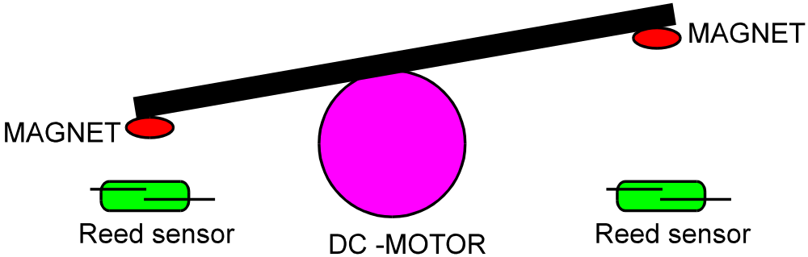

For sensing the sun light we mount the photo sensor on the top of the solar seeker. Photo sensor sense the light and provide to the motor control circuit. If the light is sufficient then Photodetecter provide a signal to the microcontroller and microcontroller stop the motor at this position.
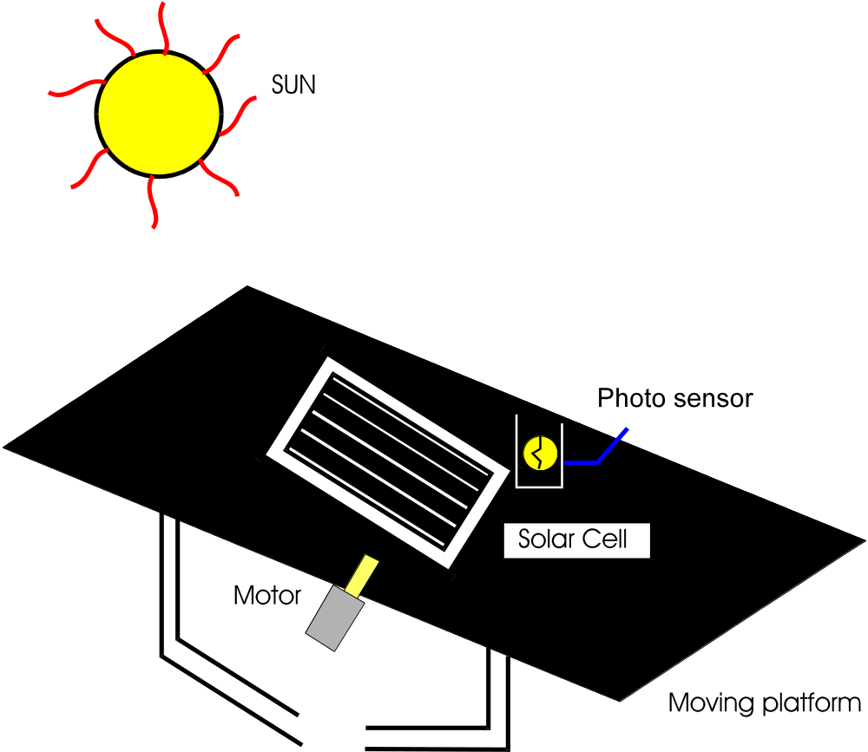

Component detail:
- Microcontroller ()at 89s52
- Lm 339
- Lm358
- Resistor(10k,1k,270,470ohm,imohm)
- Diode()in 4007
- Capacitor(100uf,27pf,10uf)
- Uln 2003
- Stepper motor
- Battery
- Regulator(7805)
- Led
- Crystal osci(12mhz)

In this project we use two LDR as a photo sensor. One LDR monitor the light and provide to the controller for stop the motor and second LDR sense a day or night logic. If the dark ness is there then controller stop the seeker for searching a light. Now seeker search a light in the day light only. If the darkness is there or in the night then seeker stop the seeker for movement.
To control the intensity of the LDR we use op-amp as a comparator. In this project we mount a solar cell on the solar seeker to get a voltage from the sun. when solar cell is under the sun then solar cell provide a voltage. We get this voltage and charge the chargeable battery. So what we are getting from the solar cell is display by the voltage level indicator circuit. With the help of this voltage level monitor circuit we monitor the voltage level with op-amp as a comparator ( LM 339) and display the voltage content by l.e.d monitor circuit.
c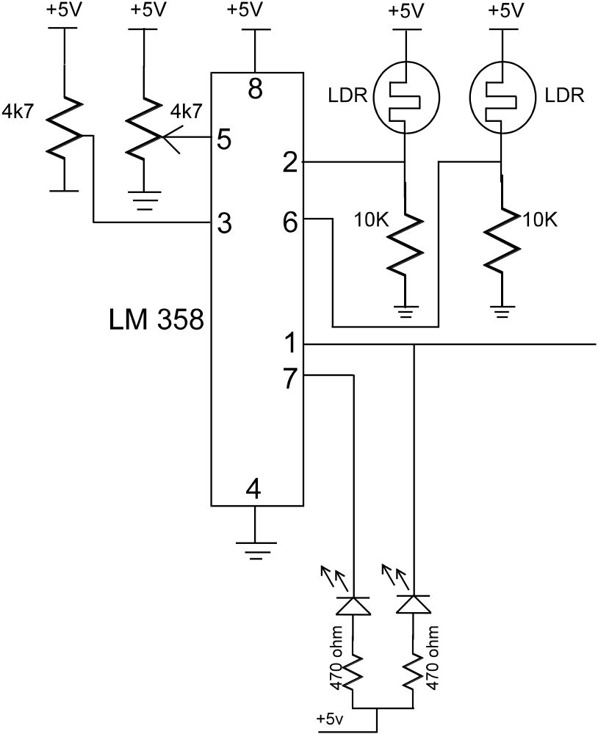

In this portion of circuit diagram we show the ldr sensing with op-amp as a comparator circuit. Here we use LM 358 as comparator circuit. LM 358 is further connected to the microcontroller. LM 358 is a dual op-amp package. Out of this one opamp is connected with the one LDR and second op-amp is connected with the second op-amp circuit. Both op-amp is work as a comparator

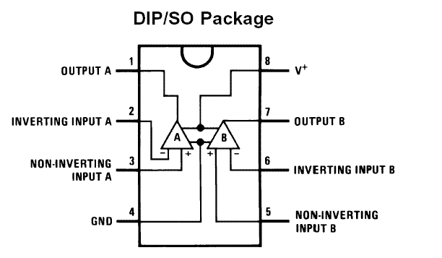

In this OP-AMP, pin no 1 and pin no 7 is the output pins for both the op-amp amplifier. Pin no 2,3 and pin no 5,6 is a input pins of the op-amp circuit. Pin no 4 is connected to the ground pin and pin no 8 is connected to the positive supply. In this circuit we use two ldr circuit , one is connected to the pin no 2 and second is connected to the pin no 6. reference level is set by the pin no 3 and 5 of the IC. On this pin we connect a variable resistor to set the reference level of the light. When light on the ldr is much more and above the set value of the reference value then op-amp provide a negative output to controller for sensing. Microcontroller when gets a active low input on pins then controller provide a action and stop the motor for movement.

Solar cell output is also connected to the opamp amplifier. Here in this portion of comparator we show the level of solar cell with the help of four l.e.d. All these l.e.d’s are connected with op-amp lm 339. LM 339 op-amp provide its output in four stage .
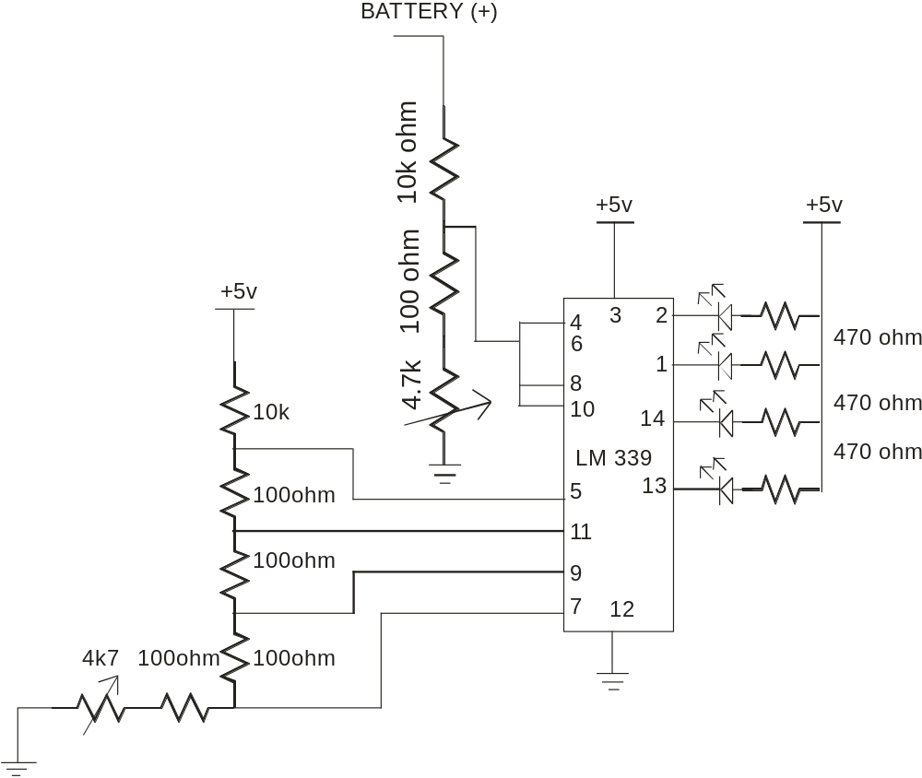
In this circuit we monitor the battery level by set reference . we monitor the battery level in four step. If the battery is fully charge then all the l.e.d’s are on. All the l.e.d’s are on if the battery level is on 6 volt. If the battery level is down to .5 volt then one l.e.d is off. So on every .5 volt drop one l.e.d is off.

Here in this project we monitor the solar cell voltage level as the same in the battery level. We use the same circuit for solar cell voltage monitor .
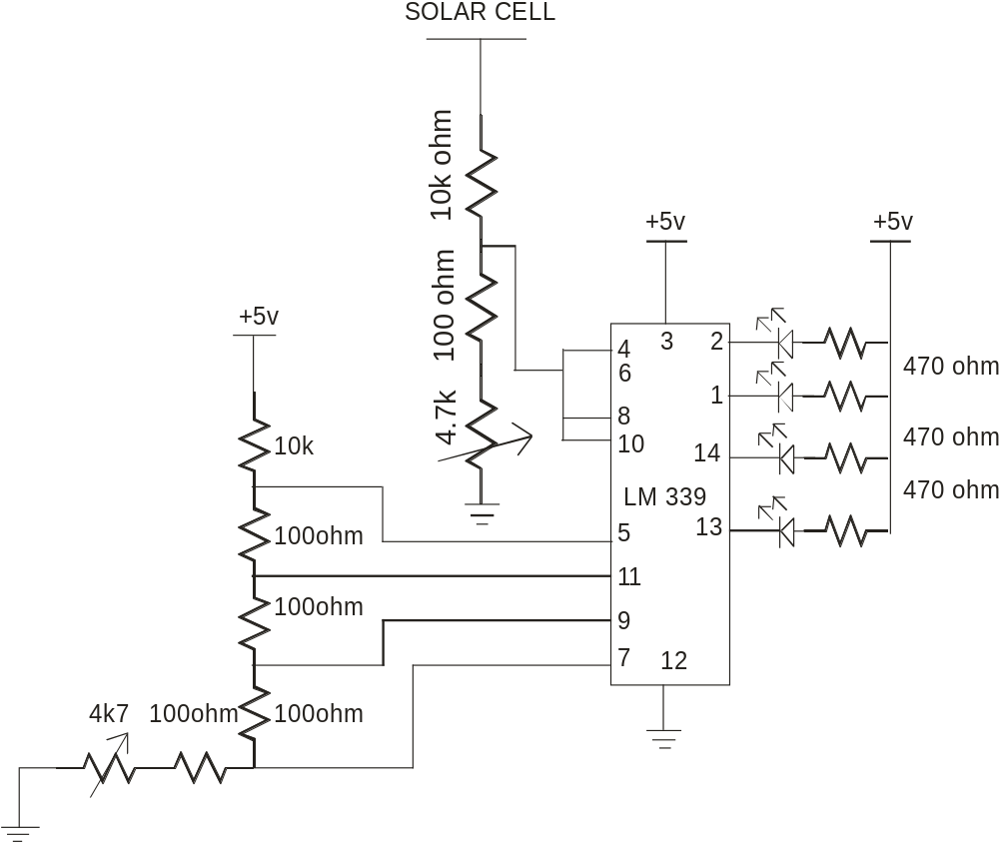

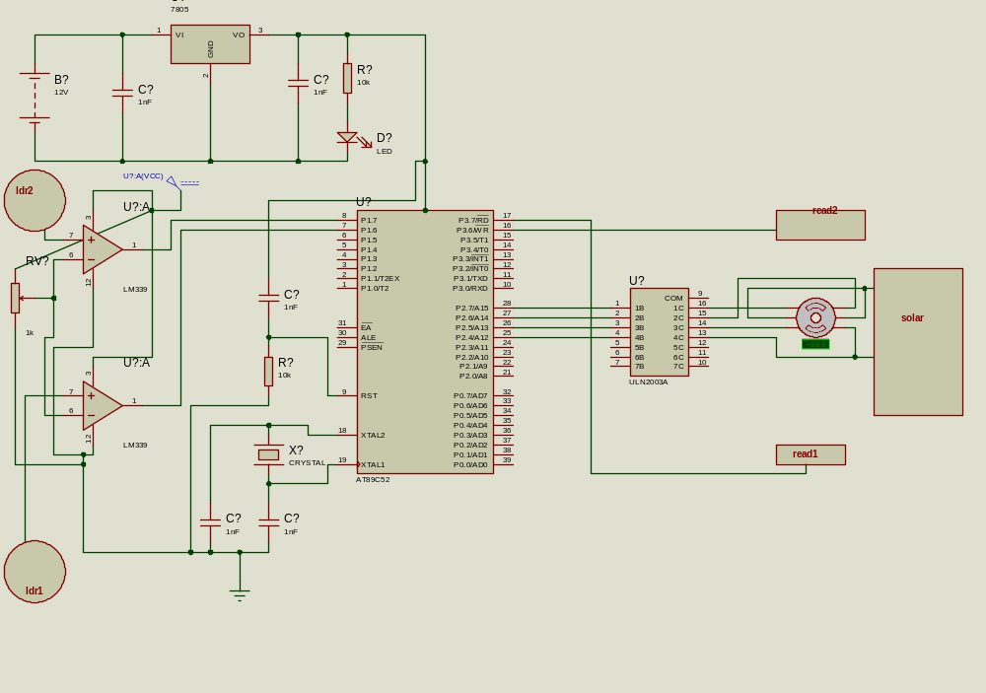

MOTOR CONTROL CIRCUIT.
In the motor control circuit we use one slow speed dc gear motor to left and right movement. In this portion of the circuit. We use one motor driver circuit with the microcontroller circuit.
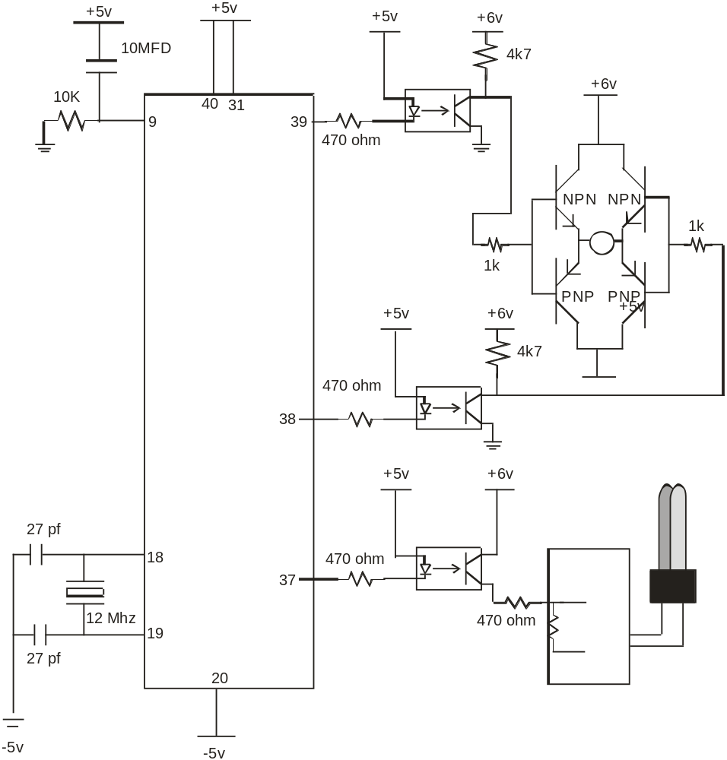
In the motor driver circuit we use H bridge driver circuit to drive the motor. Motor is to be control by the two transistor circuit. With the help of the four transistor circuit we move the motor for forward and reverse direction. Output from the controller is connected to the H bridge circuit via opto-coupler circuit. In this project we use two opto-coupler to drive the motor . Opto-coupler provide a optical isolation between microcontroller circuit and motor control circuit.
REED SENSOR CONNECTED WITH THE CONTROLLER IS TO PROVIDE A BREAK ON LEFT AND RIGHT MOVEMENT OF THE SOLAR SEEKER CIRCUIT.

When dark sensor sense a darkness then opamp provide a signal to the controller , controller stop the motor . On this time if the battery is charge then output cfl is on.
Output of the controller is further connected to the MOSFET
MOSFET CIRCUIT DRIVE THE SMALL INVERTER CIRCUIT.
With the help of the small inverter circuit we convert the dc voltage into ac voltage and further run the small CFL tube.

MICRCONTROLLER INTERFACE.
Here we use ic 89s51 controller. This controller is a 40 pin ic. Pin no 40 of the ic is connected with the positive 5 volt supply. Pin no 31 is also connected to the positive supply. Pin no 20 of the ic is connected to the ground pin. Pin no 9 is reset pin. In this pin we connect a one capacitor and resistor to provide a auto reset circuit. When supply is on then capacitor is charge through the supply and immediately discharge through the resistor , so pin no 9 ia active high for a second and due to this ic is to be reset properly and always start from the 0000 location.
Pin no 1 to pin no 8 is port 1 and pin no 10 to 17 is port 3. pin no 18 and 19 of the ic is connected to the external crystal to provide a external clock to run the internal cpu of controller . pin no 20 is ground pin. Pin no 21 to 28 is port 2 pins. Pin no 29,30,31 is not use in this project. We use these pin when we require a extra memory for the project. If we internal memory of the 89s51 ( which is 4k rom) then we connect pin no 31 to the positive supply.
There is total 32 pins are available for the input and output. Pin no 39, 38 is connected to the motor control circuit via H bridge circuit and opto-coupler circuit. Pin no 2,3,4,5 is connected to the four l.e.d. Out of hese four le.d, two l.e.d is for the reed sensor output indicator and two led for the photo-sensor output. Output of lm 358 is connected to the pin no 2,3 of the controller. Pin no 4,5 is connected to the external external l.e.d and reed sensor. Reed sensor sense a magnet which is place under the platform of the solar seeker. When solar seeker move from left o right then magnet under the seeker effect the sensor and further change the direction of the solar seeker.

BASIC OF THE MICRCONTROLLER:

WELCOME TO THE WORLD OF THE MICROCONTROLLERS.

Look around. Notice the smart “intelligent” systems? Be it the T.V, washing machines, video games, telephones, automobiles, aero planes, power systems, or any application having a LED or a LCD as a user interface, the control is likely to be in the hands of a micro controller!
Measure and control, that’s where the micro controller is at its best.
Micro controllers are here to stay. Going by the current trend, it is obvious that micro controllers will be playing bigger and bigger roles in the different activities of our lives.

These embedded chips are very small, but are designed to replace components much bigger and bulky In size. They process information very intelligently and efficiently. They sense the environment around them. The signals they gather are tuned into digital data that streams through tributaries of circuit lines at the speed of light. Inside the microprocessor collates and calculators. The software has middling intelligence. Then in a split second, the processed streams are shoved out.

What is the primary difference between a microprocessor and a micro controller?

Unlike the microprocessor, the micro controller can be considered to be a true “Computer on a chip”.
In addition to the various features like the ALU, PC, SP and registers found on a microprocessor, the micro controller also incorporates features like the ROM, RAM, Ports, timers, clock circuits, counters, reset functions etc.

While the microprocessor is more a general-purpose device, used for read, write and calculations on data, the micro controller, in addition to the above functions also controls the environment.

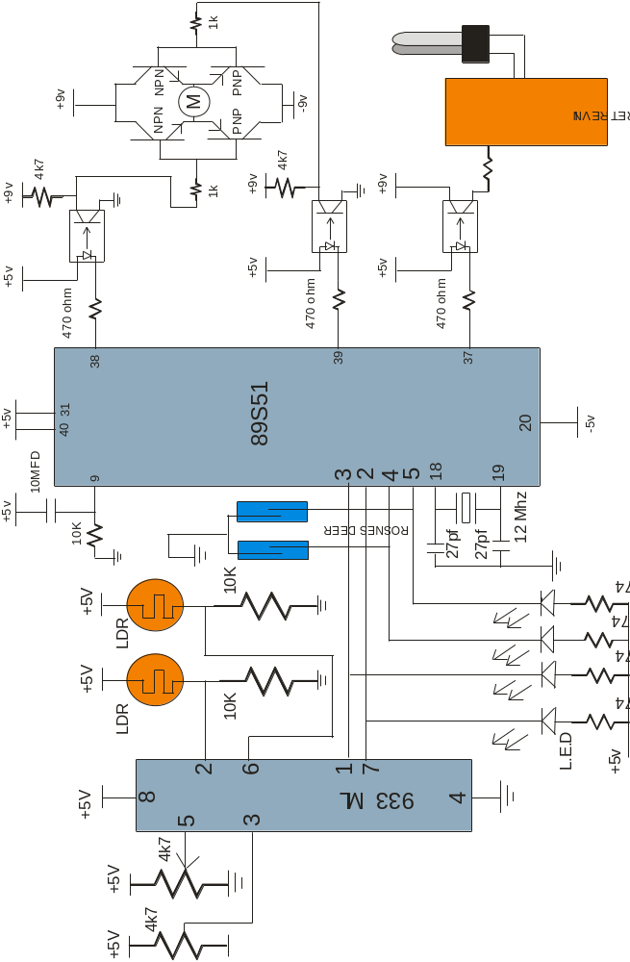

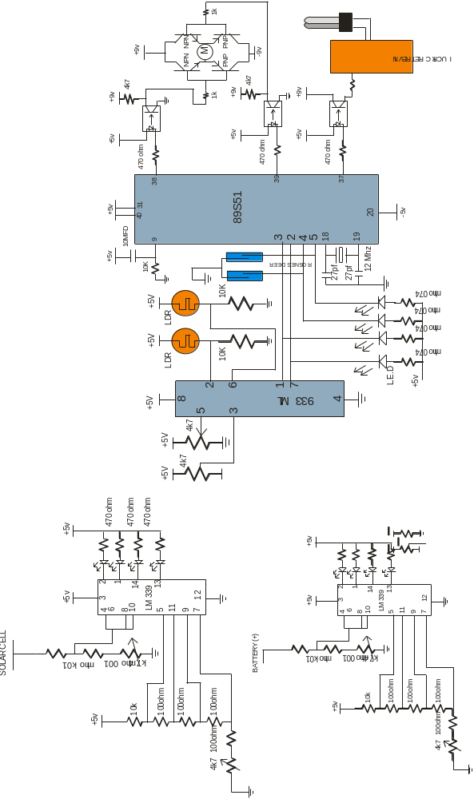

8051 micro controller

The 8051
The 8051 developed and launched in the early 80`s, is one of the most popular micro controller in use today. It has a reasonably large amount of built in ROM and RAM. In addition it has the ability to access external memory.
The generic term `8x51` is used to define the device. The value of x defining the kind of ROM, i.e. x=0, indicates none, x=3, indicates mask ROM, x=7, indicates EPROM and x=9 indicates EEPROM or Flash.
A note on ROM
The early 8051, namely the 8031 was designed without any ROM. This device could run only with external memory connected to it. Subsequent developments lead to the development of the PROM or the programmable ROM. This type had the disadvantage of being highly unreliable.
The next in line, was the EPROM or Erasable Programmable ROM. These devices used ultraviolet light erasable memory cells. Thus a program could be loaded, tested and erased using ultra violet rays. A new program could then be loaded again.
An improved EPROM was the EEPROM or the electrically erasable PROM. This does not require ultra violet rays, and memory can be cleared using circuits within the chip itself.
Finally there is the FLASH, which is an improvement over the EEPROM. While the terms EEPROM and flash are sometimes used interchangeably, the difference lies in the fact that flash erases the complete memory at one stroke, and not act on the individual cells. This results in reducing the time for erasure.

Different microcontrollers in market.

- PIC One of the famous microcontrollers used in the industries. It is based on RISC Architecture which makes the microcontroller process faster than other microcontroller.

- INTEL These are the first to manufacture microcontrollers. These are not as sophisticated other microcontrollers but still the easiest one to learn.

- Atmel Atmel’s AVR microcontrollers are one of the most powerful in the embedded industry. This is the only microcontroller having 1kb of ram even the entry stage. But it is unfortunate that in India we are unable to find this kind of microcontroller.

Intel 8051

Intel 8051 is CISC architecture which is easy to program in assembly language and also has a good support for High level languages.

The memory of the microcontroller can be extended up to 64k.

This microcontroller is one of the easiest microcontrollers to learn.

The 8051 microcontroller is in the field for more than 20 years. There are lots of books and study materials are readily available for 8051.

Derivatives

The best thing done by Intel is to give the designs of the 8051 microcontroller to everyone. So it is not the fact that Intel is the only manufacture for the 8051 there more than 20 manufactures, with each of minimum 20 models. Literally there are hundreds of models of 8051 microcontroller available in market to choose. Some of the major manufactures of 8051 are

- Atmel

- Philips

Philips
The Philips‘s 8051 derivatives has more number of features than in any microcontroller. The costs of the Philips microcontrollers are higher than the Atmel’s which makes us to choose Atmel more often than Philips

Dallas
Dallas has made many revolutions in the semiconductor market. Dallas’s 8051 derivative is the fastest one in the market. It works 3 times as fast as a 8051 can process. But we are unable to get more in India.

Atmel
These people were the one to master the flash devices. They are the cheapest microcontroller available in the market. Atmel’s even introduced a 20pin variant of 8051 named 2051. The Atmel’s 8051 derivatives can be got in India less than 70 rupees. There are lots of cheap programmers available in India for Atmel. So it is always good for students to stick with 8051 when you learn a new microcontroller.

]

Architecture

Architecture is must to learn because before learning new machine it is necessary to learn the capabilities of the machine. This is some thing like before learning about the car you cannot become a good driver. The architecture of the 8051 is given below.

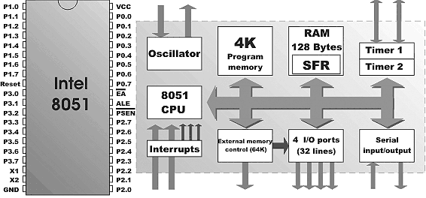

The 8051 doesn’t have any special feature than other microcontroller. The only feature is that it is easy to learn. Architecture makes us to know about the hardware features of the microcontroller. The features of the 8051 are

- 4K Bytes of Flash Memory
- 128 x 8-Bit Internal RAM
- Fully Static Operation: 1 MHz to 24 MHz
- 32 Programmable I/O Lines
- Two 16-Bit Timer/Counters
- Six Interrupt Sources (5 Vectored)
- Programmable Serial Channel
- Low Power Idle and Power Down Modes

The 8051 has a 8-Bit CPU that means it is able to process 8 bit of data at a time. 8051 has 235 instructions. Some of the important registers and their functions are

Let’s now move on to a practical example. We shall work on a simple practical application and using the example as a base, shall explore the various features of the 8051 microcontroller.
Consider an electric circuit as follows,
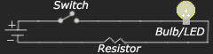
The positive side (+ve) of the battery is connected to one side of a switch. The other side of the switch is connected to a bulb or LED (Light Emitting Diode). The bulb is then connected to a resistor, and the other end of the resistor is connected to the negative (-ve) side of the battery.
When the switch is closed or ‘switched on’ the bulb glows. When the switch is open or ‘switched off’ the bulb goes off
If you are instructed to put the switch on and off every 30 seconds, how would you do it? Obviously you would keep looking at your watch and every time the second hand crosses 30 seconds you would keep turning the switch on and off.
Imagine if you had to do this action consistently for a full day. Do you think you would be able to do it? Now if you had to do this for a month, a year??
No way, you would say!
The next step would be, then to make it automatic. This is where we use the Microcontroller.
But if the action has to take place every 30 seconds, how will the microcontroller keep track of time?
Execution time
Look at the following instruction,
clr p1.0
This is an assembly language instruction. It means we are instructing the microcontroller to put a value of ‘zero’ in bit zero of port one. This instruction is equivalent to telling the microcontroller to switch on the bulb. The instruction then to instruct the microcontroller to switch off the bulb is,
Set p1.0
This instructs the microcontroller to put a value of ‘one’ in bit zero of port one.
Don’t worry about what bit zero and port one means. We shall learn it in more detail as we proceed.
There are a set of well defined instructions, which are used while communicating with the microcontroller. Each of these instructions requires a standard number of cycles to execute. The cycle could be one or more in number.
How is this time then calculated?
The speed with which a microcontroller executes instructions is determined by what is known as the crystal speed. A crystal is a component connected externally to the microcontroller. The crystal has different values, and some of the used values are 6MHZ, 10MHZ, and 11.059 MHz etc.
Thus a 10MHZ crystal would pulse at the rate of 10,000,000 times per second.

The time is calculated using the formula
No of cycles per second = Crystal frequency in HZ / 12.
For a 10MHZ crystal the number of cycles would be,
10,000,000/12=833333.33333 cycles.
This means that in one second, the microcontroller would execute 833333.33333 cycles.
Therefore for one cycle, what would be the time? Try it out.
The instruction clr p1.0 would use one cycle to execute. Similarly, the instruction setb p1.0 also uses one cycle.
So go ahead and calculate what would be the number of cycles required to be executed to get a time of 30 seconds!
Getting back to our bulb example, all we would need to do is to instruct the microcontroller to carry out some instructions equivalent to a period of 30 seconds, like counting from zero upwards, then switch on the bulb, carry out instructions equivalent to 30 seconds and switch off the bulb.
Just put the whole thing in a loop, and you have a never ending on-off sequence.
Let us now have a look at the features of the 8051 core, keeping the above example as a reference,
1. 8-bit CPU.( Consisting of the ‘A’ and ‘B’ registers)
Most of the transactions within the microcontroller are carried out through the ‘A’ register, also known as the Accumulator. In addition all arithmetic functions are carried out generally in the ‘A’ register. There is another register known as the ‘B’ register, which is used exclusively for multiplication and division.
Thus an 8-bit notation would indicate that the maximum value that can be input into these registers is ‘11111111’. Puzzled?
The value is not decimal 111, 11,111! It represents a binary number, having an equivalent value of ‘FF’ in Hexadecimal and a value of 255 in decimal.
We shall read in more detail on the different numbering systems namely the Binary and Hexadecimal system in our next module.
2. 4K on-chip ROM
Once you have written out the instructions for the microcontroller, where do you put these instructions?
Obviously you would like these instructions to be safe, and not get deleted or changed during execution. Hence you would load it into the ‘ROM’
The size of the program you write is bound to vary depending on the application, and the number of lines. The 8051 microcontroller gives you space to load up to 4K of program size into the internal ROM.
4K, that’s all? Well just wait. You would be surprised at the amount of stuff you can load in this 4K of space.
Of course you could always extend the space by connecting to 64K of external ROM if required.
3. 128 bytes on-chip RAM
This is the space provided for executing the program in terms of moving data, storing data etc.
4. 32 I/O lines. (Four- 8 bit ports, labeled P0, P1, P2, P3)
In our bulb example, we used the notation p1.0. This means bit zero of port one. One bit controls one bulb.
Thus port one would have 8 bits. There are a total of four ports named p0, p1, p2, p3, giving a total of 32 lines. These lines can be used both as input or output.
5. Two 16 bit timers / counters.
A microcontroller normally executes one instruction at a time. However certain applications would require that some event has to be tracked independent of the main program.
The manufacturers have provided a solution, by providing two timers. These timers execute in the background independent of the main program. Once the required time has been reached, (remember the time calculations described above?), they can trigger a branch in the main program.
These timers can also be used as counters, so that they can count the number of events, and on reaching the required count, can cause a branch in the main program.
6. Full Duplex serial data receiver / transmitter.
The 8051 microcontroller is capable of communicating with external devices like the PC etc. Here data is sent in the form of bytes, at predefined speeds, also known as baud rates.
The transmission is serial, in the sense, one bit at a time
7. 5- interrupt sources with two priority levels (Two external and three internal)
During the discussion on the timers, we had indicated that the timers can trigger a branch in the main program. However, what would we do in case we would like the microcontroller to take the branch, and then return back to the main program, without having to constantly check whether the required time / count has been reached?
This is where the interrupts come into play. These can be set to either the timers, or to some external events. Whenever the background program has reached the required criteria in terms of time or count or an external event, the branch is taken, and on completion of the branch, the control returns to the main program.
Priority levels indicate which interrupt is more important, and needs to be executed first in case two interrupts occur at the same time.
8. On-chip clock oscillator.
This represents the oscillator circuits within the microcontroller. Thus the hardware is reduced to just simply connecting an external crystal, to achieve the required pulsing rate.

PIN FUNCTION OF IC 89C51.

- Supply pin of this ic is pin no 40. Normally we apply a 5 volt regulated dc power supply to this pin. For this purpose either we use step down transformer power supply or we use 9 volt battery with 7805 regulator.
- Ground pin of this ic is pin no 20. Pin no 20 is normally connected to the ground pin ( normally negative point of the power supply.
- XTAL is connected to the pin no 18 and pin no 19 of this ic. The quartz crystal oscillator connected to XTAL1 and XTAL2 PIN. These pins also needs two capacitors of 30 pf value. One side of each capacitor is connected to crystal and other pis is connected to the ground point. Normally we connect a 12 MHz or 11.0592 MHz crystal with this ic.. But we use crystal upto 20 MHz to this pins
- RESET PIN.. Pin no 9 is the reset pin of this ic.. It is an active high pin. On applying a high pulse to this pin, the micro controller will reset and terminate all activities. This is often referred to as a power on reset. The high pulse must
be high for a minimum of 2 machine cycles before it is allowed to go low.

5. PORT0 Port 0 occupies a total of 8 pins. Pin no 32 to pin no 39. It can be used for input or output. We connect all the pins of the port 0 with the pullup resistor (10 k ohm) externally. This is due to fact that port 0 is an open drain mode. It is just like a open collector transistor.

6. PORT1. ALL the ports in micrcontroller is 8 bit wide pin no 1 to pin no 8 because it is a 8 bit controller. All the main register and sfr all is mainly 8 bit wide. Port 1 is also occupies a 8 pins. But there is no need of pull up resistor in this port. Upon reset port 1 act as a input port. Upon reset all the ports act as a input port

7. PORT2. port 2 also have a 8 pins. It can be used as a input or output. There is no need of any pull up resistor to this pin.

PORT 3. Port3 occupies a totoal 8 pins from pin no 10 to pin no 17. It can be used as input or output. Port 3 does not require any pull up resistor. The same as port 1 and port2. Port 3 is configured as an output port on reset. Port 3 has the additional function of providing some important signals such as interrupts. Port 3 also use for serial communication.

ALE ALE is an output pin and is active high. When connecting an 8031 to external memory, port 0 provides both address and data. In other words, the 8031 multiplexes address and data through port 0 to save pins. The ALE pin is used for demultiplexing the address and data by connecting to the ic 74ls373 chip.

PSEN. PSEN stands for program store eneable. In an 8031 based system in which an external rom holds the program code, this pin is connected to the OE pin of the rom.

EA. EA. In 89c51 8751 or any other family member of the ateml 89c51 series all come with on-chip rom to store programs, in such cases the EA pin is connected to the Vcc. For family member 8031 and 8032 is which there is no on chip rom, code is stored in external memory and this is fetched by 8031. In that case EA pin must be connected to GND pin to indicate that the code is stored externally.

SPECIAL FUNCTION REGISTER ( SFR) ADDRESSES.

ACC ACCUMULATOR 0E0H

B B REGISTER 0F0H

PSW PROGRAM STATUS WORD 0D0H

SP STACK POINTER 81H

DPTR DATA POINTER 2 BYTES

DPL LOW BYTE OF DPTR 82H
DPH HIGH BYTE OF DPTR 83H

P0 PORT0 80H

P1 PORT1 90H

P2 PORT2 0A0H

P3 PORT3 0B0H

TMOD TIMER/COUNTER MODE CONTROL 89H

TCON TIMER COUNTER CONTROL 88H

TH0 TIMER 0 HIGH BYTE 8CH

TLO TIMER 0 LOW BYTE 8AH

TH1 TIMER 1 HIGH BYTE 8DH

TL1 TIMER 1 LOW BYTE 8BH

SCON SERIAL CONTROL 98H

SBUF SERIAL DATA BUFFER 99H

PCON POWER CONTROL 87H

INSTRUCTIONS

SINGLE BIT INSTRUCTIONS.

SETB BIT SET THE BIT =1

CLR BIT CLEAR THE BIT =0

CPL BIT COMPLIMENT THE BIT 0 =1, 1=0

JB BIT,TARGET JUMP TO TARGET IF BIT =1

JNB BIT, TARGET JUMP TO TARGET IF BIT =0

JBC BIT,TARGET JUMP TO TARGET IF BIT =1 &THEN CLEAR THE BIT

MOV INSTRUCTIONS

MOV instruction simply copy the data from one location to another location

MOV D,S

Copy the data from(S) source to D(destination)

MOV R0,A ; Copy contents of A into Register R0

MOV R1,A ; Copy contents of A into register R1

MOV A,R3 ; copy contents of Register R3 into Accnmulator.

DIRECT LOADING THROUGH MOV

MOV A,#23H ; Direct load the value of 23h in A

MOV R0,#12h ; direct load the value of 12h in R0

MOV R5,#0F9H ; Load the F9 value in the Register R5

ADD INSTRUCTIONS.

ADD instructions adds the source byte to the accumulator ( A) and place the result in the Accumulator.

MOV A, #25H

ADD A,#42H ; BY this instructions we add the value 42h in Accumulator ( 42H+ 25H)

ADDA,R3 ;By this instructions we move the data from register r3 to accumulator and then add the contents of the register into accumulator .

SUBROUTINE CALL FUNCTION.

ACALL,TARGET ADDRESS

By this instructions we call subroutines with a target address within 2k bytes from the current program counter.

LCALL, TARGET ADDRESS.

ACALL is a limit for the 2 k byte program counter, but for upto 64k byte we use LCALL instructions.. Note that LCALL is a 3 byte instructions. ACALL is a two byte instructions.

AJMP TARGET ADDRESS.

This is for absolute jump

AJMP stand for absolute jump. It transfers program execution to the target address unconditionally. The target address for this instruction must be withib 2 k byte of program memory.

LJMP is also for absoltute jump. It tranfer program execution to the target addres unconditionally. This is a 3 byte instructions LJMP jump to any address within 64 k byte location.

INSTRUCTIONS RELATED TO THE CARRY

JC TARGET

JUMP TO THE TARGET IF CY FLAG =1

JNC TARGET

JUMP TO THE TARGET ADDRESS IF CY FLAG IS = 0

INSTRUCTIONS RELASTED TO JUMP WITH ACCUMULATOR

JZ TARGET

JUMP TO TARGET IF A = 0

JNZ TARGET

JUMP IF ACCUMULATOR IS NOT ZERO

This instructions jumps if registe A has a value other than zero

INSTRUCTIONS RELATED TO THE ROTATE

RL A

ROTATE LEFT THE ACCUMULATOR

BY this instructions we rotate the bits of A left. The bits rotated out of A are rotated back into A at the opposite end

RR A

By this instruction we rotate the contents of the accumulator from right to left from LSB to MSB

RRC A

This is same as RR A but difference is that the bit rotated out of register first enter in to carry and then enter into MSB

RLC A

ROTATE A LEFT THROUGH CARRY

Same as above but but shift the data from MSB to carry and carry to LSB

RET

This is return from subroutine. This instructions is used to return from a subroutine previously entered by instructions LCALL and ACALL.

RET1

THIS is used at the end of an interrupt service routine. We use this instructions after intruupt routine,

PUSH.

This copies the indicated byte onto the stack and increments SP by . This instructions supports only direct addressing mode.

POP.

POP FROM STACK.

This copies the byte pointed to be SP to the location whose direct address is indicated, and decrements SP by 1. Notice that this instructions supports only direct addressing mode.

DPTR INSTRUCTIONS.

MOV DPTR,#16 BIT VALUE

LOAD DATA POINTER

This instructions load the 16 bit dptr register with a 16 bit immediate value

MOV C A,@A+DPTR
This instructions moves a byte of data located in program ROM into register A. This allows us to put strings of data, such as look up table elements.

MOVC A,@A+PC

This instructions moves a byte of data located in the program area to A. the address of the desired byte of data is formed by adding the program counter ( PC) register to the original value of the accumulator.

INC BYTE

This instructions add 1 to the register or memory location specified by the operand.

INC A
INC Rn
INC DIRECT

DEC BYTE

This instructions subtracts 1 from the byte operand. Note that CY is unchanged

DEC A
DEC Rn
DEC DIRECT

ARITHMATIC INSTRUCTIONS.

ANL dest-byte, source-byte

This perform a logical AND operation

This performs a logical AND on the operands, bit by bit, storing the result in the destination. Notice that both the source and destination values are byte –size only

`

DIV AB

This instructions divides a byte accumulator by the byte in register B. It is assumed that both register A and B contain an unsigned byte. After the division the quotient will be in register A and the remainder in register B.

TMOD ( TIMER MODE ) REGISTER

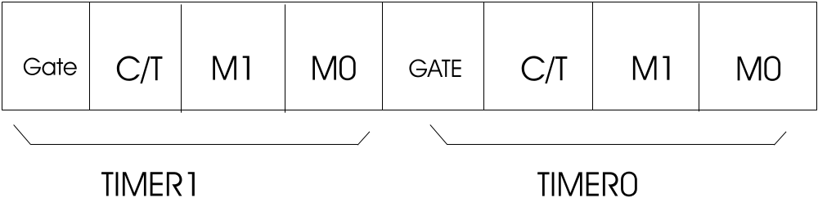

Both timer is the 89c51 share the one register TMOD. 4 LSB bit for the timer 0 and 4 MSB for the timer 1.

In each case lower 2 bits set the mode of the timer

Upper two bits set the operations.

GATE: Gating control when set. Timer/counter is enabled only while the INTX pin is high and the TRx control pin is set. When cleared, the timer is enabled whenever the TRx control bit is set

C/T : Timer or counter selected cleared for timer operation ( input from internal system clock)

M1 Mode bit 1

M0 Mode bit 0

M1 M0 MODE OPERATING MODE

0 0 0 13 BIT TIMER/MODE

0 1 1 16 BIT TIMER MODE

1 0 2 8 BIT AUTO RELOAD

1 1 3 SPLIT TIMER MODE

PSW ( PROGRAM STATUS WORD)

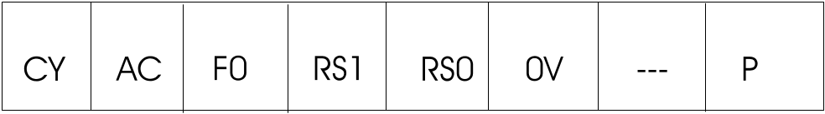

CY PSW.7 CARRY FLAG

AC PSW.6 AUXILIARY CARRY

F0 PSW.5 AVAILABLE FOR THE USER FRO GENERAL PURPOSE

RS1 PSW.4 REGISTER BANK SELECTOR BIT 1

RS0 PSW.3 REGISTER BANK SELECTOR BIT 0

0V PSW.2 OVERFLOW FLAG

-- PSW.1 USER DEFINABLE BIT

P PSW.0 PARITY FLAG SET/CLEARED BY HARDWARE

PCON REGISATER ( NON BIT ADDRESSABLE)

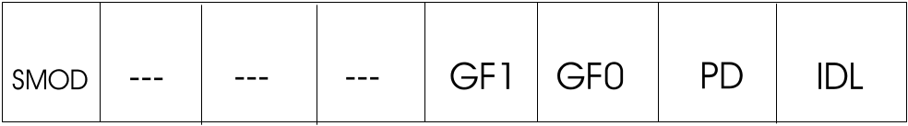

If the SMOD = 0 ( DEFAULT ON RESET)

TH1 = CRYSTAL FREQUENCY
256---- ____________________

- X BAUD RATE

If the SMOD IS = 1
CRYSTAL FREQUENCY

TH1 = 256--------------------------------------
192 X BAUD RATE

There are two ways to increase the baud rate of data transfer in the 8051

- To use a higher frequency crystal
- To change a bit in the PCON register

PCON register is an 8 bit register . Of the 8 bits, some are unused, and some are used for the power control capability of the 8051. the bit which is used for the serial communication is D7, the SMOD bit. When the 8051 is powered up, D7 ( SMOD BIT) OF PCON register is zero. We can set it to high by software and thereby double the baud rate

BAUD RATE COMPARISION FOR SMOD = 0 AND SMOD =1

TH1 ( DECIMAL) HEX SMOD =0 SMOD =1

-3 FD 9600 19200
-6 FA 4800 9600
-12 F4 2400 4800
-24 E8 1200 2400

XTAL = 11.0592 MHZ

IE ( INTERRUPT ENABLE REGISTOR)

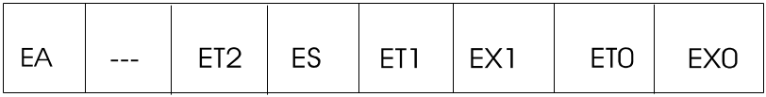

EA IE.7 Disable all interrupts if EA = 0, no interrupts is acknowledged
If EA is 1, each interrupt source is individually enabled or disbaled
By sending or clearing its enable bit.

IE.6 NOT implemented

ET2 IE.5 enables or disables timer 2 overflag in 89c52 only

ES IE.4 Enables or disables all serial interrupt

ET1 IE.3 Enables or Disables timer 1 overflow interrupt

EX1 IE.2 Enables or disables external interrupt

ET0 IE.1 Enables or Disbales timer 0 interrupt.

EX0 IE.0 Enables or Disables external interrupt 0

INTERRUPT PRIORITY REGISTER

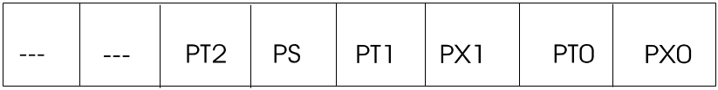

If the bit is 0, the corresponding interrupt has a lower priority and if the bit is 1 the corresponding interrupt has a higher priority

IP.7 NOT IMPLEMENTED, RESERVED FOR FUTURE USE.

IP.6 NOT IMPLEMENTED, RESERVED FOR FUTURE USE

PT2 IP.5 DEFINE THE TIMER 2 INTERRUPT PRIORITY LELVEL

PS IP.4 DEFINES THE SERIAL PORT INTERRUPT PRIORITY LEVEL

PT1 IP.3 DEFINES THE TIMER 1 INTERRUPT PRIORITY LEVEL

PX1 IP.2 DEFINES EXTERNAL INTERRUPT 1 PRIORITY LEVEL

PT0 IP.1 DEFINES THE TIMER 0 INTERRUPT PRIORITY LEVEL

PX0 IP.0 DEFINES THE EXTERNAL INTERRUPT 0 PRIORITY LEVEL

SCON: SERIAL PORT CONTROL REGISTER , BIT ADDRESSABLE

SCON
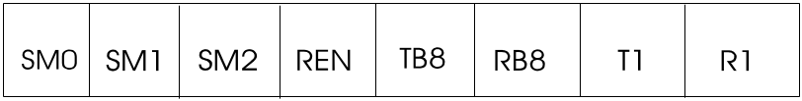

SM0 : SCON.7 Serial Port mode specifier

SM1 : SCON.6 Serial Port mode specifier

SM2 : SCON.5

REN : SCON.4 Set/cleared by the software to Enable/disable reception

TB8 : SCON.3 The 9th bit that will be transmitted in modes 2 and 3, Set/cleared
By software

RB8 : SCON.2 In modes 2 &3, is the 9th data bit that was received. In mode 1,
If SM2 = 0, RB8 is the stop bit that was received. In mode 0
RB8 is not used

T1 : SCON.1 Transmit interrupt flag. Set by hardware at the end of the 8th bit
Time in mode 0, or at the beginning of the stop bit in the other
Modes. Must be cleared by software

R1 SCON.0 Receive interrupt flag. Set by hardware at the end of the 8th bit
Time in mode 0, or halfway through the stop bit time in the other
Modes. Must be cleared by the software.

TCON TIMER COUNTER CONTROL REGISTER

This is a bit addressable

TF1 TCON.7 Timer 1 overflow flag. Set by hardware when the Timer/Counter 1
Overflows. Cleared by hardware as processor

TR1 TCON.6 Timer 1 run control bit. Set/cleared by software to turn Timer
Counter 1 On/off

TF0 TCON.5 Timer 0 overflow flag. Set by hardware when the timer/counter 0
Overflows. Cleared by hardware as processor

TR0 TCON.4 Timer 0 run control bit. Set/cleared by software to turn timer
Counter 0 on/off.

IE1 TCON.3 External interrupt 1 edge flag

ITI TCON.2 Interrupt 1 type control bit

IE0 TCON.1 External interrupt 0 edge

IT0 TCON.0 Interrupt 0 type control bit.

- 8051 Instruction Set

Arithmetic Operations

Mnemonic Description Size Cycles

ADD A,Rn Add register to Accumulator (ACC). 1 1

ADD A,direct Add direct byte to ACC. 2 1

ADD A,@Ri Add indirect RAM to ACC . 1 1

ADD A,#data Add immediate data to ACC . 2 1

ADDC A,Rn Add register to ACC with carry . 1 1

ADDC A,direct Add direct byte to ACC with carry. 2 1

ADDC A,@Ri Add indirect RAM to ACC with carry. 1 1

ADDC A,#data Add immediate data to ACC with carry. 2 1

SUBB A,Rn Subtract register from ACC with borrow. 1 1

SUBB A,direct Subtract direct byte from ACC with borrow 2 1

SUBB A,@Ri Subtract indirect RAM from ACC with borrow. 1 1

SUBB A,#data Subtract immediate data from ACC with borrow. 2 1

INC A Increment ACC. 1 1

INC Rn Increment register. 1 1

INC direct Increment direct byte. 2 1

INC @Ri Increment indirect RAM. 1 1

DEC A Decrement ACC. 1 1

DEC Rn Decrement register. 1 1

DEC direct Decrement direct byte. 2 1

DEC @Ri Decrement indirect RAM. 1 1

INC DPTR Increment data pointer. 1 2

MUL AB Multiply A and B Result: A <- low byte, B <- high byte. 1 4

DIV AB Divide A by B Result: A <- whole part, B <- remainder. 1 4

DA A Decimal adjust ACC. 1 1

Logical Operations

Mnemonic Description Size Cycles

ANL A,Rn AND Register to ACC. 1 1

ANL A,direct AND direct byte to ACC. 2 1

ANL A,@Ri AND indirect RAM to ACC. 1 1

ANL A,#data AND immediate data to ACC. 2 1

ANL direct,A AND ACC to direct byte. 2 1

ANL direct,#data AND immediate data to direct byte. 3 2

ORL A,Rn OR Register to ACC. 1 1

ORL A,direct OR direct byte to ACC. 2 1

ORL A,@Ri OR indirect RAM to ACC. 1 1

ORL A,#data OR immediate data to ACC. 2 1

ORL direct,A OR ACC to direct byte. 2 1

ORL direct,#data OR immediate data to direct byte. 3 2

XRL A,Rn Exclusive OR Register to ACC. 1 1

XRL A,direct Exclusive OR direct byte to ACC. 2 1

XRL A,@Ri Exclusive OR indirect RAM to ACC. 1 1

XRL A,#data Exclusive OR immediate data to ACC. 2 1

XRL direct,A Exclusive OR ACC to direct byte. 2 1

XRL direct,#data XOR immediate data to direct byte. 3 2

CLR A Clear ACC (set all bits to zero). 1 1

CPL A Compliment ACC. 1 1

RL A Rotate ACC left. 1 1

RLC A Rotate ACC left through carry. 1 1

RR A Rotate ACC right. 1 1

RRC A Rotate ACC right through carry. 1 1

SWAP A Swap nibbles within ACC. 1 1

Data Transfer

Mnemonic Description Size Cycles

MOV A,Rn Move register to ACC. 1 1

MOV A,direct Move direct byte to ACC. 2 1

MOV A,@Ri Move indirect RAM to ACC. 1 1

MOV A,#data Move immediate data to ACC. 2 1

MOV Rn,A Move ACC to register. 1 1

MOV Rn,direct Move direct byte to register. 2 2

MOV Rn,#data Move immediate data to register. 2 1

MOV direct,A Move ACC to direct byte. 2 1

MOV direct,Rn Move register to direct byte. 2 2

MOV direct,direct Move direct byte to direct byte. 3 2

MOV direct,@Ri Move indirect RAM to direct byte. 2 2

MOV direct,#data Move immediate data to direct byte. 3 2

MOV @Ri,A Move ACC to indirect RAM. 1 1

MOV @Ri,direct Move direct byte to indirect RAM. 2 2

MOV @Ri,#data Move immediate data to indirect RAM. 2 1

MOV DPTR,#data16 Move immediate 16 bit data to data pointer register. 3 2

MOVC A,@A+DPTR Move code byte relative to DPTR to ACC (16 bit address). 1 2

MOVC A,@A+PC Move code byte relative to PC to ACC (16 bit address).1 2

MOVX A,@Ri Move external RAM to ACC (8 bit address). 1 2

MOVX A,@DPTR Move external RAM to ACC (16 bit address). 1 2

MOVX @Ri,A Move ACC to external RAM (8 bit address). 1 2

MOVX @DPTR,A Move ACC to external RAM (16 bit address). 1 2

PUSH direct Push direct byte onto stack. 2 2

POP direct Pop direct byte from stack. 2 2

XCH A,Rn Exchange register with ACC. 1 1

XCH A,direct Exchange direct byte with ACC. 2 1

XCH A,@Ri Exchange indirect RAM with ACC. 1 1

XCHD A,@Ri Exchange low order nibble of indirect
RAM with low order nibble of ACC 1 1

Boolean Variable Manipulation

Mnemonic Description Size Cycles

CLR C Clear carry flag. 1 1

CLR bit Clear direct bit. 2 1

SETB C Set carry flag. 1 1

SETB bitSet direct bit 2 1

CPL C Compliment carry flag. 1 1

CPL bit Compliment direct bit. 2 1

ANL C,bit AND direct bit to carry flag. 2 2

ANL C,/bit AND compliment of direct bit to carry. 2 2

ORL C,bit OR direct bit to carry flag. 2 2

ORL C,/bit OR compliment of direct bit to carry. 2 2

MOV C,bit Move direct bit to carry flag. 2 1

MOV bit,C Move carry to direct bit. 2 2

JC rel Jump if carry is set. 2 2

JNC rel Jump if carry is not set. 2 2

JB bit,rel Jump if direct bit is set. 3 2

JNB bit,rel Jump if direct bit is not set. 3 2

JBC bit,rel Jump if direct bit is set & clear bit. 3 2

Program Branching

Mnemonic Description Size Cycles

ACALL addr11 Absolute subroutine call. 2 2

LCALL addr16 Long subroutine call. 3 2

RET Return from subroutine. 1 2

RETI Return from interrupt. 1 2

AJMP addr11 Absolute jump. 2 2

LJMP addr16 Long jump. 3 2

SJMP rel Short jump (relative address). 2 2

JMP @A+DPTR Jump indirect relative to the DPTR. 1 2

JZ rel Jump relative if ACC is zero. 2 2

JNZ rel Jump relative if ACC is not zero. 2 2

CJNE A,direct,rel Compare direct byte to ACC and jump if not equal. 3 2

CJNE A,#data,rel Compare immediate byte to ACC and jump if not equal.3 2

CJNE Rn,#data,rel Compare immediate byte to register and jump if not equal.3 2

CJNE @Ri,#data,rel Compare immediate byte to indirect and jump if not equal.3 2

DJNZ Rn,rel Decrement register and jump if not zero. 2 2

DJNZ direct,rel Decrement direct byte and jump if not zero. 3 2

The RW line is the "Read/Write" control line. When RW is low (0), the information on

I

The metal–oxide–semiconductor field-effect transistor (MOSFET, MOS-FET, or MOS FET) is a device used to amplify or switch electronic signals. The basic principle of the device was first proposed by Julius Edgar Lilienfeld in 1925. It is by far the most common field-effect transistor in both digital and analog circuits. The MOSFET is composed of a channel of n-type or p-type semiconductor material (see article on semiconductor devices), and is accordingly called an NMOSFET or a PMOSFET (also commonly nMOS, pMOS).

Etymology
The 'metal' in the name is now often a misnomer because the previously metal gate material is now a layer of polysilicon (polycrystalline silicon; why polysilicon is used will be explained below). Previously aluminium was used as the gate material until the 1980s when polysilicon became dominant, owing to its capability to form self-aligned gates.
IGFET is a related, more general term meaning insulated-gate field-effect transistor, and is almost synonymous with MOSFET, though it can refer to FETs with a gate insulator that is not oxide. Some prefer to use "IGFET" when referring to devices with polysilicon gates, but most still call them MOSFETs.

Composition
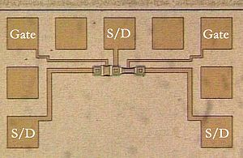

Photomicrograph of two metal-gate MOSFETs in a test pattern. Probe pads for two gates and three source/drain nodes are labeled.
Usually the semiconductor of choice is silicon, but some chip manufacturers, most notably IBM, have begun to use a mixture of silicon and germanium (SiGe) in MOSFET channels. Unfortunately, many semiconductors with better electrical properties than silicon, such as gallium arsenide, do not form good semiconductor-to-insulator interfaces and thus are not suitable for MOSFETs. However there continues to be research on how to create insulators with acceptable electrical characteristics on other semiconductor material.
To overcome power consumption increase due to gate current leakage, high-κ dielectric is replacing silicon dioxide as the gate insulator, and metal gates are making a comeback by replacing polysilicon (see Intel announcement^{[1]}).
The gate is separated from the channel by a thin insulating layer of what was traditionally silicon dioxide, but more advanced technologies used silicon oxynitride. Some companies have started to introduce a high-κ dielectric + metal gate combination in the 45 nanometer node.
When a voltage is applied between the gate and source terminals, the electric field generated penetrates through the oxide and creates a so-called "inversion layer" or channel at the semiconductor-insulator interface. The inversion channel is of the same type – P-type or N-type – as the source and drain, so it provides a channel through which current can pass. Varying the voltage between the gate and body modulates the conductivity of this layer and makes it possible to control the current flow between drain and source.

Circuit symbols
A variety of symbols are used for the MOSFET. The basic design is generally a line for the channel with the source and drain leaving it at right angles and then bending back at right angles into the same direction as the channel. Sometimes three line segments are used for enhancement mode and a solid line for depletion mode. Another line is drawn parallel to the channel for the gate.
The bulk connection, if shown, is shown connected to the back of the channel with an arrow indicating PMOS or NMOS. Arrows always point from P to N, so an NMOS (N-channel in P-well or P-substrate) has the arrow pointing in (from the bulk to the channel). If the bulk is connected to the source (as is generally the case with discrete devices) it is sometimes angled to meet up with the source leaving the transistor. If the bulk is not shown (as is often the case in IC design as they are generally common bulk) an inversion symbol is sometimes used to indicate PMOS, alternatively an arrow on the source (not depicted below) may be used in the same way as for bipolar transistors (out for NMOS, in for PMOS).
Comparison of enhancement-mode and depletion-mode MOSFET symbols, along with JFET symbols (Note, the 2nd and 4th columns of images should be flipped across y=0, so the higher voltages are above the lower voltages. The JFET symbols should be checked for correctness.):
 |  |  |  | P-channel
 |  |  |  | N-channel
JFET | MOSFET enh |  | MOSFET dep
For the symbols in which the bulk, or body, terminal is shown, it is here shown internally connected to the source. This is a typical configuration, but by no means the only important configuration. In general, the MOSFET is a four-terminal device, and in integrated circuits many of the MOSFETs share a body connection, not necessarily connected to the source terminals of all the transistors.

MOSFET operation
For the operation of MOS devices discussed next, an authoritative reference is Tsividis ^{[2]}.

Metal–oxide–semiconductor structure

Metal–oxide–semiconductor structure on P-type silicon
A traditional metal–oxide–semiconductor (MOS) structure is obtained by depositing a layer of silicon dioxide (SiO₂) and a layer of metal (polycrystalline silicon is commonly used instead of metal) on top of a semiconductor die. As the silicon dioxide is a dielectric material its structure is equivalent to a planar capacitor, with one of the electrodes replaced by a semiconductor.
When a voltage is applied across a MOS structure, it modifies the distribution of charges in the semiconductor. If we consider a P-type semiconductor (with N_{A} the density of acceptors, p the density of holes; p = N_{A} in neutral bulk), a positive voltage, V_{GB}, from gate to body (see figure) creates a depletion layer by forcing the positively charged holes away from the gate-insulator/semiconductor interface, leaving exposed a carrier-free region of immobile, negatively charged acceptor ions. See doping (semiconductor). If V_{GB} is high enough, a high concentration of negative charge carriers forms in an inversion layer located in a thin layer next to the interface between the semiconductor and the insulator. (Unlike the MOSFET, discussed below, where the inversion layer electrons are supplied rapidly from the source/drain electrodes, in the MOS capacitor they are produced much more slowly by thermal generation through carrier generation and recombination centers in the depletion region.) Conventionally, the gate voltage at which the volume density of electrons in the inversion layer is the same as the volume density of holes in the body is called the threshold voltage.
This structure with P-type body is the basis of the N-type MOSFET, which requires the addition of an N-type source and drain regions.

[edit] MOSFET structure and channel formation
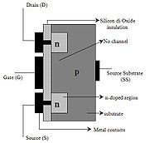

Cross section of an NMOS without channel formed: OFF state
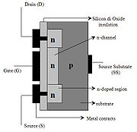

Cross section of an NMOS with channel formed: ON state
A metal–oxide–semiconductor field-effect transistor (MOSFET) is based on the modulation of charge concentration by a MOS capacitance between a body electrode and a gate electrode located above the body and insulated from all other device regions by a gate dielectric layer which in the case of a MOSFET is an oxide, such as silicon dioxide. If dielectrics other than an oxide such as silicon dioxide (often referred to as oxide) are employed the device may be referred to as a metal–insulator–semiconductor FET (MISFET). The MOSFET includes two additional terminals (source and drain), each connected to individual highly doped regions that are separated by the body region. These regions can be either p or n type, but they must both be of the same type, and of opposite type to the body region. The highly doped source and drain regions typically are denoted by a '+' following the type of doping. The body is not highly doped, as denoted by the lack of a '+' sign.
If the MOSFET is an n-channel or nMOS FET, then the source and drain are 'n+' regions and the body is a 'p' region. As described above, with sufficient gate voltage, above a threshold voltage value, electrons from the source (and possibly also the drain) enter the inversion layer or n-channel at the interface between the p region and the oxide. This conducting channel extends between the source and the drain, and current is conducted through it when a voltage is applied between source and drain.
For gate voltages below the threshold value, the channel is lightly populated, and only a very small subthreshold leakage current can flow between the source and the drain.
If the MOSFET is a p-channel or pMOS FET, then the source and drain are 'p+' regions and the body is a 'n' region. When a negative gate-source voltage (positive source-gate) is applied, it creates a p-channel at the surface of the n region, analogous to the n-channel case, but with opposite polarities of charges and voltages. When a voltage less negative than the threshold value (a negative voltage for p-Channel) is applied between gate and source, the channel disappears and only a very small subthreshold current can flow between the source and the drain.
The source is so named because it is the source of the charge carriers (electrons for n-channel, holes for p-channel) that flow through the channel; similarly, the drain is where the charge carriers leave the channel.
The device may comprise a Silicon On Insulator (SOI) device in which a Buried OXide (BOX) is formed below a thin semiconductor layer. If the channel region between the gate dielectric and a Buried OXide (BOX) region is very thin, the very thin channel region is referred to as an Ultra Thin Channel (UTC) region with the source and drain regions formed on either side thereof in and/or above the thin semiconductor layer. Alternatively, the device may comprise a SEMiconductor On Insulator (SEMOI) device in which other semiconductors than silicon are employed. Many alternative semicondutor materials may be employed.
When the source and drain regions are formed above the channel in whole or in part, they are referred to as Raised Source/Drain RSD) regions.

Modes of operation
The operation of a MOSFET can be separated into three different modes, depending on the voltages at the terminals. In the following discussion, a simplified algebraic model is used that is accurate only for old technology. Modern MOSFET characteristics require computer models that have rather more complex behavior. For example, see Liu ^{[3]} and the device modeling list in [1].
For an enhancement-mode, n-channel MOSFET the three operational modes are:
Cut-off or Sub-threshold or Weak Inversion Mode
When V_{GS} < V_{th}:
where V_{th} is the threshold voltage of the device.
According to the basic threshold model, the transistor is turned off, and there is no conduction between drain and source. In reality, the Boltzmann distribution of electron energies allows some of the more energetic electrons at the source to enter the channel and flow to the drain, resulting in a subthreshold current that is an exponential function of gate–source voltage. While the current between drain and source should ideally be zero when the transistor is being used as a turned-off switch, there is a weak-inversion current, sometimes called subthreshold leakage.
In weak inversion the current varies exponentially with gate-to-source bias V_{GS} as given approximately by:^{[4][5]}
,
where I_{D0} = current at V_{GS} = V_{th} and the slope factor n is given by
n = 1 + C_{D} / C_{OX},
with C_{D} = capacitance of the depletion layer and C_{OX} = capacitance of the oxide layer. In a long-channel device, there is no drain voltage dependence of the current once V_{DS} > > V_{T}, but as channel length is reduced drain-induced barrier lowering introduces drain voltage dependence that depends in a complex way upon the device geometry (for example, the channel doping, the junction doping and so on). Frequently threshold voltage V_{th} for this mode is defined as the gate voltage at which a selected value of current I_{D0} occurs, for example, I_{D0} = 1 μA, which may not be the same V_{th}-value used in the equations for the following modes.
Some micropower analog circuits are designed to take advantage of subthreshold conduction.^{[6][7][8]} By working in the weak-inversion region, the MOSFETs in these circuits deliver the highest possible transconductance-to-current ratio, namely: g_{m} / I_{D} = 1 / (nV_{T}), almost that of a bipolar transistor. Unfortunately, bandwidth is low due to the low drive currents. Also, the subthreshold I-V relation depends exponentially upon threshold voltage, introducing a strong dependence on any manufacturing variation that affects threshold voltage; for example: variations in oxide thickness, junction depth, or body doping that change the degree of drain-induced barrier lowering. The resulting sensitivity to fabricational variations complicates optimization of circuits operating in the subthreshold mode.^{[9][10]}

MOSFET drain current vs. drain-to-source voltage for several values of V_{GS} − V_{th}; the boundary between linear (Ohmic) and saturation (active) modes is indicated by the upward curving parabola

Cross section of a MOSFET operating in the linear (Ohmic) region; strong inversion region present even near drain

Cross section of a MOSFET operating in the saturation (active) region; channel exhibits pinch-off near drain
Triode Mode or Linear Region (also referred to as the Ohmic Mode^{[11][12]})
When V_{GS} > V_{th} and V_{DS} < ( V_{GS} - V_{th} )
The transistor is turned on, and a channel has been created which allows current to flow between the drain and source. The MOSFET operates like a resistor, controlled by the gate voltage relative to both the source and drain voltages. The current from drain to source is modeled as:
where μ_{n} is the charge-carrier effective mobility, W is the gate width, L is the gate length and C_{ox} is the gate oxide capacitance per unit area. The transition from the exponential subthreshold region to the triode region is not as sharp as the equations suggest.
Saturation Mode (also referred to as the Active Mode^{[13][14]} )
When V_{GS} > V_{th} and V_{DS} > ( V_{GS} - V_{th} )
The switch is turned on, and a channel has been created, which allows current to flow between the drain and source. Since the drain voltage is higher than the gate voltage, the electrons spread out, and conduction is not through a narrow channel but through a broader, two- or three-dimensional current distribution extending away from the interface and deeper in the substrate. The onset of this region is also known as pinch-off to indicate the lack of channel region near the drain. The drain current is now weakly dependent upon drain voltage and controlled primarily by the gate–source voltage, and modeled very approximately as:
The additional factor involving λ, the channel-length modulation parameter, models current dependence on drain voltage due to the Early effect, or channel length modulation. According to this equation, a key design parameter, the MOSFET transconductance is:
,
where the combination V_{ov} = V_{GS} - V_{th} is called the overdrive voltage.^{[15]} Another key design parameter is the MOSFET output resistance r_{O} given by:
.
If λ is taken as zero, an infinite output resistance of the device results that leads to unrealistic circuit predictions, particularly in analog circuits.
As the channel length becomes very short, these equations become quite inaccurate. New physical effects arise. For example, carrier transport in the active mode may become limited by velocity saturation. When velocity saturation dominates, the saturation drain current is more nearly linear than quadratic in V_{GS}. At even shorter lengths, carriers transport with near zero scattering, known as quasi-ballistic transport. In addition, the output current is affected by drain-induced barrier lowering of the threshold voltage.

Body effect

Ohmic contact to body to insure no body bias; top left:subthreshold, top right:Ohmic mode, bottom left:Active mode at onset of pinch-off, bottom right: Active mode well into pinch-off - channel length modulation evident
The body effect describes the changes in the threshold voltage by the change in the source-bulk voltage, approximated by the following equation:
,
where V_{TN} is the threshold voltage with substrate bias present, and V_{TO} is the zero-V_{SB} value of threshold voltage, γ is the body effect parameter, and 2φ is the surface potential parameter.
The body can be operated as a second gate, and is sometimes referred to as the "back gate"; the body effect is sometimes called the "back-gate effect". ^{[16]}

The primacy of MOSFETs
In 1960, Ernesto Labate, Dawon Kahng and Martin M. (John) Atalla at Bell Labs invented the metal oxide semiconductor field-effect transistor (MOSFET).^{[17]} Operationally and structurally different from the bipolar junction transistor,^{[18]} the MOSFET was made by putting an insulating layer on the surface of the semiconductor and then placing a metallic gate electrode on that. It used crystalline silicon for the semiconductor and a thermally oxidized layer of silicon dioxide for the insulator. The silicon MOSFET did not generate localized electron traps at the interface between the silicon and its native oxide layer, and thus was inherently free from the trapping and scattering of carriers that had impeded the performance of earlier field-effect transistors. Following the (expensive) development of clean rooms to reduce contamination to levels never before thought necessary, and of photolithography^{[19]} and the planar process to allow circuits to be made in very few steps, the Si − SiO₂ system possessed such technical attractions as low cost of production (on a per circuit basis) and ease of integration. Largely because of these two factors, the MOSFET has become the most widely used type of integrated circuit. A historical timeline of semiconductors can be found at computerhistory.org.

CMOS circuits
The principal reason for the success of the MOSFET was the development of digital CMOS logic,^{[20]} which uses p- and n-channel MOSFETs as building blocks. Overheating is a major concern in integrated circuits since ever more transistors are packed into ever smaller chips. CMOS logic reduces power consumption because no current flows (ideally), and thus no power is consumed, except when the inputs to logic gates are being switched. CMOS accomplishes this current reduction by complementing every nMOSFET with a pMOSFET and connecting both gates and both drains together. A high voltage on the gates will cause the nMOSFET to conduct and the pMOSFET not to conduct and a low voltage on the gates causes the reverse. During the switching time as the voltage goes from one state to another, both MOSFETs will conduct briefly. This arrangement greatly reduces power consumption and heat generation. Digital and analog CMOS applications are described below.

Digital
The growth of digital technologies like the microprocessor has provided the motivation to advance MOSFET technology faster than any other type of silicon-based transistor. A timeline can be found at computerhistory.org.^{[21]} A big advantage of MOSFETs for digital switching is that the oxide layer between the gate and the channel prevents DC current from flowing through the gate, further reducing power consumption and giving a very large input impedance. The insulating oxide between the gate and channel effectively isolates a MOSFET in one logic stage from earlier and later stages, which allows a single MOSFET output to drive a considerable number of MOSFET inputs. Bipolar transistor-based logic (such as TTL) does not have such a high fanout capacity. This isolation also makes it easier for the designers to ignore to some extent loading effects between logic stages independently. That extent is defined by the operating frequency: as frequencies increase, the input impedance of the MOSFETs decreases.

Analog
The MOSFET's advantages in most digital circuits do not translate into supremacy in all analog circuits. The two types of circuit draw upon different features of transistor behavior. Digital circuits switch, spending most of their time outside the switching region, while analog circuits depend on MOSFET behavior held precisely in the switching region of operation. The bipolar junction transistor (BJT) has traditionally been the analog designer's transistor of choice, due largely to its higher transconductance and its higher output impedance (drain-voltage independence) in the switching region.
Nevertheless, MOSFETs are widely used in many types of analog circuits because of certain advantages. The characteristics and performance of many analog circuits can be designed by changing the sizes (length and width) of the MOSFETs used. By comparison, in most bipolar transistors the size of the device does not significantly affect the performance. MOSFETs' ideal characteristics regarding gate current (zero) and drain-source offset voltage (zero) also make them nearly ideal switch elements, and also make switched capacitor analog circuits practical. In their linear region, MOSFETs can be used as precision resistors, which can have a much higher controlled resistance than BJTs. In high power circuits, MOSFETs sometimes have the advantage of not suffering from thermal runaway as BJTs do. Also, they can be formed into capacitors and gyrator circuits which allow op-amps made from them to appear as inductors, thereby allowing all of the normal analog devices, except for diodes (which can be made smaller than a MOSFET anyway), to be built entirely out of MOSFETs. This allows for complete analog circuits to be made on a silicon chip in a much smaller space.
Some ICs combine analog and digital MOSFET circuitry on a single mixed-signal integrated circuit, making the needed board space even smaller. This creates a need to isolate the analog circuits from the digital circuits on a chip level, leading to the use of isolation rings and Silicon-On-Insulator (SOI). The main advantage of BJTs versus MOSFETs in the analog design process is the ability of BJTs to handle a larger current in a smaller space. Fabrication processes exist that incorporate BJTs and MOSFETs into a single device. Mixed-transistor devices are called Bi-FETs (Bipolar-FETs) if they contain just one BJT-FET and BiCMOS (bipolar-CMOS) if they contain complementary BJT-FETs. Such devices have the advantages of both insulated gates and higher current density.
BJTs have some advantages over MOSFETs for at least two digital applications. Firstly, in high speed switching, they do not have the "larger" capacitance from the gate, which when multiplied by the resistance of the channel gives the intrinsic time constant of the process. The intrinsic time constant places a limit on the speed a MOSFET can operate at because higher frequency signals are filtered out. Widening the channel reduces the resistance of the channel, but increases the capacitance by the exact same amount. Reducing the width of the channel increases the resistance, but reduces the capacitance by the same amount. R*C=Tc1, 0.5R*2C=Tc1, 2R*0.5C=Tc1. There is no way to minimize the intrinsic time constant for a certain process. Different processes using different channel lengths, channel heights, gate thicknesses and materials will have different intrinsic time constants. This problem is mostly avoided with a BJT because it does not have a gate.
The second application where BJTs have an advantage over MOSFETs stems from the first. When driving many other gates, called fanout, the resistance of the MOSFET is in series with the gate capacitances of the other FETs, creating a secondary time constant. Delay circuits use this fact to create a fixed signal delay by using a small CMOS device to send a signal to many other, many times larger CMOS devices. The secondary time constant can be minimized by increasing the driving FET's channel width to decrease its resistance and decreasing the channel widths of the FETs being driven, decreasing their capacitance. The drawback is that it increases the capacitance of the driving FET and increases the resistance of the FETs being driven, but usually these drawbacks are a minimal problem when compared to the timing problem. BJTs are better able to drive the other gates because they can output more current than MOSFETs, allowing for the FETs being driven to charge faster. Many chips use MOSFET inputs and BiCMOS (see above) outputs.

MOSFET scaling
Over the past decades, the MOSFET has continually been scaled down in size; typical MOSFET channel lengths were once several micrometres, but modern integrated circuits are incorporating MOSFETs with channel lengths of less than a tenth of a micrometre. Indeed Intel began production of a process featuring a 65 nm feature size (with the channel being even shorter) in early 2006. Until the late 1990s, this scaling resulted in great improvement in MOSFET circuit operation. Historically, the difficulties with decreasing the size of the MOSFET have been associated with the semiconductor device fabrication process, the need to use very low voltages, and with poorer electrical performance necessitating circuit redesign and innovation (small MOSFETs exhibit higher leakage currents, and lower output resistance, discussed below). The semiconductor industry maintains a "roadmap", the ITRS ^{[22]}, describing forecasts and technology barriers to development for device sizes updated approximately annually. The 2006 roadmap^{[23]} refers to devices with a physical gate length of 13 nm in size by the year 2013.

Reasons for MOSFET scaling
Smaller MOSFETs are desirable for several reasons. The main reason to make transistors smaller is to pack more and more devices in a given chip area. This results in a chip with the same functionality in a smaller area, or chips with more functionality in the same area. Since fabrication costs for a semiconductor wafer are relatively fixed, the cost per integrated circuits is mainly related to the number of chips that can be produced per wafer. Hence, smaller ICs allow more chips per wafer, reducing the price per chip. In fact, over the past 30 years the number of transistors per chip has been doubled every 2–3 years once a new technology node is introduced. For example the number of MOSFETs in a microprocessor fabricated in a 45 nm technology is twice as large as in a 65 nm chip. This doubling of the transistor count was first observed by Gordon Moore in 1965 and is commonly referred to as Moore's law.^{[24]}
It is also expected that smaller transistors switch faster. For example, one approach to size reduction is a scaling of the MOSFET that requires all device dimensions to reduce proportionally. The main device dimensions are the transistor length, width, and the oxide thickness, each (used to) scale with a factor of 0.7 per node. This way, the transistor channel resistance does not change with scaling, while gate capacitance is cut by a factor of 0.7. Hence, the RC delay of the transistor scales with a factor of 0.7.
While this has been traditionally the case for the older technologies, for the state-of-the-art MOSFETs reduction of the transistor dimensions does not necessarily translate to higher chip speed because the delay due to interconnections is more significant.

Difficulties arising due to MOSFET size reduction
Producing MOSFETs with channel lengths much smaller than a micrometre is a challenge, and the difficulties of semiconductor device fabrication are always a limiting factor in advancing integrated circuit technology. In recent years, the small size of the MOSFET, below a few tens of nanometers, has created operational problems.

Higher subthreshold conduction
Because of small MOSFET geometries, the voltage that can be applied to the gate must be reduced to maintain reliability. To maintain performance, the threshold voltage of the MOSFET has to be reduced as well. As threshold voltage is reduced, the transistor cannot be switched from complete turn-off to complete turn-on with the limited voltage swing available; the circuit design is a compromise between strong current in the "on" case and low current in the "off" case, and the application determines whether to favor one over the other. Subthreshold leakage (including subthreshold conduction, gate-oxide leakage and reverse-biased junction leakage), which was ignored in the past, now can consume upwards of half of the total power consumption of modern high-performance VLSI chips.^{[25][26][27]}

Increased gate-oxide leakage
The gate oxide, which serves as insulator between the gate and channel, should be made as thin as possible to increase the channel conductivity and performance when the transistor is on and to reduce subthreshold leakage when the transistor is off. However, with current gate oxides with a thickness of around 1.2 nm (which in silicon is ~5 atoms thick) the quantum mechanical phenomenon of electron tunneling occurs between the gate and channel, leading to increased power consumption.
Insulators (referred to as high-k dielectrics) that have a larger dielectric constant than silicon dioxide, such as group IVb metal silicates e.g. hafnium and zirconium silicates and oxides are being used to reduce the gate leakage from the 45 nanometer technology node onwards. Increasing the dielectric constant of the gate dielectric allows a thicker layer while maintaining a high capacitance. (Capacitance is proportional to dielectric constant and inversely proportional to dielectric thickness.) All else equal, a higher dielectric thickness reduces the quantum tunneling current through the dielectric between the gate and the channel. On the other hand, the barrier height of the new gate insulator is an important consideration; the difference in conduction band energy between the semiconductor and the dielectric (and the corresponding difference in valence band energy) also affects leakage current level. For the traditional gate oxide, silicon dioxide, the former barrier is approximately 8 eV. For many alternative dielectrics the value is significantly lower, tending to increase the tunneling current, somewhat negating the advantage of higher dielectric constant.

Increased junction leakage
To make devices smaller, junction design has become more complex, leading to higher doping levels, shallower junctions, "halo" doping and so forth,^{[28][29]} all to decrease drain-induced barrier lowering. See also section on junction design. To keep these complex junctions in place, the annealing steps formerly used to remove damage and electrically active defects must be curtailed,^{[30]} increasing junction leakage. Heavier doping also is associated with thinner depletion layers and more recombination centers that result in increased leakage current, even without lattice damage.

MOSFET version of gain-boosted current mirror; M₁ and M₂ are in active mode, while M₃ and M₄ are in Ohmic mode, and act like resistors. The operational amplifier provides feedback that maintains a high output resistance

Lower output resistance
For analog operation, good gain requires a high MOSFET output impedance, which is to say, the MOSFET current should vary only slightly with the applied drain-to-source voltage. As devices are made smaller, the influence of the drain competes more successfully with that of the gate due to the growing proximity of these two electrodes, increasing the sensitivity of the MOSFET current to the drain voltage. To counteract the resulting decrease in output resistance, circuits are made more complex, either by requiring more devices, for example the cascode and cascade amplifiers, or by feedback circuitry using operational amplifiers, for example a circuit like that in the adjacent figure.

Lower transconductance
The transconductance of the MOSFET decides its gain and is proportional to hole or electron mobility (depending on device type), at least for low drain voltages. As MOSFET size is reduced, the fields in the channel increase and the dopant impurity levels increase. Both changes reduce the carrier mobility, and hence the transconductance. As channel lengths are reduced without proportional reduction in drain voltage, raising the electric field in the channel, the result is velocity saturation of the carriers, limiting the current and the transconductance.

Interconnect capacitance
Traditionally switching time was roughly proportional to the gate capacitance of gates. However, with transistors becoming smaller and more transistors being placed on the chip, interconnect capacitance (the capacitance of the wires connecting different parts of the chip) is becoming a large percentage of capacitance.^{[31]} ^{[32]} Signals have to travel through the interconnect, which leads to increased delay and lower performance.

Heat production
The ever-increasing density of MOSFETs on an integrated circuit is creating problems of substantial localized heat generation that can impair circuit operation. Circuits operate slower at high temperatures, and have reduced reliability and shorter lifetimes. Heat sinks and other cooling methods are now required for many integrated circuits including microprocessors.
Power MOSFETs are at risk of thermal runaway. As their on-state resistance rises with temperature, if the load is approximately a constant-current load then the power loss rises correspondingly, generating further heat. When the heatsink is not able to keep the temperature low enough, the junction temperature may rise quickly and uncontrollably, resulting in destruction of the device.

Process variations
With MOSFETS becoming smaller, the number of atoms in the silicon that produce many of the transistor's properties is becoming fewer, with the result that control of dopant numbers and placement is more erratic. During chip manufacturing, random process variations affect all transistor dimensions: length, width, junction depths, oxide thickness etc., and become a greater percentage of overall transistor size as the transistor shrinks. The transistor characteristics become less certain, more statistical. The random nature of manufacture means we do not know which particular example MOSFETs actually will end up in a particular instance of the circuit. This uncertainty forces a less optimal design because the design must work for a great variety of possible component MOSFETs. See design for manufacturability, reliability engineering, six sigma and statistical process control.^{[33]}

Modeling challenges
Modern ICs are computer-simulated with the goal of obtaining working circuits from the very first manufactured lot. As devices are miniaturized, the complexity of the processing makes it difficult to predict exactly what the final devices look like, and modeling of physical processes becomes more challenging as well. In addition, microscopic variations in structure due simply to the probabilistic nature of atomic processes require statistical (not just deterministic) predictions. These factors combine to make adequate simulation and "right the first time" manufacture difficult.

MOSFET construction

Gate material
The primary criterion for the gate material is that it is a good conductor. Highly-doped polycrystalline silicon is an acceptable, but certainly not ideal conductor, and it also suffers from some more technical deficiencies in its role as the standard gate material. Nevertheless, there are several reasons favoring use of polysilicon as a gate material:
- The threshold voltage (and consequently the drain to source on-current) is modified by the work function difference between the gate material and channel material. Because polysilicon is a semiconductor, its work function can be modulated by adjusting the type and level of doping. Furthermore, because polysilicon has the same bandgap as the underlying silicon channel, it is quite straightforward to tune the work function, so as to achieve low threshold voltages for both NMOS and PMOS devices. By contrast the work functions of metals are not easily modulated, so tuning the work function to obtain low threshold voltages becomes a significant challenge. Additionally, obtaining low threshold devices on both PMOS and NMOS devices would likely require the use of different metals for each device type, introducing additional complexity to the fabrication process.
- The Silicon-SiO₂ interface has been well studied and is known to have relatively few defects. By contrast many metal–insulator interfaces contain significant levels of defects which can lead to fermi-level pinning, charging, or other phenomena that ultimately degrade device performance.
- In the MOSFET IC fabrication process, it is preferable to deposit the gate material prior to certain high-temperature steps in order to make better performing transistors. Such high temperature steps would melt some metals, limiting the types of metals that could be used in a metal-gate based process.
While polysilicon gates have been the defacto standard for the last twenty years, they do have some disadvantages, which have led to the announcement of their replacement by metal gates. These disadvantages include:
- Polysilicon is not a great conductor (approximately 1000 times more resistive than metals) which reduces the signal propagation speed through the material. The resistivity can be lowered by increasing the level of doping, but even highly doped polysilicon is not as conductive as most metals. In order to improve conductivity further, sometimes a high temperature metal such as tungsten, titanium, cobalt, and more recently nickel, is alloyed with the top layers of the polysilicon. Such a blended material is called silicide. The silicide-polysilicon combination has better electrical properties than polysilicon alone and still does not melt in subsequent processing. Also the threshold voltage is not significantly higher than polysilicon alone, because the silicide material is not near the channel. The process in which silicide is formed on both the gate electrode and the source and drain regions is sometimes called salicide, self-aligned silicide.
- When the transistors are extremely scaled down, it is necessary to make the gate dielectric layer very thin, around 1 nm in state-of-the-art technologies. A phenomenon observed here is the so-called poly depletion, where a depletion layer is formed in the gate polysilicon layer next to the gate dielectric when the transistor is in the inversion. To avoid this problem a metal gate is desired. A variety of metal gates such as tantalum, tungsten, tantalum nitride, and titanium nitride are used, usually in conjunction with high-k dielectrics. An alternative is to use fully-silicided polysilicon gates, and the process is referred to as FUSI.

Insulator
As devices are made smaller, insulating layers are made thinner, and at some point tunneling of carriers through the insulator from the channel to the gate electrode takes place. To reduce the resulting leakage current, the insulator can be made thicker by choosing a material with a higher dielectric constant. To see how thickness and dielectric constant are related, note that Gauss' law connects field to charge as:
,
with Q = charge density, κ = dielectric constant, ε₀ = permittivity of empty space and E = electric field. From this law it appears the same charge can be maintained in the channel at a lower field provided κ is increased. The voltage on the gate is given by:
,
with V_{G} = gate voltage, V_{ch} = voltage at channel side of insulator, and t_{ins} = insulator thickness. This equation shows the gate voltage will not increase when the insulator thickness increases, provided κ increases to keep t_{ins} /κ = constant. See the article on high-κ dielectrics for more detail, and the section in this article on gate-oxide leakage.
The insulator in a MOSFET is a dielectric which can in any event be silicon oxide, but many other dielectric materials are employed. The generic term for the dielectric is gate dielectric since the dielectric lies directly below the gate electrode and above the channel of the MOSFET.

Junction design
The source-to-body and drain-to-body junctions are the object of much attention because of three major factors: their design affects the current-voltage (I-V) characteristics of the device, lowering output resistance, and also the speed of the device through the loading effect of the junction capacitances, and finally, the component of stand-by power dissipation due to junction leakage.

MOSFET showing shallow junction extensions, raised source and drain and halo implant. Raised source and drain separated from gate by oxide spacers.
The drain induced barrier lowering of the threshold voltage and channel length modulation effects upon I-V curves are reduced by using shallow junction extensions. In addition, halo doping can be used, that is, the addition of very thin heavily doped regions of the same doping type as the body tight against the junction walls to limit the extent of depletion regions.^{[34]}
The capacitive effects are limited by using raised source and drain geometries that make most of the contact area border thick dielectric instead of silicon. ^{[35]}
These various features of junction design are shown (with artistic license) in the figure.
Junction leakage is discussed further in the section increased junction leakage.

Other MOSFET types

Dual gate MOSFET
The dual gate MOSFET has a tetrode configuration, where both gates control the current in the device. It is commonly used for small signal devices in radio frequency applications where the second gate is normally used for gain control or mixing and frequency conversion.

FinFET

A double-gate FinFET device.
The Finfet, see figure to right, is a double gate device, one of a number of geometries being introduced to mitigate the effects of short channels and reduce drain-induced barrier lowering Depletion-mode MOSFETs
There are depletion-mode MOSFET devices, which are less commonly used than the standard enhancement-mode devices already described. These are MOSFET devices that are doped so that a channel exists even with zero voltage from gate to source. In order to control the channel, a negative voltage is applied to the gate (for an n-channel device), depleting the channel, which reduces the current flow through the device. In essence, the depletion-mode device is equivalent to a normally closed (on) switch, while the enhancement-mode device is equivalent to a normally open (off) switch.[2]
Due to their low noise figure in the RF region, and better gain, these devices are often preferred to bipolars in RF front-ends such as in TV sets. Depletion-mode MOSFET families include BF 960 by Siemens and BF 980 by Philips (dated 1980s), whose derivatives are still used in AGC and RF mixer front-ends NMOS logic
n-channel MOSFETs are smaller than p-channel MOSFETs and producing only one type of MOSFET on a silicon substrate is cheaper and technically simpler. These were the driving principles in the design of NMOS logic which uses n-channel MOSFETs exclusively. However, unlike CMOS logic, NMOS logic consumes power even when no switching is taking place. With advances in technology, CMOS logic displaced NMOS logic in the 1980s to become the preferred process for digital c Power MOSFET

Cross section of a Power MOSFET, with square cells. A typical transistor is constituted of several thousand cells
Main article: Power MOSFET
Power MOSFETs have a different structure than the one presented above.^{[36]} As with all power devices, the structure is vertical and not planar. Using a vertical structure, it is possible for the transistor to sustain both high blocking voltage and high current. The voltage rating of the transistor is a function of the doping and thickness of the N epitaxial layer (see cross section), while the current rating is a function of the channel width (the wider the channel, the higher the current). In a planar structure, the current and breakdown voltage ratings are both a function of the channel dimensions (respectively width and length of the channel), resulting in inefficient use of the "silicon estate". With the vertical structure, the component area is roughly proportional to the current it can sustain, and the component thickness (actually the N-epitaxial layer thickness) is proportional to the breakdown voltage.
It is worth noting that power MOSFETs with lateral structure are mainly used in high-end audio amplifiers. Their advantage is a better behaviour in the saturated region (corresponding to the linear region of a bipolar transistor) than the vertical MOSFETs. Vertical MOSFETs are designed for switching application DMOS
DMOS stands for double-Diffused Metal Oxide Semiconductor. Most of the power MOSFETs are made using this technology.

MOSFET analog switch
MOSFET analog switches use the MOSFET channel as a low–on-resistance switch to pass analog signals when on, and as a high impedance when off. Signals flow in both directions across a MOSFET switch. In this application the drain and source of a MOSFET exchange places depending on the voltages of each electrode compared to that of the gate. For a simple MOSFET without an integrated diode, the source is the more negative side for an N-MOS or the more positive side for a P-MOS. All of these switches are limited on what signals they can pass or stop by their gate-source, gate-drain and source-drain voltages, and source-to-drain currents; exceeding the voltage limits will potentially damage the switch.

Single-type MOSFET switch
This analog switch uses a four-terminal simple MOSFET of either P or N type. In the case of an N-type switch, the body is connected to the most negative supply (usually GND) and the gate is used as the switch control. Whenever the gate voltage exceeds the source voltage by at least a threshold voltage, the MOSFET conducts. The higher the voltage, the more the MOSFET can conduct. An N-MOS switch passes all voltages less than (V_{gate}–V_{tn}). When the switch is conducting, it typically operates in the linear (or Ohmic) mode of operation, since the source and drain voltages will typically be nearly equal.
In the case of a P-MOS, the body is connected to the most positive voltage, and the gate is brought to a lower potential to turn the switch on. The P-MOS switch passes all voltages higher than (V_{gate}+V_{tp}). Threshold voltage (V_{tp}) is typically negative in the case of P-MOS.
A P-MOS switch will have about three times the resistance of an N-MOS device of equal dimensions because electrons have about three times the mobility of holes in silicon.

Dual-type (CMOS) MOSFET switch
Main article: Transmission gate
This "complementary" or CMOS type of switch uses one P-MOS and one N-MOS FET to counteract the limitations of the single-type switch. The FETs have their drains and sources connected in parallel, the body of the P-MOS is connected to the high potential (V_{DD}) and the body of the N-MOS is connected to the low potential (Gnd). To turn the switch on the gate of the P-MOS is driven to the low potential and the gate of the N-MOS is driven to the high potential. For voltages between (V_{DD}–Vtn) and (Gnd+Vtp) both FETs conduct the signal, for voltages less than (Gnd+Vtp) the N-MOS conducts alone and for voltages greater than (V_{DD}–Vtn) the P-MOS conducts alone.
The only limits for this switch are the gate-source, gate-drain and source-drain voltage limits for both FETs. Also, the P-MOS is typically three times the width of the N-MOS so the switch will be balanced.
Tri-state circuitry sometimes incorporates a CMOS MOSFET switch on its output to provide for a low ohmic, full range output when on and a high ohmic, mid level signal when off.
Program code of the project.
bt_chrg bit p1.0
lit_max bit p1.1
lit_min bit p1.2
end_ccw bit P1.3
end_acw bit P1.4
motor_ccw bit p0.0
motor_acw bit p0.1
org 0000h
ljmp main
org 0003h
reti
org 000bh
reti
org 0013h
reti
org 001bh
reti
org 0023h
reti
main:
mov psw,#00h
mov sp,#040h
mov tmod,#00h
mov tcon,#00h
mov ie,#00h
mov ip,#00h
mov scon,#00h
mov tl1,#00h
mov th1,#00h
mov p0,#0ffh
mov p1,#0ffh
mov p2,#0ffh
mov p3,#0ffh
setb bt_chrg
setb lit_max
setb lit_min
setb end_ccw
setb end_acw
setb motor_ccw
setb motor_acw
setb out1
main_lp1:
jb bt_chrg,chrg_notok
jnb lit_max,chrg_notok
jnb lit_min,chrg_notok
clr out1
sjmp main_lp1
chrg_notok:
setb motor_ccw
setb motor_acw
setb out1
nxt1:

clr motor_ccw
setb motor_acw
jb end_ccw,nxt1
nxt2:
setb motor_ccw
clr motor_acw
jb end_acw,nxt2
sjmp main_lp1
end

