

11 II February 2023

https://doi.org/10.22214/ijraset.2023.48883

International Journal for Research in Applied Science & Engineering Technology (IJRASET)

ISSN: 2321-9653; IC Value: 45.98; SJ Impact Factor: 7.538

Volume 11 Issue II Feb 2023- Available at www.ijraset.com

Road Accident Prediction Model Using Machine Learning

Swati Mane¹, Nikita Shelke², Pooja Patil³, Swapna Bijale⁴, Dr. Jayashree Shinde⁵
¹Assistant Professor GHRCEM Pune
^{2, 3, 4}Student (B.Tech IT), GHRCEM Pune

Abstract: Last year, the number of traffic accidents declined to 3.66 lakh, the lowest level in the last 20 years. The strong rules buried in these common item sets frequently reveal the relationship between influencing variables of accidents, which may be exploited to break them and limit the incidence of accidents. The guidelines may also be used to investigate common accident sites, and appropriate security improvements can be implemented to prevent accidents and, as a result, enhance the city's traffic safety. In general, association rule mining can generate many weak rules; thus, the study first devised a technique for calculating the minimum Support value of training parameters, then proposed a method for extracting strong rules automatically. The experiment results revealed that the strategies provided in the research are successful. As a result, an automatic modelling technique based on association rules was developed to help promote the successful use of association rule mining in intelligent transportation systems.

Keywords: Road Accident, Accuracy, Prediction, Random Forest, ML, Security, Traffic, Severity Prediction.

- INTRODUCTION

Exploring the influence of accident-causing elements and implementing efficient ways to limit the number of accidents is a pressing issue. Scholars have been studying the influence of influencing variables on traffic accidents in recent years, with a particular focus on people, automobiles, roads, and the environment. Research on the effect of road conditions on traffic accidents, with the conclusion that a high and steep roadbed will compromise traffic safety. Road accident prediction is one of the most important research areas in traffic safety.

The occurrence of road traffic accidents is mainly affected by the geometric characteristics of the road, traffic flow, drivers' characteristics and the road's environment. Many studies have been conducted to predict accident frequencies and analyse the characteristics of traffic accidents, including studies on hazardous location/hotspot identification, accident injury-severities analysis, and accident duration analysis. Some studies focus on the mechanism of accidents. Other factors include weather and light conditions on the road.

- LITERATURE SURVEY

As we studied many previous papers and the methods used in that, we studied about that and tried to find out the drawbacks.

A. A Road Accident Prediction ModelUsing Data Mining Techniques

This paper uses SVM/ Apriori algorithm technique which is for road accident prediction.

This paper mainly focused on the model was implemented by making use of several data mining and machine learning algorithms applied over the dataset.

B. Analysis of Road Accidents in Indiausing Data Mining Techniques and Classification Algorithms

This paper uses a Classification algorithm, linear regression, SVM algorithm technique for road accident prediction. The algorithm used in this paper which has the lowest mean absolute error and higher accuracy is chosen as the best algorithm.

- Traffic Road Accident Severity Prediction Based on Decision Level Fusionof Machine and Deep Learning Model. This paper uses RFCNN/CNN algorithm technique which is for road accident prediction.
The work in this paper focused on improving the efficiency of the transport system, there is a .need to manage accidents by investigating related Factors

©IJRASET: All Rights are Reserved | SJ Impact Factor 7.538 | ISRA Journal Impact Factor 7.894 | | 1

International Journal for Research in Applied Science & Engineering Technology (IJRASET)

ISSN: 2321-9653; IC Value: 45.98; SJ Impact Factor: 7.538

Volume 11 Issue II Feb 2023- Available at www.ijraset.com

D. Road Accident Analysis and HotspotPrediction using Clustering

This paper uses Clustering, a supervised learning algorithm technique which is for road accident prediction. The work in this paper focused on Generalization in ML is the key factor that is used in clustering to make a dataset function faster.

- FIGURES/USE CASE DIAGRAM

A use case diagram at its simplest is a representation of a user's interaction with the system and depicts the specifications of a use case. A use case diagram can portray the different types of users of a system and the various ways that they interact with the system.
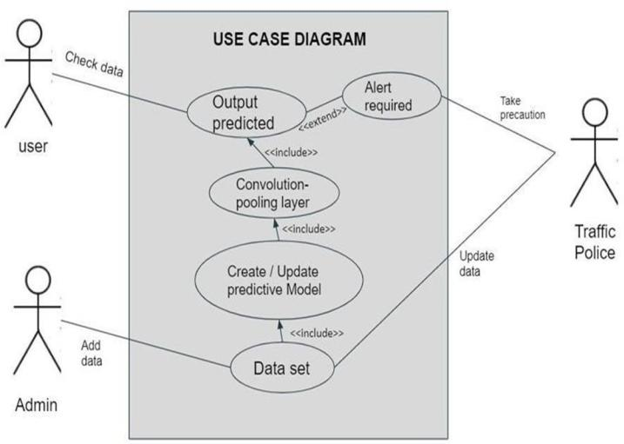

IV. PROPOSED METHODOLOGY

The model would be built utilising accident data records, which may aid in understanding the characteristics of a variety of elements such as driver behaviour, highway conditions, lighting conditions, and weather conditions, among others. This can assist users in calculating safety measures that are beneficial in preventing accidents. The model may be used to discover statistically significant characteristics that can be used to forecast the likelihood of collisions and injuries, as well as risk factors that can be utilised to minimise risk.

Road accident research is carried out by examining certain data and posing some pertinent questions. What is the most dangerous time to drive, and what percentages of accidents occur in rural, urban, and other areas? What is the annual trend in the number of accidents, and do incidents in locations with high-speed limits result in greater casualties etc.

A. Dataset

This Dataset contains many attributes such as Severity, Road Surface, Weather conditions, Light Conditions, location, Longitude, Latitude, Sex, Driver Age, Date, Time, day, etc

B. Model Training

Model is to be trained when a data scientist has pre-processed the acquired data and divided it into train and test groups. The procedure primarily works with the algorithm's training dataset. An algorithm will analyze data and produce a model that can locate a target value (attribute) in fresh data and provide the answer you're looking for via predictive analysis. Building a good machine learning model is the main focus of model training.

C. Model Evaluation & Testing

The main goal of evaluating and testing the model is to develop a simple form of the model which is able to formulate the target value fast and in an accurate form. Model tuning is the one through which data scientists can achieve this goal. The motive is to get better and more accurate performance measures for the algorithm by improving and enhancing the performance of the given model features.

©IJRASET: All Rights are Reserved | SJ Impact Factor 7.538 | ISRA Journal Impact Factor 7.894 | | 2
International Journal for Research in Applied Science & Engineering Technology (IJRASET)

ISSN: 2321-9653; IC Value: 45.98; SJ Impact Factor: 7.538

Volume 11 Issue II Feb 2023- Available at www.ijraset.com

- WORKFLOW
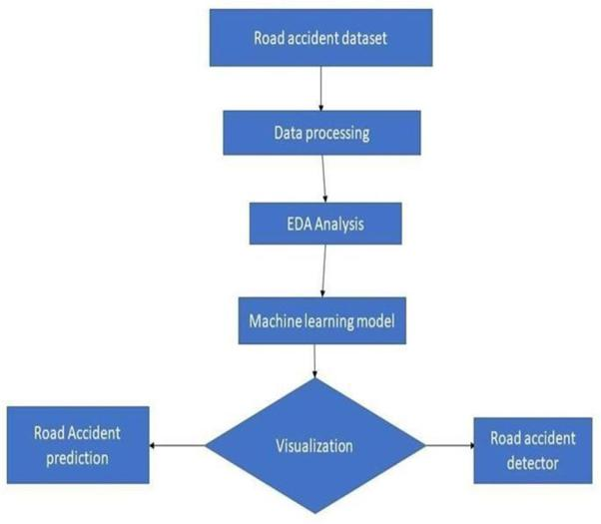

VI. ADVANTAGES

- Overcome the accident rate and save the lives of innocent people.

- Accurate traffic road accident severity prediction.

- Improving traffic safety management,

- To provide beneficial suggestions for improving road safety.

VII. CONCLUSION

This project aims at using Machine Learning classification techniques to predict the severity of an accident at any particular location. Machine Learning has enabled us to analyze meaningful data to provide solutions with greater accuracy than humans. This study will allow researchers to assess the severity of road accidents as well as the variables that contribute to them. Lighting conditions, for example, were found to have a significant impact on the severity of an accident. Traffic safety may be enhanced by improving factors such as illumination and conditions, which can lead to decreased incidence of road accidents.

Providing a database with such a diverse set of data, such as three levels of accident severity (mild, severe, and deadly), light conditions, and information on the police officers on the site, might be studied further to provide important insights and contribute to road safety. In future, we would try to increase our model’s accuracy and try to work with a hybrid model for getting more satisfactory results.

VIII. ACKNOWLEDGMENT

We hereby wish to take this opportunity to express our gratitude to our teachers and friends and all who have helped toward the completion of our project.

We take great honour in presenting this Project Report to our Director, Dr R. D. Kharadkar. We also like to give thanks to our Guide Dr.Jayashree Shinde for helping and guiding us throughout our endeavour.

We are very grateful to our teaching staff for guiding us all over the duration of the degree. They were very helpful to us, as and when we required their help. We are also very grateful to the non-teaching staff to help us in the laboratory in various ways.

REFERENCES

- Suganya, E. and S. Vijayarani. “Analysis of road accidents in India using data mining classification algorithms.” 978-1-5386-4031-9/17/ IEEE (2017).

- Mubariz Manzoor, Muhammad Umer. ”Traffic Accident Severity Prediction Based on Decision Level Fusion of Machine and Deep Learning Model ”https://creativecommons.org/licenses/by/4.0/ IEEE Access September 14, 2021.
- Prayag Tiwari, Sachin Kumar, Denis Kalitin (2017). “Road-User Specific Analysis of Traffic Accident Using Data Mining Techniques”. IEEE Xplore Part Number: CFP21K25-ART (ICCMC 2021).

- Kakoli Banerjee, Vikram Bali. ”Traffic Accident Risk Prediction Using Machine Learning” 978-0-7381-1405- 7/21/ IEEE (2022).

- K. Crammer, M. Kearns, and J. Wortman.Learningfrom multiple sources.JMLR, 2008

©IJRASET: All Rights are Reserved | SJ Impact Factor 7.538 | ISRA Journal Impact Factor 7.894 | | 3
International Journal for Research in Applied Science & Engineering Technology (IJRASET)

ISSN: 2321-9653; IC Value: 45.98; SJ Impact Factor: 7.538

Volume 11 Issue II Feb 2023- Available at www.ijraset.com

- ] R. Collobert, F. Sinz, J. Weston, and Bottou.Largescaletransductivesvms.JMLR, 2006

- A data mining approach to characterize road accident locations”, Sachin Kumar, Durga Toshniwal.

- Road traffic accidents prediction modelling: An analysis of Anambra State, Nigeria” Chukwutoo C. Ihueze, Uchendu O. Onwurah, Department of Industrial and Production.Engineering, Nnamdi Azikiwe University,

- Awka, Nigeria

- An Integrated Approach for Weather Forecasting based on Data Mining and Forecasting Analysis”, G. Vamsi Krishna Research scholar, Department of CSE, GITAM University.

©IJRASET: All Rights are Reserved | SJ Impact Factor 7.538 | ISRA Journal Impact Factor 7.894 | | 4



