SQL QUERIES & RESULT

--Total Revanue

SELECT SUM(total_price) AS Total_Revanue

FROM pizza_sales

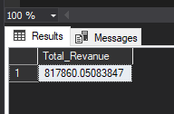

--Av. amount spent per order

SELECT SUM(total_price)/COUNT(DISTINCT(order_id)) AS Avg_order_value

FROM pizza_sales

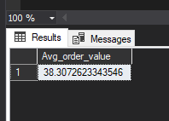

--Total pizza sold

SELECT SUM(quantity) AS Total_Pizza_Sold

FROM pizza_sales

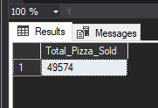

--Total number of orders

SELECT COUNT(DISTINCT(order_id)) AS Total_orders

FROM pizza_sales

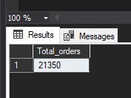

--Avg Pizza per order

SELECT CAST(CAST(SUM(quantity) AS DECIMAL(10,2))/

CAST(COUNT(DISTINCT(order_id)) AS DECIMAL(10,2)) AS DECIMAL(10,2))

AS Avg_pizza_per_order

FROM pizza_sales

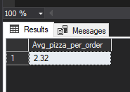

--Daily trends of total order

SELECT DATENAME(DW,order_date) AS DAY, COUNT(DISTINCT(order_id)) AS total_order

FROM pizza_sales

GROUP BY DATENAME(DW,order_date)

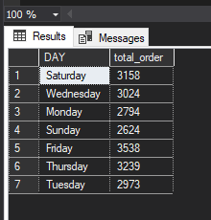

--Monthly trends of Orders

SELECT DATENAME(MONTH,order_date) AS month, COUNT(DISTINCT(order_id)) AS total_order

FROM pizza_sales

GROUP BY DATENAME(MONTH,order_date)

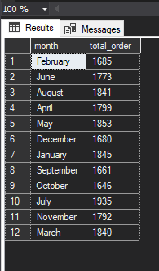

--Percentage of sales by pizza category

SELECT pizza_category,

SUM(total_price)*100/(SELECT SUM(total_price) FROM pizza_sales)

AS percent_sales

FROM pizza_sales

GROUP BY pizza_category

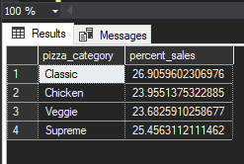

--Percentage of sales by pizza size

SELECT pizza_size,

CAST(SUM(total_price)*100/(SELECT SUM(total_price) FROM pizza_sales)

AS DECIMAL(10,2))

AS percent_sales

FROM pizza_sales

GROUP BY pizza_size

ORDER BY percent_sales

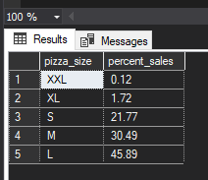

--Total pizza sold by pizza category

SELECT pizza_category, SUM(quantity) AS total_quantity

FROM pizza_sales

GROUP BY pizza_category

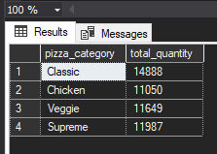

--Top 5 Best Sellers by Revenue

SELECT TOP 5 pizza_name as Top_5_Pizza, SUM(total_price) AS Total_Revenue

FROM pizza_sales

GROUP BY pizza_name

ORDER BY Total_revenue DESC

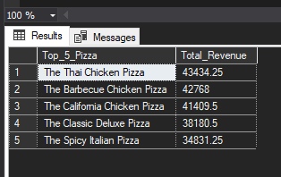

--Bottom 5 Worst Sellers by Revenue

SELECT TOP 5 pizza_name as Bottom_5_Pizza, SUM(total_price) AS Total_Revenue

FROM pizza_sales

GROUP BY pizza_name

ORDER BY Total_revenue ASC

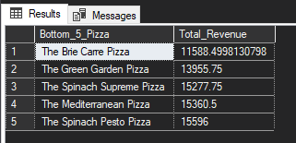

--Top 5 Best Sellers by Total Quantity

SELECT TOP 5 pizza_name as Top_5_Pizza, SUM(quantity) AS Total_quantity

FROM pizza_sales

GROUP BY pizza_name

ORDER BY Total_quantity DESC

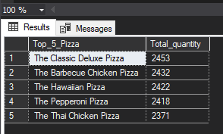

--Bottom 5 Worst Sellers by Total Quantity

SELECT TOP 5 pizza_name as Bottom_5_Pizza, SUM(quantity) AS Total_quantity

FROM pizza_sales

GROUP BY pizza_name

ORDER BY Total_quantity ASC

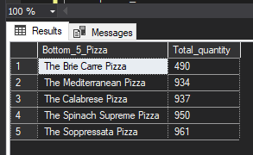

--Top 5 Best Sellers by Total Orders

SELECT TOP 5 pizza_name as Top_5_Pizza, COUNT(DISTINCT(order_id)) AS Total_Order

FROM pizza_sales

GROUP BY pizza_name

ORDER BY Total_Order DESC

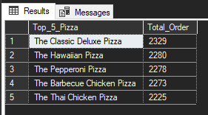

--Bottom 5 Worst Sellers by Total Orders

SELECT TOP 5 pizza_name as Top_5_Pizza, COUNT(DISTINCT(order_id)) AS Total_Order

FROM pizza_sales

GROUP BY pizza_name

ORDER BY Total_Order ASC

