

**School of Computer Science and Engineering**

**J-Component Report**

**Programme:** B-Tech CSE Core

**Course Title:** Image Processing

**Course Code:** CSE4019

**Slot:** C2+TC2

**Project Title:** Malaria Parasite Classification using Deep Learning

**Team Members:** Tanvi Shrikhande | 20BCE1710

Harsh Chauhan | 20BCE1886

**Faculty:** Dr. Vedhapriyavadhana R **Date:** 29 April 2023

**Contents**

Abstract 3

Introduction 3

Proposed Model 5

1. Data Augmentation and Preprocessing 6
   1. Gaussian Blur 6
   2. Histogram Equalization 6
   3. Sharpening Filter 7
2. ImageDataGenerator and generator flow 7
3. Model Training 7
   1. VGG-19 8
   2. CNN 8
4. Visualization 8
5. Literature Survey 11
6. Results and Discussion 24
7. Conclusion 27
8. References 27

ABSTRACT

Malaria is the deadliest disease on the earth and big hectic work for the health department. The traditional way of diagnosing malaria is by schematic examining blood smears of human beings for parasite-infected red blood cells under the microscope by lab or qualified technicians. This process is inefficient and the diagnosis depends on the experience and well knowledgeable person needed for the examination. Conventional microscopy, which is currently “the gold standard” for malaria diagnosis has occasionally proved inefficient since it is time consuming and results are difficult to reproduce. As it poses a serious global health problem, automation of the evaluation process is of high importance. In this work, an accurate, rapid and affordable model of malaria diagnosis using stained thin blood smear images was developed. The method used made use of the intensity features of Plasmodium parasites and erythrocytes. Images of infected and non-infected erythrocytes were acquired, pre-processed, relevant features extracted from them and eventually diagnosis was made based on the features extracted from the images. A sequential model is built using TensorFlow and Keras, consisting of convolutional layers, max-pooling layers, dropout layers, and dense layers with rectified linear unit (ReLU) activation function. The models CNN and VGG-19 are trained on the pre-processed dataset with binary cross-entropy loss function and Adam optimizer for 50 epochs. This project showcases the potential of using image processing and machine learning techniques for malaria detection from digital images of blood smears. It provides a comprehensive code implementation using TensorFlow and Keras, along with various image processing techniques that can be used for malaria diagnosis and treatment.

INTRODUCTION

Malaria is a potentially fatal illness that impacts millions of individuals globally. Appropriate treatment and management of malaria depend on early and precise recognition of the illness. The detection of parasites in blood smears is the basis for traditional malaria diagnosis techniques, which can be laborious and need specialised staff. Researchers have been investigating the application of image processing methods for malaria detection in recent years. The goal of this project is to use machine learning algorithms and image processing techniques to identify malaria. The dataset is provided by the National Library of Medicine which consists of two wide classifications of Malaria on the bases of blood smears: Thick and Thin blood smear. Within Thick smears there are three classifications: Falciparum and Vivax both being the parasites and the third classification is uninfected. Within Thin blood smears Falciparum and uninfected are classified as one and Vivax is classified as the other class label. Thick and thin blood smears are two common laboratory techniques used for the diagnosis of malaria; a parasitic disease caused by Plasmodium species. These smears are prepared from a patient's blood sample and examined under a microscope to detect the presence of malaria parasites. A thick smear is made with a concentrated drop of blood, providing better detection of parasites, especially at low concentrations due to its greater thickness, and is lightly stained. In contrast, a thin smear involves spreading a smaller blood drop evenly on a slide and using a specialized stain like Giemsa for enhanced contrast, aiding in identifying Plasmodium species and quantifying parasitaemia levels. Plasmodium falciparum and Plasmodium vivax, two common species of the malaria-causing Plasmodium parasite, exhibit distinct visual differences in thick and thin blood smears. Plasmodium falciparum often presents smaller and more uniform ring-stage parasites in both smear types, while Plasmodium vivax displays larger and more irregularly shaped ring-stage parasites. Additionally, Plasmodium falciparum schizonts typically contain more merozoites, making them more conspicuous in thin smears, and may show a higher abundance of hemozoin pigment, resulting in a darker appearance in the infected red blood cells. To further aid in the accurate identification and differentiation of these species, image processing techniques can play a crucial role. These techniques can enhance contrast, extract features such as size and shape, employ pattern recognition and machine learning to classify species, and automate the quantification of parasitaemia in thin smears. By harnessing the power of image processing, healthcare professionals can achieve more accurate and efficient malaria diagnosis and treatment. Utilizing this knowledge we proceeded with our project by carrying out the methodology which is explained briefly in this section.

The Keras ImageDataGenerator class was used to preprocess and enhance the photographs. Two deep learning models which were: Convolutional Neural Network (CNN) model and VGG-19 model were then developed and trained on the pre-processed dataset to classify the cells as infected or uninfected. These models were then used to predict the class of a new image, which was pre-processed in the same way as the training data. In addition to classification, image processing techniques such as histogram equalization, Gaussian filtering, and Laplacian filtering were applied to the images to aid in the detection of malaria. These techniques can be used to enhance the contrast of the images, isolate the infected cells, and generate segmentation masks. The use of image processing techniques and machine learning algorithms shows promise for the accurate and efficient detection of malaria. This approach has the potential to complement traditional diagnostic methods and provide a valuable tool for the control and management of malaria.

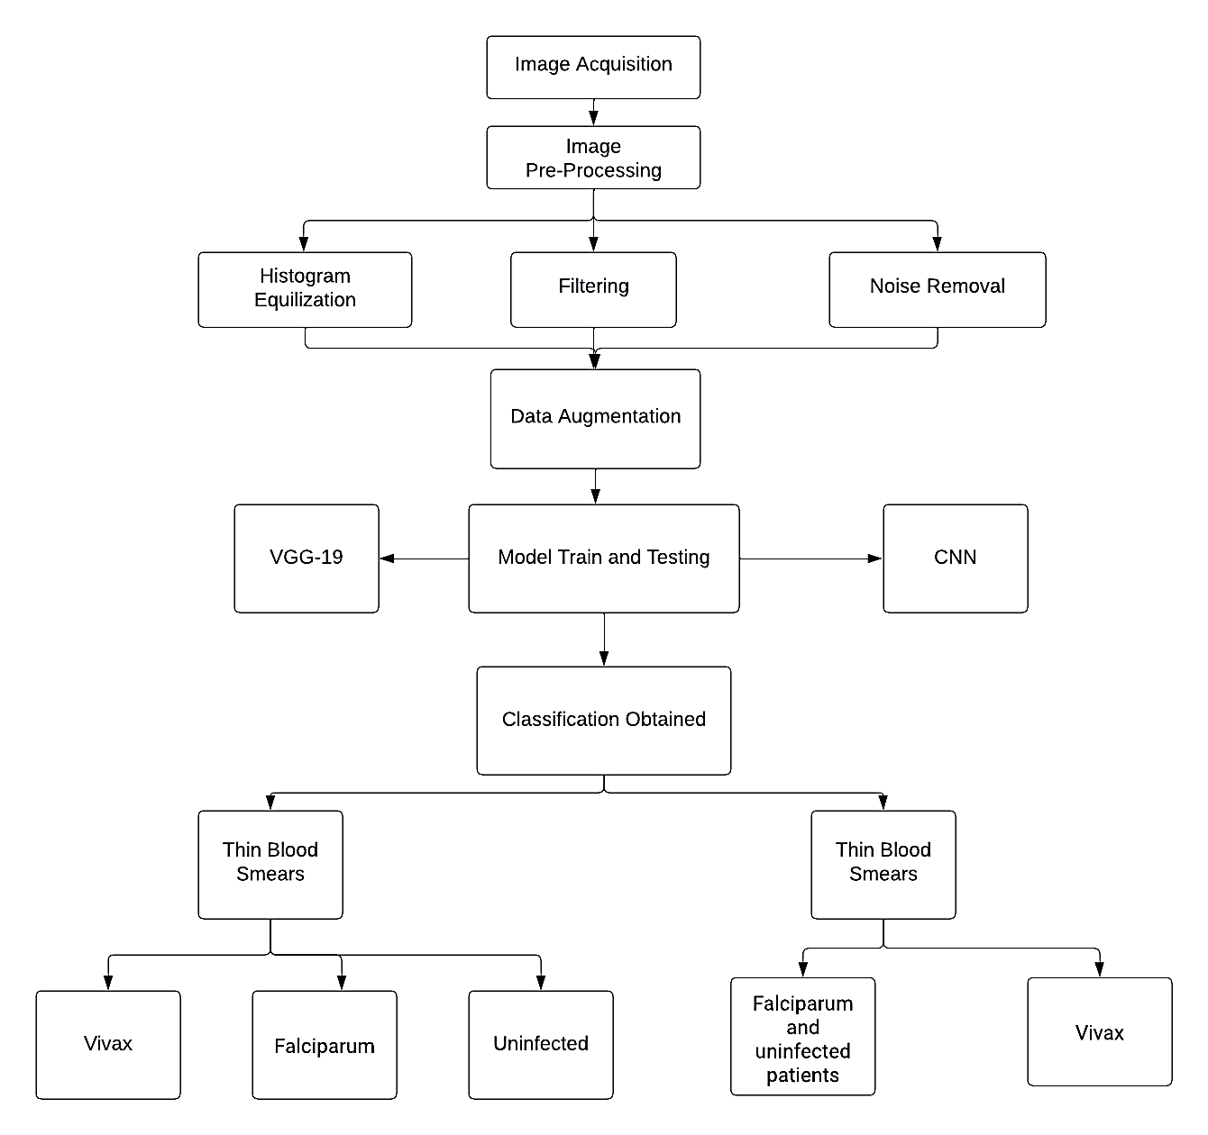PROPOSED MODEL

In this section, we explain the methods used in this experiment. The implementation consists of various tasks related to image classification, data preprocessing, model training, model evaluation, and image processing. The models trained for the purpose of image classification are : CNN and VGG-19. Each of the stages are explained below:

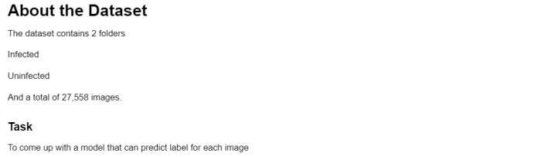

1. Data Augmentation and Pre-Processing

User defined functions are created for performing image processing operations and for resizing images for the project. These images are in two categories: Uninfected and Parasitized. Firstly, the images are pre-processed by using the OpenCV library. Gaussian blur is used to remove noise from the image and they are turned into grey scale for better processing and visual knowledge. Histogram Equalization is used to enhance the contrast of the grayscale images and they are sharpened to highlight features.

* 1. Gaussian Blur

Gaussian blur is an image processing technique used to reduce noise and smooth images. In the project, it's applied during preprocessing to minimize high-frequency noise by averaging pixel values around each pixel, emphasizing the central pixel. By removing fine details and noise, Gaussian blur enhances image quality, making it easier for subsequent steps to focus on vital cell features. The application of Gaussian blur in malaria classification is crucial for improving accuracy and reliability by reducing noise and artifacts in blood cell images. This noise reduction results in cleaner images, enhancing feature extraction and enabling the models to focus on important, larger-scale cell characteristics. Furthermore, it leads to improved model generalization, reducing overfitting and enhancing performance on new, unseen images. Gaussian blur's noise reduction and smoothing effect provide a noise-free image foundation for machine learning models, contributing to the overall success of malaria classification.

* 1. Histogram Equalization

Histogram equalization is an image processing technique used to enhance the contrast and overall visibility of details in an image. It works by redistributing the intensity values of an image's pixels to cover the entire available range. This process can help bring out fine details in both dark and light regions of the image, making it particularly useful when dealing with images that have uneven lighting or limited contrast. Histogram equalization contributes to improved image quality, making it easier to identify and analyse features within the image, which is valuable in various image processing and computer vision applications. Histogram equalization enhances image contrast and feature visibility, which is crucial in malaria classification. By addressing uneven lighting and low contrast issues in blood cell images, it ensures that staining patterns and cell texture variations are discernible. This improvement aids machine learning models in accurately distinguishing between infected and uninfected cells, ultimately contributing to more reliable malaria classification results.

* 1. Sharpening Filtering

Sharpening filtering is an image processing method that accentuates edges and fine details by enhancing rapid changes in pixel intensity. This technique is valuable for highlighting subtle image features, improving local contrast, and aiding in precise feature recognition, such as identifying specific characteristics in malaria-infected blood cell images. Sharpening filters are beneficial in malaria classification as they enhance the visibility of critical features within blood cell images. By accentuating edges and fine details, these filters make it easier for machine learning models to recognize specific characteristics of infected and uninfected cells, like staining patterns and cell morphology. This heightened feature visibility aids in accurate classification and improves the models' ability to distinguish between the two categories, ultimately contributing to more reliable results in malaria diagnosis.

User defined function is used to get images from both before and after preprocessing methods. This is done for visual comparison between the two and this also proves how image processing helps in classification. This data was then used to train machine learning models for image classification tasks, such as distinguishing between infected and uninfected blood cells in the context of malaria diagnosis.

1. ImageDataGenerator and generator flow

It is used to create data generators for both the training and testing datasets. These generators apply various transformations and augmentations to the image data to improve model generalization and performance. Two generators are used one for train data and one for test data with parameters such as rescale, zoom_range, horizontal_flip and rotation_range.

After configuring the data generators, the flow method is used to generate batches of preprocessed and augmented data. For the training data generator, it takes the training features X_train and labels y_train and specifies a batch size of 64. The purpose of using data generators is to efficiently feed batches of data to the neural network during training and testing, making it possible to work with large datasets without loading all data into memory at once. Data augmentation techniques applied during training can help improve the model's ability to generalize and perform well on new, unseen data.

1. Model Training and Testing

The dataset is divided in testing and training data and we have chosen two models for this implementation which are CNN and VGG-19. Convolutional Neural Networks (CNNs) and the VGG-19 architecture are particularly well-suited for the task of differentiating Plasmodium falciparum and Plasmodium vivax in malaria-infected blood smears. These neural networks excel at automatically extracting relevant features from images, which is critical in identifying the distinct visual characteristics of different Plasmodium species. The VGG-19 model, in particular, is advantageous due to its pre-trained nature, having already learned a wide array of features from a vast dataset. This facilitates fine-tuning for the specific task of species classification, even when the dataset available for training is relatively small. Moreover, CNNs and VGG-19 create a hierarchical representation of features, enabling them to recognize complex patterns and details in the blood smear images as they progress through the network's layers. Their high accuracy, scalability to handle large datasets, and adaptability to real-world clinical variations make them powerful tools for achieving precise and reliable malaria species classification.

* 1. Visual Geometry Group 19

VGG19, or Visual Geometry Group 19, is a deep convolutional neural network (CNN) architecture renowned for its exceptional performance in image recognition and computer vision tasks. Featuring 19 layers, including 16 convolutional and 3 fully connected layers, VGG19 is celebrated for its uniform structure, employing 3x3 convolutional filters consistently. It is often used with pre-trained weights, making it a powerful tool for transfer learning in which it adapts its learned features from large image datasets.

* 1. Convolutional Neural Network

A Convolutional Neural Network (CNN) is a specialized deep learning model for visual data processing, especially images and videos. CNNs employ convolutional layers to automatically extract features like edges and textures. As data passes through the network, pooling layers down-sample it, and fully connected layers perform classification. Weight sharing ensures uniform feature recognition across the input. CNNs offer hierarchical feature learning, translational invariance, and convolution and pooling operations, enabling object recognition regardless of location. They have revolutionized computer vision, with applications spanning image recognition, object detection, and more.

1. Visualization

For viewing results the training and validation accuracy and loss is printed. Training accuracy is a metric used during the training of a machine learning model, such as a neural network. It measures the proportion of correctly classified examples in the training dataset. Training loss, on the other hand, is a measure of the error or how well the model's predictions match the actual target values in the training dataset. It represents the difference between the predicted values and the true values, with the goal of minimizing this loss during training.

Validation accuracy is a metric used to assess a model's performance on a separate dataset not seen during training, known as the validation dataset. It measures the proportion of correctly classified examples in the validation dataset and is a valuable indicator of how well the model generalizes to new, unseen data. Validation loss is similar to training loss but is computed on the validation dataset. It provides an estimate of how well the model's predictions align with the true values in the validation data. Monitoring validation loss helps to prevent overfitting, where the model performs well on the training data but poorly on new data. Visualizations are invaluable when selecting the best model from various alternatives, tuning hyperparameters, and communicating findings within a team. They provide a shared language for assessing model performance and offer insights into the model's learning behaviour, facilitating optimization and enhanced generalization to real-world scenarios.

In the below graphs the x axis denote the number of epochs and the y axis denote the accuracy percentage.

VGG-19:

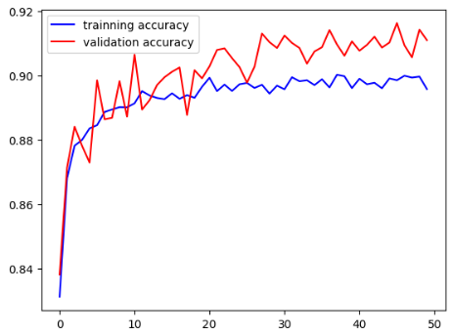

Inference: Accuracy increasing with each epoch and streamlining around 85% meaning the proportion of correctly classified labels are increasing as model is being further trained

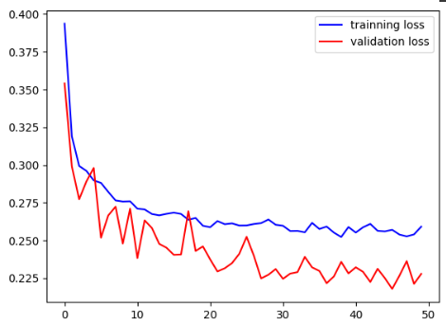

Inference: Loss decreasing with each epoch meaning the difference between the model prediction and the actual target value is decreasing with each epoch as the model is being further trained.

CNN:

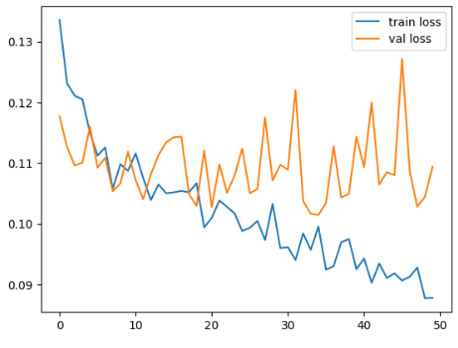

Inference: The validation loss has a volatile nature for CNN model

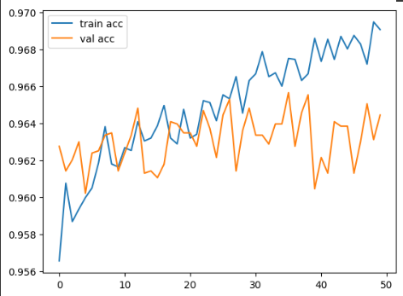

Inference: Accuracy increasing with each epoch meaning the proportion of correctly classified labels are increasing as model is being further trained.

LITERATURE REVIEW

1. A comparative analysis of deep learning architectures on high variation malaria parasite classification dataset.

The paper addresses the pressing issue of malaria diagnosis in underdeveloped regions. It introduces a unique approach, converting a malaria parasite object detection dataset into a classification dataset, creating the largest dataset of its kind with 63,645 cells. The dataset BBBC041v1 comprises 1364 microscopic images of Plasmodium falciparum and Plasmodium vivax infected samples, with bounding box annotations. It's categorized into uninfected (RBC) and infected (gametocytes, rings, trophozoites, schizonts) classes, with a significant class imbalance. Color constancy was used for preprocessing, and DCNN models like VGG-16, VGG-19, ResNet50, and Xception were employed for classification. Transfer learning from the NIH Malaria dataset was conducted. To address class imbalance, conditional image synthesis with CycleGAN was applied. Evaluation metrics included F1-score, accuracy, sensitivity, specificity, PPV, and NPV. Independent testing on the MP-IDB dataset validated the models' generalization.

In conclusion, this study successfully converts an object detection dataset for malaria into a binarized classification dataset while testing the effectiveness of different Deep Convolutional Neural Networks (DCNNs). It investigates transfer learning using real-world and medical imagery, pointing out a modest performance boost from pretraining in the medical sector. Interestingly, the accuracy, F1-score, and PPV increase from 97.05% to 98.28%, 88.36% to 92.51%, and 66.13% to 78.45% respectively.

1. Deep learning for smartphone-based malaria parasite detection in thick blood smears.

In this study, the authors explored the potential of smartphones as a tool for malaria detection—a significant global health challenge. They introduced a two-phase deep learning approach for analyzing malaria parasites in thick blood smear images. Initially, the Iterative Global Minimum Screening (IGMS) method is used to swiftly scan images, highlighting potential parasite regions. Subsequently, a specialized Convolutional Neural Network (CNN) assesses these regions, differentiating between parasites and background elements. This study makes a noteworthy approach of applying deep learning to detect parasites via smartphones, especially when evaluated at a patient-specific level. This study utilizes a dataset of over 1800 images from 150 patients. The methodology of this research includes 3 main stages: Parasite Candidate Screening which includes WBC detection and Parasite Preselection using IGMS, Parasite Classification and lastly the Smartphone-Based Application. The scores of ResNet50, VGG19, AlexNet, and the customized CNN are recorded and the performance of each architecture combined with IGMS is recorded in separate tables respectively. The future ambitions of this research include refining their detection method's performance and enhancing its operational speed on smartphones. In essence, this research bridges the gap between technology and healthcare, offering an innovative solution in the fight against malaria.

1. Malaria detection using deep residual networks with mobile microscopy.

The paragraph discusses the challenge of automatically segmenting erythrocytes in microscopic blood smear phone images to identify malaria using machine learning. To address this, the authors propose a multi-magnification deep residual neural network (MM-ResNet) that classifies images as infected or non-infected at multiple magnifications. Their approach outperforms baseline architectures in terms of accuracy and is the first application of MM-ResNet for malaria-infected erythrocyte identification in these images. The MM-ResNet is a modified ensemble of individual ResNets designed for classifying blood smear images, particularly challenging due to limited training data and varying image quality. Smartphone-captured images of erythrocytes differ significantly from high-end microscope images, making it necessary for MM-ResNet to recognize and classify them based on faded shape, color, and texture cues. Smartphone datasets offer potential for malaria detection in remote areas, with low-cost and transformable blood smear slides. However, the low-quality smartphone images with luminance variations, smudged textures, and edge variations make classification difficult. MM-ResNet addresses these challenges and shows promising results using residual units. The framework utilizes batch normalization and individual residual units to address issues like vanishing gradients and image degradation, resulting in a reliable

classification of infected and non-infected samples with an average accuracy of 98.08%. These results demonstrate the effectiveness of MM-ResNet compared to other existing methods.

1. A new approach for microscopic diagnosis of malaria parasites in thick blood smears using pre-trained deep learning models.

Malaria poses a significant health challenge in sub-Saharan Africa due to a shortage of expertise in accurately diagnosing the disease using traditional microscopy methods. This study investigates the use of advanced deep learning models, namely Faster R-CNN, SSD, and RetinaNet, to detect malaria in a dataset of thick blood smear images. Among these models, Faster R-CNN achieved the highest accuracy, while SSD demonstrated potential for deployment on mobile devices. These results suggest that Faster R-CNN excels in accuracy, while SSD is well-suited for mobile applications in malaria detection. The data collection and preprocessing involved gathering suitable data and preparing it for training. However, due to limited memory resources, a batch size of 1 was used for training the machine learning models. Evaluation metrics such as COCO metrics, mean average precision, precision, and recall were employed to assess the performance of object detection and the algorithm's ability to predict the presence of parasites in images. Faster R-CNN with ResNet101 as the backbone performed the best, achieving a mean average precision score of 94.5%. Additionally, models like SSD MobileNet show promise as they offer scalability and can be deployed on devices with limited computational power, such as mobile smartphones, while still maintaining a reasonable level of accuracy and reliability for end-users in real-time environments.

1. Counting and Classification of Malarial Parasite From Giemsa-Stained Thin Film Images.

Malaria diagnosis, historically rooted in the manual microscopy of Giemsa-stained infected cells, has faced challenges due to equipment and expertise limitations, especially in resource-constrained settings. These traditional methods, while cost-effective, can be unreliable due to their dependence on human proficiency, thus leading to potential inaccuracies. This research pivots towards a more technologically advanced approach, harnessing the capabilities of computer vision and machine learning. By integrating these techniques, the study aims to automate the identification and classification of both healthy and malaria-infected red blood cells, showcasing promising results with an accuracy rate of 96.18%. This is achieved by WELM in conjunction with deep-learned (AlexNet_FC7) and the hand-crafted (color) features.The process of this research is: Morphological image processing and Hough transform were used as image pre-processing techniques. Morphological image processing techniques were used to clean noises and reconstruct object structures. Hough transform technique was used to segment RBC objects. Transfer learning technique and Weighted Similarity Extreme Learning Machine are used to perform deep feature extraction and classify the RBCs. By juxtaposing user-defined image features with deep-learned attributes, the study underscores the potential of modern methodologies to revolutionize malaria diagnostics. In conclusion, the embrace of these advanced techniques heralds a significant leap forward, offering a more reliable and efficient means of detecting and managing this pervasive disease.

1. Explainable anatomical shape analysis through deep hierarchical generative models.

In the study conducted by Biffi et al., the authors address the critical aspect of anatomical shape analysis in medical images to derive insights into disease manifestations. The research acknowledges the advancements in medical image analysis, especially with the advent of extensive population-based datasets and the growth of automated segmentation tools. However, it also emphasizes the limitations of current methodologies in capturing subtle pathological remodeling in organs, which can be essential markers for various diseases. Even with sophisticated tools like MR imaging, the granularity needed to discern these intricate changes often goes unnoticed. While deep learning has made significant strides in medical image analysis, its "black box" nature poses challenges in clinical interpretability. The proposed approach in the paper seeks to amalgamate precision with explainability. By developing a deep learning framework that not only identifies diseases but also provides insights into its decision-making process, the research aims to bridge a significant gap in the field of medical imaging. In order to achieve this: Variable Autoencoder(VAE), Ladder Variational Autoencoder(LVAE) and a slight modification of LVAE known as LVAE for Interpretable Shape Analysis are used. This study is carried out on two datasets: Cardiac and Brain dataset. Compared to the VAE+MLP model, the LVAE+MLP model achieves higher reconstruction accuracy in terms of 3D Dice score and 2D slice-by-slice Hausdorff distance between the original segmentations and the reconstructed ones

1. Unsupervised deep learning cad scheme for the detection of malaria in blood smear microscopic images.

The paper introduces a computer-aided diagnosis (CAD) method for detecting malaria parasites in thick blood smear images. With the backdrop of recent progress in deep learning and the availability of unlabelled medical data, this study harness these tools for the timely detection of malaria to ensure early and effective treatment. The CAD system's design incorporates a functional link artificial neural network followed by a sparse stacked autoencoder, resulting in a deep architecture. Specifically, its structure has five layers, starting with 12,500 nodes at the input and culminating in a 2-node Softmax classifier output layer. When subjected to 10-fold cross-validation, the system demonstrated its reliability, suggesting it can effectively classify new, unseen blood smear images. When tested on a dataset of malaria blood smear images, the CAD system achieved a detection accuracy of 89.10%, a sensitivity of 93.90%, and a specificity of 83.10%. The results not only confirm the system's effectiveness but also show its superior performance compared to other deep learning techniques in the same domain. In essence, this work presents a promising and expedient approach for disease detection, potentially providing valuable support in clinical settings.

1. Advances Towards Automatic Detection and Classification of Parasites Microscopic

Images Using Deep Convolutional Neural Network: Methods, Models and Research

Directions.

This review explores the potential of deep learning, particularly Convolutional Neural Networks (CNNs) and digital slide scanning, to automate parasite detection and classification. It summarizes 70 selected research papers, spanning from traditional machine learning to deep learning methods over the past decade, offering insights, limitations, and future directions for improving parasite detection and classification in clinical settings. The research systematically explores the methods and models employed in recent research within this domain, highlighting the advancements made in leveraging CNNs for precise parasite detection. It also provides insights into future research directions, shedding light on the potential for further improvements and innovations in the field of automated parasite detection, which holds significant promise for enhancing diagnostic accuracy and healthcare outcomes. This paper also overviews upon basics of Deep Learning, CNN and the layers of a CNN along with giving a brief explanation of evaluation metrics such as precision, recall, sensitivity, f1-score etc. Models which were compared were: AlexNet, VGG, GoogLeNet, Inception-V3, Inception-V4, ResNet, Inception-ResNet-v2, Xception, DenseNet, MobileNet-v2, HRNetV2 etc. t. Results show that the proposed model yields classification accuracy up to 98.4%

1. Deep Learning for Real-Time Malaria Parasite Detection and Counting Using YOLO-mp.

The research highlights the significant public health challenge posed by malaria in rural and remote tropical regions. Timely and accurate diagnosis, along with prompt treatment, is essential to effectively manage malaria and reduce mortality. Currently, Rapid Diagnostic Tests (RDTs) are commonly used alongside microscopy but RDT has accuracy issues and the impracticality of microscopy in remote areas due to limited expertise and lengthy diagnostic processes hinder disease diagnosis and treatment, increasing the risk of severe malaria and mortality. Leveraging deep learning-based methods, which have demonstrated human-level performance in image-based object detection and classification, offers a solution for automating the assessment of a large number of microscope images of blood samples. The paper introduces a novel approach to enhance deep learning model performance in detecting pathogens in thick blood smear microscope images by ensuring consistent labeling of ground truth. Regarding the methodology of their research, the review provides an overview of deep learning techniques and their applications in image-based object detection and classification. It may discuss the use of YOLO-mp (a custom deep learning architecture) for malaria parasite detection, explaining its advantages over standard models. On a publicly available dataset of thick blood smear microscope images taken with a phone camera, the custom three-layered YOLO-mp-3l and four-layered YOLO-mp-4l models outperformed standard YOLOv4 (mAP 92.56 @IoU=0.5) for detection of the malaria pathogen. Both the YOLO-mp-3l and the YOLO-mp-4l surpassed the regular YOLOv4 (BFLOPs=127.232, model sizte=244Mb) in terms of compute and memory needs, demonstrating their suitability for use on low resource devices.

1. Benchmarking of deep architectures for segmentation of medical images.

Segmentation of medical images is an important task frequently preceding other image analysis tasks like detection and assessment of abnormalities e.g. tumors or lesions. The research aims to impartially assess the performance of the U-Net architecture and five of its extensions(UNet++, ResUNet, CPFNet, CS2-Net, UNet 3+) across various medical imaging datasets, ensuring uniform conditions in training and evaluation. Results show that these architecture modifications do not enhance inference quality compared to the basic U-Net, despite increasing resource requirements. Key evaluation metrics include Dice coefficient, surface Dice coefficient, average surface distance, Hausdorff distance, training, and prediction time. This research paper gives an in depth description regarding the 9 medical datasets upon which the 6 deep architectures were trained and the description of each architecture is also described. These 9 datasets were labeled as tasks and a graph was plotted for each architecture performance. There was no conclusive evidence of one model outperforming the other. In certain tasks some architectures performed better than others. In this study, the six selected architectures were fairly compared using the unified nnU-Net framework, ensuring that the final outcomes depended only on architectural detail and not on other elements such as data preprocessing, data split into training and testing sets, or training strategy.

1. Artificial intelligence-based tools applied to pathological diagnosis of microbiological diseases.

This study conducts a comprehensive review of AI applications in pathology microbiology, analyzing a substantial dataset of 4596 articles and ultimately focusing on 110 relevant studies. The research underscores the efficacy of AI in the detection of various microorganisms, with malaria, bacteria, nematodes, and other protozoa being the prominent targets. Notably, 86% of the examined materials were cytological in nature, and image data acquisition predominantly involved microscope cameras (59%) and smartphones (15%). Deep learning techniques were employed to analyze these digital images, consistently yielding highly satisfactory outcomes. The majority of studies (54 papers, 8693 patients) focused on Plasmodium species causing malaria, followed by bacteria (28 papers, 7141 patients), metazoa (14 works, 1940 patients), other protozoa (11 publications, 1672 patients), and viruses/fungi (10 studies, 5506 patients). Among the patient materials, 86% examined cytopathology/hematology specimens, primarily peripheral blood smears (55 articles). Most studies utilized static images from microscopes with cameras (65 papers) or smartphones coupled with microscopes (16 studies). Around 43% used Convolutional Neural Networks (CNNs) for image analysis, while the remaining employed different machine learning algorithms. Conventional light microscopy (LM) served as the gold standard in 88% of cases, with microbiological tests (culture and PCR) in 7 and 9 articles, respectively. Internal datasets were favored for AI algorithm validation (85%) over external datasets (16 studies). These AI-based techniques have started to show their potential to assist in reducing the threat posed by known and new infectious illnesses, together with increased availability of reference datasets and reasonably priced portable devices. Countries with low resources would particularly benefit from widespread adoption of AI-based systems because they have the highest disease load and the greatest lack of equipment and experienced laborers.

1. Malaria parasite detection using deep learning algorithms based on (CNNs) technique.

In the fight against malaria, a life-threatening disease transmitted by female Anopheles mosquitoes, we introduce a novel approach using deep Convolutional Neural Networks (CNNs). We focus on improving the accuracy of malaria diagnosis by analyzing patches extracted from microscopic images of red blood cell smears. To overcome the limitations of small datasets, we employ transfer learning with three pre-trained CNN models: VGG19, ResNet50, and MobileNetV2. Transfer learning allows us to leverage visual features learned from larger datasets to enhance the performance on smaller, malaria-specific datasets. Our experimental evaluation, conducted on the National Institute of Health (NIH) Malaria Dataset, demonstrates the effectiveness of our approach, achieving an impressive accuracy rate of nearly 100% in the detection and classification of malaria parasites. This breakthrough has significant implications for more accurate and timely malaria diagnosis. The proposed methodology comprises three key stages: Data preprocessing, feature extraction, and classification. Data preprocessing plays a pivotal role in enhancing image quality by mitigating various noise sources, including camera angle and microscope position. Multiple noise reduction techniques are applied to clean up the images. For efficient malaria detection, this study leverages three distinct CNN models. Firstly, VGG-19 is utilized, characterized by 5 convolutional layers, 5 max-pooling layers, and 2 fully connected layers for processing 50 × 50 × 3-dimensional input images.The second model, ResNet-50, features convolution blocks and identity blocks in each stage, with three convolution layers in each identity or convolution block.The third model, MobileNetV2, is based on an inverted residual structure with quick access links between thin slowing layers. The outcomes show that scaling, normalization, stain standardization, and other preprocessing methods have very little impact on the model's ability to perform on VGG-19, ResNet-50, and MobilenetV2. On the same, the data augmentation technique has shown promising outcomes.The proposed system models achieved high-performance indicators such as sensitivity (100%), specificity (100%), precision (100%), and F1 score (100%) compared to underlying techniques.

1. A new ensemble learning approach to detect malaria from microscopic red blood cell images.

Currently, the detection process relies on professional microscopists, which can be time-consuming and yield suboptimal results for large-scale diagnoses. To tackle this challenge, the study presents an innovative ensemble learning-based deep learning model for malaria parasite identification in red blood cell images. The model utilizes three retrained deep learning architectures: VGG16, VGG19, and DenseNet201, forming adaptive weighted average ensemble models. To enhance prediction consistency, a max voting ensemble technique is combined with these adaptive weighted average models. Additionally, various image processing techniques, including data augmentation, are applied to augment the dataset and mitigate overfitting issues.The model utilizes three retrained deep learning architectures: VGG16, VGG19, and DenseNet201, forming adaptive weighted average ensemble models. To enhance prediction consistency, a max voting ensemble technique is combined with these adaptive weighted average models. Additionally, various image processing techniques, including data augmentation, are applied to augment the dataset and mitigate overfitting issues.

1. Deep learning enabled multi-wavelength spatial coherence microscope for the classification of malaria-infected stages with limited labeled data size.

This paper addresses the critical need for early and efficient detection of malaria, a life-threatening mosquito-borne disease. The conventional Giemsa-stained blood smear test requires highly skilled technicians, making automated classifications of different malaria phases, particularly early trophozoite and late trophozoite/schizont phases with limited labeled data, a significant challenge. The study's objective is to develop a rapid, robust, and fully automated malaria classification system using a multi-wavelength based approach and pre-trained convolutional neural networks (CNNs). The different layers architecture of CNN which were used for the classification purpose such as AlexNet, VGG16, ResNet50, GoogLeNet, and custom-made network. The multi-wavelength system enhances classification performance by expanding the training dataset. Furthermore, the paper conducts a comparative analysis of their customized CNN's performance against conventional CNNs, demonstrating that their network, with fewer layers, achieves comparable results. Notably, the proposed approach achieves significant advancements in malaria detection with limited annotated data, particularly in identifying early trophozoite and late trophozoite/schizont phases. The potential applicability of this method to other limited annotated biological datasets highlights its broader significance in the field of medical image analysis and classification. The performance of identification of healthy and infected RBCs is: AlexNet gives an accuracy of 94%, VGG16 gives an accuracy 96%, ResNet50 has an accuracy of 97%, GoogLeNet gave an accuracy of 96% and customized CNN gave an accuracy of 97% and the performance metric regarding the identification of early and late trophozoite RBCs is: AlexNet gives an accuracy of 88%, VGG16 gives an accuracy 89%, ResNet50 has an accuracy of 90%, GoogLeNet gave an accuracy of 90% and customized CNN gave an accuracy of 88%. The purpose of multi-wavelength SCM with CNN promises to serve as an effective diagnostic system where there is a limited annotated sample of data. We achieved 97% accuracy, 97% sensitivity and 96.9% specificity for healthy versus malaria-infected RBCs, while 88% accuracy, 90% sensitivity and 86% specificity for malaria-infected stages between early and late trophozoite.

1. Diagnosis of Malaria Using Double Hidden Layer Extreme Learning Machine Algorithm

With CNN Feature Extraction and Parasite Inflator

In this paper, the authors tackle the pressing issue of malaria diagnosis, a life-threatening disease with global significance. Traditional diagnostic methods involving antigen and microscopy tests are error-prone and time-consuming. To address this challenge, the paper introduces an innovative approach based on the Extreme Learning Machine (ELM) algorithm for early malaria prognosis. The authors employ Convolutional Neural Networks (CNNs) as feature extractors and classifiers, comparing their performance with ELM and Double Hidden Layer (DELM) classifiers. Two versions of the malaria image dataset are used, including one with ambiguous samples removed. Additionally, a parasite inflator is employed to enhance the detection of small, darker malaria parasites in red blood cell (RBC) images. Notably, the CNN-DELM model achieves outstanding results, boasting an accuracy of 97.79% for the original dataset and an impressive 99.66% for the modified version. These results outperform other methods in the literature, highlighting the robustness and effectiveness of the proposed CNN-DELM approach in malaria detection, representing a significant advancement in automated diagnostic techniques for this life-threatening disease.

1. On the analyses of medical images using traditional machine learning techniques and convolutional neural networks.

In examining the research paper, we delved into the world of convolutional neural networks (CNNs) and their crucial role in medical image analysis. Amidst the complex landscape of healthcare data, the need for swift, accurate, and cost-effective deep learning models is apparent. This necessity drives the healthcare industry toward a future rich in innovation and technological progress. Exploring this research, it becomes clear that combining theoretical knowledge with cutting-edge technology holds immense potential for revolutionizing healthcare. This marks a new era where practical applications of AI in healthcare promise to transform how we understand, diagnose, and treat various medical conditions.

1. A novel stacked CNN for malarial parasite detection in thin blood smear images.

Examining the challenges of diagnosing malaria, a disease transmitted by mosquitoes and caused by the Plasmodium parasite, reveals the inherent subjectivity in conventional diagnostic methods. Addressing these hurdles, this study presents an innovative solution. Introducing a new Stacked Convolutional Neural Network architecture, the complexity of detailed feature engineering is elegantly bypassed, streamlining the detection process significantly. Using a dataset of 27,558 cell images and rigorous 5-fold cross-validation, the proposed model achieves an impressive accuracy rate of 99.98%. What sets this approach apart is its ability to outperform existing models, boasting an exceptional 100% precision, 99.9% recall, and a robust 99% F1-measure. This development not only represents a leap forward in malaria detection but also establishes a more reliable and efficient diagnostic method, marking a significant advancement in the field.

1. Image analysis and artificial intelligence in infectious disease diagnostics.

Examining the realm of clinical microbiology, this study explores the integration of artificial intelligence (AI) to automate essential tasks performed by microbiologists. By analyzing peer-reviewed literature and preprint articles, the research investigates the application of AI in diagnosing infectious diseases. Specifically, it explores the progress made in interpreting various microbiologic images, such as smears and agar plates. The study emphasizes the collaborative potential of AI and microbiologists, envisioning AI algorithms prescreening and pre classifying data. This integration not only boosts productivity but also enhances the accuracy of diagnoses. Additionally, the cost-effectiveness and adaptability of AI-based analysis make it a practical solution for both local and remote diagnostic applications, representing a significant advancement in clinical microbiology diagnostics.

1. Clustering-based dual deep learning architecture for detecting red blood cells in malaria diagnostic smears.

In the domain of biomedical applications, computer-assisted algorithms have significantly enhanced the accuracy and consistency of repetitive tasks, particularly in manual segmentation and annotation. This study introduces a groundbreaking approach named RBCNet for the detection and counting of red blood cells in thin blood smear microscopy images. RBCNet employs a dual deep learning architecture, featuring a U-Net for initial cell-cluster segmentation and a subsequent Faster R-CNN stage for precise detection of small cell objects within these clusters. Unlike conventional methods, RBCNet utilizes cell clustering, ensuring robustness against cell fragmentation and scalability for detecting fine-scale morphological structures in large images. The system's adaptability to varying cell-cluster scales, its low memory usage during inference, and the ability to train it using non-overlapping tiles make it a powerful tool. Tested on a substantial dataset comprising nearly 200,000 labeled cells from human malaria smears, RBCNet exhibited a cell detection accuracy exceeding 97%. The innovative dual cascade architecture of RBCNet, guided by U-Net-generated foreground cell-cluster masks, significantly enhances true positive rates while minimizing false alarms. This advancement represents a critical step toward automated malaria diagnosis, offering a promising avenue for improving disease detection methodologies.

1. Classifying parasitized and uninfected malaria red blood cells using convolutional-recurrent neural networks.

This research leverages deep learning, specifically Convolutional-Recurrent Neural Networks (CNN-RNN), to detect infected cells. Two CNN-RNN architectures are proposed: one based on Convolutional Long Short-Term Memory (LSTM) and the other on Convolutional Bidirectional Long Short-Term Memory (Bi-LSTM). They use a public dataset of malaria-infected and uninfected red blood cell images for training and testing. The models were evaluated using various metrics, and they demonstrated competitive performance compared to state-of-the-art methods. The best results were achieved with 96x96 pixel images, with accuracies of 99.86% and 99.89% for CNN-LSTM and CNN-BiLSTM, respectively, after at least 100 epochs of training. Future work includes implementing these architectures on FPGAs for real-time image processing. The study also considered the trade-off between processing delay and cell detection accuracy with images of different sizes.

1. A Fully Automated System to Detect Malaria Parasites and their Stages from the Blood Smear

Female Anopheles mosquitoes are the primary carrier of malaria, a widespread disease. Malaria primarily affects four species, each of which has four phases. Proper patient management and the reduction of malaria-related deaths depend heavily on early detection of the disease. The conventional method of identifying malaria takes a long time and is dependent on the pathologist's level of skill. An automated technique for identifying malaria parasites was used in multiple trials to reduce the need for human dependency for accurate identification. This paper proposes the automatic detection of malaria parasites and their stages using blood smears. Images of blood smears from malaria patients were retrieved from an internet database. Following some preprocessing, CNN was used to detect RBCs infected by malaria parasites, U-Net was used to segment RBCs from blood smear pictures, and an award-winning neural network named VGG16 was used to identify the various types and stages of malaria. The U-Net model's segmentation accuracy and specificity were 92.05% and 97.67%, respectively. Using the CNN model, the infected RBC was detected with 100% and 95% specificity, respectively. The VGG16 model's average accuracy and specificity for identifying malaria species are 95.55% and 94.75%, respectively. The average accuracy and specificity of the VGG16 model for malaria species detection 95.55% and 94.75% respectively. The average staging accuracy and specificity of different types of malaria parasites for the ring stage were respectively 96.25% and 94.82% by applying VGG16.

1. Tile-based microscopic image processing for malaria screening using a deep learning approach

The rise of deep learning algorithms has accelerated the field, although challenges persist in detecting small objects, such as malaria parasites, in microscopic blood smear images. Current deep learning-based object detectors face issues due to the scarcity of small objects in benchmark datasets and the loss of spatial information during network downscaling. This review delves into a study that introduces an efficient and robust tile-based image processing approach to enhance the performance of state-of-the-art (SOTA) malaria parasite detection models. The study utilizes three variants of YOLOV4-based object detectors, chosen for their detection accuracy and speed. These models are trained using tiles extracted from 1780 high-resolution P. falciparum-infected thick smear microscopic images, improving detection accuracy and generalization capabilities. Tiling high-resolution images plays a pivotal role in augmenting the performance of object detection models, significantly improving detection accuracy. The best-performing model, employing the proposed tile-based approach, surpasses baseline methods with notable differences in recall (95.3% vs. 57%) and average precision (87.1% vs. 76%). he proposed method outperforms existing techniques employing various machine learning methods on similar datasets. Advancements in the field of automated malaria parasite detection are crucial, given the limitations of manual microscopy. The proposed tile-based image processing method, combined with YOLOV4-based object detectors, offers a promising solution by significantly improving accuracy and real-time detection speed. This development has the potential to address critical skill gaps and shortages of experts in remote, malaria-endemic regions of developing countries.

1. A Photoacoustic-Surface-Acoustic-Wave Sensor for Ring-Stage Malaria Parasite Detection

The application of a novel photoacoustics (PA) excited surface acoustic wave (SAW) sensor is examined for the detection of the malaria parasite (plasmodium falciparum). The SAW sensor is made using conventional two-step photolithography and is intended to resonate at approximately 10 MHz. The SAW sensor, in conjunction with a pulsed laser, a neutral density filter, a convex lens, two analogue front ends (AFEs), and an oscilloscope, make up the photoacoustic PA-SAW sensing system. After obtaining the PA signals and their spectrums of various materials for calibration, the PA-SAW sensing system is used to characterise the PA signals of both infected and normal blood. It is possible to identify contaminated blood at 1% concentrations of cultured ring-stage malaria parasites.The demonstration shows that the PA-SAW sensor has good potential in the diagnosis of malaria at early stage. A PA-SAW (Photoacoustic Surface Acoustic Wave) sensor has been developed for malaria detection, with optimal performance at a 10 MHz frequency. The sensor's calibration experiments involved investigating various substances, including blue and red ink, soya oil, full blood, plasma, and red blood cells, under different experimental conditions. Notably, it can distinguish malaria-infected blood samples, even with a low parasite concentration of 1%, in less than 2 minutes per test. Future enhancements for this sensor involve redesigning it for a higher responding frequency and integrating it with microfluidic channels to increase sensitivity in malaria detection. The sensor's potential to detect other parasite species, such as hemozoin in plasma, is also under consideration.

1. A Hybrid Heuristic Dimensionality Reduction Methods for Classifying Malaria Vector Gene Expression Data

Malaria, transmitted by Anopheles mosquitoes, is a global leading cause of mortality. Gene expression analysis serves as a fundamental level to discern the underlying genetic factors and developmental systems, enabling the detection of variations in malaria infections and the comprehension of biological processes in humans. The utilization of Ribonucleic Acid (RNA) sequencing yields extensive, quantifiable transcriptional data, applicable to various domains, including scientific research and clinical investigations.

However, RNA sequencing encounters inherent challenges such as high dimensionality, data sparsity, and noise, rendering gene classification a complex task. Numerous methodologies have been proposed to address the issue of the curse of dimensionality, but the pursuit of accurate results remains paramount. In this research, we introduce a hybrid dimensionality reduction approach that employs an optimized Genetic Algorithm for the purpose of selecting a relevant subset of features from the data. These selected features are subsequently subjected to Principal Component Analysis (PCA) and Independent Component Analysis (ICA) based on their class-specific variations, enabling the transformation of these features into a lower-dimensional representation. Support Vector Machine (SVM) kernel classifiers are then applied to the reduced dataset, allowing for the evaluation of the classification performance in the context of malaria vectors.

1. Automated Complete Blood Cell Count and Malaria Pathogen Detection Using Convolution Neural Network

The complete blood cell count (CBC) is a vital indicator of overall health and serves as a diagnostic tool for a range of disorders, including anemia, infections, and leukemia. Automating CBC not only accelerates diagnosis but also reduces treatment costs. This study employs a convolutional neural network (CNN) to perform CBC on blood smear images, with an added capability of detecting malarial pathogens in the blood samples. Experimental results reveal the system's high performance, with a mean average precision (mAP) exceeding 0.95 and a 100% accuracy in identifying malarial parasites in the images. The software is also optimized for low-cost microcomputers, enabling rapid prototyping.

In terms of training, the ModifiedYolo network required approximately 4 hours on an NVIDIA Tesla P100 GPU for 29 epochs, with a learning rate adjustment after 26 epochs. The optimized CNN was trained for about 6 hours across 55 epochs, with a similar learning rate adaptation. Resnet-18, however, did not exhibit improved performance beyond 12 epochs.

In the context of Malaria detection, the focus shifts to the detection and false detection rates, as even identifying pathogens in a small fraction of red blood cells is indicative of infection. Notably, all three networks, ModifiedYolo, optimized CNN, and Resnet-18, correctly detected infections with a true detection rate of 100%. False detection rates were 2.53% and 2.08% for ModifiedYolo and Resnet-18, while the optimized CNN exhibited a 4.48% false detection rate. Additionally, mAP scores for ModifiedYolo and the optimized CNN were quite close and outperformed Resnet-18, highlighting the optimized CNN's competitive performance despite its smaller size.

RESULTS AND DISCUSSION

In conclusion, malaria detection using image processing is a promising approach that can help with the timely diagnosis and treatment of the disease. The first implemented step is that of data augmentation and pre-processing using Gaussian filter, sharpening filter and turning it to grayscale. This was used for better visualization. 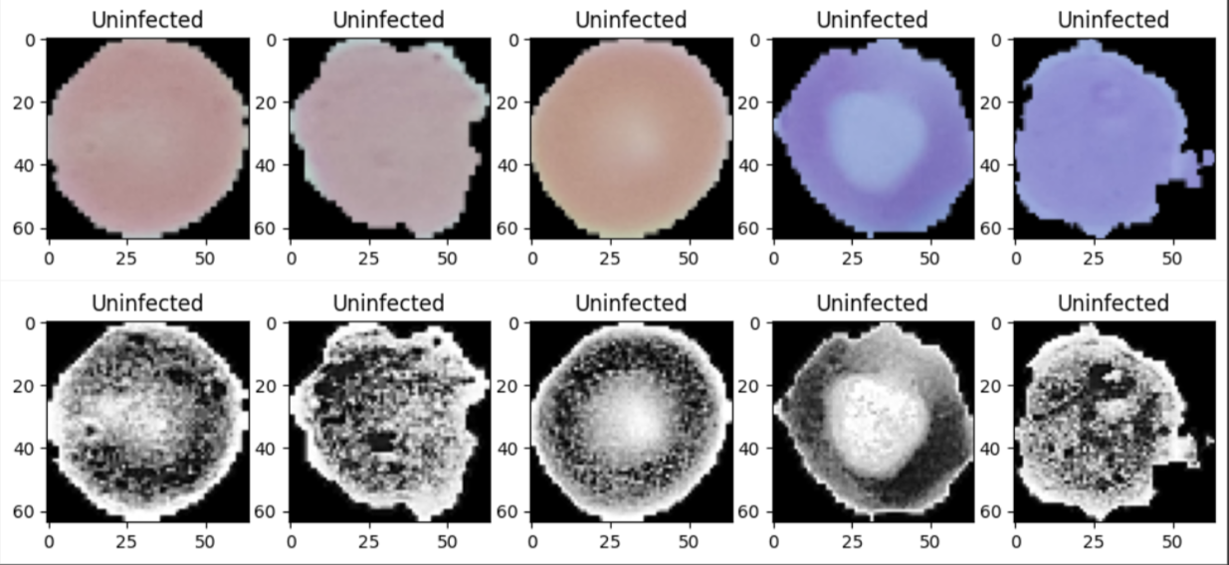

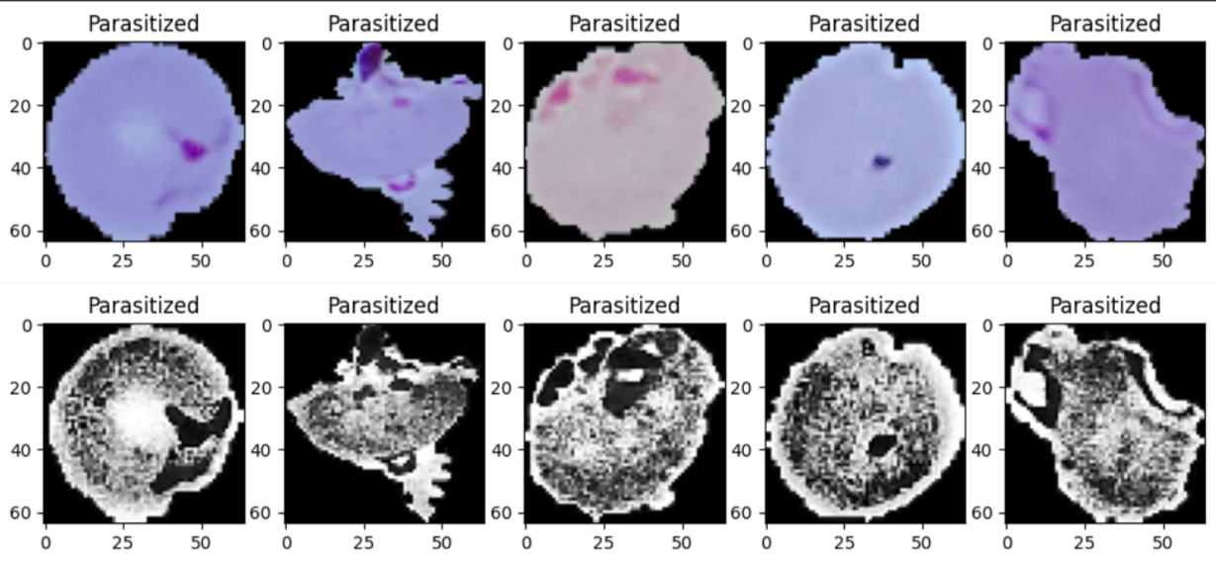

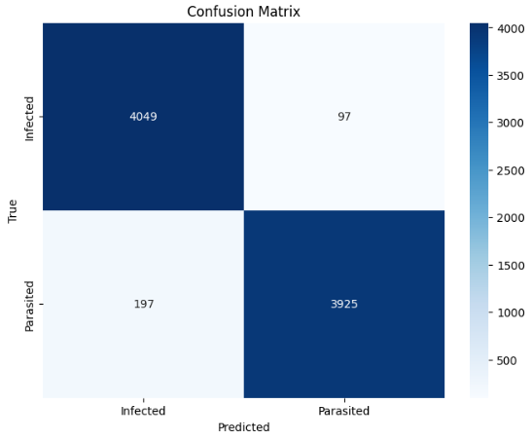As observed the areas with the highlighted the weakest area of frequencies can help us identify the type of parasite as well which has caused malaria such that it can help in the treatment. Plasmodium falciparum often presents in the ring stage, appearing as a single, small, and ring-shaped parasite within a red blood cell. This ring is characterized by a compact, dark-staining nucleus. P. falciparum infections can exhibit multiple parasites within a single red blood cell and may have irregular shapes. P. vivax trophozoites, a stage in its life cycle, are typically larger than ring-stage parasites. They exhibit an ameboid or irregular shape. In the schizont stage, mature P. vivax parasites may display a distinctive amoeboid form with a central dark-staining nucleus and surrounding smaller merozoites, often arranged in a pattern resembling "schüffner's dots."

This dataset contains aroung 25000 images which is a relatively big dataset. VGG-19 performs well on a large dataset for several compelling reasons. First and foremost, its deep architecture with 19 layers allows it to capture intricate and hierarchical features within the images, making it highly effective in recognizing complex patterns and structures. The model's extensive depth facilitates the learning of a wide range of features, from basic edges and textures to more intricate object parts, enhancing its ability to generalize on a large and diverse dataset. VGG-19 gave an accuracy of 97.5%.

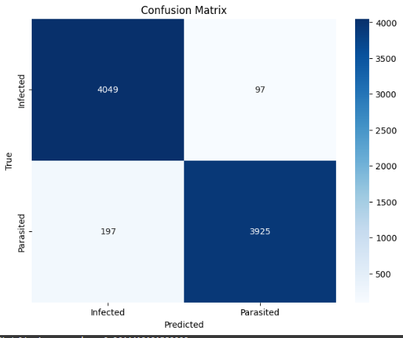It presented code implements a Convolutional Neural Network (CNN) model, which is trained on a dataset of infected and uninfected blood cell images using ImageDataGenerator to perform data augmentation and reduce overfitting. The code also demonstrates how to use the trained model to classify a new blood cell image as infected or uninfected. Additionally, several image processing techniques such as segmentation, Gaussian filtering, and Laplacian filtering are used to improve the accuracy of the model by preprocessing the images. Overall, the presented code provides a practical and effective way to detect malaria using image processing techniques and deep learning. This approach has the potential to improve the accuracy and speed of malaria diagnosis, especially in resource-limited settings, where traditional diagnostic methods are not easily accessible. Further research can be done to improve the accuracy of the model and make it more suitable for real-world applications.

CNN model has a more volatile performance compared to VGG-19. This is due to large number of images in the dataset. But overall. Both CNN and VGG-19 have around the same accuracy with CNN getting 96.44% and VGG-19 getting 97.5%.

The final output classification looks as follows:

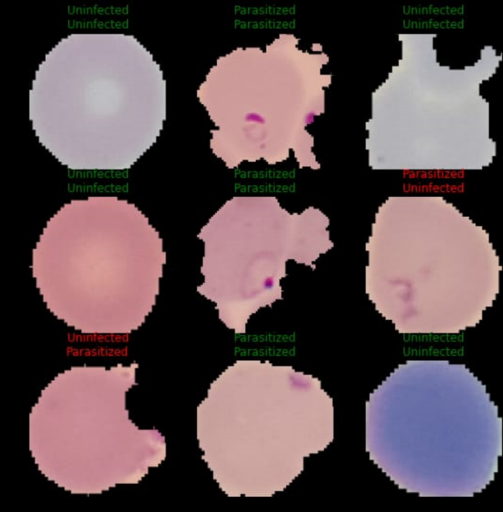

To improve the model's performance, we could consider adding more convolutional layers to increase the model's capacity to detect features. We could also try different activation functions and optimizers, adjust hyperparameters, or fine-tune a pre-trained model. Additionally, we could consider using more extensive and diverse datasets to improve the model's generalization ability. Finally, we could use techniques such as transfer learning and data augmentation to improve the model's performance further.

CONCLUSION

In conclusion, malaria detection using image processing is a promising approach that can help with the timely diagnosis and treatment of the disease. The presented code implements a Convolutional Neural Network (CNN) model and Visual Geometry Group 19 model, which were trained on a dataset of infected and uninfected blood cell images using ImageDataGenerator to perform data augmentation and reduce overfitting. The models achieved an accuracy of 96.44% and 97.5% respectively, which is a good indication of its effectiveness in detecting malaria. The code also demonstrates how to use the trained model to classify a new blood cell image as infected or uninfected. Additionally, several image processing techniques such as segmentation, Gaussian filtering, and Laplacian filtering are used to improve the accuracy of the model by preprocessing the images. Overall, the presented code provides a practical and effective way to detect malaria using image processing techniques and deep learning. This approach has the potential to improve the accuracy and speed of malaria diagnosis, especially in resource-limited settings, where traditional diagnostic methods are not easily accessible. Further research can be done to improve the accuracy of the model and make it more suitable for real-world applications.

REFERENCES

1. Rahman, A., Zunair, H., Reme, T. R., Rahman, M. S., & Mahdy, M. R. C. (2021). A comparative analysis of deep learning architectures on high variation malaria parasite classification dataset. *Tissue and Cell*, *69*, 101473.
2. Yang, F., Poostchi, M., Yu, H., Zhou, Z., Silamut, K., Yu, J., ... & Antani, S. (2019).

Deep learning for smartphone-based malaria parasite detection in thick blood smears. *IEEE journal of biomedical and health informatics*, *24*(5), 1427-1438.

1. Pattanaik, P. A., Mittal, M., Khan, M. Z., & Panda, S. N. (2022). Malaria detection using deep residual networks with mobile microscopy. *Journal of King Saud University-Computer and Information Sciences*, *34*(5), 1700-1705.
2. Nakasi, R., Mwebaze, E., Zawedde, A., Tusubira, J., Akera, B., & Maiga, G. (2020). A new approach for microscopic diagnosis of malaria parasites in thick blood smears using pre-trained deep learning models. *SN Applied Sciences*, *2*, 1-7.
3. Kudisthalert, W., Pasupa, K., & Tongsima, S. (2020). Counting and classification of malarial parasite from giemsa-stained thin film images. *IEEE Access*, *8*, 78663-78682.
4. Biffi, C., Cerrolaza, J. J., Tarroni, G., Bai, W., De Marvao, A., Oktay, O., ... & Rueckert, D. (2020). Explainable anatomical shape analysis through deep hierarchical generative models. *IEEE transactions on medical imaging*, *39*(6), 2088-2099.
5. Pattanaik, P. A., Mittal, M., & Khan, M. Z. (2020). Unsupervised deep learning cad scheme for the detection of malaria in blood smear microscopic images. *IEEE Access*, *8*, 94936-94946.
6. Kumar, S., Arif, T., Alotaibi, A. S., Malik, M. B., & Manhas, J. (2023). Advances Towards Automatic Detection and Classification of Parasites Microscopic Images Using Deep Convolutional Neural Network: Methods, Models and Research Directions. *Archives of Computational Methods in Engineering*, *30*(3), 2013-2039.
7. Koirala, A., Jha, M., Bodapati, S., Mishra, A., Chetty, G., Sahu, P. K., ... & Hukkoo, A. (2022). Deep Learning for Real-Time Malaria Parasite Detection and Counting Using YOLO-mp. *IEEE Access*, *10*, 102157-102172.
8. Gut, D., Tabor, Z., Szymkowski, M., Rozynek, M., Kucybała, I., & Wojciechowski, W. (2022). Benchmarking of deep architectures for segmentation of medical images. *IEEE Transactions on Medical Imaging*, *41*(11), 3231-3241.
9. Marletta, S., L’Imperio, V., Eccher, A., Antonini, P., Santonicco, N., Girolami, I., ... & Pantanowitz, L. (2023). Artificial intelligence-based tools applied to pathological diagnosis of microbiological diseases. *Pathology-Research and Practice*, 154362.
10. Alnussairi, M. H. D., & İbrahim, A. A. (2022). Malaria parasite detection using deep learning algorithms based on (CNNs) technique. *Computers and Electrical Engineering*, *103*, 108316.
11. Bhuiyan, M., & Islam, M. S. (2023). A new ensemble learning approach to detect malaria from microscopic red blood cell images. *Sensors International*, *4*, 100209.
12. Singla, N., & Srivastava, V. (2020). Deep learning enabled multi-wavelength spatial coherence microscope for the classification of malaria-infected stages with limited labeled data size. *Optics & Laser Technology*, *130*, 106335.
13. Goni, M. O. F., Mondal, M. N. I., Islam, S. R., Nahiduzzaman, M., Islam, M. R.,

Anower, M. S., & Kwak, K. S. (2023). Diagnosis of Malaria Using Double Hidden Layer Extreme Learning Machine Algorithm With CNN Feature Extraction and Parasite Inflator. *IEEE Access*, *11*, 4117-4130.

1. Iqbal, S., N. Qureshi, A., Li, J., & Mahmood, T. (2023). On the analyses of medical images using traditional machine learning techniques and convolutional neural networks. *Archives of Computational Methods in Engineering*, *30*(5), 3173-3233.
2. Umer, M., Sadiq, S., Ahmad, M., Ullah, S., Choi, G. S., & Mehmood, A. (2020). A novel stacked CNN for malarial parasite detection in thin blood smear images. *IEEE Access*, *8*, 93782-93792.
3. Smith, K. P., & Kirby, J. E. (2020). Image analysis and artificial intelligence in infectious disease diagnostics. *Clinical Microbiology and Infection*, *26*(10), 1318-1323.
4. Kassim, Y. M., Palaniappan, K., Yang, F., Poostchi, M., Palaniappan, N., Maude, R. J., ... & Jaeger, S. (2020). Clustering-based dual deep learning architecture for detecting red blood cells in malaria diagnostic smears. *ieee journal of biomedical and health informatics*, *25*(5), 1735-1746.
5. Alonso-Ramírez, A. A., García-Capulín, C. H., Rostro-González, H.,

Prado-Olivarez, J., Gutiérrez-López, M., & Barranco-Gutiérrez, A. I. (2022). Classifying parasitized and uninfected malaria red blood cells using convolutional-recurrent neural networks. *IEEE Access*, *10*, 97348-97359.

[21] Sifat, M. M. H., & Islam, M. M. (2020, June). A fully automated system to detect malaria parasites and their stages from the blood smear. In 2020 IEEE Region 10 Symposium (TENSYMP) (pp. 1351-1354). IEEE.

[23] Shewajo, F. A., & Fante, K. A. (2023). Tile-based microscopic image processing for malaria screening using a deep learning approach. BMC Medical Imaging, 23(1), 1-14.

[24] Wang, S., Yang, C., Preiser, P., & Zheng, Y. (2020). A photoacoustic-surface-acoustic-wave sensor for ring-stage malaria parasite detection. IEEE Transactions on Circuits and Systems II: Express Briefs, 67(5), 881-885.

[24] Arowolo, M. O., Adebiyi, M. O., Adebiyi, A. A., & Okesola, O. J. (2020). A hybrid heuristic dimensionality reduction method for classifying malaria vector gene expression data. IEEE Access, 8, 182422-182430.

[25] Chowdhury, A. B., Roberson, J., Hukkoo, A., Bodapati, S., & Cappelleri, D. J. (2020). Automated complete blood cell count and malaria pathogen detection using convolution neural network. IEEE robotics and automation letters, 5(2), 1047-1054.