<html>

<head>

<title>

God de Futbol

</title>

</head>

<body>

<h1>This is Messi</h1>

<p align=center> Messi is a footballing genius </p>

<h2>Messi's unique records </h2>

<!-- Add more records like the most successful dribbles, etc -->

<p align=left> Steven Gerrard once said, "Messi is the best footballer he has seen", he addes, "I wish I could play with him as much as possible." </p>

<p align=right> Messi has 91 goals in a calendar year, 68 coming only from La liga <p>

<h3>Messi's style of play</h3>

<p> Arsene Wenger once said, "Messi is like a footballing genius of a Playstation game. He takes turns as we take turns in a video game."</p>

<h1>Let us explore the best sides of him</h1>

<p><font size = 7> He, single handedly, led Argentina to the qualifying rounds in the last two world cups and then in the last world cup, he took the team to the finals.</font>

<font size = 6> Although, he played and led Argentina NT in 4 finals, he is blamed for the loss as well.</font><br>

<font size = 5> The scenario, however, is totally different. He is not responsible for the losses, instead he should be given credit for the team's performance in the cups which led the team into the finals.</font>

</body>

</html>

output:

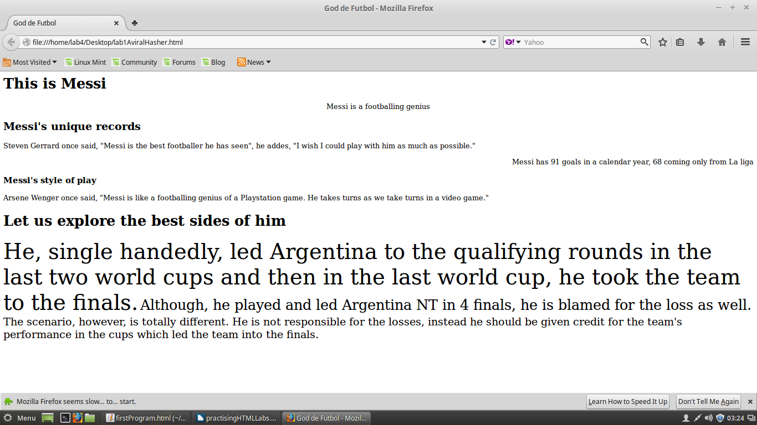

<!DOCTYPE HTML>

<html>

<title> HTML Tutorial </title>

<body>

<h1>This is a heading</h1>

<p> This is a paragraph </p>

</body>

</html>

o/p:



<!DOCTYPE HTML>

<html>

<body>

<p align="left">

My Bonnie lies over the ocean.

</p>

<p align="right">

My Bonny lies over the sea

</p>

<p align="center">

My Bonny does nothign.

</p>

</body>

</html>

o/p:

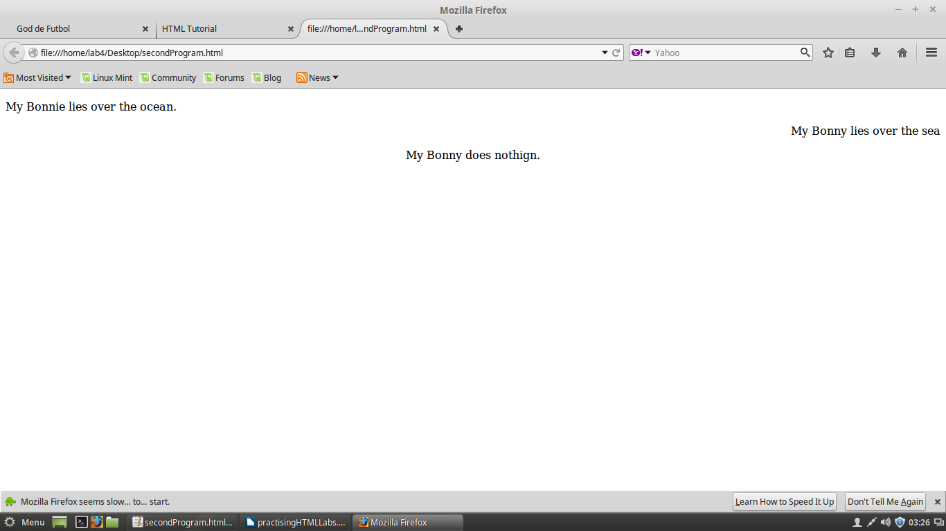

<!DOCTYPE HTML>

<html>

<title> HTML Tutorial </title>

<body>

<h1>This is a heading</h1>

<p> This is a paragraph </p>

<img src="/home/lab4/Desktop/live-apple.jpg" width="50" height="50"></img><a href="http:/live-apple.com">Apple Hubspot</a>

</body>

</html>

o/p:



<!DOCTYPE HTML>

<html>

<title> Aviral Srivastava </title>

<body>

<h1>Hi this is Aviral Srivastava, web name aviralHasher</h1>

<p> I will be writing about myself </p>

<h2>Contact</h2>

<a href="mailto:avi.srivastava254084@gmail.com">Email</a> &nbsp; <a href="https://www.google.co.in/maps/place/Vellore+Institute+of+Technology/@12.969264,79.155938,15z/data=!4m5!3m4!1s0x0:0xfef222e5f36ecdeb!8m2!3d12.969264!4d79.155938"> VIT University </a>

<br>

<h2>Work Experience</h2>

<a href="http://commutatus.com/"><b>Commutatus</b></a>

<p align="center"> I worked as a full stack developer and my stack was on HTML, CSS, Angular2.js, PHP, MongoDB, MySQL </p>

<br>

<a href="http://leaguesx.com/"><b> LeagueSX </b></a>

<p align="center"> I was a Python/Django backend developer. The game has a feature of private league, codede by me.</p>

</body>

</html>

o/p:

