PRD: Bulk Bid — Ediig Auction Platform
Author: Avinash Singh
Date: 2026-05-30
Status: Draft
Platform: Ediig

1. Overview
Bulk Bid is a group-based bidding workflow on Ediig that lets buyers curate vehicles from bank-authorised auctions, organise them into named groups ("My Bid Groups"), and place a single confirmed bid across the entire group — with the ability to review and adjust all bids simultaneously before submitting. It replaces the repetitive one-by-one bidding process when a buyer is targeting multiple vehicles from the same or related auctions.

2. Problem Statement
Fleet buyers, dealers, and procurement managers frequently bid on multiple vehicles in a single auction or across a set of related auctions. The current experience forces them to:
- Bid individually — navigate to each vehicle, set a price, confirm — repeated for every lot.
- Lose coordination — price adjustments (e.g., "increase everything by ₹5,000 after market intel") must be applied manually to each vehicle.
- Miss the confirmation window — placing 10+ individual bids takes time; some lots close before they get to them.
- Lose overview — there is no single view that shows a buyer's total committed spend across vehicles in a session.
Bulk Bid solves this by introducing a group layer between the vehicle and the bid: buyers build groups, tune bids together, and confirm once.

3. Goals
Goal | Metric
Reduce time to place bids on 5+ vehicles | ≥ 60% reduction vs. individual bidding baseline
Give buyers a single-view spend summary | 100% of bulk sessions show live group total before confirmation
Prevent accidental below-floor bids | Zero bids placed below a vehicle's base/reserve price
Increase multi-lot participation per buyer session | ≥ 30% increase in avg. vehicles bid per session vs. individual flow

4. Non-Goals
- Auto-bidding or auto-responding to rival bids within a group (see Auto-Bid PRD)
- Cross-auction budget pooling with shared ceiling across all groups
- Backend payment or escrow integration (outside product scope)
- AI-based bid suggestions or market price benchmarking (future phase)

5. User Personas
Primary — Fleet Procurement Manager
Sources 10–50 vehicles per month from bank auctions. Has a per-vehicle budget but needs to stay within a total session budget. Needs to adjust pricing based on real-time intelligence and confirm everything before auction close.
Secondary — Active Dealer Buyer
Participates in 3–5 auctions per week. Targets clusters of vehicles (e.g., all SUVs from a single SBI auction). Values speed — wants to group vehicles quickly, bump bids once, and confirm.

6. Feature Description

6.1 Screen 1 — Auction Listings
The entry point. Buyers discover bank-authorised auctions and select one to browse lots.
Each auction card displays:
- Bank name and logo
- Auction name and reference ID
- Status badge: LIVE / UPCOMING / CLOSED
- Location and sale date
- Total lot count
- Vehicle category tags (Cars, SUVs, Bikes, Trucks, Scooters)
- Contact number
- "View Lots" CTA
Filters:
- Status toggle chips: All Auctions / Live / Upcoming
- Dropdown filters: Bank, City

6.2 Screen 2 — Vehicle Lots in an Auction
Buyers browse vehicles in the selected auction, manage groups, and add vehicles to them.
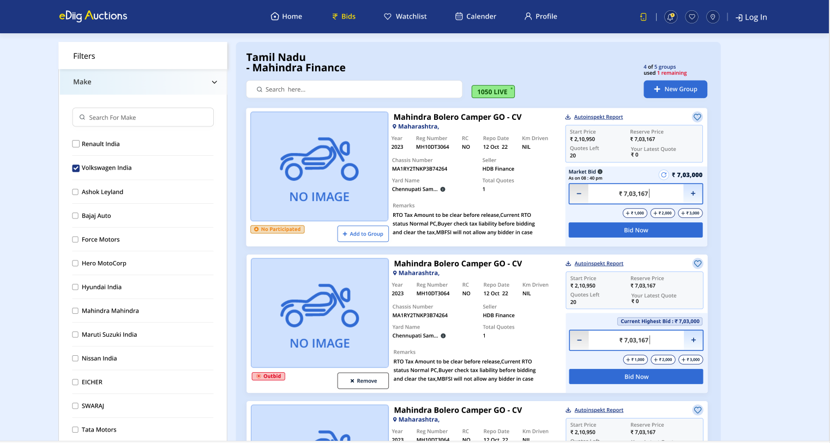
Vehicle lots view: filter sidebar (left), vehicle cards with bid panel (right), group counter and "+ New Group" top-right.
Auction header (persistent top bar):
- Auction name (e.g., "Tamil Nadu – Mahindra Finance")
- LIVE badge with active lot count (e.g., "1050 LIVE")
- Group usage counter: "X of 5 groups used, Y remaining" — a buyer may have at most 5 groups per auction session
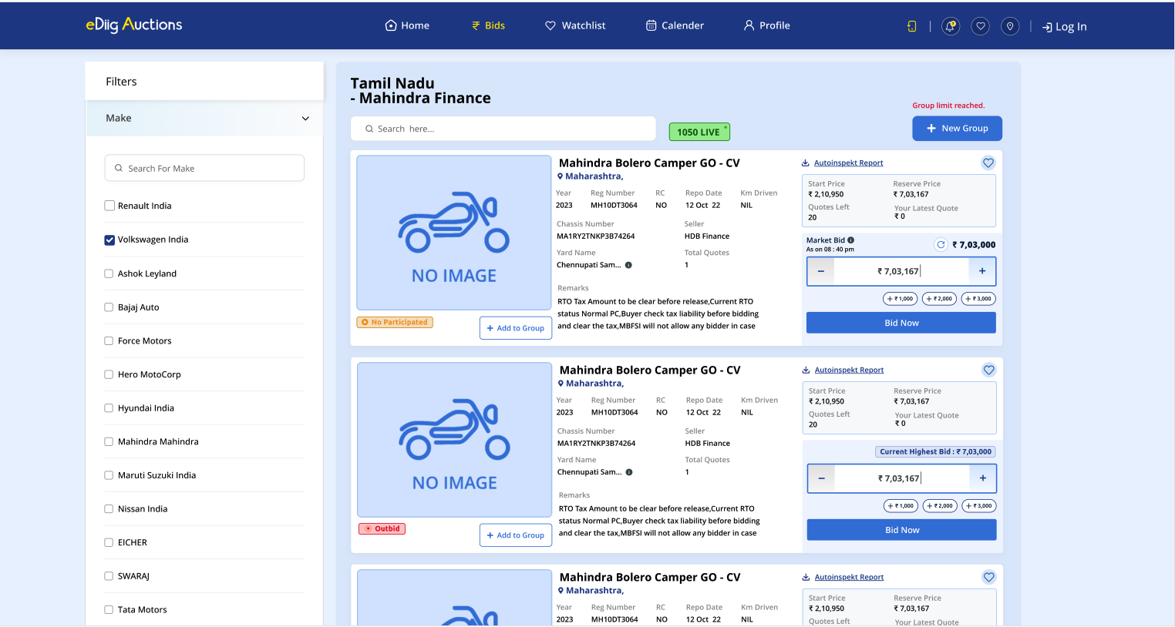
When all 5 groups are used, the counter is replaced by "Group limit reached." in red; "+ New Group" is disabled.
Left sidebar — Filters:
- Make: searchable checkbox list (Renault India, Volkswagen India, Ashok Leyland, Bajaj Auto, Force Motors, Hero MotoCorp, Hyundai India, Mahindra, Maruti Suzuki, Nissan India, EICHER, SWARAJ, Tata Motors, …)
Vehicle cards (list layout):
Element | Detail
Vehicle image | Placeholder shown as "NO IMAGE" if unavailable
Vehicle name | e.g., "Mahindra Bolero Camper GO - CV"
Location | City/state tag
Specs row | Year, Reg Number, RC, Repo Date, Km Driven
Chassis Number
Seller | e.g., "HDB Finance"
Yard Name | e.g., "Chennupati Sam…"
Total Quotes | Number of quotes on this lot
Remarks | Free-text remarks from seller
Autoinspekt Report | Download link for inspection report
Watchlist (♡) | Save vehicle to watchlist
Participation badge | "No Participated" (orange) / "Outbid" (red)
Group action button | "+ Add to Group" (if ungrouped) or "× Remove" (if grouped)
Start Price
Reserve Price
Quotes Left | Remaining bid opportunities
Your Latest Quote | Buyer's last submitted quote (₹0 if none)
Market Bid | Current highest bid, with refresh icon and timestamp
Bid input | Editable field showing current quote
Quick-add chips | +₹1,000 / +₹2,000 / +₹3,000 (tappable shortcuts)
"Bid Now" button | Places a single individual bid for this vehicle

Add to Group flow:
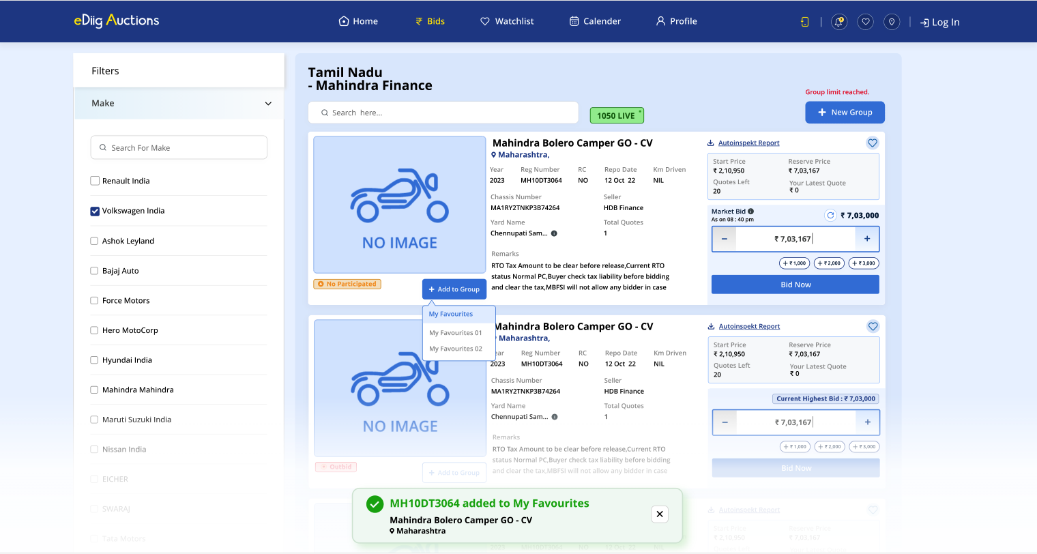
Clicking "+ Add to Group" opens a dropdown listing all existing groups by name. Selecting a group adds the vehicle and shows a success toast at bottom.
- Clicking "+ Add to Group" opens a dropdown of existing group names
- Selecting a group immediately adds the vehicle; a success toast fires: "✅ [Reg No] added to [Group Name]"
- If the vehicle is already in a group, the button changes to "× Remove"; clicking it opens the same dropdown to move or remove, and fires a removal toast
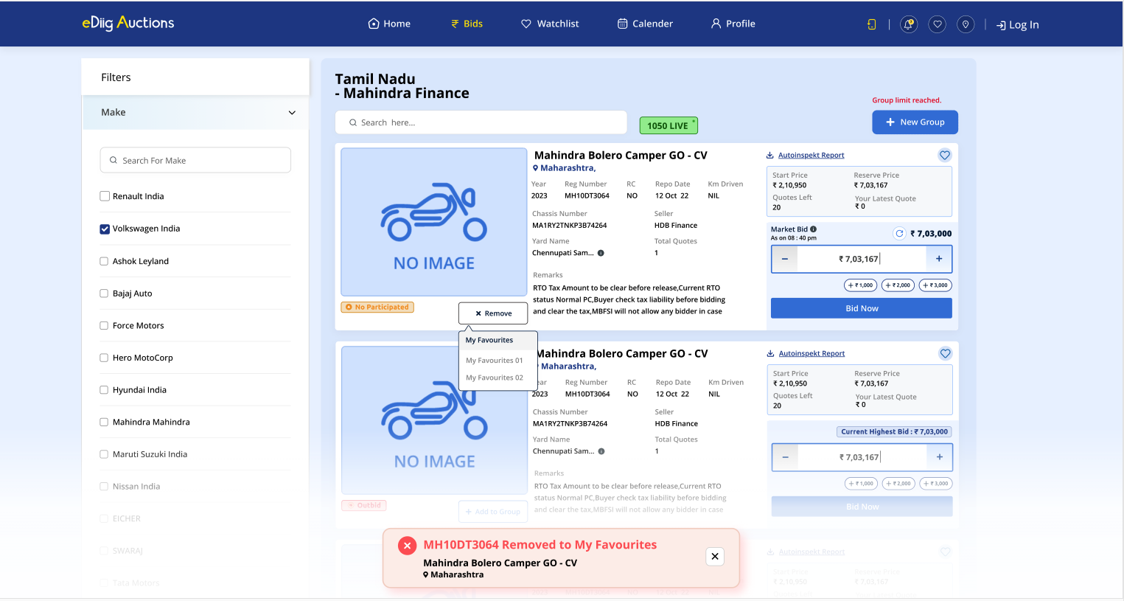
Clicking "× Remove" shows the group dropdown; choosing a group moves the vehicle, firing a removal toast at bottom.

6.3 Create New Group Modal
Triggered by "+ New Group" in the auction header.
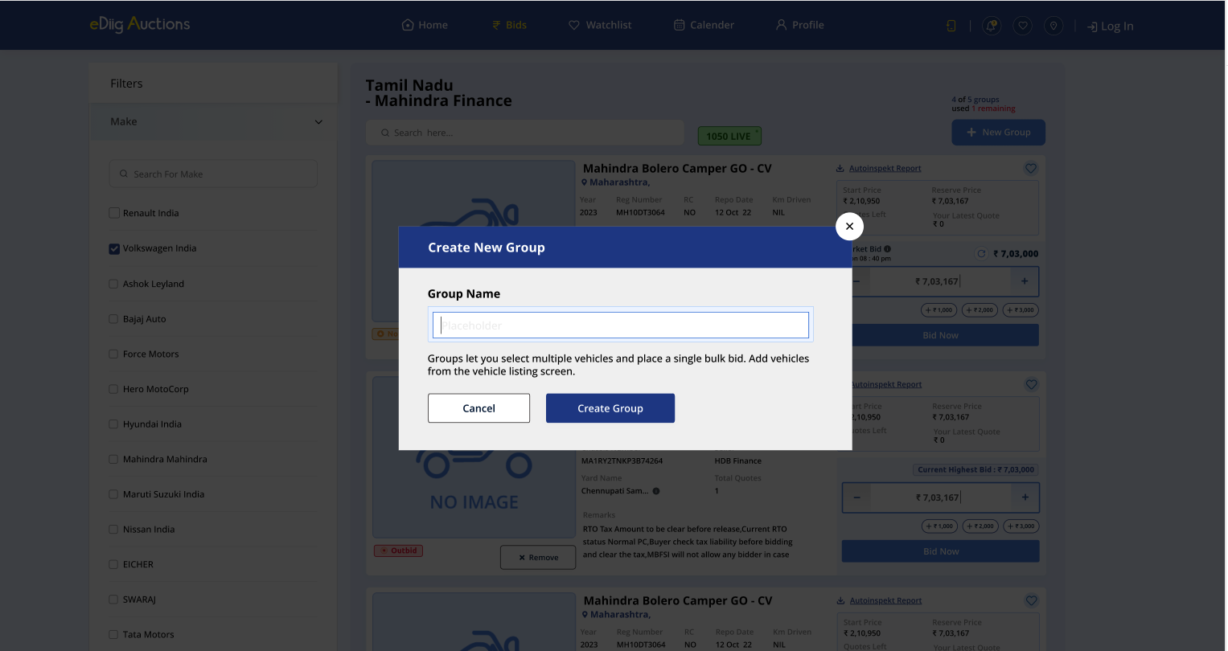
Create New Group modal with empty name field.
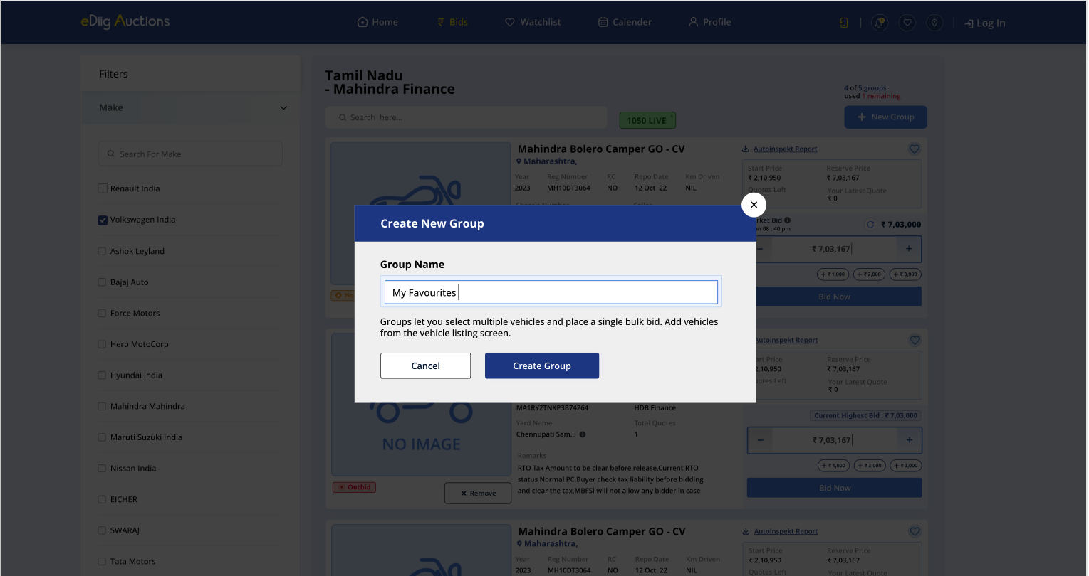
Group name entered ("My Favourites"); pressing "Create Group" creates the group and returns to the vehicle listing.
Modal elements:
- Title: "Create New Group"
- Field: "Group Name" with placeholder text
- Helper: "Groups let you select multiple vehicles and place a single bulk bid. Add vehicles from the vehicle listing screen."
- Actions: Cancel | Create Group

6.4 Screen 3 — My Bids (Group Management)
The control centre for reviewing groups, adjusting bids in bulk, and placing the final confirmation. Accessed via the "Bids" nav link or back-arrow from the vehicle listing.
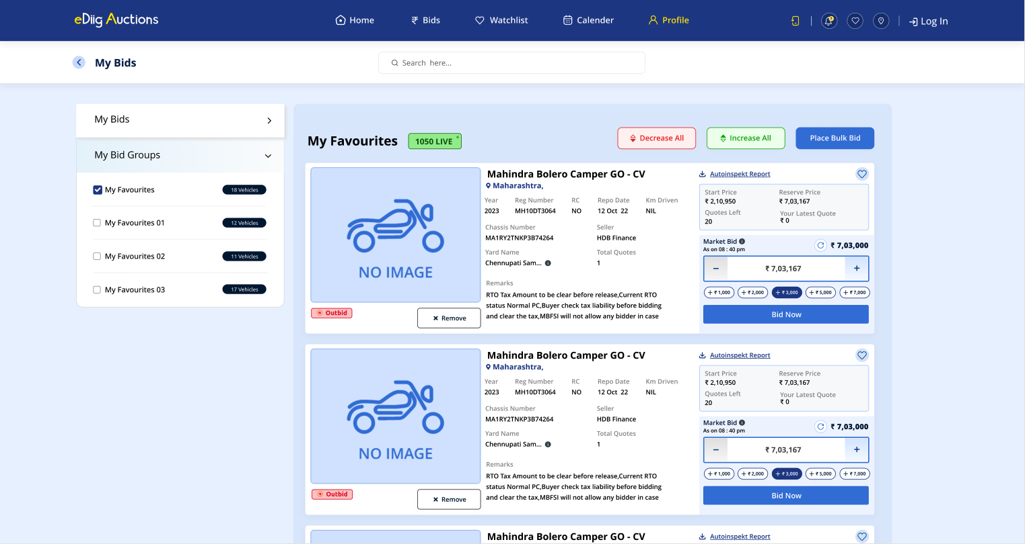
My Bids screen: left sidebar lists "My Bids" and "My Bid Groups" (with per-group vehicle counts), right panel shows the selected group's vehicles with Decrease All / Increase All / Place Bulk Bid controls.
Left sidebar:
- My Bids section (collapsible) — individual bid history
- My Bid Groups section (collapsible) — lists all groups with checkbox and vehicle count badge (e.g., "My Favourites — 18 Vehicles")
- Clicking a group checkbox selects it and loads its vehicles in the right panel
Right panel — selected group view:
Component | Detail
Group name | e.g., "My Favourites"
Auction status badge | e.g., "1050 LIVE"
Decrease All button | Triggers Review Bid Changes modal
Increase All button | Triggers Review Bid Changes modal
Place Bulk Bid button | Triggers bulk bid placement flow
Vehicle list | Each row: image, name, location, specs, bid panel with Market Bid, input field, quick chips (+₹1k / +₹2k / ±₹3k / +₹5k / +₹7k), Bid Now, and "× Remove"

6.5 Review Bid Changes Modal
Shown when "Increase All" or "Decrease All" is clicked — buyers review the impact before it applies.
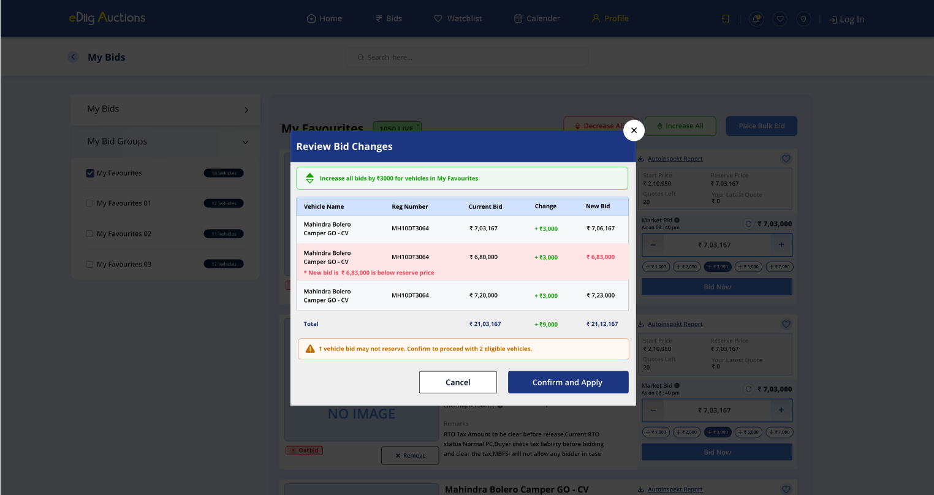
"Review Bid Changes" modal: green header shows the action, table shows per-vehicle current bid → change → new bid. Rows where the new bid is below reserve price are highlighted in red with an inline warning. A summary warning lists how many vehicles may not reserve. Confirming applies the changes.
Modal elements:
- Header banner (green for increase, red for decrease): "Increase/Decrease all bids by ₹[amount] for vehicles in [Group Name]"
- Table columns: Vehicle Name | Reg Number | Current Bid | Change | New Bid
- Below-reserve rows: highlighted in red; inline note "* New bid is ₹X is below reserve price"
- Total row: aggregate current, change delta, new total
- Warning banner (amber): "⚠ [N] vehicle bid(s) may not reserve. Confirm to proceed with [M] eligible vehicles."
- Actions: Cancel | Confirm and Apply
Behaviour:
- Below-reserve vehicles are included in the preview but excluded from the applied changes
- Confirming applies the increase/decrease only to eligible vehicles

6.6 Bulk Bid Placement
Triggered by "Place Bulk Bid" in the group panel.
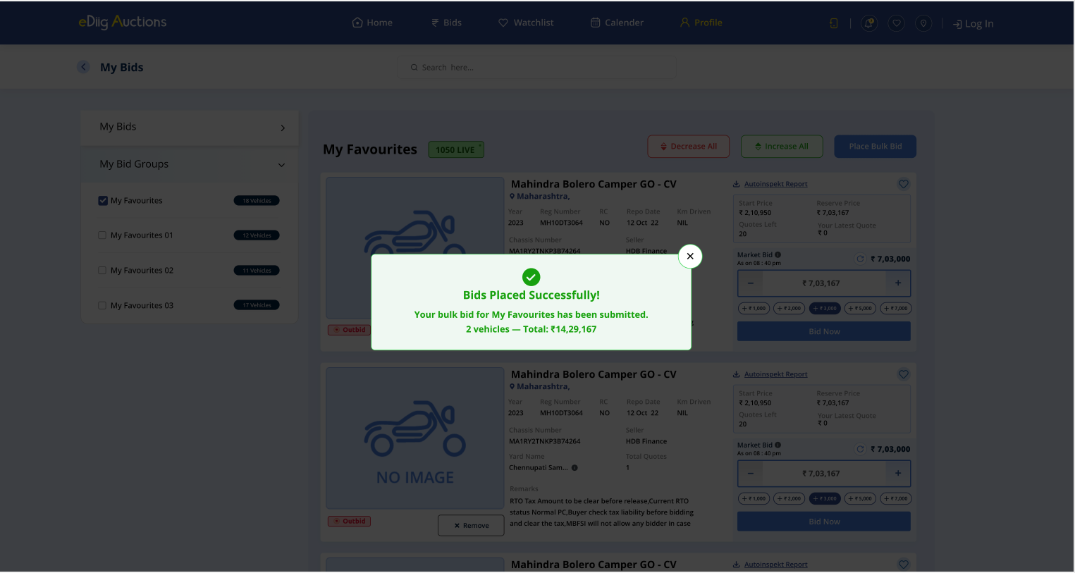
Success modal after bulk bid placement: group name, vehicle count, and grand total are confirmed.
Success modal elements:
- Green checkmark icon
- "Bids Placed Successfully!"
- "Your bulk bid for [Group Name] has been submitted."
- "[N] vehicles — Total: ₹[amount]"
- Close (×) button

7. Key User Flows

Flow 1 — Create a Group and Add Vehicles
- On Screen 2, click "+ New Group."
- Enter group name → "Create Group."
- On any vehicle card, click "+ Add to Group" → select group from dropdown.
- Success toast confirms: "✅ [Reg No] added to [Group Name]."
- Repeat for all target vehicles.

Flow 2 — Adjust Individual Bids
- Use the bid input field or quick-add chips (+₹1k/+₹2k/+₹3k) on any vehicle card (Screen 2 or Screen 3).
- Bid updates in real time. Cannot go below base bid.

Flow 3 — Apply a Bulk Adjustment
- On Screen 3, select a group.
- Click "Increase All" or "Decrease All."
- Review Bid Changes modal opens — shows per-vehicle impact, flags below-reserve vehicles.
- Click "Confirm and Apply" — changes apply to eligible vehicles only; below-reserve vehicles are skipped.
- Group total updates in real time.

Flow 4 — Place a Bulk Bid
- On Screen 3, select group → click "Place Bulk Bid."
- Success modal confirms: vehicle count + grand total.
- Close modal — group status updates to PLACED.

Flow 5 — Move a Vehicle Between Groups
- On a vehicle already in a group, click "× Remove."
- The group dropdown appears — select a different group to move the vehicle, or click outside to cancel.
- Toast confirms the move or removal.

Flow 6 — Navigate Between Screens
- Screen 2 → Screen 3: "Bids" nav item or "My Bids" back arrow
- Screen 3 → Screen 2: "Continue Bidding" returns to vehicle listing

8. Business Rules
Rule | Detail
Group cap | Maximum 5 groups per buyer per auction session. "+ New Group" is disabled when the cap is reached; header shows "Group limit reached." in red.
Bid increments | Quick-chip shortcuts: +₹1,000 / +₹2,000 / +₹3,000 on vehicle listing; +₹1,000 / +₹2,000 / ±₹3,000 / +₹5,000 / +₹7,000 on My Bids view. Stepper input allows free entry.
Base bid floor | No bid can be adjusted below a vehicle's reserve price. Bulk Increase/Decrease previews the impact; below-reserve vehicles are skipped on Confirm.
Vehicle → group mapping | Each vehicle belongs to one group at a time. Moving a vehicle via "× Remove" → dropdown transfers it immediately.
Group deletion | Deletes the group and removes all its vehicles (bids reset to base). Not available on groups with PLACED status — buyer must reset first.
Bulk amount | Set by the buyer before clicking Increase All / Decrease All. Previewed in the Review Bid Changes modal before applying.
Group locking | After bulk bid placement, group status changes to PLACED.
Reset | Unlocks the group and resets all bids to base — does not cancel a bid already submitted to the backend.
Group name | Required. Recommend 30 chars max.
Simultaneous groups | Up to 5 groups active per auction session. Multiple auctions can each have their own set of 5.
Individual Bid Now | Available on each vehicle card regardless of group membership. Does not affect group status.
Below-reserve bulk skip | Vehicles skipped during a bulk adjustment retain their current bid; they are not set to reserve price.

9. UI/UX Requirements

Visual States
State | Indicator
Ungrouped vehicle — not bid | "No Participated" orange badge; "+ Add to Group" button
Grouped vehicle — outbid | "Outbid" red badge; "× Remove" button
Group at cap (5/5) | "Group limit reached." in red; "+ New Group" disabled
Below-reserve row in review modal | Row highlighted red; inline warning note
Bulk bid placed | Success modal with green checkmark; group status → PLACED

Notifications (Toasts)
Event | Type | Message
Vehicle added to group | Success | "✅ [Reg No] added to [Group Name] — [Vehicle Name], [City]"
Vehicle removed from group | Error/Info | "✖ [Reg No] Removed to [Group Name] — [Vehicle Name], [City]"
Bid below base attempted | Error | "Cannot go below base bid of ₹X"
Bulk bid placed | Success modal | "Bids Placed Successfully! … [N] vehicles — Total: ₹[amount]"
Group reset | Info | "Group reset — bids cleared to base"
Group name empty | Warning | "Group name is required"

Toast position: bottom-centre. Auto-dismiss: ~4 seconds (with manual close ×).

Responsive Behaviour
Breakpoint | Change
< 700px | Filter sidebar collapses; vehicle list goes single-column; bulk controls stack vertically and go full-width

10. Data Model (Logical)
Auction
id, bank, name, ref, location, city, saleDate
status (live / upcoming / closed)
totalLots, categories[]

Vehicle
id, auctionId, name, year
type (4w / 2w)
fuel, odometer, city
startPrice, reservePrice, currentMarketBid
bidInput (buyer's current quote), quotesLeft
lotNumber, chassisNumber, seller, yardName, remarks

Group
id, buyerId, auctionId, name
status (active / placed)
vehicleIds[]
createdAt
-- max 5 per buyer per auction

BidEntry
vehicleId, groupId, buyerId
bidAmount, reservePrice
placedAt

BulkBidConfirmation
confirmationId, groupId, buyerId
vehicles[{ vehicleId, bidAmount }]
eligibleCount, grandTotal
placedAt

11. Edge Cases & Error Handling
Scenario | Behaviour
Bulk adjustment would push vehicle below reserve | Shown in Review Bid Changes modal as a red row with inline warning. Vehicle is skipped on "Confirm and Apply"; amber banner states count of skipped vehicles.
Buyer tries to create a 6th group (cap reached) | "+ New Group" is disabled; "Group limit reached." shown. Buyer must delete an existing group first.
Buyer tries to add vehicle already in another group | "× Remove" dropdown allows moving directly to another group in one step.
Buyer tries to delete a group with PLACED status | Block with error: "Cannot delete a group with bids placed. Reset the group first."
Auction closes while group is ACTIVE | Lock the group automatically; notify buyer: "Auction closed — your group has been locked at current bids."
Confirmation modal dismissed mid-flow | No bids placed; group remains ACTIVE and editable.
Reset on a group where bids were already sent to backend | Reset UI only; backend bids are not cancelled. Surface a clear disclaimer in the Reset confirmation.
Zero vehicles in group when "Place Bulk Bid" clicked | Disable button; tooltip: "Add at least one vehicle to place a bulk bid."
All vehicles in a group are below reserve | "Confirm and Apply" is blocked; all rows shown red in review modal; amber banner: "0 eligible vehicles."

12. Success Metrics (Post-Launch)
Metric | Target (90 days post-launch)
Bulk Bid adoption (% of multi-vehicle sessions using groups) | ≥ 35%
Avg. vehicles per bulk bid group | ≥ 4
Time to confirm a 5-vehicle group bid vs. individual | ≥ 50% faster
Below-reserve-bid errors reaching backend | 0
Group reset rate (proxy for buyer regret) | < 15% of PLACED groups
Support tickets related to Bulk Bid | < 5% of Bulk Bid sessions

13. Open Questions
- Backend bid submission — Is "Place Bulk Bid" a single atomic API call or N individual calls? If atomic, what is the rollback behaviour if some vehicles fail?
- Cross-auction groups — Can a buyer add vehicles from two different auctions into the same group? Currently scoped to per-auction; confirm if cross-auction is needed.
- Bid validity window — How long is a placed bulk bid valid? Does the platform hold the bid or is it subject to change by the auctioneer?
- Reset behaviour post-submission — Should Reset cancel the backend bid (requires API), or only reset the UI state? Needs policy decision.
- Concurrent buyers on same lot — If two buyers bid on the same vehicle simultaneously via Bulk Bid, how does conflict resolution work?
- Group cap configurable? — The design hard-codes 5 groups per auction. Should this be configurable by auction type or buyer tier?
- Notifications — Should bulk bid placement trigger an SMS/WhatsApp confirmation to the buyer?
- Audit & export — Does the buyer need a downloadable summary (CSV/PDF) of their placed bulk bids for internal approvals?

14. Milestones
Phase | Scope | Target
M1 — Group Management | Create, name, delete groups (max 5); assign/remove/move vehicles; group counter; group limit state | TBD
M2 — Bid Controls | Individual bid input + quick chips, stepper; base bid floor enforcement | TBD
M3 — Bulk Adjustment | Increase All / Decrease All; Review Bid Changes modal with reserve-price validation; below-reserve skip | TBD
M4 — Bulk Bid Placement | Place Bulk Bid → success modal; PLACED status | TBD
M5 — Reset & Re-bid | Reset flow, UI unlock, disclaimer for submitted bids | TBD
M6 — Filters & Discovery | Make filter sidebar wired to data; auction status live count | TBD
M7 — Notifications & Export | SMS/WhatsApp confirmation; bid history export | TBD

