Practical Project: Rock–Paper–Scissors
This is additional practical project and it is not mandatory and it is not included in the final score. The main purpose is to use gained knowledge in different type of problems and to improve your portfolio and GitHub skills.
Today we will make the console game "Rock – Paper – Scissors":
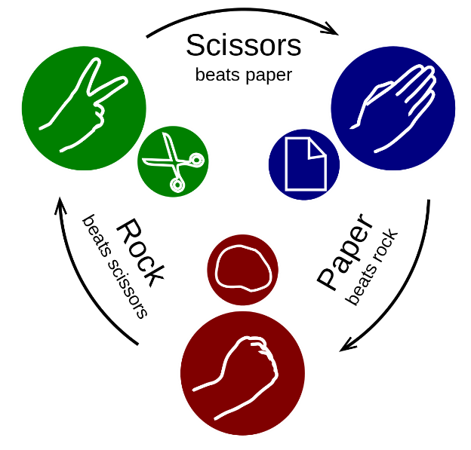
Rock-Paper-Scissors is a simple two-player game where you and your opponent (the computer) simultaneously choose one of the following three options: "rock", "paper" or "scissors". The rules are as follows:
- Rock beats scissors (the scissors get broken by the rock)
- Scissors beats paper (the paper gets cut by the scissors)
- Paper beats rock (the paper covers the rock)
The winner is the player whose choice beats the choice of his opponent. If both players choose the same option (e.g., "paper"), the game outcome is "draw":

Create a GitHub Profile and Repo
Everyone should have a GitHub developer profile. First, we should create our profile on GitHub.

Register a GitHub Profile
Register for a free developer account at GitHub here: http://github.com. With an email and a username:
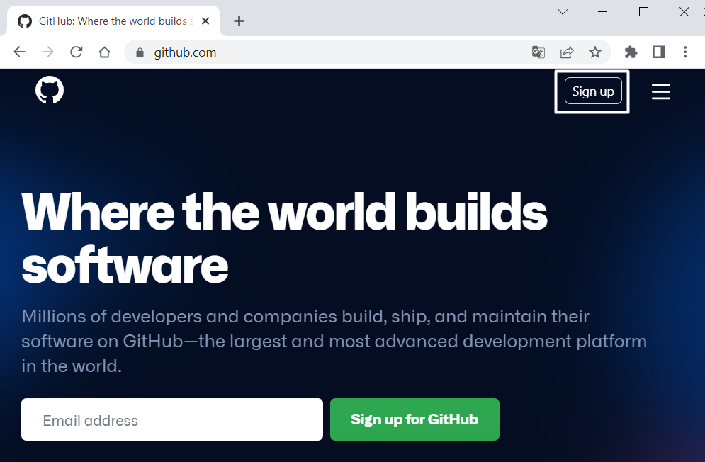
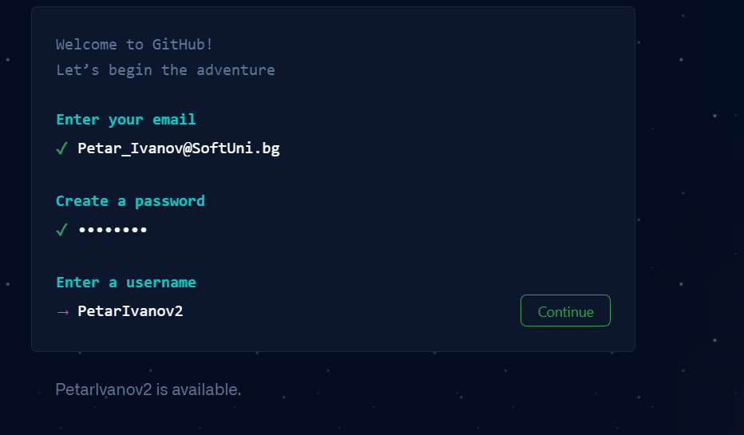
When you are ready, it is time to create your first repository. A repository contains all of your project's files and each file's revision history. You can discuss and manage your project's work within the repository.

Create a GitHub Repo
Create a new repository from: https://github.com/new. Choose a meaningful name, e. g. "RockPaperScissorsByUsername" add a short description and make your repo public:
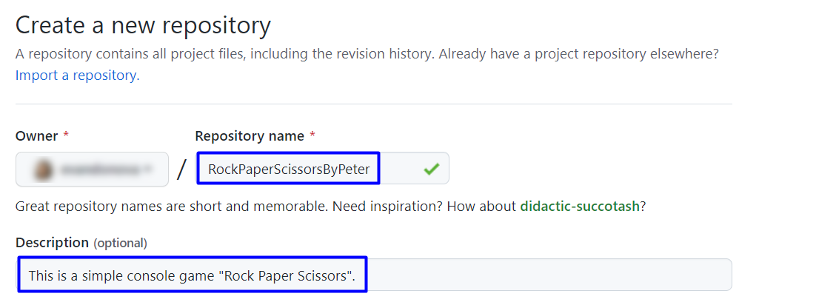
 | Please choose your original and unique name for your project!  Your GitHub profile should be unique, not the same as your classmates.  You can follow this tutorial, but you can also make changes and implement your project differ from your classmates.
Also, add a README.md file and .gitignore for Visual Studio, as shown below:
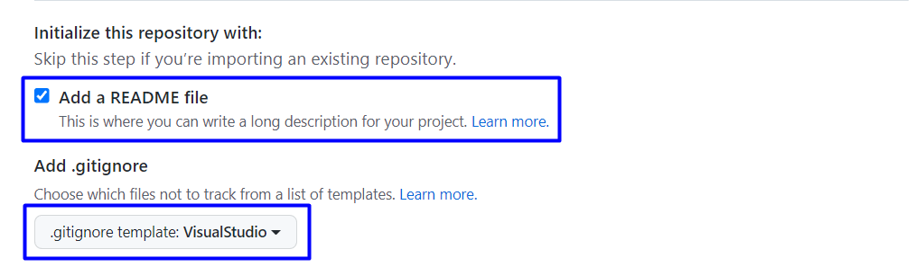
In Git projects, the .gitignore file specifies which files from your repo are not part of the source code and should be ignored (not uploaded in the GitHub repo). Typically in GitHub, we upload in the repo only the source code, and we don’t upload the compiled binaries and temp files.
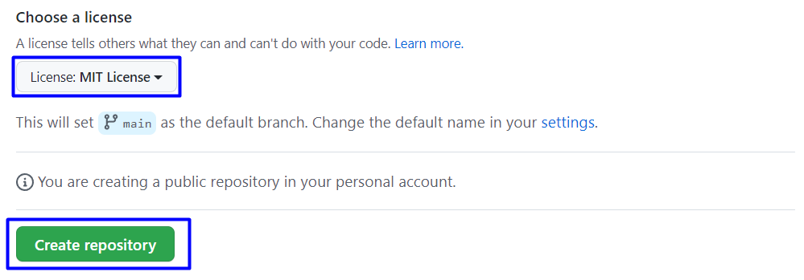
Now your repository is created and looks like this:
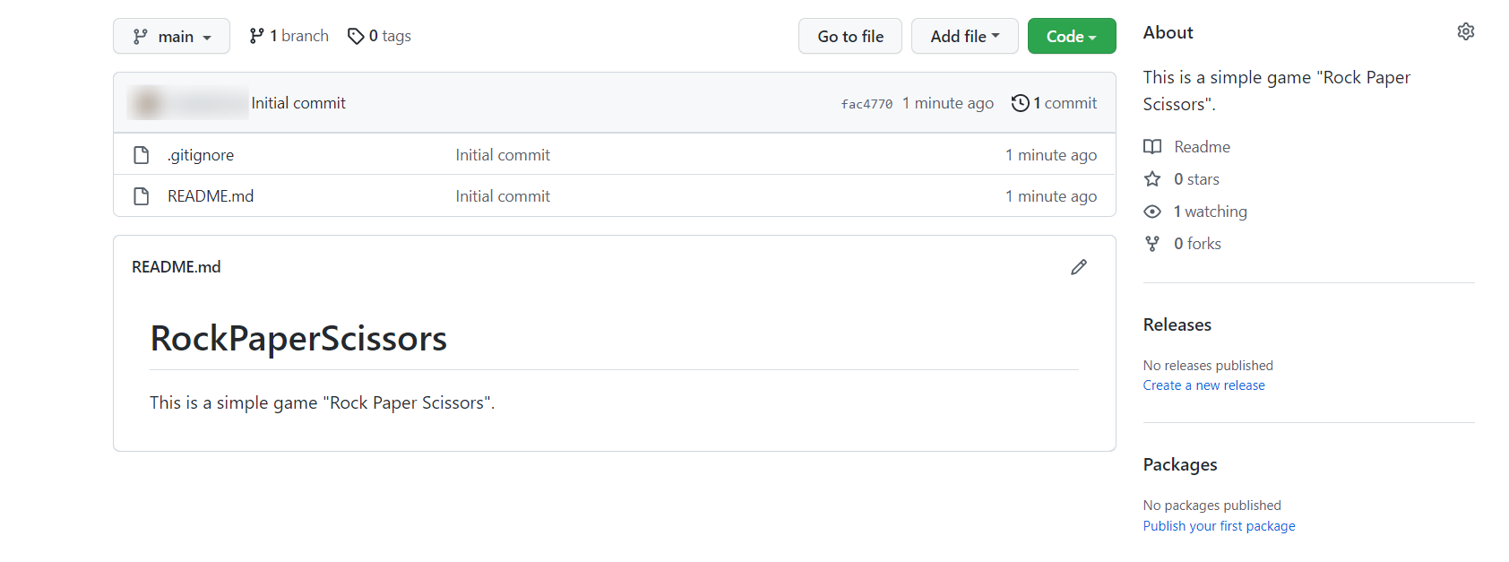
Now let's see how to write the code of our game.

Write the Game's Code
Let’s create the game and play with it.

Create a Visual Studio Project
- Open the folder from GitHub Desktop. If you don't have GitHub Desktop on your computer, download and install it from here: https://desktop.github.com/
- Go to "File" and choose "Clone repository".
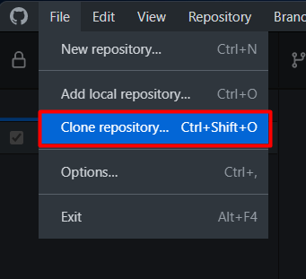
- Chose the repository for the project, in our case, "RockPaperScissors" and hit the "Clone" button.
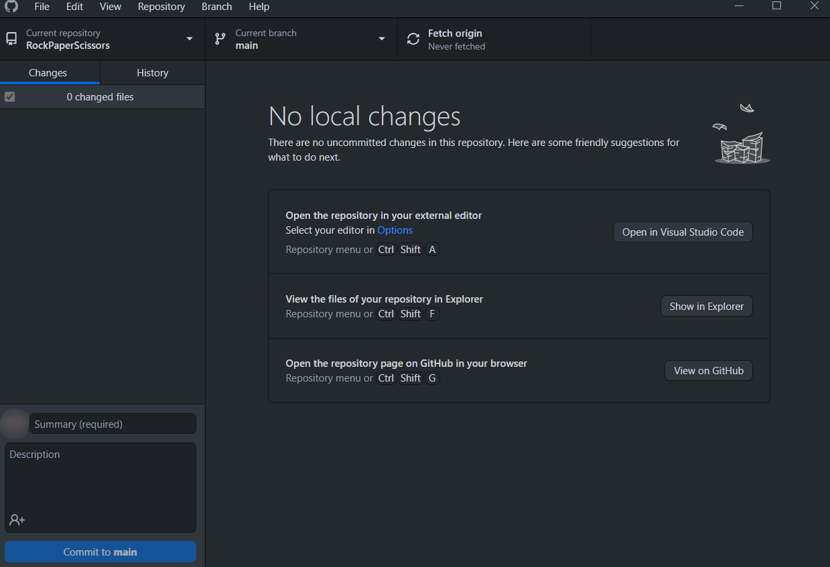
- Click in GitHub Desktop on "Open in Visual Studio Code":
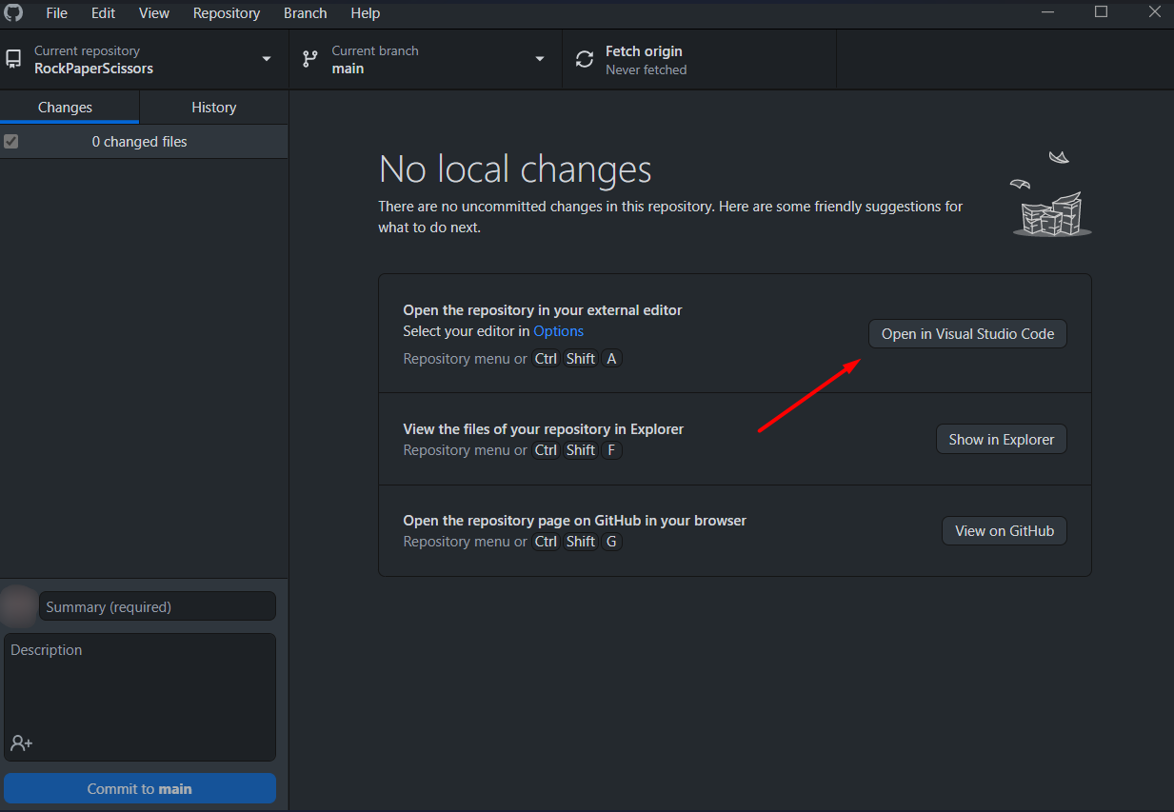
- When Visual Studio Code is open, click to create a new file
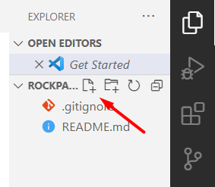
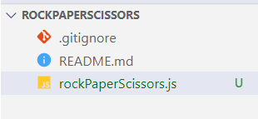

Implement the Game Logic

Read Player's Move
Now let's start working on our code.
Create three constants for our "Rock", "Paper" and "Scissors", which we will use later. Constants are values that do not change for the life of the program. They should look like this:
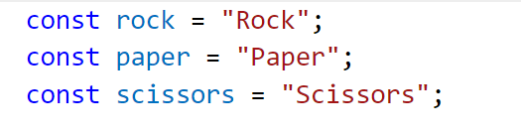

Match Player's Move with Possible Options
Now it is time to turn the user input into one of our player's movement options. To do this, create an if-else statement with the possible moves and change the variable value with our constants.
First, if the user has entered "r" or "rock", then they chose "Rock". Write it like this:
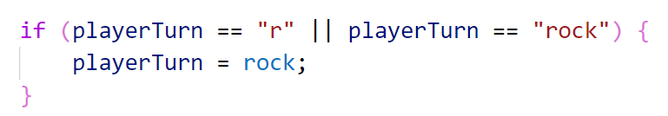
And if they entered "p" or "s", then they chose "paper" or "scissors" accordingly. Write the else-if statements by yourself:
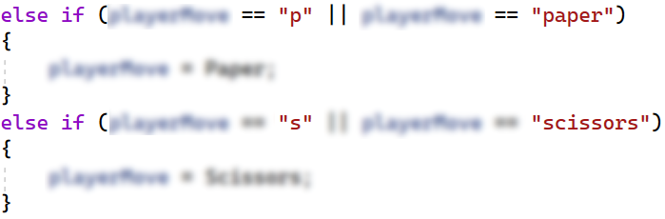
Now we should cover the case where the user enters an invalid value. To do this, use else and print a message on the console and stop the program execution:
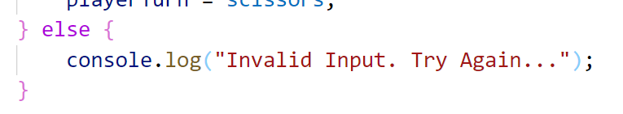
Now let's run the app in the console and check whether our current code works properly. At the moment, we have logic only for the incorrect input, so the results should be as follow:
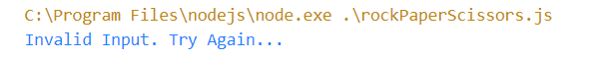

Choose Computer's Move
Then, use the method "random", which will help us choose a random number. We will use this number so that the computer can randomly select from "rock", "paper" or "scissors":
You can learn a little more about it here:
https://developer.mozilla.org/en-US/docs/Web/JavaScript/Reference/Global_Objects/Math/random
Choose the computer's random move, to make this happen, use the conditional statements switch-case or else-if. Also, check the input of the player, e. g.:
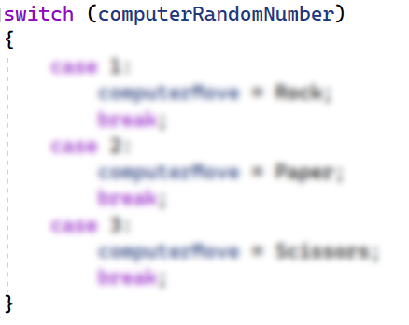
Think about how you can complete these conditional statements.

Check and Write the Result
Write to the console what is the random selection of the computer. e. g. "The computer chose {computerMove}.". Now we need to compare the choice of the player and the computer, again using conditional statements.
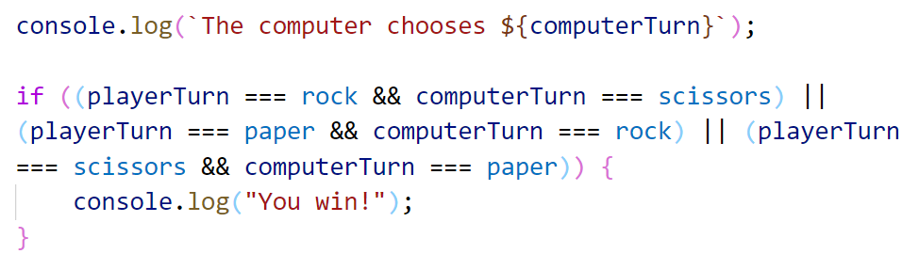
You can use this table for the possible moves:
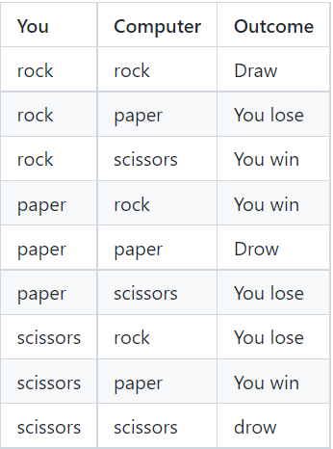
Consider all the cases where the player loses, or the result between them is equal, and write down the conditional statements. That's all it takes for the game to work.
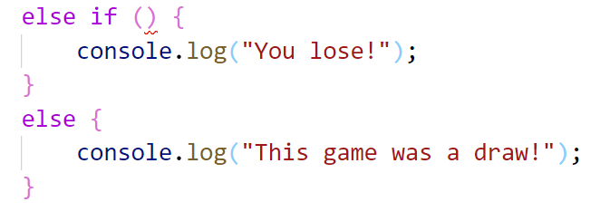
After you run it, the game should look like this:
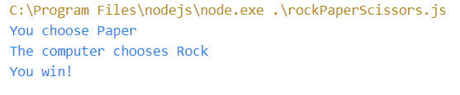
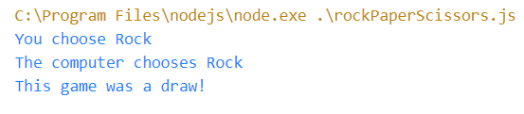
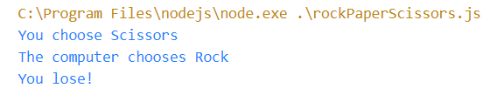

Upload Your Project to GitHub
Now we want to deploy our project to GitHub so the other developers can see it, and if they want to test it, they can clone it and try it themself on their machine. You have two options, choose one and follow the steps.

Use Git Bash (Option 1)
If you don’t use GitHub Desktop, you could use the "Git Bash" command line tool to upload your project to your GitHub repo.
First, if you don’t have Git on your computer, you should install it from https://git-scm.com/downloads.
Go to the desired directory, right-click on a blank space anywhere in the folder, and select "Git Bash Here" to open the Git command line console. If the "Git Bash Here" menu is missing, you should first install Git.
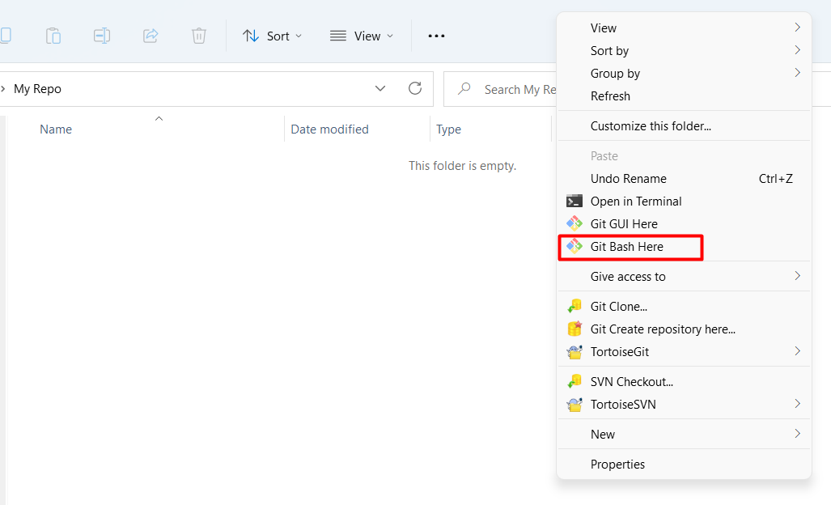
Type the "git clone" command followed by the link to your repository:
git clone
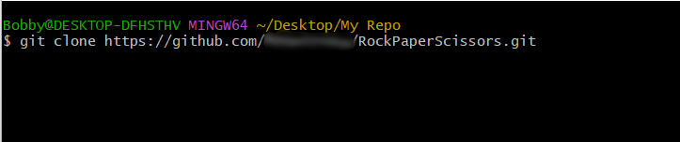
The result should be something like this:
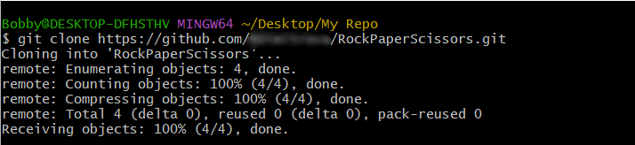
Your files from your GitHub repo will be downloaded to a sub-folder called your project in GitHub, "RockPaperScissors" in our case.
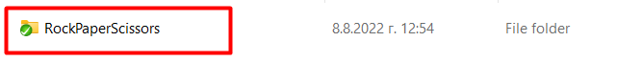
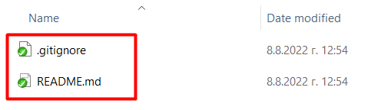
The next thing to do is to add your project files to your cloned repository folder. It should look like this:
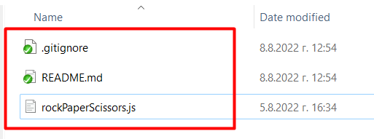
Now we are ready to upload our changes from the "Git Bash clone". Go to the desired folder, right-click on a blank space anywhere in the folder, select "Git Bash Here" and run the following commands.
Type the following command:
git status
The git status command displays the state of the working directory and the staging area.
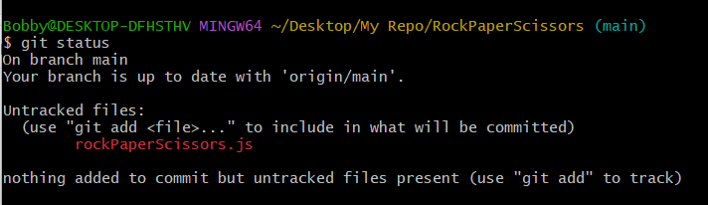
Now type:
git add .
The above command adds all modified files to your local Git repo.
Now type:
git commit -m "Uploaded my first project."
This command commits your changes to your local Git repo. We also should add an appropriate commit message.
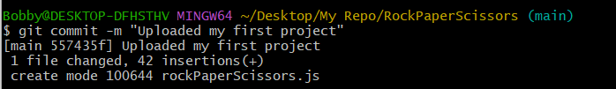
We have two more commands left. Second to the last type.
git pull
This command updates your local repository from GitHub. It downloads the latest project version from GitHub and merges it with your local copy.
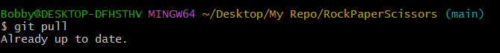
Now the last thing that we should do is to push our changes by using the command.
git push
This command pushes your local changes to GitHub.
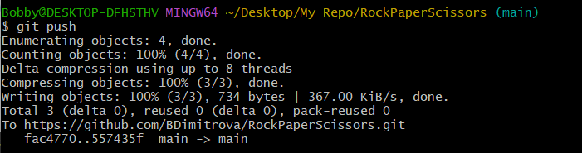
This is all you need to update your repository using Git Bash.
A little more information about Git Bash: https://git-scm.com/about.

Use GitHub Desktop (Option 2)
- If you use GitHub Desktop from the start, after you are done with your project, your GitHub Desktop will look like this:
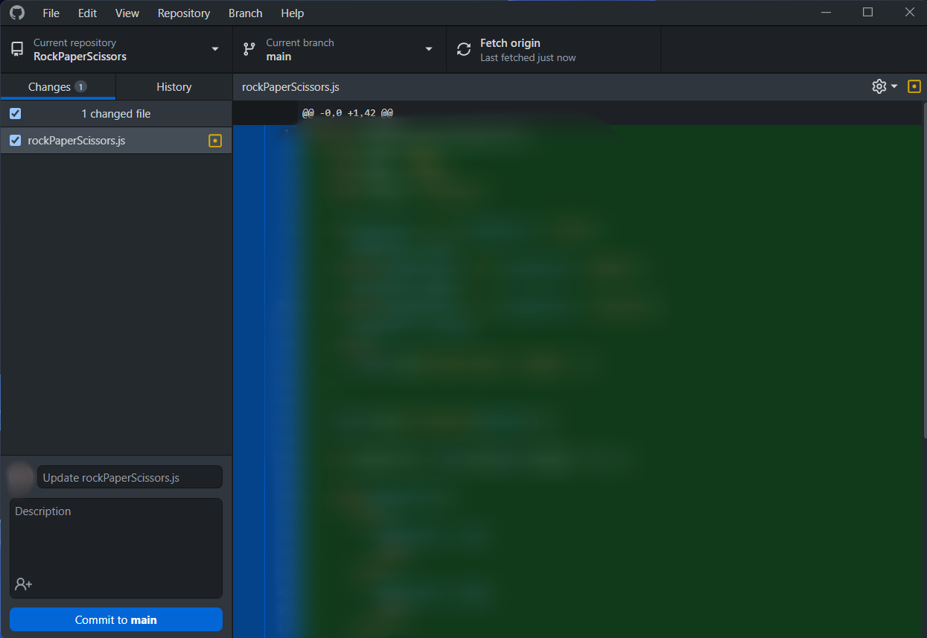
- Create a commit, just like this.
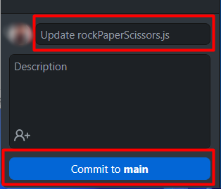
Then push the commit to the repository.
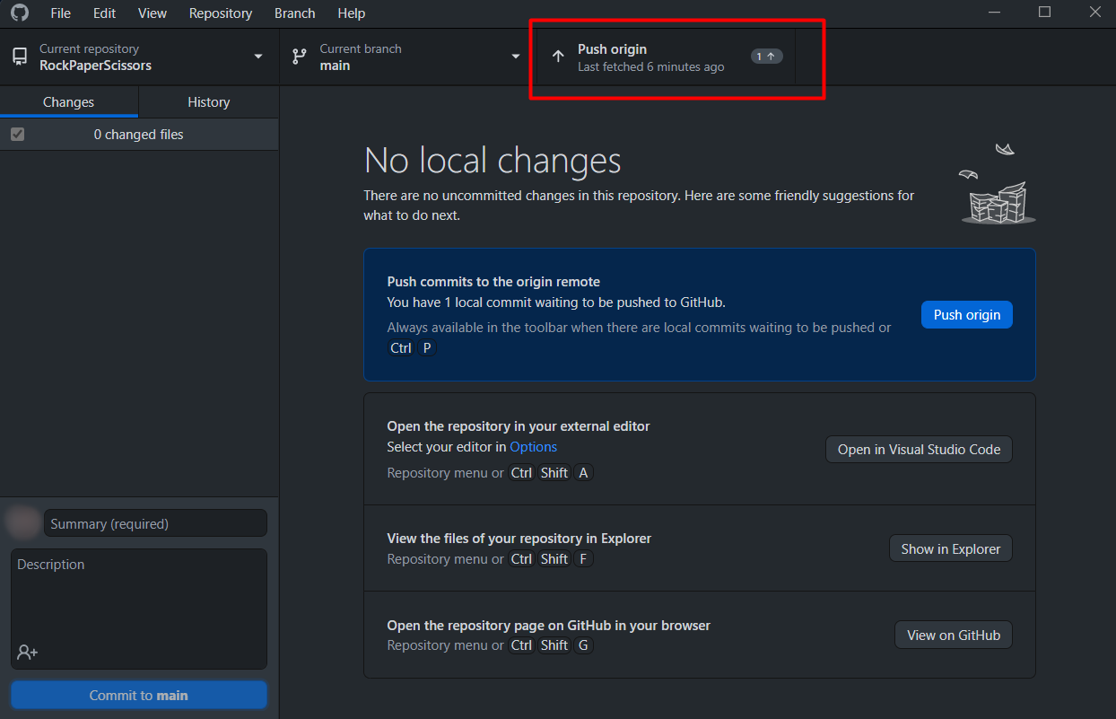
This is all you need to update your repository using GitHub Desktop.

*Modify the Code, Write Your Features
 | This is your project. Be unique. Don’t be a copy/paster!  - Implement your features.  - Implement the code yourself, using your coding style, code formatting, comments, etc.  - Make the project more interesting. Learn by playing with the code and adding your changes.
Below are a few ideas of what you can implement or modify in addition to your code.

Add Colors
You can modify the text color and text background in the console: https://blog.logrocket.com/using-console-colors-node-js/#implementing-console-colors-node-js-apps
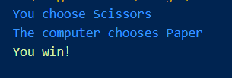
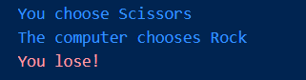
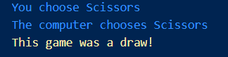

Scoring System
You can add a scoring system and display the player’s and the computer’s scores after each game session.

Additional Ideas
- Can you change your logic, so you can increase the chances of the player winning?
- Can you add anything else to your code based on your ideas?

Commit to GitHub
Now commit and push your code changes to your GitHub repo!
 | It is very important to commit your code frequently to GitHub. This way, you create a rich commit history for your project, and your GitHub contribution graph is growing:  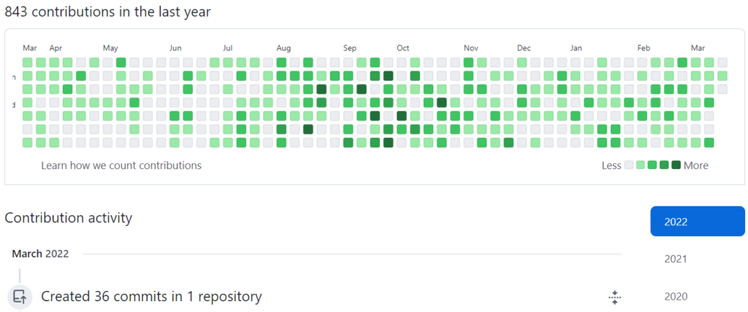

Create a README.md File
It's highly recommended to provide documentation as part of your project on GitHub to describe what the project is doing. So, let's make one for this project. Let's start by editing the README.md file from our repo on GitHub:
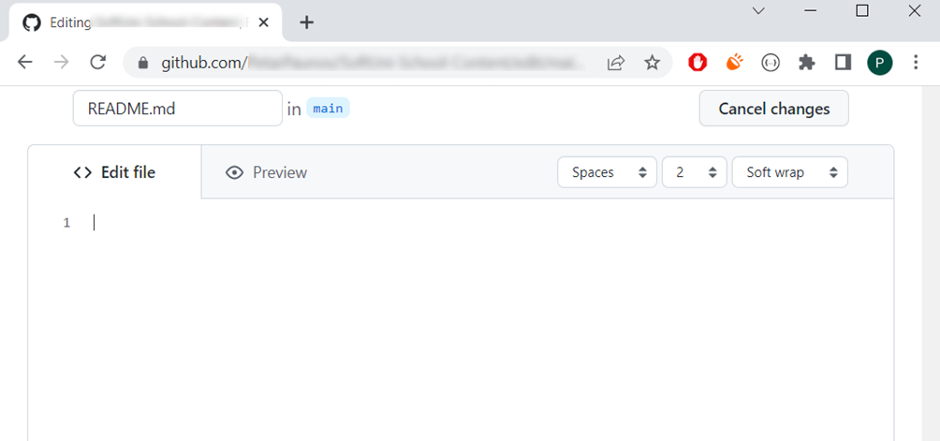
Add a project name. Use "#" in front of the text to indicate the title:
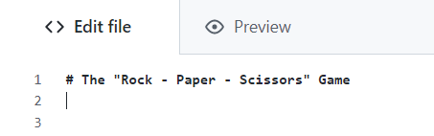
You can view the current progress by pressing the [Preview] button:
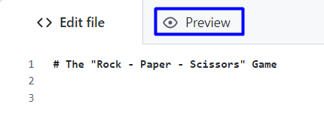
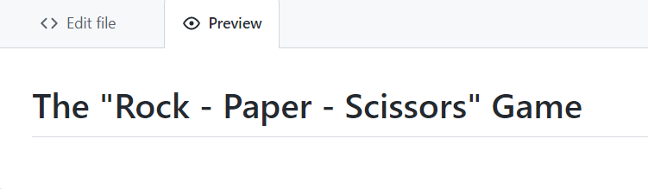

Documentation Sections
Add information about your project in your README.md file: project goals, technologies used, screenshots, live demo, etc. Typically, you should have the following sections:
- Project title (should answer the question "What’s inside this project)
- Project goals (what problem do we solve, e. g., we implement a certain game)
- Solution (should describe how we solve the problem algorithms, technologies, libraries, frameworks, tools, etc.)
- Source code link (give a direct link to your source code)
- Screenshots (add screenshots from your project in different scenarios of its usage)
- Live demo (add a one-click live demo of your code)

Use Markdown
Note that the GitHub README.md file is written in the Markdown language. Markdown combines text and special formatting tags to describe formatted text documents.
You can learn more about Markdown here: https://docs.github.com/en/get-started/writing-on-github/getting-started-with-writing-and-formatting-on-github/basic-writing-and-formatting-syntax.

Project Goals
Start your documentation by describing your project goals. What problem does your project solve?

Sample Documentation
This is an example of how you can document your project. Don’t copy-paste it!
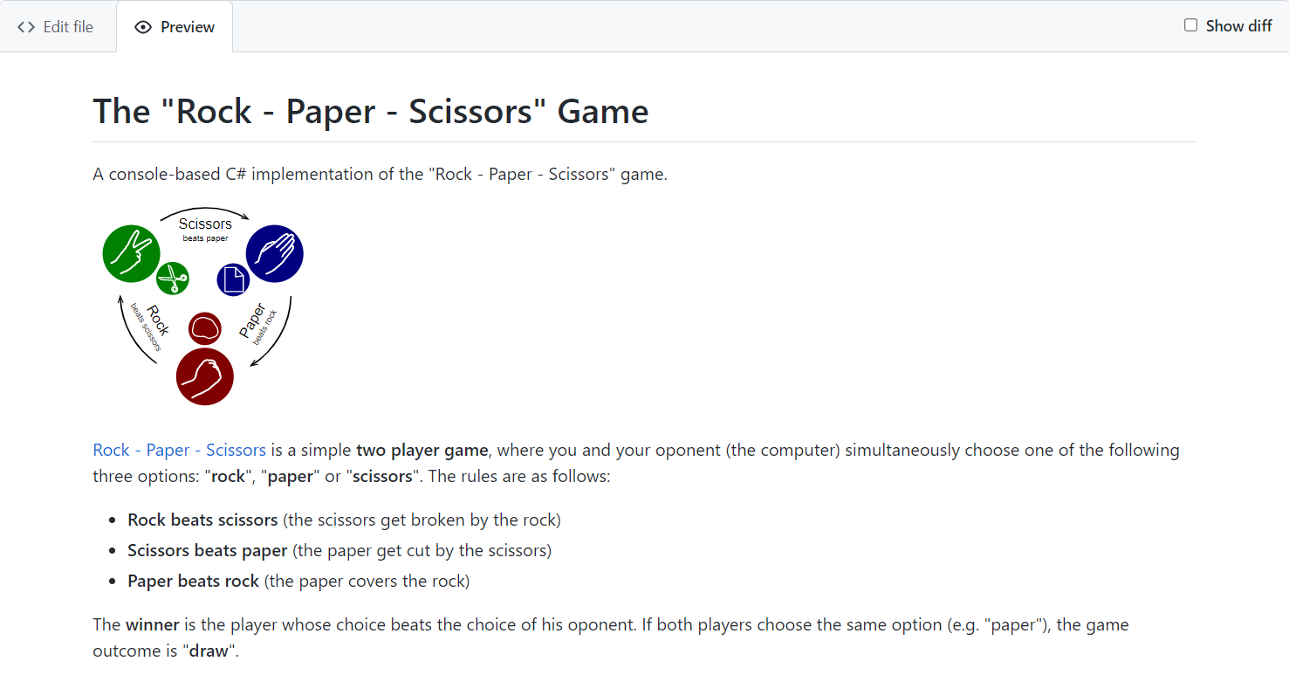
 | Write the project documentation yourself. Don’t copy/paste it!  This is your unique GitHub profile and your unique project. Be different from others.
You can add appropriate images to make your documentation better. You can add an image as follows:
You can add information about the inputs and outputs of the project:
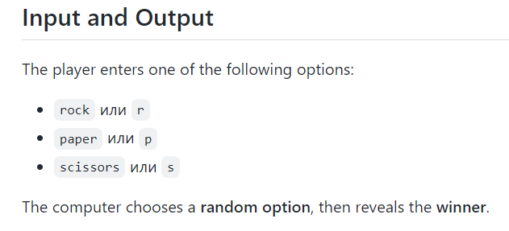

Your Solution
Describe how you solve the problem: algorithms, technologies, libraries, frameworks, tools, etc.
For example, for our simple game, you may analyze all possible game situations in a table:
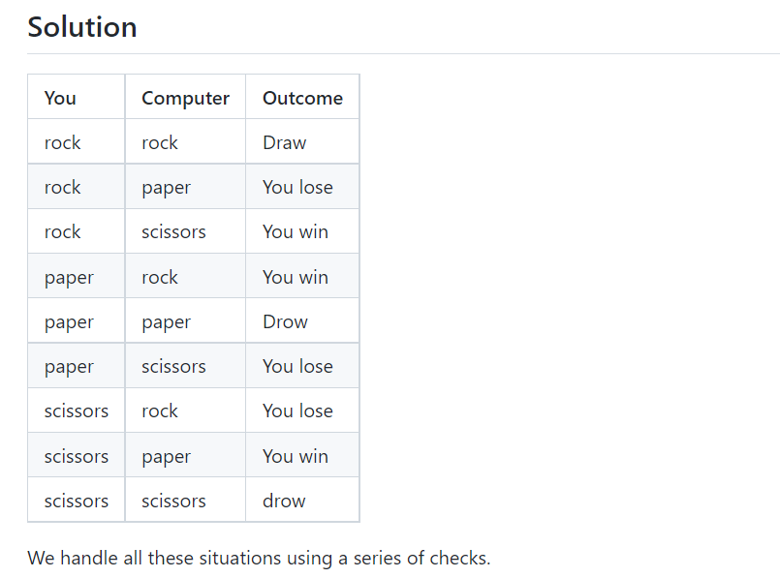

Link to the Source Code
Add a link to your source code as follows:
[Source Code](rock_paper_scissors.py)

Screenshots
Add screenshots of your project:
- Take a screenshot with your favorite tool (e.g., the Snipping Tool in Windows).
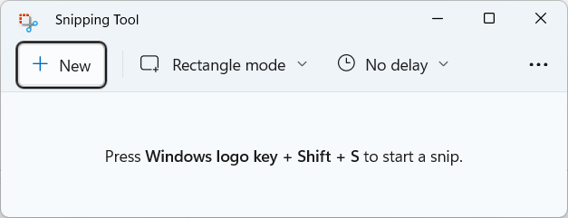
- Paste the screenshot in the GitHub Markdown editor using [Ctrl+V]:
- Take a screenshot with your favorite tool (e.g., the Snipping Tool in Windows).

- Paste the screenshot in the GitHub Markdown editor using [Ctrl+V]:

Upload Your App to Replit
Replit is an online coding environment (online IDE) that allows you to write software projects, share them through a simple link, and run your projects directly in the Web browser. We shall upload our project in Replit to allow the users to run and interact with the project with just one click.
Create your Replit profile so you can show your projects to your friends and put "live demo links" in your GitHub project documentation. Create a Replit account for free: https://replit.com.

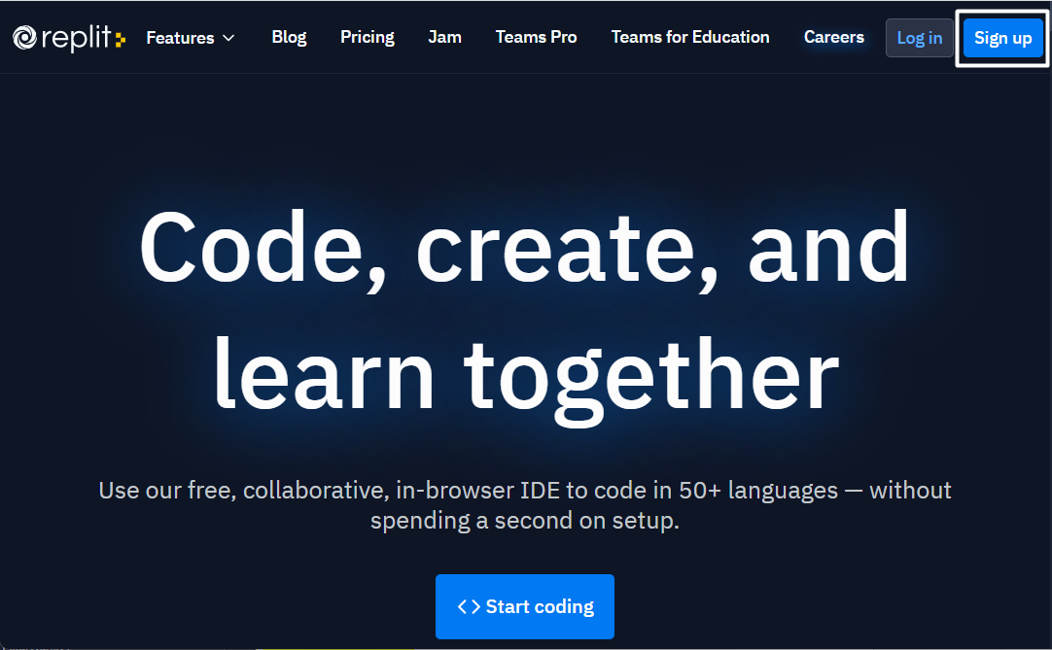
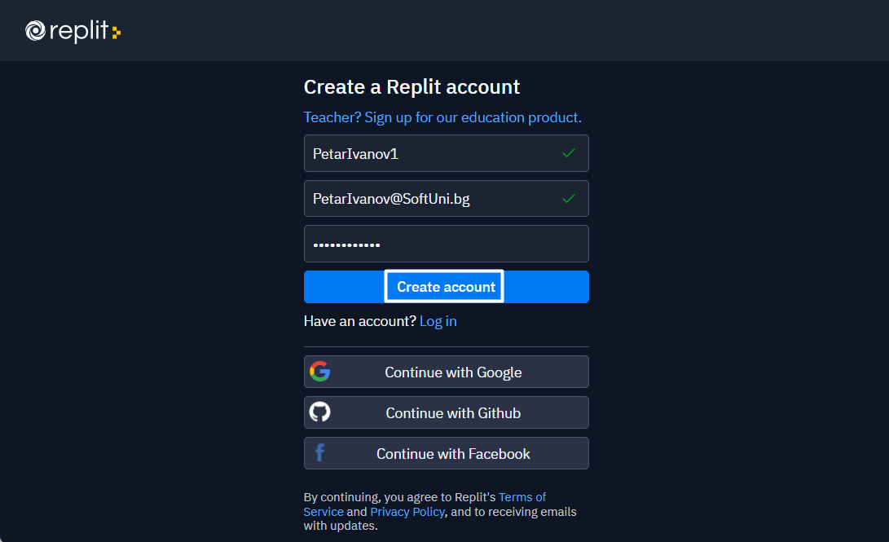
Create a new project in Replit, open the menu in the upper left corner.
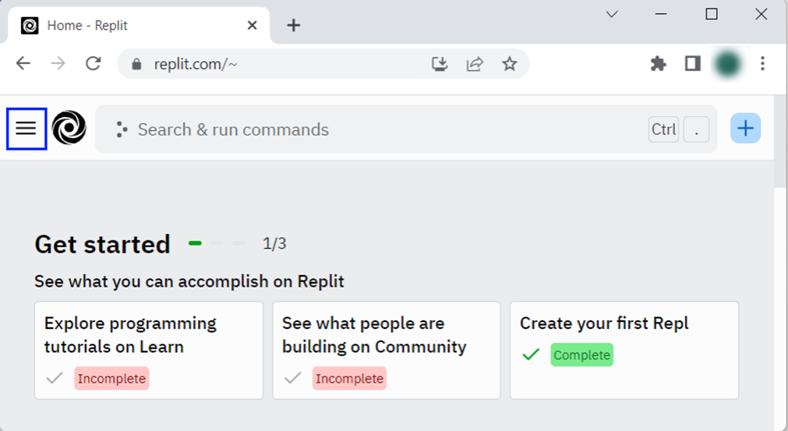
Click [Create], then select the language in which your project is written, select a name, and create the project.
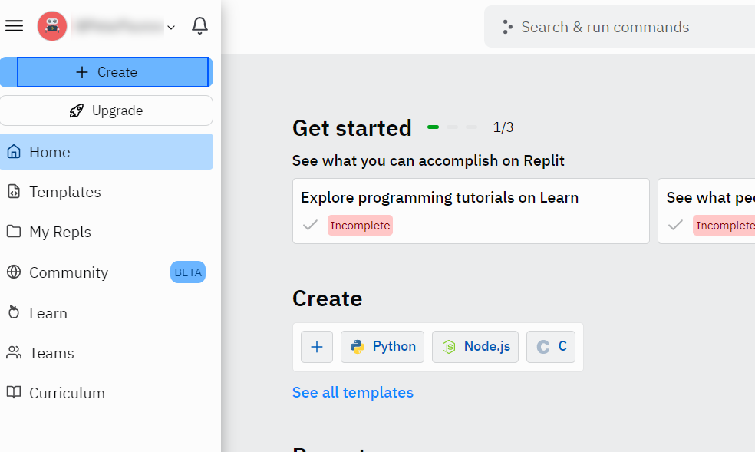
Chose "Node.js" for your project.
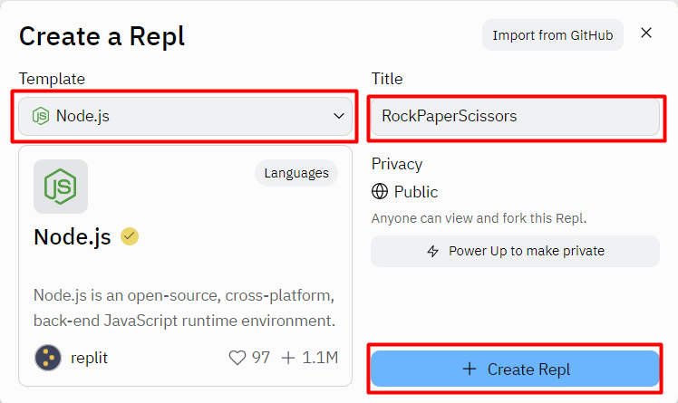
Add a meaningful name to your Replit project, e.g., "RockPaperScissors ".
Paste your code in the "rockPaperScissors.js" file:
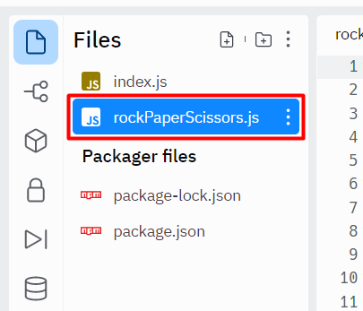
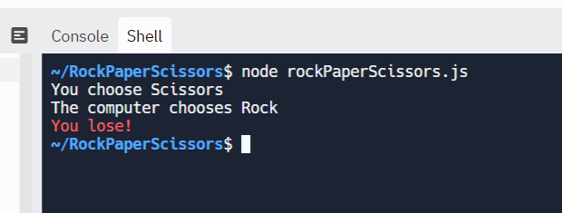

Add Replit Link to Your README.md
Now add a "one-click live demo" of your project from your GitHub project documentation. You can do it as follows:
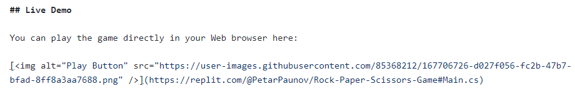
You can take a screenshot from Replit.com and paste it into the GitHub documentation editor directly with [Ctrl+V].
When the [Run] button is clicked, you will be redirected to your demo in Replit.
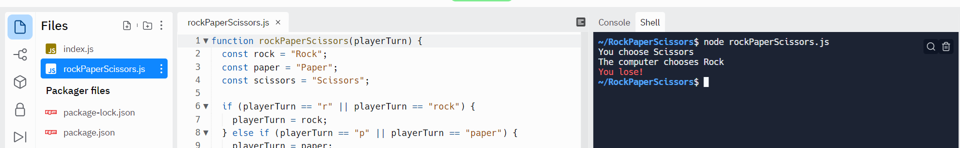
Now we have completed our first console game, and we have our first project in our GitHub portfolio.

