Play this 2-minute fishing game and beat our high score!

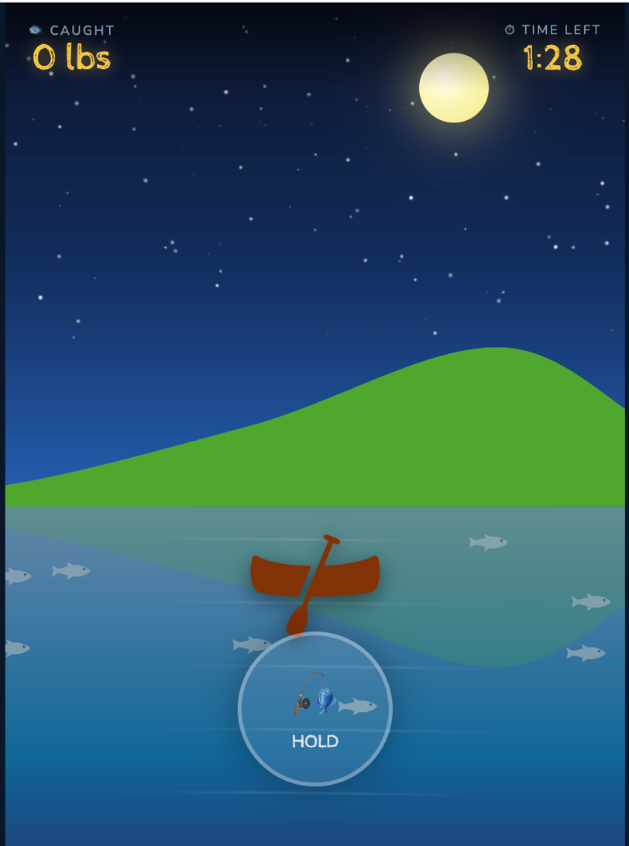
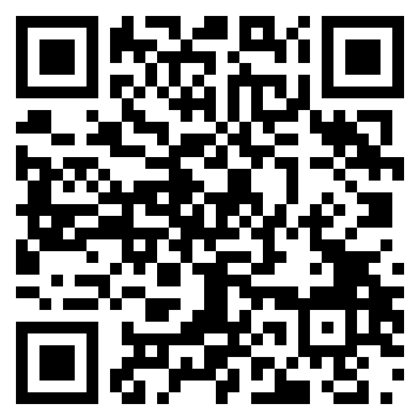
Scan QR code:

Press and hold the button to cast and wait for a fish
Release when you get a bite or when you’re done waiting

Discussion with participants:
In this game, you have to balance between waiting for a current reward and moving on to a future reward. A lot of the tasks you do in everyday life are just like this. To do well in this game, you have to understand what the opportunity cost of waiting for a fish is. In other words, how many future fish do you give up when you wait an extra second for this current fish?
We use these kinds of tasks, which are called foraging tasks, to understand how the brain incorporates information from the world in order for you to make good decisions. Important components include the dopamine reward system that located in the middle of the brain and decision-making circuits that engage areas in the prefrontal cortex, like the orbitofrontal cortex [can show these regions on the plastic brain]. Neuroscientists use versions of this task in mice while recording the electrical activity of neurons in these brain areas to understand how the brain works during foraging. Studying how these systems work in animals teaches us about how they work in humans.
These tasks also teach us about what can go wrong in our brains when a person has a disorder like depression or an addiction. For example, if your brain overestimates how many future fish you could catch, you might decide to always leave early or not try too hard to catch the fish. Our lab found that this change in behavior is correlated with depression. As another example, if your brain underestimates how many future fish are out there, you might ignore the time you waste waiting for this current fish and just focus on it. This behavior is maybe more like an addiction or a compulsion.
Overall, these decision-making games give us insight into how people (and their brains) make decisions, and we are hoping we can use them to better understand and treat mental health conditions.

