My model(CNN from scratch)

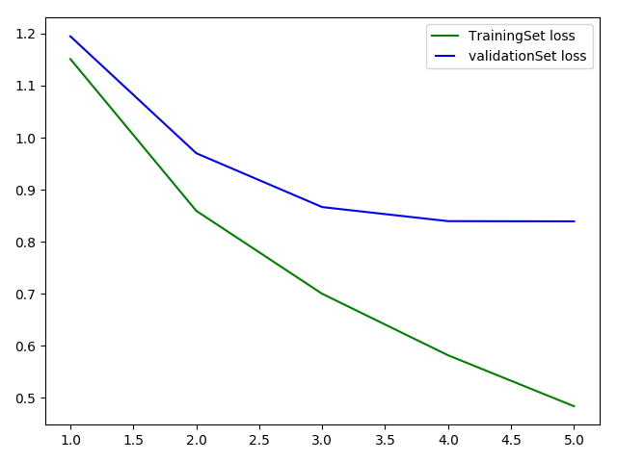

conv matrix:

[[768 18 31 19 18 12 4 7 84 39]
[ 19 832 4 16 3 5 3 0 44 74]
[ 84 6 578 63 61 108 30 33 25 12]
[ 21 11 57 492 38 282 31 28 22 18]
[ 24 3 84 69 582 92 37 85 20 4]
[ 13 1 40 134 25 717 8 45 10 7]
[ 11 5 54 114 28 61 695 7 14 11]
[ 13 5 25 33 32 102 3 764 7 16]
[ 51 30 9 10 6 6 1 0 867 20]
[ 34 110 6 17 4 7 1 7 37 777]]

GO NEXT PAGE

preTrained (resnet)

