**Twitter Rumor Detection**

**User Manual**

1. Main Window –

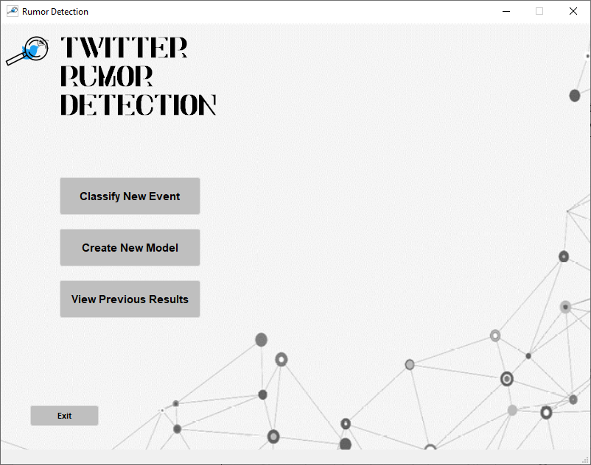

* “Classify New Event” – this button will allow you to classify an event using an existing model in the classify event window.
* “Create New Model” – this button will allow you to train a new model in the new model window.
* “View Previous Results” – this button will allow you to view the previously classified events in the previous events window.
* “Exit” – pressing this button will exit the application.

1. Classify event window –

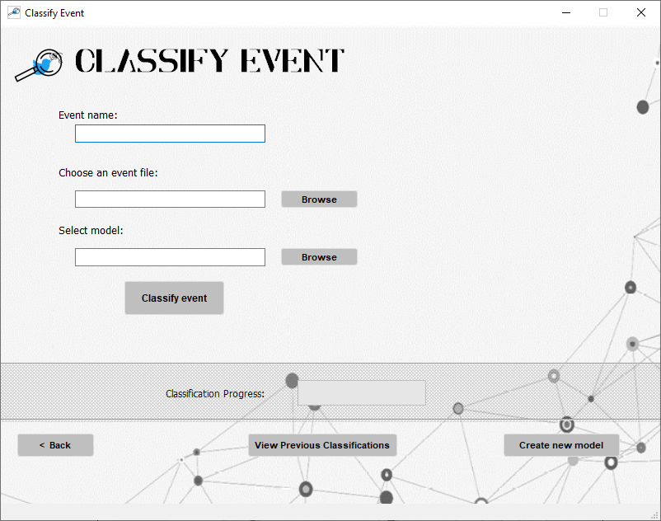

In this window you will be able to classify an event using a trained model. The results will be shown in a pop-up window and they also will be saved so you will be able to see them later.

* “Browse” – these 2 buttons will allow you to choose a file from your file explorer. The requested files’ format is .xls. the path will then be shown in the relevant text box.
* “Classify event” – this button will start the classification process.
* “< Back” – go back to the main window
* “View Previous Classifications” - this button will allow you to view the previously classified events in the previous events window.
* “Create New Model” – this button will allow you to train a new model in the new model window.

During the classification, all the buttons will be blocked, and the progress bar will show you the progress of the classification:

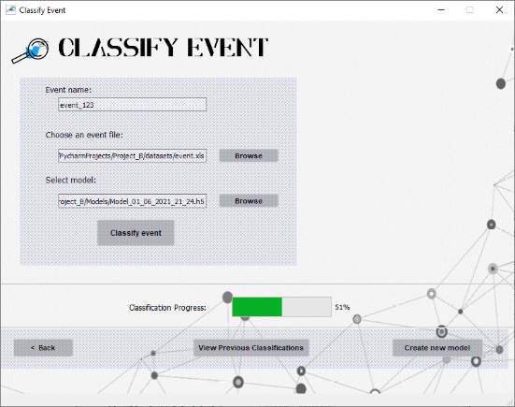

In the end, the pop-up message will appear: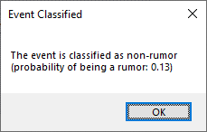

1. Create new model window –

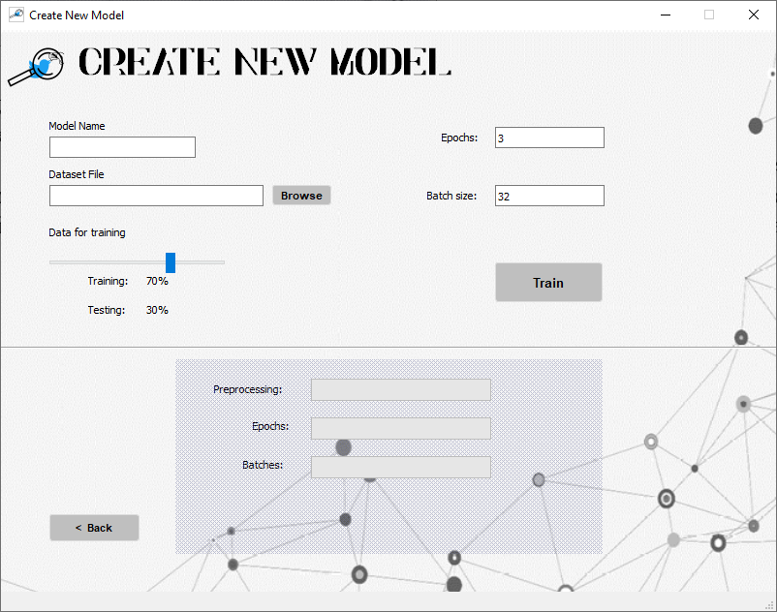

In this window you will be able to train a new model and set its parameters.

* “Browse” – this button will allow you to choose a file from your file explorer. The requested file’s format is .xls. the path will then be shown in the relevant text box.
* Train/test slider – this slider allows you to change the train/test split in the training process. Change in the slider will change the train/test percent that appear below it accordingly.
* “Train” – this button will start the training process.
* “< Back” – go back to the main window

After pressing “Train”, the parameters and buttons will be blocked, and the progress bars will become active and show the progress of the train:

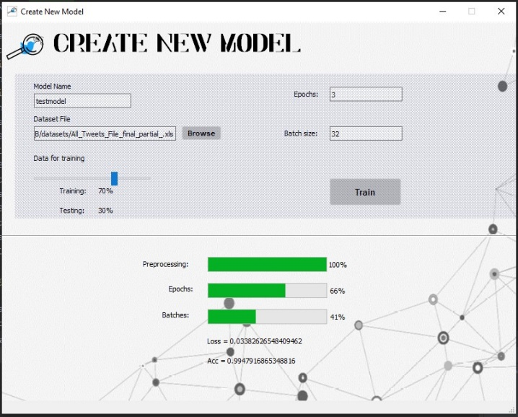

When the training process is finished, a pop-up window will appear, and you will be able to save the trained model:

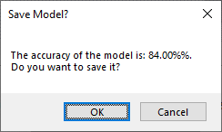

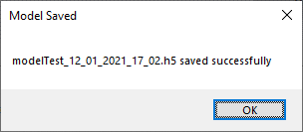Pressing cancel will take you back to the main window. Pressing OK will save the model in the “Models” directory and the name will include the date and time it was created (to avoid name duplications):

1. View Previous Classifications –

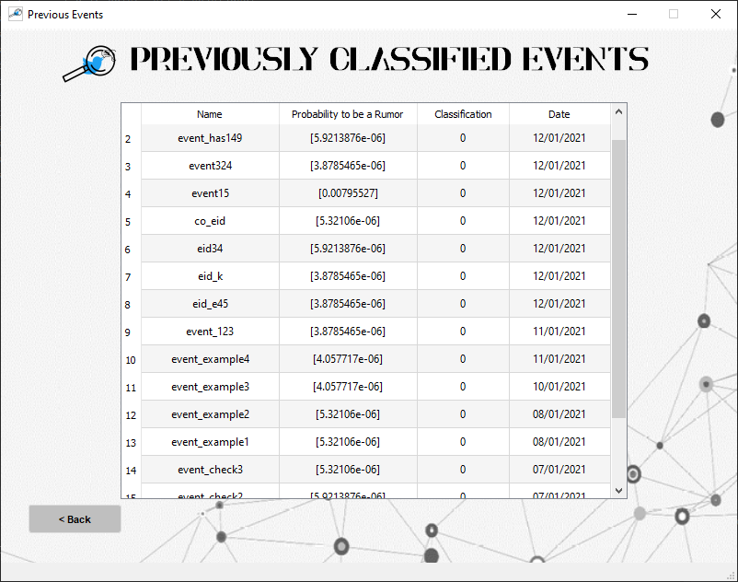

This window will allow you to view all the classifications that were made.

For each event you can see its name, the probability to be a rumor, the final classification, and the date that the classification was performed.

* “< Back” – go back to the main window

Notes:

* When performing a training on a dataset, the model creates a “clean” version of that dataset, removing URLs, emojis and other non-words. The model then uses the newer dataset to train. The new file has the same name but with the addition of “_RES” in the end.
* The classification process uses the dataset again for the TF-IDF calculation and the use file is: “DatasetForClassification.xls” (in the datasets directory. When performing a classification, it is important to make sure that this file contains your cleaned dataset.