**Experienced Full-Stack Developer – Saoud Asla**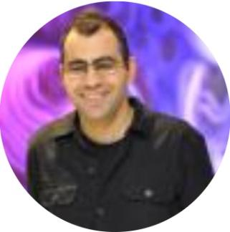

**Name:** Saoud Asla

**Cell Phone:** +972-053 4825 323

**Address:** Nazareth, Israel

**Email:** [saoud.asla@gmail.com](mailto:saoud.asla@gmail.com)

**Education**

**2014 – 2019: B.Sc., Applied Computer Science,** Heidelberg University (Best German university in the Academic Ranking 2019)

* **Topic of the bachelor thesis:** Real-Time Non-Photorealistic Rendering for Video Sequences (with implementation using C++ and OpenGL: https://pille.iwr.uni-heidelberg.de/~npr01/)

**Work Experience**

* **12/2019 – 08/2020** Java Full Stack engineer, Accenture Technology Solutions GmbH (Germany)

Application development in **Java**, **Spring** **Framework**, **Angular**, **CSS3**, **JavaScript**, **HTML5**, **Git**

Development of cloud native applications.

Certificate of excellent results in all tasks, flexibility, loyalty, impeccable personal behavior, personal integrity and the ability to work in a team (08/2020) : <https://docs.google.com/document/d/1kiw7ZjMqMroQU2ZcE7OT3k_ZFLwmbOInMkpxd6B0T1o/edit?usp=sharing>

* **07/2019 – 09/2019** Java Full stack development - practical training course by Tsofen in cooperation with Amdocs:

Assisted in the development of Project for assigning skilled employees to relevant worldwide projects, based on **Java EE** in Back End and **React** in Front End.

* **Apr 2019 - Jul 2019** Developing User-extensible dictionary (website) for Arabic-German translation, based on **Java EE, Spring, Spring Security, JPA** and **Hibernate** in Back End and **React, Html5, CSS3** in Front End.

**Certifications**

* **30/06/2020:** Microsoft Azure Fundamentals
* **24/01/2020:** Oracle Certified Associate, Java SE 8 Programmer
* **08/01/2020:** Professional Scrum Master (PSM 1)

**Technical Skills**

* **Java**, C, **C++,** C#, PHP, Python
* ASP.NET, **SQL**, **MySQL**, **HTML5**, **CSS3**, **JavaScript**, **ECMAScript**, **React**, Angular, Node.js
* Windows, Linux
* **Spring**, **Hibernate**, **OpenGL**, OpenCV, DirectX, QT, Visual Studio, Android Studio, **Eclipse**, **Git**

**Language Skills**

* Arabic (first language), Hebrew (very good), English (very good), German (professional)

**Interests and Hobbies**

* **Interests** **(in the field of computer science):** Full Stack Development, embedded systems, computer graphics and visualization
* **Hobbies:** Reading, traveling, sports, programming