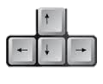Movement Drop a bomb

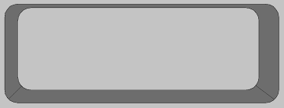

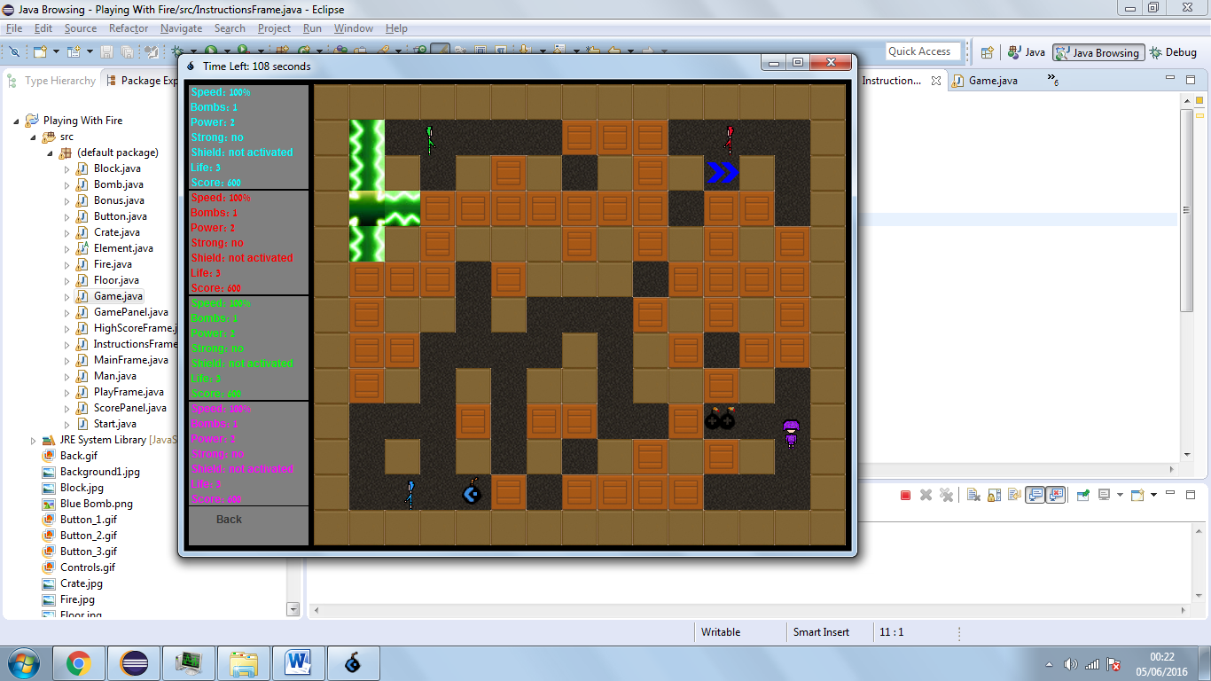

Explode crates to get bonuses that will help you DESTROY the other players!

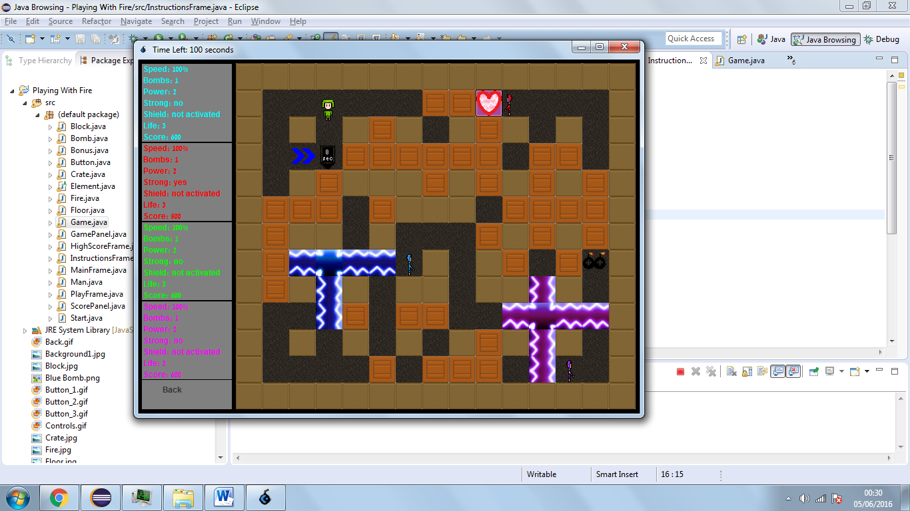

BE AWARE of your enemies' bombs as well as your own, as you have ONLY 3 SECONDS to run for your life!

*The winner is the last survivor or the player who has the highest score after 2 minutes.*

Bonuses: ****

**

**

*Life Speed Strength Shield Bomb Bomb Power*