LEASING SWD
Commercial Leasing, Billing & Investor Disbursement Platform
Application Architecture & On-Premise Deployment Document
Smart World Developers — Gems-2 (Adhikaansh), Sector-89, Gurugram
Prepared for: HOD & Infrastructure Team | Version 1.0 | August 2026

Table of Contents

1. Application Overview
Leasing SWD is an internal web application that manages the complete commercial leasing lifecycle for Smart World Developers’ retail assets — currently the Gems-2 (Adhikaansh Realtors) commercial development at Sector-89, Gurugram (blocks Commercial 06 / 08 / 09, 90 leasable units).
Functional modules:
- Masters — Company, Project, Block, Unit, Brand and User management with role-based access
- Leases — MG / MG-vs-Revenue-Share / Pure RS / Variable RS rental structures with LOI, CD, possession, CAM, brokerage and security-deposit tracking
- Billing — Automated monthly invoice generation (MG, RevShare, CAM, Utility, Ad-hoc) with GST bifurcation (CGST/SGST/IGST), HSN/SAC, PAN/GSTIN, bank details and payment terms
- Collections — Receipt entry with TDS capture and security-deposit adjustment
- Investor Disbursement — Investor-owned unit registry (maker-checker) and monthly NEFT/NRI rent disbursal processing
- Reports — Disbursement, hold-rent, SD liability, SAP GL entry book, GST / TDS / Agreement / SD reconciliations, Excel (CSV) exports
- Alerts — Dashboard notifications for bills not raised, overdue invoices and payments due within 7 days

2. Technology Stack
Layer | Technology | Notes
Frontend | React 18 + Vite 5 | SPA, built to static files (dist/)
Styling | Custom CSS | No external UI framework
Backend | Node.js 18+ / Express 4 | REST API, stateless
Auth | JWT (jsonwebtoken) + bcryptjs | 8-hour token expiry, RBAC
Database | Microsoft SQL Server 2014+ | mssql (tedious) driver, schema: leasing
Process manager | PM2 or NSSM | Run Node as a Windows service
Web server | IIS (ARR) or Nginx | Serves frontend + reverse-proxies /api

3. Deployment Architecture
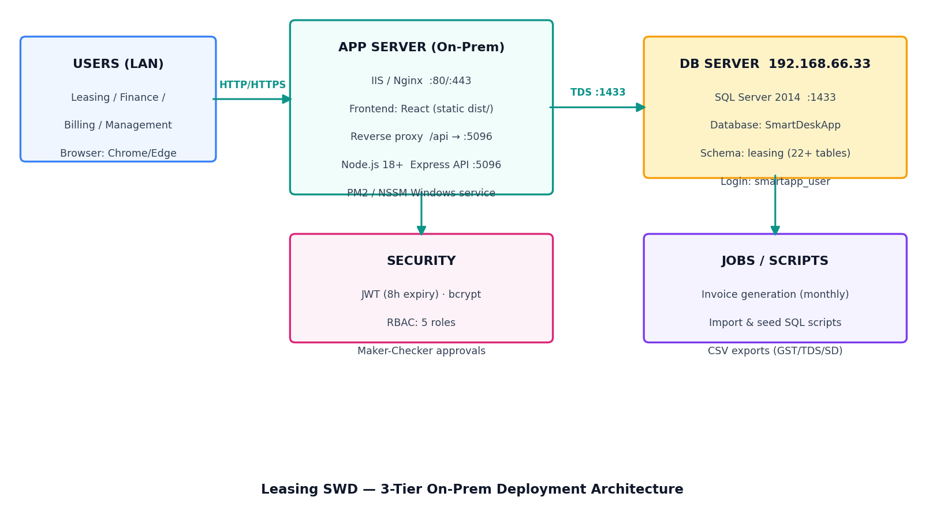
Three-tier layout: users on the corporate LAN reach the app server over HTTP/HTTPS; the app server hosts the static React frontend and the Node/Express API as a background service; the API connects to the existing SQL Server (192.168.66.33) over TDS port 1433. No internet exposure is required — the application is LAN-only.

4. Repository Structure
Path | Purpose
backend/server.js | Express entry point — registers routes, auth middleware, port 5096
backend/db.js | SQL Server connection pool (env-driven), schema prefix helper
backend/routes/ | auth, masters, leases, sales, invoices, collections, investors, disbursement, reports, userAdmin, deletionRequests
backend/lib/ | billing.js (GST split, invoice engine), helpers, brand fields, delete gate
backend/sql/schema.sql | Base schema — 22+ tables under the leasing schema
backend/sql/migration_v2.sql | Finance-requirements migration (GST bifurcation, PAN/GSTIN, HSN, SD adjust, settings)
backend/sql/seed_gems2_units.sql | Direct SQL seed — 90 Gems-2 units
backend/sql/update_gems2_details.sql | Unit type / PLC / covered area / RERA updates from Excel
backend/import_gems2.js | API-based inventory import (alternative to SQL seed)
frontend/src/App.jsx | All views: dashboard, masters, leases, billing, disbursement, reports
frontend/src/api.js | REST client with JWT header injection
frontend/src/helpers.js | Master schemas, navigation, permissions metadata
frontend/dist/ | Production build output (deployed to web server)

5. Server Requirements
Item | Minimum | Recommended
OS | Windows Server 2016 / Ubuntu 20.04 | Windows Server 2019+
CPU | 2 vCPU | 4 vCPU
RAM | 4 GB | 8 GB
Disk | 20 GB | 40 GB SSD
Node.js | v18 LTS | v20 LTS
Network | LAN access to 192.168.66.33:1433 | Static IP + internal DNS name
Concurrent users | ≤ 25 | ≤ 100
The database tier already exists (2023-DT1 / 192.168.66.33 — SQL Server hosting SmartDeskApp). Only an application server is needed.

6. Network & Port Matrix
Source | Destination | Port / Proto | Purpose
User LAN | App server | 80 / 443 TCP | Web UI (HTTP/HTTPS)
App server (local) | App server | 5096 TCP | Express API (behind reverse proxy; not exposed to LAN)
App server | 192.168.66.33 | 1433 TCP | SQL Server (TDS)
Admin PCs | App server | 3389 / 22 | RDP / SSH administration
Firewall notes: allow only 80/443 inbound to the app server from user VLANs; port 5096 should be bound to localhost or blocked externally; ensure the SQL Server firewall permits the app server IP on 1433.

7. Environment Configuration (backend/.env)
Variable | Example | Description
DB_SERVER | 192.168.66.33 | SQL Server host
DB_DATABASE | SmartDeskApp | Database name
DB_SCHEMA | leasing | Schema for all app tables
DB_USER / DB_PASSWORD | smartapp_user / **** | SQL login (db_owner on SmartDeskApp or DML + DDL on leasing schema)
DB_PORT | 1433 | SQL port
PORT | 5096 | Express API port
ADMIN_ID / ADMIN_PASSWORD | admin / **** | Bootstrap admin login
JWT_SECRET | (random 32+ chars) | Token signing key — MUST be changed for production
Security note: production values (DB password, JWT secret, admin password) must be rotated from development values and stored only on the server.

8. Deployment Steps (Windows Server + IIS)

8.1 One-time database setup
- Run backend/sql/schema.sql (or schema_existing_db.sql) in SSMS against SmartDeskApp
- Run backend/sql/migration_v2.sql — finance columns (idempotent)
- Run backend/sql/seed_gems2_units.sql then update_gems2_details.sql — Gems-2 inventory (already executed)

8.2 Backend (API service)
- Install Node.js LTS on the app server
- git clone https://github.com/aviverma007/Leasing_swd.git (or copy release ZIP)
- cd backend && npm install --production
- Create backend/.env with production values (Section 7)
- npm install -g pm2 && pm2 start server.js --name leasing-api && pm2 save (or register with NSSM as a Windows service)
- Verify: http://localhost:5096/api/health returns { ok: true }

8.3 Frontend (static site)
- cd frontend && npm install && npm run build — outputs dist/
- IIS: create a site pointing at frontend/dist on port 80/443
- Install IIS URL-Rewrite + ARR; add a reverse-proxy rule: /api/* → http://localhost:5096/api/*
- Add SPA fallback rewrite: all non-file routes → /index.html
- Bind internal DNS name, e.g. leasing.smartworld.local, and (recommended) an internal TLS certificate

8.4 Smoke test checklist
- Login as admin → Dashboard KPIs load
- Unit Master shows 90 Gems-2 units (38 / 6 / 46 across blocks)
- Create a test lease → Generate invoice → verify GST bifurcation & invoice print view
- Record a collection with TDS → verify TDS reconciliation report

9. Operations: Backup, Monitoring & Recovery
Area | Practice
Database backup | Include SmartDeskApp in the existing SQL backup plan (daily full + hourly log recommended). All application data lives in the leasing schema.
App backup | Application is stateless — repo + .env file is sufficient to rebuild. Keep .env in the infra vault.
Monitoring | pm2 monit / Windows service status; probe GET /api/health every 5 min; disk & CPU via existing tooling.
Logs | PM2 log files (~/.pm2/logs) or NSSM stdout redirect; SQL errors surface in API responses and logs.
Recovery (app) | Reinstall Node, restore repo + .env, pm2 start — RTO under 30 minutes.
Recovery (DB) | Standard SQL Server restore of SmartDeskApp.
Updates | git pull → npm install (if package.json changed) → npm run build (frontend) → pm2 restart leasing-api. Run any new sql/*.sql migration in SSMS first.

10. Security Summary
- Authentication: JWT bearer tokens, 8-hour expiry; passwords hashed with bcrypt
- Authorization: 5 roles (Admin, Leasing, Billing, Finance, Viewer) with per-module access control enforced server-side
- Maker-Checker: investor units and disbursals require second-person approval
- Deletion governance: destructive deletes route through an approval queue (deletion requests)
- Network: LAN-only; API not directly exposed; SQL access restricted to the app server IP
- Secrets: .env stored only on the server; JWT secret and DB password rotated for production
- Audit: ChangeLog table records key actions with user attribution
Prepared by: Anirudh Verma (IT) — for review by HOD & Infrastructure Team.

