Statistical Reporting Module – Technical Design
Overview: This module analyzes an Apache web server log file and generates a statistical report showing the percentage of requests by Country, Operating System (OS), and Browser. The system is designed using a modular pipeline architecture that separates parsing, data enrichment, aggregation, and reporting.
Architecture: The processing pipeline consists of the following stages: Log Parser → Dimensions → Aggregator → Report Generator
- The Log Parser reads the log file and converts each line into a structured LogRecord containing fields such as IP address and User-Agent.
- Dimension modules extract specific attributes from each record.
- The Aggregator counts occurrences of each dimension value and tracks the total number of requests.
- The Report Generator calculates percentage distributions and formats the output according to the requirements.
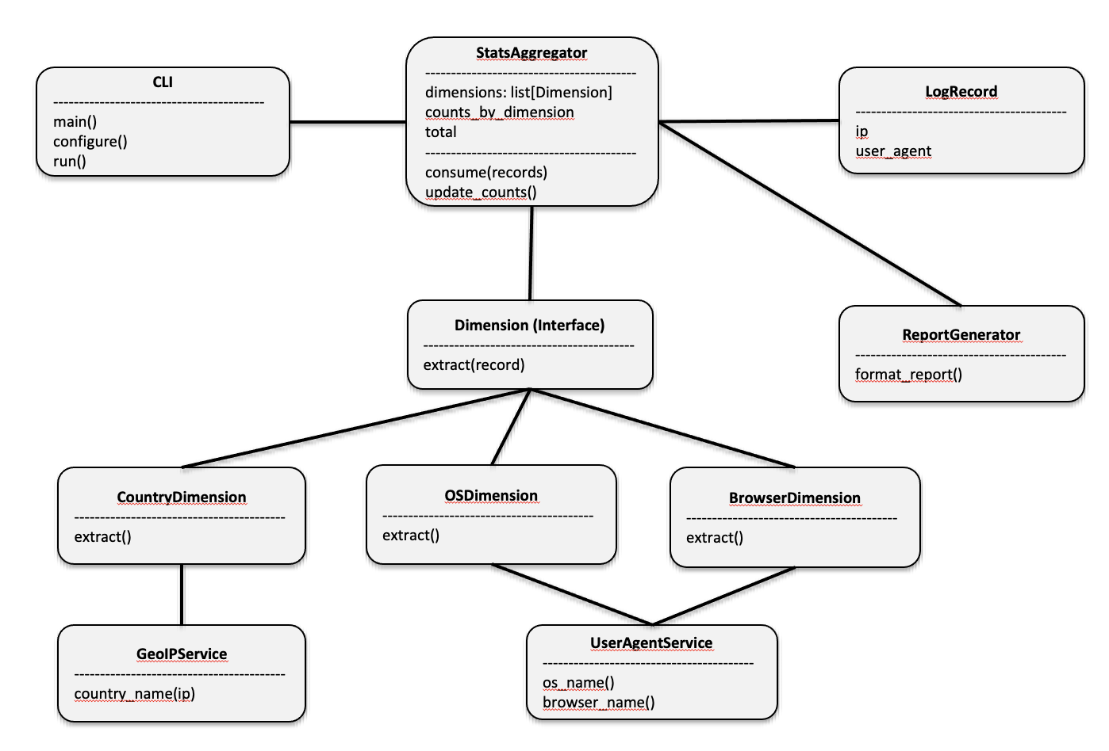
Extensibility: The system uses a plug-in design where each dimension implements a common interface. New dimensions can be added without modifying existing components. Similarly, new output formats can be supported by adding a new report generator.
Technology Choices: Python was chosen for its simplicity and strong support for data processing. The geoip2 library is used for IP-to-country resolution, and ua-parser is used for parsing User-Agent strings. External libraries improve accuracy and reliability while keeping the core system simple.

