Dataset Description and
Data Cleaning for
Ecobee Donate Your Data (DYD):
The Benchmark Datasets Project

Na Luo
Tianzhen Hong

Lawrence Berkeley National Laboratory

March 2022

Acronyms and Abbreviations

CSV | Comma Separated Value
DOI | Digital Object Identifier
DYD | Donate Your Data
HVAC | Heating, Ventilation, and Air Conditioning
JSON | JavaScript Object Notation

1.0 Introduction
Ecobee Inc., founded in 2007, is a Canadian home automation company that makes smart thermostats, temperature and occupancy sensors, smart light switches, smart cameras, and contact sensors. Figure 1 shows an example of the ecobee4 smart thermostat and the remote sensor. The thermostat is mounted to the wall and connects to the home’s heating, ventilation and air conditioning (HVAC) system; while remote sensors are independent, wireless, battery operated devices which send the measured temperature and occupancy information back to the thermostat through a radio channel. Remote sensors can be placed in multiple rooms in the house, ideally within a distance of 13.7m from the thermostat and far away from direct heating and cooling sources [1].
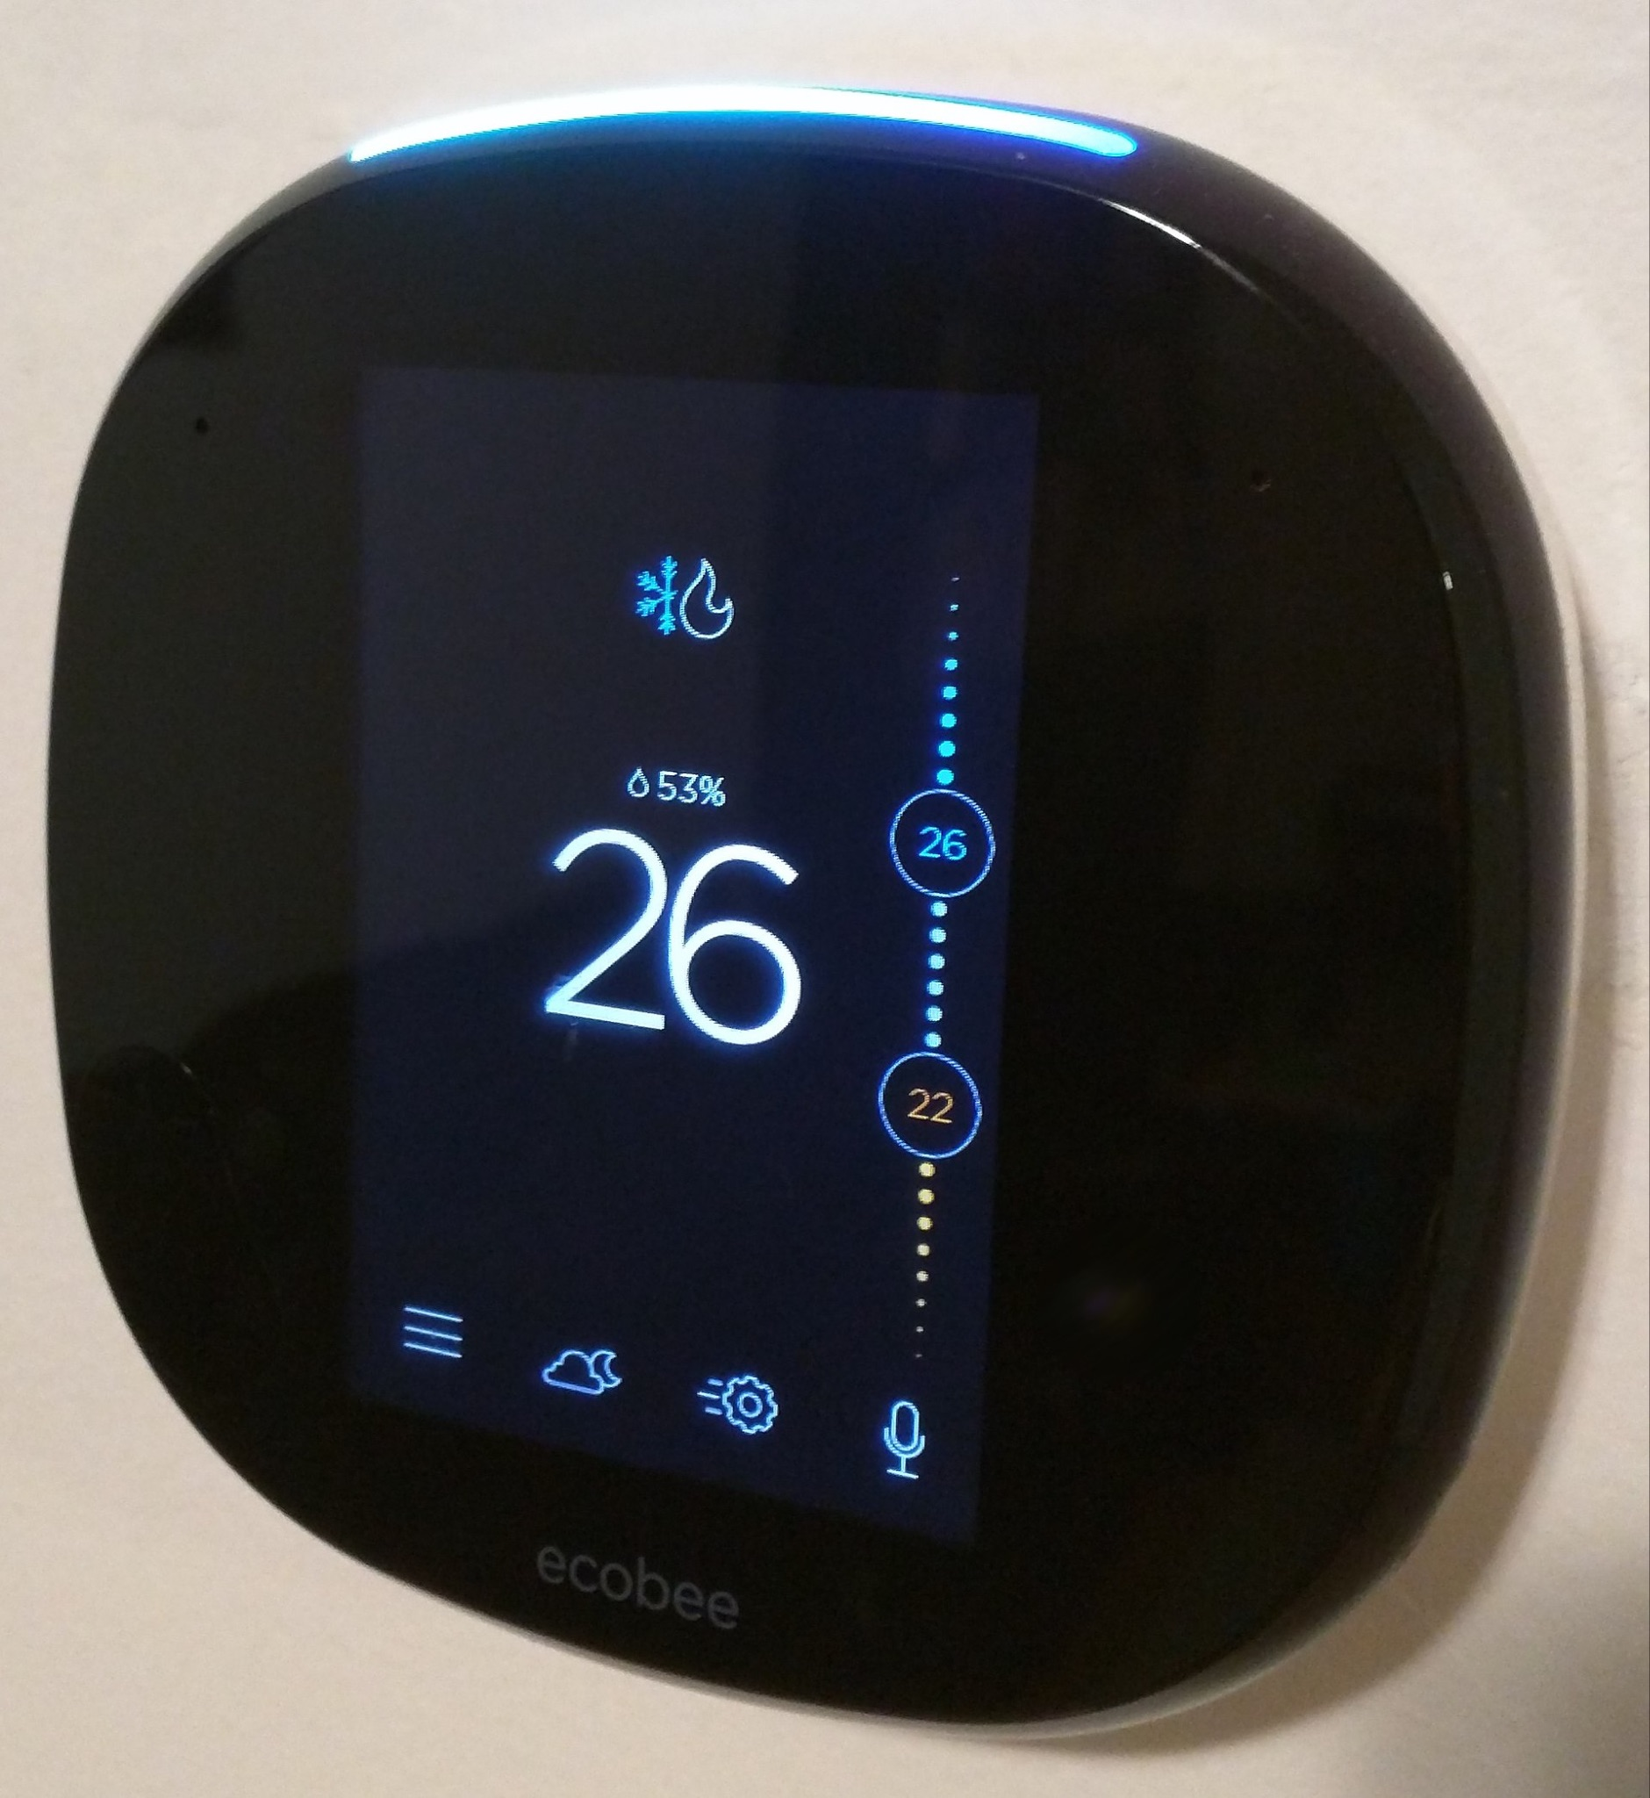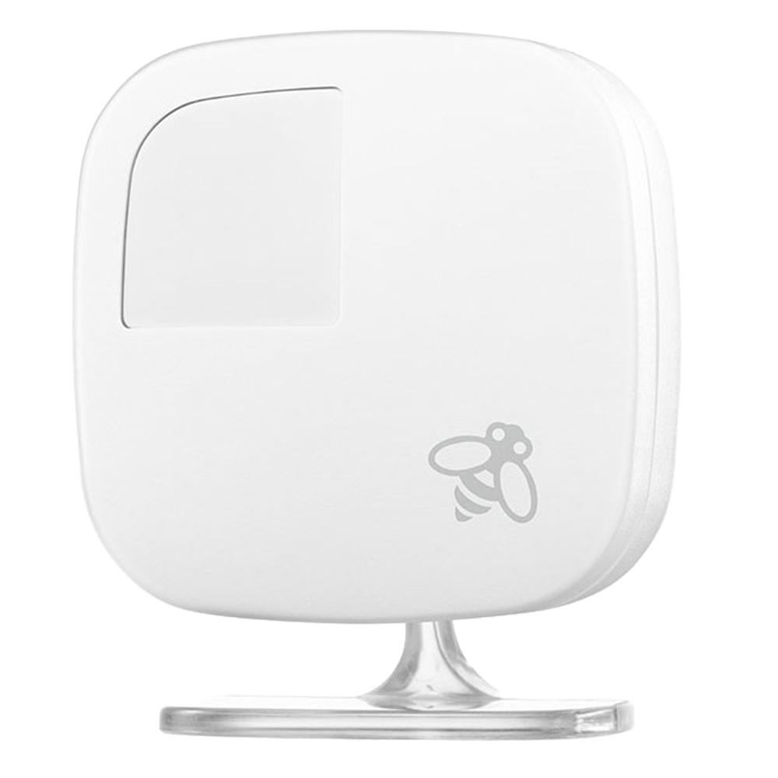
Figure 1. Ecobee4 smart thermostat (left) and a remote sensor (right)
In 2015, Ecobee launched a program called “Donate Your Data” (DYD) to allow users voluntarily share the anonymized data from their ecobee smart thermostats. Research partners (e.g., academic labs, non-government organizations, research institutes) have agreed to use this DYD dataset for non-commercial causes, and the results from their studies will ultimately enter the public domain to achieve the goal of a more efficient and sustainable future.
Generally, the dataset consists of five-minute interval data that is measured by the thermostat and any connected remote sensors the users have placed in their homes. Data records include the thermostat setpoints and motions, the actual indoor temperature, and relative humidity, as well as the run-time for HVAC equipment and devices. Personally identifiable information has been anonymized as a random identifier code. However, metadata information such as the home characteristics (e.g., city, province, floor area, number of floors, vintage, etc.), system characteristics (e.g., heating and cooling types and installation status), occupant characteristics (e.g., number of occupants), as well as user-defined metadata (e.g., housing schedule characteristics and equipment configuration) are all attached within the DYD dataset. Besides, the DYD dataset also contains outside temperature and humidity data collected from nearby weather stations.
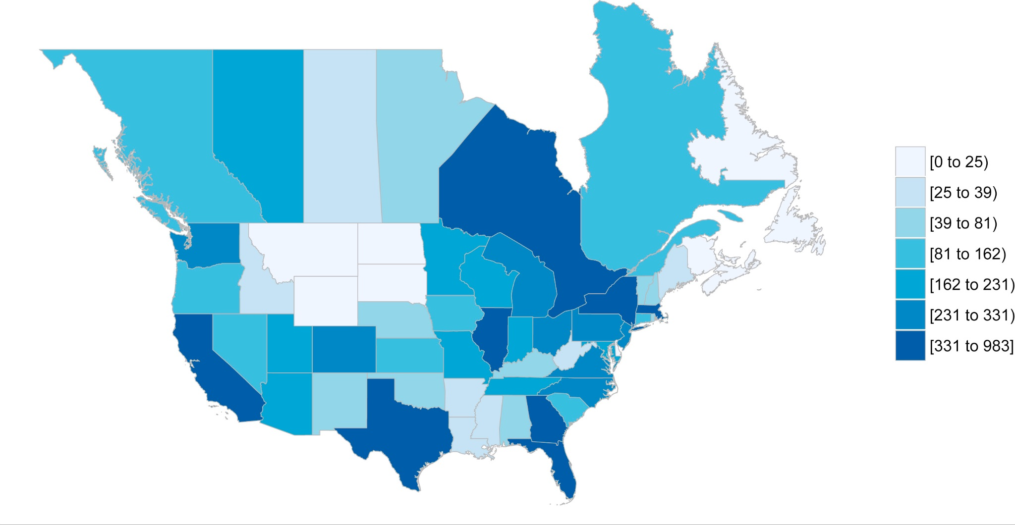
Figure 2. Number of thermostats in the continental U.S. states and Canadian provinces in 2018 (adopted from [2])
The participating thermostats are located across the U.S. and Canada. Figure 2 shows the number of thermostats in the continental U.S. states and Canadian provinces in 2018 [2]. The global data sample size increased rapidly from 7,000 in 2015 to over 100,000 by the end of 2019 [3]. Figure 3 shows the steady growth of the measured thermostats for each U.S. state from September 2015 to August 2018 [4].
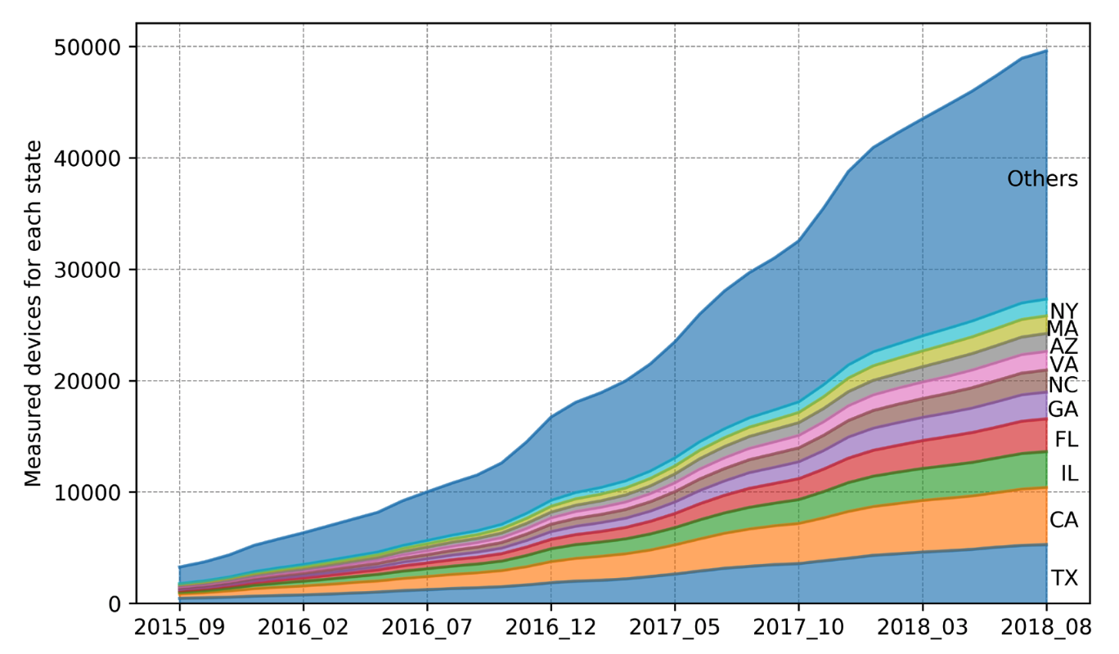
Figure 3. Trend of participating thermostats by state in DYD dataset (adopted from [4])

2.0 Curation of a subset of Ecobee DYD dataset
The Ecobee DYD data that we requested from the Ecobee DYD server were collected from multiple states in the U.S., from 2015 to 2019. Based on the metadata records, the thermostats were installed in multiple residential home types, such as detached single family house, townhouse, condo, apartment, etc. Some homes installed more than one ecobee device, with various generations/versions of the ecobee models (e.g., ecobee3, ecobee3Lite, ecobee4, etc.) as well.
With permission from Ecobee, we queried this Ecobee DYD dataset (2015-2019) to develop a subset of data (1,000 homes in total) based on the following criteria first:
- Data spanning for an entire year of 2017;
- The home type (“Style” in the metadata) is the detached single-family only;
- The generation of the Ecobee thermostat (“Model” in the metadata) is ecobee3 only;
- The selected home (“UserID” in the metadata) has only one ecobee device (“Identifier” in the metadata) installed;
- Covering four U.S. states - CA, TX, NY and IL, which represent four typical climate zones (3C, 2A, 4A and 5A) in the U.S.
We then prioritized the ultimate 1,000 home data from the aforementioned qualified homes based on the summation of two following metrics of the data quality:
- The number of missing data for the variable of thermostat temperature, e.g., displayed as blank, “NaN”, or “Null”;
- The number of wrong/invalid data for the variable of thermostat temperature, when the value is greater than 120ºF or less than -20ºF.
Since the data from NY state is much less than that from the other three states, while CA has much more homes than the other three states, we ultimately selected the 1,000 homes as follows:
- CA - 350 homes/thermostats
- TX - 250
- NY - 150
- IL - 250

3.0 Data File Aggregation and Categorization
The Ecobee DYD data was curated into a subset of 1,000 homes, with data from one home stored in one CSV file. We then packaged these 1,000 CSV files into 12 CSV files, with one file containing one month of data for 1,000 homes. In the raw dataset uploaded to the data portal, 12 CSV files are named by 12 months, from Jan to Dec.
Table 1 shows the various data points contained in each CSV file, in addition to a brief description and the associated units. The data was collected every five minutes, covering user-defined metadata (e.g., event, schedule), measurements from the thermostat (e.g., thermostat setpoints, the actual inside temperature, relative humidity, motion, and HVAC run-time), as well as temperature and humidity information collected from the nearest weather station. Note that energy consumption data is not collected through this system.
Table 1. Data points in the Ecobee DYD dataset
Data Point | Description | Units
DateTime | Date and time that the reading was taken | NA
Event | Items override the set schedule (e.g., a temperature hold, demand response event, vacation, smart recovery feature) | NA
Schedule | User-defined comfort period (e.g., home, away, sleep, etc.) | NA
T_ctrl | Average indoor temperature based on relevant sensors as defined by the schedule or mode the user is in | ºF
T_stp_cool | Indoor cool setpoint | ºF
T_stp_heat | Indoor heat setpoint | ºF
Humidity | Indoor relative humidity | %
auxHeat*  (* = 1,2,3) | Runtime for any heat source other than a heat pump (where 1,2,3 are the stages of the equipment) | seconds
compCool*  (* = 1,2) | Runtime for any cooling (where 1,2 are the stages of the equipment) | seconds
compHeat*  (* = 1,2) | Runtime for heat-pumps used in heating | seconds
fan | Runtime for fan | seconds
Thermostat_Temeprature | Indoor measurement at the thermostat | ºF
Thermostat_Motion | Detects motion at that date/time | boolean
Remote_Sensor_*_Temperature  (* = 1,2,3,4,5) | Indoor temperature measurement at the remote sensor (where 1,2,3,4,5 denotes different sensors) | ºF
Remote_Sensor_*_Motion  (* = 1,2,3,4,5) | Detects motion at that date/time at the remote sensor (where 1,2,3,4,5 denotes different sensors) | boolean
T_out | Outdoor temperature for nearest weather station | ºF
RH_out | Outdoor humidity for nearest weather station | %

4.0 Data Gap Filling
The data cleaning and gap filling process was conducted using the data pipeline that the project team has developed. The raw data file is first read into the pipeline by a user-defined file handler. Output from the filehandler is then organized and standardized through user-defined yaml configuration files, where variable names and metadata are specified. Data will then be run through quality control functions built into Tsdat, which are also specified in the yaml configuration files.
During the first round of curation described in Section 2.0, we have selected 1,000 homes with the best data quality. The data quality for the raw dataset that we uploaded to the data portal is already pretty promising, with the missing rate lower than 3%. Most of the data gaps are scattered through the dataset, normally not extended for more than two hours. Therefore, in the data pipeline, we applied simple linear interpolation to fill in all gaps that are less than 120 minutes; for those gaps larger than 120 minutes, they will remain blank to avoid the potential inaccuracy using linear interpolation, or expensive computational resources if using other more advanced interpolation algorithms.
After filling the data gaps, the cleaned dataset has a missing rate less than 0.2%.

5.0 Analysis and Diagnostics of the Data Gap Filling
The data pipeline is capable of visualizing the data variable before and after the gap filling. Figure 4 and Figure 5 show the outdoor temperature data and the outdoor humidity data, respectively, from one particular home in January, 2017. The missing rate for the raw data is 0.3%, with gaps scattered through this month. The blue line represents the raw data, while the orange line represents the filled values following the simple linear interpolation algorithm.
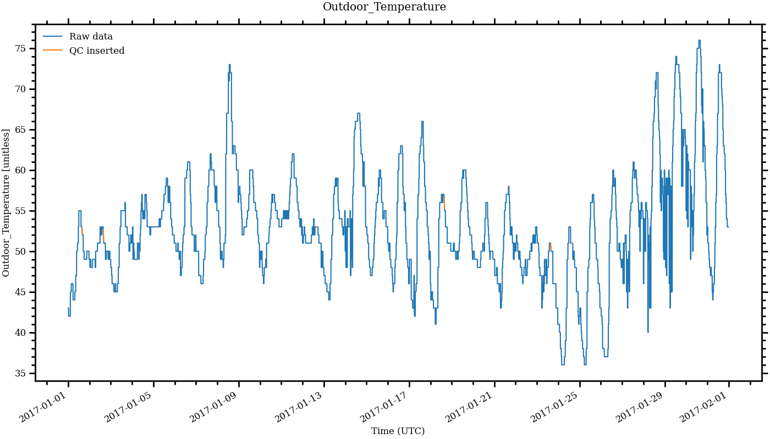
Figure 4. Outdoor air temperature data for one particular home in January, 2017
After filling the data gaps, the cleaned data has no more missing gaps. And the filled values look consistent in general pattern.
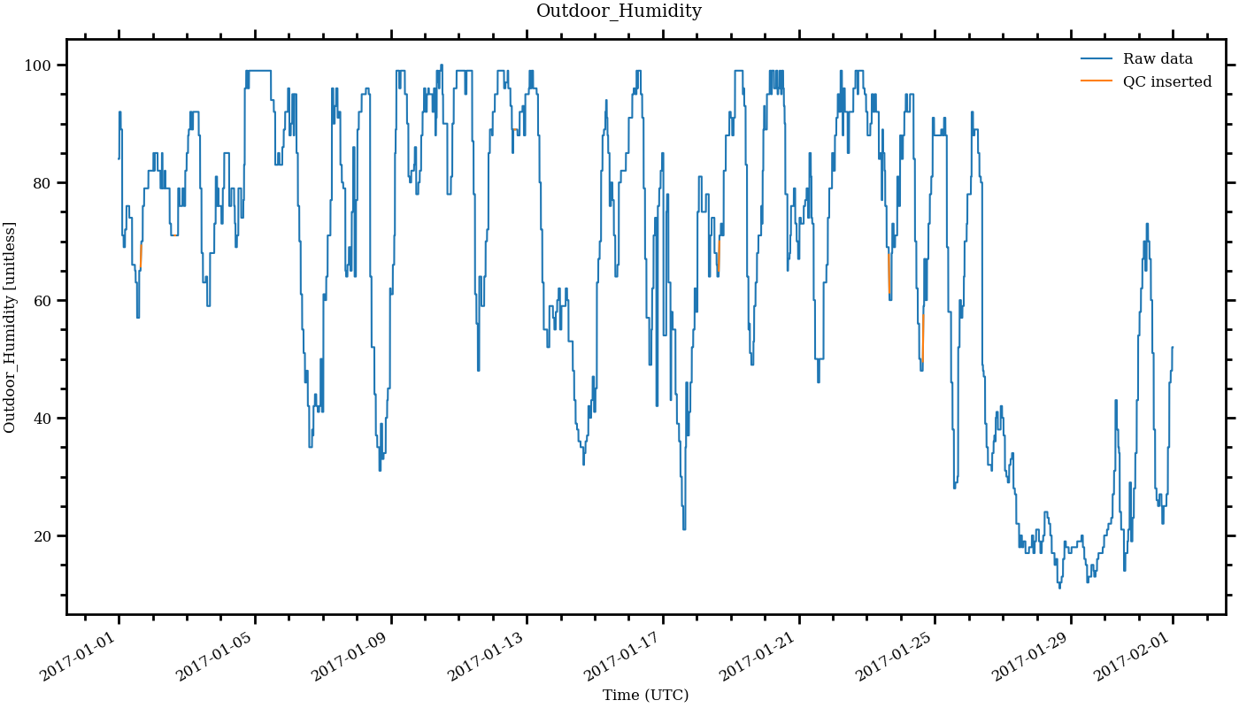
Figure 5. Outdoor air humidity data for one particular home in January, 2017
6.0 Summary
This dataset is a subset of the Ecobee Donate Your Data (DYD) dataset. The Ecobee DYD data is part user-reported (metadata including home and occupant characteristics), and part collected by ecobee thermostats (reported in 5-minute intervals). Participant data is pulled from the ecobee servers, and then anonymized to remove any personal identifiable information. This subset selects 1,000 single family homes, covering four U.S. states - CA, TX, NY, and IL, spanning the entire year of 2017. In addition to the measurements, a metadata JSON file to illustrate the high-level contextual information of the dataset, as well as a Brick TTL model to illustrate the system metadata are both included. The dataset can be analyzed to understand how single-family HVAC systems operate, occupant behavior, and building thermal dynamics.

7.0 Other information

7.1 Dataset DOIs

Cleaned dataset | 2017-01-01 through 2017-12-31 | 10.25584/ecobee/1854924
Raw dataset | 2017-01-01 through 2017-12-31 | 10.25584/ecobee/1854924

7.2 Dataset and Script Links

Benchmark Datasets Data Portal | Raw and Cleaned Datasets | https://bbd.labworks.org/ds/bbd/ecobee

7.3 Contacts

Tianzhen Hong | Principal Investigator | thong@lbl.gov
Na Luo | Data curator | nluo@lbl.gov

7.4 Acknowledgments
This effort was supported by the Assistant Secretary for Energy Efficiency and Renewable Energy, Office of Building Technologies of the United States Department of Energy, under Contract No. DE-AC02-05CH11231. The authors appreciate the cooperation of ecobee Inc., and its anonymous customers who participated in the Donate Your Data program.

References
[1] Ecobee Inc., Room Sensor Installation Guide, ecobee Inc (2015).
[2] Huchuk, Brent, William O'Brien, and Scott Sanner. "A longitudinal study of thermostat behaviors based on climate, seasonal, and energy price considerations using connected thermostat data." Building and Environment 139 (2018): 199-210.
[3] Wang, Zhe, Tianzhen Hong, and Han Li. "Informing the planning of rotating power outages in heat waves through data analytics of connected smart thermostats for residential buildings." Environmental Research Letters 16, no. 7 (2021): 074003.
[4] Meier, Alan, L. Rainer, A. Daken, T. Ueno, M. Pritoni, and Dan Baldewicz. What can connected thermostats tell us about American heating and cooling habits?. 2019.

https://bbd.labworks.org/ds/bbd/ecobee
https://tsdat.readthedocs.io/en/latest/about.html
https://www.ecobee.com/en-us/
https://www.ecobee.com/donate-your-data/
https://basc.pnnl.gov/images/iecc-climate-zone-map

