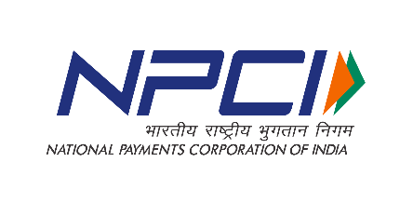


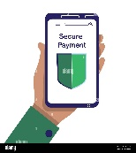





Bharat’s trusted
Bharat’s Own
Payments App
-Scan to download-
Download Now
TRUSTED AND SIMPLIFIED PAYMENTS FOR ALL
SECURE PAYMENTS Simple interface, built 15+ Languages, split an Expense, spend
Absolutely safe transactions for Bharat Analytics, UPI Lite And family Mode

