Group 7 – Samy Laalioui, Antwon Jenkins, Logan Zoller
Ethical Hacking Project Screenshots

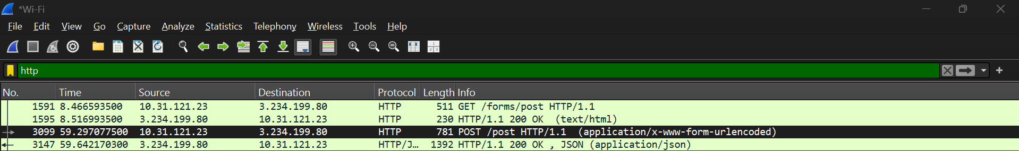
Showing the packets with our credentials we entered in

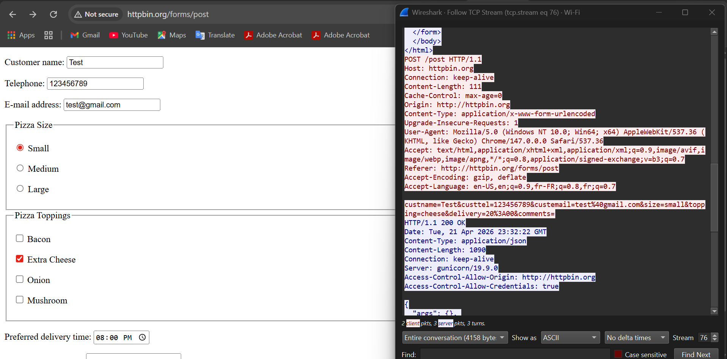

We used the website on the left to create a fake account. On the right it shows us following the TCP stream to find our credentials we entered.

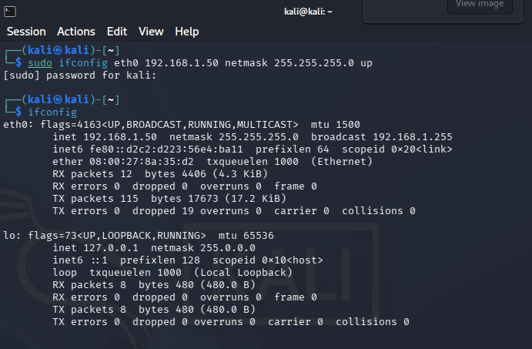
Screenshot of us setting up a new IP address for one of our Kali Linux Virtual Machines. We did this so we could connect two VMs with each other so they could send packets to one another.

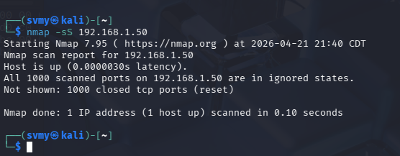
Code we used to start the SYN Scan
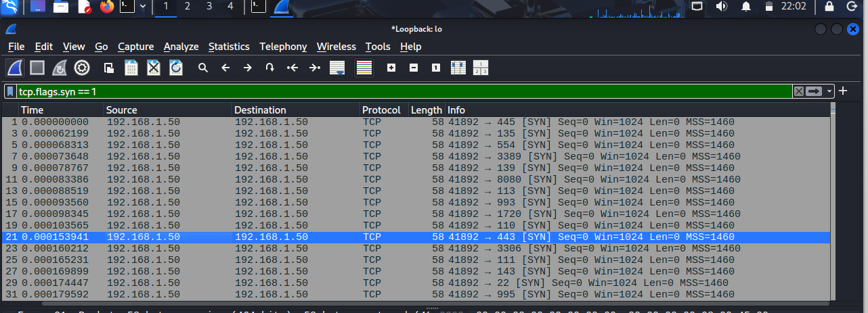
Picture of the SYN packets showing the ports on the system

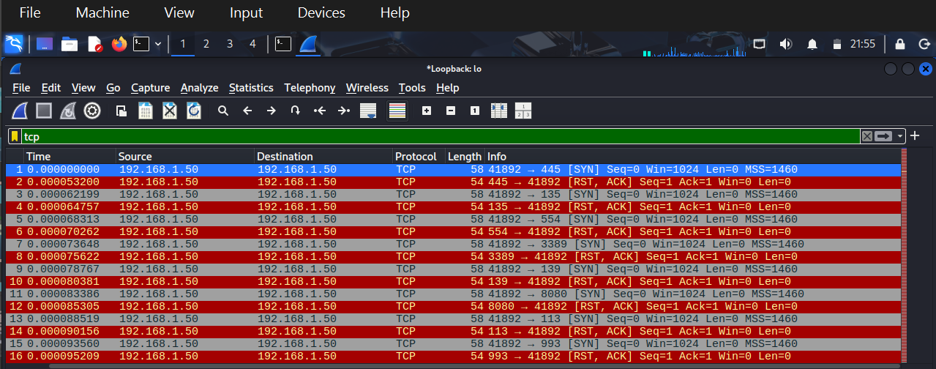
Picture showing half open ports. Showing SYN packets, but the other system is not acknowledging the SYN packets and shutting the connection down

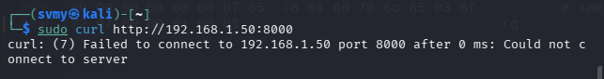
Picture showing that are VMs wouldn’t connect for the three-way handshake.
Picture of our packets for a Three-way Handshake if we went into a google browser. Showing you the SYN packet, then the computer saying it got the packet, and then acknowledging it.

