AsProgrammer dregmod
AsProgrammer dregmod allow you to program flash memory on the protocols spi, I2C, MicroWire. Supports Buzzpirat, Bus Pirate, CH341a, UsbAsp, CH347, AVRISP(LUFA), Arduino & FT232H
http://dangerousprototypes.com/forum/index.php?topic=10698.0
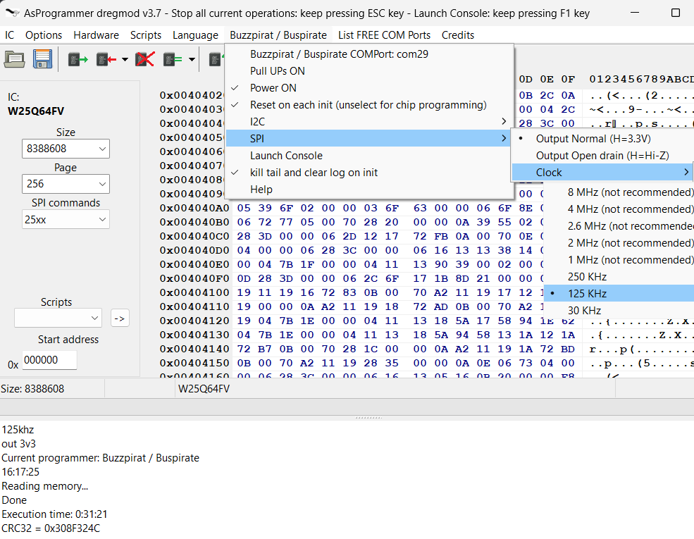
WARNING: While the Bus Pirate part is operational, the GUI part of the AS Programmer remains frozen; this is normal. Refer to the debug console and be patient... I will be enhancing this mod over time (integration included). If buzzpirat console freezes(~2 mins without output)/crash : close this program, reconnect USB port and try again
WARNING: Virtual Machines (VM) and/or USB Hubs can cause problems. It is advisable to ALWAYS use a native OS, and connect the Bus Pirate directly to a USB port
WARNING: I recommend using a speed of approximately 100kHz for each protocol as the maximum, since the quality of the cables is important and I do not trust that the length of yours is short, especially if there is an adapter to clips, etc. The longer the cable and the more adapters there are, coupled with lower voltage, the more you will need to use a lower speed
WARNING: USE SHORT HIGH-QUALITY USB CABLE
WARNING: Some firmwares have a bug in the binary SPI mode (like the latest community firmware). To make it work, you should select the checkbox: Buzzpirat Menu -> Fix SPI Firmware Bug. Note that if you activate this option, a firmware that does not have the bug will not function properly! Activate it only if you are experiencing issues.
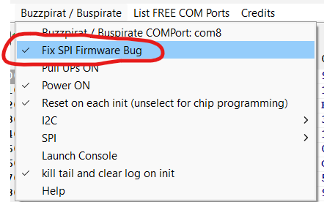
Best Firmware
I recommend using the latest Buzzpirat firmware for the Bus Pirate v3: https://buzzpirat.com/docs/firmware-update/
Download
https://github.com/therealdreg/asprogrammer-dregmod/releases
WARNING
Only issues and/or PRs related to the buzzpirat & bus pirate function are accepted. If you encounter any other kind of problem, please check if the same issue occurs with the official UsbAsp-flash and report it there:
- https://github.com/nofeletru/UsbAsp-flash/issues
- https://github.com/nofeletru/UsbAsp-flash/discussions

Example reading & writing microchip at24c256 i2c eeprom 5v
1. Connect Buzzpirat to at24c256 chip
Connect the 5V from the Buzzpirat to both VCC and VPU
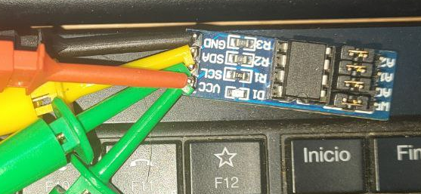
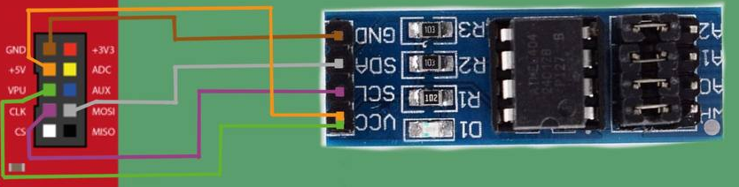
(THX TO David Sanchez & Mecanico for images)
2. Click on Buzzpirat menu -> COM Port, Select Pull UPs ON
Check the available COM ports by clicking on the "List Free COM Ports" menu
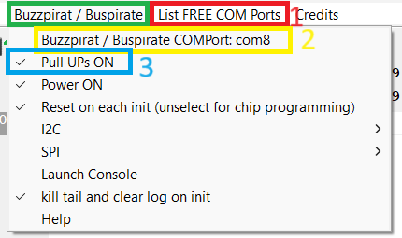
3. Click on IC menu -> I2C -> _24Cxxx -> _24C256
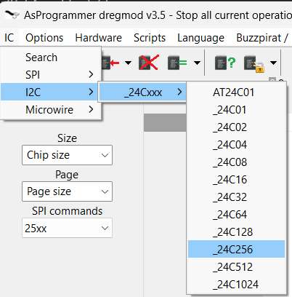
4. Press the "Read IC" button and wait patiently (the GUI will become unresponsive)
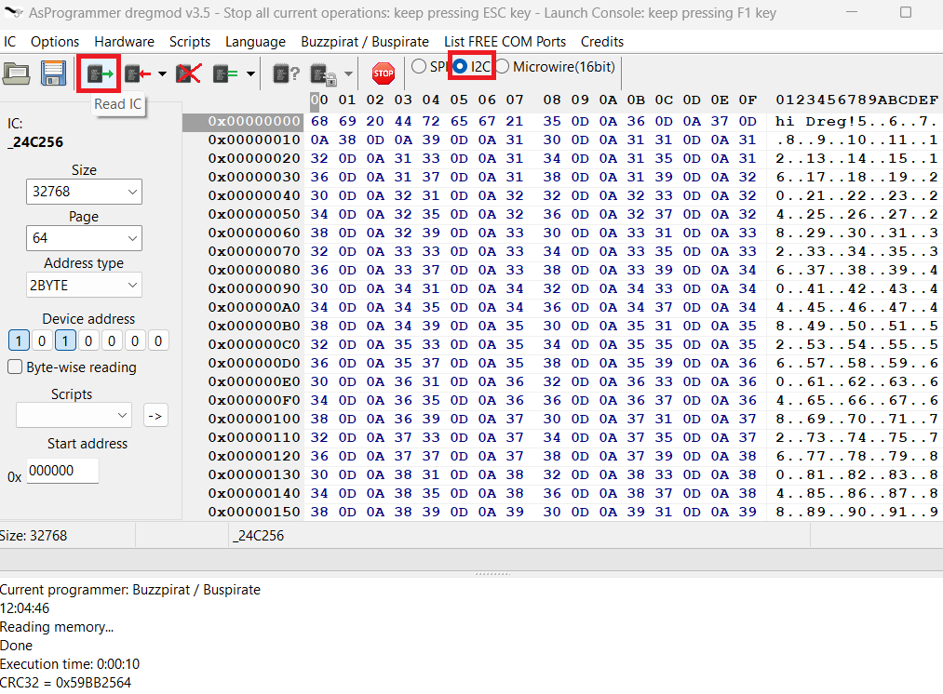
5. I2C Scanner: Click on Buzzpirat Menu -> I2C -> Just I2C Scanner
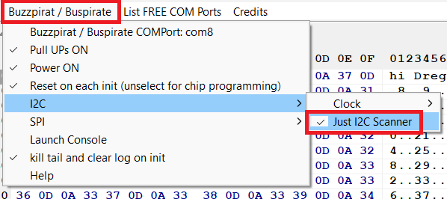
If nothing appears here, you have connected something incorrectly
6. Press the "Read IC" button and wait patiently (the GUI will become unresponsive)
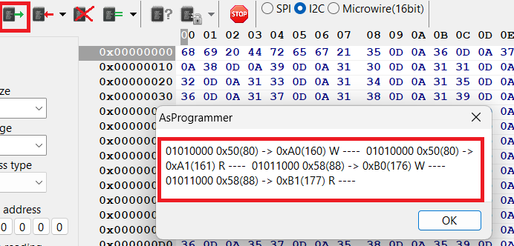

Example reading & writing winbond 25q64 3v3 spi flash
1. Connect Buzzpirat to at24c256 chip
Connect the 3V3 from the Buzpirat to VCC
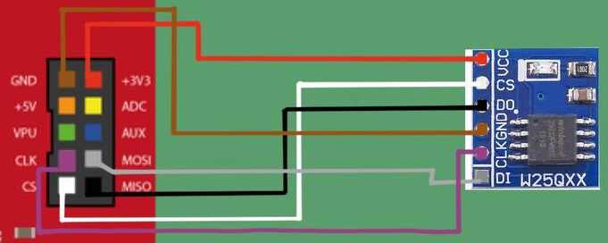
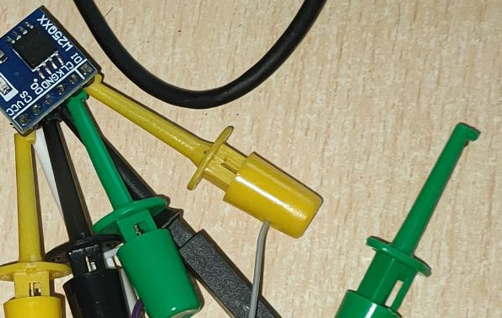
(THX TO David Sanchez & Mecanico for images)
2. Click on SPI radio button
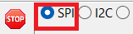
3. Click on Read ID (wait patiently, the GUI will become unresponsive) and select W25Q64BV

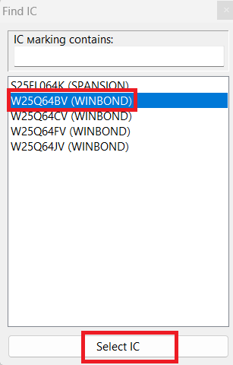
If nothing appears here, you have connected something incorrectly
4. Press the "Read IC" button and wait patiently (~30 mins) (the GUI will become unresponsive)


Example reading & writing winbond W25Q64FW 1.8v spi flash
WARNING: Don't connect +3v3 or +5V to WINBOND CHIP.
Follow the same steps as in the previous chapter for the 3.3v Windbond, but Connect the Winbond's VCC & Bus Pirate's VPU to an external 1.8v power source (all GNDs together):
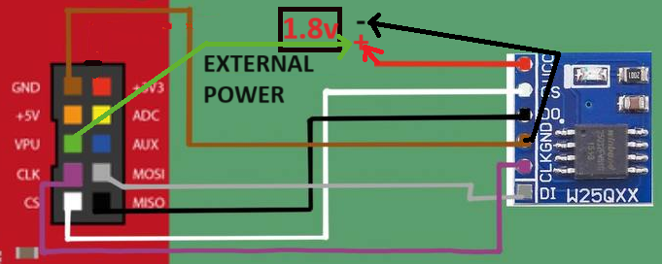
Change the following in the configuration:
- Activate pull-ups of the Bus Pirate
- SPI Output: Open-drain
- SPI Speed: 30kHz
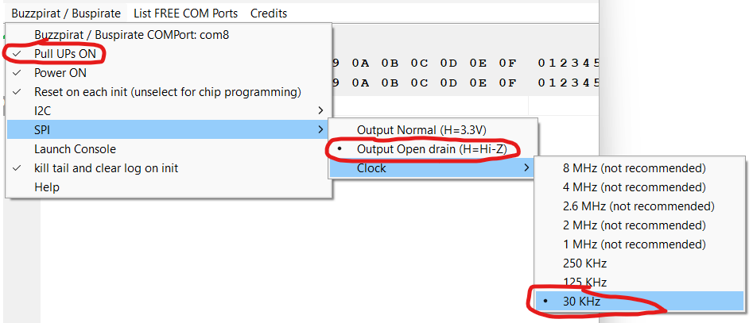
Select W25Q64FW 1.8v when found
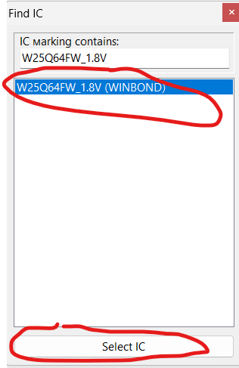
Press "Read IC" button and wait patiently (~40 mins) (the GUI will become unresponsive)
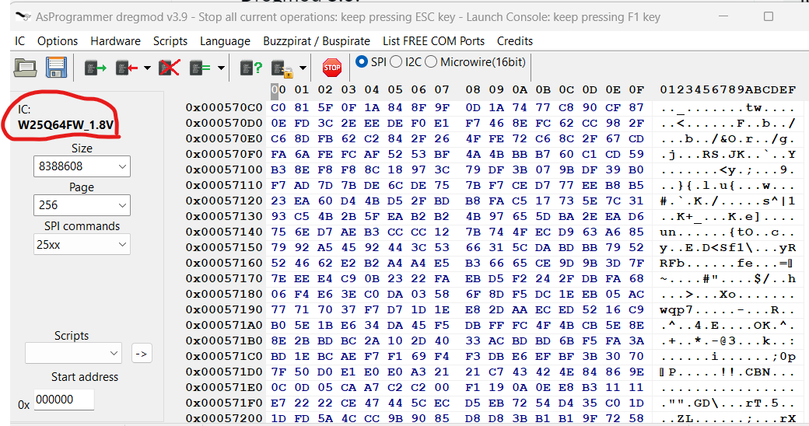

How to build & debug
Instructions tested for Windows 11
WARNING: Reading flash content in debug mode .exe can cause exceptions! Please use a Release .exe version and run it outside of the Lazarus IDE
WARNING: Caution when editing a FORM if you or the Lazarus IDE is altering a caption in main.lfm as it will disrupt the translation system. I prefer to manually edit the .lfm files to avoid this kind of issue
1. download & Install lazarus 32 bits
https://www.lazarus-ide.org/
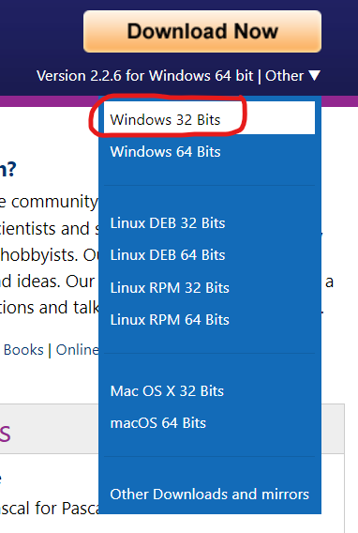
2. clone this repo
git clone https://github.com/therealdreg/asprogrammer-dregmod.git
3. extract mphexeditor.zip to root project folder
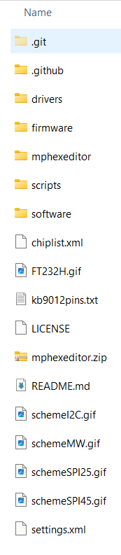
4. Copy chiplist.xml to software/ directory
5. Open AsProgrammer.lpi with lazarus
Just ignore hexeditor errors/warnings
6. Install mphexeditor
Go to Package menu --> Open package file (.lpk)
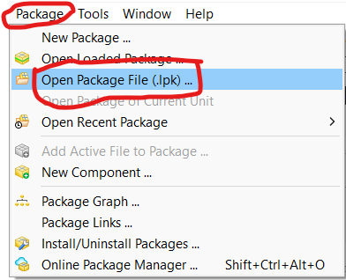
Select file:
asprogrammer-dregmod\mphexeditor\mphexeditor\src\mphexeditorlaz.lpk
Go to Use menu -> Install
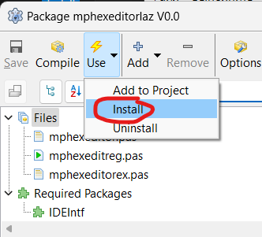
Click yes and wait....
7. Change build mode to debug
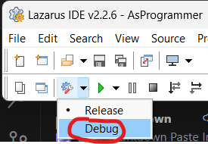
8. Press F9 key to run & select Enable Dwarf 3
Done!
9. How to rebuild all (ex: after a Menu Form change)
Go to Run menu -> Clean up and Build...
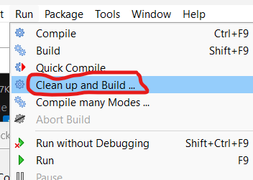
And just click on Clean up and Build button
10. Compile & Debug buzzpirathlp.dll
First and foremost, close the Lazarus IDE and all instances of ASPROGRAMMER.EXE
Download & install visual studio 2019 community edition:
https://visualstudio.microsoft.com/es/vs/older-downloads/
11. Compile x86 debug version
Open: asprogrammer-dregmod\software\buzzpirathlp\buzzpirathlp.sln
Select Debug version and x86:

Go to Build menu -> Rebuild solution
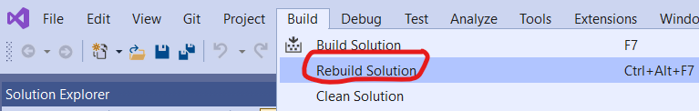
12. Compile a Release version of asprogrammer in the Lazarus IDE
13. Open the release version of ASProgrammer outside of the Lazarus IDE
14. Attach to AsProgrammer.exe from Visual Studio 2019
From VS 2019
Go to Debug menu -> Attach to Process..
Select ASprogrammer.exe and click to Attach button
And done! You can debug a native C/C++ DLL in a FreePascal Lazarus .EXE Project from Visual Studio 2019
Just insert a:
__debugbreak();
in your DLL code to initiate debugging from the desired point
How to Add unsupported chip to AsProgrammer by Floyd77
[TUTORIAL] Add unsupported chip to AsProgrammer
Search for your unsupported chip here:
https://chromium.googlesource.com/chromiumos/third_party/flashrom/+/798d2adc9527f724bc5096a646cf99efdbb6b59e/flashchips.h
Tip: Ctrl+F to search through the list.
I'll take W25Q256JW as example. You'll see this on that list:
#define WINBOND_NEX_W25Q256_W 0x6019 /* W25Q256JW */
Open chiplist.xml located on AsProgrammer folder. I use Notepad++ to edit the file. Search for the brand on the list, in this case "Winbond".
You have to add a new line into that list, following with the example you need to insert this line:
<W25Q256JW_1.8V id="EF6019" page="256" size="33554432"/>
Save and open AsProgrammer, search for it manually, it has to appear on the list and it will be auto detected when you connect the chip to the programmer and click on "Read ID" button.
Notes:
When the chip uses 1.8V you add "_1.8V" after the model name.
The first characters for the "id" differ for each brand. In this case (Winbond) they are the letters "EF" followed by the number taken from the "flashchips.h" list from step 1: 0x6019 translates to "EF6019".
Page and size are easy to fill if you compare the data with another similar chip from the database. In this example, all Winbond chips have a page value of 256 and the size value is the result of dividing 256/8 to get Mebibytes (32) and then convert to bytes.
Converter:
https://convertlive.com/u/convert/mebibytes/to/bytes#32
Credits
- nofeletru for ASprogrammer: https://github.com/nofeletru/UsbAsp-flash
- Ian Lesnet (Bus Pirate Creator): https://buspirate.com/
Related
- https://github.com/therealdreg/flashrom_build_windows_x64
- https://github.com/therealdreg/flashrom-dregmod
- https://github.com/therealdreg/buzzpirat

