**Tasks:**

|  |  |
| --- | --- |
| Used Command | Purpose |
| adb devices -l | list devices |
| adb install C:\devTools\EPAMTestApp.apk | Install apk application |
| adb -s emulator-5554 install C:\devTools\EPAMTestApp.apk | Install apk on specific device |
| adb -s emulator-5554 shell pm list packages -f | findstr -i "epam" | Find package name of installed application |
| adb -s emulator-5554 uninstall platkovsky.alexey.epamtestapp | Uninstall application |
| adb -s emulator-5556 shell  su  chmod 777 /data/local/tmp/  exit  exit | Get grants to add/remove files |
| adb -s emulator-5556 push C:\devTools\anyTextFile.txt /data/local/tmp | Add file to device |
| adb -s emulator-5556 shell rm /data/local/tmp/anyTextFile.txt | Remove file from device |
|  |  |
| adb -s emulator-5554 emu kill | stop 'emulator-5554' emulator |

1. Create or select some AVD (use AVD Manager) and make sure it listed by ADB. Make screenshot of CLI console with ADB output and AVD appearance.  
   A picture containing text, monitor, screenshot, electronics

   Description automatically generated
2. Install EPAMTestApp to AVD. Make screenshot of CLI console with ADB output. Make sure you can launch and use it (confirm by screenshot).  
   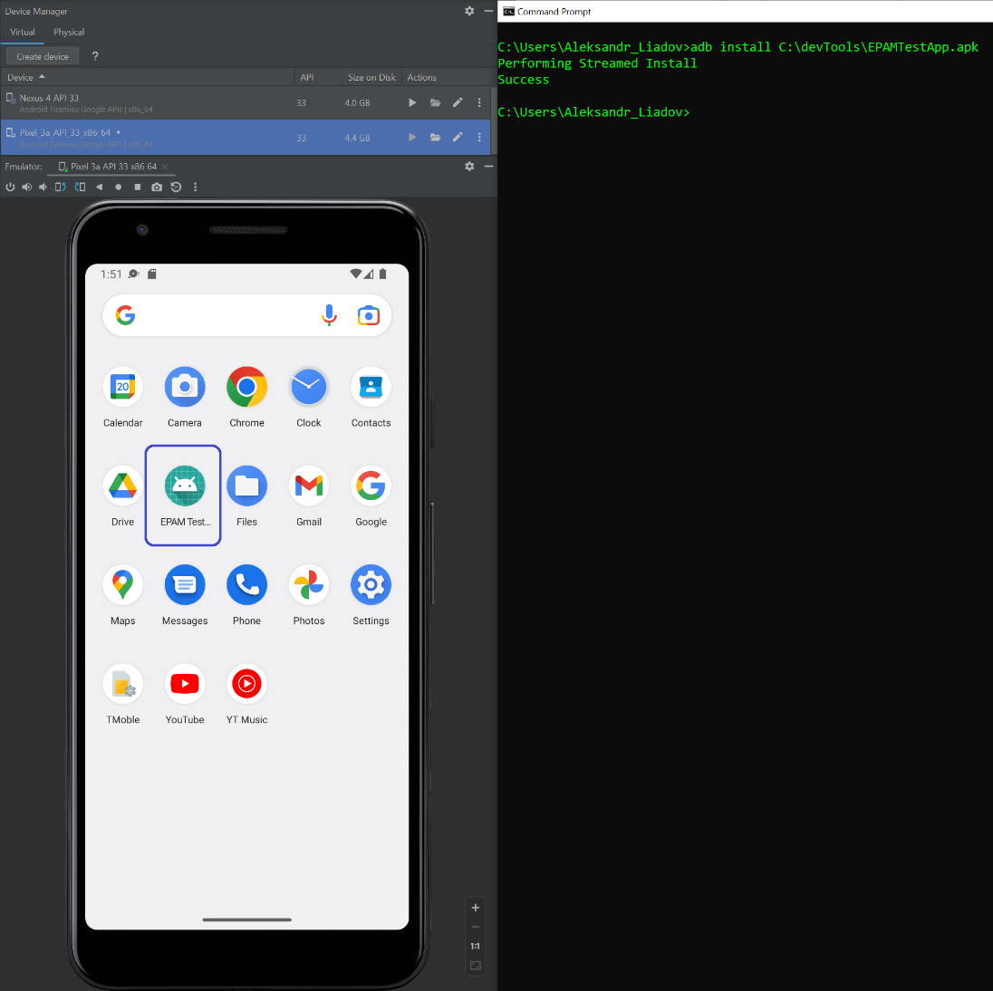 Graphical user interface, application

   Description automatically generated
3. If you have a physical Android device, please connect it to PC via USB and use for purposes of this home task further. If no please create the second AVD.   
   **I do not have physical device ☹.**
4. Make sure the second AVD or the physical device is listed by ADB along with the first AVD. Make screenshot of CLI console with ADB output  
   A picture containing text, monitor, electronics, screenshot

   Description automatically generated
5. Learn how to refer to certain device via ADB  
   adb -s emulator-5554 install C:\devTools\EPAMTestApp.apk
6. Install EPAMTestApp to the second AVD or the physical Android device using ADB. Make screenshot of CLI console with ADB output. Make sure you can launch and use it.  
   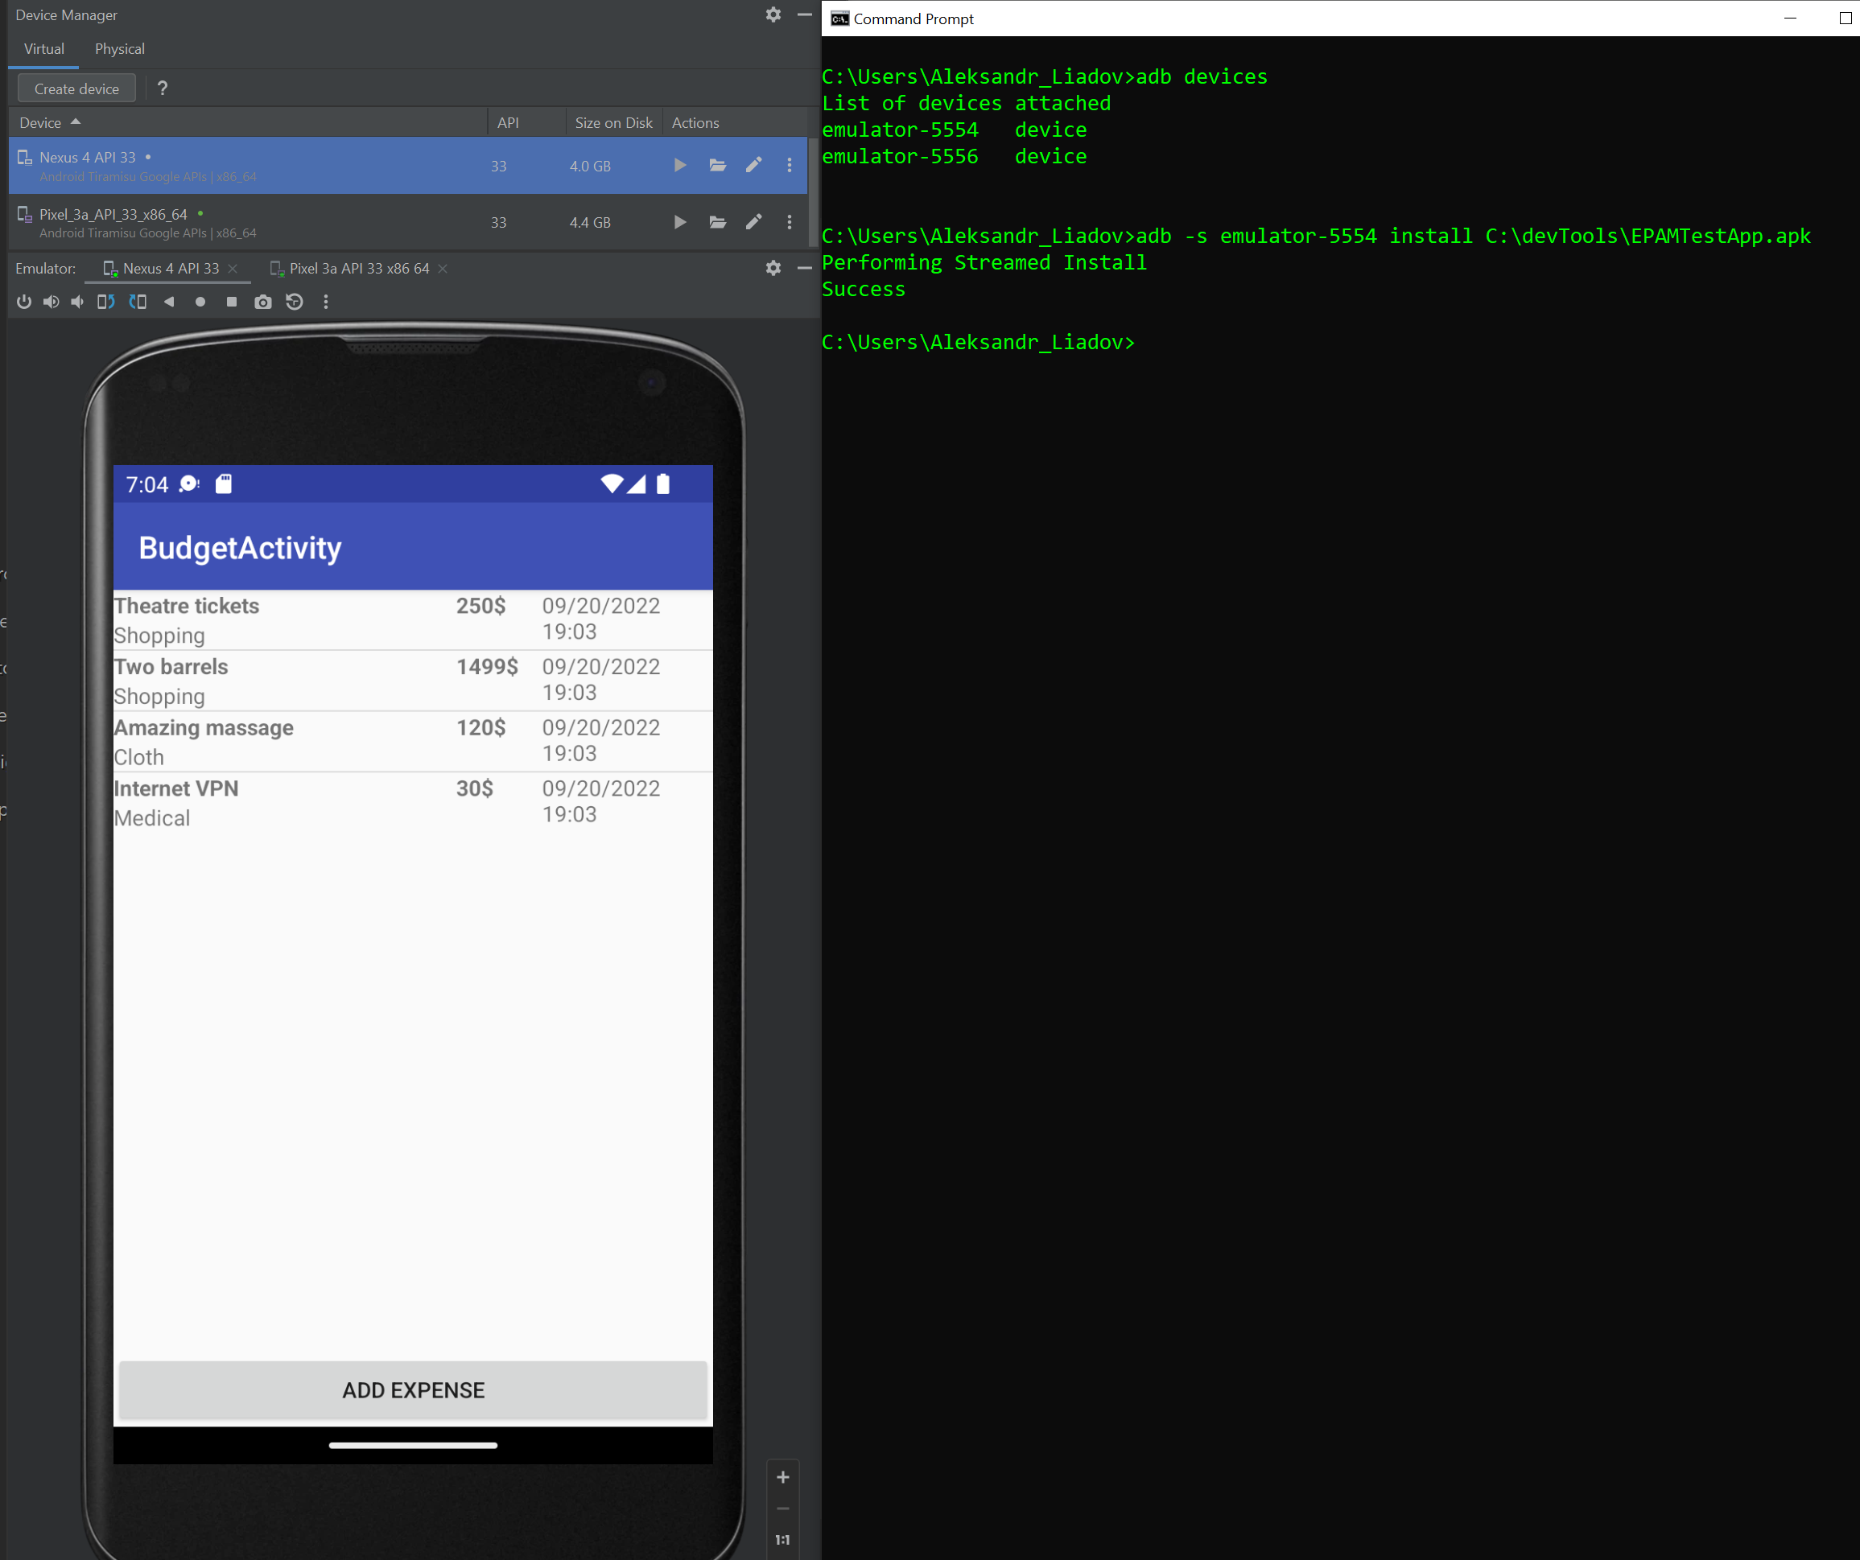
7. Uninstall EPAMTestApp from all AVDs and/or physical device via ADB. Make screenshot of CLI console with ADB output   
   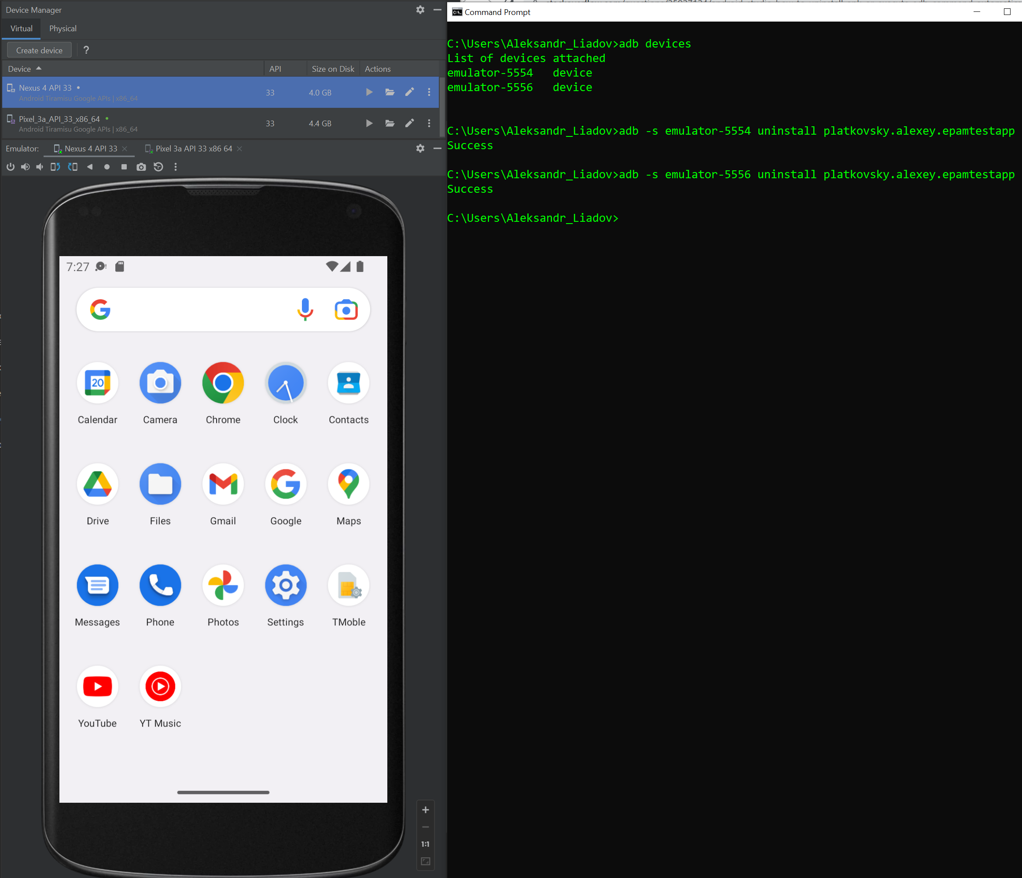
8. Put any text file to physical device and AVD via ADB. Make screenshot of CLI console with ADB output  
   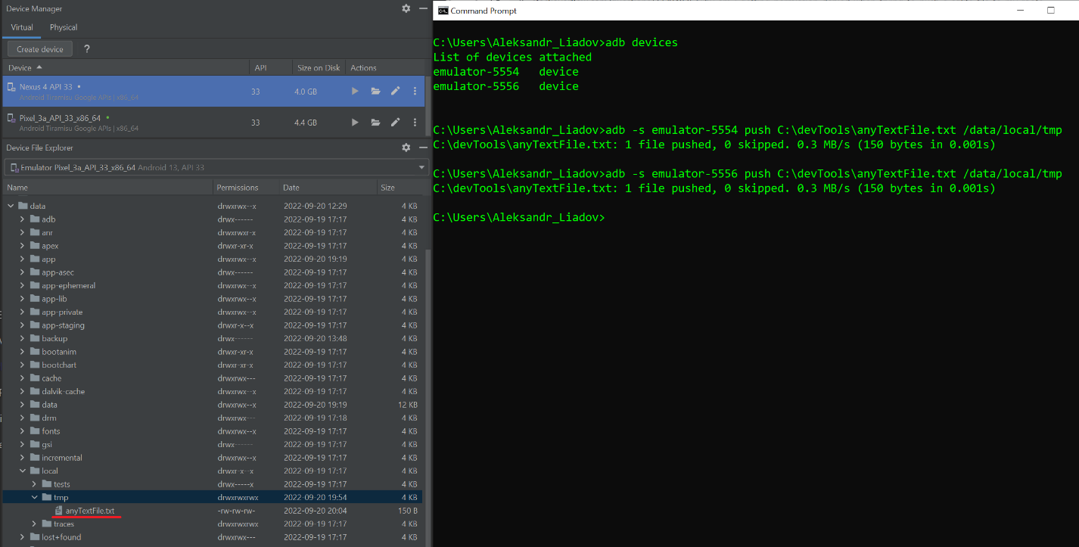
9. If you are using a physical device, please find this file out via WIndows File Explorer (Android dev. should be connected as external USB drive).  
   **I do not have physical device ☹.**
10. Make sure that this is exactly the same file you have put in the previous step - confirm by screenshot.  
    **I do not have physical device ☹.**
11. Remove file from all AVDs/devices (study ADB docs). Make screenshot of CLI console with ADB output.  
    