Algorithm | Best | Average | Worst Case
Bubble Sort | O(n) | O(n^2) | O(n^2)
Selection Sort | O(n) | O(n^2) | O(n^2)
Insertion Sort | O(n) | O(n^2) | O(n^2)
Merge Sort | O(n log n) | O(n log n) | O(n log n)
Quick Sort | O(n log n) | O(n log n) | O(n^2)
Heap Sort | O(n log n) | O(n log n) | O(n log n)
Radix | O(n) | O(n) | O(n)
Counting | O(n) | O(n) | O(n)
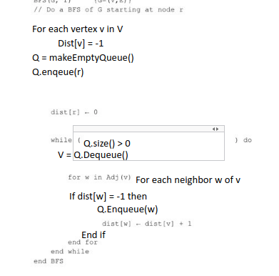
DFS(G) {G=(V,E)}
for each vertex v in V do
mark[v] ← unvisited
end for
for each vertex v in V do
if mark[v]=unvisited then
Search(v, mark)
end if
end for
end DFS
Search(v, mark)
mark[v] ← visited
for each vertex w in Adj(v) do
if mark[w]=unvisited
then Search(w)
end if
end for
end Search

