Summary
The Child Call System allows workers in the Children’s Ministry to call for a parent by number using a keypad located in the northeast corner of the “Room 3” (blueprint room number 027/029). The selected number is displayed on the front projectors in the auditorium and on livestream.

Usage
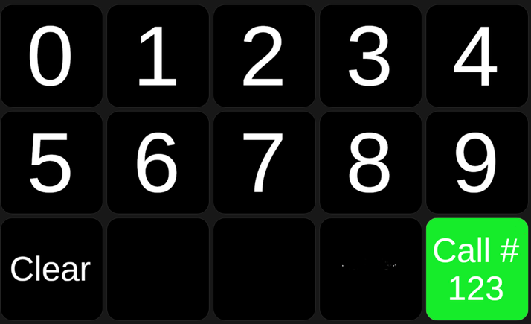
When you need to call a parent, type the child’s 3-digit number on the keypad. When the third number is entered the lower right “Call #” button turn from red to green with the entered number displayed on the button.
In this example, the child number is “123”. Push the “Call #” button and the number will be displayed on the projectors. It will stay there for 60 seconds. If you put in another number before the 60 seconds is up, it will replace the prior number and the 60 seconds will restart.
If you make a mistake and enter the wrong digits, press the clear button to start over.
If the display looks different than depicted, please advise leadership.

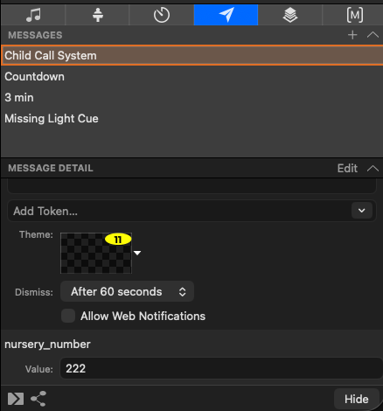
ProPresenter
The child number system is supposed to work automatically without operational intervention. The keypad is controlled by software called “Companion”, when the call button is pressed it uses the ProPresenter APIs to invoke the “Child Call System” Message, providing the “nursery_number” value.
You cannot easily disable the message mechanism, but you can force the early hiding of the message by pressing the “hide” button. (See the image to the right).
The there is a theme defined which controls how the message will be displayed on the projectors and livestream. The theme is named “Child Call Message” which is in the “3_uac utility” theme folder.
The final piece of the puzzle is that the “messages” layer must be enabled for every screen on which the message is to be displayed which should include the centre screen and the key/fill screen.

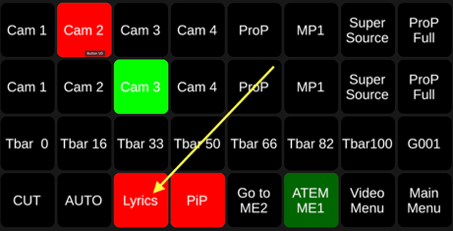
Video
The child call message is not separately displayable from other ProPresenter content. It is displayed via downstream key #1, which is activated via the “Lyrics” button.
It is important the number is displayed as parents in other rooms in the building need to see it.

