Introduction
In the event of a major power failure, one that out lasts the reserve power of one of more UPSs, it is possible that the AVL systems will not power on properly and may need intervention. This document provides a checklist of everything to be verified and recovery actions for select scenarios.

Throughout the text you will see references to asset tags, for example “2408-2704” or “CUMU-G001”. If you are unsure what those refer to or need to find them within the building, you can look them up in the AVL Assistant website. This is a option that is available on the default web page for all media arts computers.

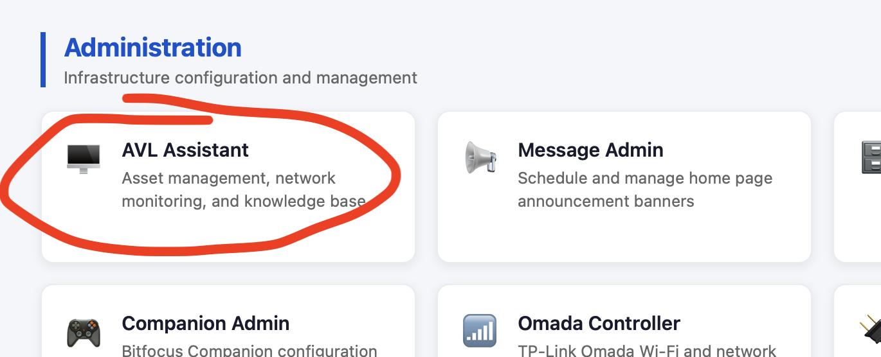

Look at the asset details, diagram or location tabs for basic information.

You will also see references to KB# s. These are knowledge base numbers which can also be looked up in the same website under “Knowledge base”.
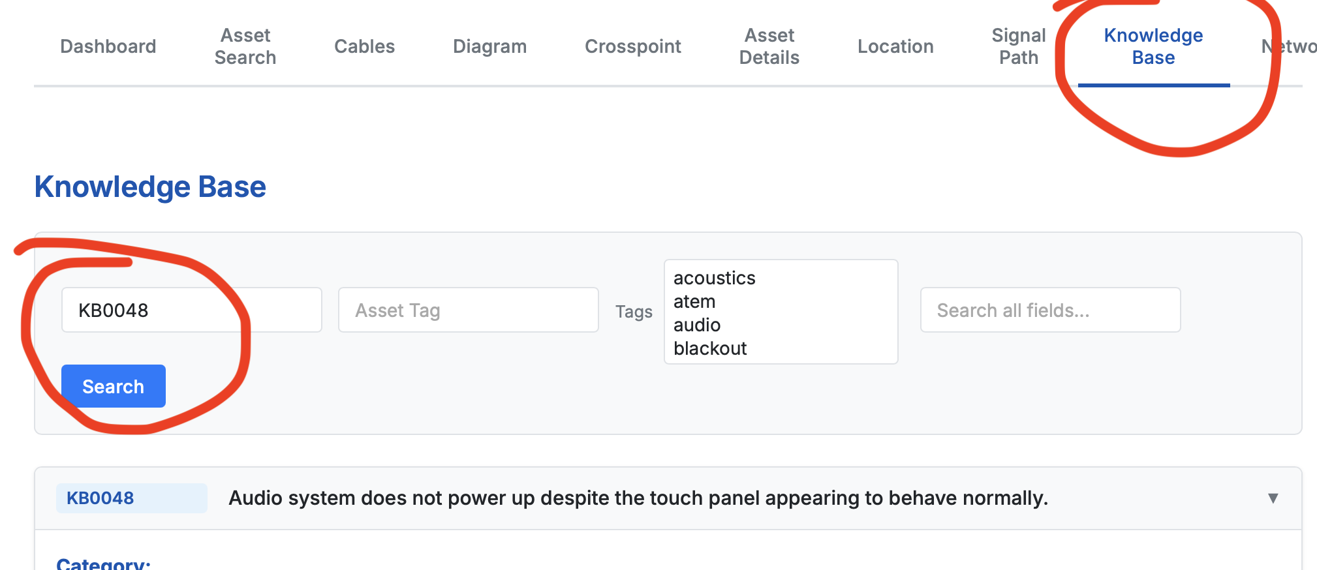

Activities by system

2408-2704 - Audio System Touch Screen
- Turn on the audio system. If it appears to be doing its normal cycle but not actually doing the job, then the QSC Core needs to be rebooted. See KB0048.

2407-3001 - Main Audio Mixer Surface
- After powering on as normal, validate that the system is passing audio as normal. Test audio from ProPresenter, a wireless microphone, the drum kit, and a floor jack (eg the piano or room mics).

CUMU-G001 - Video Computer
- Login
- Respond to the run automation request with a yes. (Or is it “ok”?) This enables CueCommander-NR automations such as the lighting controls from ProPresenter.
- Open Dante Controller (this can be done from E001 and G002 as well - same result). Ensure that all Dante devices are online. (Audio system needs to be on).
- Ensure Dante Virtual Sound Card is Running and in “Start” State.
- Ensure that Docker is running - Whale icon in menu bar - open Desktop. If the websites like AVL Assistant isn’t responding, this is the likely cause.
- Ensure that CueCommander-NR is running - gear icon in menu bar. Can validate also by opening the web page or seeing that the lights respond to ProPresenter Light cues.
- Login to Resi. Start encoder and record a segment. playback that segment from Resi Media page and ensure audio and video are working. (This can be done from any computer.)

CUMU-G002 - ProPresenter Computer
- Login
- Ensure Dante Virtual Sound Card is running and in “Start” state. Can validate by playing an audio (or video) track and ensuring that the audio system sees the signal. (See KB0012 if not).
- Check lighting cues - observe console response (see KB0011 if not).
- Validate video output to front projectors, stage display TV and Key/Fill to video desk.
- If the monitor (2311-2701) remains black it (despite being powered on) - try switch video inputs - hdmi1 versus 2. See KB0047
- Verify the OneDrive is running and service_media appear to be getting updates. (Create a file and look for it on another computer)

ZVKU-A004 - Camera Controller
- Turn on the video system
- Verify that camera PTZ controls work - visually verify cameras respond to the joystick.

2603-1301 - Video Stream Deck
- Ensure that video mixer (2601-2800) responds to button presses. If not, ensure that video mixer is powered. Do the buttons have their regular text (and on the right page in the menu system), ensure Companion (2607-2316) is running. See KB0014.

CUMU-E001 - DAW/Reaper Computer
- Login
- Ensure Dante Virtual Sound Card is running and in “Start” state.
- Open Reaper and ensure that audio can be heard coming into the system (turn up the room mics and listen for noise … likely a door latch closing - or have somebody play the piano.).
- Open Klang:App and verify that Kontrollers are getting audio … again the room or piano mics are handy for that.

ZLKU-B002 – Lighting Button Box
- Press a few buttons and verify the lights respond as expected. If they don’t, we may need to power cycle them via the breakers in LP1 in the electrical room.
- (Note: ensure that the main lighting console (2607-2500) is not also on and taking priority control).

2607-2500 – GrandMA3 Lighting Console
- Power on and verify that lighting controls are working properly.

