Lighting
- Basic lighting is on the keypad by the office double doors. Push the button for what you want. When All done select ‘Night Light’ (this turns on the sconce lights during the evening hours for safety purposes).
- More advanced lighting uses the lighting console. Set it to ‘Console’ mode if that is what you want.
  - The lighting console is current ‘on’ all the time, but inactive.
  - It is possible that somebody could be working remotely on ProPresenter or the lighting, so lights may be on even if nobody is around physically. A timer will turn them off at 11pm and 2am if they were left on.
  - If the touch screens are all blue and the message says “desk locked”, press the ‘pause’ key on the keyboard.
  - The upper left corner of the right screen should say “Simple Menu”, if not you can scroll to the top (position #1) using the scroll wheel on the mouse.
  - In the centre section of the right screen you should see some buttons that look like this, you can use these for prettier looks and well by default be the colours of the current series. 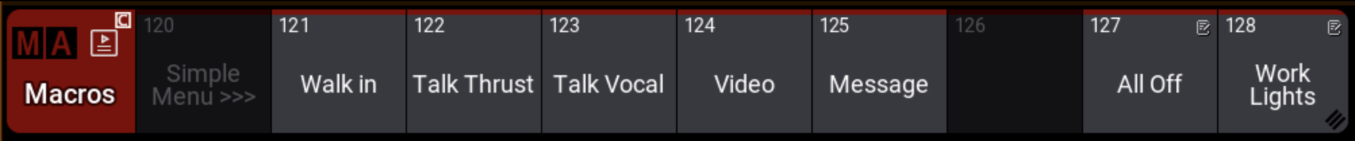
  - “All off” will turn off all the lights (but the keypad by the door will override). “Work Lights” will turn on house lights for general work.
  - Lights can also be controlled from ProPresenter. (you may need to start with the “walk-in” button above).
  - If you want even more sophisticated looks, you will need more advanced training.

Propresenter
- Turn On
- Move the mouse or click the power button to turn on the computer, you may need to press the monitor power button (bottom centre).
- Password: … I don’t put it on the printed page
- Remember: This password is for our use only, please do not share

- Projectors
- The projectors can be turned on (and off) using the first three buttons on the “Stream Deck” - see picture. The button will turn green after a minute when the projector is on.
- There is also a button for the lobby TV. (I eventually will have working buttons for other TVs as well).

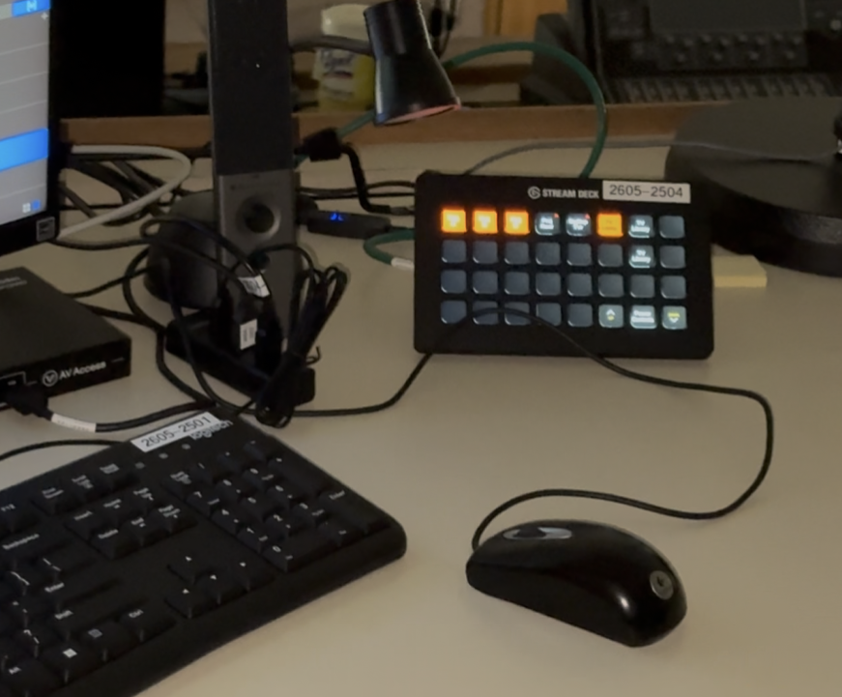

- When turning off, use the same buttons. I recommend that you have an image projected so that you have a visual confirmation that the projector has turned off. The buttons will turn red again after several seconds.

- ProPresenter
- Open ProPresenter - Click on ProPresenter icon on the far left of screen

- Tips for ProPresenter
- You can access the pre-made playlists on the bottom left of the screen.
- You can create a new playlist using the upper left “+” control beside “Library”: 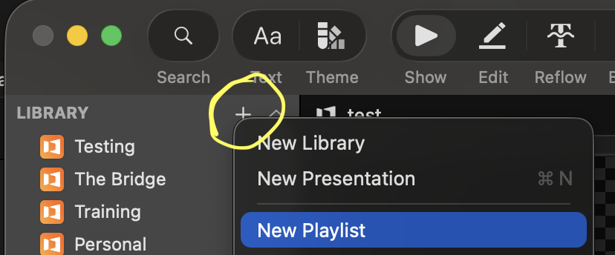
- You can create a new presentation, in the same area. In the create dialog, there is an option to add it to your playlist.
- You can find existing presentations using the search dialog (cmd+F), and “Add to Playlist”
- You can add graphics and videos to a presentation by using drag-n-drop from the source files. Never drag-n-drop directly from a USB stick -copy content to the local machine first, eg the desktop . (If you drag directly from a USB stick, you will lose it as soon as you remove the stick).
- You can jump around the playlists by clicking on the lower left sidebar
- Panic Buttons (in top left corner). These buttons immediately stop/clear the content – Red items are active:
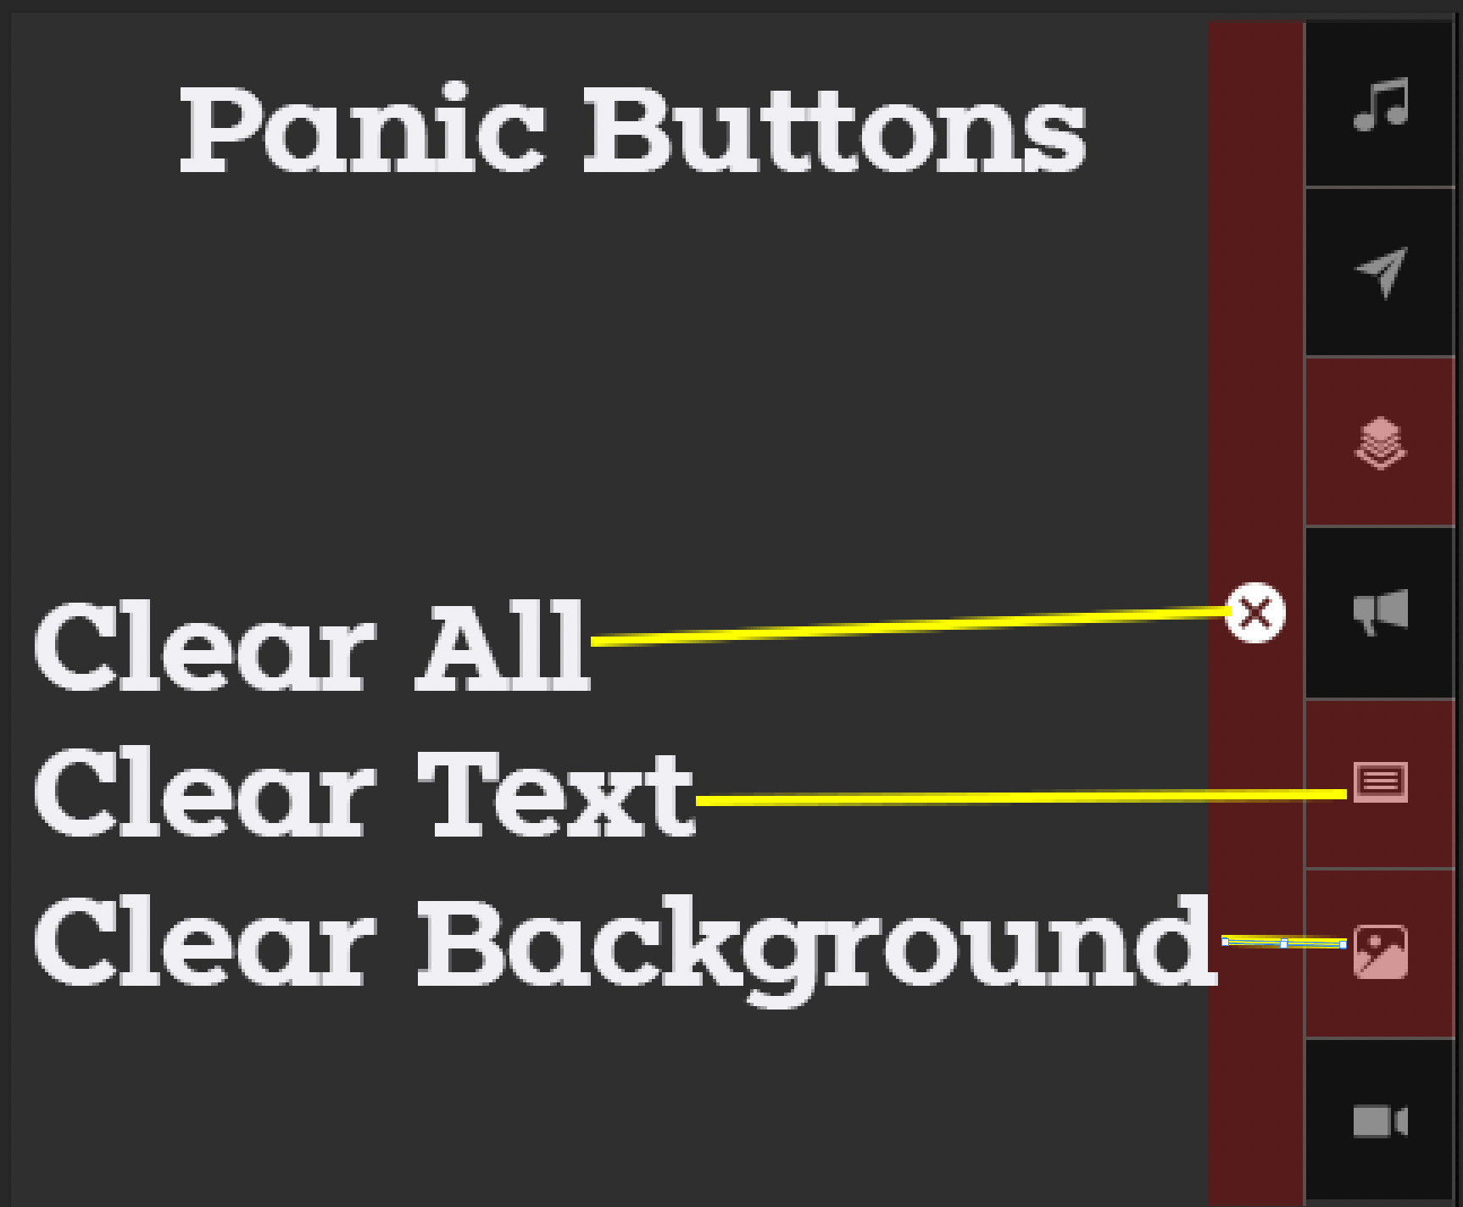

AUDIO
- Setting Up
- Using the touch pad, press the power button. It will take about 2 minutes to complete.

- Scene Recall (if needed)
  - Near the right-hand side of the console there is a button labelled ‘Scenes’ (#1 in the picture), press it. On the right-hand screen there will be a list of scenes, find ‘staff’, touch it, and then the ‘go’ button (under the green tape).

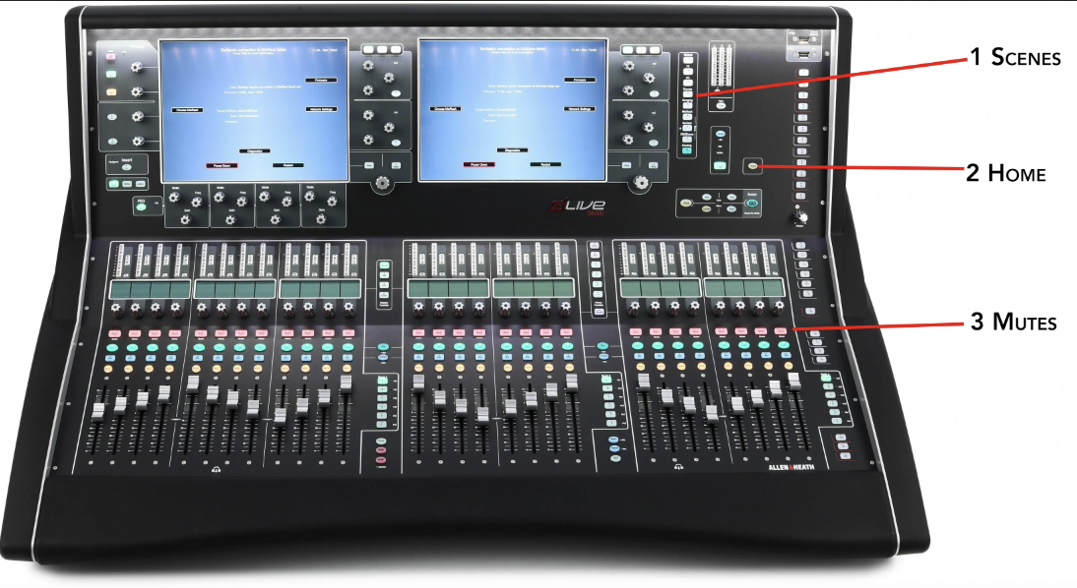

- Using Mics
- Turn on with on switch
- 2 bars of battery are the minimum amount of battery level. After a minute or so the time remaining will appear on the display. Batteries can be found in the recharger or in another mic.
- Numbers on mic corresponds to mic numbers on the sound board

- Controlling Mics
- Turn mic on by pressing the button above each of the mic numbers on the sound board
- To prevent feedback, turn down volume on soundboard
- In there are only 2-3 people on stage, turn mic volume down

- Computer Sound
- Computer sound is on the far right and should only be turned up about halfway
- Computer sound should always be on but can be turned down when not in use

- Turning Off
- On the mixer surface press the home button (#2 on the photo),
- Then press “Power Down” and wait for the message confirm it is ok to proceed
- On the touch pad, press the power button (green “on”) and confirm that the surface has been shutdown.

Video
- Turn on the power button on the top of the rack (labelled #4).
- Turn on the cameras using the joystick controller. Press-and-hold the power button and then in turn press the 1, 2, and 3 buttons.
- You can reposition each camera by pressing the 1,2, or three buttons and then using the joystick. The twist knob on the joystick zooms.
- The live image is the upper right image. Select the desired camera using the top ‘1’, ‘2’, ‘3’ buttons on the stream deck.
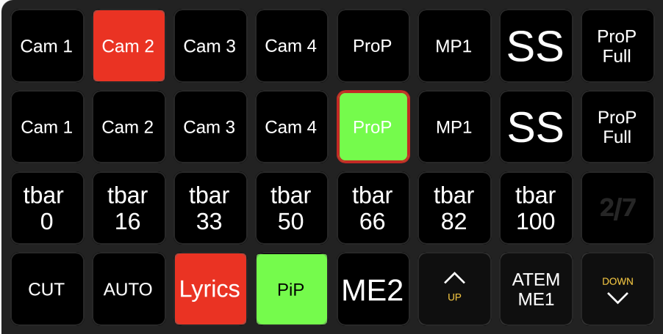
- Route the video mixer output to the projector using the stream deck. Navigate to the ‘Video Hub’ page. And then select either “Pgm to B (Centre)” or “Pgm to A & C”. When All done select “Normal Projectors”. There will likely be times when you don’t want live camera, for those times use the “ProP” as the source.
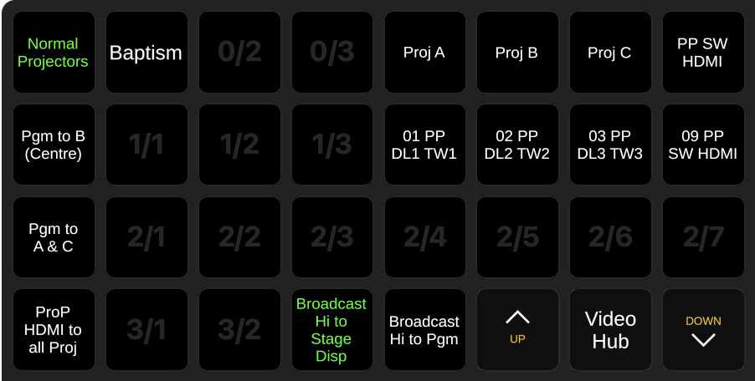
- Turn off the cameras using the joystick controller. Press-and-hold the power button and then in turn press the 1, 2, and 3 buttons.
- Note: if planning on playing copyright material, please discuss with Terry. It can be tricky.

