Propresenter
- Turn On
- Move the mouse or click the power button to turn on the computer
- Password: joyoftheLord
- Remember: This password is for our use only, please do not share
- The monitor power may be off. The switched is located at the bottom centre.

- Projectors
- The projectors can be turned on ( and off ) using the first three buttons on the “Stream Deck” - see picture. The button will turn green after a minute when the projector is on.

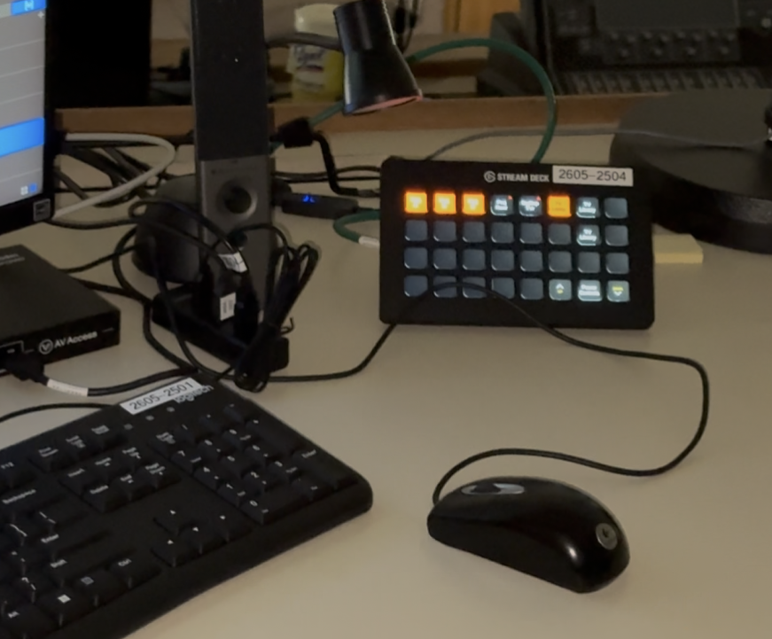

- When turning off, I recommend that you have an image projected so that you have a visual confirmation that the projector has turned off. The buttons will turn red again after a moment.

- ProPresenter
- Open ProPresenter
- Click on ProPresenter application on far left of screen

- Tips for ProPresenter
- You can access the pre-made playlists on the bottom left of the screen
- Remember to click on the desired background and then the desired words
- When advancing the slides during worship, click on the arrow to move onto the next slide on the last or second last word to prevent going too slow
- You can jump around the playlists by clicking on the sidebar
- Panic Buttons (in top left corner) – Red items are active:
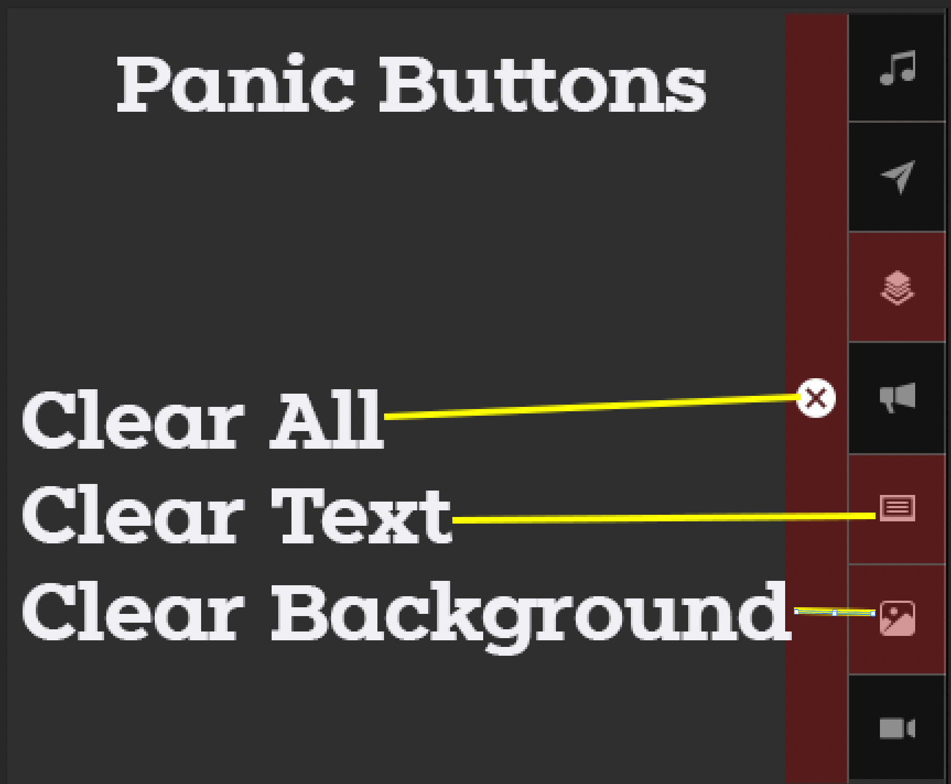

AUDIO
- Setting Up
- Using the touch pad, press the power button. It will take about 2 minutes to complete.

- Scene Recall (if needed)
  - Near the right-hand side of the console there is a button labelled ‘Scenes’ (#1 in the picture), press it. On the right-hand screen there will be a list of scenes, find ‘camp’, touch it, and then the ‘go’ button.

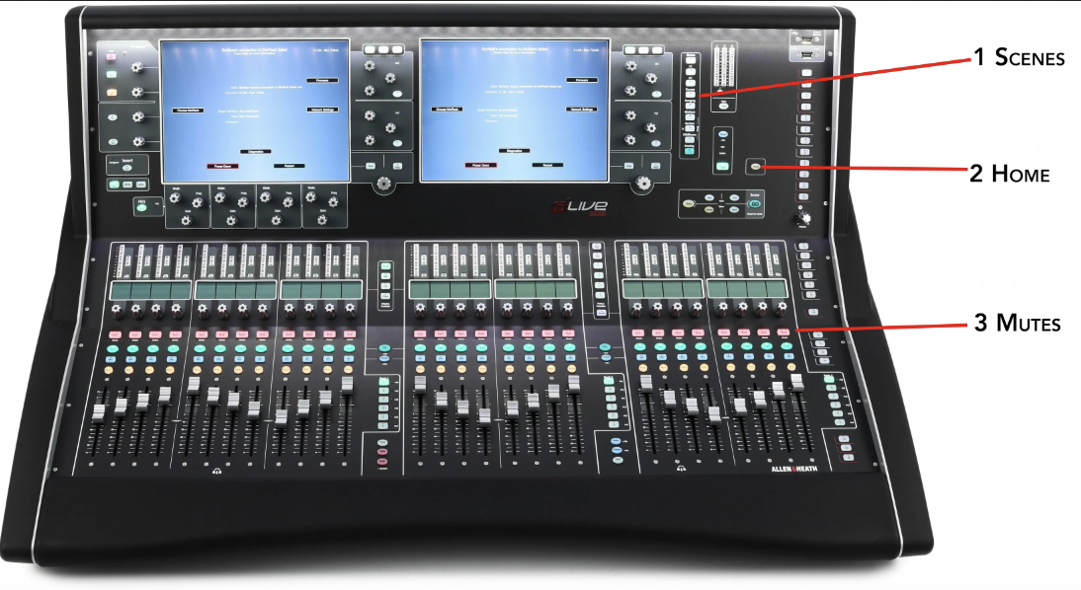

- Using Mics
- Turn on with on switch
- 2 bars of battery are the minimum amount of battery level. After a minute or so the time remaining will appear on the display. Batteries can be found in the recharger or in another mic.
- Numbers on mic corresponds to mic numbers on the sound board

- Controlling Mics
- Turn mic on by pressing the button above each of the mic numbers on the sound board
- To prevent feedback, turn down volume on soundboard
- In there are only 2-3 people on stage, turn mic volume down

- Computer Sound
- Computer sound is on the far right and should only be turned up about halfway
- Computer sound should always be on but can be turned down when not in use

- Turning Off
- On the mixer press the home button (#2 on the photo),
- Then press power off and wait for the message confirm it is ok to proceed
- Press the power button on the touch pad and confirm that the surface has been shutdown.

Video
- Turn on the power button on the top of the rack (labelled #4).
- Turn on the cameras using the joystick controller. Press-and-hold the power button and then in turn press the 1, 2, and 3 buttons.
- You can reposition each camera by pressing the 1,2, or three buttons and then using the joystick. The twist knob on the joystick zooms.
- The live image is the upper right image. Select the desired camera using the top ‘1’, ‘2’, ‘3’ buttons on the stream deck.
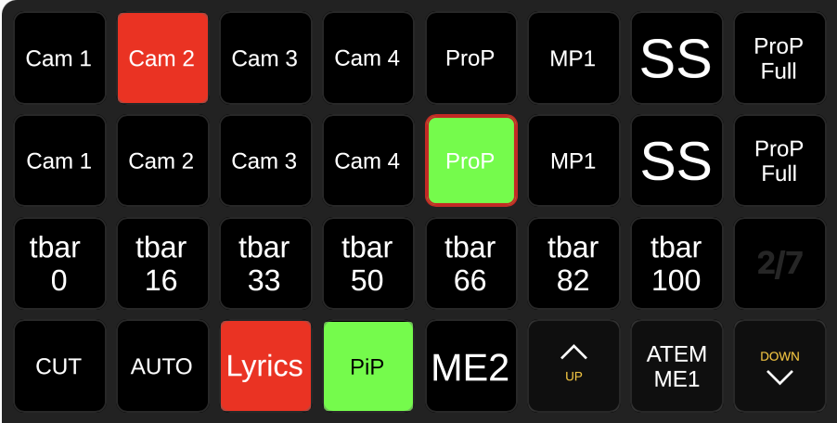
- Route the video mixer output to the projector using the stream deck. Navigate to the ‘Video Hub’ page. And then select either “Pgm to B (Centre)” or “Pgm to A & C”. When All done select “Normal Projectors”. There will likely be times when you don’t want live camera, for those times use the “ProP” as the source.
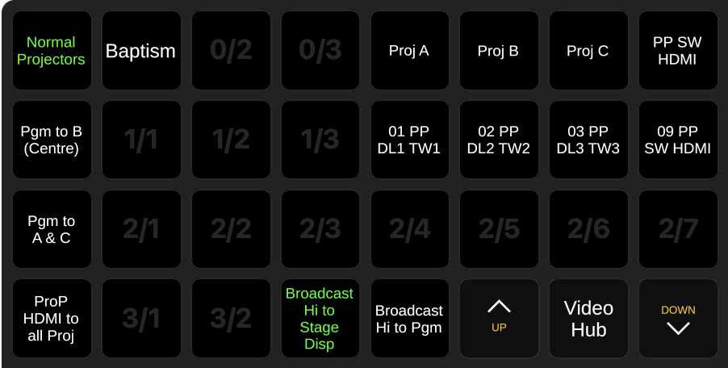
- Turn off the cameras using the joystick controller. Press-and-hold the power button and then in turn press the 1, 2, and 3 buttons.

