Power

The audio system has two power switches, one at the rear desk, and one on top of the amp rack at the stage. Those are the only two power switches that should be used.
Note that there is an order required “First On”, etc.

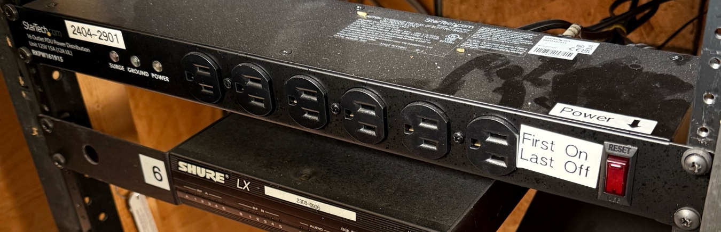

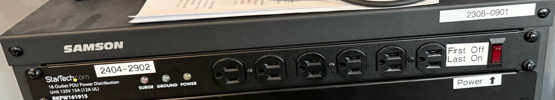

Sometimes people are turning off other switches so if you aren’t getting sound, check the other switches as well.
The projector remote is kept at the rear desk under the computer monitor near the keyboard. The remote is used for turning on the projector and for changing the inputs. A green light at the front of the projector will flash when it is powering up – it takes about a minute.

Laptop at Front

Video
There is an HDMI cable that hangs down from the ceiling near the west speaker. This is input_C on the projector.

Audio

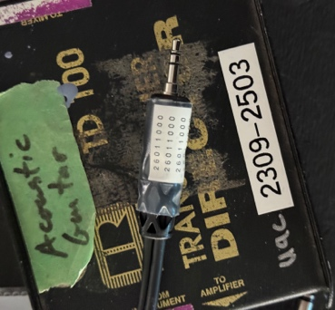
There is a “direct Box” with the label 2309-2503, the cable labelled 26011000 should be plugged into it. The will be on fader #2 on the mixer. One end plugs into your laptop, and the red end of other end goes into the “From Instrument” connector on the direct box.

Laptop at Rear

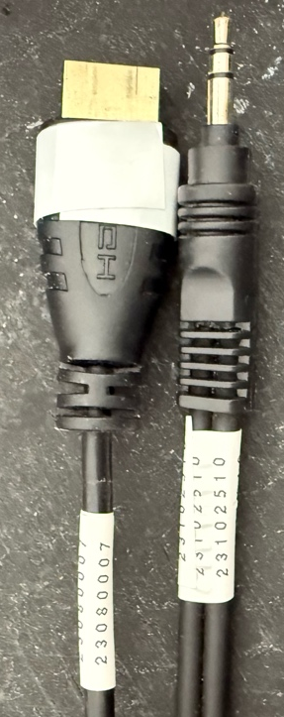
Video
There is also a guest HDMI cable at the rear desk, labelled 23080007 which is input_D on the projector.

Audio
The cable to use for audio is labelled 23102510 and is connected to inputs 21&22 on the mixer.

General Operations

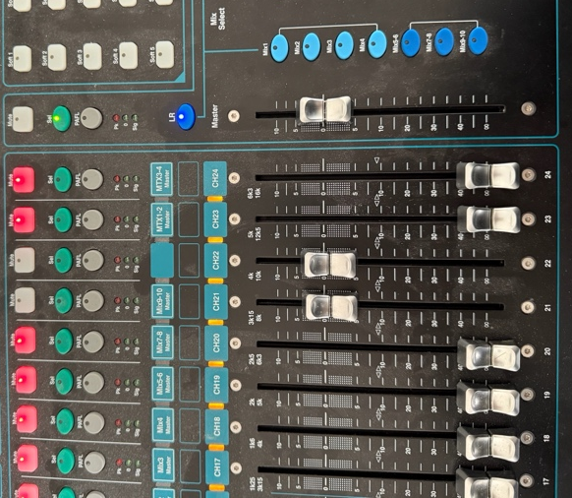
Before plugging in your laptop, ensure that the audio mixer input is muted, red light on; the picture shows strips 21 and 22 unmuted. (#2 if using the front position, or #21&22 if using the rear)

Your computer may be default want to send sound out over the HDMI cable to the projector. If it does, you will need to go into your computer audio settings and select the headphone output.

Before unplugging your laptop, mute the audio channel on the audio mixer.

