# Introduction

We occasionally have the need to display a live web page as part of one of our services, for example Mentimeter. In this document I will review a new way to do this that is easier to operate and more seamless.

# Step 1 – Open the site in Safari

This is straightforward, just open the web page you want to display. Size the browser window to be roughly 16:9 in ratio (that is almost twice as wide as it is tall).

* For Mentimeter specifically, you ‘present’ the quiz, but that has the behaviour of taking control of all screens. If you hit escape after it releases global control an contains itself to the window.

# Step 2 – NDI Scan Converter

Open the NDI Scan Converter application (search for it using ⌘Space and typing in the name), then once the application has started, use the capture menu item to select the safari window.

* If you have two safari windows, you will have to pick the desired one.

# Step 3 – ProPresenter

Within Propresenter create a slide where you want to show the webpage. Edit the slide and add an “Video Input” object to the page, using the white + sign.

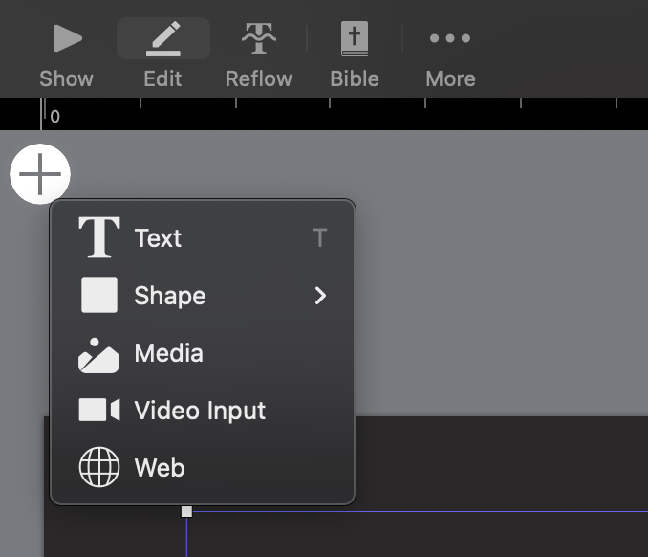

It won’t be in the correct size or position. So set the “shape” parameters to have a position of x=0, y=0, Width=1920, Height=1080. Example:

Next ensure that the fill fields are set correctly.

In the above screen capture it says “Input 6: Scan Converter”, The number might be different, more likely “Input 1”.

That is about all the is needed to set it up. When you show that slide, ProPresenter will display the web page, you can switch to Safari and interact with it.