## Admin Dashboard

Admin Dashboard gives an overview about the system.

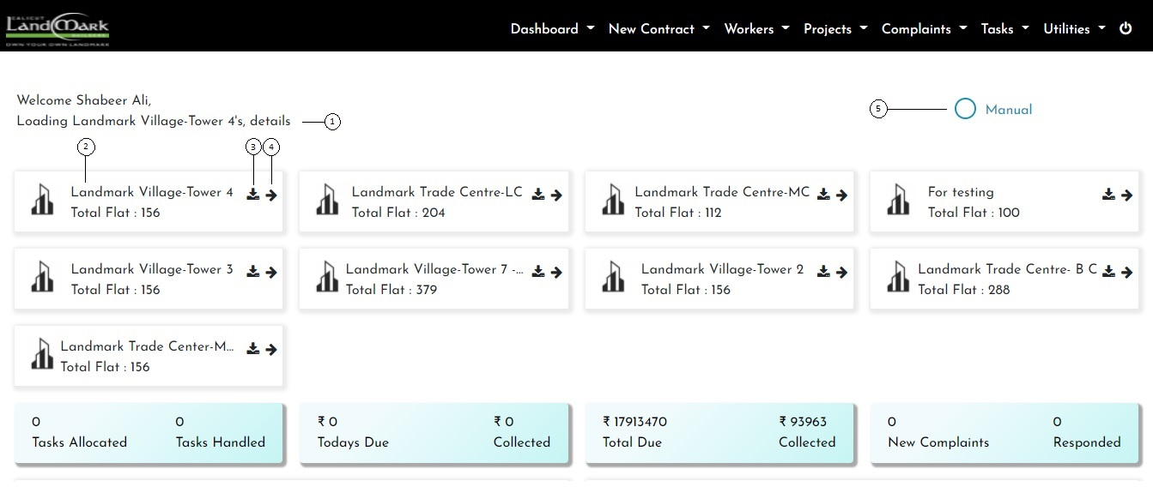

1. It denotes tower name of the loaded dashboard. By default generate tower location of the first card.
2. Each Card denotes various Tower, and on click generate corresponding dashboard.
3. Report generator.
4. View all about the tower.
5. If manual is enable, communication type is manually. Otherwise it will be automatically.

By default manual is enable.

## **Everything about the project**

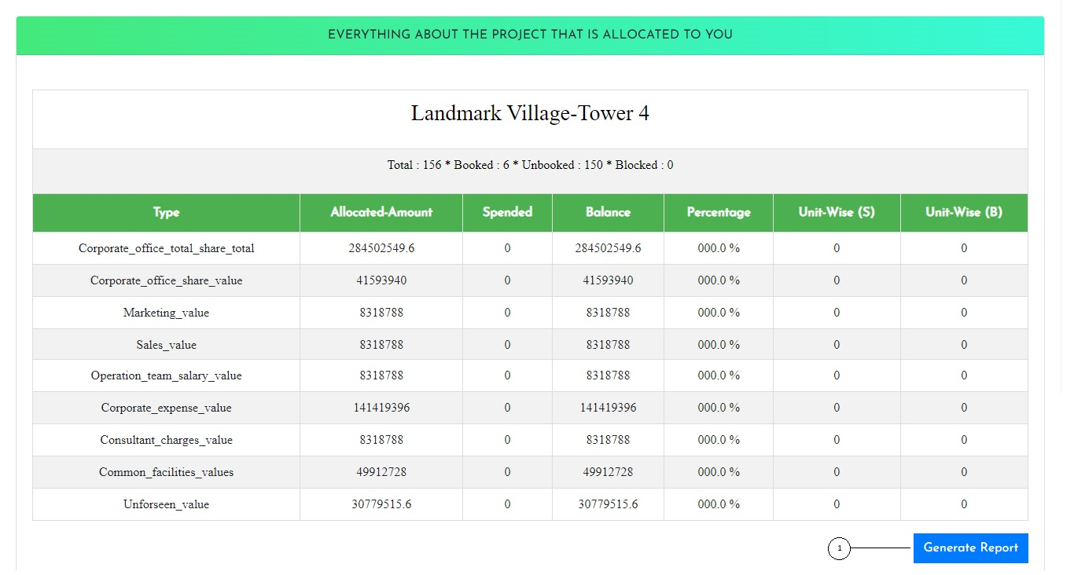

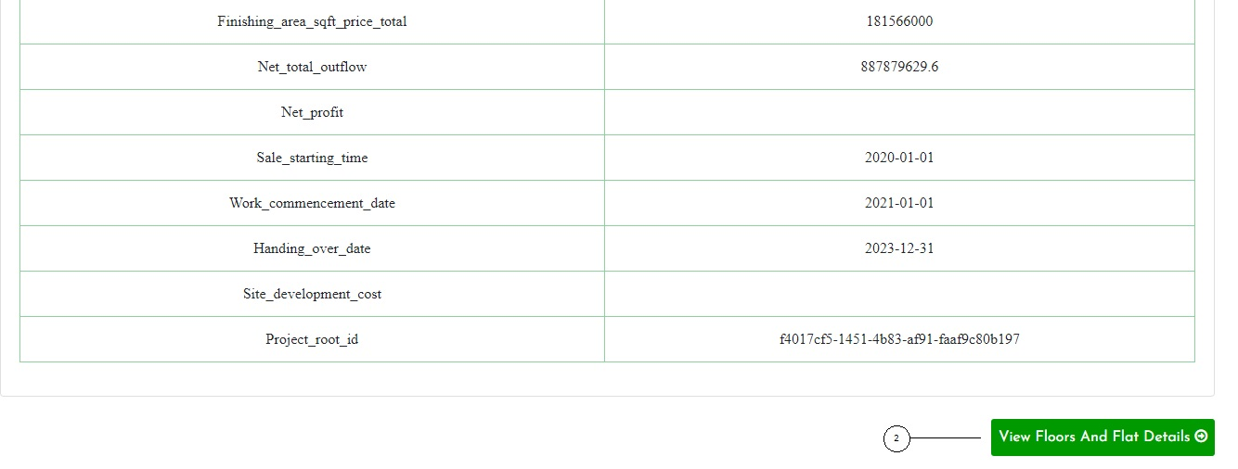

1. Generate report for the corresponding tower.
2. Detailed view of tower.

## Registration Form for New Normal Applicant

This is the form for register new normal applicant with his personal details, family details, nominee details and all other relevant data.

### Personal Details

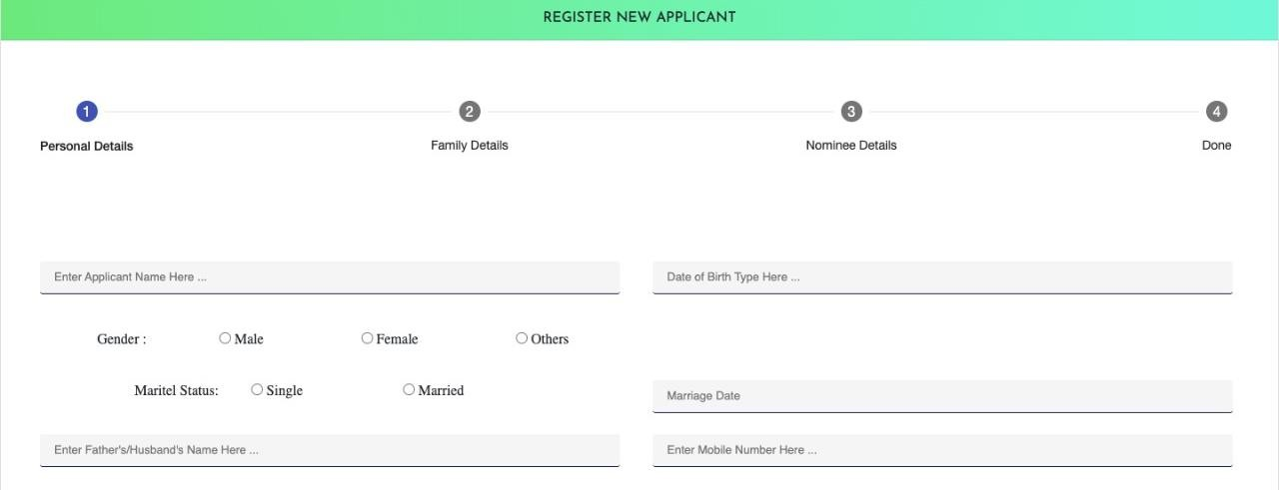

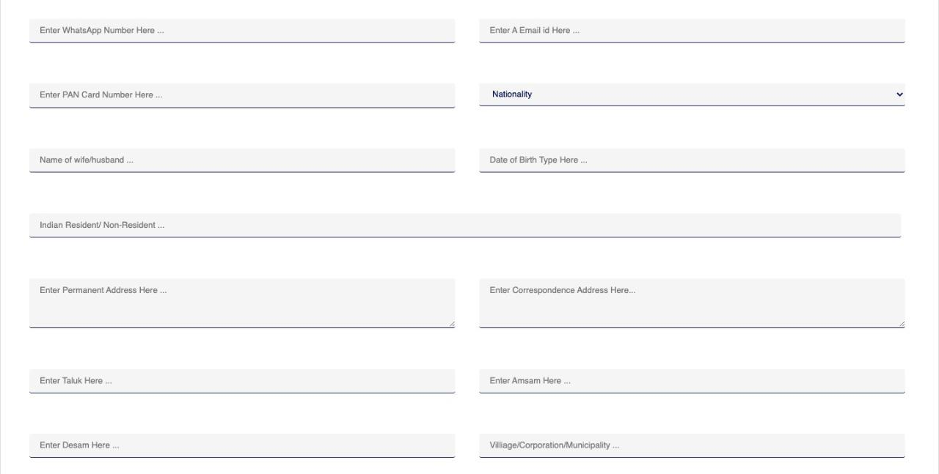

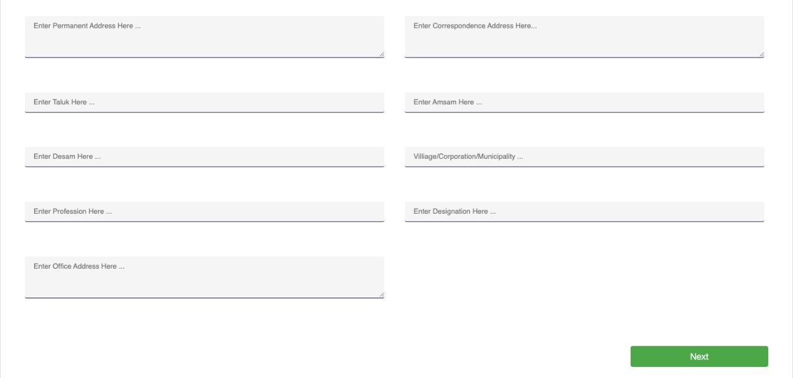

**Family Details**

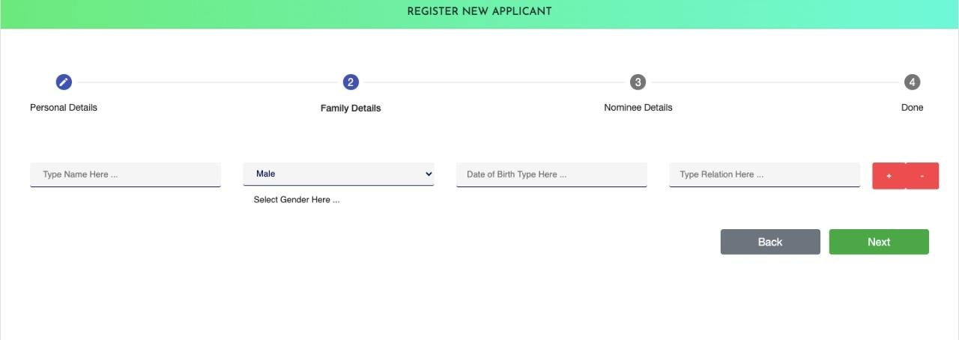

1. Add one more family member.
2. Remove family member.

**Nominee Details**

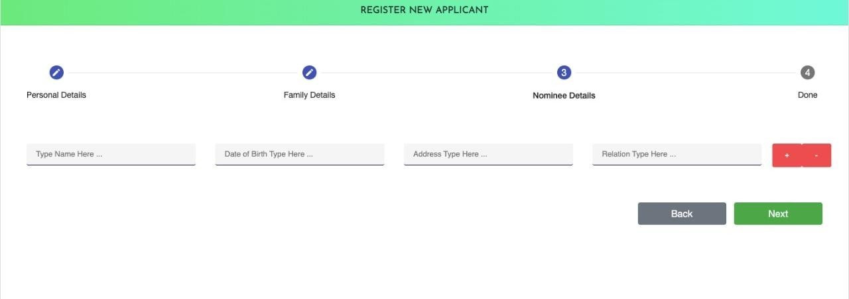

1. Add one more nominee.
2. Remove Nominee.

## Legal Entity Registration

Legal Entity Registration for cooperative firm, company, partnership firm or others.

### Common Details

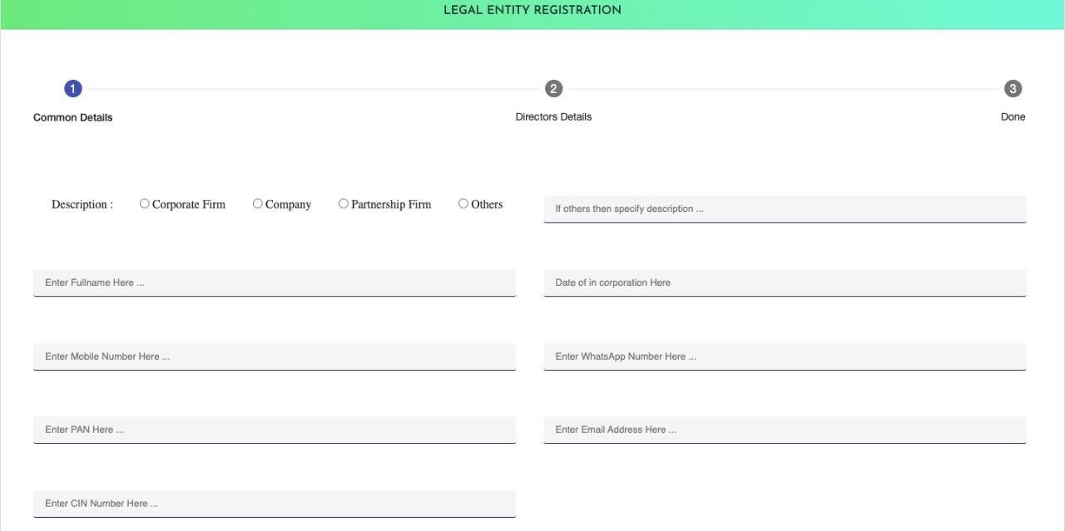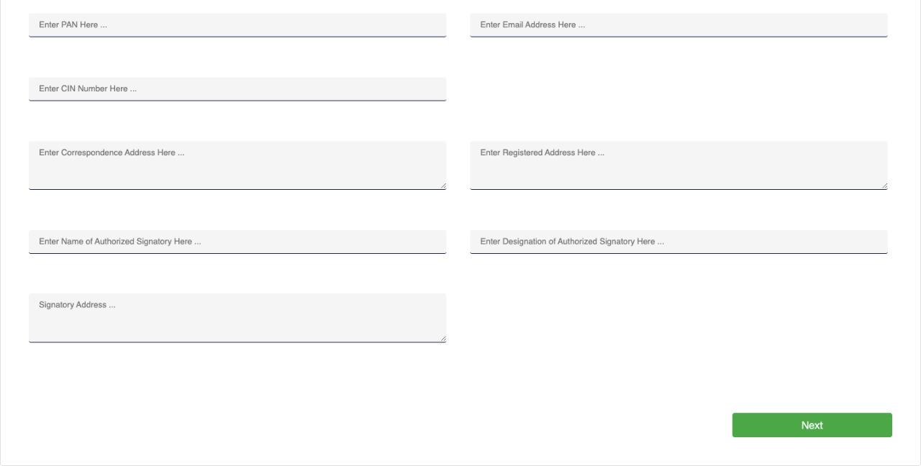

**Directors Details**

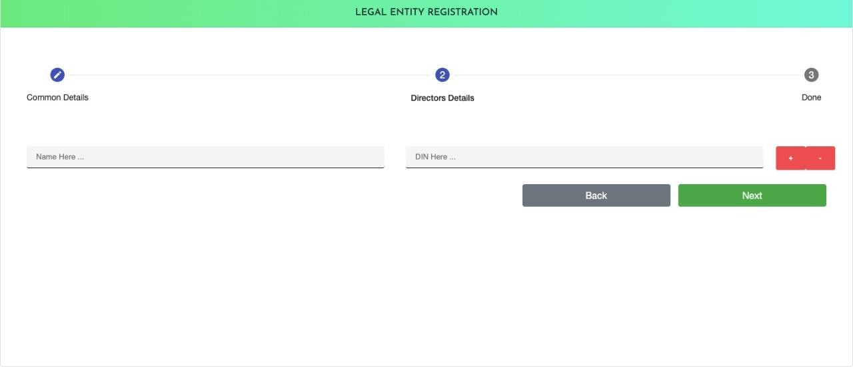

1. Add more Director Details
2. Delete already added Director details

### Legal entity Added successfully

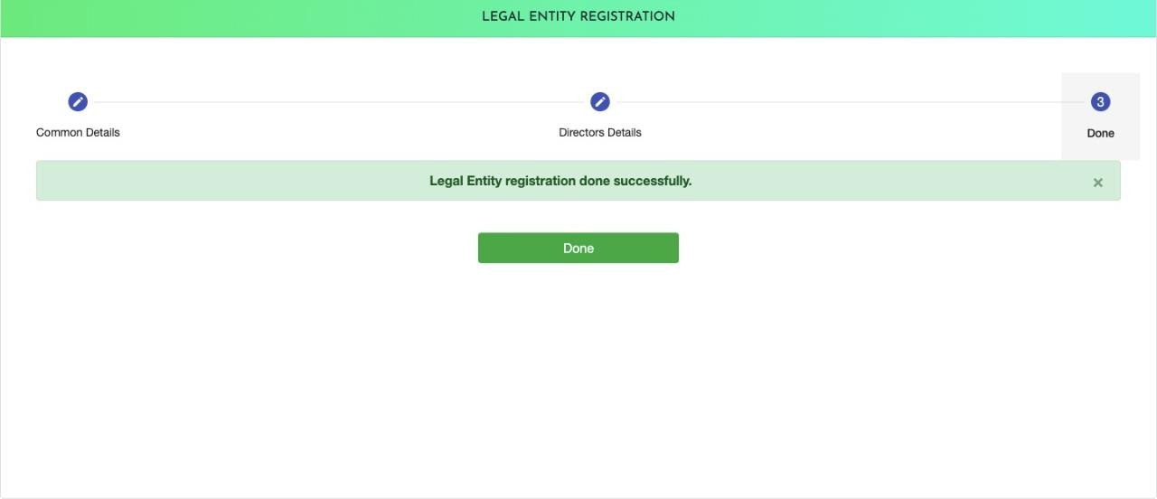

1. This is the message to indicate successful legal entity registration

## 4. All Contracts and All About the Contract

View all contract with date-wise and work progress based scheduled and single-time payment.

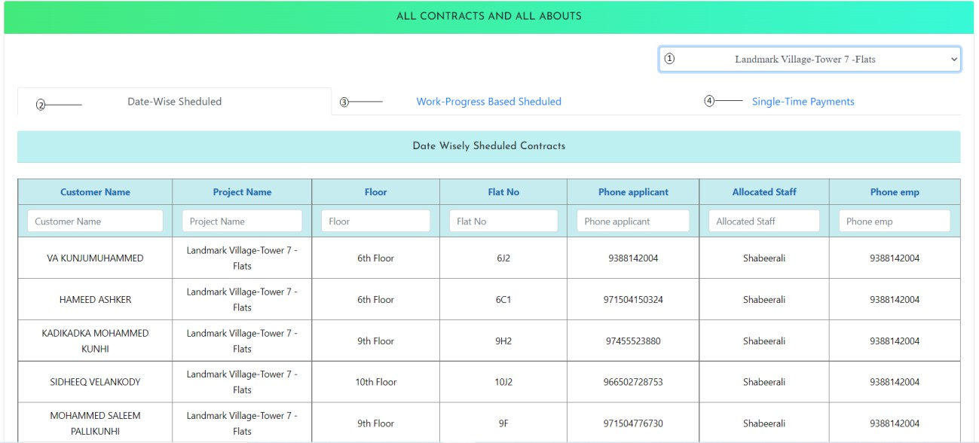

1. Select a project to view contract details
2. To view sheduled contracts as date-wise for selected project
3. To view sheduled contracts as work-progress based for selected project
4. To view one time payment based contracts

## Cancel or Close Existing Contract

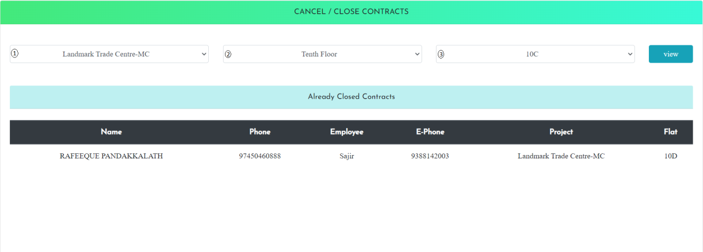

1. Select Project
2. Select Floor
3. Select Flat

## 6. Allocate contract to payment collection agents

Allocate contracts to the payment collection agents and manage it. View all payment collection history in according with agents and change the contracts to different collection agents. Allocate payment collection according with the selected project to the selected employee.

### Agents Contracts to Collection Agents

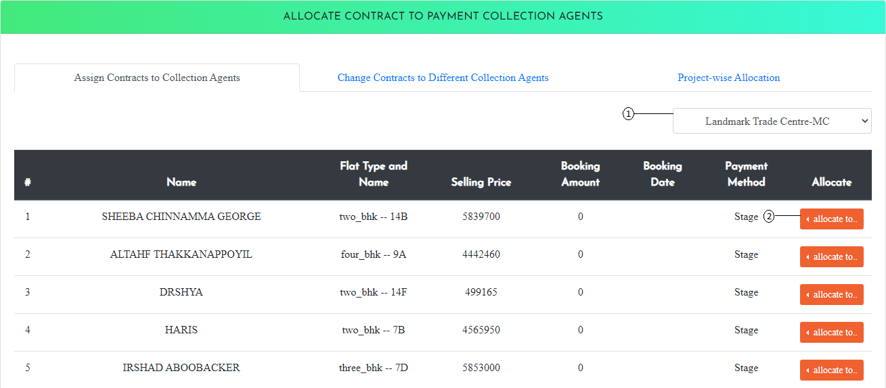

1. Select project for contract allocation
2. Allocate agents

### Change contracts to Different Collection Agents

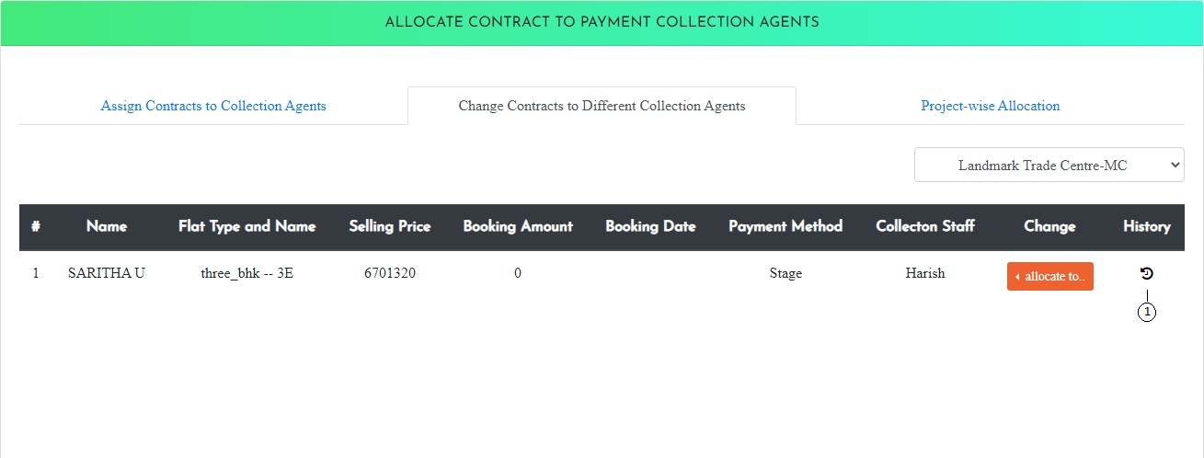

1. To view payment history of contract

### Payment History

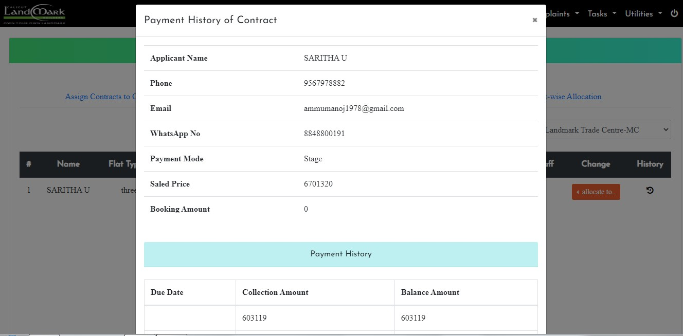

**Project-wise Allocation**

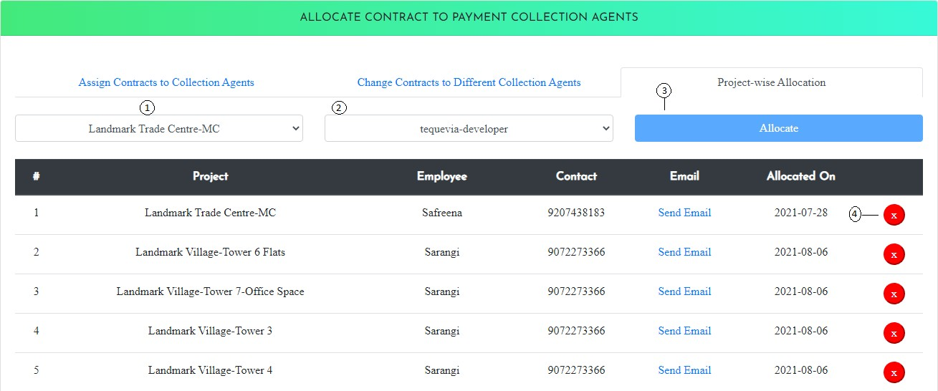

1. Select project
2. Select employee
3. Allocate payment collection
4. Close allocated payment collection

## Date Extension Requests For Flat Allocation

Date extension request for blocking or unblocking

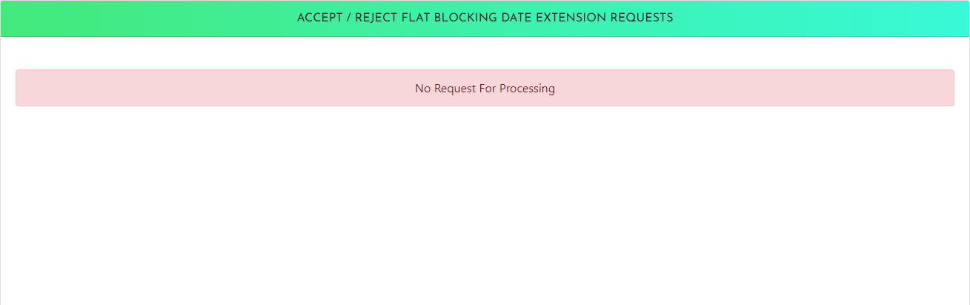

## All about Payment Collection and Contract Due

### All about Payment Collection

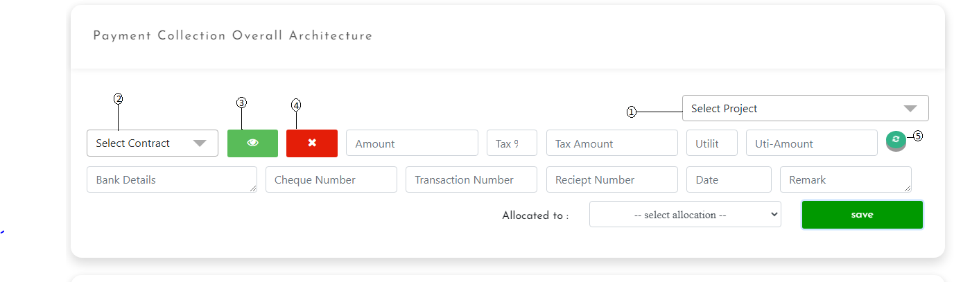

1. Select project for payment collection
2. Select contract under the selected project
3. Payment History of contract, previous response history and all payment history
4. Report contact
5. Refresh the filled fields

### Payment History of Contract

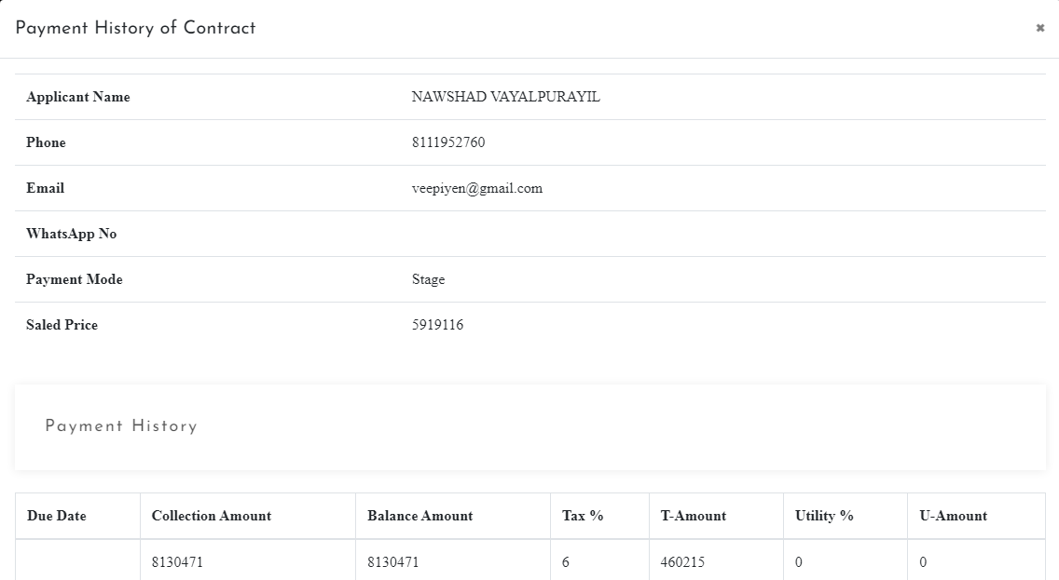

**Previous response history and all payment History**

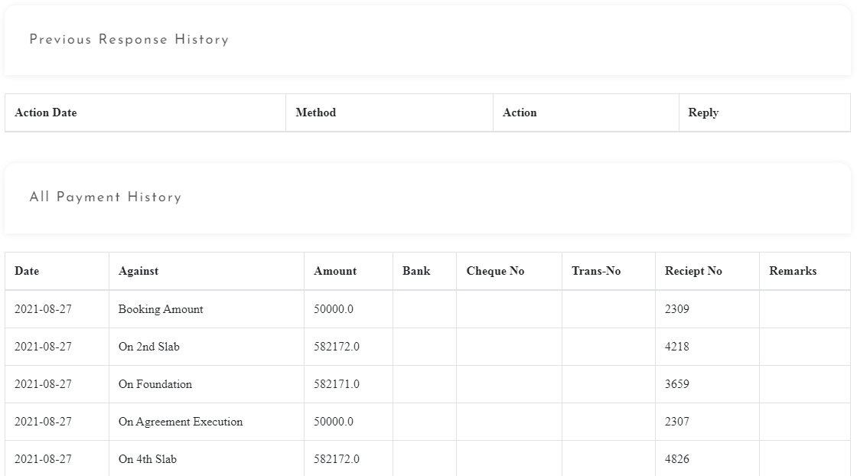

### Contract Due

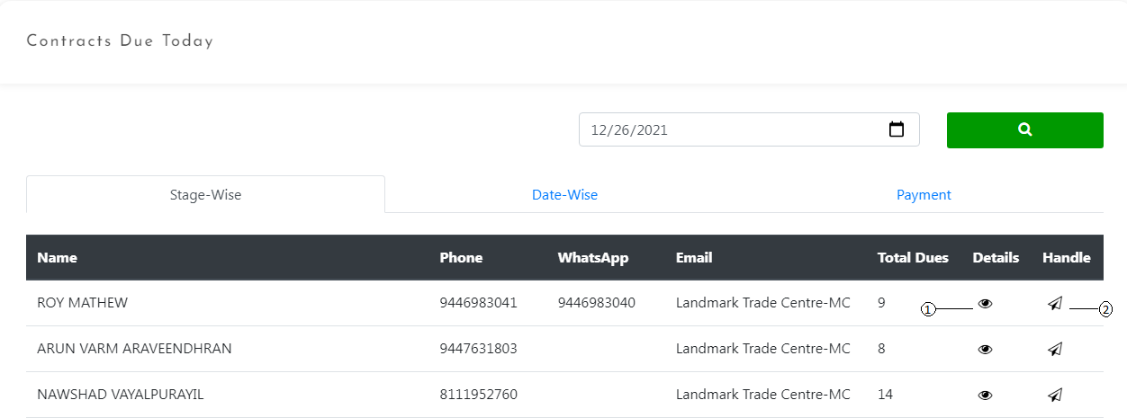

1. View payment history of the contract
2. Manual Notification

## Contracts Having Payment Over Dues and Fee Up the Blocked Flats

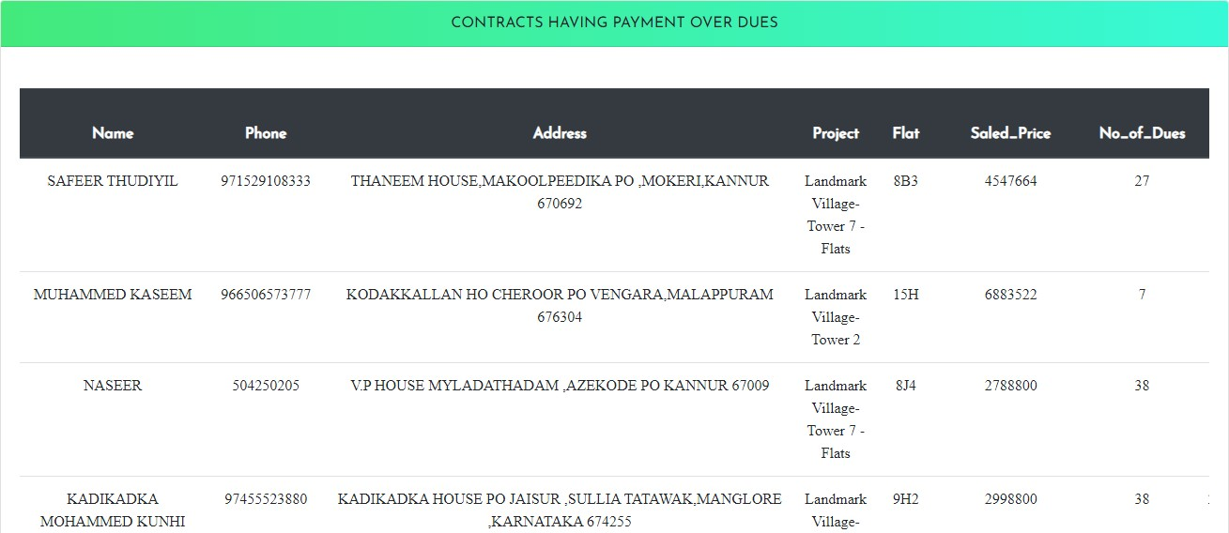

**Free up Blocked Flats**

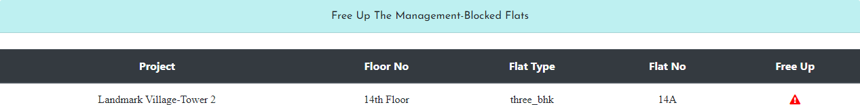

## Post Dated Cheque Information

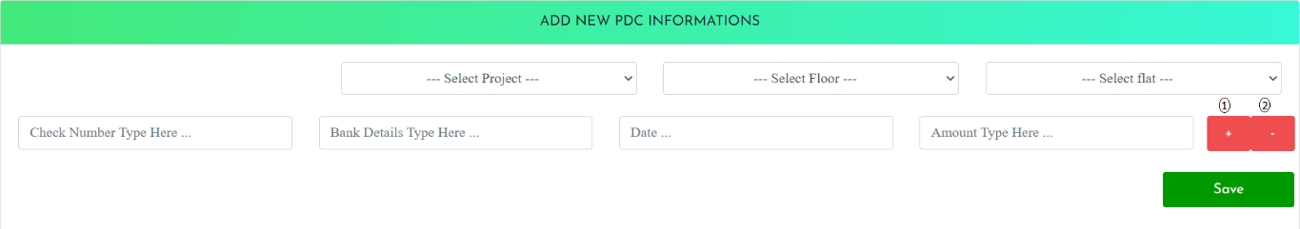

1. Add new PDC information
2. Remove PDC Information

## View Post Dated Cheque Information Added

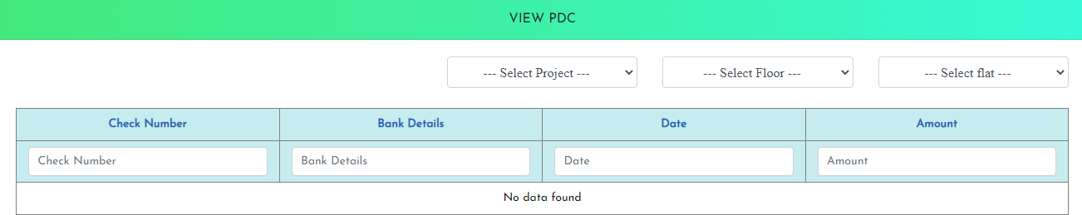

1. **Profession Based Listing**

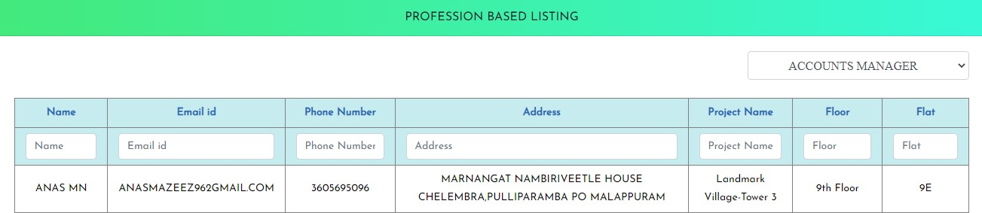

## Update Already Listed Stages of Contract

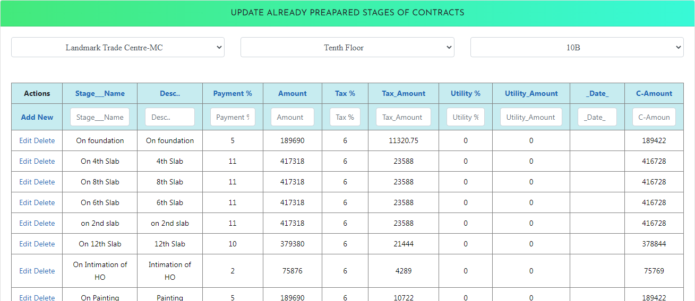

1. **Update Documents of Contract and Manage Already Uploaded Documents**

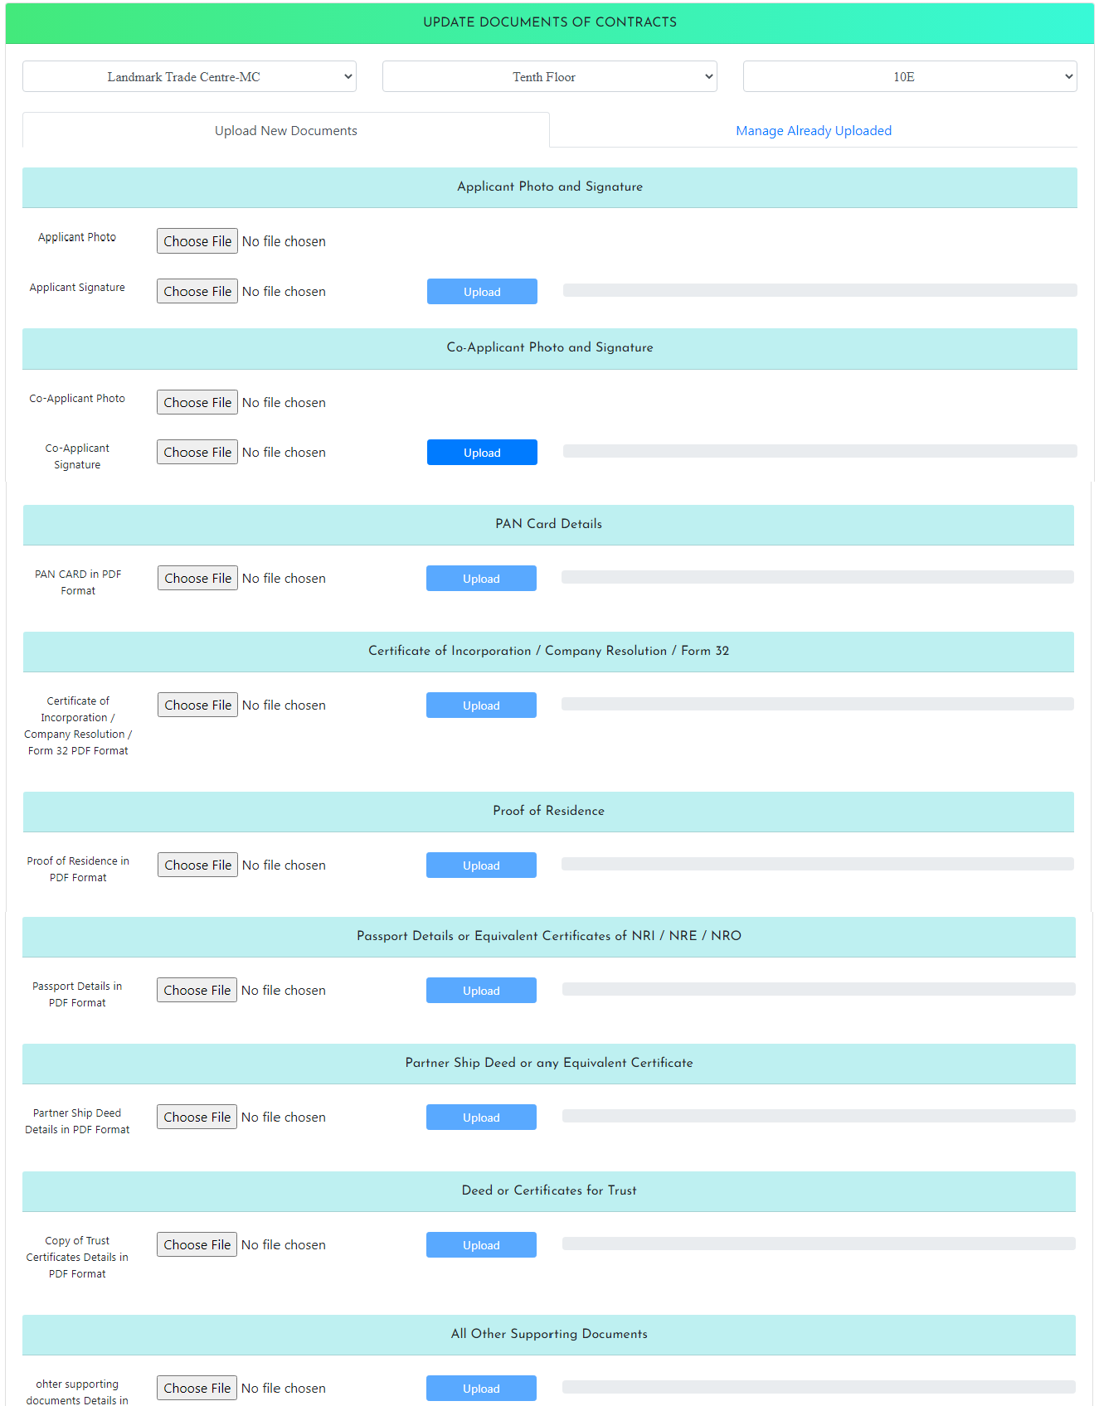

## Register New Employees with Company Designation and Manage Registered Employee

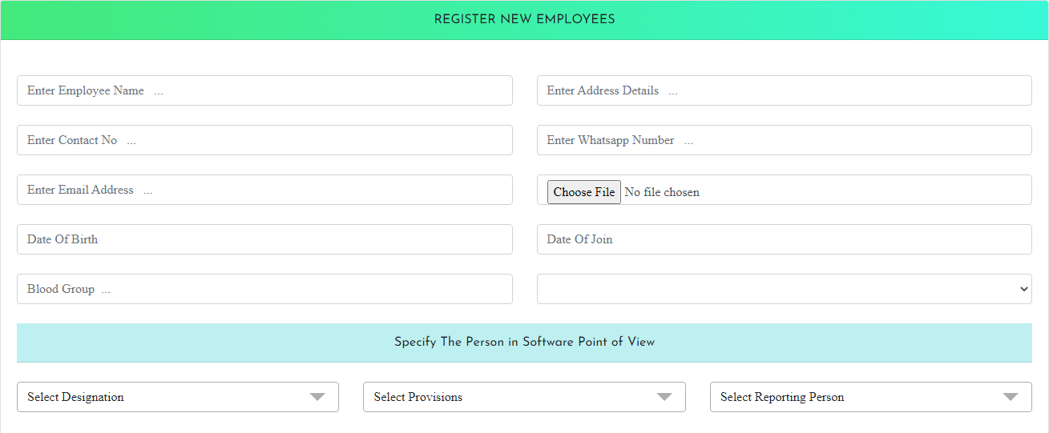

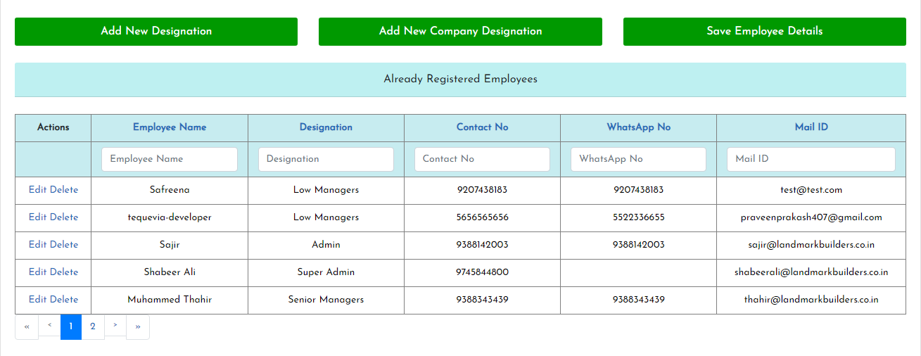

1. **Add New Provisions and Manage Existing Provisions**

Add new provisions to the employees, update details and manage existing provisions

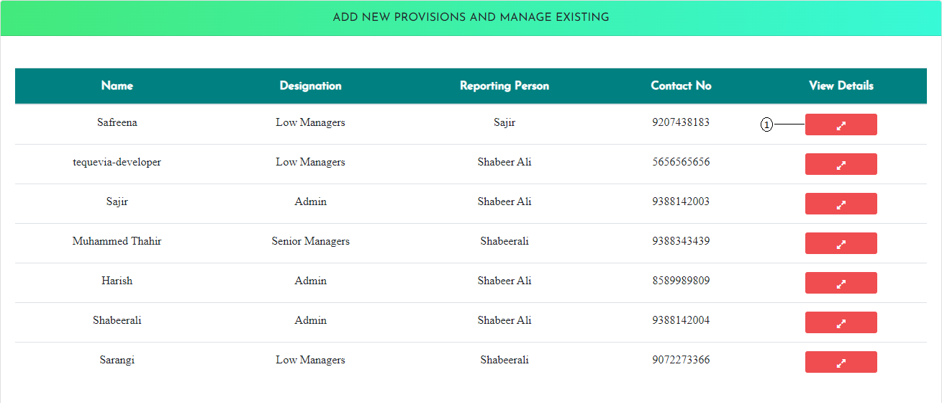

1. Update existing provision details

### Update Details

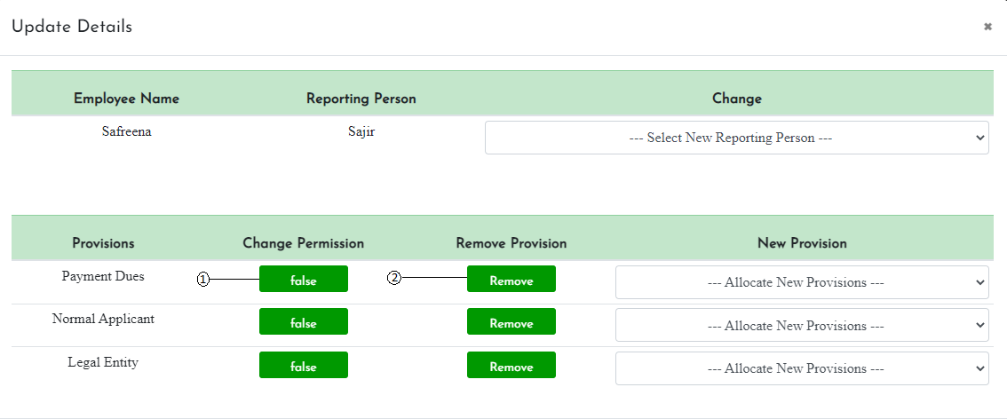

1. Provision permission to true or false
2. Remove already granted leave

## 17. Task Allocation and Tracking Customer Based or Staff Based

Task allocation and task management is based on customer based or staff based.

### Allocate New Task

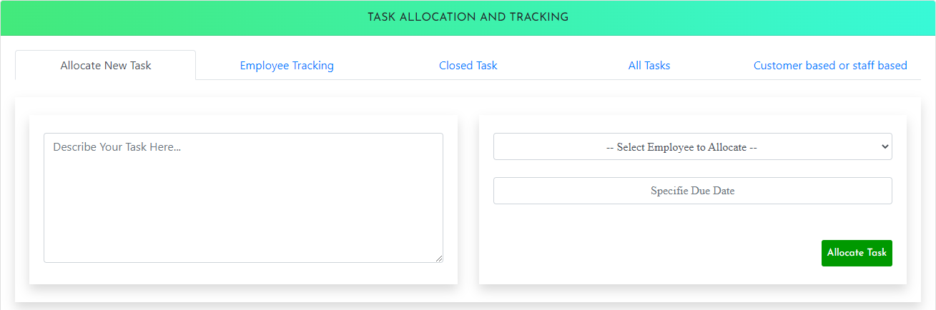

**Employee Tracking**

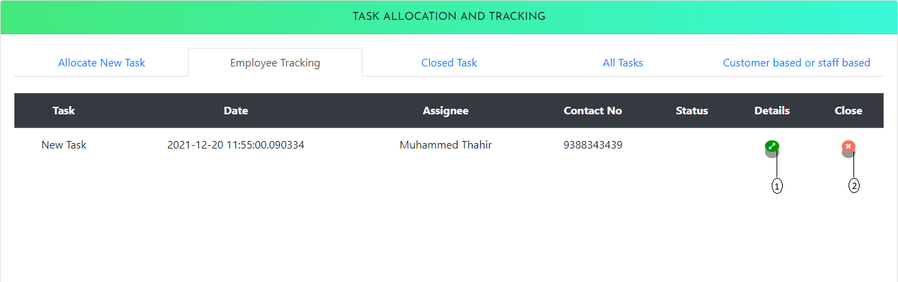

1. All details about the allocated task
2. Closing already allocated task

### All details about the allocated task

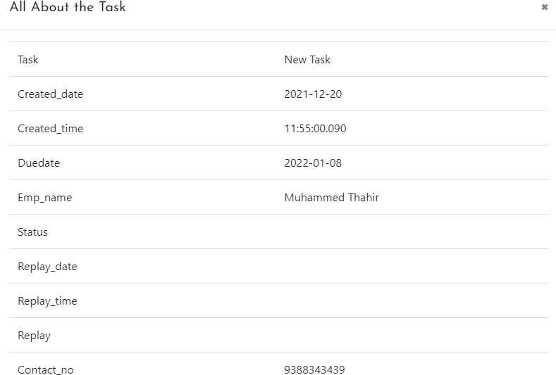

**Closed Task**

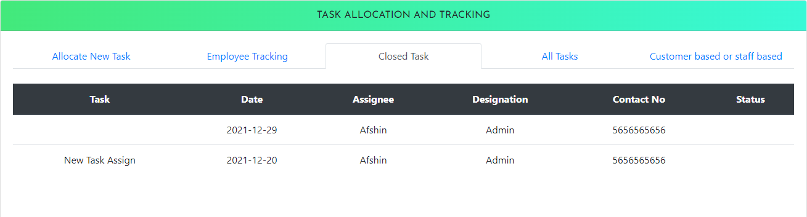

### All Task

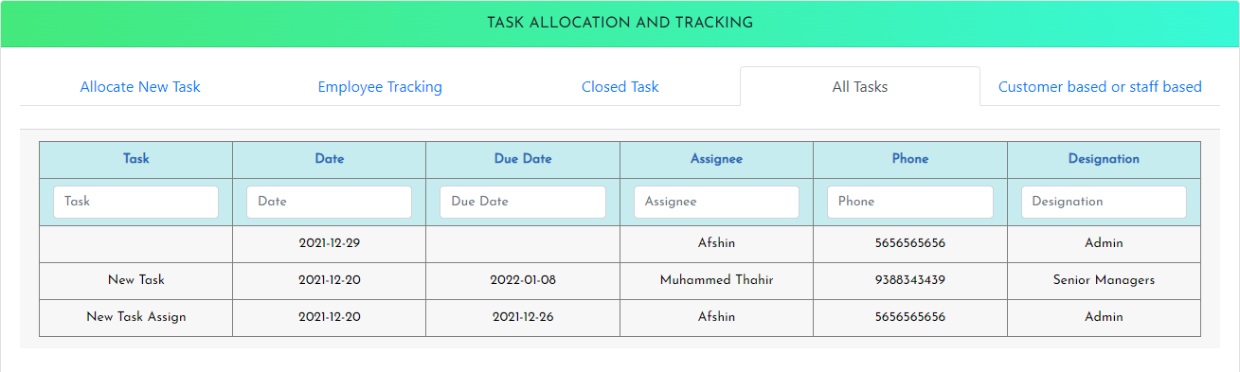

**Customer Based or Staff Based**

There are two options for selection, customer-oriented task allocation and staff-oriented task allocation.

### Customer Oriented

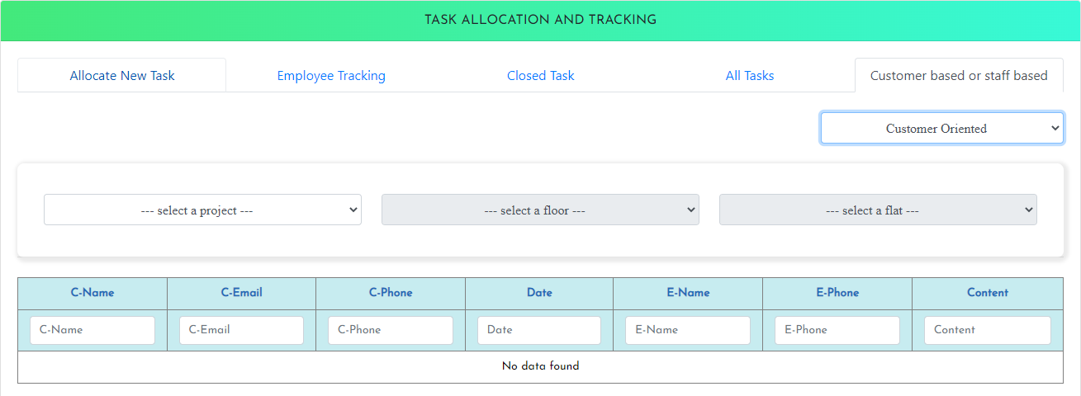

**Staff Oriented**

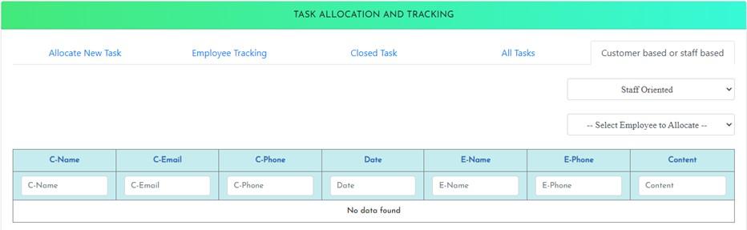

## Communication History

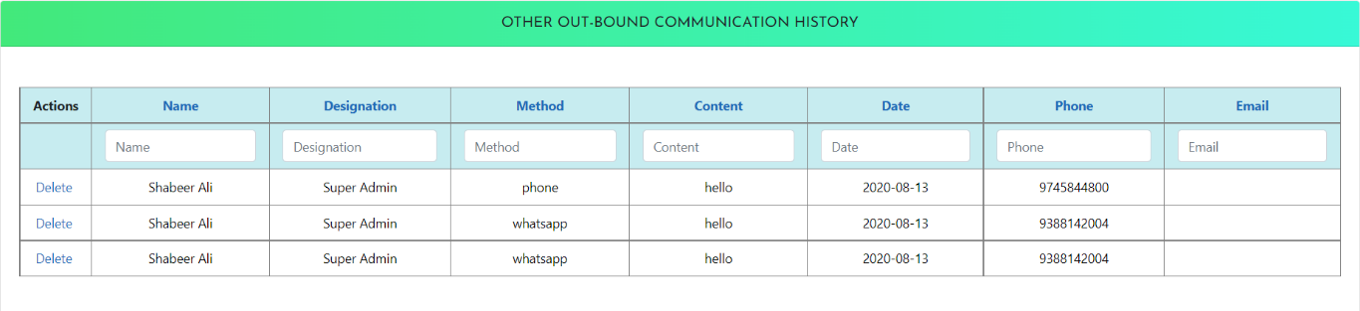

1. **Project Information Management and Project Allocation**

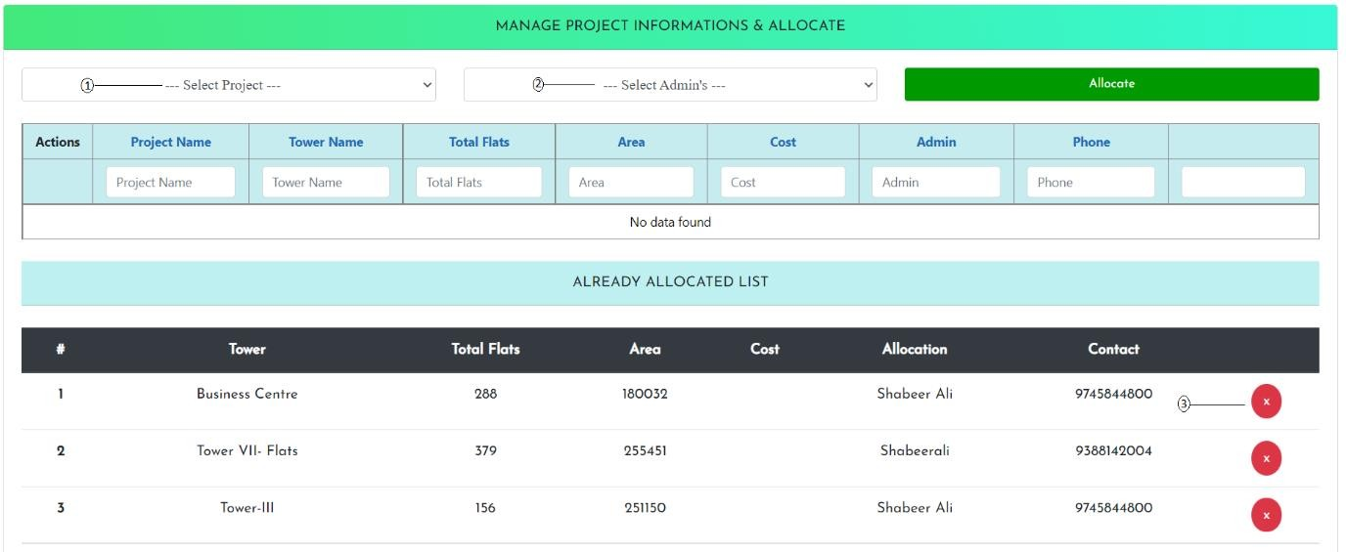

1. Select project
2. Select Admin
3. Close Already allocated Project

## Incentive Claim Application for Employee

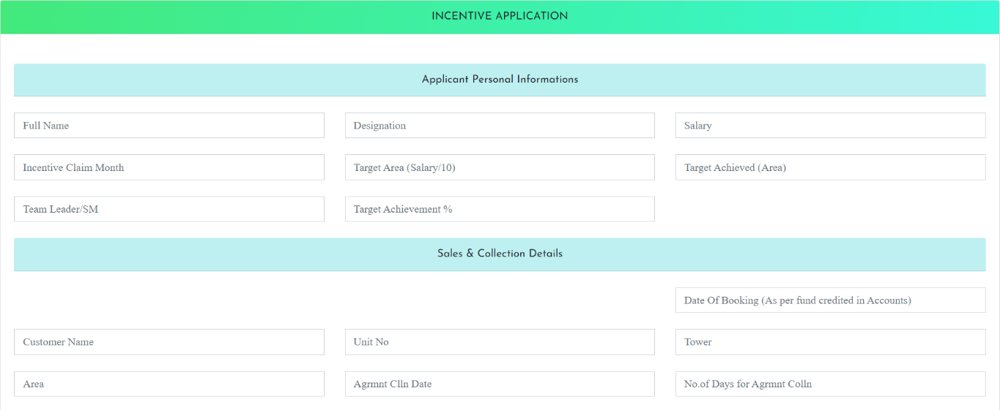

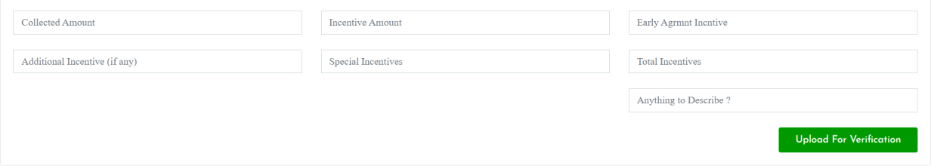

1. **Verify and Approve Payments from Towers**

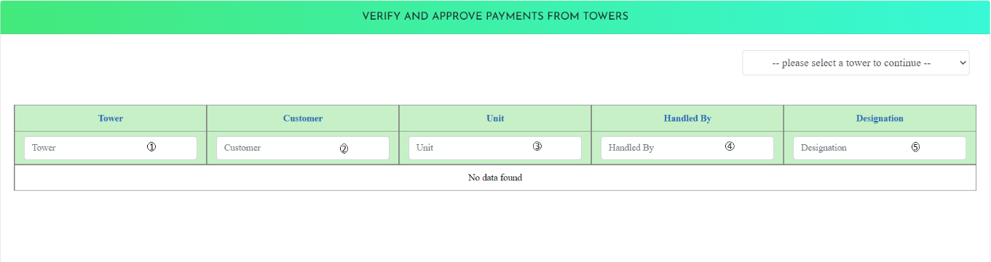

1. To select a Tower
2. To Select Customer
3. Select unit
4. Select Employee
5. Select Description

## 22. Add New Project Information with All Details and View Already Registered Pages

### Information About Scalable Area

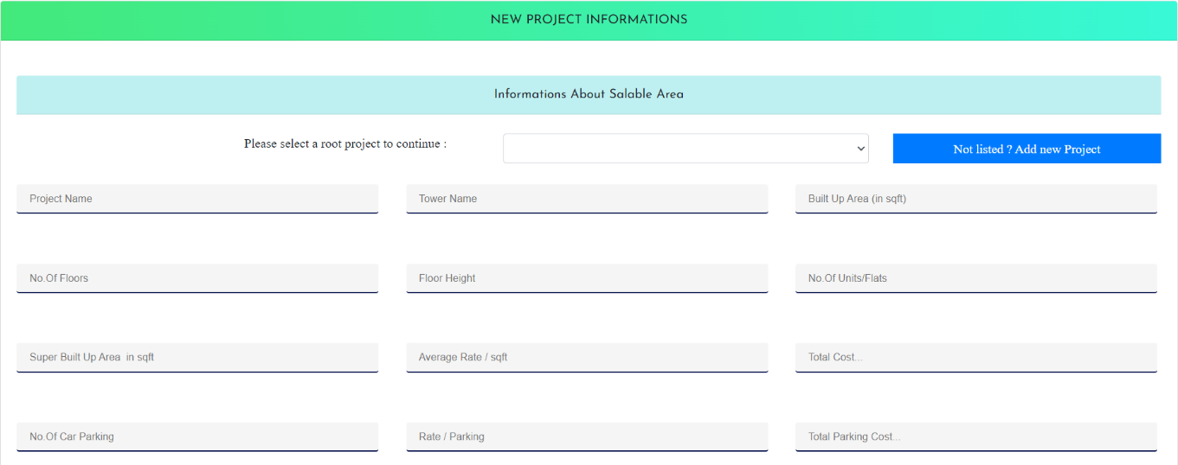

**Flat Counts and Details**

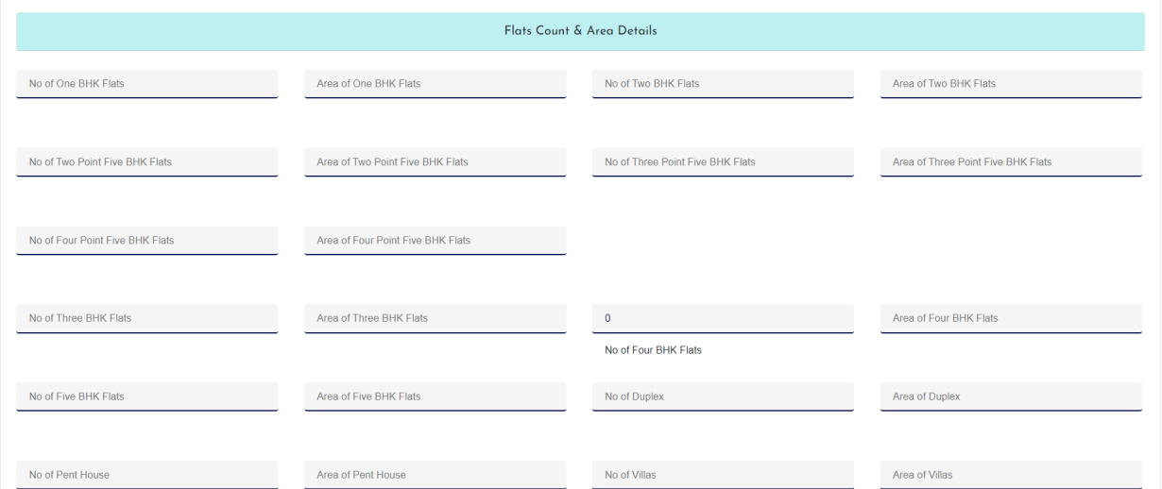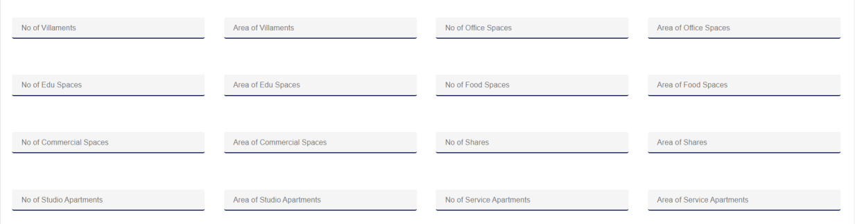

### Information About the Outflow

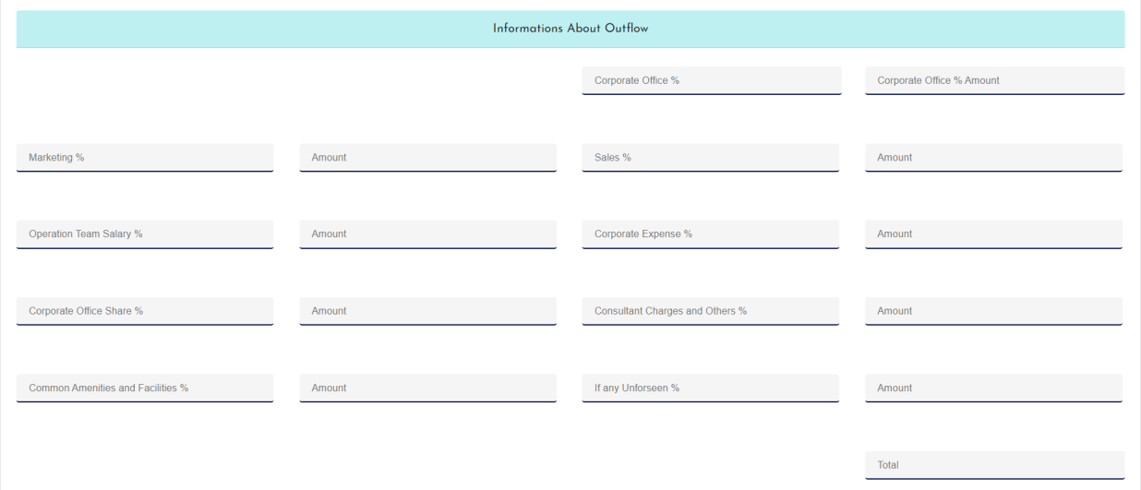

**Site Development Charges and Construction Cost Up to Super Structure**

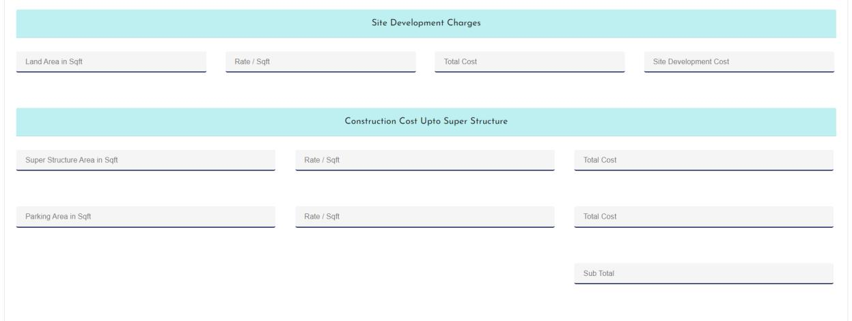

### For Finishing as Per Project Specification

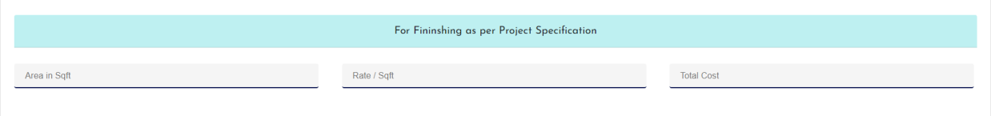

**Final Calculations**

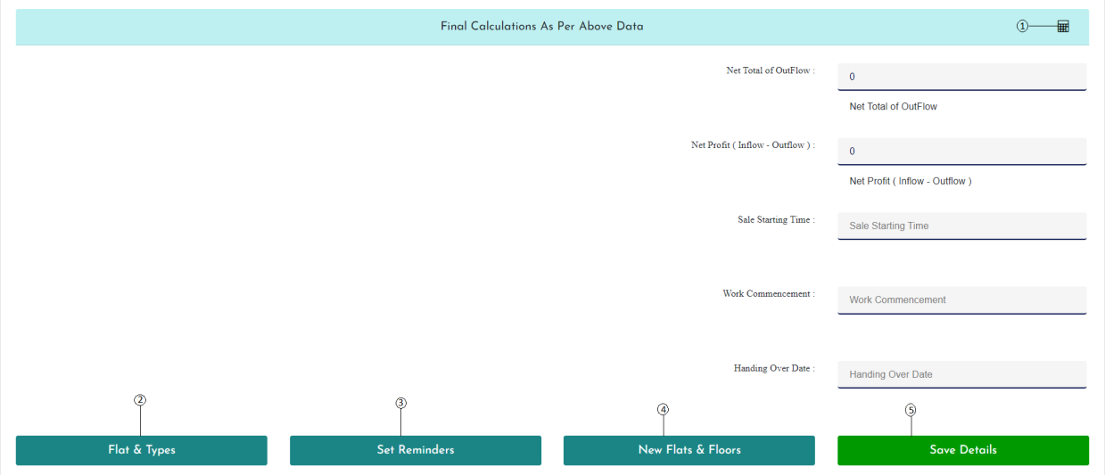

1. To Calculate as per the input data
2. Specify the details of flat type
3. Provide Reminders of Flat type
4. Provide Details of new floor and flat
5. Save all Details

### Specify The Details of Flat Type

Select a project and register new flat and its type

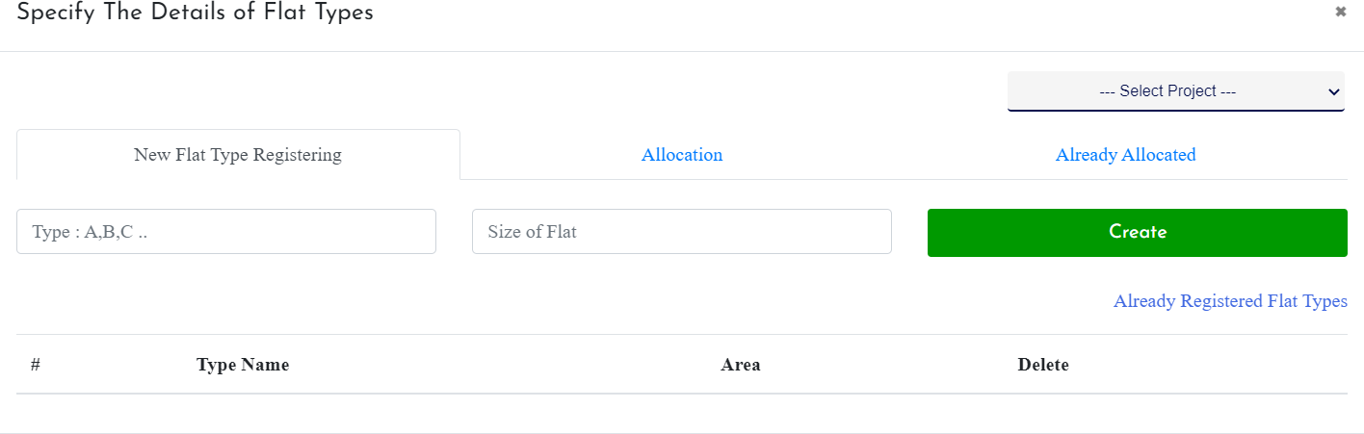

Registered flat Type Allocation

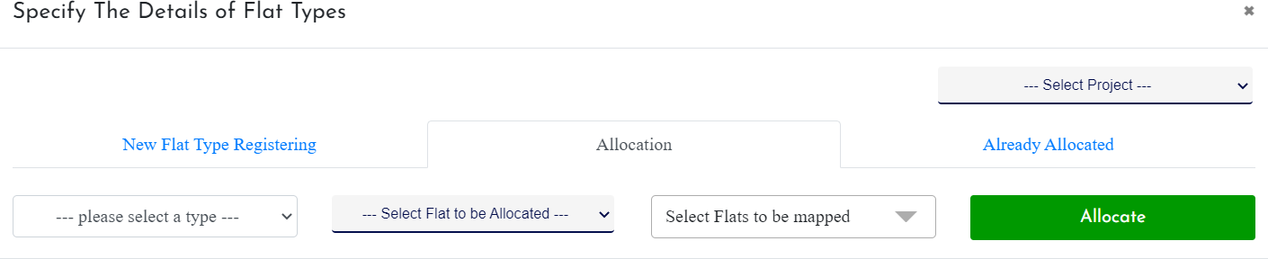

**Already Allocated**

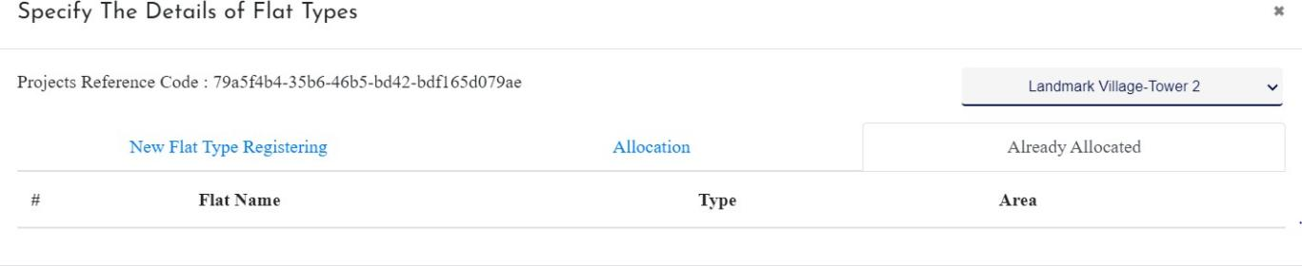

**Add Flat Details with Appropriate Names and Add Reminders**

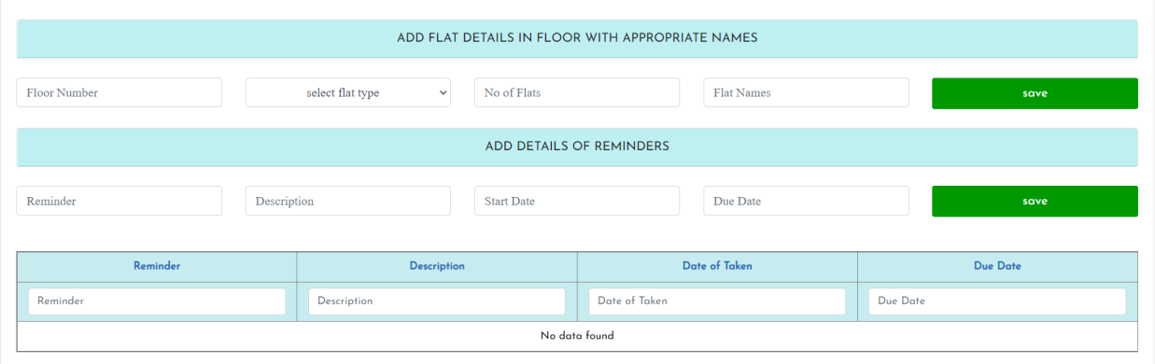

## Registering New Stages

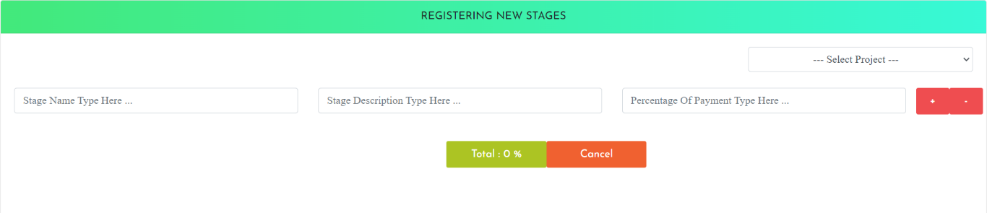

1. **Manage the pre-setted stages and finished Stage Update Pre-setted stages**

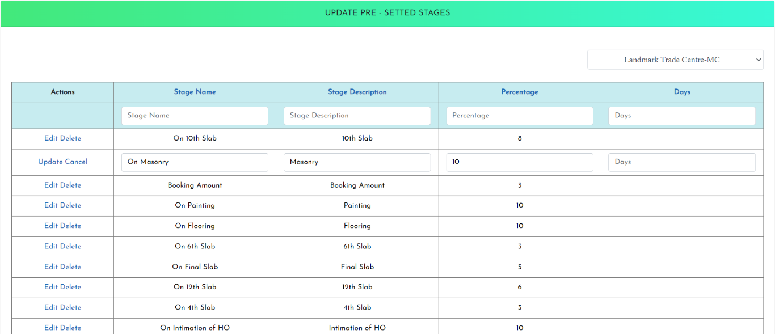

### Update finished stages

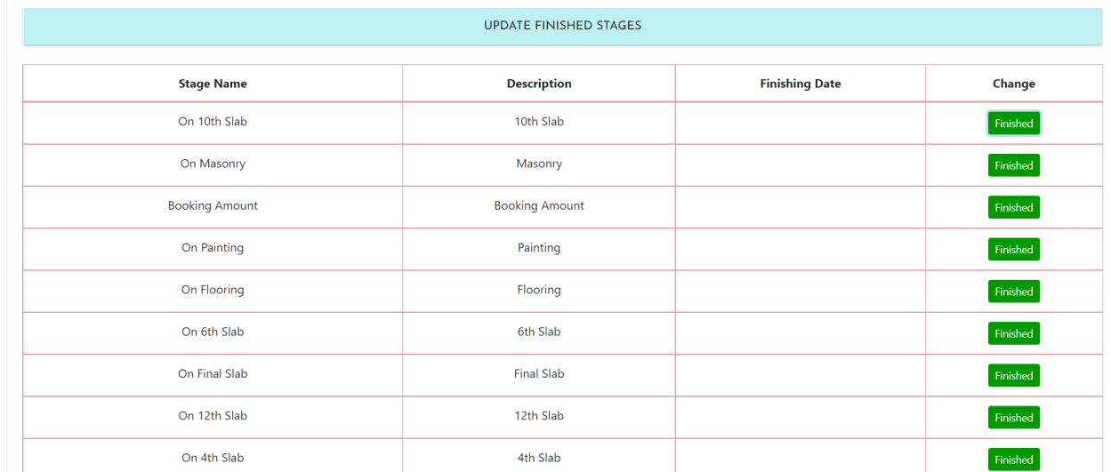It specify the date of complestion of stages for the selected project

**Tequevia**

## Closed Project Informations

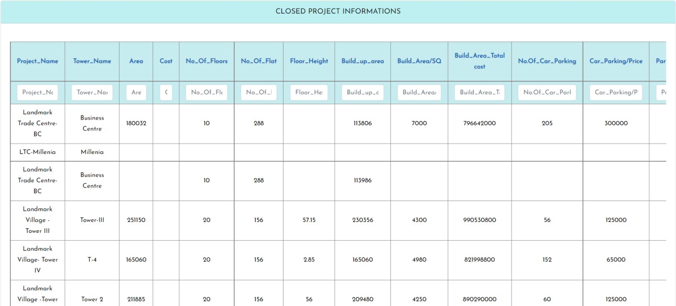

1. **Blocked Flats for Clients with or without Documents**

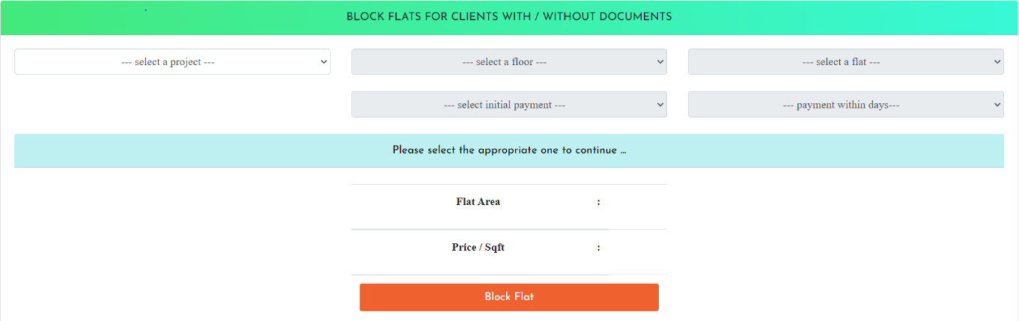

# Tequevia

## Predefine the proposal templates for projects Description

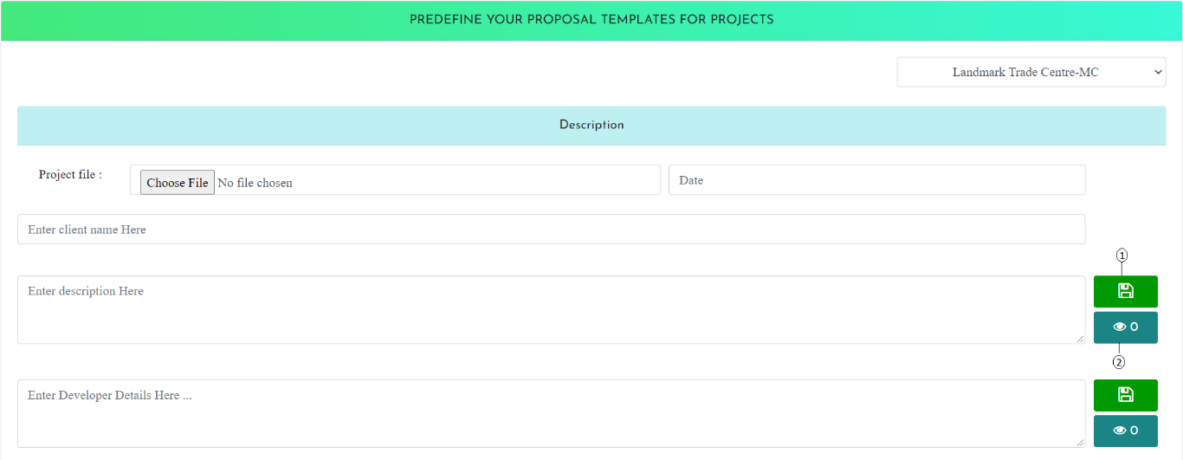

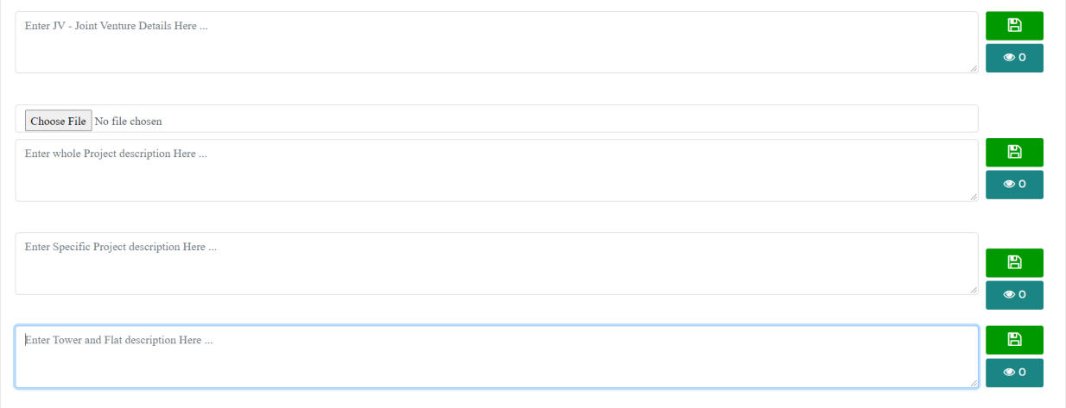

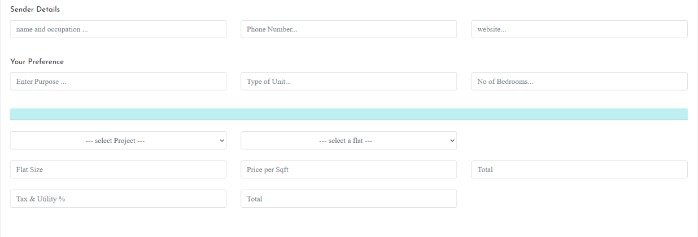

1. Save details

### Payment schedule



1. Prepare payment schedule for stages

### Payment schedule preparation

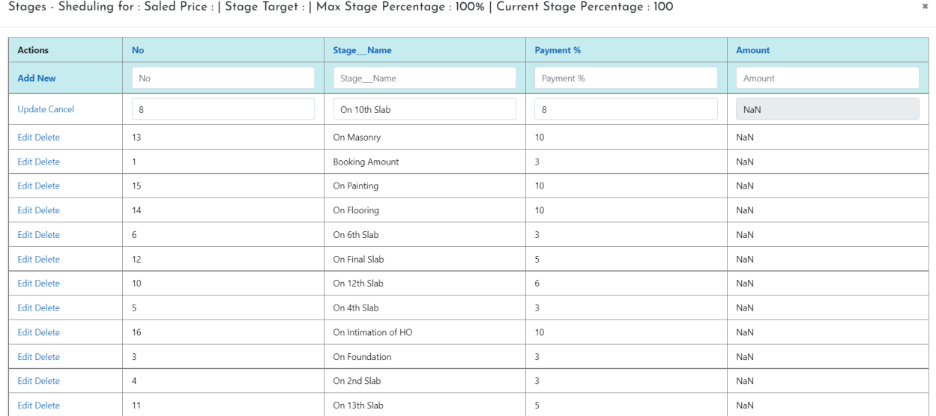

**Site Layout Preparation**

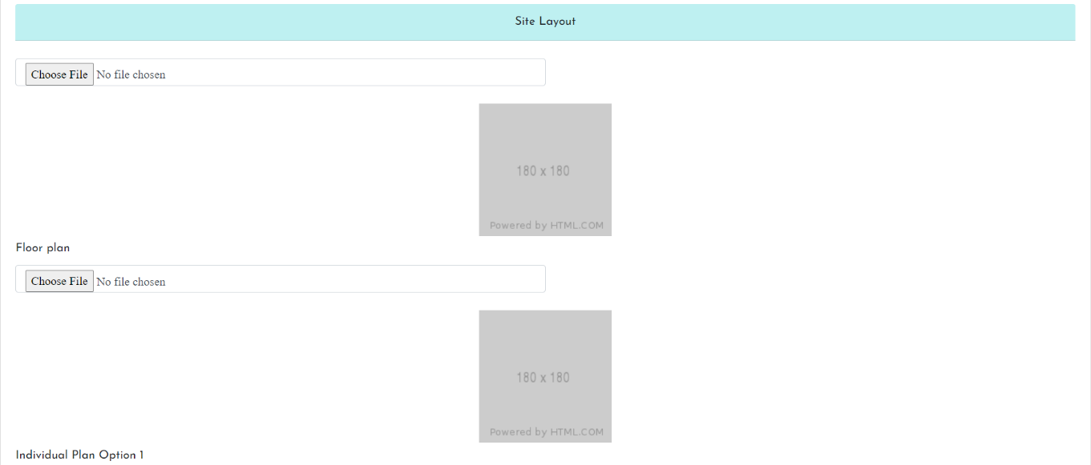

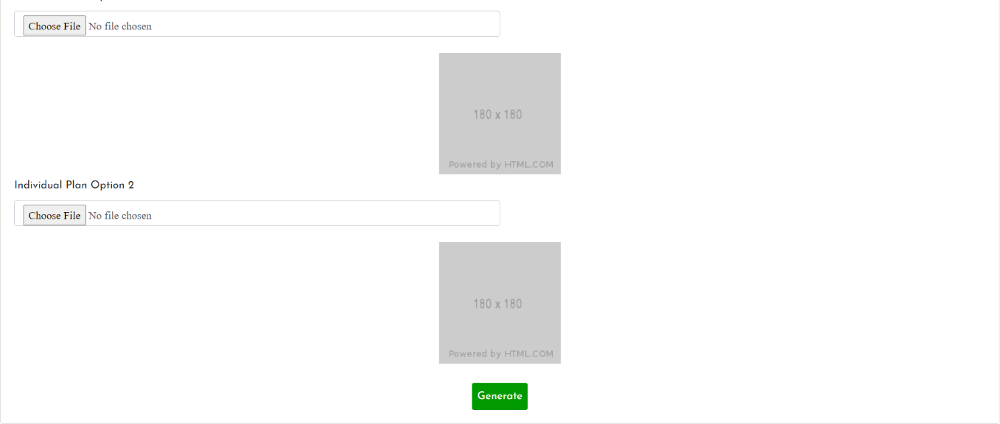

## Gallery Management

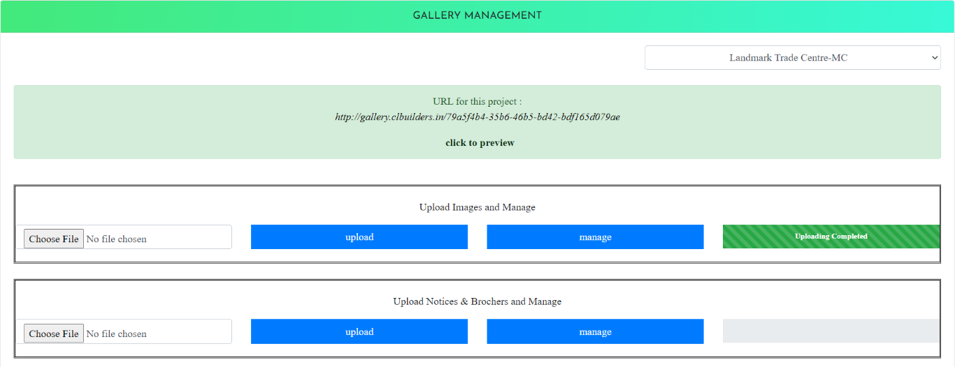

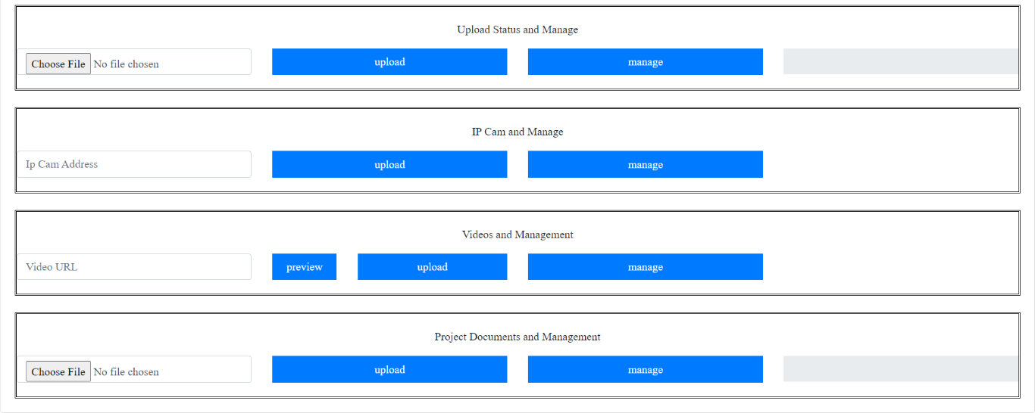

1. **Price List Management**

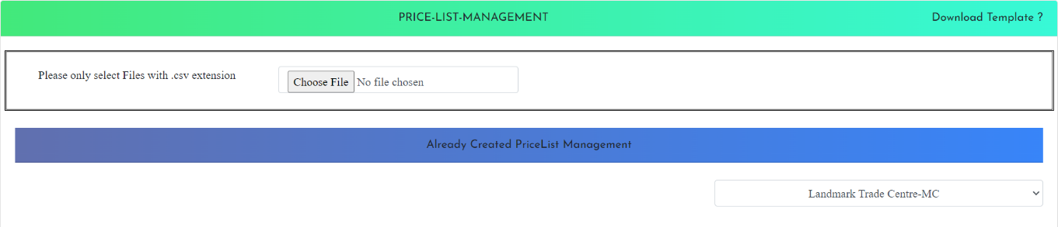

## Create and Manage Agreement Templates

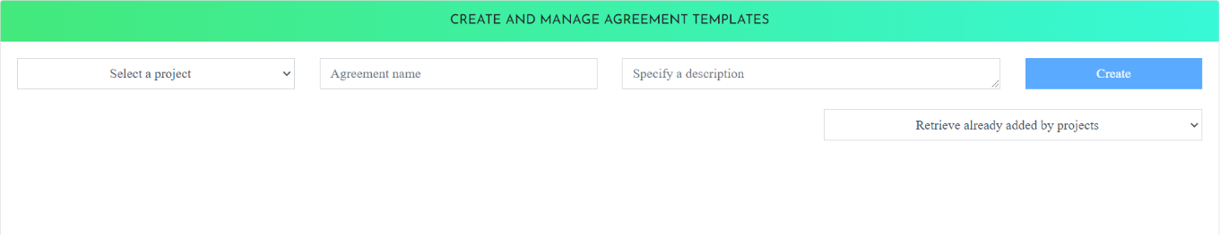

1. **Generate Agreement Draft for CustomersBuilding with Existing Data**

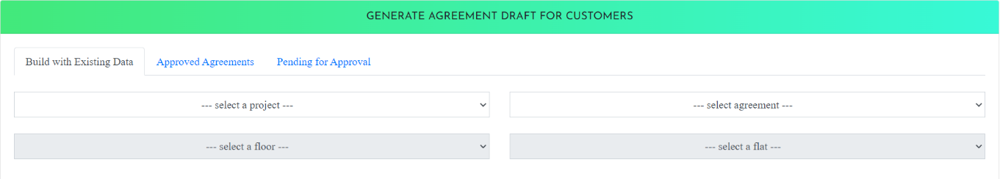

### Approved Agreements

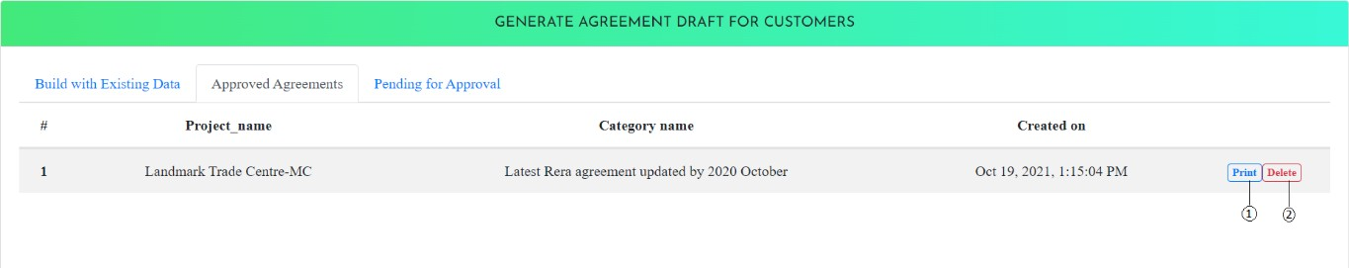

1. Print Agreement
2. Delete Agreement

**Pending For Approval**

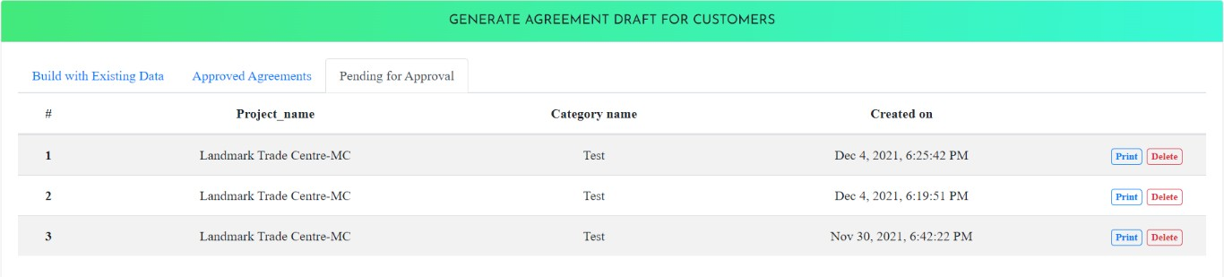

## View, Verify and Approve Agreement Request

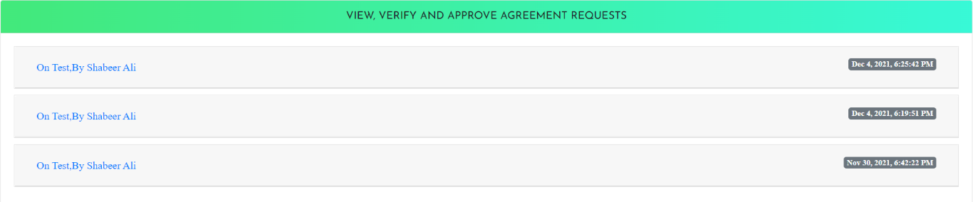

1. **To Manage Un-Allocated Complaints and Un-Handled Complaints**

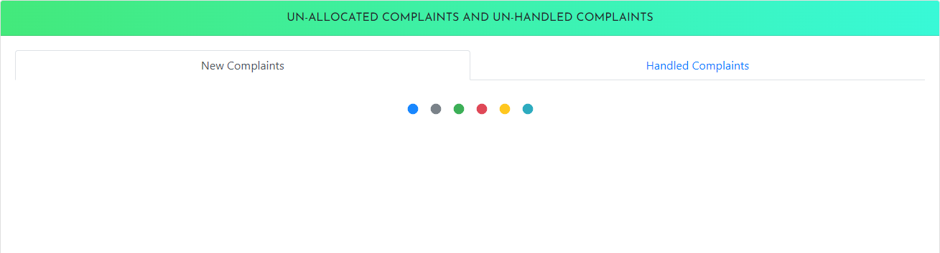

## All Enquiries Registered in the System

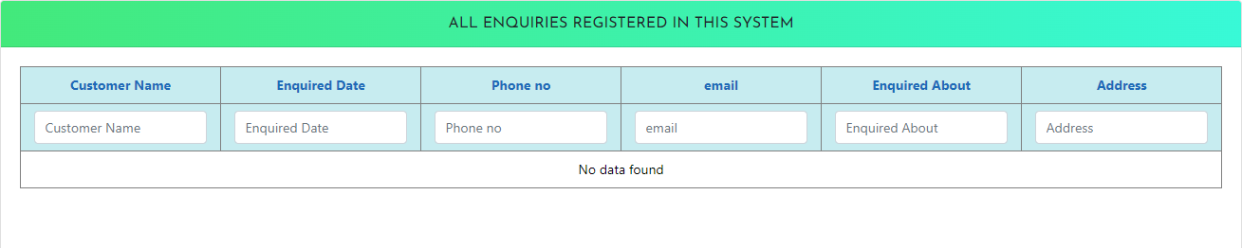

1. **Blocked Flat Details and Complaints from External**

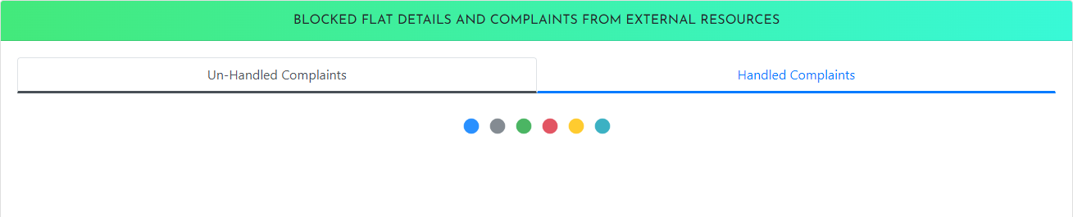

## Allocated Task List for the Employee



1. **Allocated Payment collection and Dues Payment Collection**

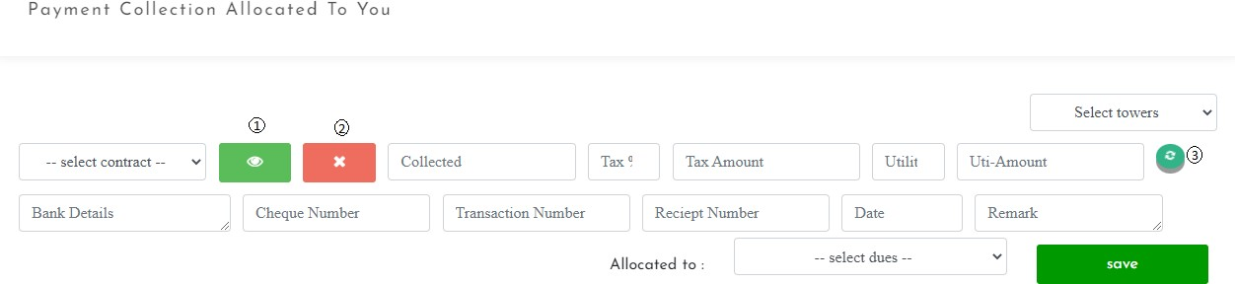

1. Payment History of contract, previous response history and all payment history
2. Report contact
3. Refresh the filled fields

### Contracts Due

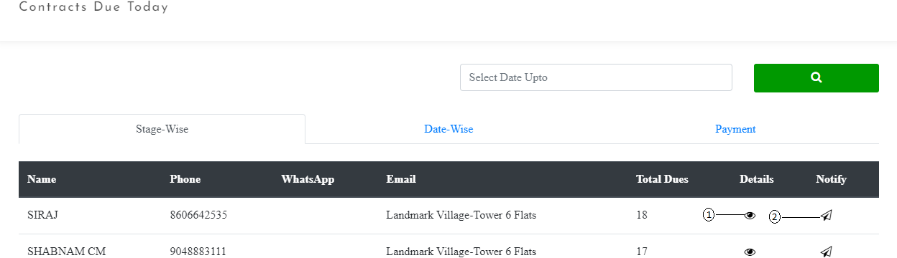

1. View Payment Details
2. Notify Manually

**View Payment Details**

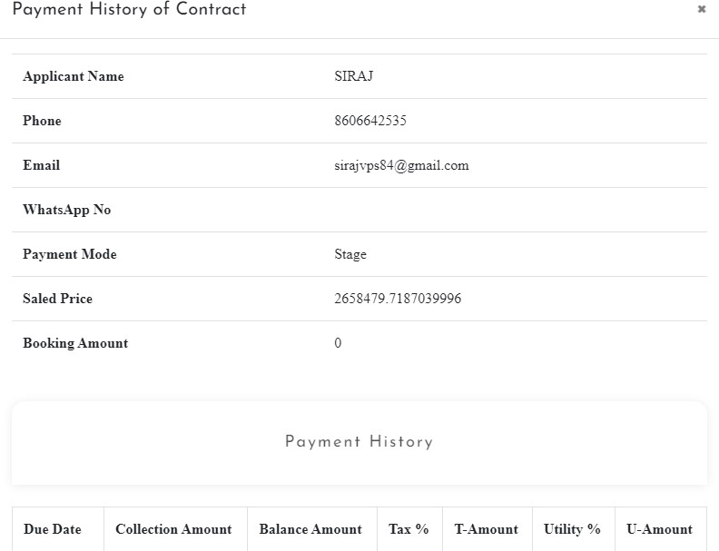

**Notify Manually**

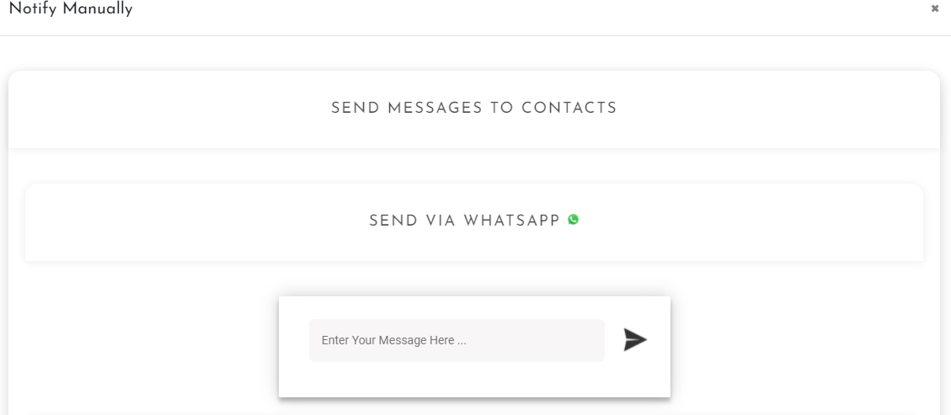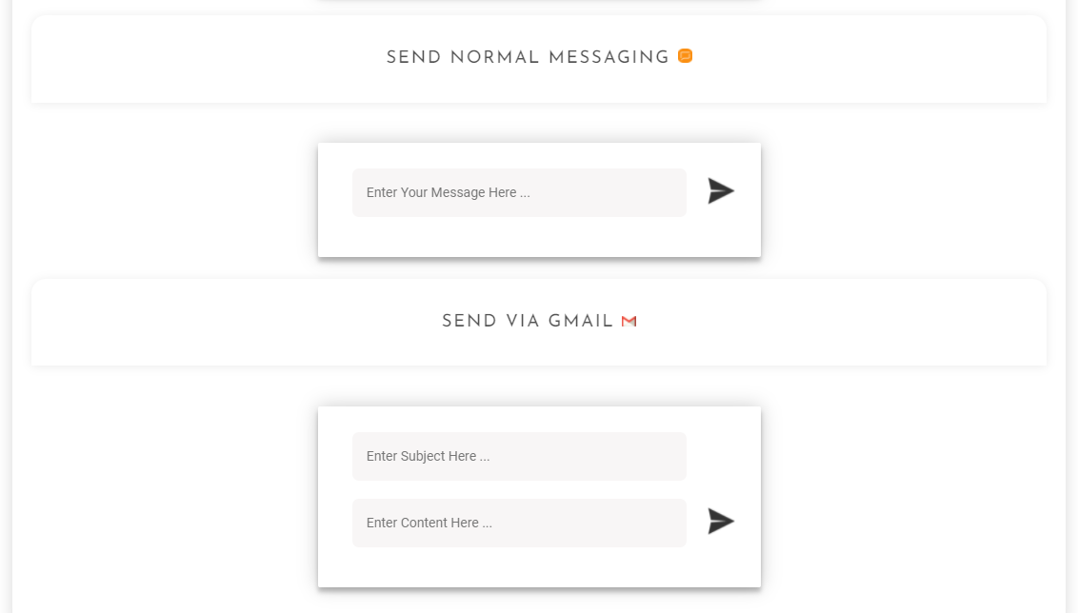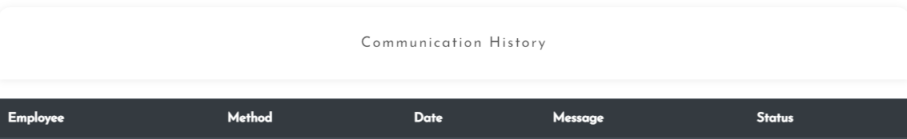

## 38. Manage Complaints and Requirements of Customers Allocated

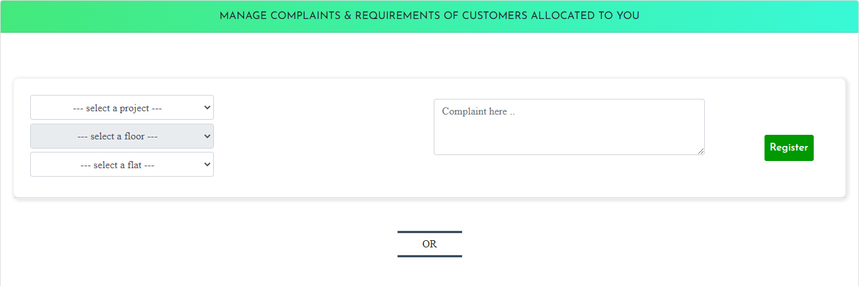

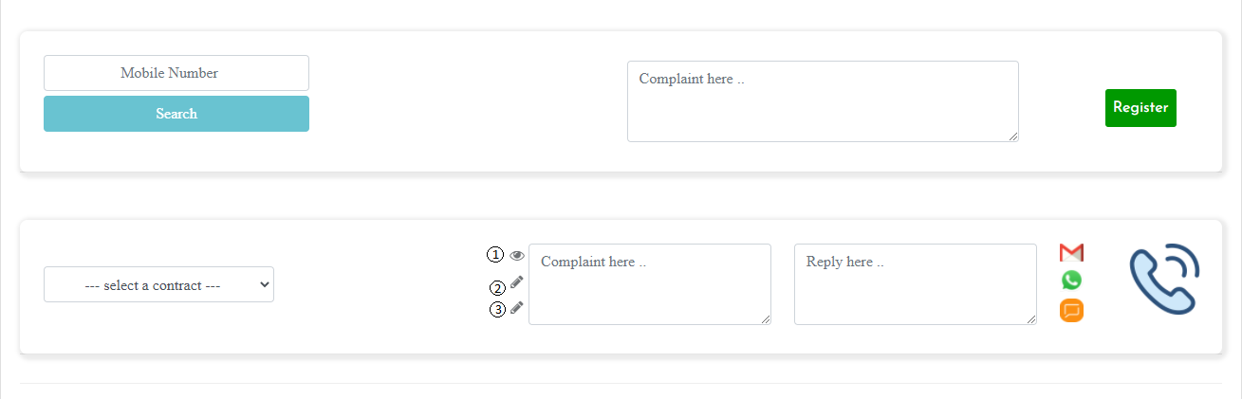

1. Contract Details
2. Edit Phone Number
3. Edit Email

Contract Details

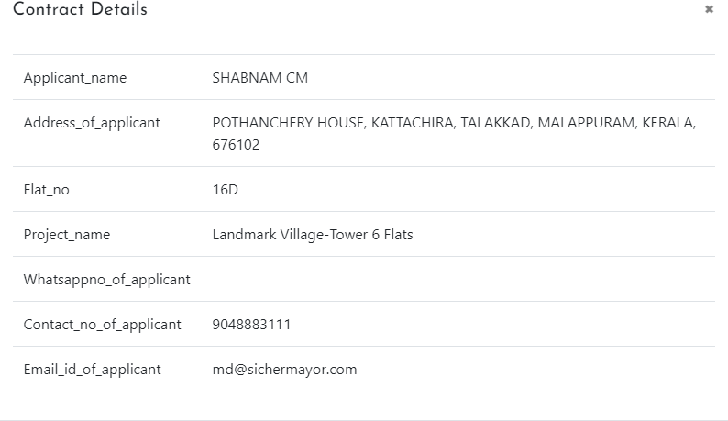

Edit Phone Number

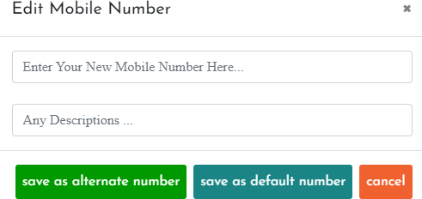

Edit Email ID

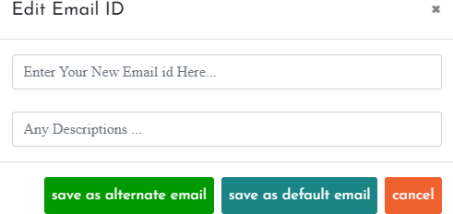

## Record Your Daily Expenses by Category

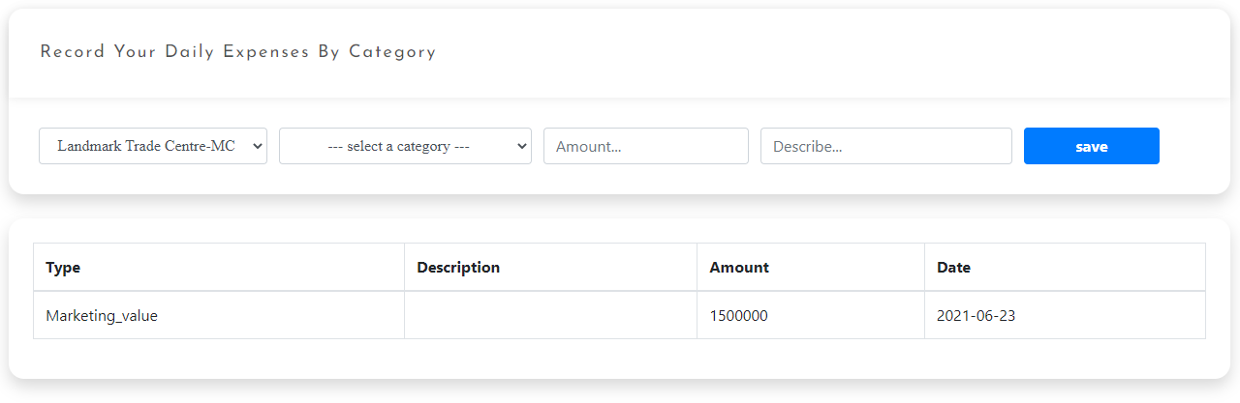

1. **Enquiries and Managements**

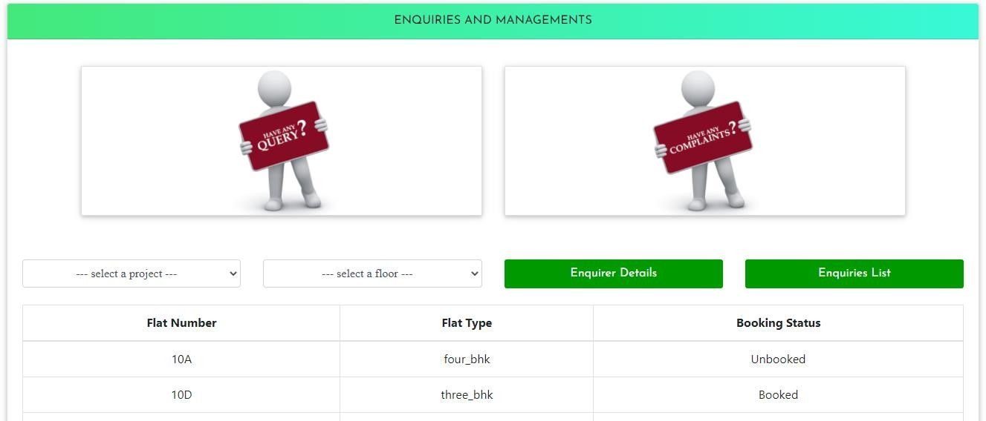

Enquirer Details

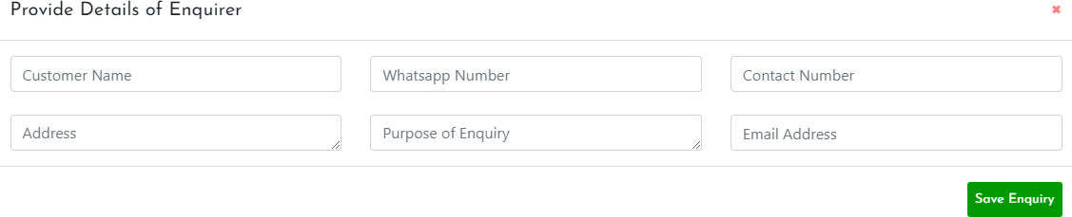

Enquiries List

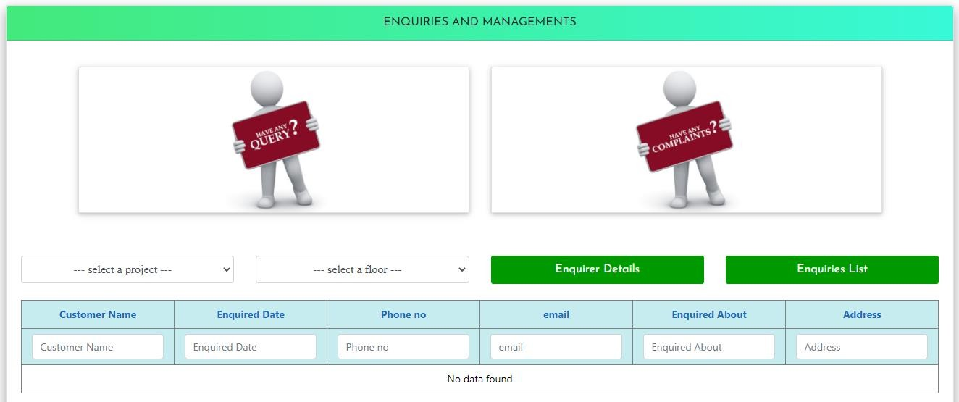

## Daily Updates of Task

### Non-Customer Related Task

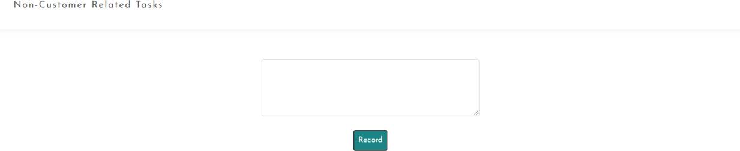

**Customer Related Task**

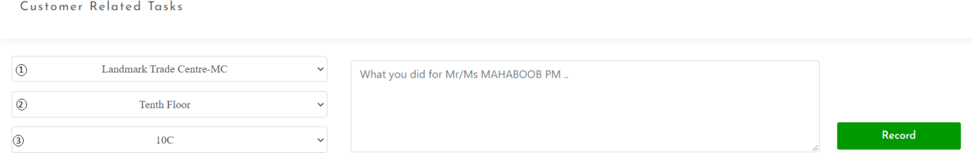

1. Select Project
2. Select Floor
3. Select Flat

**Special Task**

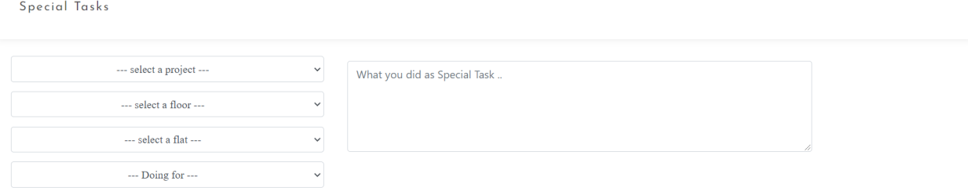

## Save and Manage Your Remainders

To add new events. Also manage,view events.

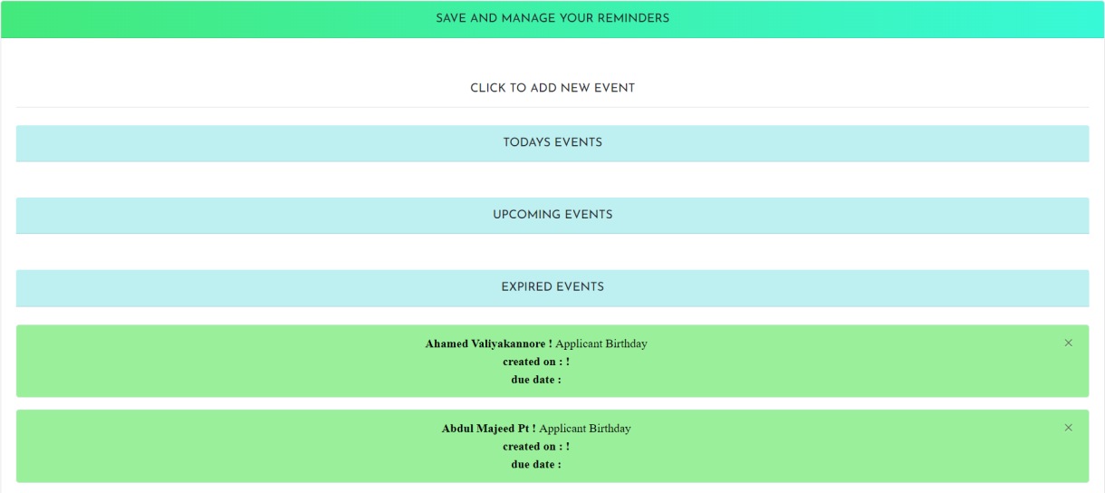

## Send Messages to Contacts

Send messeges through whtasapp, sms and email.

### Send Messages Through Whatsapp



**Send Normal Through Messages**



### Send Messages Through Email

