# Group 7

J016 Avneesh Dubey

# Practical Experiment: 10

**Aim:** Implement Database creation as per described in experiment No. 9.

**Prerequisite:** Object Oriented Concepts, SQL queries.

**Outcome: After successful completion of this practical students will be able to**

* Features of database management system
* Analyze project requirements
* Understand Structure of Project (Object Hierarchy).
* Database structure, gathering required data

**Part B**

As per E-R diagram created in experiment No. 9,

* Develop a database
* Create all the required objects(Table, views etc)
* Insert real data into created tables
* Generate SQL Queries
* Generate a project report which includes following details:

Implementation details

1. Screen shots of each object created
2. Query output and respective description.
3. Conclusion
4. Future scope
5. References

**Solution:**

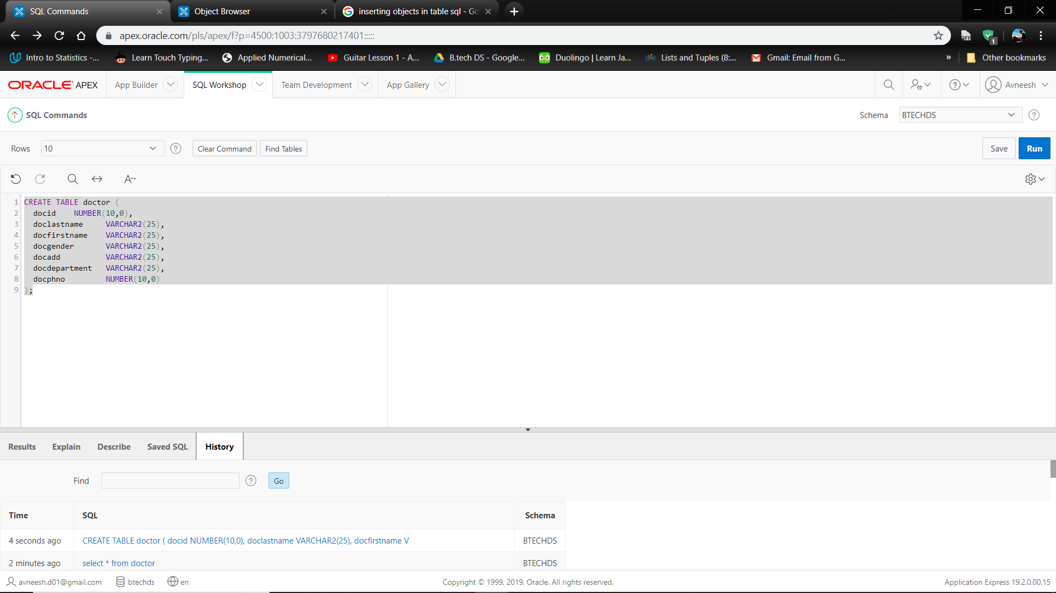

We first create a table that will consist of the following:

1. Doctor ID

2. Doctor’s Last name

3. Doctor’s First name

4. Doctor’s Gender

5. Doctor’s Address

6. Doctor’s Department

7. Doctor’s Phone number

**2.**

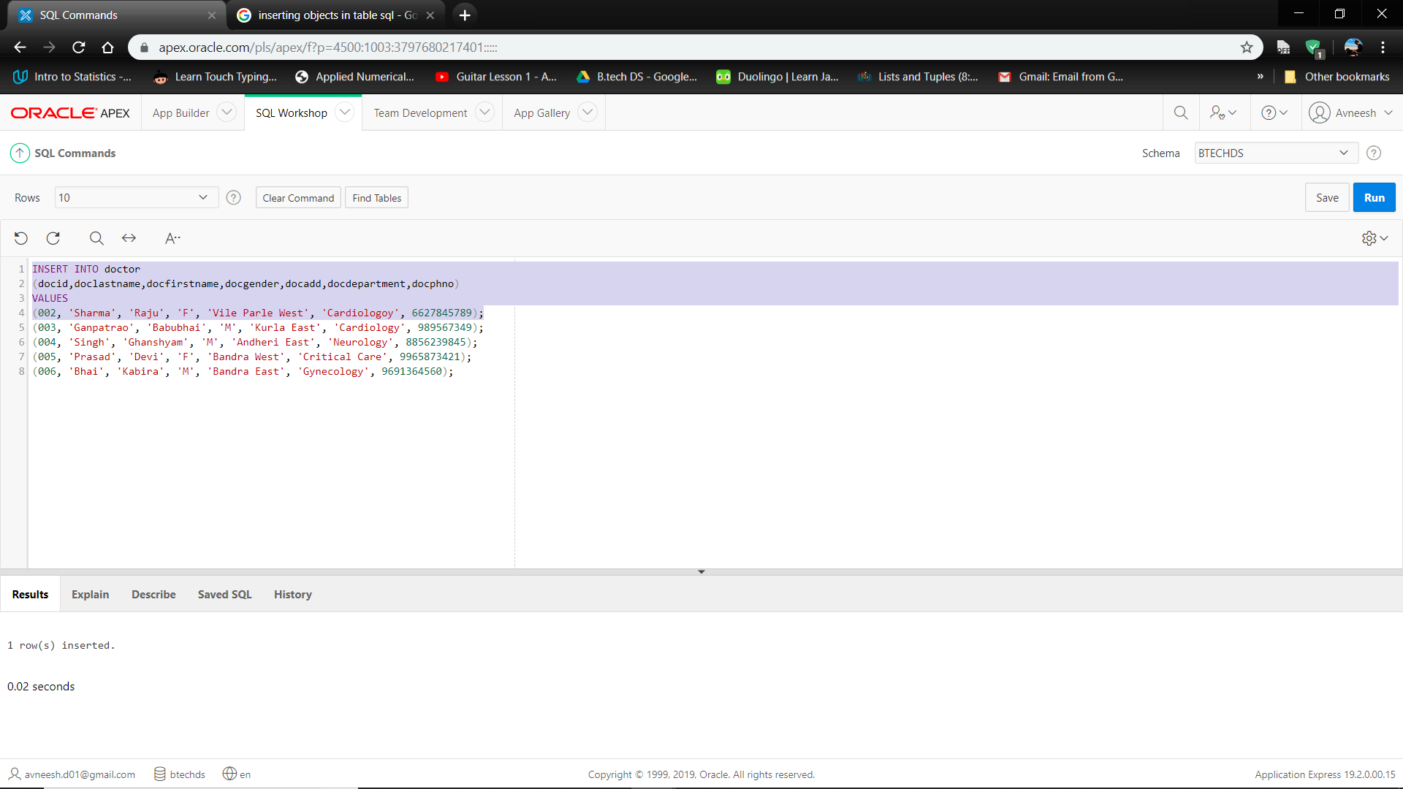

After creating the table for doctors in the hospitals, we insert the basic information of the doctors working there into their respective columns by running the queries one by one.

**3.**

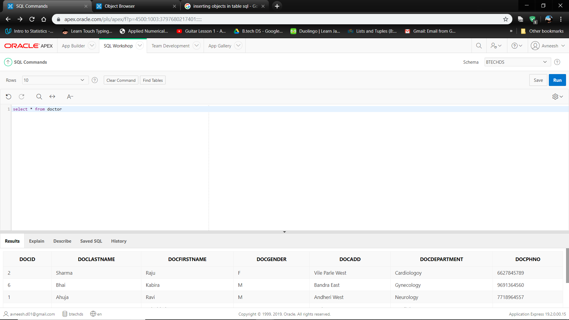

The above query when run displays the database of the doctors working in the hospitals and their respective departments.

**4.**

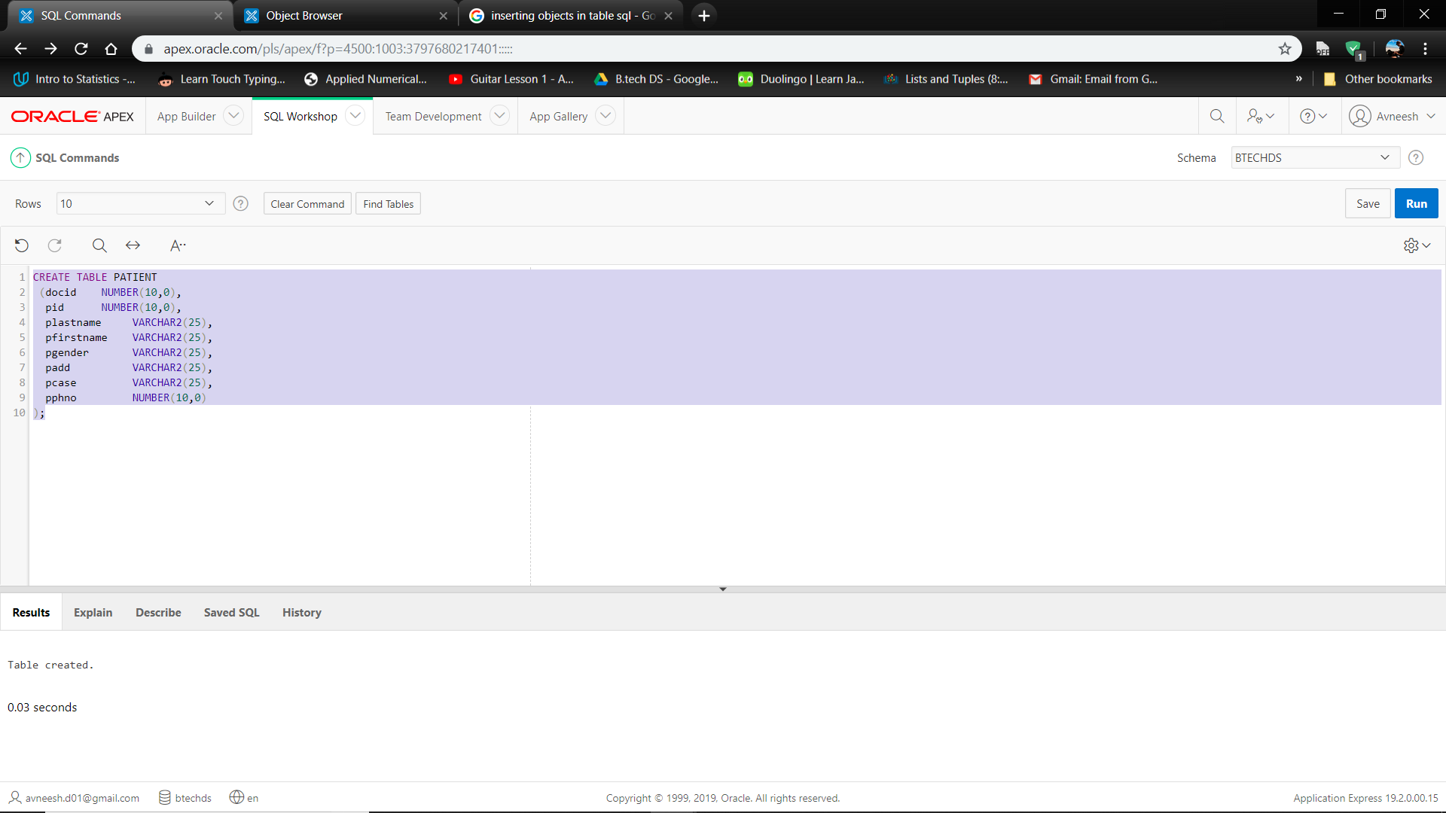We created a table for the Patients admitted at the Hospital and the following information:

1. Patient ID

2. Patient Last Name

3. Patient First Name

4. Patient Gender

5. Patient Address

6. Patient Case

7. Patient Phone number

**5.**

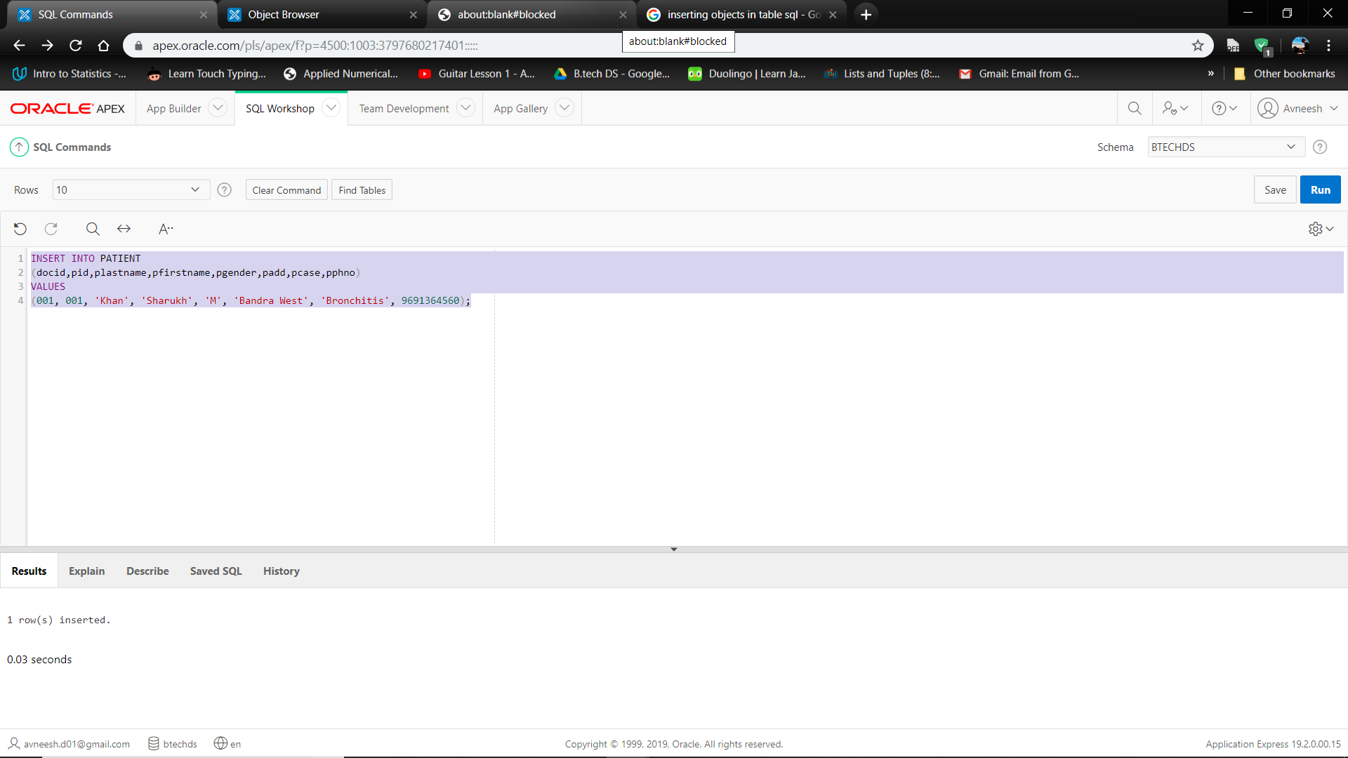

We inserted the information of the patients admitted at the hospital.

**6.**

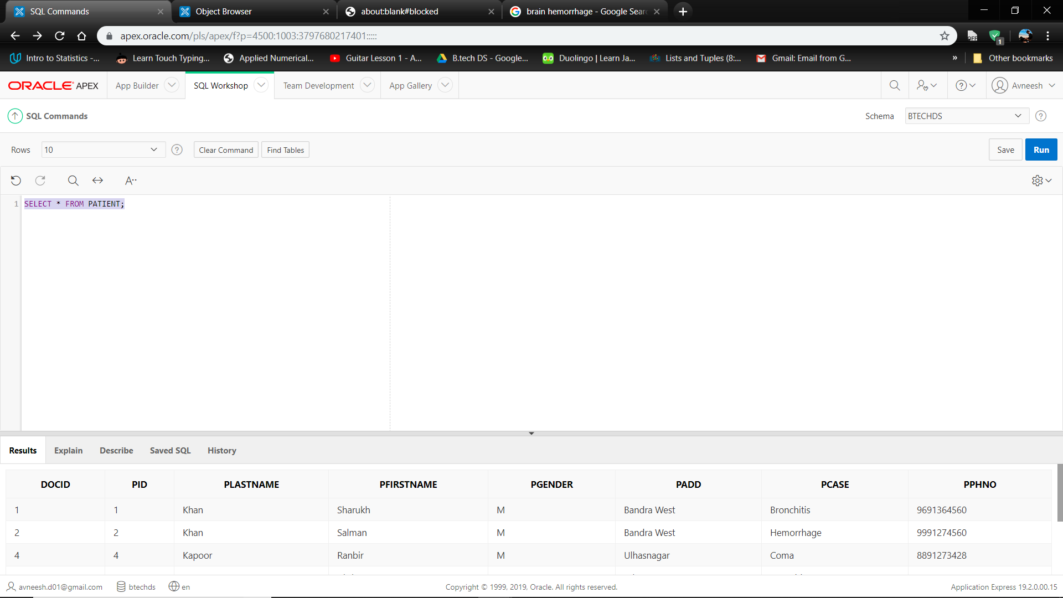

We then a ran a query to view the Patient Database.

After having made the Patient and Doctor tables, we assign the foreign key to docid in Doctor and primary key to docid in Patient.

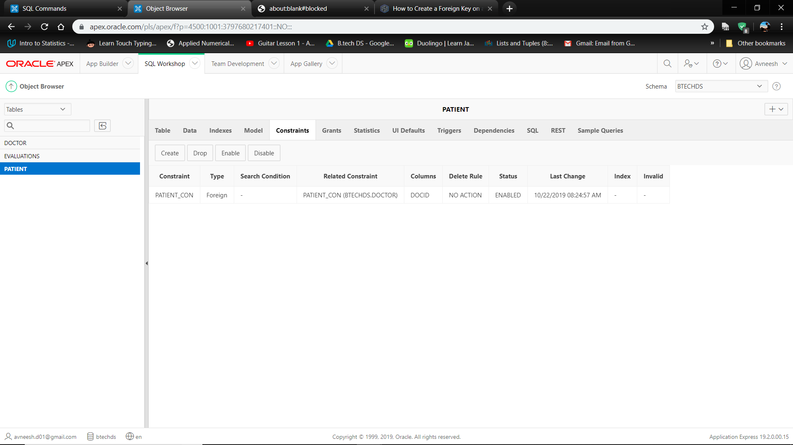

**7.**

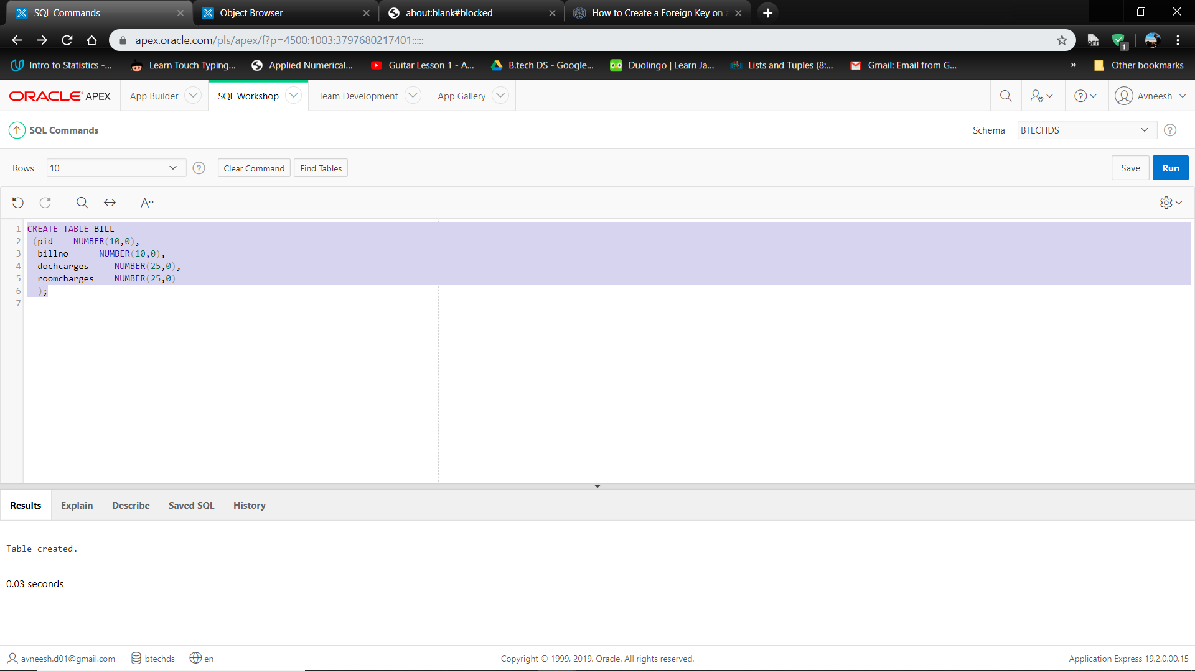

Similarly we created a table for the Billing details of the Patients consisting of the bill number associated with each patient, charges of the Doctor’s consultation and the room charges.

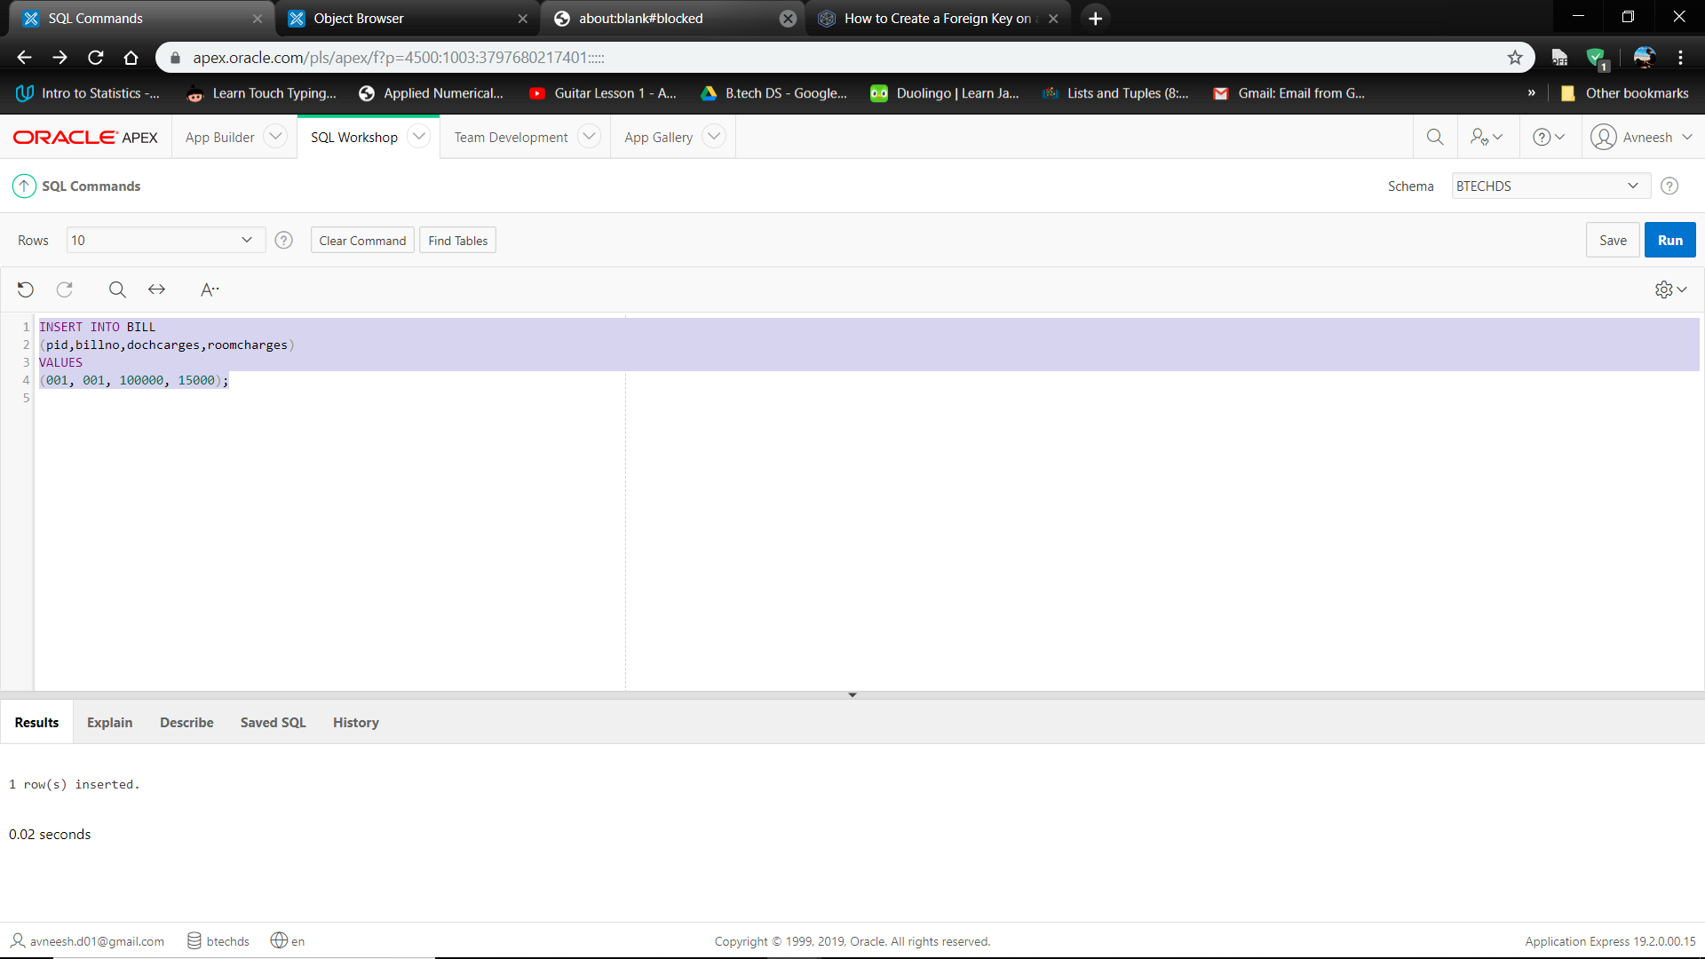

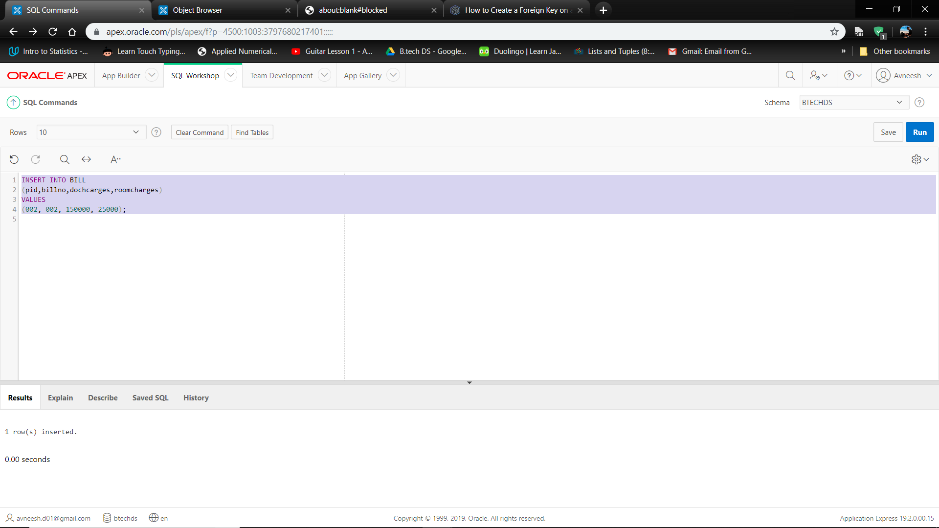

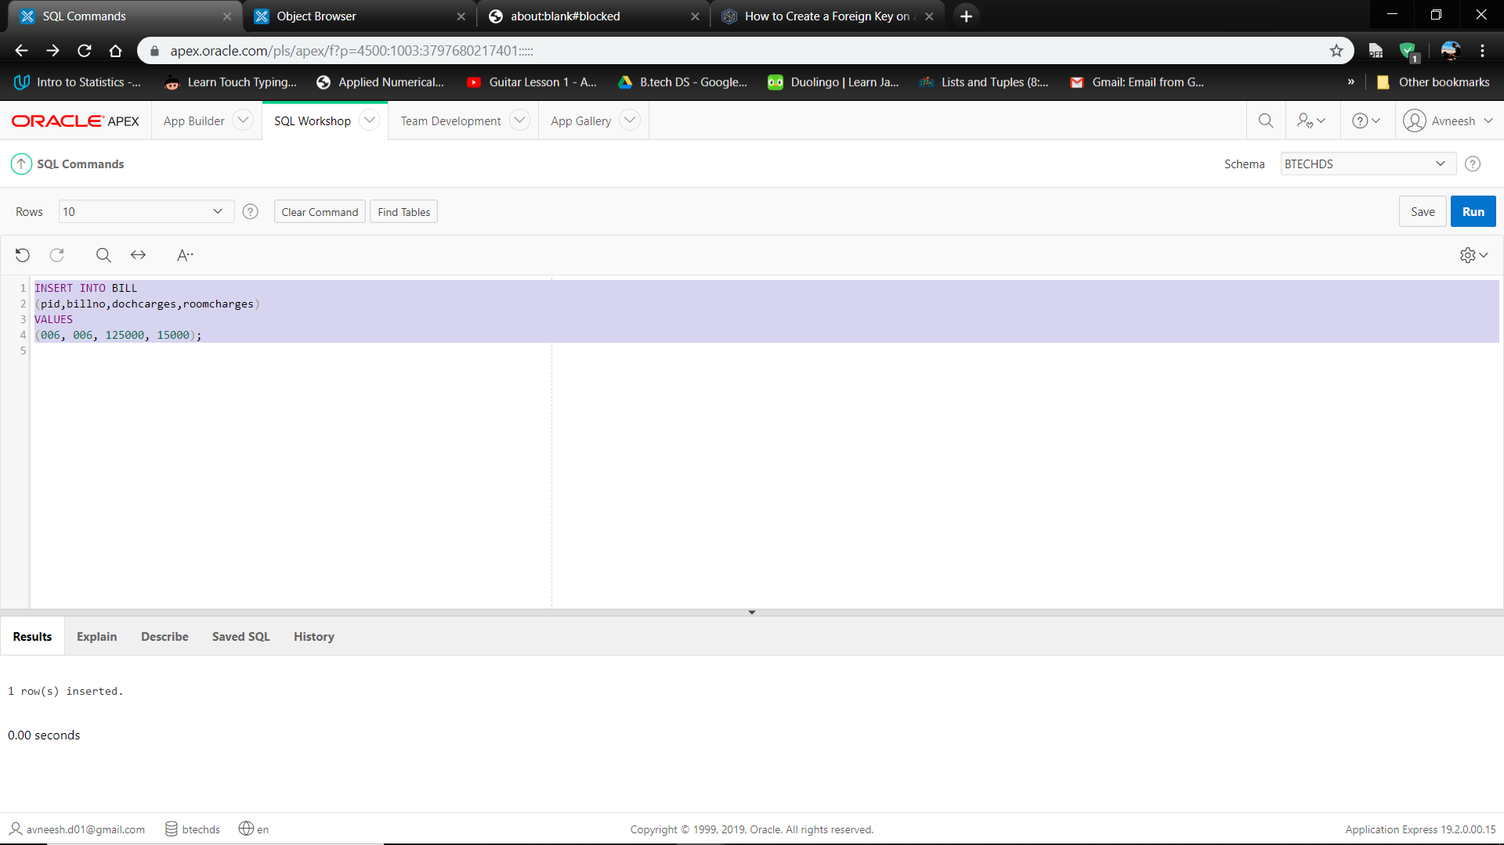

**8.**

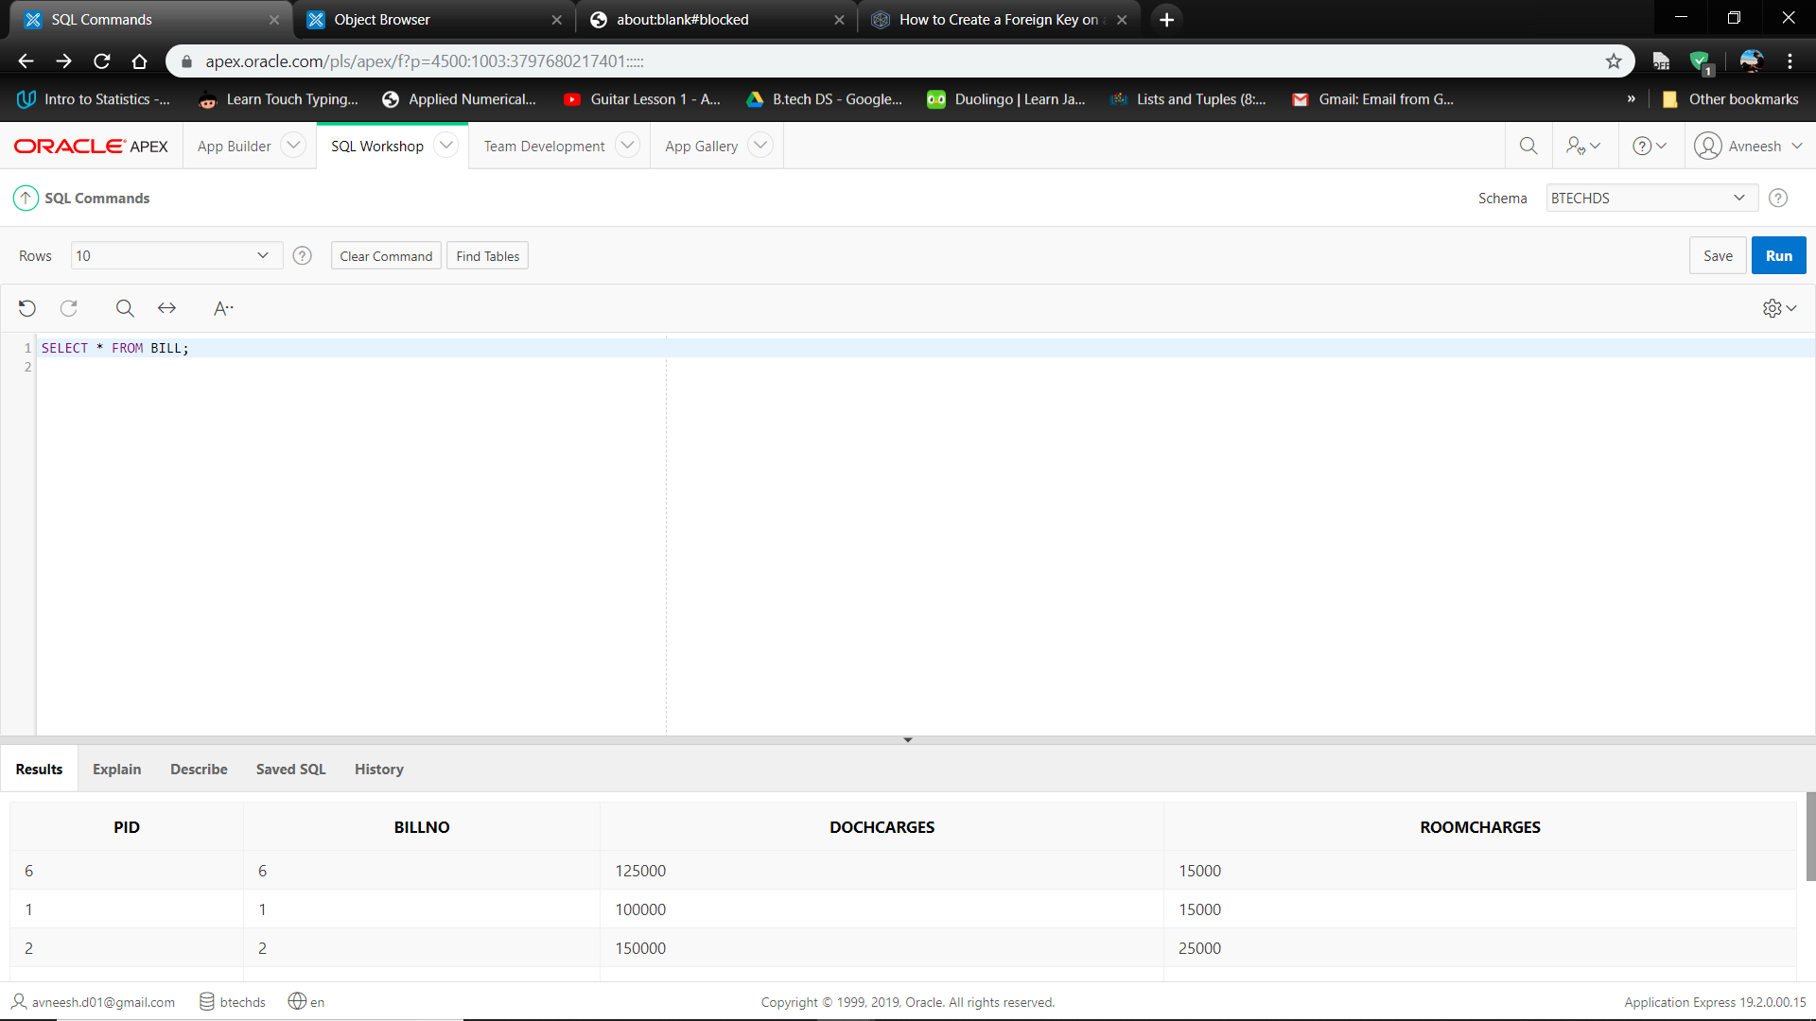

After inserting the elements into the Bill Table we ran a query to view the bill details of the patients.

**9.** Create a table and insert room id and room type with respective patients.

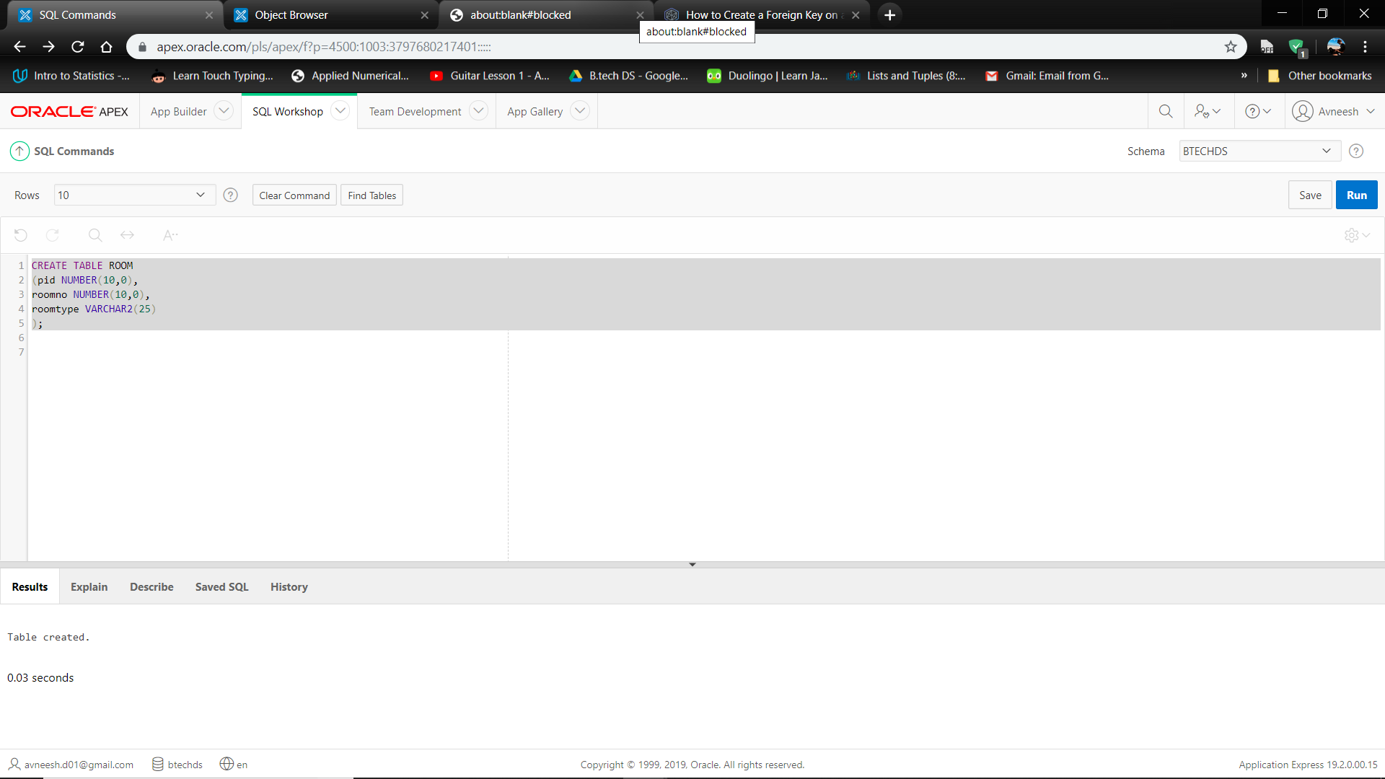

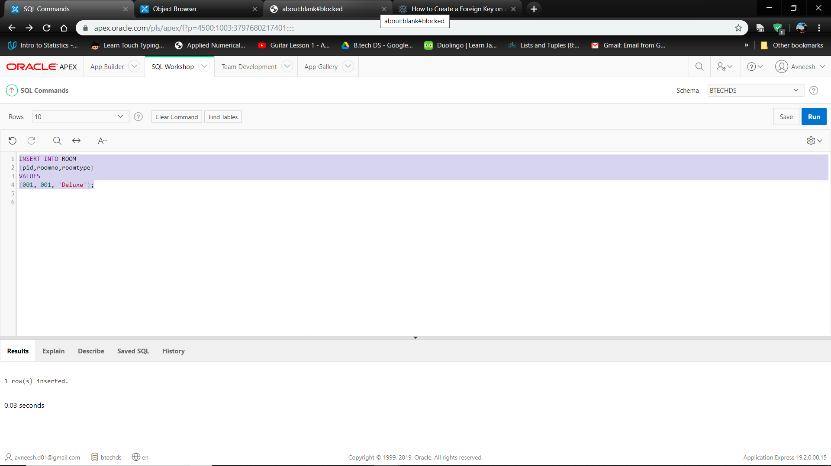

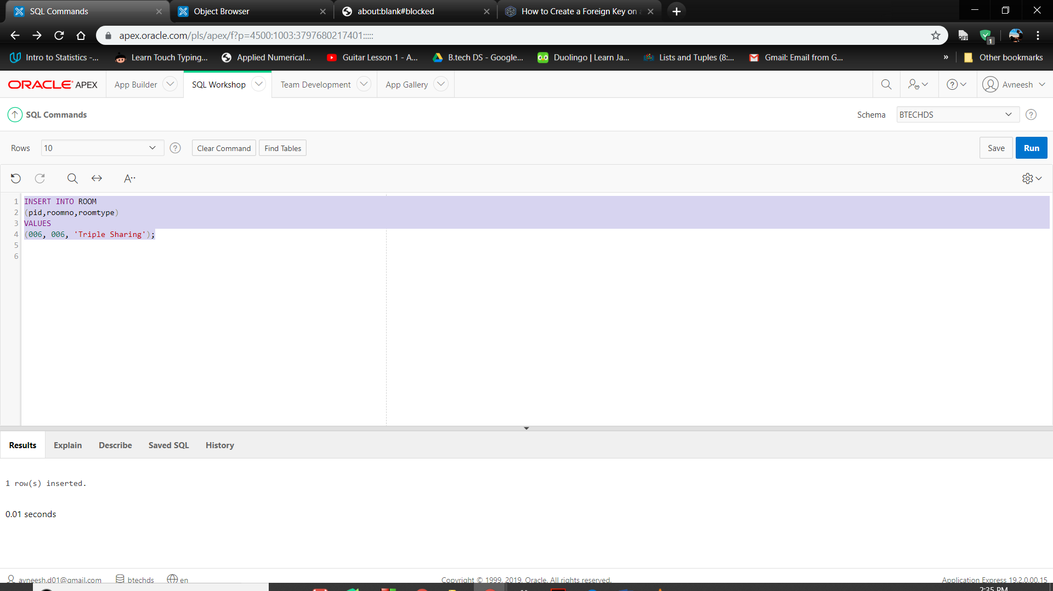

**10.** Viewing the Room table.

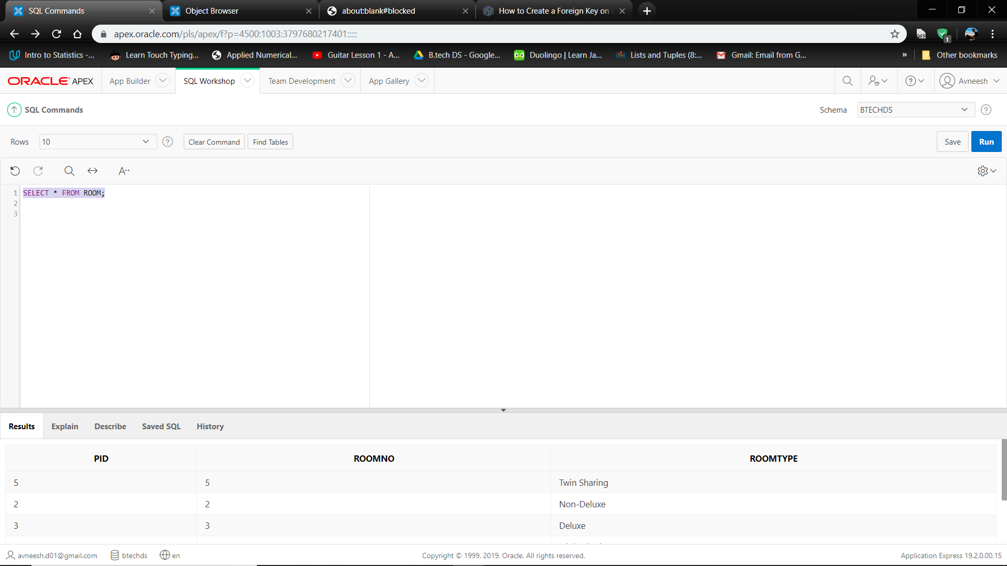

**Other Queries:**

1. **Running a query to view the various cases in the Hospital:**

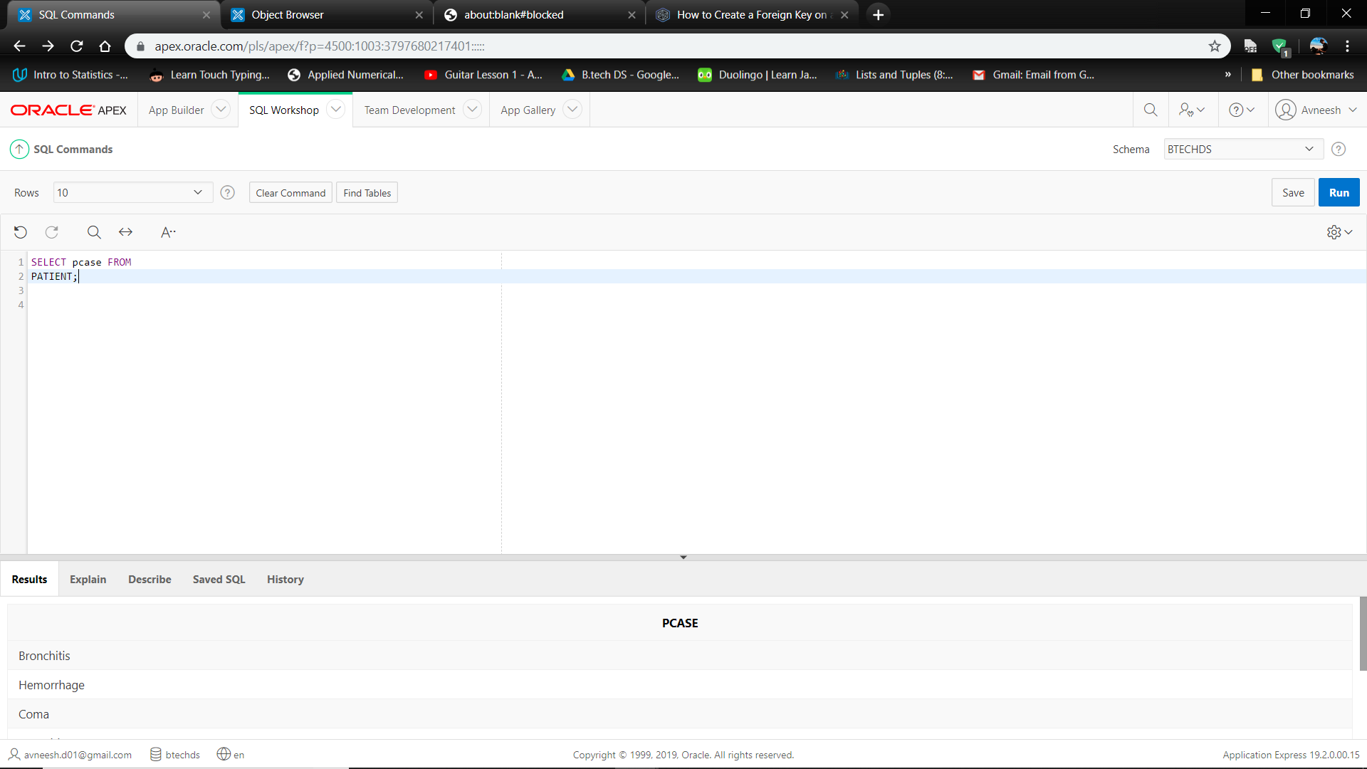

1. **Running a query to view the Doctors treating their respective patients cases.**

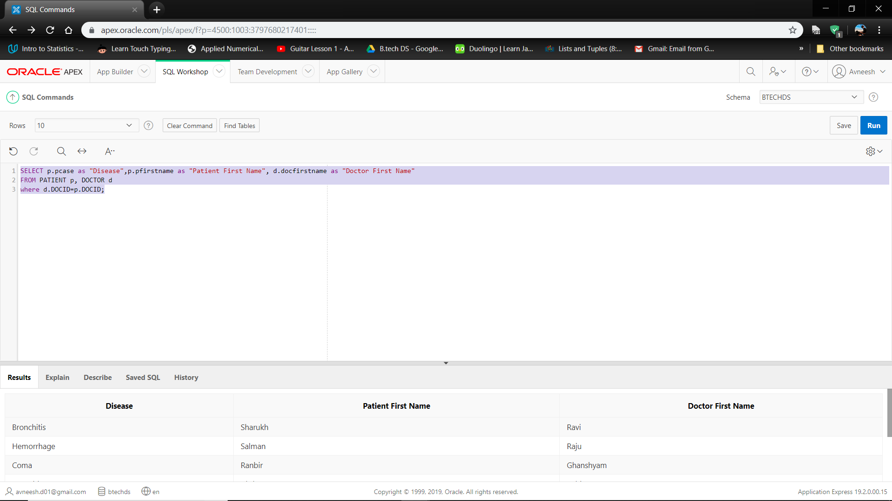

1. **Running a query to view Patients living in the same area by matching their Address.**

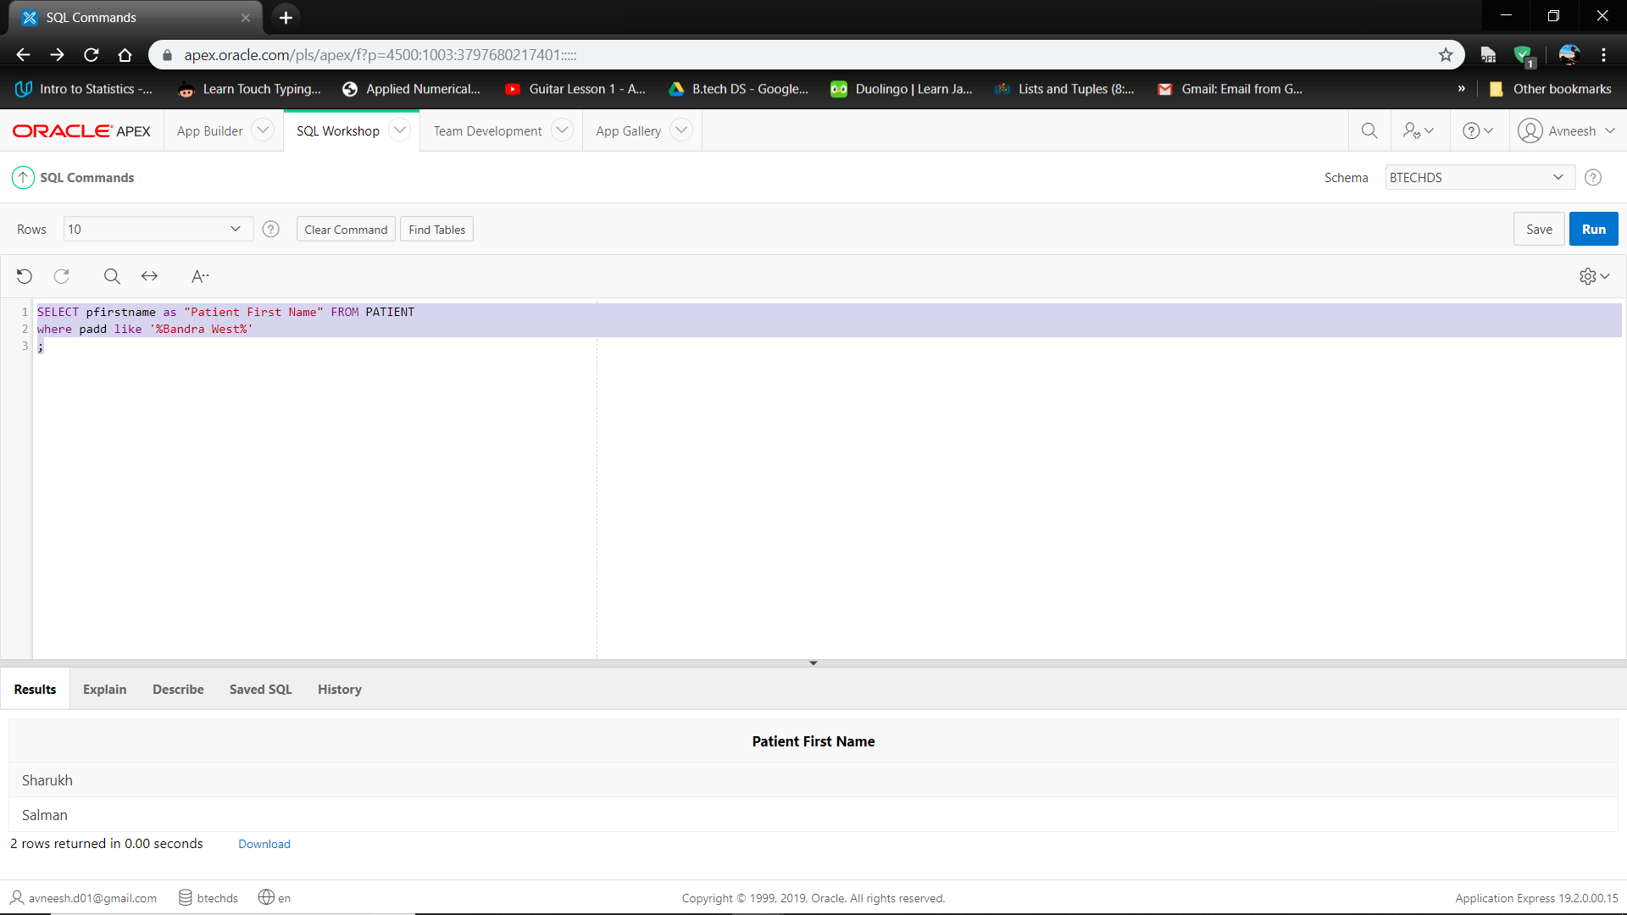

1. **Running a query to view Patients being treated with a particular case, say Bronchitis.**

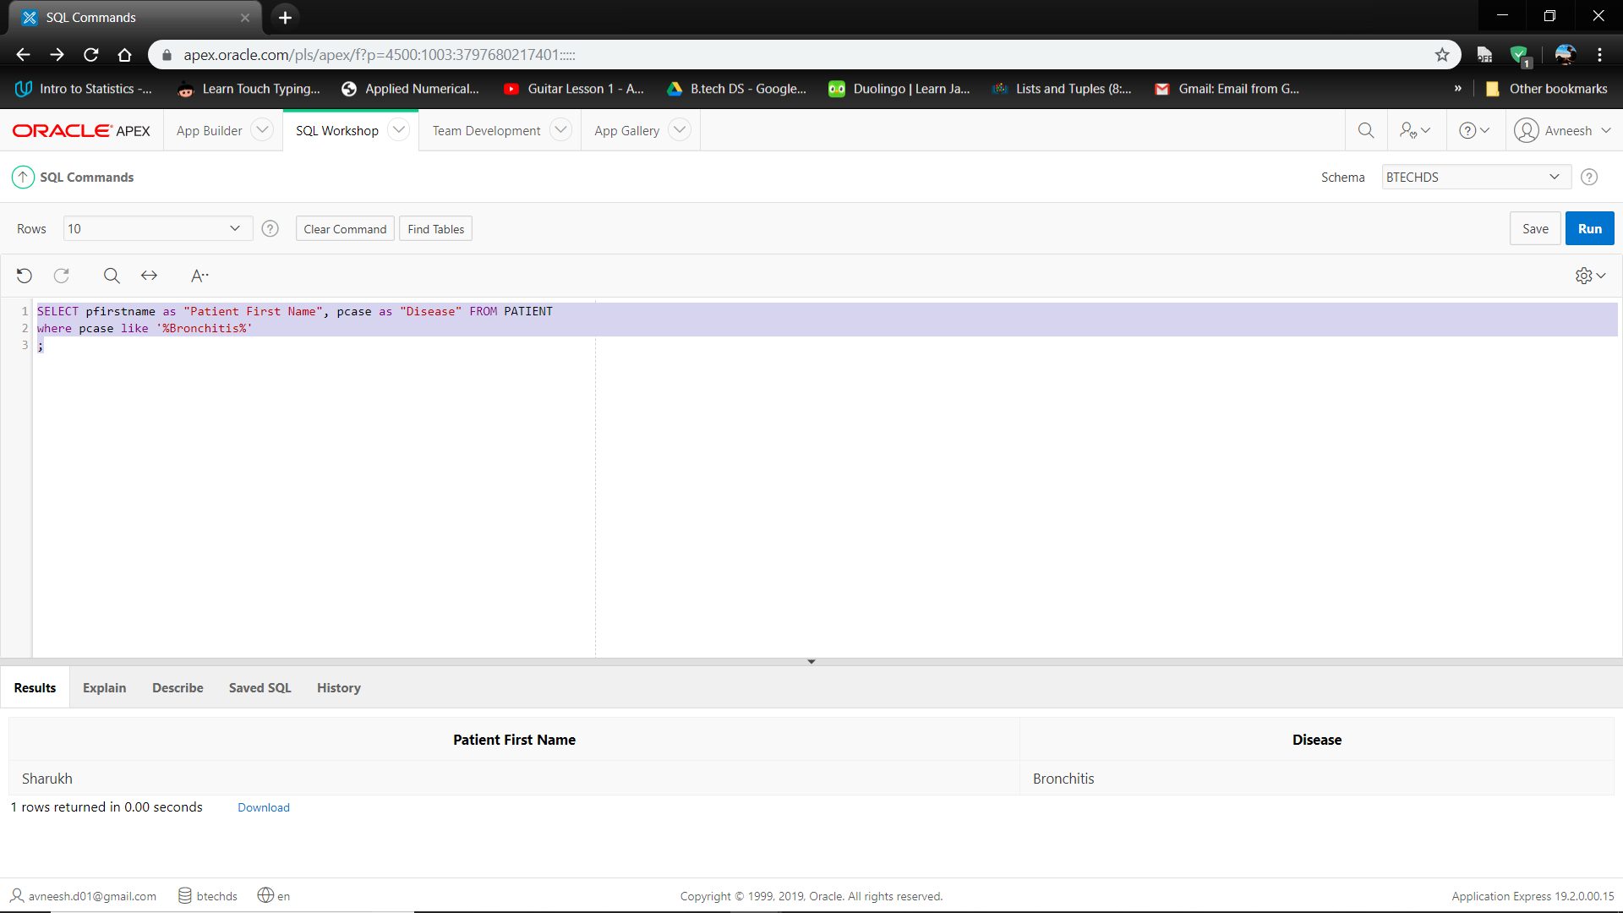

1. **Running a query to view the Patients Doctor Consultation fess according to their First names.**

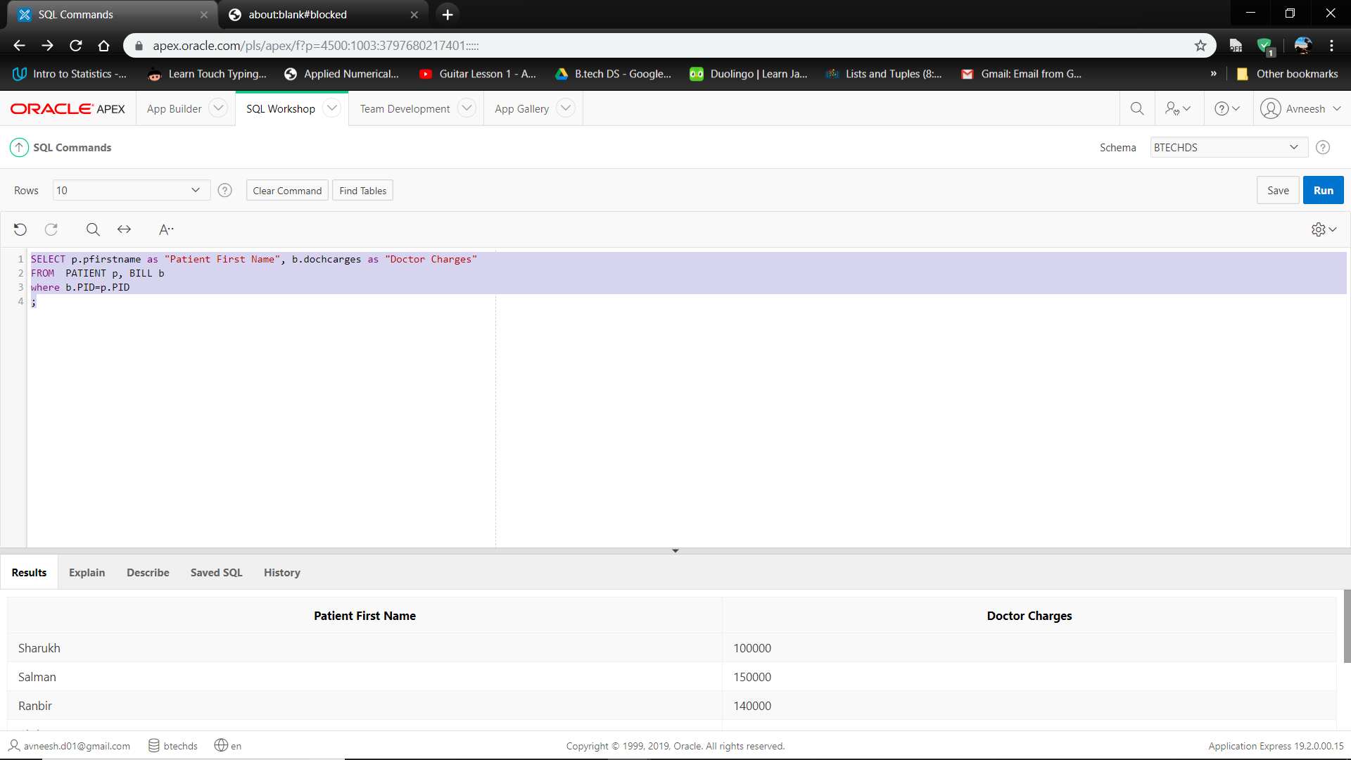

1. **Running a query to view the Doctors from a same particular department and where they live.**

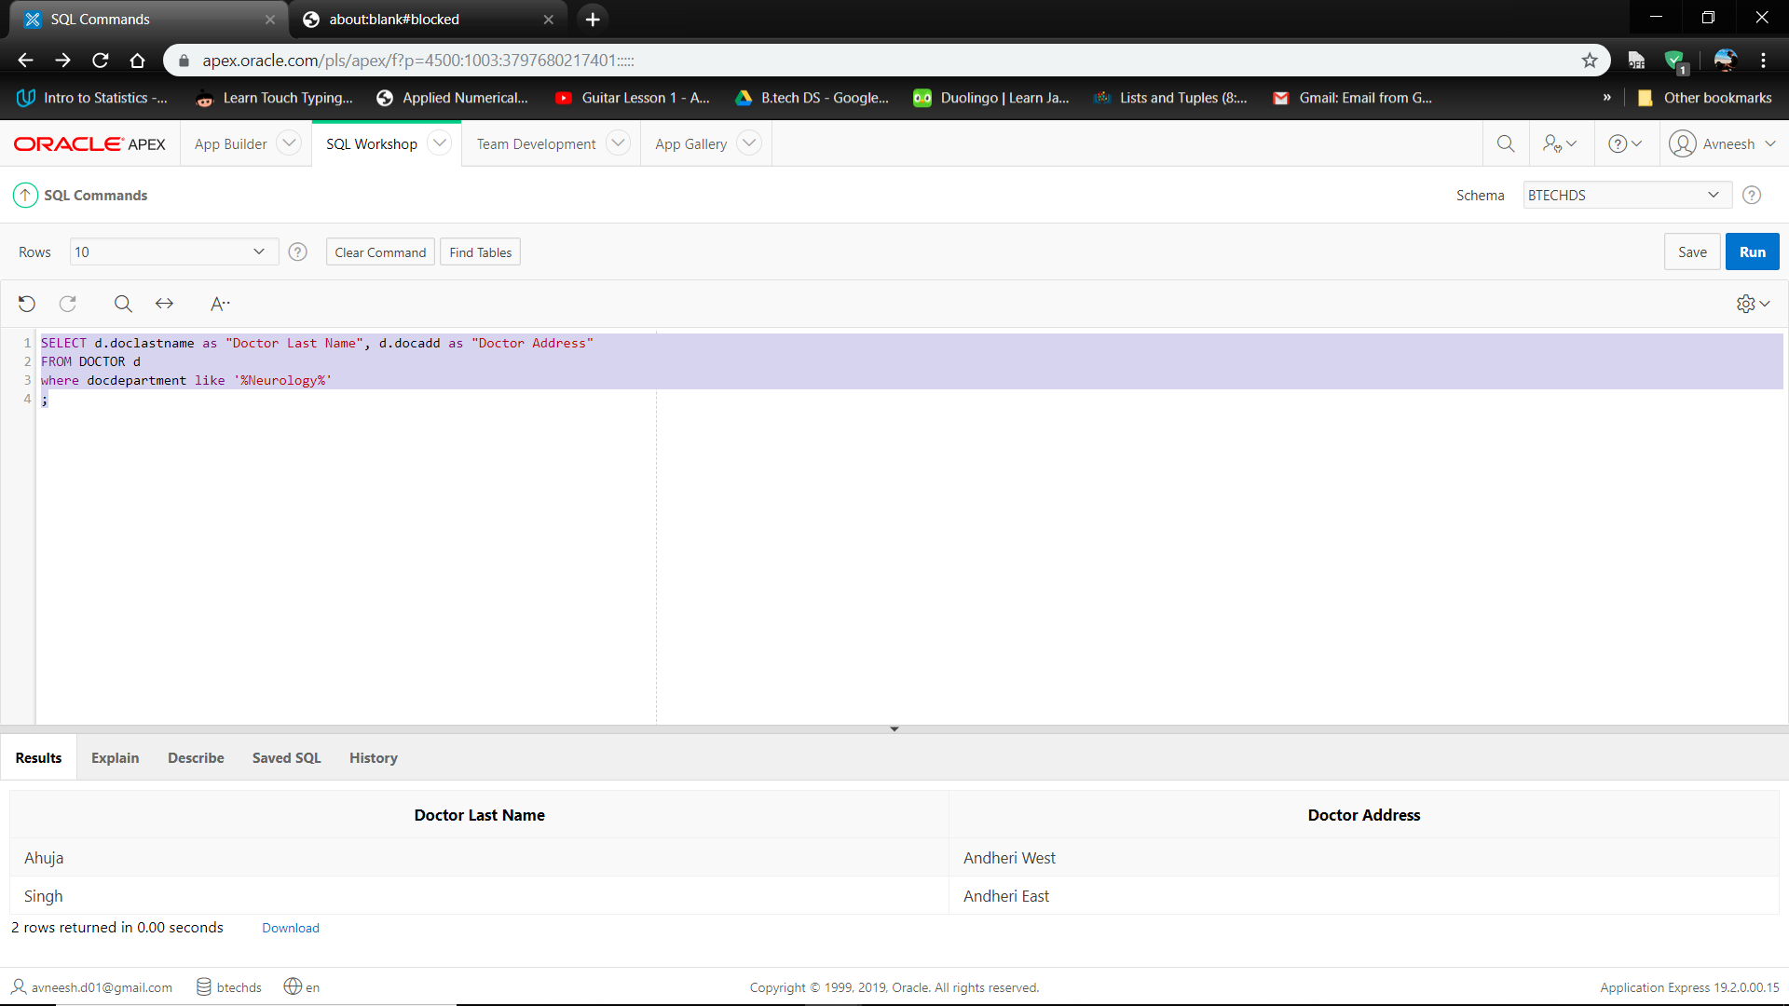

1. **Running a query to classify the patients according their billing information.**

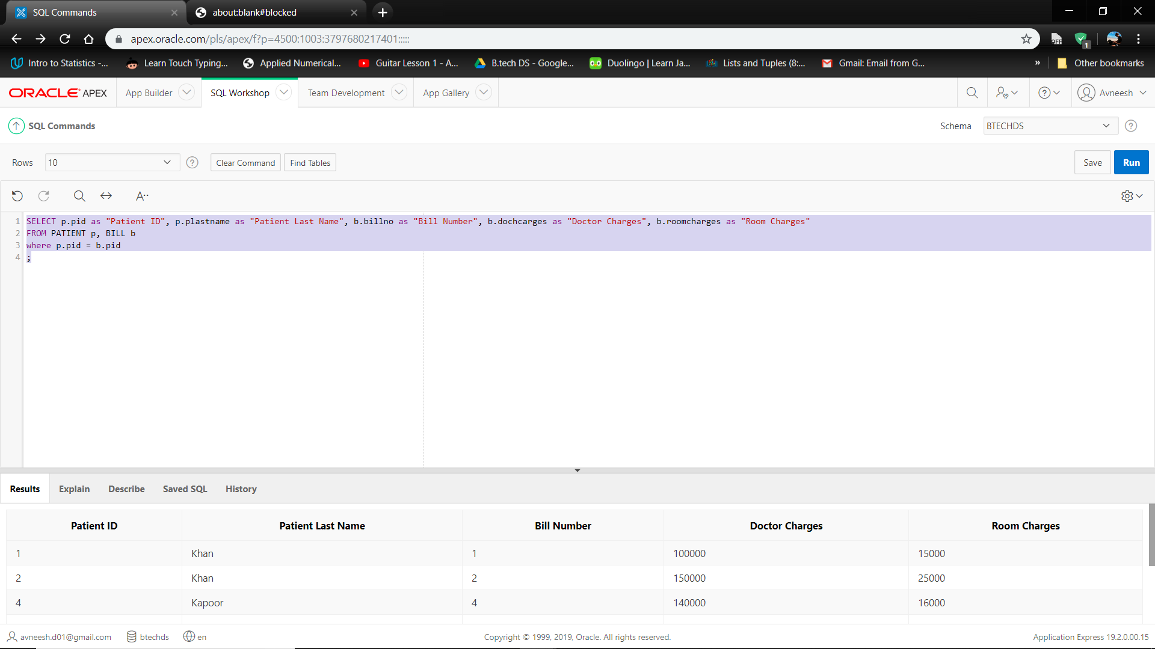

**Conclusion:** By creating tables to enter the details of the Doctors, the patients and the patient’s billing details we eliminate any errors and mistakes that the Hospital Management can make. Making entries into the database is made simpler and viewing the patient’s basic information and case information is also made simpler.

The project **Hospital Management System (HMS)** is for

computerizing the working in a hospital. The software

takes care of all the requirements of an average

hospital and is capable to provide easy and effective

storage of information related to patients that come up

to the hospital.

**Future Scope:** There lies immense scope in implementing Hospital Management System or Patient Registration Systems.It can also help generate test reports; provide prescription details

including various tests, check-up and medicines

prescribed to patient and doctor. It also provides

injection details and billing facility.

• The system also provides the facility of backup as per

the requirement.

**References:**

[https://www.w3schools.com](https://www.w3schools.com/)

[https://cloud.ibm.com](https://cloud.ibm.com/)