# Group 7

# J016 Avneesh Dubey

# Experiment No. 9

Aim: Implementation of ER diagram for DBMS project

Part B:

Detailed System Requirement Study.

ER Diagram for the selected project topic (Diagram, assumptions, description of diagram)

ER-Diagram:

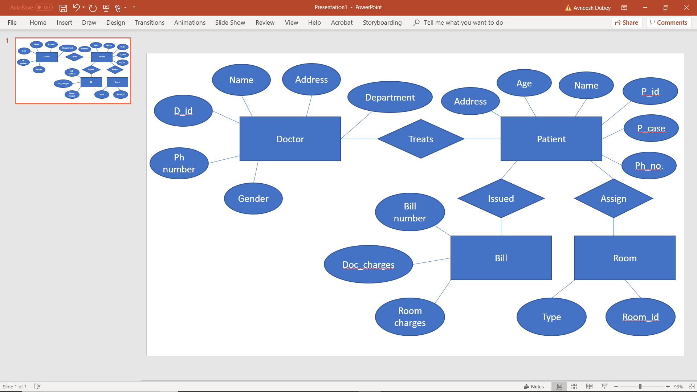

Assuming: The doctor id corresponds to the respective patient ids and patient ids correspond to their respective bill numbers and room numbers.

Description: 1. Entity sets include DOCTOR, PATIENT, BILL and ROOM

2. Attributes associated with DOCTOR such as phone number, name, address, department etc. Attributes associated with PATIENT such as address, age, name, patient id etc. Attributes associated with BILL such as Bill number, doctor charges, room charges. Attributes associated with ROOM such as room type, room id.

3. Relationships between DOCTOR who Treats the PATIENT, PATIENT who is Issued a BILL and Assigned a ROOM.

Logical Schema:

DOCTOR:

d_id, lastname, firstname, d_gender, d_add, d_dept, ph_no

PATIENT:

P_id, plastname, pfirstname, p_age, p_add, p_case, p_ph_no

BILL:

Bill_no, doc_charges, room_charges

ROOM:

room_id, roomtype

SQL Commands:

CREATE TABLE doctor (

docid NUMBER(10,0),

doclastname VARCHAR2(25),

docfirstname VARCHAR2(25),

docgender VARCHAR2(25),

docadd VARCHAR2(25),

docdepartment VARCHAR2(25),

docphno NUMBER(10,0)

);

CREATE TABLE PATIENT

(docid NUMBER(10,0),

pid NUMBER(10,0),

plastname VARCHAR2(25),

pfirstname VARCHAR2(25),

pgender VARCHAR2(25),

padd VARCHAR2(25),

pcase VARCHAR2(25),

pphno NUMBER(10,0)

);

INSERT INTO ROOM

(pid,roomno,roomtye)

VALUES

(001, 001, 'Deluxe'),

(002, 002, 'Non-Deluxe'),

(003, 003, 'Twin Sharing'),

(004, 004, 'Single Sharing'),

(005, 005, 'Deluxe'),

(006, 006, 'Non-Deluxe')

);

SELECT p.pcase as "Disease",p.pfirstname as "Patient First Name", d.docfirstname as "Doctor First Name"

FROM PATIENT p, DOCTOR d

where d.DOCID=p.DOCID;