**UNIVERSAL PARABOLIC CONSTANT**

Universal parabolic constant is one of the irrational number constant in the field of mathematics defined for a parabola. It is calculated by the ratio of the arc length of the parabolic segment formed by latus rectum over the focal parameter.

Latus rectum in parabola is defined as a line segment which is perpendicular to the major axis and passes through the focus and it’s both endpoints lie on the curve.

Focal Parameter is the distance from the vertex to the directrix or focus.

The value of P (Universal Parabolic Constant) is

P= ln(1+ √2) + √2 = 2.29558714939..

The green line in the picture represents focal parameter, red represents arc length of the parabolic segment and latus rectum in red.

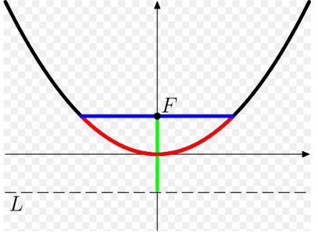

In field of mathematics, the parabola and circle are same in a way that they have universal constant. Circle has pie and parabola has universal parabolic constant. However, the ratios defined for ellipses and hyperbolas depends upon their eccentricities.

References: >

1. Sylvester Reese and Jonathan Sondow. [*"Universal Parabolic Constant"*](http://mathworld.wolfram.com/.html). [*MathWorld*](https://wikivisually.com/wiki/MathWorld)., a Wolfram Web resource